1.3 Atomic structure
Looking at atoms
All matter is made up of elements, either as individual elements, or joined to other elements as compounds. Imagine, then, that you have a piece of copper and you cut it into smaller and smaller pieces. What will you eventually find? Yes, you will find that you have a huge number of very small bits. The smallest that you can go and still know that you have copper is to a particle the size of a single atom of copper.
Atoms are so small that they cannot be seen by the naked eye, or common magnifying equipment. In fact, the first time that there was visual proof that atoms actually exist was with the invention of the scanning tunnelling microscope.
Key Concept
The atom is smallest possible particle of any element that still has all the characteristics of the element

So what do we know about atoms?
Since an atom is so small it is difficult for us to see one, even with very strong microscopes, so here are a few interesting facts to give you an idea:

To draw a line about 1 cm in length with your pencil would use about 20 million carbon atoms arranged in a chain.
- If an atom were the size of a soccer ball, then the soccer ball would have a diameter of 6 450 kilometres.

The smallness of atoms makes them very difficult to study. How does one investigate something that is too small to see and handle? As science and technology advanced more and more became known about atoms, so it is useful to have some understanding of the timeline for these discoveries. And as more became known scientists were able to build models of what they believed atoms would look like if we could indeed see them.

The early history of our understanding of the nature of the atom
Some of the major historical milestones in the development of our understanding of atoms are summarised below.
- As long ago as 450 B.C. Democritus proposed that matter could not be infinitely divided and that at some point a fundamental, indivisible particle would be found. This ultimate particle he called the atom from the Greek word atomos meaning indivisible.
- This idea was not popular at all, but scientists began to accept it many centuries later when John Dalton, an English schoolteacher, published his atomic theory in 1808. You already know that he suggested that atoms were tiny, indivisible, indestructible balls. He also proposed that atoms of different elements could combine to form compounds.
- In 1897, the English physicist, J.J. Thomson, did experiments using cathode rays which proved that atoms could in fact be broken down into smaller particles, called subatomic particles:
  - Positively charged subatomic particles were named protons (p⁺)
  - Negatively charged subatomic particles were named electrons (e⁻)
  - The protons and electrons had equal but opposite charges
- By 1911 Thomson had determined the masses of the subatomic particles:
Pic of plum pudding model
p203

  - The mass of an electron is 9.11 x 10⁻²⁸ g
  - The mass of a proton is 1.67 x 10⁻²⁴ g
  - The mass of an electron is only 1/1836 x the mass of a proton, so it is regarded as having a negligible mass when compared to a proton and its contribution to the mass of an atom is generally ignored.
  - Thomson ‘s model (called the plum pudding or raisin bun model) was that an atom was a sphere of uniform positive charge with negatively charged electrons distributed throughout to give a net zero charge as the positive and negative charges would cancel each other out.
- Ernest Rutherford, one of Thomson’s students, improved on the model. He studied radioactivity and identified three types, alpha rays, beta rays and gamma rays. Using alpha rays he conducted a now-famous experiment called the gold foil experiment to show that the plum pudding model was inaccurate. His results indicated the following:
Pic of Rutherford model
P207
  - The atomic has a diameter of 1 x 10⁻⁸ cm
  - The protons are all located in the centre of the spherical atom in the atomic nucleus
  - The atomic nucleus has a diameter of 1 x 10⁻¹³ cm
  - The electrons are distributed around the nucleus in the relatively huge remaining space forming the atom.
To get some idea of the relative sizes of the atom and its nucleus consider this: imagine a marble placed in the centre of one of the huge soccer stadiums built for the Soccer World Cup. The stadium would represent the atoms while the marble would represent the nucleus! So you can see, and atom is mostly made up of empty space!
- In 1932 James Chadwick discovered that the nucleus of an atom does not only contain positively charged protons, but also neutral particles, carrying no charge. He called these neutrons (nº).The mass of a neutron is about the same as the mass of a proton, 1.67 x 10⁻²⁴ g. This means that neutrons contribute significantly to the total mass of the atom.
- A Danish physicist named Niels Bohr worked first with Thomson and then with Rutherford on the structure of the atom. In 1913 Bohr proposed a new model that furthered our understanding of the atom. He proposed that electrons are not free to move at random around the nucleus, but rather that they travel around the nucleus in the same way that the planets in our solar system orbit around the sun. This means that the electrons travel in set orbitals which have fixed energy levels and fixed distances form the nucleus.
In sert pic

P213?

Bohr’s ‘solar system’ model was only a theory, so it needed to be tested experimentally. Fortunately, at that time other physicists were doing experiments that provided the support that Bohr needed. You will take a further look at the Bohr model later.
Relative atomic mass
The information that you have about the subatomic particles is summarized in the following table:
Key concepts
Name of subatomic particle | Symbol | Location | Relative charge | Relative mass (u)
Electron | e⁻ | Outside nucleus, always moving | -1 | 1/1836
Proton | P⁺ | In nucleus, packed tightly | +1 | 1
Neutron | nº | In nucleus, packed tightly | 0 | 1

It is impossible to weigh an atom because its mass is too small. For example, a single atom of carbon (C) has a mass of about
1.99 x 10⁻²¹ g. However, if the number of protons and neutrons in the nucleus is known, and each of these particles has a mass of 1u, then by totaling the number of protons and neutrons present in the nucleus an idea of the mass of an atom can be obtained.
Scientists then introduced the concept of Relative atomic mass (ram). The mass of one atom of each of the elements is measured relative to the mass of one carbon atom in an instrument called a mass spectrometer.
The mass of a carbon atom is set at 12 u
(because there are 6 protons and 6 neutrons in the most abundant and most stable form of carbon).
The mass of a hydrogen atom (H) relative to a C atom is measured to be
1 u = 1 atomic mass unit
1 u = 1 dalton (D)
1 u = 1.661 x 10⁻²⁴ g
1 u while the mass of an oxygen atom (O) is 16 u.

Atomic notation

You are already familiar with the concept that scientists use a kind of short hand to refer to elements and compounds. Atomic notation refers to the shorthand used when describing elements, atoms and subatomic particles.

- Each element has a particular number of protons in its nucleus. In fact, it is the number of protons that differentiates one element from another. For example, a hydrogen atom (H) contains only 1 proton in its nucleus but a carbon atom (C) contains 6 protons in its nucleus, and an atom of gold has 79 protons.
The number of protons is called the atomic number, Z
- Most elements also have neutrons in the nucleus. These add to the total mass of each atom, but have no effect on the charge since they are neutral.
The mass number, A, gives the total number of protons and neutrons in the nucleus.

- Number of neutrons = mass number (A) – atomic number (Z)

- The shorthand notation for adding this information to the symbol of an element is as follows:
^{A} _{Z}Sy where A = atomic number
Z = mass number
Sy = symbol of element

e.g. ²³₁₁Na

p212

- It is not necessary to include the number of electrons in the notation because, in a neutral atom,
number of electrons = number of protons
- Another common notation is Sy–A
For example: C-12 represents carbon with a mass number of 12.
Example
Determine the number of electrons, protons and neutrons in the following atoms;
- ¹⁰⁹₄₇Ag
- ²³⁵₉₂U
Solution
- Ag has 47 protons, therefore 47 electrons, (given by A value in symbol)
No of neutrons = Z – A = 109 – 47 = 62
- U has 92 protons, therefore 92 electrons, (given by A value in symbol)
No of neutrons = Z – A =235 – 92 = 143

Activity 1. : Determining the numbers of protons, electrons and neutrons from atomic symbols.

Complete the following table:
Atomic symbol | No of protons | No of neutrons | No of electrons
²³₁₁Na
 | 9 | 10
³²₁₆S
 |  | 14 | 13
⁴⁰₂₀Ca

Key concepts
Atomic number (Z) = number of protons in nucleus
Mass number (A) = total number of protons plus neutrons in the nucleus
Number of electrons = number of protons
Number of neutrons = mass number – atomic number (A – Z)

Representing subatomic particles in atoms
Bohr model for atomic structure
The Bohr model is one of two useful ways to represent the structure of an atom The second model is far more complex – the quantum mechanical model – and will not be studied in this course.
In the Bohr model, negatively charged electrons orbit in different energy levels around the positively charged nucleus. The electrons closest to the nucleus have the least amount of energy. Energy levels increase in proportion to the distance away from the nucleus.
A neutral atom has the same number of electrons as protons.
For example, a Bohr diagram of the element fluorine, with 9 protons shows nine electrons. The central circle represents the nucleus, followed by a larger circle around the nucleus to represent the first energy level. An atom's first energy level holds up to two electrons represented by two dots. The next step is to draw a second energy level around the first. The second energy level holds up to eight electrons, so seven dots in the second circle around the nucleus represent the remaining seven electrons in the case of fluorine
The number of protons goes inside of the nucleus next to a plus sign, because protons have a positive charge.

Isotopes

Only about 20 elements occurring naturally have a fixed number of neutrons in the nucleus. All the other elements contain mixtures of atoms all of which have the same number of protons but some have different numbers of neutrons than the others. When this happens we say that the element has different isotopes.
Key concept
Isotopes are atoms having the same atomic number (number of protons) but different mass numbers (number of protons plus neutrons).

Take hydrogen (H) as an example.
Hydrogen occurs naturally as 2 stable isotopes:
- ¹₁H (protium) contains 1 proton, 1 electron and 0 neutrons
- 21H (deuterium) contains 1 proton, 1 electrons and 1 neutron
This means that in a sample of H atoms, some of the atoms will have a mass of 1 u while others will have a mass of 2 u.

The nucleus of a specific isotope of an element is called a nuclide. Therefore, H-1 and H-2 represent two nuclides of hydrogen.

Activity 3: Recognising isotopes

Identify pairs of isotopes in the following list of elements:
³⁵₁₇Cl | ³₂He | ⁷₃Li
¹²⁰₅₀Sn | ¹⁰₅B | ³⁶₁₇Cl
⁴₂He | ⁷⁹₃₅Br | ⁶₃Li
⁸⁰₃₅Br | ³²₁₆S | ¹¹₅B

Weighted averages
You already know how to calculate a simple average:
the average of 12 g and 21 g = (12 + 21)/2 = 15.5 g

The problem is that a simple average does not give an accurate measurement of a true average when the proportions of the contributing items are not equal. So, for example, if most of the items (80 %, say) in the example above were of the 12 g mass, the true average would have to take this into account. This is called a weighted average.
Where isotopes exist they are always present in fixed proportions, called relative abundance. The example of carbon is shown below:
Isotope | Relative atomic mass (u) | Relative abundance
C-12 | 12.0 | 98.89%
C-13 | 13.0 | 1.11%
This means that most of the atoms are of the C-12 isotope, and only a few are of the C-13 type. However, the C-13 isotopes will have an effect on the relative atomic mass of a sample of C atoms. This is why weighted averages need to be calculated when determining the average atomic mass of a sample of C atoms. In this example, 98.89% of the atoms have a mass of 12 u while only 11.1% have a greater mass of 13 u.
One would therefore expect the weighted average mass to be close to 12 but not exactly 12 even although protons and neutrons are always present as whole subatomic particles.

Key concept
Weighted average = (relative atomic mass Isotope 1 x relative abundance Isotope 1) + (relative atomic mass Isotope 2 x relative abundance Isotope 2) + (relative atomic mass Isotope n x relative abundance Isotope n)
=

Example
Calculate the average atomic mass of carbon’

Solution
Weighted av = (atomic mass C-12 x Relative abundance C-12) + (atomic mass C-13 x Relative abundance C-13)
= (12.0 x 98.89%) + (13.0 x 1.11%) u
= (12.0 x 98.89/100) + (13.0 x 1.11/100) u
= 11.87 +0.144 u
= 12.01 u

Activity 4: Calculating weighted averages of isotopes

Calculate weighted averages for these sets of isotopes:
Set | Isotope | Mass (u) | Abundance (%)
1 | Cu-63 | 62.9 | 69.09
 | Cu-65 | 64.9 | 30.91
2 | Li-6 | 6.0 | 7.42
 | Li-7 | 7.0 | 92.58
3 | Mg-24 | 24.0 | 78.70
 | Mg-25 | 25.0 | 10.13
 | Mg-26 | 26.0 | 11.17

The Periodic Table
All the elements known to us have been arranged in a table to make them easier to work with. Initially you will look simply at the overall arrangement of the table. As your knowledge grows you will begin to see that more and more information is hidden there!
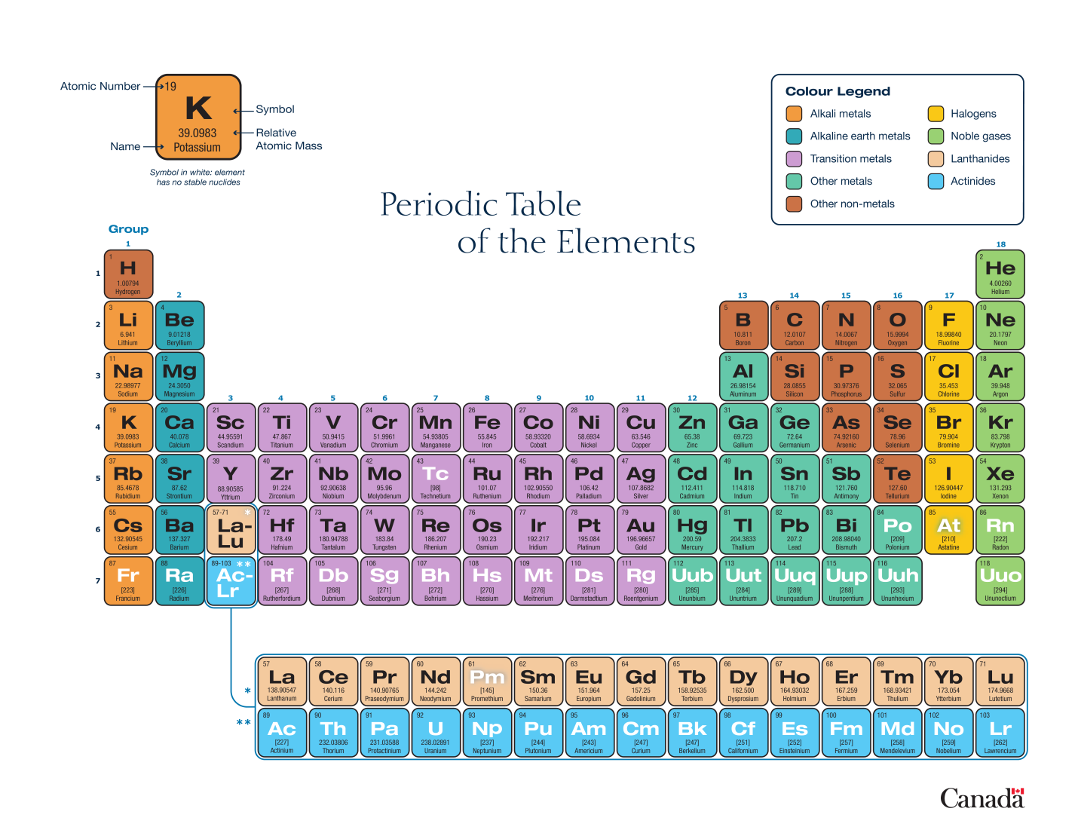
You are required to know the first 20 elements – names, symbols, position in Periodic Table
Naming of elements
Each element has its own name. The names come from various sources. For example, some come from Greek and Latin. Hydrogen comes from the Greek word hydro meaning water and carbon comes from the Latin word carbo meaning coal. Others are named after the region where they were discovered e.g. germanium comes from Germany. Still others are named after famous scientists e.g. nobelium after Alfred Nobel of Nobel Prize fame.
The name of each element is then abbreviated using a chemical symbol. In some cases the symbol is simply the first letter of the name of the element e.g. oxygen is O and carbon is C. This means that other elements whose names begin with the same letters need a different symbol which usually includes the second letter of the name as well e.g. calcium is Ca and osmium is Os. In other cases the symbol is derived from the Latin name of the element e.g. Fe stands for ferrum which is the Latin word for iron!

Each element occupies a particular block in the Periodic Table which is indicated using its chemical symbol. The chemical symbols are universally accepted which allows chemists around the world to understand one another. Also, since all matter is made up of these elements it is possible to write a chemical symbol (formula) for any substance once you know its composition i.e. what it is made up of.

Activity 4.6: Understanding the Periodic Table

Study the Periodic Table and make sure that you note each of the following points:
- The table is arranged in 7 horizontal rows in the main part of the table, plus two further rows shown below. The top 7 rows are called Periods 1-7.
- There are 18 vertical columns in the table, numbered 1 – 18. These are called Groups 1 – 18.
- A dark zig-zag line on the right hand side of the table separates metals from non-metals. The metals are on the left hand side and the non-metals on the right hand side.
- The semi-metals (or metalloids) are located on either side of the zig-zag line.
- Notice the following thin
  - The table is arranged in 18 columns called groups
  - The table is arranged in 7 rows called periods
  - On the left hand side, shaded ……. we find the metals
  - On the right hand side, shaded……. we find the non-metals
  - Between these two groups in a stepped arrangement we find the metalloids
- Insert activity 6 Unit 2 p6

The elements in the periodic table are arranged in such a way that trends are observed. What this means in practice is that elements within a group have similar chemical behaviours but, depending on the trend within a group the force of the reaction gets greater as one moves along the group. For example, in Group 1, lithium is less reactive than sodium which is less reactive than potassium and so on. When one understands what the measurements mean and what the trends are one can make predictions using the periodic table.

Subatomic particles and the Periodic Table
The Periodic Table also includes information about subatomic particles.
Take a look at your Periodic Table and note the following:
- Each block in the table contains 2 numbers. The upper number gives the number of protons (the atomic number, Z) and the lower number gives the weighted average mass of the naturally occurring stable isotopes.
- The atomic numbers are arranged in increasing numerical value as you move across the Periods. It is therefore possible to get the atomic number of any atom directly from the Periodic Table.

Activity 5: Identifying elements and their subatomic particles from the Periodic Table.
Complete the following table:
Atom | Z | A | No of neutrons | No of electrons
 |  |  |  | 15
 | 20
 |  | 59 | 82
K
 |  |  |  | 12

Electron configuration

Electronic configuration describes the location of the electrons within an atom. It takes the principal energy levels as well as the sublevels into account.
The filling of the principal energy levels is like the sequential* filling of water troughs as shown in the diagram below:
Insert pic
P216
It is still useful to use pictures, called Bohr diagrams, to show how the electrons are distributed. An example of a Bohr diagram for sodium (Na) is shown here.
Insert pic
P217
- Sodium has 11 protons and therefore 11 electrons
- 2 electrons can be accommodated in principal energy level 1
- 8 electrons can be accommodated in principal energy level 2 making 10 in total
- The last electron, 11, must move to principal energy level 3

A shorthand notation for the Bohr electron configuration would be
Na 2, 8, 1

Activity 7: Working with Bohr diagrams

Using the information you already have for the elements in Activity 5, draw Bohr diagrams for the following elements:
- Cl
- He,
- K
- S
- Li
- O
- Mg
- Ar

Electron configuration and the periodic table

You have already seen that the elements are arranged in the Periodic Table according to the number of protons in the nucleus, starting with hydrogen (H) at 1 and continuing along the rows, increasing one proton at a time. Now you are in a position to see how the electron configuration is also organised in the table.

To do this Activity 8 will be very useful.

Activity 8: Investigating electron configuration and the Periodic Table.

Prepare a grid of part of the Periodic Table to accommodate the first 18 elements. This means the first three rows. Make the blocks large enough to hold this information:
- The symbol for the element
- A Bohr diagram of the element
- the shorthand notation for the Bohr electron configuration

- Fill in this information for the first 18 elements.
- What do you notice about the following?
  - The number of electrons in the outermost principal energy level of each Group (column) of elements.
  - The number of electrons in the outermost principal energy level of each Period (row) of elements.
  - The number of electrons in the outermost principal energy level of the Group 18 elements.

Groups, periods and electron configuration

The information regarding electron configuration that you have noted on the Periodic Table can be summarised as follows

- All the elements within a particular group of elements have a similar arrangement of electrons in the outermost principal energy level. Elements are placed in the Groups because they have similar chemical behaviours. The chemical behaviours are determined primarily by the number of electrons in the outermost principal energy level.
- The number of electrons in the outermost principal energy level of elements as one moves along the row increases one at a time. The electrons are all in the same outermost principal energy level. When a new row starts, a new principal energy level is required.
- The elements in Group 18 are the noble gases. The outermost principal energy level is always full for these elements. Full outermost principal energy levels makes these elements chemically inert (unreactive).

The quantum mechanical model of the atom

Our understanding of the structure of the atom continues to grow as technology advances. The Bohr model is still used for basic understanding, but a much more sophisticated model, the quantum mechanical model, takes into account a lot more information that is available.

It is beyond the scope of this course to look at this model, but be aware that it exists, and that an even newer model might well be presented soon.

Activity 9: Match the key discovery given in the left hand column to the scientist responsible in the right hand column
Discovery | Scientist

Activity 10: Summative assessment
- Match the key term in the left hand column with the correct definition (or explanation) in the right hand column. (5)
Key term | Definition/explanation
Nuclide | The number of protons in the nucleus
Atomic number (Z) | Dense region in the centre of an atom containing protons and neutrons
Electron | A particle found within the nucleus of an atom
Mass number (A) | A particle found outside of the nucleus
Atomic nucleus | The number of protons and neutrons in the nucleus

- What is meant by the term relative atomic mass? What are the units of measurement for relative atomic mass? (3)
- Explain what is meant by isotopes. Use and example to help with your explanation. (3)
- Consider weighted averages:
  - What is meant by a weighted average? (2)
  - Why is a weighted average used for calculating the atomic mass of atoms existing as isotopes? (3)
  - Calculate the atomic mass for lithium, using the information provided: (5)
Isotope | Relative atomic mass (u) | % abundance
⁶₃Li | 6.0 | 7.42
⁷₃Li | 7.0 | 92.58

- Complete the table: (8)
Subatomic particle | Symbol | Location in atom | Relative atomic mass | Charge

- Complete the table by filling in the missing information fro the most abundant isotope: (18)
Atomic notation  (e.g. ^{A}_{Z}Sy) | Atomic notation (e.g. Sy-A | Atomic number (Z) | Atomic mass  (A) | Number of protons | Number of neutrons | Number of electrons
 |  |  | 16.00
 |  |  |  | 27
 |  |  |  |  |  | 11

- Explain the difference between a continuous emission spectrum of light and a line emission spectrum. (4)
- Why was the discovery of the line emission spectrum of hydrogen so important fro Bohr’s model of the atom?
- Explain what is meant by the concept quantisation.
What are quantised amounts of light (radiant) energy called? (3)
- Consider the elements fluorine and aluminium. For both elements
  - Draw Bohr diagrams (4)
  - Name which principal energy levels are occupied (2)
Total: 60 marks

Rating code | Rating | Marks
7 | Outstanding achievement
6 | Meritorious achievement
5 | Substantial achievement
4 | Adequate achievement
3 | Moderate achievement
2 | Elementary achievement
1 | Not achieved

