1.8 Interactions between molecules -Intermolecular forces

Chemical and Physical Change
The changes we see happening around us can be divided into two main types: physical changes and chemical changes.
What do you think the difference is between a physical change and a chemical change? What would you observe if an object underwent a physical change, and how would this differ from a chemical change?
Activity 1 Using a candle to observe physical and chemical changes [H4]
You will need
matches
a candle
a saucer

1. Light the candle. As the wax begins to melt, tilt it to one side. What do you observe? You may notice the liquid wax dripping over the edge of the candle. This change of state is a physical change, from a solid to a liquid state.

2. What happens when the dripping wax moves further away from the flame and down the side of the candle?

3. Can you smell anything? What else do you observe?

The flame is caused by a release of heat and light energy which happens when the wax combusts ( burns in the presence of oxygen (O₂). The wax breaks down carbon dioxide (CO₂) and water (H₂O) when the energy is released.

The candle shrinks and disappears when the solid wax breaks down to gas CO₂ and water (H₂O) which disappears into the environment.

Got it
A physical change is a change in which the substance changes its form or appearance, but keeps its same chemical composition. No new materials are formed. Physical changes can usually be reversed, although the substance might not look exactly the same as it did before.
In a chemical change the starting materials change into a different substance, or substances. This new substance has a different chemical composition to the original materials.

Activity 2 Classifying changes as physical or chemical
Consider each of the following examples and decide whether they represent a physical or a chemical change. Give a reason for your decision.
- Leave ice cubes in a glass to stand at room temperature.
- Take a small piece of paper and tear it in half. Continue doing this until the pieces become too small to tear any more.
- Take a piece of paper and carefully burn it with a match.
- If you have the materials take a small amount of vinegar in a glass. Add a quarter teaspoon baking powder (bicarb).
- What happens when you stir sugar into hot tea?
- Toast a slice of bread.
- An iron nail is left outside in the rain and starts to rust.
Answers:
- Ice melts – a change of state only therefore a physical change.
- The paper simply changes size, not composition – a physical change.
- The paper changes into ash – a chemical change.
- A fizzing reaction takes place meaning that some gas is escaping – new substances are forming so it is a chemical change.
- A physical change – the sugar dissolves but remains sugar.
- The bread starts to burn a little on the surface and go black. This cannot be reversed and is a chemical change – the blackened parts are chemically different from the original bread.
- The iron changes from a metallic colour to a reddish colour as a new substance forms. This is a chemical change.

The forces that hold atoms together in a compound or a molecule are called intramolecular forces. They are forces that take place between atoms within a single unit of that compound or molecule. So you will probably not be surprised to learn that intra- means within! Intramolecular forces are the ones that are broken and the new ones that are formed during chemical reactions.
However, there are also forces that hold large numbers of molecules or formula units together. These are called intermolecular forces (inter- means between). These are the forces that that determine the states of matter at various temperatures (solid, liquid or gas) and explain how soluble substances dissolve in water and other solvents.
Water is a good molecule to look at when thinking about inter- and intramolecular forces. It’s also a molecule worth understanding very well because you yourself are about 70% water, water covers about 75% of the earth’s surface. Without water to drink we will all die.
Let’s look at water a little more closely.
You know that water actually comes in three forms (phases or states):
Ice is an example of matter in its solid phase. Water is matter in its liquid phase, and the third phase of matter is gas. We often call this steam, but the more correct term is water vapour.

Got it
The solid phase of water is called ice
The liquid phase of water is just called water
The gaseous phase of water is called water vapour

The simplest way to see these forces in action is to do the following activity.
Activity: You will need some ice, and a container in which the ice can be heated and a stove or hot plate.
- Now slowly warm the ice and observe what happens.
- Continue the heating until the water begins to boil.
- Now continue heating and see what happens to the water.

What is the temperature at which ice can form? What state (phase) of matter is this?
What happens when the ice is heated?
What is the phase of water?
What is the boiling point of water?
What happens to the water when it reaches boiling point?
What phase of water is starting to appear?
What happens to the water as it continues to boil?

Answers:
Ice forms at 0ºC. Ice is in the solid phase.
The ice starts to melt.
Water is in the liquid phase.
The boiling point of water is 100ºC.
The water starts to boil – bubbles rapidly rise to the surface and the whole body of water moves around vigorously. The water turns into steam or water vapour.
Water is entering the gas phase when it starts to boil.
As boiling continues the water volume decreases until it disappears completely.
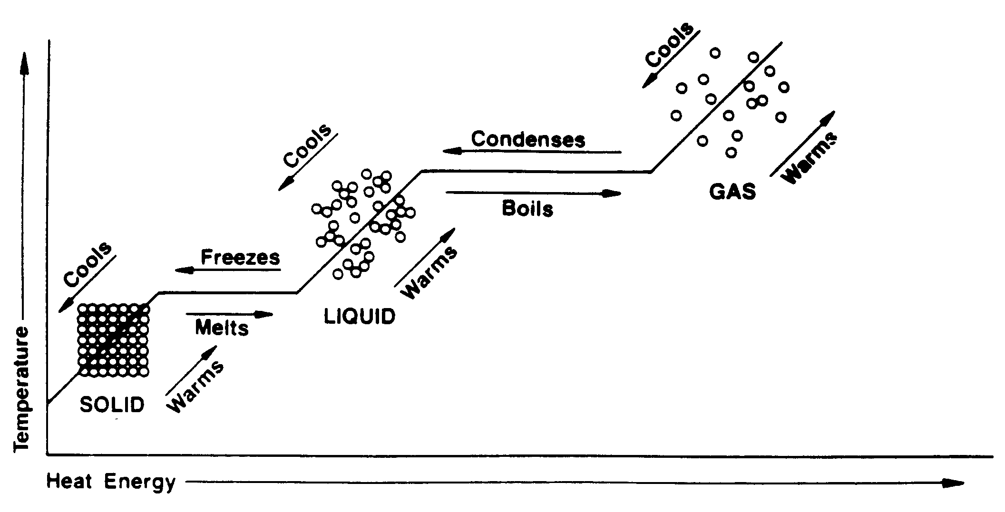

The changes you have seen happening are called macroscopic changes.
What would you see if you had such powerful eyes that you could see what was happening to the water molecules?
A single molecule of water is made up of two hydrogen (H) atoms combined to one oxygen (O) atom. The chemical symbol for water is H₂O. The shape of a water molecule is as follows:
Gr 10 p238

When ice melts to form water, or water evaporates to form water vapour, this is classified as a physical change because the state (condition) of the matter has been changed, and not the chemical composition of the water molecules. What has actually changed is the way in which the water molecules are bonded together.

During a chemical change the atoms joined together to form water can be separated from one another, but during a physical change (e.g. a change of state as you saw) these water molecules remain whole. What is happening is that the bonds holding many water molecules together are being affected by changing the temperature. The intramolecular bonds remain strong but the intermolecular bonds can be disrupted by changing the temperature of the water.
Look at this more closely:
In its solid state, strong bonds hold the water molecules together and the molecules are not free to move around freely within the solid. The atoms jiggle around a little bit in their fixed positions, but are not free to move from those positions within the solid.
Water in its solid phase
Gr 10 p 239

The diagram shows ice as we see it at the macroscopic level (the level that is easily visible to our eyes), and then the microscopic level (the level of the individual molecules of the substance, which is much too small for our eyes to see).
When the solid melts, these strong bonds are broken, and replaced by much weaker bonds, which allows the water molecules to slide past each other. This gives the water its liquid form. The bonds are strong enough to keep the water molecules from flying apart, which is why they stay together if the water is in a container.
Water in its liquid phase
Gr 10 p239

Got it
When ice changes to water, the process is called melting. When liquid water changes back into ice, we call this process freezing. This happens at a temperature of 0°C.

When water is allowed to boil for a while, the bonds between the molecules are broken, and the water molecules are free to move away from each other. The water changes phase from a liquid to a gas. The term we give to water when it is in its gaseous phase is water vapour. The molecules of water in this phase are much further away from each other than in the liquid or solid phase.
Water in its gaseous phase
Gr 10 p239

Got it
When water changes to a gas, we call the process vaporisation. This happens at the boiling point of water, which is 100°C. When gas changes back into water, we call the process condensation.
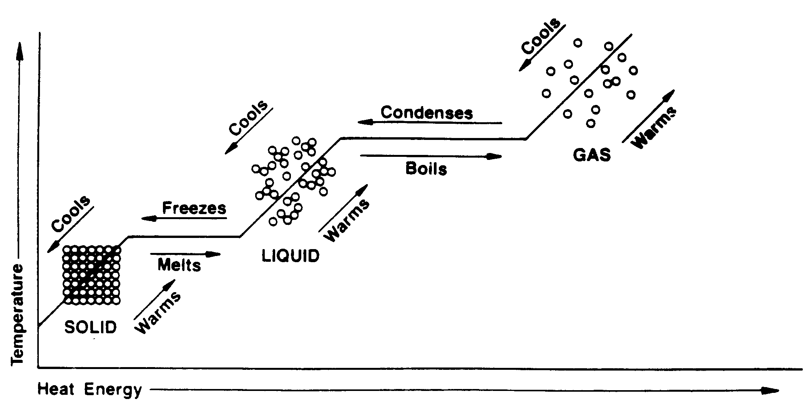
Fascinating facts
Usually the solid form of a substance is heavier (more dense) than the liquid form. But ice is different – it floats on water! This is very important for the survival of animal and plant life in very cold places in the winter. As ice starts to form on dams and lakes it covers the surface of the water but there is still water below it in which the fish and other creatures can continue to live. And the ice even forms a kind of a blanket which stops the water from freezing completely. If that happened the fish would be frozen solid. And if the ice sank to the bottom eventually the fish would be out in the air where they cannot survive.

Think about questions like the following:
1. If you hold a glass object in front of the mouth of a boiling kettle, what will you observe on the glass? Explain this in your own words.
2. Why does mist form in front of your face if you breathe through your mouth on a very cold day?
3. Explain why ice remains in a fixed shape, while water takes the shape of the container that it is poured into.
4. Explain what happens when you light a candle, and you see the wax dripping down the side of the candle. What happens to this wax after a while?
The difference between evaporation and boiling
Evaporation takes place at any temperature, speeding up as the temperature rises. A liquid changes state to a gas without boiling. It happens at the surface of a liquid where it is exposed to the atmosphere. It is a slow process, no bubbles are formed and the energy driving the process comes from the surroundings. This is the process that dries up puddles are the rain or dries laundry on the washing line.

On the other hand, boiling is a fast change of state from liquid to gas. It occurs throughout the liquid, bubbles forming as the change takes place. It occurs at a particular temperature (the boiling point) and the energy source to drive the process is usually heat.
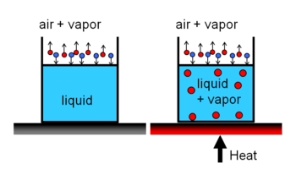

Types of intermolecular forces
Intermolecular forces occur when an electrostatic attraction takes place between two oppositely charged particles. Different kinds of intermolecular forces take place between different types of compounds and molecules. They also vary in strength depending on the size of the charges of the particles involved.
Intermolecular forces are very weak compared with intramolecular forces. However, they occur in large numbers, holding many molecules together and so, collectively, become quite significant. They are also very important for life as we know it to actually be possible. For example, without these forces water would not be able to be held together in its liquid or solid form – it would simply remain as a gas! And all the huge, complicated molecules that drive the processes of life (proteins, enzymes and DNA for example) would not be possible.
Got it. Intermolecular forces are always much weaker than intramolecular forces but play an essential role in the structure of compounds.
- Intermolecular forces involving charged particles
  - Ionic intermolecular bonds.
These are interactions between positively and negatively charged ions. The intermolecular bonds that hold the formula units of an ionic compound together to form a large crystalline structure are of this type.
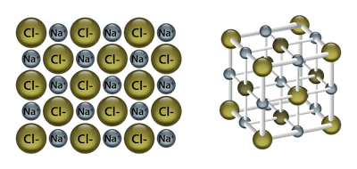
  - Ion-dipole interactions.
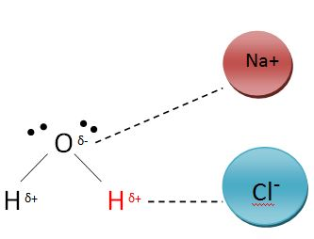
  - Ion-induced dipole forces
- Van der Waal’s forces
These are weak, short-range intermolecular electrostatic attractive forces between uncharged molecules. How can this be? Depending on how the electrons are distributed in a covalent bond, charged areas can form – and then electrostatic interactions can take place between them.

A covalent bond is something like a tug-of-war between the two atoms involved in the bond. If both nuclei are identical, or if their electro-negativities are very similar, the electron pair will be located halfway between the two and there will be no net charge associated with the bond. If, on the other hand, one nucleus is significantly more electron-negative than the other it will exert a stronger pull on the electrons. Both electrons will thus be situated closer to that nucleus than the other and the nucleus will become slightly negative in comparison to the other nucleus.

Insert tug-of-war picture
M&M U2.9
Cartoon or photo

Several kinds of these bonds can form:
  - Interactions between polar covalently-bonded molecules. This takes place between the ^{∂+} and ^{∂-} regions of different molecules.
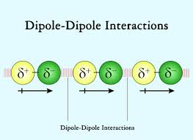
  - London forces (also called induced or temporary dipole interactions or dispersive forces)
Non-polar molecules can form induced dipoles when the electron cloud in one molecule temporarily shifts to one side of the molecules creating a slightly negative region. The opposite side of the molecule will be temporarily slightly positive in charge. Both polar molecules and temporary dipoles in one molecule will induce the same in molecules close to them.
Molecules of larger atoms have larger electron clouds which become displaced more easily. Therefore these molecules are held together more strongly. This trend can be seen with the halogens: F₂ and Cl₂ are smaller molecules and exist as gases at room temperature – the induced dipoles are quite weak. However Br₂ had stronger induced dipoles and therefore stronger intermolecular bonds and is a liquid at room temperature. I₂ has even stronger induced dipoles and is a solid at room temperature.

  - A second example would be the hydrocarbons (see Organic Chemistry). The shorter chained molecules exist as gases (e.g. butane, C₄H₈), longer chains are liquids (e.g. petrol, C₈H₁₈) and chains that are longer still are solids (e.g. candle wax, C₂₂H₄₈)
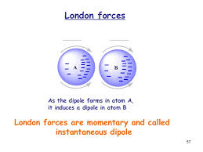
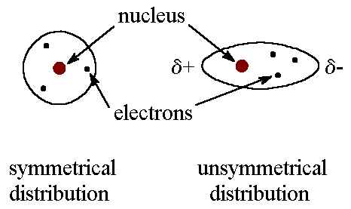
  - Dipole-induced dipole interactions
These take place between polar molecules and molecules with induced dipoles.
  - Hydrogen bonds
These are particularly strong dipole-dipole interactions involving molecule containing –OH, -NH or -FH groups. The O, H and F atoms pull very strongly on the single electron in the H atom creating a relatively strong positive charge around the H atom which is strongly attracted to the negative regions formed in the H, O and F atoms. Water molecules are examples of hydrogen bonding. 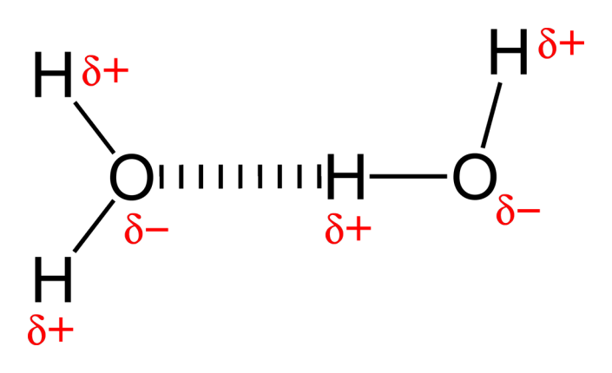
So a wide variety of intermolecular bonds can form as shown in the diagram below:

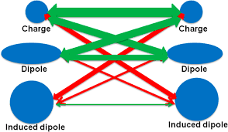

Activity : Observing the changes taking place in water as it is heated.
you changed the temperature of water. The change in this experiment is a physical change. There is no change to the chemical composition of the water because it still consists of H₂O molecules. In the following activity you will explore the change that does take place as the temperature of water increases.

You will need
two glasses or jars
a jug of water (room temperature)
a jug of hot water
food colouring

1. Put the hot water into one beaker, and the water at room temperature in another.
2. Place two or three drops of food colouring into each beaker and observe what happens. Record your observations.

In this activity, the movement of the food colouring tells us something about the speed of the molecules moving in the beakers. You will notice that the food colouring diffuses (travels, mixes through) the hot water more quickly than it does through the colder water. On a microscopic level, we can deduce (come to a reasonable conclusion) that the molecules move faster in hot water than in cold water.
Think about this
If the temperature of a solid substance is increased, what effect do you think this will have on the molecules in the substance?

Activity 4 Summative Assessment [H4]

Question 1
Classify each of the changes below as either chemical or physical changes. Give an explanation for each of your answers.
1. Sugar and flour are mixed together in a mixing bowl. (3)
2. Vinegar and baking powder are added to the mixture of sugar and flour, and these are
all mixed together. The vinegar and baking powder start to fizz. (3)
3. An apple is cut into quarters. (3)
4. This apple is baked in the oven until it is browned. (3)

Question 2
The melting points and boiling points of four chemical elements are shown in the table below:
Element | Melting point (ºC) | Boiling point (ºC)
bromine | -7 | 59
chlorine | -101 | -34
iodine | 114 | 184
fluorine | -220 | -188

- In which physical state will each of these elements be at room temperature? (about 24°C)? (4)
- What state would iodine be in at a temperature of 200°C? (1)
- Explain in your own words what happens to the particles of bromine if it is cooled to
7°C, and continues to lose heat. (3)

Question 3
The melting point of chocolate is 30°C. Explain what happens on the microscopic level when a piece of chocolate at 20°C is put into your mouth, and melts on your tongue. (Your body temperature is 37°C). (4)
Total:

Different types of intermolecular forces.
Depending on the nature of the molecules or formula units being held together different intermolecular forces are involved.
- Ion-dipole forces
- Ion-induced dipole forces
- Van der Waals forces

