2.3 Energy changes during chemical reactions

Any chemical reaction involves the breaking of existing intramolecular bonds and the formation of new bonds. Another way of saying this is that, during a chemical reaction, bonds in the reactants are broken so as to allow the formation of new bonds in the products.
Both the breaking and making of chemical bonds involve the exchange of energy:
In order to break bonds energy is required. Energy-requiring activities are called endothermic, so bond breaking is an endothermic process.
When new bonds are formed energy is released. Energy releasing activities are called exothermic, so bond making is a exothermic process.
It is possible to do a kind of energy accounting where the energy required to break the bonds of the reactants in a reaction is compared to the energy released during the formation of new bonds in the products. This will let you know whether the whole chemical reaction is exothermic (energy releasing) or endothermic (energy consuming).
So a reaction would be an exothermic reaction if more energy is released when the new bonds are being formed than was consumed in the breaking of the bonds.
An endothermic reaction would be one which requires more energy for the formation of the new bonds than is released in the breaking of the bonds of the reactants.
- If more heat energy is released when making the bonds than was taken in, the reaction is exothermic
- If more heat energy was taken in when making the bonds than was released, the reaction is endothermic

Energy diagrams

Energy diagrams (also called potential energy profiles) provide a visual representation of what is taking place during a particular reaction. They show the potential energy levels of the reactants and of the products. The greater the difference between the two, the more energy either released or used up in the reaction.

Consider the following energy diagram for an exothermic reaction:

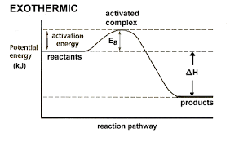
In exothermic reactions the potential energy levels of the reactants are higher than the potential energy present in the products.
The difference between the energy of the reactants and the energy of the products (H_{products} –H_{reactants}) is called the enthalpy change (∆H) of the reaction. For an exothermic reaction, the enthalpy change is always negative because the amount of energy present in the products is less than that present in the reactants.
A general equation can be written as follows:
Exothermic reactions: (H_{products} –H_{reactants}) = - ∆H
Now look at an energy diagram for an endothermic reaction:

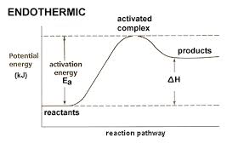

In an endothermic reaction, the products are at a higher energy than the reactants. This means that the enthalpy change of the reaction (∆H) is positive.
A general equation can be written as follows:
Endothermic reactions: (H_{products} –H_{reactants}) = + ∆H

Activation energy (E_{a})
You will notice that in both energy diagrams there is a hump in the curve labeled E_{a}. This is the activation energy.
Activation energy is the minimum energy which must be available reactants for them to be able to be converted into products.
You can get an idea of what activation energy is from the following diagram:
In order for the cyclist to get up the hill he needs to put in a lot of work (energy). However, once he reaches the top of the hill he can free-wheel down the other side.
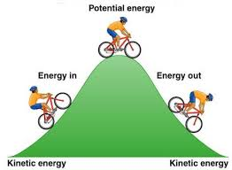

https://www.youtube.com/watch?v=YacsIU97OFc

Catalysts
The rate of a reaction can be increased by adding a suitable catalyst. A catalyst is a substance which changes the rate of reaction but is unchanged at the end of the reaction.
Only a very small amount of catalyst is needed to increase the rate of reaction between large amounts of reactants.
A catalyst is specific to a particular reaction:
- Different catalysts catalyse different reactions
- Not all reactions have suitable catalysts
- Biological reactions are catalysed by special types of catalysts called an enzymes
The effect of a catalyst can be shown on and energy diagram as follows:
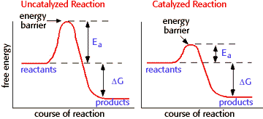
Did you know:

To reduce the production of toxic gases in the exhaust fumes of cars, modern cars have a catalytic converter. Catalytic converters speed up the reactions between carbon monoxide and unburned fuel with oxygen from the air to form less harmful carbon dioxide and water. They use catalysts made of platinum and rhodium. These catalysts work best at the higher temperatures found in an engine.
Some types of catalysts:
- Sulfuric acid acts as a catalyst in substitution reactions such as when an organic alcohol is converted into an organic alkyl halide.
CH₃CH₂OH(g) + HCl(g) | H₂SO₄ | CH₃CH₂Cl + H₂O()
- Hydrogen peroxide catalyses the decomposition reaction of water into hydrogen and oxygen gases.
H₂O₂
2H₂O(l) 2H₂(g) + O₂(g)
- Enzymes
The names of enzymes usually end in the letters -ase. Three of the most common families of enzymes involved in digestion are:
  - lipases – these break down fats
  - proteases - break down proteins
  - carbohydrases - break down carbohydrates.

Summative assessment:
- A catalyst increases the rate of a reaction by
A. Increasing the concentration of the reactant(s)
B. Decreasing the concentration of the reactant(s)
C. Increasing the activation energy of the overall reaction
D. Decreasing the activation energy of the overall reaction
- A forward reaction has an activation energy of 50 kJ and a ∆H of –100 kJ.
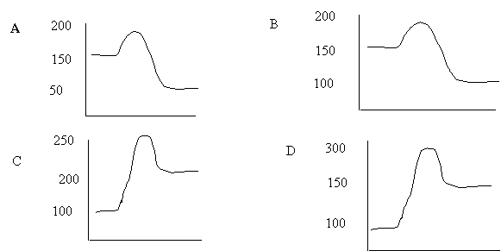The PE diagram, which describes this reaction, is
- What is the activation energy of a reaction, and how is this energy related to the activated complex of the reaction?
Ea is the minimum amount of energy for a reaction to occur. It is the amount of energy required to create an activated complex.

- What happens when a catalyst is used in a reaction?

A catalyst changes the reaction mechanism, in the process lowering the activation
energy.

- Name 4 things that will speed up or slow down a chemical reaction.

Increase concentration by distillation of a solvent
Increase concentration by increasing pressure of a gas,
Increase temp
Add a catalyst

- 6.Draw an energy diagram for a reaction.
Label the axis,
Potential energy(PE) of reactants = 350 KJ/mol,
Ea = 100 KJ/mol,
PE of products = 250 KJ/mol.

Is this reaction in exothermic or endothermic? Explain.

Exothermic. The ΔH is -100 KJ/mol which means heat is released.

- How could you lower the activation energy for the reaction in #6?

Add a catalyst

