2.4 Rate and Extent of Reaction

Here you have a chance to ask some more sophisticated questions about chemical reactions, such as: How fast is a reaction? How can we measure the speed of a chemical reaction? What factors affect the speed of a reaction? How can we change the speed of chemical reactions, and under what circumstances would we want to do so?

Consider some examples of chemical reactions.
- Rusting of iron
Suitable pic
- Hardening of concrete
- Fermentation of sugar to produce alcohol during wine making
- Bubbles being released when vinegar is added to sodium bicarbonate
- A dynamite explosion in a mine

Are some of these reactions slower than others? Which would you think is the fastest, and which the slowest? Put them is order of slowest to fastest. You have probably realised that some reactions occur much more rapidly than others. In the examples given above, the slowest reaction is probably the rusting of iron which can be very slow (depending of the amount of water or humidity available), fermentation of sugar is a bit quicker, taking weeks rather than months, hardening of concrete takes a day or two while the bubbles are released as soon as the vinegar comes into contact with the sodium bicarbonate. What we are looking at is called the rate of reaction. This is a measure of how fast or slow something is.

Activity 1: What does rate mean?

In this activity you have a chance to think about some examples so that you can get a clear understanding of what is meant by rate of reaction.

- Consider the following examples and decide on the rate of each activity:
  - A driver travelling from Durban to Cape Town by car covers a distance of 1635 km and takes 15 hours and 45 minutes.
  - A driver travelling from Gauteng to Cape Town in a car covers 1398 km and takes 14 hours and 10 minutes.
  - Filling a car with petrol with 55 litres takes 5 minutes
  - Filling a swimming pool with 30 000 litres takes 63 hours
  - A multicopy machine can print 75 pages in 3.4 minutes
  - A modern printing press can print 50 pages in 36 seconds
- Which is faster: a or b; c or d; e or f?
- What procedure have you used to determine the rate of each activity?
- Can you write a general definition for the concept of rate?
- Now consider the following chemical reaction:
Insert diagram of completed reaction
Insert diagram of intermediate reaction

Insert diagram of starting reaction e.g.zinc and HCl
  - Write a balanced equation for this reaction. Show the state symbols.
  - Can you think of 4 different things you could measure to describe the rate of this reaction?
  - What units would you use to measure your results for each of the four possibilities?
  - Which of the four options would be the easiest to measure? Why?
  - Can you describe a way in which you could conduct this experiment?
Answers:

- In order to be able to compare rates one needs to express the speed of the activity (i.e. the change that is taking place) per unit time measurement (hours for examples a and b, minutes for the other examples).
- Rate = change per single unit of time.

  - Zinc + hydrochloric acid → zinc chloride + hydrogen
Zn(s) + 2HCl(aq) → ZnCl₂(aq) + H₂(g)
  - One could measure the following:
    - the rate at which the zinc is used up (amount used up per minute)
    - the rate at which the hydrochloric acid is used up (amount used up per minute)
    - the rate at which the zinc chloride is produced (amount produced per minute)
    - the rate at which the hydrogen gas is produced (amount produced per minute)
  - The units would be the following:
    - grams (or mg) per minute
    - ml per minute
    - grams (or mg) per minute
    - ml per minute
  - The amount of hydrogen produced is released as bubbles so it could be collected and measured. All the other reactants and products remain in solution and so are not easily measured – they would have to be separated from one another first.
  - A possible method is to conduct the experiment in a container closed with a cork through which a tube is inserted. The tube can then be attached to a syringe that can be used to measure the volume of the released gas.
Insert diagram
Access RSC p219
Insert diagram of apparatus
GCSE p119
Another possible method would be to conduct the experiment in an open container on a balance. As the reaction proceeds the gas will escape into the atmosphere and the mass of the reaction vessel plus contents would decrease. Therefore the changing mass over time would give an indication of the mass of gas produced over time.
Got it: The rate of a reaction is the speed of the reaction and it can be measured as follows:
    - The amount of reactant used up per unit time or
    - The amount of product formed per unit time

The rate of a reaction can be measured by the rate at which a reactant is used up, or the rate at which a product is formed.
The temperature, concentration, pressure of reacting gases, surface area of reacting solids, and the use of catalysts, are all factors which affect the rate of a reaction.
Chemical reactions can only happen if reactant particles collide with enough energy. The more frequently particles collide, and the greater the proportion of collisions with enough energy, the greater the rate of reaction.

Measuring reaction rates
Different reactions take place at different rates. Reactions that happen slowly have a low rate of reaction, for example rusting or weathering of stone buildings. Other reactions can take place quickly. These reactions have a high rate of reaction, for example explosions and fireworks.
There are two general ways in which reaction rates can be measured:
- The rate at which a reactant is used up during the time that the reaction needs to take place
- The rate at which a product is formed during the time that the reaction needs to take place
Which method you used is determined by the nature of the reactants and products and the type of reaction that is involved. The question you need to ask is: Which is the easiest thing to measure in this reaction?
What exactly can be measured?
- The changing mass of a reactant or a product (mass reduces for a reactant and increases for a product).
- The volume of a gas that can be collected as it is released during a reaction.
Some possible ways of setting up experiments
- Measuring the volume of gas released during a reaction
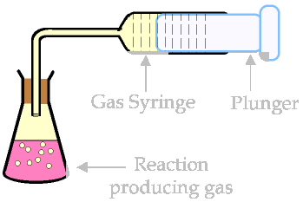
A syring is useful because the volume of gas can be measured directly from the graduations on the syringe over measured time intervals, e.g. each minute.
- Measuring the reduction in mass of a reactant
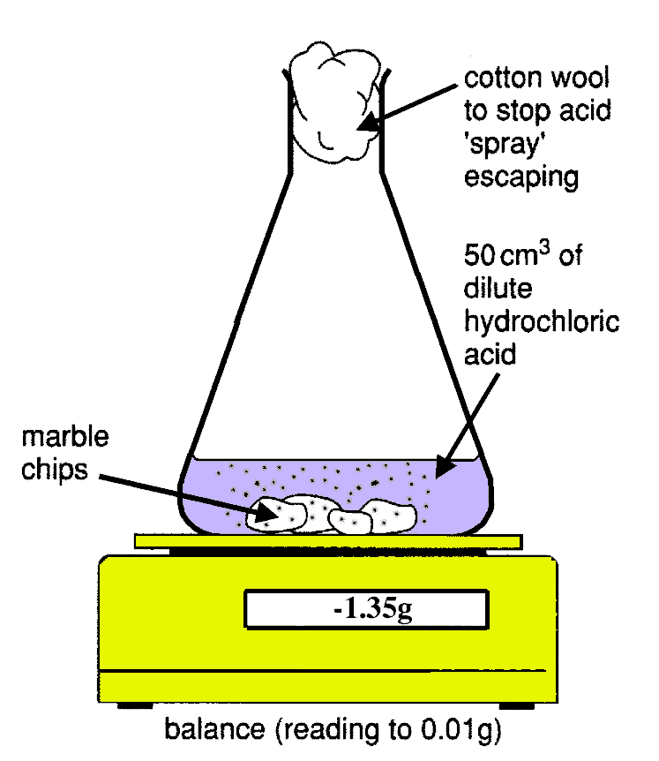
The gas product is allowed to escape, so the overall mass of the vessel plus its contents reduces. This is a measure of the mass of product forming over time.

How is the information used?
Let’s say you are measuring the volume of gas being released. You need a timer and a graduated collection vessel for the gas. Then at regular intervals, say each minute, you will read the volume of the gas in the collection vessel. This information is then plotted on a graph where the x-axis (horizontal axis) represents time and the y-axis (vertical axis) represents volume of gas.
A typical reaction rate graph for a fast and a slow reaction looks like this:
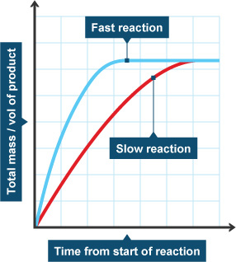
The rate of the reaction can then be calculated with information obtained from the graph:
Rate of reaction = amount of product formed (cm³) /time taken (min)
If measuring the disappearance of a reactant (by mass) the formula for calculating rate of reaction would be:
Rate of reaction = amount of reactant used (g) /time taken (min)
So, for example, if 2.5 cm³ of a gas was produced in 2 minutes for a particular reaction, the reaction rate would be determined as follows:
Rate of reaction = amount of gas formed (cm³) /time taken (min)
= 2.5 cm³/2 min
= 1.25 cm³/min
Factors affecting the rate of a reaction
There are a number of factors that can affect the rate of a reaction.
The major factors that increase the reaction rate are:
- You can increase the temperature at which the reaction takes place.
- You can increase the concentration of one of the reactants. If a solid and a liquid are reacting together one usually increases the concentration of the liquid.
- You can increase the surface area of a solid reactant.
- If the reactants include a gas you can increase the pressure of the reaction mixture.
- You can add a catalyst to the mixture of reactants.
The reaction graphs will change as shown in the following diagrams:
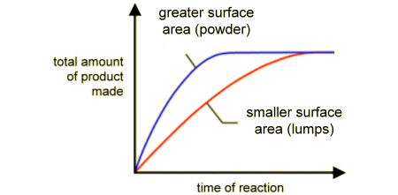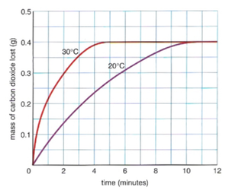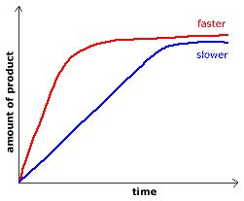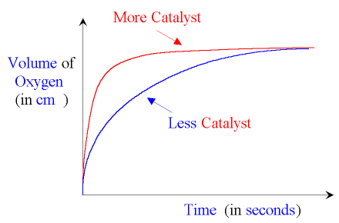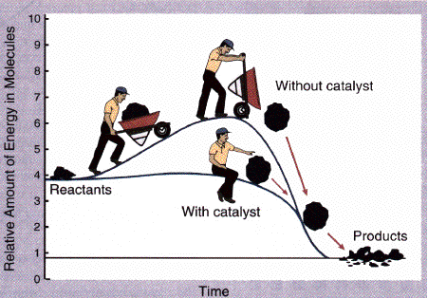

The steeper the line (called the slope) on the graph, the higher the rate of reaction. You will notice that the steepness is greatest at the start of the reaction. Why do you think this is the case? It’s because the concentration of the reactants is greatest at the start of the reaction.
Over time the line becomes horizontal (parallel to the x-axis). This indicates that the reaction has stopped.
Collision theory
The collision theory is a convenient way to explain the observations made regarding rates of reaction.
For a reaction to occur particles of the various reactants need to collide with another with sufficient energy, and in the correct orientation for a successful conversion to products.
What does this actually mean?
In order for a reaction to actually take place several things must be present :
- The reactant particles must actually collide with one another.
- The particles be in the correct positions (correct orientation) with respect to each other. You can see in the diagram below that collisions can occur which cannot lead to the formation of products because the orientation is not correct.
- There must be enough energy available for the particles that have collided in the correct orientation to actually break reactant bonds and form new product bonds. The minimum energy required is something you have already heard of. Can you remember? Yes, it is the activation energy.

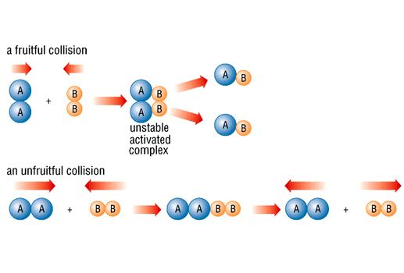

Now let’s look at collision theory to explain why the methods you have looked at to change the rates of reaction might work.

- Changing temperature
If one increases the temperature at which a reaction takes place the following happens:
  - The reactant particles move faster
  - More of these particles have the required activation energy
  - There are more particle collisions
  - More of these collisions have sufficient energy to lead to products.
  - As a result the reaction rate speeds up.
- Changing concentration
By changing the concentration of a reactant which in in solution (dissolved) the following happens:
  - More particles are present in the same volume
  - More particles means that there is a greater chance of a collision happening
  - As a result the reaction rate speeds up.
- Changing surface area of a solid reactant
breaking a solid reactant into smaller pieces, or grinding it into a powder has the following effects:
  - The surface area of the reactant is increased
  - More particles come into contact with the other reactant(s)
  - There is a greater chance of particles colliding
  - As a result the reaction rate increases.
- Changing pressure
Increasing the pressure only has an effect if at least one of the reactants is a gas. The effect is very similar to that of increasing the concentration:
  - More particles are present in the same volume
  - More particles means that there is a greater chance of a collision happening
  - As a result the reaction rate speeds up.
- Adding a catalyst
Catalysts have the effect of speeding reactions up without themselves being used up in the reaction. They achieve this by lowering the energy of activation. As a result more collisions have enough energy for the conversion into products to take place.

Got it: Reaction rates are influenced by the frequency (number) of collisions that take place between reacting particles, by the orientation (geometry) of the collisions and by the energy with which the collisions occurs.

Activity 2: Measuring the rate of a chemical reaction

In this activity you have the opportunity to measure the rate of an actual chemical reaction. The information that has been gathered in Activity 1 will come in useful for you here.

Assessment standards:
1.1 Conducting an investigation: conduct a scientific investigation to collect data systematically with regard to accuracy, reliability and the need to control one variable. (LO1)
1.2 Interpreting data to draw conclusions: seek patterns and trends in the information collected and link it to existing scientific knowledge to help draw conclusions. (LO 1)
1.3 Solving problems: apply given steps in a problem-solving strategy to solve standard exercises. (LO 1)
1.4 Communicating and presenting information and scientific arguments: communicate information and conclusions with clarity and precision. (LO 1)
2.1 Recalling, stating and discussing prescribed concepts: recall and state basic prescribed scientific knowledge. (LO 2)
2.3 Constructing and applying scientific knowledge: apply scientific knowledge in familiar, simple contexts. (LO 2)

- Work in pairs or small groups for this activity
You will need:
- A flask containing a cork through which a glass tube is inserted
- A gas syringe with a plunger
- A stopwatch
- Graph paper
- Zinc pellets
- 1 M Hydrochloric acid
Insert diagram of apparatus
GCSE p 120
- Set up the apparatus as shown in the diagram.
- When you are ready to start the reaction push the plunger down to add the acid to the metal in the flask.
- Now the plunger is fully in and no gas is present in the syringe and the reaction begins (time 0)
- As the reaction proceeds gas collects in the syringe and the plunger is pushed out so that you can read the volume of collected gas.
- Make sure that the total amount of zinc disappears during the reaction. If it does not repeat the experiment with a smaller mass.
- Gather data according to the following guidelines. You may find that you need to change the time intervals, in which case you need to repeat the experiment. Continue the reaction until you get a number of readings for the gas volume that no longer change. That means that the reaction has stopped.
Time (minutes) | 0 | 0.5 | 1.0 | 1.5 | 2.0 | 2.5 | 3.0 | 3.5 | 4.0 | 4.5 | 5.0 | 5.5 | 6.0 | 6.5
Volume of hydrogen gas (ml)
- Plot a graph showing the volume of gas produced on the y-axis and the time elapsed on the x-axis.
- Answer the following questions:
  - What do you notice about the shape of the curve? What does it tell you?
  - What would the rate of the reaction be in the first minute? Calculate it.
  - What is the rate of the reaction for the second minute? Calculate it.
  - What is the rate of the reaction for the third minute? Calculate it.
  - What is the rate of the reaction for the last minute? Calculate it.
  - How can you tell that the reaction is over?
  - What do you notice about the reaction rate as the reaction proceeds?
  - How does the steepness of the curve relate to the reaction rate?
  - What is the rate of the overall reaction (also known as the average rate)? Calculate it.
  - How long would it take to collect one third of the total volume of gas?
  - How long would it take to collect three quarters of the total volume of the gas?
  - Would it be possible to measure the reaction rate for any reaction? What condition(s) would make it very difficult to do so?
- Meet with the class for a teacher-led discussion. Be prepared to share your findings with the class.
Formative assessment:
Assess the performance of your group according to the checklist provided below
At the end of this activity our group was able to: | Yes | No
Set up the apparatus and perform the experiment satisfactorily
Gather the data and plot the graph
Get a graph of the correct shape
Calculate the reaction rates at different times during the reaction
Calculate the overall average reaction rate
Calculate the time in which the specific reaction will generate certain volumes of gas
Decide when a reaction was complete
Understand for which types of reactions it would be difficult to measure the reaction rate and why
Understand the relationship between the steepness of the curve and the rate of the reaction.

Answers:
Insert diagram of graph
GCSE p121
Example – not exact
  - The typical shape for the graph is shown in the diagram
  - Rate is calculated as follows:
Rate 1st min = (vol H₂ released)/time
= (vol at end of min – vol at start of min)/1 min
  - Rate 2nd min = (vol H₂ released)/time
  - Rate 3rd min = (vol H₂ released)/time
  - Rate last min = (vol H₂ released)/time
  - The curve levels off showing that no more gas is being released.
  - The reaction rate slows down as the reaction proceeds.
  - The steeper the curve the higher the reaction rate
  - Average rate of reaction = (total vol H₂ released)/ total time of reaction
  - Use the graph for this. Calculate 1/3 of the total volume and then read off from the graph the time that would have elapsed
  - Use the graph for this. Calculate 3/4 of the total volume and then read off from the graph the time that would have elapsed
  - Reactions that take place extremely quickly would be difficult to investigate
Got it: The rate of a chemical reaction is the time taken (in seconds) for a measured change in the amount of a product to be formed (or a reactant to be used up).
Average rate of reaction = (change in amount of product or reactant)/ time elapsed
The units are often concentration units for the amounts and seconds for the time

Now that you have an understanding of the concept of rate of reaction you may find yourself asking such questions as: Can the rate be speeded up? What could be done to speed it up? Can it be slowed down? How? What is actually happening on a microscopic level to explain the observations? In the following few activities you have an opportunity to answer some of these questions.

Activity 3: Investigating the effect of changing concentration of reactants on the reaction rate.

Assessment standards:
1.1 Conducting an investigation: conduct a scientific investigation to collect data systematically with regard to accuracy, reliability and the need to control one variable. (LO1)
1.2 Interpreting data to draw conclusions: seek patterns and trends in the information collected and link it to existing scientific knowledge to help draw conclusions. (LO 1)
1.3 Solving problems: apply given steps in a problem-solving strategy to solve standard exercises. (LO 1)
1.4 Communicating and presenting information and scientific arguments: communicate information and conclusions with clarity and precision. (LO 1)
2.1 Recalling, stating and discussing prescribed concepts: recall and state basic prescribed scientific knowledge. (LO 2)
2.2 Explaining relationships: express and explain prescribed scientific theories and models by indicating some of the relationships of different facts and concepts with each other. (LO 2)
2.3 Constructing and applying scientific knowledge: apply scientific knowledge in familiar, simple contexts. (LO 2)

- Work in pair or small groups for this activity.
- Before proceeding with the experiment ask yourselves the following question: If we use the same reaction that we used previously, namely the reaction between zinc and hydrochloric acid, what would we expect to happen if we use 2M HCl instead of 1M HCl? Also, what would we expect to happen if we use 0.5M HCl instead of 1M HCl?
- Now you can go ahead and test your hypothesis!
You will need:
- A flask containing a cork through which a glass tube is inserted
- A gas syringe with a plunger
- A stopwatch
- Graph paper
- Zinc pellets or granules – approx 0.5 g per experiment
- 1.0M HCl, 2.0M HCl and 0.5M HCl

- Set up the apparatus as shown in Activity 2. Use the same mass of zinc that you used previously that was totally used up in the reaction
- When you are ready to start the reaction push the plunger down to add the acid to the metal in the flask.
- Now the plunger is fully in and no gas is present in the syringe and the reaction begins (time 0)
- As the reaction proceeds gas collects in the syringe and the plunger is pushed out so that you can read the volume of collected gas.
- Gather data according to the following guidelines. You may find that you need to change the time intervals, in which case you need to repeat the experiment. Continue the reaction until you get a number of readings for the gas volume that no longer change. That means that the reaction has stopped.
Time (minutes) | 0 | 0.5 | 1.0 | 1.5 | 2.0 | 2.5 | 3.0 | 3.5 | 4.0 | 4.5 | 5.0 | 5.5 | 6.0 | 6.5
Volume of hydrogen gas (ml)
- Plot a graph showing the volume of gas produced on the y-axis and the time elapsed on the x-axis.
- Repeat the experiment for each of the concentrations of HCl plotting all three graphs on the same page.
- Answer the following questions:
  - What do you notice about the shapes of the three curves?
  - From the shapes of the curves can you tell which reaction was the fastest and which was the slowest?
  - How long does the reaction last in each case?
  - How much product (hydrogen in this experiment) is produced in each case? What do you notice about your answers?
  - Why is the same amount of product produced in all three experiments?
  - Can you make a general statement concerning the effect of concentration on the reaction rate?
- Meet with the class for a teacher-led discussion. Be prepared to share your findings with the class.
Formative assessment:
Assess the performance of your group according to the checklist provided below
At the end of this activity our group was able to: | Yes | No
Set up the apparatus and perform the experiment satisfactorily
Gather the data and plot the three graphs on the same axes
Get graphs of the correct shape
Calculate the overall average reaction rate in each case
Notice that the reaction rate is directly proportional to the concentration of a reactant
Decide when a reaction is complete
Notice that all three reactions produce the same amount of product. What varies is the time that it takes for this to happen
Understand the relationship between the steepness of the curve and the rate of the reaction.
Answers:
- The curves have a similar shape. The variation is in the steepness of the curves. The higher the concentration of the reagent, the steeper the curve. The lower the concentration, the longer it takes for the curve to level out i.e. for the reaction to stop.
Insert typical graph
GCSE p 122 as example – not exact
- The fastest reaction has the steepest slope while the slowest reaction has the least steep slope.
- One reads the answers off on the graph. The reaction stops when the curve levels off.
- The amount of hydrogen produced is read off from the graph where the curve has levelled off. The learners should notice that each reaction results in the same amount of product. What changes is the speed (rate) at which it is formed. They should also notice that the reaction rates are directly proportional to the changes in concentration.
- The amount of product formed will depend on the amount of the limiting reagent i.e. the one that gets used up. The speed that it gets used up can vary but once it is gone no more product can be formed.
- A reaction goes faster when the concentration of a reactant is increased. When the concentration is doubled, the reaction rate doubles. When the concentration is halved, the reaction rate halves.
Activity 4: Testing you understanding of the concept of reaction rate.

- These following results are from two experiments
You will need:
- Graph paper
  - 0.06 g of magnesium was reacted with 50 ml of 1M HCl
  - 0.06 g of magnesium was reacted with 50 ml of 0.5M HCl

Time (seconds) | 10 | 20 | 30 | 40 | 50 | 60 | 70 | 80 | 90 | 100 | 110 | 120 | 130 | 140
ml of H₂ gas (A) | 19 | 33 | 44 | 52 | 58 | 60 | 60 | 60 | 60 | 60 | 60 | 60 | 60 | 60
ml of H₂ gas (B) | 9 | 17 | 24 | 30 | 37 | 42 | 47 | 51 | 55 | 58 | 59 | 60 | 60 | 60

  - Use the data provided to plot suitable graphs on the same axes (7)
  - Write a balanced equation (with state symbols) for this reaction. (3)
  - When was the reaction complete in each experiment? (2)
  - How much hydrogen was produced in each experiment after completion? (2)
  - Explain why the two experiments produced the same amounts of hydrogen (2)
  - Based on the shapes of the curves which reaction was faster? Explain your answer (2)
  - What happens to the rate of the reaction when the concentration of the hydrochloric acid is doubled from 1M to 0.5M? Use calculations to support your answer. (4)
  - Can you predict what might happen to the rate of the reaction when the concentration of the hydrochloric acid is doubled from 1M to 2M? (1)
  - Write a general statement about the effect of concentration of a reagent on reaction rate. (2)

Answers:

Insert graph
GCSE p 122
  - (7)
  - magnesium + hydrochloric acid → magnesium chloride + hydrogen
Mg(s) + HCl(aq) → MgCl₂(aq) + H₂(g) (3)
  - Experiment A was complete after about 57 sec
Experiment B was complete after about 115 sec (2)
  - In both experiments the amount of product was 60 ml (2)
  - The amount of product depends on the amount of limiting reagent (reagent that is completely used up). If the same amount of reagent is used up in both experiments the same amount of product will be obtained. The thing that changes is the rate at which the product is formed. (2)
  - Reaction A was faster because the curve was steeper (2)
  - Rate of reaction A = 60 ml/60 sec = 1 ml/sec
rate of reaction B = 60 ml/ 120 sec = 0.5 ml/sec
When the concentration of the acid is halved from 1M to 0.5M the rate of the reaction decreases from 1 ml/sec to 0.5 ml/sec i.e. it is also halved (4)
  - The prediction is that the rate of the reaction will double (to 2 ml/sec) when the HCl concentration is doubled. (1)
  - The reaction goes faster (increased reaction rate) when the concentration of a reactant is increased. (2)

Activity 5: Investigating the effect of changing temperature of reactants on the reaction rate.

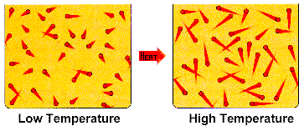

Questions:

  - How do you predict the rate of reaction will change as the temperature is increased?
  - Give an explanation for your prediction.
  - Give at least 2 examples in everyday life where temperature is used to alter the rate of reactions.
  - Draw a sketch graph showing the unheated reaction and the heated reaction on the same graph. Explain why the graph for the heated reaction is different from the unheated reaction’s graph.

Answers:
- The prediction should be that increasing temperature increases reaction rate.
- When the temperature is higher the movement of the reactant particles increases and the energy of the particles also increases so the chance of them meeting and reacting with one another increases.
- Refrigeration slows down the reactions that cause food to rot.
Warming speeds up the reactions such as fermentation of yeast for bread- making, wine making etc.

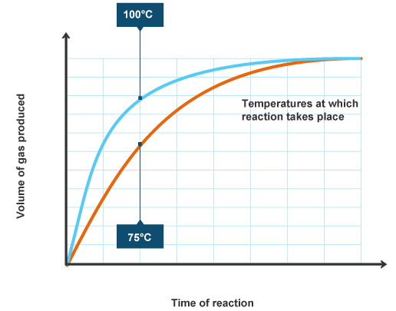

Activity 6: Investigating the effect of changing surface area of contact of reactants on the reaction rate.

Solid calcium carbonate reacts with hydrochloric acid to form soluble calcium chloride, water and carbon dioxide. This is a reaction that causes the stone of buildings to decay when rain is acidic.
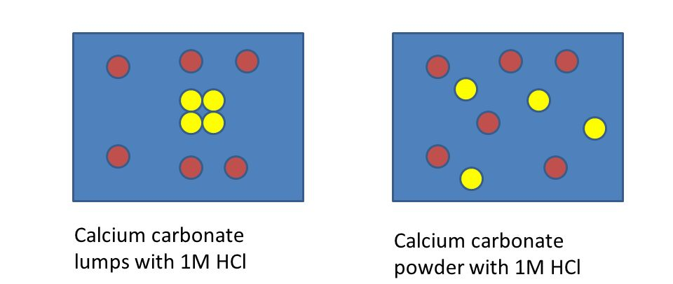

Answer the following questions:
  - How do you predict the rate of reaction will change as the surface area of a solid reactant increases?
  - Give an explanation for your prediction.
  - Draw a sketch graph showing the two reactions on the same graph. Explain why the graph for the reaction with smaller pieces is different from the reaction with bigger pieces.
  - Write a balanced equation for this reaction
  - What types of reactants are affected by increasing surface area? Why?
  - Can you make a general statement concerning the effect of surface area on the reaction rate?
  - Can you think of a biological example of this effect?

Answers:
- I predict that the reaction with the solid broken into smaller pieces will take place at a higher rate.
- The surface area of the solid will be greater so there is a greater chance for the other reactant to come into contact with the solid in effective collisions that convert into product.

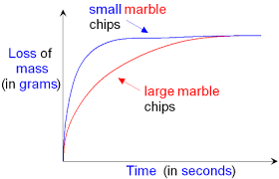
The smaller the pieces, the greater the surface area and the greater the chance of meaningful collisions taking place between reactants to lead to products.
The curve for the smaller chips is therefore steeper than the curve for the larger chips but both curves eventually flatten out at the same total mass of the reaction vessel.

- Calcium carbonate + hydrochloric acid → Calcium chloride + water + carbon dioxide
CaCO₃(s) + 2HCl(aq) → CaCl₂(aq) + H₂O(l) + CO₂(g)
- Solid reactants are affected by changing surface area. Solutions and gases are already fully available to reacting reagents.
- The rate of a reaction of a solid reactant increases when its surface area is increased.
- As example would be the chewing of food. The purpose of chewing is to increase the surface area of the food so that the digestive enzymes can react more effectively.

Activity 7: Looking at reactions more closely
In this activity you do some thinking about the “mechanics” of a chemical reaction. What is actually going on in the reaction vessel? Presumably a reaction can only take place if particles of the reactants actually come into contact with one another. Also simply coming into contact may not be enough. A productive collision – one resulting in a conversion to products – must have enough energy to cause the change. The change needs the old chemical bonds to be broken so that new ones can form, and this requires energy. Armed with this information, you are able to describe what is actually happening!

- Write down the balanced equation for the reaction between magnesium metal and hydrochloric acid.
- Explain, in words, two things that need to happen for the particles to react with each other and produce product.
- Using symbols, for example, ○ to depict water particles, ● to depict acid particles and ө to depict magnesium particles, draw diagrams to explain what you think happens during this chemical reaction. Use word descriptions to explain your diagrams.
Have 3 separate diagrams.
  - The first one should show the reaction vessel at the start of the reaction, when the reactants have been mixed but no change has begun.
  - The second diagram should depict what happens as the reaction happens
  - The third diagram should depict what would be present in the reaction vessel when the reaction is over – assuming that all the magnesium is used up.
- Now do a diagram that explains your expected observations if you increased the concentration of the hydrochloric acid. Again, support your diagram with a word explanation.
- Now do a diagram that explains your expected observations if you increased the temperature of the reaction mixture. Again, support your diagram with a word explanation
- Now do a diagram that explains your expected observations if you increased the surface area of the magnesium. Again, support your diagram with a word explanation.
- Now see if you can draw diagrams that can explain why the reaction starts off very vigorously, but slows down over time. Again, support your diagram with a word explanation.

Answers:

- Magnesium + hydrochloric acid → magnesium chloride + hydrogen
Mg(s) + 2HCl(aq) → MgCl₂(aq) + H₂(g)
- For a reaction to take place the following two things need to happen:
  - The magnesium and acid particles must collide with one another
  - The collision must happen with enough energy for the reaction to take place
Insert fig a
GCSE p126
Insert fig c
Insert fig b
GCSE p126

Insert fig increased conc
GCSE p126

Insert fig increased temp
GCSE p127

Insert fig increased surface area
GCSE p127

Insert figs showing how the acid conc decreases over time
GCSE p127

Insert fig
GCSE p127

Got it:
Reaction rates are influenced by the frequency (number) of collisions that take place between reacting particles as well as the energy with which the collision occurs. One other aspect which may be surprising is that the “geometry” of the collision is also important. Some collisions that have enough energy still do not result in product because the reacting particle collided in an unfavourable position with respect to one another. This concept is depicted in the accompanying diagram.
Insert diagram
Corwin p533 for example
Ask yourselves: The reactions that you have been considering up to now have involved a solid reactant and a solution or two solutions being mixed together. If the two reactants were gases for example oxygen and hydrogen reacting together, what additional thing could you do to increase the rate of the reaction. Explain your suggestion clearly.
Answer:
By increasing the pressure exerted of the gases one would effectively be increasing the concentration because the same amount of gas would now be in a smaller volume. The more particles there are in a given volume the greater the likelihood of effective collisions and the reaction rate will increase.

Catalysts

You have discovered several ways in which you can cause the rate of a chemical reaction to speed up, but there remains another very important way of doing this, and this involves the use of catalysts. A catalyst is a substance that can be added to a reaction to speed it up without it actually being used up or permanently altered during the reaction. As you can imagine, industry uses a lot of different catalysts, as do biological systems. In this section you will be investigating the behaviour of catalysts more closely.

Activity 8: Investigating the behaviour of a catalyst

If you mix hydrogen peroxide and water together any reaction that takes place happens very slowly. However, if you add some magnesium dioxide to the mixture the reaction speeds up. The magnesium dioxide acts as a catalyst – it is not used up in the reaction at all.
The reaction is measured by measuring the amount of oxygen produced over time and a typical graph would look like the following:

NB: Add a no catalyst line to this drawing
Answer the following questions:
  - Write a balanced equation for the reaction in which hydrogen peroxide (H₂O₂) decomposes into water and oxygen.
  - Explain the graph for ‘no catalyst’.
  - Would you expect more gas to collect if you waited longer? Explain your answer.
  - Why do you think that changing the mass of the manganese dioxide made a difference? Remember that manganese dioxide is a solid.

Answers:
- H₂O₂(aq) → 2 H₂O(l) + O₂(g)
- In the absence of manganese dioxide no gas was collected.
- Waiting longer would not make any difference because the reaction rate is so slow as to be imperceptible, and the rate is usually fastest at the start of the reaction
- Increasing the mass of catalyst increases the rate of the reaction because there is more surface area available to catalyse the reaction.

Got it: A catalyst is a substance that speeds up the rate of a chemical reaction without itself getting used up or changed during the reaction.

Reversible reactions
So far we have been looking at reactions that are not reversible, that is reactants are converted into products and the result stays that way. Reversible reactions, on the other hand, can go in either direction.

Here are some examples:
- Reaction between nitrogen and hydrogen to form ammonia
N₂(g) + 3H₂(g) ↔ 2NH₃(g)
- Thermal (using heat) decomposition of ammonium chloride
NH₄Cl(s) ↔ NH₃(g) + HCl(g)
- Dehydration of blue copper sulphate crystals to form white anhydrous copper sulfate
CuSO₄.5H₂O(s) ↔ CuSO₄(s) + 5H₂O(l)
- Reaction between sulphur dioxide and oxygen to form sulphur trioxide
2SO₂(g) + O₂(g) ↔ 2SO₃(g)
Got it: Reversible reactions can go in both directions, meaning that the product(s) can break down and return to the starting reactant(s). In fact most chemical reactions are reversible. A reversible reaction is symbolised using the double headed arrow: ↔
Dynamic equilibrium
When a reversible reaction is allowed to continue uninterrupted, there will come a time when the rate at which the forward reaction is taking place equals the rate at which the reverse reaction is taking place. When this happens no further overall change can be measured. In fact, it looks as though the reaction has stopped altogether. This is not actually the case. No overall change is measurable, but the forward and back reactions are continuing all the time, at the same rate.
The important thing to remember is that both the forward and the reverse reactions are continually happening, but the concentrations (amounts) of each reactant and each product remain constant.

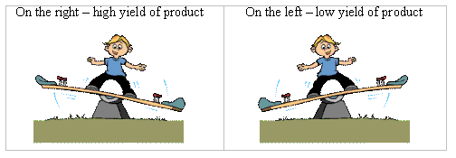
Note: These observations of a dynamic equilibrium must be made in a closed system. A closed system is one in which no substances are either added to or removed from it. This is important because one does not want a situation where some of the reactants or products can escape from the system, as equilibrium will then never be reached.

As you can see in the graphs below:
- Initially the amount of reactants decreases and the amount of products increases.
- Eventually, at equilibrium, the amount of reactants stays steady and the amount of products also stays steady.
- Over time the forward rate of the reaction (reactants to products) slows down while the reverse rate (products back to reactants) speeds up.
- Eventually, at equilibrium, the forward and reverse rates equalise.
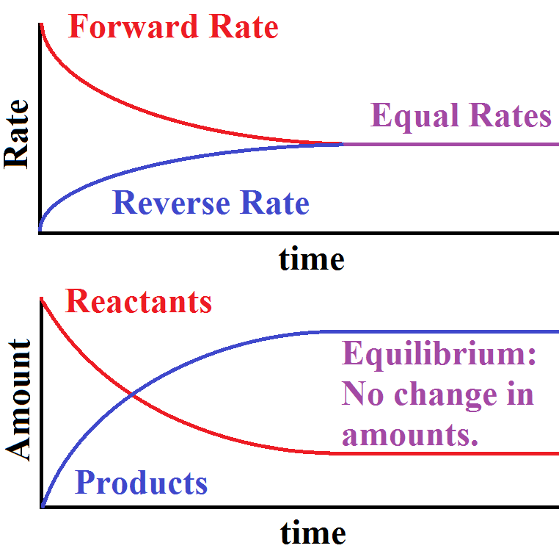

Got it: Dynamic equilibrium means that the forward and reverse reactions continue to take place (dynamic means still continuing) while the overall numbers (concentrations) of reactants and products no longer change (equilibrium means no apparent change).

Le Chatelier’s Principle
If a reversible reaction that is in a state of dynamic equilibrium is disturbed by changing the conditions, the reaction will do what it can to oppose that change.

Activity: In the following activity you can think about various possible changes that can be applied to a reaction in dynamic equilibrium and what the reaction might do to counteract the effect of the changes according to le Chatelier’s Principle.

- Consider the given equation of a chemical reaction in dynamic equilibrium and answer the questions that follow, remembering what Le Chatelier’s Principle says about changes in such reactions:
A + 2B ↔ C + D
  - What would happen to the equilibrium if one increased the concentration of A in the reaction?
Hint: What could the reaction do to decrease the concentration of A again?
  - What would happen to the equilibrium if one decreased the concentration of A in the reaction?
Hint: What could the reaction do to increase the concentration of A again?
  - If the reaction given above involved gases, what would happen to the equilibrium if the pressure was increased?
  - If the reaction given above involved gases, what would happen to the equilibrium if the pressure was decreased?
  - What would happen to the equilibrium in a reaction where both sides of the equation have the same number of gaseous particles (e,g, A + B ↔ C + D) and the pressure was changed?
  - What would happen to the equilibrium of the reaction if the temperature was increased?
Hint: Assume that the forward reaction is exothermic i.e. gives out heat, and the reverse reaction is endothermic i.e. takes in heat. The amount of heat given out is exactly equal to the amount of heat taken in.
  - What would happen to the equilibrium of the reaction if the temperature was decreased?
  - What effect might a catalyst have of the equilibrium of a reaction?
  - If you wanted to make more C and D in the present example what changes would you make to the reaction conditions?
- Consider the following diagram which depicts the reaction for the synthesis of ammonia from nitrogen and hydrogen, then answer the questions that follow:
  - Write a balanced equation for the reaction
Insert diagram
GCSE p134
  - Study the following three diagrams:
ExpExplain what they are showing. If you were interested in the commercial manufacture of ammonia in which direction would you like the equilibrium to be shifted?
Shifting equilib to RHS
Equilibrium

Shifting equilib to LHS
GCSE p134
  - Can you suggest what might happen if you increased the temperature of the reaction?
  - Will more ammonia form if the temperature is raised? Explain your answer. Note: The forward reaction is exothermic
  - Can you suggest what might happen if you increased the pressure of the reaction? Hint: The greater the number of particles present in gases, the greater the pressure.
  - What would happen if you removed ammonia from the reaction vessel as it was being formed?
  - What would happen if a catalyst was added to the system? The commonly used catalyst for this reaction is iron.
  - Imagine that you have a company that produces ammonia for sale. What conditions would you suggest to maximise your ammonia output and therefore your profit?

Answers:

  - In order to decrease the concentration of A again more A and B must react to give C and D, so the equilibrium will move to the right.
  - In order to increase the concentration of A again more C and D must react to give A and B, so the equilibrium will move to the left.
  - The reaction would have to adjust so as to reduce the pressure again. This can only be done by decreasing the number of particles present. In this case there are 3 particles on the left for every 2 particles on the right, so the reaction would move towards the right.
  - The reaction would have to adjust so as to increase the pressure again. This can only be done by increasing the number of particles present. In this case there are 3 particles on the left for every 2 particles on the right, so the reaction would move towards the left.
  - Changing the pressure would have no effect on the equilibrium.
  - The reaction would have to adjust so as to decrease the temperature again. This means that the reaction would need to use up the extra heat. In our example the reverse reaction uses up (takes in) heat so the equilibrium will be pushed to the left.
  - The reaction would have to adjust so as to increase the temperature again. This means that the reaction would need to give out extra heat. In our example the forward reaction gives out heat so the equilibrium will be pushed to the right.
  - It would speed up the rate at which equilibrium is reached but would not affect the position of the equilibrium. This is because the catalyst affects both the forward and the reverse reaction equally.
  - One would make changes that force the reaction to the right such as increasing the concentration of one of the reactants (for example A), reduce the temperature and, if dealing with gases, raise the pressure.

  - N₂(g) + 3H₂(g) ↔ 2NH₃(g)
  - In the first diagram the equilibrium has shifted to the LHS. This means that less of the product is formed when equilibrium is reached.
In the middle diagram the reaction is taking place under “normal” conditions.
In the third diagram the equilibrium has shifted to the RHS, so more product can be formed when equilibrium is reached.
In order to increase the amount of ammonia produced the reaction needs to be pushed to the right.
  - When the temperature is increased the rate of the reaction will increase, so the reaction reaches equilibrium faster.
  - No extra ammonia will be formed. In fact, the rate of the reverse reaction will increase to counteract the increase in temperature (Le Chatelier’s Principle) so that there will be less ammonia at equilibrium.
  - When the pressure in increased the reaction equilibrium will move in such a way as to reduce the number of particles, thereby reducing the pressure. This means the equilibrium would move towards the right.
  - If ammonia was removed the equilibrium would be destroyed so more hydrogen and nitrogen would react to form ammonia and try to restore the equilibrium.
  - A catalyst would speed up the rate at which equilibrium is reached (saving time and therefore money) but would not change the position of the equilibrium.
  - Work under conditions of high pressure to push the reaction to the right. Remove ammonia as it forms so that more hydrogen and nitrogen will convert to ammonia. Use a catalyst to speed up the rate of the reaction. Maybe use moderate heat to speed up the reaction rate without forcing the reaction towards the left.
Activity 12: Testing your understanding of reactions in equilibrium
- Answer the questions that follow:
  - Write an equation for a reversible reaction when solid ammonium nitrate decomposes to give gaseous dinitrogen oxide and water vapour. (3)
  - Charcoal reacts with steam according to the following equation:
C(s) + H₂O(g) + heat ↔ CO(g) + H₂(g)
Predict (giving reasons) the direction of the shift in equilibrium after the stresses listed below:
    - Temperature is increased
    - Pressure is increased
    - A catalyst is added
    - Concentration of water vapour is increased
    - H₂(g) is removed (10)
  - Name the principle you used to make these predictions (1)
  - Sulfur dioxide (a gas) reacts with oxygen to produce sulphur trioxide (also a gas). The reaction is exothermic and reversible.
    - Write a balanced equation for the reaction (2)
    - What would happen to the yield of sulphur trioxide if you increased the pressure? (2)
    - What would happen to the yield of sulphur trioxide if you increased the temperature? (2)

Answers:

  - NH₄NO₃(s) ↔ N₂O(g) + 2H₂O(g) (3)

    - Equilibrium shifts to the right since the forward reaction is endothermic
    - Equilibrium shifts to the left since it must shift towards fewer gas molecules
    - Reaction rate increases but equilibrium does not shift
    - Equilibrium shifts to the right to use up more water vapour
    - Equilibrium shifts to the right since product is being removed so more product must be produced to regain equilibrium (10)
  - Le Chateliers’s Principle (1)

    - 2SO₂(g) + O₂(g) ↔ 2SO₃(g) (2)
    - Increased pressure would increase the yield of SO₃(g) because the reaction equilibrium would move in the direction of fewer gas molecules. (2)
    - Increased temperature in an exothermic reaction would shift the reaction towards the left and the yield of SO₃(g) would decrease. (2)

Activity 13: Summative assessment Marks: 50

- What is meant by the rate of a reaction? (2)
- For reactants to successfully convert into products what two things need to happen between the reacting particles? (2)
- What is a catalyst? (1)
- What is an enzyme? (1)
- If you had a biological detergent (one that contains enzymes) you would not use it in very hot water. Why?
You would also not use it to wash woollen or silk clothes. Why? (2)
- Give two ways in which catalysts reduce production costs in industry. (2)
- Draw a diagram showing how a catalyst changes the energy needed for a reaction to take place and therefore speeds up the rate of the reaction. (6)
- Suggest a reason for each of the following:
  - Zinc powder burns more vigorously in oxygen than zinc foil does. (1)
  - The reaction between manganese carbonate and dilute hydrochloric acid speeds up when some concentrated hydrochloric acid is added. (1)
  - One can prevent spilled acid from causing too much damage if one pours a lot of water onto it. (1)
  - Teeth decay more rapidly the more sweet things you consume. (1)
  - A dead animal decays quite quickly in South Africa, especially in the summer. However, in Siberia, the bodies of mammoths that died about 30 000 years ago have been discovered, fully preserved under the ice.
(1)
- Explain what is meant by a reaction that is in dynamic equilibrium. (2)
- State Le Chatelier’s Principle (2)
- For a reversible reaction between gases, if the forward reaction is exothermic what is the effect of raising the temperature? (2)
- For a reversible reaction between gases, if the forward reaction is endothermic what is the effect of raising the temperature? (2)
- Consider the following reaction which describes what happens in a catalytic converter used to reduce carbon monoxide emissions in motor car exhausts:
2CO(g) + O₂(g) ↔ 2CO₂(g)
Suppose the reaction is taking place in a closed vessel and is at equilibrium.
  - What would happen to the reaction equilibrium and the concentration of CO if a platinum catalyst were added? (2)
  - What would happen to the reaction equilibrium and the concentration of CO if the temperature were increased? (2)
(Note: this is an exothermic reaction in the forward direction).
  - What would happen to the reaction equilibrium and the concentration of CO if the pressure were increased? (2)
  - What would happen to the reaction equilibrium and the concentration of CO if the concentration of oxygen were increased? (2)
Answers:
- The rate of a reaction is a measure of the change that happens over time, given by the amount of reactant used up per unit of time or the amount of product produced per unit of time. (2)
- The particles need to collide with one another in the proper orientation and they need to collide with sufficient energy. (2)
- A catalyst is a substance that speeds up the rate of a reaction without taking part in the reaction itself. (1)
- An enzyme is a biological catalyst, made primarily of protein, which catalyses biological reactions. (1)
- Hot water would destroy the enzymes in a biological detergent. Also, wool and silk are natural fibres that might be damaged by the enzymes in the biological detergent. (2)
- Catalysts save money in industry by speeding up the process – time costs money, and they also allow reactions to take place at lower temperatures, so reducing the fuel costs. (2)

  - The zinc powder has a greater surface area than the foil so more reactants can come into contact with one another and the reaction proceeds faster. (1)
  - By increasing the concentration of one reactant (hydrochloric acid) the reaction proceeds more rapidly. (1)
  - Dilution of the acid slows down any reaction that it might be involved in. (1)
  - Increasing the consumption of sweet things increases the reactant, sugar, that bacteria convert into acid which causes tooth decay (1)
  - The decay of animal flesh is catalysed by enzymes in bacteria. In the ice the temperature is too low for these reactions to take place and the frozen animals are preserved. (1)
e.g GCSE p128

(6)
- A reaction that is in dynamic equilibrium is one in which the rate of the forward reaction and the rate of the reverse reaction are equal, so the concentrations of reactants and products no longer change. (2)
- Le Chatelier’s Principle states that if a reversible reaction that is in a state of dynamic equilibrium is disturbed by changing the conditions, the reaction will do what it can to oppose that change. (2)
- For a reversible reaction between gases, if the forward reaction is exothermic raising the temperature? (2)
- For a reversible reaction between gases, if the forward reaction is endothermic raising the temperature increases the yield. (2)

  - Equilibrium remains the same and CO concentration does not change
(2)
  - Equilibrium moves to the left and CO concentration increases (2)
  - Equilibrium moves to the right and CO concentration decreases (2)
  - Equilibrium moves to the right and CO concentration decreases (2)

