Atoms - Electronic Configuration
Electronic configuration is about the arrangement of electrons within the atom.
As you already know, atoms contain protons, neutrons and electrons. The protons and neutrons are in the nucleus of the atom. The electrons orbit the nucleus in energy levels, also called shells. The positive charges of the protons in the nucleus hold the electrons in the energy levels.
You also know that each energy level can contain only a certain number of electrons. For your purposes you only need to think about the first three energy levels. The first level can hold a maximum of 2 electrons, the second a maximum of 8 and the third a maximum of 8.
The Bohr Diagrams are a simple representation of electrons in the energy levels (shells).
For example: Here are 4 elements showing the Bohr diagrams and the notation used to indicate the distribution of the atoms in the neutral elements.
Fluorine | Neon | Sodium | Calcium
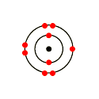 | 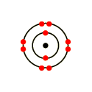 | 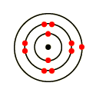 | 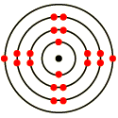
F 2,7 | Ne 2,8 | Na 2,8,1 | Ca 2,8,8,1

The energy of an electron depends mainly on which shell it occupies. Electrons in shells further from the nucleus have a higher energy than electrons in shells closer to the nucleus.

If you were to write out the Bohr diagrams for all of the elements on the Periodic Table you would see a pattern. For the Noble gases (Ne is an example above) the outermost energy level is full. For elements in Group 1 the outermost shell holds just 1 electron (see Na and Ca above) and for the halogens of Group 17 the outermost shell holds 7 electrons (see F above).

Later electrons were discovered to occupy a three dimensional volume of space with a characteristic shape, called an orbital. Each orbital can hold a maximum of two electrons.

So the first energy level, shell 1, only 2 electrons can be accommodated and there is one orbital, called the s orbital. The s orbital has a spherical shape. The s orbital for shell 1 is called 1s.

Electrons in an orbital mostly move around inside the orbital, but they can spend a small amount of time completely outside the orbital

The second energy level can hold 8 electrons, so more orbitals are required. Again there is a spherical s orbital. In addition there are 3 p orbitals, each of which can hold 2 electrons. The orbitals for the second energy level are called 2s and 2p.

The third energy level can hold 8 electrons, it has the following orbitals: 3s and 3p.
In the following diagram the energy levels of the orbitals form 1sto 4s are shown:

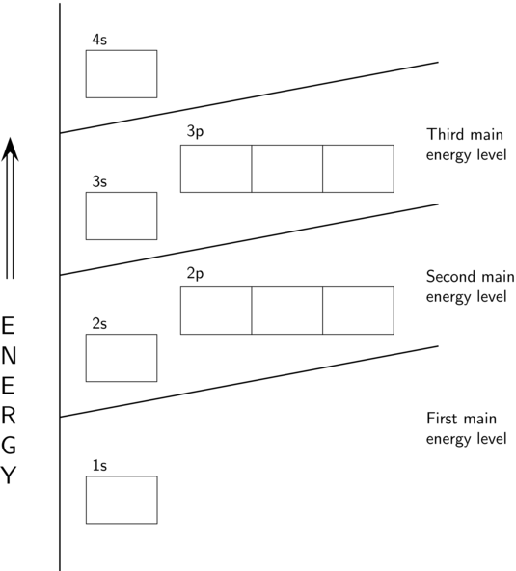

The electrons fill an orbital of lower energy before starting to occupy an orbital of higher energy. So they start at 1s, moving to 2s and so on.

Representing electronic configuration

Several Principles govern how the electrons are located in orbitals:

- The Aufbau principle electrons orbiting the nucleus of an atom fill the lowest available energy levels before filling higher levels (e.g. 1s is filled with two electrons before 2s can be occupied). This produces the most stable position for the electrons.
For the first 20 elements in the Periodic Table the electron filling pattern is therefore: 1s, 2s, 2p, 3s, 3p, 4s. The s orbitals can each hold 2 electrons and the 3 p orbitals hold 2 electrons each which makes a total of 6 electrons for the full p orbitals of a particular energy level shell).
Example: For Carbon (C): 1s², 2s²
- The Pauli exclusion principle states that two electrons occupying a single orbitals must have opposite spins. This is a quantum physics concept, beyond the understanding of this course. However, just remember that when you represent electrons in a box diagram the arrows point in opposite direction to indicate opposite spin (see below).
- Hund's rule: every orbital in a orbital (subshell) is singly occupied with one electron before any one orbital is doubly occupied, and all electrons in singly occupied orbitals have the same spin (the arrows point in the same direction – see below).

There are two popular methods used to write out the positions of electrons in a particular element.

- The Aufbau diagram method
In this method the orbitals are represented by boxes. Each box can hold 2 electrons. The presence of electrons within a box is shown by an arrow.

If two electrons are present the arrows point in opposite directions (see Paulis exclusion principle).
Let’s use F (fluorine) as an example. It has 9 electrons.
F:
1s 2s 2p 2p 2p
There’s something else to remember!
Within a group of p orbitals (remember there are 3) of a single energy level e.g. the three p orbitals of energy level 2 you would draw 3 boxes. When filling the boxes with arrow (to represent electrons) you would also need to obey Hunds Rule (see above) and put one electron in each box before starting to double up.
Let’s look at boron (5 electrons), carbon (6 electrons), nitrogen (7 electrons) and oxygen (8e electrons):
B:
↑↓
↑↓

↑

↑↓
↑↓

↑↓

↑↓

↑

1s 2s 2p 2p 2p
C:
↑↓
↑↓

↑

↑

1s 2s 2p 2p 2p

N:
1s 2s 2p 2p 2p
↑↓
↑↓

↑

↑

↑

O:
1s 2s 2p 2p 2p
↑↓
↑↓

↑↓

↑

↑

- The spectroscopic electronic configuration
This method uses the orbitals s and p only in your case, although there are also d and f orbitals for elements with more than 20 electrons.
The electrons are denoted in the following forms:
1s² means that there are 2 electrons in the s orbital of energy level (shell) 1 while 2s¹ means that there is only 1 electron in the s orbital of energy level (shell) 2.
2p³ means that there are 3 electrons in the p orbital of energy level 2 while 3p¹ means that there is only 1 electron in the p orbital of energy level (shell) 3.
As you already know, the order of filling (for the first 20 elements) is as follows: 1s 2s 2p 3s 4s
For example: Sodium has 11 protons and therefore 11 electrons to place in orbitals.
1s² takes up 2 electrons
2s² takes up 2 more electrons (4 in total)
2p⁶ takes up 6 more electrons (10 in total)
3s¹ takes up 1 more electron (all 11 accounted for)

The full spectroscopic electron configuration for sodium is therefore:
1s²2s²2p⁶3s¹

Note: Elements with one or two s electrons in their outermost shell are called s-block elements. They fall into Groups 1 and 2 of the Periodic Table.
Elements with one to six p electrons in their outermost shell are called p-block elements. They fall into Groups 13 to 18 of the Periodic Table.
Relationship to core and valence electrons

Core electrons are the electrons that occupy filled electron orbitals. They are stable electrons.
Valence electrons are electrons that occupy partially filled electron orbitals. These are the electrons that are of particular interest as they are less stable than core electrons They are the ones that get involved in chemical reactions. You will learn more about this later.

For example:
- Na: 1s²2s²2p⁶3s¹
The 1s²2s²2p⁶ orbitals are all full. The core electrons are in these orbitals.
3s¹ is short of one electron so is not full. The single electron present is a valence electron.
- N: 1s²2s²2p³
The 1s²2s² orbitals are all full. The core electrons are in these orbitals.
2p³ is short of three electrons so is not full. The three electrons present are valence electrons.

Activity : Answer the following questions:

- Draw Aufbau diagrams to show the electron configuration of each of the following elements:
magnesium, potassium, neon, nitrogen
- Give the spectroscopic electron configuration for phosphorus (P) and draw an Aufbau diagram.
- Complete the following table:

Element | Electron configuration | Core electrons | Valence electrons
Sulfur (S)
Magnesium (Mg)
Lithium (Li)
Aluminium (Al)

- Answer the following multiple choice questions:
  - Most of the volume of an atom is occupied by
(A). electrons.
(B). protons.
(C). neutrons.
(D). empty space
  - The atomic number of an atom identifies the number of
(A). protons.
(B). neutrons.
(C). quantum orbits.
(D). excited states.
  - What is the electron configuration for potassium?
(A). 1s²2p⁶3s⁴3p⁶4s²
(B). 1s⁴2p⁶3s²3p⁶4s²
(C). 1s²2s²2p⁶3s²3p⁶4s¹
(D).1s²2s²2p⁶3s²3p⁸

Answers :
↑↓
↑↓

↑↓

↑↓

↑↓

↑↓

- Mg:
1s 2s 2p 2p 2p 3s
K:
1s 2s 2p 2p 2p 3s 3p 3p 3p 4s
Ne:
1s 2s 2p 2p 2p
N:
1s 2s 2p 2p 2p
↑↓
↑↓

↑

↑

↑
↑↓
↑↓

↑↓

↑↓

↑↓

↑
↑↓
↑↓

↑↓

↑↓

↑↓

↑↓

↑↓

↑↓

↑↓

- P has 15 electrons that need to be accommodated.
Spectroscopic electron configuration: 1s²2s²2p⁶3s²3p³
Aufbau diagram:
↑↓
↑↓

↑↓

↑

↑

↑↓

↑↓

↑↓

↑

1s 2s 2p 2p 2p 3s 3p 3p 3p

Element | Electron configuration | Core electrons | Valence electrons
Sulfur (S) | 1s²2s²2p⁶3s ²3p⁴ | 10 (1s²2s²2p⁶) | 6 (3s ²3p⁴)
Magnesium (Mg) | 1s²2s²2p⁶3s ² | 10 (1s²2s²2p⁶) | 2 (3s ²)
Lithium (Li) | 1s²2s¹ | 2 (1s²) | 1 (2s¹)
Aluminium (Al) | 1s²2s²2p⁶3s ²3p¹ | 10 (1s²2s²2p⁶) | 3 (3s ²3p¹)

  - D
  - A (and therefore electrons in a neutral atom).
  - C

Representing the spectroscopic electronic configuration of the first 20 elements of the Periodic Table
1A | 2A | 3A | 4A | 5A | 6A | 7A | 8A
1  H  1s¹ |  |  |  |  |  |  | 2  He  1s²
3  Li  1s²  2s¹ | 4  Be  1s²  2s² | 5  B  1s²  2s²2p¹ | 6  C  1s²  2s²2p² | 7  N  1s²  2s²2p³ | 8  O  1s²  2s²2p⁴ | 9  F  1s²  2s²2p⁵ | 10  Ne  1s²  2s²2p⁶
11  Na  1s²  2s²2p⁶  3s¹ | 12  Mg  1s²  2s²2p⁶  3s² | 13  Al  1s²  2s²2p⁶  3s²3p¹ | 14  Si  1s²  2s²2p⁶  3s²3p² | 15  P  1s²  2s²2p⁶  3s²3p³ | 16  S  1s²  2s²2p⁶  3s²3p⁴ | 17  Cl  1s²  2s²2p⁶  3s²3p⁵ | 18  Ar  1s²  2s²2p⁶  3s²3p⁶

Below is a repeat of the third row in the table above. It shows an abbreviated way to express the spectroscopic electronic configuration of the elements represented. You will see that the first 2 lines of the configuration have been replaced by the symbol [Ne]. This is because the electronic configuration up to that point is exactly the same as that of Neon itself.
11  Na  [Ne]  3s¹ | 12  Mg  [Ne]  3s² | 13  Al  [Ne]  3s²3p¹ | 14  Si  [Ne]  3s²3p² | 15  P  [Ne]  3s²3p³ | 16  S  [Ne]  3s²3p⁴ | 17  Cl  [Ne]  3s²3p⁵ | 18  Ar  [Ne]  3s²3p⁶

