Chemistry answers Section 1

Activity 1.2: Solutions/hints:
Statement | Answer
Wax melts | Physical property - changing from solid to liquid state
Water can be broken down to H₂ and O₂ | Chemical property – need a chemical reaction to cause water to break down to hydrogen and oxygen
Water boils at 100ºC | Physical property – the BP is the temperature at which water changes from a liquid into a gas (vapour).
Mercury is toxic | Physical property - no change needed in mercury to make it toxic.
Mercury is a liquid at room temperature | Physical property - describes physical state at a particular temperature.
A candle gives light | Chemical property – the light comes when the candle burns and changes into new substances.
Iron is magnetic | Physical property – describes something about the nature of iron
Iron sulfide is black | Physical property – describes the appearance of iron sulphide
Iron rusts to form iron oxide | Chemical property – describes a change that occurs by chemical means
Iron sulfide is made from iron and sulfur | Chemical property – describes the formation of a new substance from iron and sulphur.

Activity 1.3: Solutions/hints:
Statement | Answer
Hydrogen and oxygen explode when a flame is applied to them. | Chemical change. Something new (water) is being formed in explosive chemical reaction.
Sand does not dissolve in water | Physical change – the water and sand are mixed but still visible separately.
Water evaporates | Physical change – water changes from a liquid to a gas but is chemically the same.
Mercury cools to a silvery solid | Physical change – mercury changes from a liquid to a solid but is chemically the same.
Sodium reacts with chlorine to form sodium chloride | Chemical change – sodium and chlorine combine chemically to form a completely new substance, sodium chloride (salt)
Milk goes sour | Chemical change – sour milk is made of different substances from sweet milk
Air is pumped into a tyre | Physical change – air fills tyre without changing in any way.
Wood burns | Chemical change – the products after burning are different from wood
Copper and nickel form an alloy | Physical change – this is a homogeneous mixture of two metals.
Sugar makes coffee sweet | Physical change – sugar dissolves in coffee but remains sugar.
Fireworks explode when ignited | Chemical change - the fireworks burn up to form new products.
Sugar dissolves in water | Physical change - a homogeneous mixture of sugar and water forms. Sugar and water are still both present, chemically unchanged.

Activity 1.4: Solutions/hints:
- Mixture A is a heterogeneous mixture because the sand remains visible in the water after mixing.
A possible way to remove the sand from the water would be to pour the mixture through a piece of fine cloth and collect the water that comes through in a clean container. The sand should remain in the cloth. The finer the cloth the more sand will be removed.
In an equipped laboratory you would use filter paper instead of cloth and a funnel to hold the filter paper.
- Mixture B is a homogeneous mixture. Because the sugar disappears into the water and can no longer be seen.
A possible way to get the sugar back is to leave the glass in a safe place in the sun. The water will evaporate off leaving the sugar behind.
In an equipped laboratory you would heat the container with the mixture to speed up the process. You could also collect the water coming off as steam by letting it condense as liquid using suitable equipment.

Solutions for Assessment 1.1: Check that you understand about pure substances and mixtures.
- Coca cola: homogeneous mixture of water, sugar, colourants, flavours, gas (for the fizz).
- Milk: homogeneous mixture of water, fats, sugar and all sorts of other soluble foods.
- Air (clean): homogeneous mixture of gases like nitrogen, oxygen and hydrogen
- Tap water: homogeneous mixture of water and dissolved gases and salts.
- Stew: a heterogeneous mixture of meat, vegetables, water, salt.
- Table salt: pure substance made up of only one thing. The chemical name of salt is sodium chloride.
- Oil and water: heterogeneous mixture because the oil will remain separate from the water as soon as you stop shaking the container.
- Sugar: Pure substance made up of only one thing. The chemical name of sugar is sucrose.
- Paraffin: a homogeneous mixture of fuels that can burn to give heat and energy.
- Egg: a heterogeneous mixture of the yellow part (yolk) and the white part and the shell.

Activity 1.5: Solutions/hints:
- Ice is found in cold places either in nature (frozen streams in the winter) or man-made (freezers). Ice has a very low temperature (0ºC)
Ice is a solid
Ice is made by cooling water down until it becomes cold enough to become solid
- Water is found in rivers and taps.
Water cannot be made. It occurs naturally.
Water can vary in temperature from very cold (when it gets close to freezing), to very hot (when it boils).
Water is a liquid.
- Steam is found where water is at very high temperatures e.g. above a pot of boiling water, in a hot shower. Steam rises off boiling water. Steam has a high temperature (100ºC) and burns badly. Steam is a gas or vapour.
- Ice is a solid, water is a liquid and steam is a gas so they appear very different.
- Ice, water and steam are actually the same thing, namely water, appearing in different states.

Activity 1.6: Solutions/hints:
- Nitrogen (MP -209.9ºC, BP -195.8ºC): Nitrogen would be a gas at 25ºC because it would boil (become a gas) at -195.8ºC which is a lower temperature.
- Iodine (MP 113.5ºC, BP 184.0ºC): Iodine would be a solid at 25ºC because it’s melting point is 113.5ºC and it would only become a liquid at that temperature.
- Mercury (MP -38.9ºC, BP 356.6ºC): Mercury would be a liquid at 25^{O}C because it would melt at -38.9ºC but only become a gas at 356.6ºC
- Sulfur (MP 115.2ºC, BP 444.6ºC): Sulfur would be a solid at 25ºC because it’s melting point is 115.2ºC and it would only become a liquid at that temperature.
- Benzene (MP 5.5ºC, BP 80.2ºC): Benzene would be a liquid at 25^{O}C because it would melt at 5.5ºC but only become a gas at 80.2ºC

Activity 1.6: Solutions/hints

- HF is a compound as it is made of two different kinds of elements, hydrogen (H) and fluorine (F). There is 1 H atom and 1 F atom for each particle of the compound. (Note: the combining ratio of atoms would be 1:1, H:F).
- Gold is an element as it is not combined with anything else (Au). (Note: in the symbol for an element if the second letter is lower case it is part of the symbol, not a separate element).
- Iron oxide is a compound made of two different kinds of elements, iron (Fe) and oxygen (O). (Note: the combining ratio of atoms would be 2:3, Fe:O).
- Sodium sulfide is a compound made of two elements, sodium (Na) and sulfur (S). There is 1 Na atom and 1 S atom in each particle of the compound. (Note: the combining ratio of atoms would be 1:1, Na:S)
- Calcium carbonate is a compound made of three different kinds of elements, calcium (Ca), carbon (C) and oxygen (O). (Note: the combining ratio of atoms would be 1:1:3, Ca:C:O)

Activity 1.7: Solutions
Atomic symbol | No of protons | No of neutrons | No of electrons
²³₁₁Na | 11 | 23 - 11 = 12 | 11
¹⁹₉F | 9 | 19 – 9 = 10 | 9
³²₁₆S | 16 | 32 – 16 =16 | 16
²⁷₁₃Al | 13 | 27 – 13 = 14 | 13
⁴⁰₂₀Ca | 20 | 40 – 20 = 20 | 20
Isotope activity?

Activity 1.8 Bohr diagrams for:
Cl | 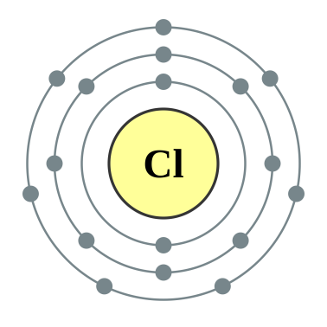
He | 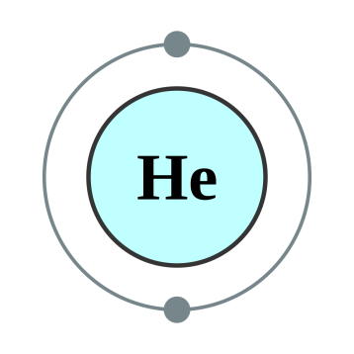
K
S
O
Be | 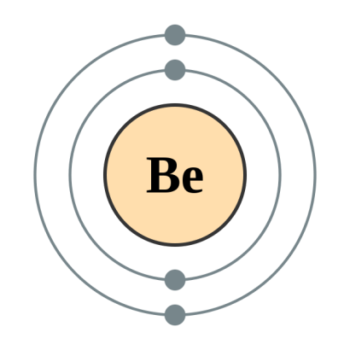
Ne | 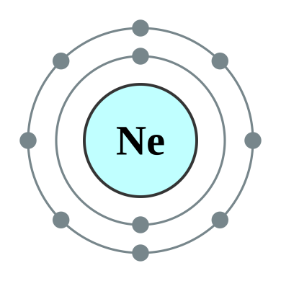
Mg | 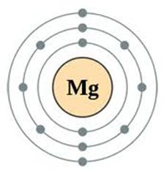

Activity 1.9: Solutions
Atom | Z  (mass number) | A  (atomic number) | No of neutrons | No of electrons
³¹₁₅P | 31 | 15 | 31 – 15 = 16 | 15
²⁰₁₀Ne | 20 | 10 | 20 – 10 = 10 | 10
¹⁴¹₅₉Pr | 141 | 59 | 141 – 59 = 82 | 59
³⁹₁₉K | 39 | 19 | 39 – 19 = 20 | 19
²⁴₁₂Mg | 24 | 12 | 24 – 12 = 12 | 12

Activity 1.10: Assessment

Key term | Definition/explanation
Nuclide | A particle found within the nucleus of an atom
Atomic number (Z) | The number of protons in the nucleus
Electron | A particle found outside of the nucleus
Mass number (A) | The number of protons and neutrons in the nucleu
Atomic nucleus | Dense region in the centre of an atom containing protons and neutrons

- The relative atomic mass of an element is a measure of the mass of one atom of the element relative to one-twelfth the mass of an atom of carbon-12
The unit of measurement is the atomic mass unit = 1 dalton (D) = 1.661 x 10⁻²⁴ g

Subatomic particle |  | Symbol |  | Location in atom |  |  | Relative atomic mass |  | Charge
proton |  | p |  | nucleus |  |  | 1 |  | +1
neutron |  | n |  | nucleus |  |  | 1 |  | 0
electron |  | e |  | outside nucleus |  |  | 0 |  | -1
Atomic notation  (e.g. ^{A}_{Z}Sy) | Atomic notation (e.g. Sy-A |  | Atomic number (Z) |  | Atomic mass  (A) | Number of protons |  | Number of neutrons |  | Number of electrons
¹⁶₈O | O-16 |  | 8 |  | 16 | 8 |  | 16 – 8 = 8 |  | 8
⁵⁹₂₇Co | Co-59 |  | 27 |  | 59 | 27 |  | 59 – 27 = 32 |  | 27
²³₁₁Na | Na-23 |  | 11 |  | 23 | 11 |  | 23 – 11 = 12 |  | 11

F | 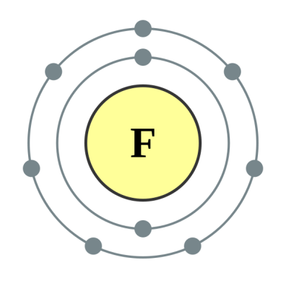
Al | 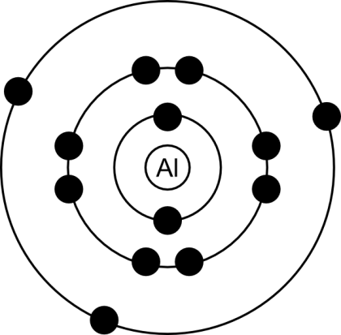

Activity 1.11: Working with electronic configurations.

P | ↑  ↑  ↑↓  ↑↓  ↑↓  ↑↓  ↑↓  ↑↓  ↑
Ne | ↑↓  ↑↓  ↑↓  ↑↓  ↑↓
Ca | ↑↓  ↑↓  ↑↓  ↑↓  ↑↓  ↑↓  ↑↓  ↑↓  ↑↓  ↑↓
Li | ↑  ↑↓
Cl | ↑↓  ↑↓  ↑↓  ↑↓  ↑↓  ↑↓  ↑↓  ↑↓  ↑

Al | 1s²2s²2p⁶3s²3p¹
B | 1s²2s²2p¹
Ar | 1s²2s²2p⁶3s²3p⁶
Si | 1s²2s²2p⁶3s²3p²
Na | 1s²2s²2⁶3s¹

Activity 1.12: Lewis dot diagrams

B | 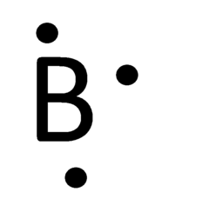 | Ne | 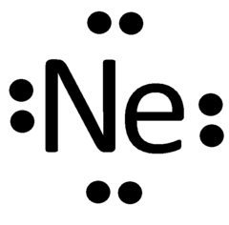
C |  | S
N | 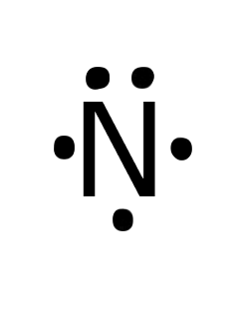 | Ar | 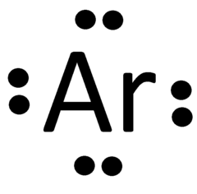
O |  | Na | 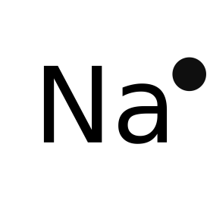
F |  | Ca | ●  Ca●

Activity 1.13:

●●
●S● + 2e⁻ → S²⁻
●●

Cs● → Cs⁺ + e⁻

●Be● → Be²⁺ + 2e⁻

●●
●P● + 3e⁻ → P³⁻
●

●●
●●I ● + e⁻ → I⁻
●●

Activity 1.14:
- Aufbau diagrams:
Magnesium:
Potassium:
↑↓
↑↓
↑↓
↑↓
↑↓
↑↓
↑↓
↑↓
↑↓
↑↓
↑↓
↑↓
↑↓
↓
↑$↓$
↑
Neon:
↑↓
↑↓
↑↓
↑↓
↑↓
↑
↑
↑
↑↓
↑↓
Nitrogen:
- Spectroscopic electron configuration for P:
1s²2s²2p⁶3s²3p³
↑
↑
↑↓
↑↓
↑↓
↑↓
↑↓
↑↓
↑
Orbital (Aufbau) diagram
- Complete the following table:

Element | Spectroscopic Electron configuration | Number of Core electrons | Number of Valence electrons
Sulfur (S) | 1s²2s²2p⁶3s²3p⁴ | 16 | 6
Magnesium (Mg) | 1s²2s²2p⁶3s² | 10 | 2
Lithium (Li) | 1s²2s¹ | 2 | 1
Aluminium (Al) | 1s²2s²2p⁶3s²3p¹ | 10 | 3

  - Most of the volume of an atom is occupied by
(A). electrons.
  - The atomic number of an atom identifies the number of
(A). protons.
  - What is the electron configuration for potassium?
(C). 1s²2s²2p⁶3s²3p⁶4s¹
Activity 1.15: Electron configuration and ions

- Write out an equation for the formation of the ions of the following elements:
K● → K⁺ + e⁻
  - Potassium
●Ca● → Ca²⁺ + 2e⁻
  - Calcium

●●
●●Br● + e⁻ → Br⁻
●●

  - Bromine
  - Sulfur
●●
●N● + 3e⁻ → N³⁻
●

●●
●S● + 2e⁻ → S²⁻
●●

  - Nitrogen

S²⁻ | Argon
Na⁺ | Neon
Al³⁺ | Neon
Br⁻ | Krypton
P³⁻ | Argon

- Use Lewis Dot formulae to depict the electron arrangement in compounds such as
  - lithium oxide (Li₂O)
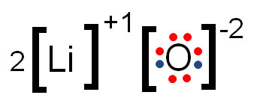
  - calcium chloride (CaCl₂)

  - aluminium oxide (Al₂O₃)?

- Formula:
 | Formula | Name
Potassium and iodine | KI | Potassium iodide
Aluminium and chlorine | AlCl₃ | Aluminium chloride
Lithium and sulfur | Li₂S | Lithium sulfide
Magnesium and oxygen | MgO | Magnesium oxide
Sodium and nitrogen | Na₃N | Sodium nitride

Activity 1.16: Naming ionic compounds
KBr | Potassium bromide
CaCl₂ | Calcium chloride
LiF | Lithium fluoride
Al₂O₃ | Aluminium oxide
Na₂S | Sodium sulfide

Activity 1.17: Using the Periodic Table to determine ionic charges
Group | Charge
Group 18 | 0
Group 2 | +2
Group 15 | -3
Group 17 | -1
Group 16 | -2

Activity 1.18 : Complete the following table:

Compound name | Compound formula | Cation | Anion
Ammonium hydroxide | NH₄OH | NH₄⁺ | OH⁻
Sodium carbonate | Na₂CO₃ | Na⁺ | CO₃²⁻
Potassium permanganate | KMnO₄ | K⁺ | MnO₄⁻
Magnesium nitrate | Mg(NO₃)₂ | Mg²⁺ | NO₃⁻
Calcium hydroxide | Ca(OH)₂ | Ca²⁺ | OH⁻
Sodium phosphate | Na₃PO₄ | Na⁺ | PO₄³⁻

Activity 1.19 : Electron tug-of-war
- Fluorine
- F has a strong attraction for electrons so can form highly polar covalent bonds.
- N, O, Cl, Br all above 2.5
- Non-metals.
- Francium (Fr) 0.7.
- It easily loses and electron so is very reactive in forming ionic bonds.
- The elements on the left hand side of the Periodic Table.
- Metals.
- The EN reduces as you move down a group.
- The EN values increase as you move along a Period.
- Study the following diagram which depicts a covalent bond between two hydrogen atoms:
  - EN = 2.1
  - The electrons will be shared equally between the two atoms since the EN values are the same.
  - The electron pair would be closer to the F atom since the EN for F is 4.0 and the EN for H is 2.1

Lewis do to H-F bonding showing electrons closer to F

  - A bond can only be neutral if the electron pair is shared equally between tow atoms. If it is closer to one of the atoms that atom will have a stronger electron cloud around it so would tend towards being negatively charged, although not completely.

Activity 1:20:

- O₂, N₂, H₂, F₂, Cl₂, Br₂, I₂
- When the electro-negativity value of one non-metal is the same as the electro-negativity of another different non-metal element e.g. C and S, B and As
- When the electro-negativity value of one non-metal element is different from the electro-negativity of the other element in the bond the bond is polar, e.g. H and O in H₂O and C and O in CO₂

Activity 1:21:
Element pairs | ΔEN | Type of bond
H and F | 4.0 - 2.1 = 1.9 | Polar covalent
P and O | - 2.1 = 1.4 | Polar covalent
K and Cl | 3.0 - 0.8 = 2.2 | Ionic
Ca and O | 3.5 -1.0 = 2.5 | Ionic
H and H | 2.1 - 2.1 = 0 | Non-polar covalent
N and O | 3.5 - 3.0 = 0.5 | Polar covalent
Na and S | 2.5 - 0.9 = 1.4 | Ionic
N and H | 3.0 - 2.1 = 0.9 | Polar covalent
Li and F | 4.0 - 1.0 = 3.0 | Ionic
C and H | 2.5 - 2.1 = 0.4 | Polar covalent
C and Cl | 3.0 - 2.5 = 0.5 | Polar covalent
N and N | 3.0 - 3.0 = 0 | Non-polar covalent

Activity 1.22:

- An ionic bond forms when a metal atom donates its valence electron(s) to a non-metal atom. The metal becomes positively charged and the non-metal negatively charged. The two ions then bond by means of electrostatic attraction.
- A covalent bond forms between two non-metal elements which share a pair of electrons to form a bond.
- Bond types:
  - Covalent
  - Ionic
  - Ionic
  - Covalent
  - Covalent

HBr

NaCl | 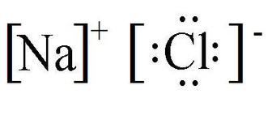
H₂O
NH₃

- Using electro-negativity data:
  - C-O ΔEN = 3.5 – 2.5 = 1.0 Bond is polar covalent
  - N-N ΔEN = 3.0 – 3.0 = 0 Bond is non-polar covalent
  - P-I ΔEN = 2.5 – 2.1 = 0.4 Bond is non-polar covalent
  - S-F ΔEN = 4.0 – 2.5 = 1.5 Bond is polar covalent
  - H-Br ΔEN = 2.8 – 2.1 = 0.7 Bond is polar covalent
- Electro-negativity decreases down a group
- Electro-negativity increases across a period

- Answers in bold:
  - A bond composed of one shared electron pair between two atoms..single bond
  - The valence electrons in a molecule that are not shared…non-bonding electrons
  - The ability of an atom to attract a shared pair of electrons…electro-negativity.
  - A bond in which the electron pair is shared equally between two atoms…non-polar covalent bond
  - A bond in which the electron pair is shared unequally between two atoms…polar covalent bond.
  - A method used to indicate partial positive and partial negative charges in a covalent bond…delta (δ) notation
  - The statement that an atom must be surrounded by eight valence electrons to be stable….octet rule

Activity 1:23

potassium chloride | KCl
sodium oxide | Na₂O
lithium nitride | Li₃N
magnesium fluoride | MgF₂
calcium oxide | CaO
aluminium bromide | AlBr₃
aluminium sulfide | Al₂S₃
aluminium nitride | AlN
copper (II) chloride | CuCl₂
iron (III) chloride | FeCl₃
mercury (I) oxide | Hg₂O
mercury (II) oxide | HgO
zinc bromide | ZnBr₂
silver oxide | Ag₂O
lead sulfide | PbS

Activity 1.24

Compound name | Ions | Chemical formula
magnesium sulfate | Mg²⁺, SO₄²⁻ | MgSO₄
calcium sulfite | Ca²⁺, SO₃²⁻ | CaSO₃
potassium sulfate | K⁺, SO₄²⁻ | K_{s}SO₄
potassium carbonate | K⁺, CO₃²⁻ | K₂CO₃
sodium hydrogen carbonate (bicarbonate of soda) | Na⁺, HCO₃⁻ | NaHCO₃
ammonium sulfide | NH₄⁺, S²⁻ | (NH₄)₂S
ammonium hydroxide | NH₄⁺, OH⁻ | NH₄OH
barium nitrate | Ba²⁺, NO₃⁻ | Ba(NO₃)₂
lithium hydroxide (Li⁺, OH | Li⁺, OH⁻ | LiOH
aluminium hydroxide | Al³⁺, OH⁻ | Al(OH)₃

Activity 1.25
NO₂ | Nitrogen dioxide
CO₂ | Carbon dioxide
HCl | Hydrogen chloride
N₂O₄ | Dinitrogen tetroxide
P₄S₃ | Tetraphosphorus trisulfide
NO₂ | Nitrogen dioxide
I₂O₄ | Di-iodine tetroxide
CO | Carbon monoxide
SIO₂ | Silicon dioxide
P₂I₄ | Diphosphorus tetraiodide
HF | Hydrogen fluoride

Activity 1.26:

Ice forms at 0ºC. Ice is in the solid phase.
The ice starts to melt.
Water is in the liquid phase.
The boiling point of water is 100ºC.
The water starts to boil – bubbles rapidly rise to the surface and the whole body of water moves around vigorously. The water turns into steam or water vapour.
Water is entering the gas phase when it starts to boil.
As boiling continues the water volume decreases until it disappears completely.
Activity 1.27

  - SiH₄
  - The greater the size of the molecule the higher the boiling point.
  - No. Oxygen, which is in Period 2, is bonded to H to form water and it has the highest boiling point.
  - H₂O is liquid. The rest are gases as they boil before reaching room temperature (25ºC).
  - Water remains a liquid for drinking as well as for many other uses over a wide range of temperatures (0 - 100 ºC). Usual climate temperatures remain well within this range so life is not compromised by water changing phase without an input of energy.
- London forces. London forces are relatively weak forces of attraction that exists between nonpolar molecules and noble gas atoms.
Activity 1.28:

Name | Formula | Structural formula
Methane | C₁H₄ | 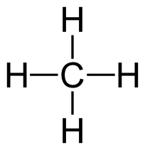
Ethane | C₂H₆ | 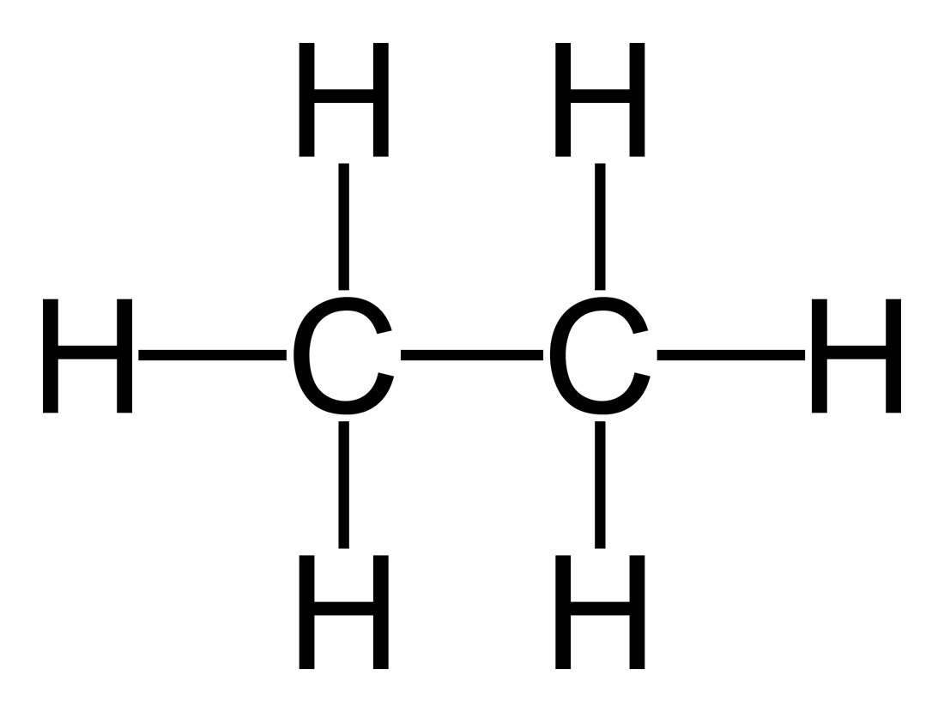
Propane | C₃H₈ | 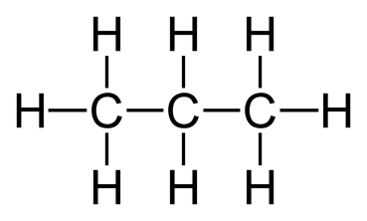
Butane | C₄H₁₀ | 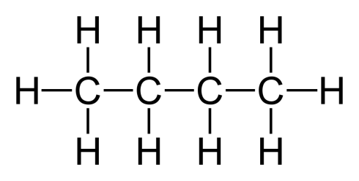
Pentane | C₅H₁₂ | 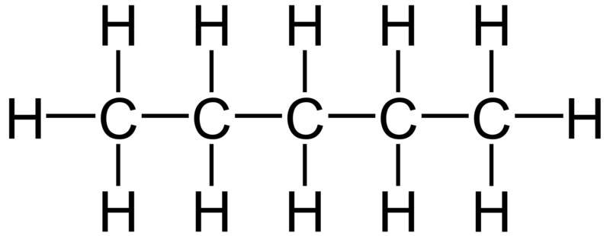
Hexane | C₆H₁₄ | 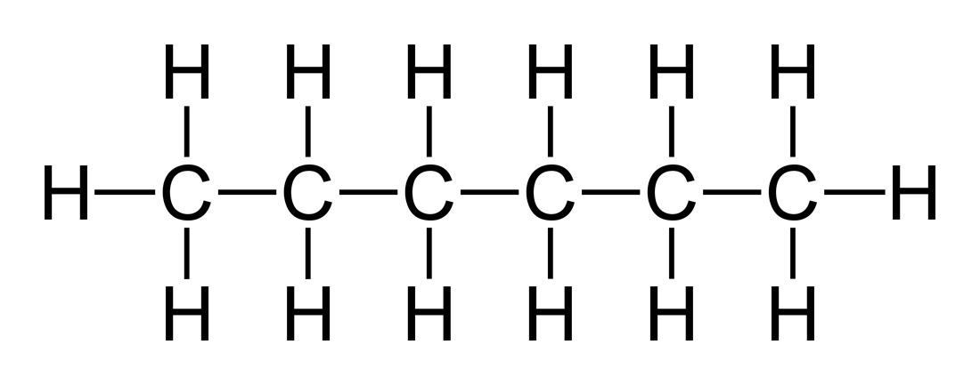
Heptane | C₇H₁₆ | 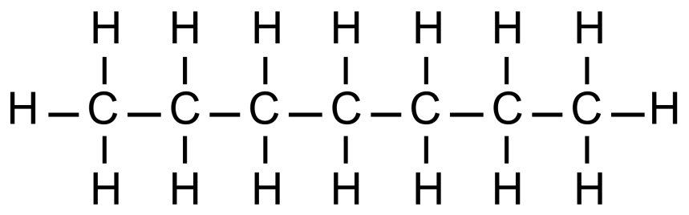
Octane | C₈H₁₈ | 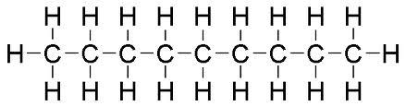

Activity 1.29:
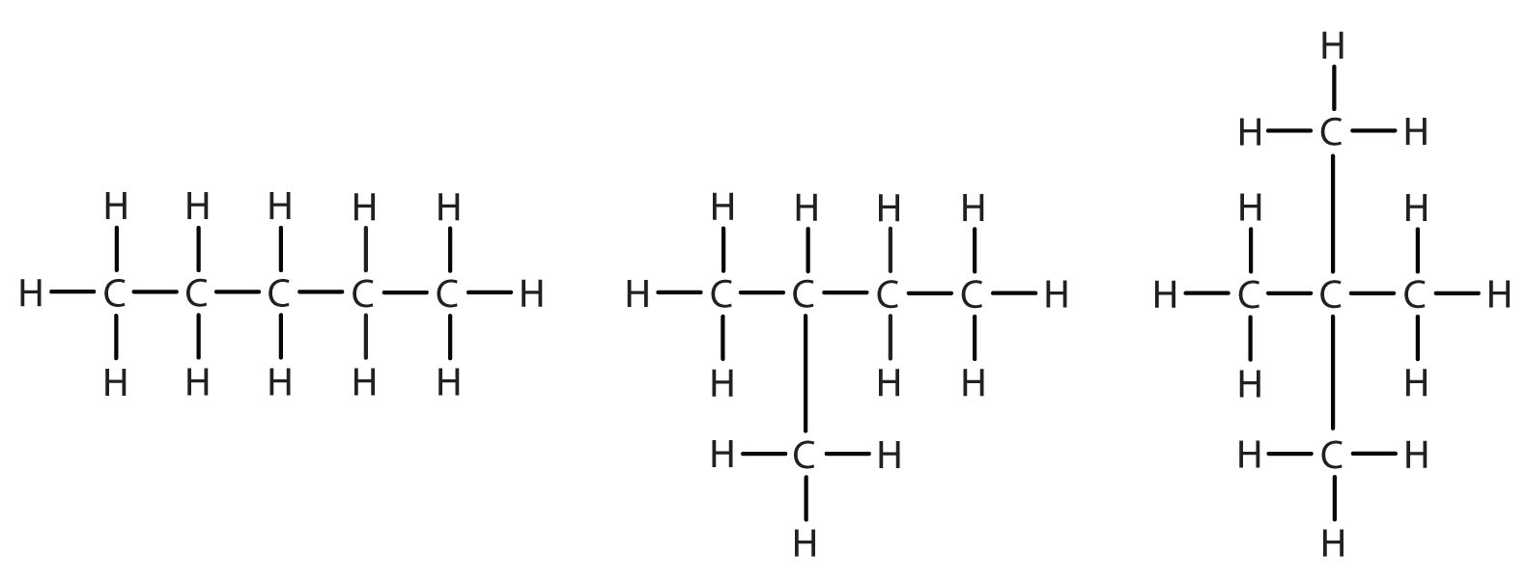
Activity 1:30:

Name | Formula | Structural formula
Ethene | C₂H₄ | 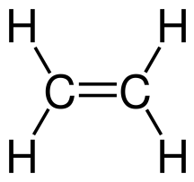
Prop-1-ene | C₃H₆
But-1-ene | C₄H₈ | 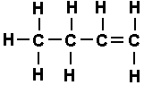
Pent-1-ene | C₅H₁₀ | 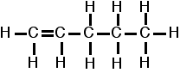
Hex-1-ene | C₆H₁₂ | 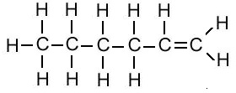
Hept-1-ene | C₇H₁₄ | 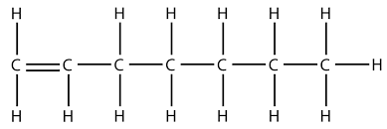
Oct-1-ene | C₈H₁₆ | 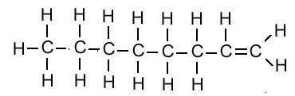

Activity 1.31

Name | Formula | Structural formula
Ethyne | C₂H₂ | 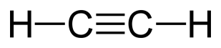
Prop-1-yne | C₃H₄ | 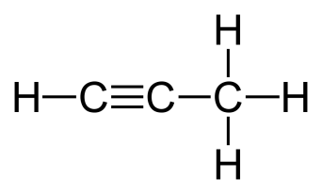
But-1-yne | C₄H₆ | 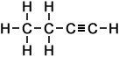
Pent-1-yne | C₅H₈ | 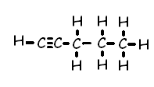
Hex-1-yne | C₆H₁₀ | 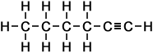
Hept-1-yne | C₇H₁₂ | 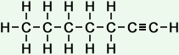
Oct-1-yne | C₈H₁₄ | 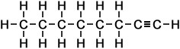

Activity 1.32

Compound | Name
CH₂=CH-CH₂-CH₂-CH₃ | 1-butene
CH≡C-CH₂-CH₂-CH₃ | 1-butyne
CH₃-CH-CH₂-CH=CH₂ | 1-butene
CH₃- CH₂- CH₂-CH₂-C≡CH | 1-pentyne
CH₃-CH=CH-CH₂-CH₃ | 2-pentene
CH₃-CH₂-CH=CH-CH₃ | 2-pentene
CH₃-CH₂-CH₂-CH=CH₂ | 1-pentene
CH₃-C≡C-CH₂-CH₃ | 2-pentyne
CH₃-CH₂-C≡C-CH₃ | 2-pentyne
CH₃-CH₂-CH₂-C≡CH | 1-pentyne

Activity 1.33

But-1-ene

1,2 - dibromobutane

Activity 1.34:

1 | butanoic acid | 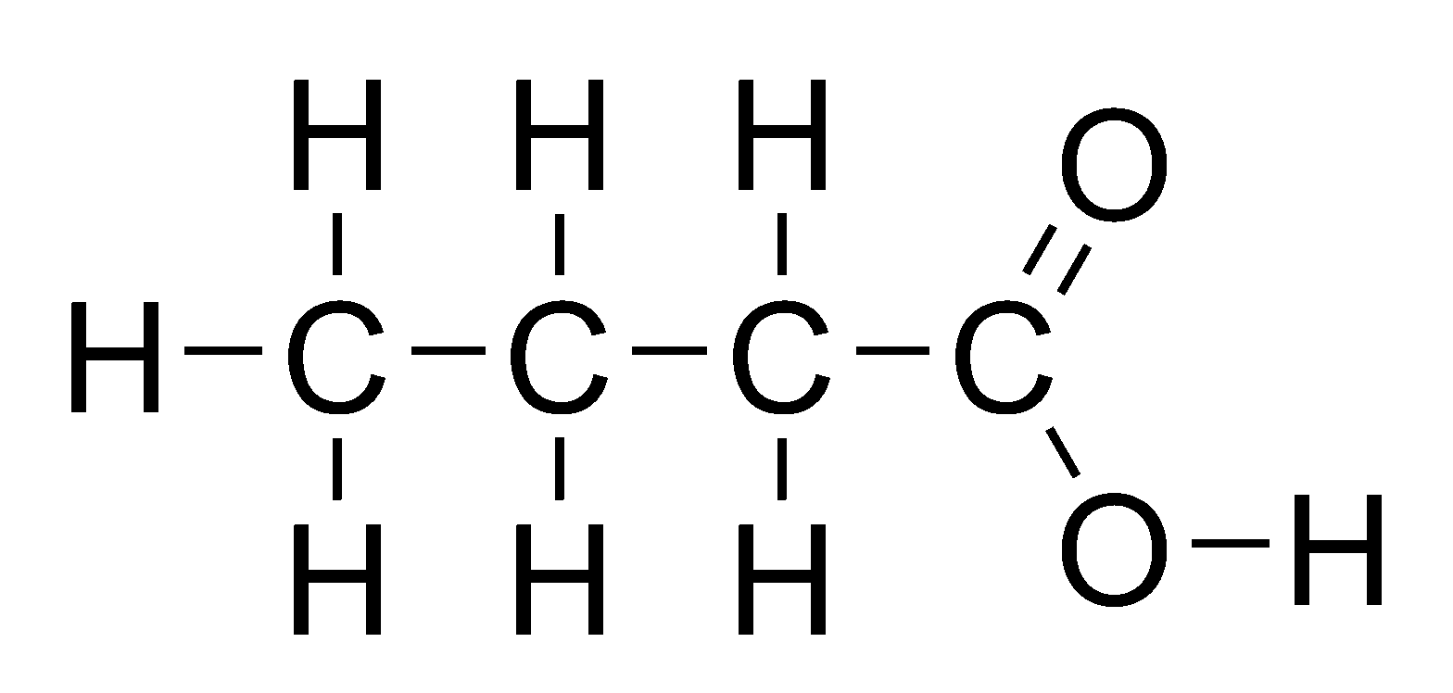
2 | 2 - octyne | 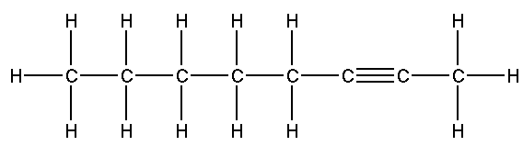
3 | 3 – pentanol | 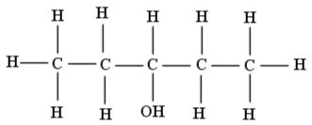
4 | 3 - heptene | 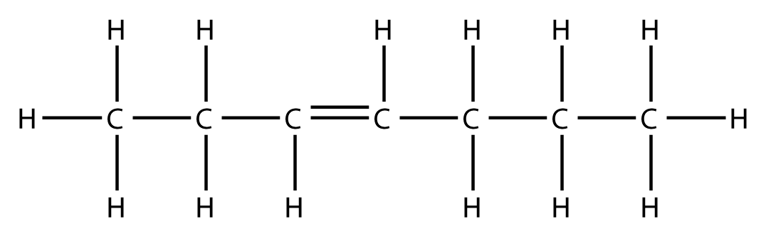
5 | butanone | 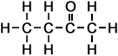
6 | hexaldehyde | 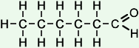
7 | propyl pentanoate | 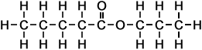
8 | 2-bromopropane | 