NASCA Chemistry Materials Draft 1

Units 1-6

Topic 1: Matter

Introduction
Chemistry spans the relationship between the macroscopic, the particulate and the symbolic aspects of matter. The macroscopic aspect of matter is what you can detect with your senses (seeing, hearing and smelling) in and outside the laboratory. The aim of the discipline of chemistry is to try to explain these happenings by understanding more about what happens at the particulate level and represent the macroscopic aspect using recognised symbols in chemistry, called the symbolic level. Chemistry is a language and during this section of the course, we will teach you to use these symbols correctly. Chemistry is much easier when you can link the macroscopic, particulate and symbolic levels of representation. Figure 1.1 below shows you how they link using the example of water.

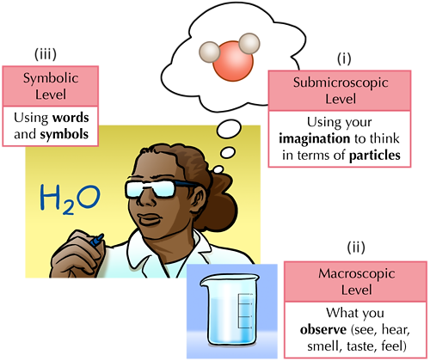

Figure 1.1: The three levels of representation of matter
(Source: http://www.mstworkbooks.co.za/natural-sciences/gr9/gr9-mm-02.html )

In figure 1.1 you can see a beaker of water at the macroscopic level. We can say that the water is directly observable. At the particulate level you can see a molecule of water (really many molecules in the actual water), represented by three balls, one showing oxygen (red) and two showing hydrogen (white). At the symbolic level the figure mentions words and symbols and underneath is the formula H₂O. In the chemistry units below, we will constantly be moving from one level to another. In unit 1 you will learn how to represent matter at the particulate level and this will be important in all the later units.

Unit 1: Particle theory of matter and the three states of matter

Outcomes

By the end of the unit, you should be able to:
- State the Kinetic molecular theory;
- Describe the states of matter (solid, liquid and gas) in terms of the arrangement and movement of the particles of matter;
- Explain the state changes in terms of Kinetic molecular theory.

Unit 1: Particle theory of matter and the three states of matter

Introduction
One of the most important ideas in science is that matter is made of particles. This is difficult to believe when you first hear about it and scientists in history argued about it for a long time. The first person we know about who believed that matter is made of particles was an ancient Greek philosopher called Democritus. Democritus argued that if you broke a stone in two and carried on breaking the smaller pieces, eventually you would reach a point where it would not be possible to break it any further. Many powerful philosophers disagreed with him and his ideas lay buried for many years until the early 19th when John Dalton, an Englishman picked them up. Nowadays we have very advanced equipment and although we cannot actually see these particles with our eyes, by detecting light rays, we can detect them with other rays, such as X rays. Figure 1.2 shows the detection of a pinhead made of a metal called Tungsten. The pattern shows that many particles were deflecting the rays. Each dot represents a tungsten atom.
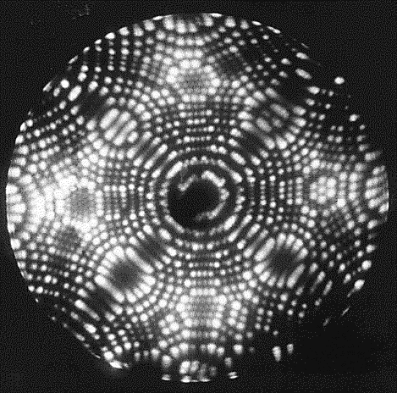

Figure 1.2: X Ray detection of a tungsten pin head

The video in the link below was made by IBM, a big computer company showing how they made this video by moving single atoms frame by frame, creating the world’s smallest movie.

https://www.youtube.com/watch?v=rNf-A3m6HVo

The next link shows how they made it.
https://www.youtube.com/watch?v=rNf-A3m6HVo

Although there are very advanced theories about atoms and what they are made of, there are many happenings in nature, called scientific phenomena such as evaporation of water which we can explain using a very simple model of the atom. Through this chemistry component we will study a number of models of the atom starting with the simplest model which was suggested by John Dalton. He proposed that atoms were tiny balls or solid spheres which cannot be penetrated. By picturing an atom as a solid sphere we can explain many ideas in chemistry. Today we know that atoms have a more complex structure but scientists believe that it is best to use the simplest possible model to explain experimental observations. In later units we will move on to more complex models of the atom when we need them.
In Activity 1.1 you will be making a model to try and explain how particles of matter behave.

Activity 1.1: Particle model of matter

Purpose to make a model to see how particles behave

What you need:

- A rectangular box, as big as a shoe box lid, large enough to allow free movement for 5 marbles
- 5 marbles (or small hard balls of the same size) – one should be different in colour from the others
- A broad flat board that can fit into the box and can close off the end of the box (see diagram in Part A), like a small ruler
- A watch

Suggested time: [20 minutes]

What you will do:

Part A
Place the marbles in the box on a flat surface like a table. (Remember your box should be large enough to allow free movement of the marbles.) Shake the box in all directions for 30 seconds but without lifting it off the table then answer the questions below:

Fig 1.3: Marbles in box
(Source: Rollnick, M.S. Atoms in Action: A People's College Book. SACHED trust/Maskew Miller Longman, 1996, p9.

- Describe the movement of the marbles.
- Can you predict where a marble will move? Explain your answer.
- Watch one marble. Name all the things it bumps against in the 30 seconds.

We call this disorganised movement shown by the marbles random motion.
In part B of activity 1.1 we will reduce the space in the box to find out how the marbles behave in a smaller space.

Part B:
Use the broad flat board (or a ruler) to make the space half as big as shown in the figure below.

Fig 1.4: Marbles in box with less space
(source: Rollnick, M.S. Atoms in Action: A People's College Book. SACHED trust/Maskew Miller Longman, 1996, p10.)

Now shake the box as before.
- Compare the movement of the marbles with your observations in part A (1).
- Count the number of collisions the marble makes with its neighbours and with the sides of the box.

In part C we will decrease the space still further.

Part C

Place your board such that the marbles are as closely packed as possible, but do not squash them.

Fig 1.5: Marbles in box with less space
(Source: Rollnick, M.S. Atoms in Action: A People's College Book. SACHED trust/Maskew Miller Longman, 1996, p11.)

Shake the box as before.
- How do the marbles move now?
Shake the box faster.
- Can you see any difference in the motion of the marbles?
- Count the collisions of the marbles and compare the movement of the marbles now to how they moved in parts A and B of this activity.

Guided reflection
Let us now see what this activity tells us about how particles of matter behave and how they are arranged, relating our model to the behaviour of particles in solids, liquids and gases. Let us now see how our model helps us to explain the behaviour of real particles.
In part A, the marbles were far apart and moved freely in a large space. This is also true of the particles in a gas. They have large spaces between them and move about freely. You saw in the activity that the particles collide with each other and with the walls of the container. There are also large spaces between the particles on average. By 'on average' we mean there are large spaces most of the time except when they are colliding. Clearly when they are colliding, they are close together. But at all times they have great freedom of movement.

You can see this activity in a PHET simulation
Go to the following web address:
(https://phet.colorado.edu/en/simulation/states-of-matter-basics )
Click on the Play arrow in States of Matter: Basics, then click on States.
Select argon and click on “gas”
You will see the particles moving in all directions (randomly) in the container as in the screenshot shown in figure 1.6 below

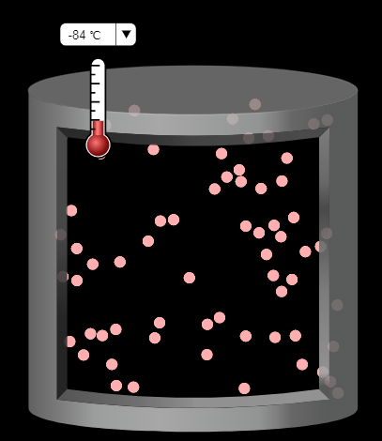
Figure 1.6: Screenshot of argon atoms in the gaseous state

Notice for the collection of atoms we use the macro word, which is “gas” but at the sub-micro level we refer to “atoms”.

Notice the temperature is -84⁰C (you can change it from 189 K, which is another unit for measuring temperature, by clicking on the little downward-pointing arrow)

In Part B of Activity 1, the particles were closer together. They were very loosely packed and there was some room for the marbles to move. This is like the arrangement of particles in a liquid. In a liquid, the particles are close together but they can still slide over one another. Go back to the PHET simulation and change the simulation to “liquid”. You will now see the particles sliding over each other but not occupying the whole container. Notice the temperature is lower than before.
This is why a liquid takes up the shape of the container into which it was poured but has a definite volume which can be measured. See figure 1.7 Below for a screenshot.

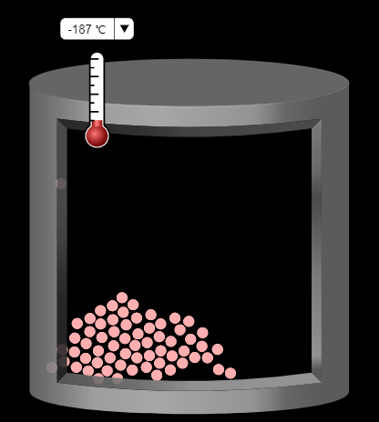
Figure 1.7: Screenshot of argon atoms in the liquid state

Notice that we refer to the collection of particles as a liquid which is a macro level word but the liquid in this case is made of atoms.

In Part C of Activity 1, the marbles were fixed in position and could not move about. This arrangement is similar to the arrangement of particles in solids. Go back to the PHET simulation and change the simulation to “solid”. You will now see the particles arranged in a regular fashion as shown in the screenshot in figure 1.8 below.

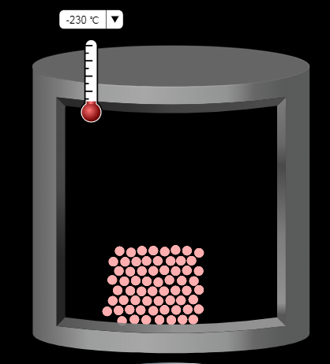
Figure 1.8: Screenshot of argon atoms in the solid state

You can now see the particles in regular arrangement. Notice again that the temperature is lower than that of the liquid. Particles of solids attract each other strongly and only vibrate in their fixed positions. This means that solids have a fixed volume and shape.
Notice that we refer to the collection of particles as a solid which is a macro level word but the liquid here is made of atoms.

Now answer the following questions:

- Use what you have observed on the model to explain why liquids take up the shape of the container into which they are put.
- Solids, for example, coal, wood, iron have a fixed shape and volume. Look back at the model and see if you can explain why this is so.

[BOX]: MAIN IDEA:
START TEXT BOX
The ideas we have been discussing have been put together with some others to make a theory of how particles behave in gases. This theory is called the kinetic molecular theory. We can express it in six important statements. They are
- All matter is made of particles that are constantly moving
- They are moving because they have energy.
- Their energy increases with increasing temperature
- Particles in the solid state have the least amount of energy
- Particles in the liquid state have more energy
- Particles in the gaseous state have the most energy

END TEXT BOX

Activity 1.2: Observing change of state at the macro level

Purpose to observe change of state

What you need:
[suggest alternatives to glasses. Maybe the cut-off end of a 2 litre “coke” bottle]
The easiest substance to observe is water
Take some cubes of ice from the refrigerator and place two cubes in two different containers.
Pour water on to the cubes in one container, filling it half full, and leave the cubes in the other glass for about 15 minutes or until all the ice has melted.
Draw pictures of the water level in the two container after a while
Next, boil some water in a kettle and hold a cup upside down near the spout of the kettle while the water is boiling.
What happens to the steam?

Guided reflection
You should have noticed the following:
The ice cubes move to the surface of the water in the first container but float with most of their volume below the surface
After the ice cubes melt, the water takes the shape of the container
The steam from the kettle moves away from the kettle to occupy the space in the room
When you hold a cold cup near the spout of the kettle, the steam changes back to water

You can see an interesting application of the ability of ice to float on water when you observe icebergs in the sea. Icebergs are mountains of ice. We can only see a small part of the iceberg. The rest is hidden under the water as you can see in figure 1.9.

Figure 1.9: Iceberg floating in water
https://www.istockphoto.com/no/photo/iceberg-floating-in-arctic-sea-gm693474546-128066809
(they say it is royalty free)

Unit 2: Classification and separation of matter

Outcomes

By the end of the unit, you should be able to:
- Define and differentiate between elements and compounds, mixtures and pure substances, heterogeneous and homogenous mixtures;
- Differentiate between physical and chemical change
- Differentiate between atoms and molecules
- Classify different examples of matter according to a classification scheme for matter involving homogenous mixtures (solid, liquid and gaseous solutions), heterogeneous mixtures, compounds and elements;
- Identify examples from everyday life of elements, compounds, pure substances, homogenous mixtures, heterogeneous mixtures;
- Describe the separation of different types of mixtures (solid-solid, solid-liquid when soluble and insoluble, liquid-liquid when miscible and immiscible).

This version not yet incorporated all comments from Tony Lelliott

Unit 2: Classification and separation of matter

Introduction
Usually scientists describe chemistry as the study of matter and the changes that occur in matter. But what is matter? Matter is anything that occupies space and has mass. Other words that can be used instead of matter are substances or materials. All the stuff around us - everything that makes up our planet and the universe is matter! So chemistry is a very broad subject.

Many people think that chemistry involves the study and use of dangerous, poisonous or explosive chemicals that have to be carefully stored in laboratories. You may have read books or watched programmes on TV that make it seem like this. However everything around us involves chemistry! Some examples of matter (or chemicals) that you will be very familiar with are the air you breathe, the water you drink, the pencil you write with, the chair you are sitting on, the light bulb glowing over your head! Your body is a big bundle of many, many hundreds of substances. While you are reading this unit, hundreds of complicated and very fast changes involving these substances are taking place in your body. It is these changes that keep you alive!

As chemists, we have to describe matter very carefully in terms of its structure and composition (what it is made up of). Some of the words or terms we use may be new to you or they may be words that you are familiar with in everyday language but in chemistry they are used rather differently. In this unit we will try to help you understand and use some of these words or terms correctly as we study various ideas (or concepts) about matter. In later units you will look at changes that can occur in matter.

Macroscopic Descriptions of matter
In the last unit we talked about three important ways of looking at matter that are used in chemistry – macroscopic, sub-microscopic and symbolic. In this unit we will start by taking a closer look at various macroscopic descriptions of matter. Generally we use our eyes or other senses, such as smell, touch and occasionally taste to describe matter macroscopically. However, it is not generally a good idea to go around touching, smelling or tasting unfamiliar substances. Some of them may be poisonous! In the last unit, we learnt about the three states of matter and the difference between them. We will now look more closely at how matter looks when you examine it more closely.
When we look around us, some objects appear to look the same throughout. We say such matter is homogeneous or uniform. For example, a pane of glass (if it is clean) appears homogeneous. Some other objects may not appear the same throughout. Some other objects may not appear that same throughout. We can see different parts in them, e.g. a piece of word or a rock. In figure 2.1 we provide some examples of heterogeneous and homogeneous matter.

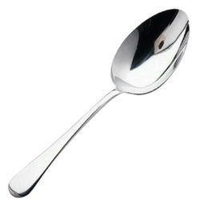
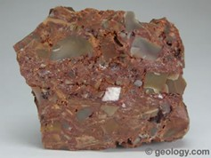

Figure 2.1: Examples of heterogeneous (a rock) and homogeneous matter (a spoon)
Rock https://slideplayer.com/slide/10843476/
Spoon https://www.google.com/search?biw=1280&bih=561&tbm=isch&sa=1&ei=vVToW9HjJs-ua_T3i5gB&q=image+metal+spoon&oq=image+metal+spoon&gs_l=img.3...20839.21901.0.22638.5.5.0.0.0.0.230.657.2-3.3.0....0...1c.1.64.img..2.1.230...0i8i30k1.0.p9No2gm9rck#imgrc=FxiE8h6sSHPENM
Now let’s use some examples you can find around your home to see if you understand these terms

Activity 2.1: Classifying matter
Say whether the following examples are in the solid, liquid or gas phase. Then decide whether they are homogeneous or heterogeneous. Make your own decision before looking at the guided reflection below.
- A cup of black tea (ie tea with no milk)
- A cup containing some vinegar and cooking oil (stirred and allowed to settle)
- The air in the room you are in
- A bottle containing some soil from the garden and some water (stirred and allowed to settle)
- Half a teaspoon of salt in a cup or cooking oil (stirred and allowed to settle)
- Half a teaspoon of sugar in a cup of water (stirred and allowed to settle)

Guided reflection
For each of the examples try to decide if the examples look the same throughout (homogeneous) or if it is possible to see different separate parts of matter (heterogeneous).

Exemplar answers
- The black tea is a liquid. When you look at the black tea, it should look the same throughout (as long as no tea leaves have escaped from the tea bag). You only see one brownish liquid so we say the tea is homogeneous.
- The vinegar and oil are two liquids. After you have mixed the vinegar and oil you will see that they settle out to form two separate layers (both are liquids). You can tell where the one liquid ends and the other begins. You see two phases so the contents of the cup are not the same throughout. Thus, the contents of the cup are heterogeneous.
- Air is in the gas phase. The air in the room appears the same throughout (unless someone is smoking or water in a kettle is boiling!) We only see one gas phase and so the air can be described as being homogeneous.
- Probably you see bits of leaved, twigs (solid phases) etc. ﬂoating on the muddy coloured water (a liquid phase) and some soil which has settled at the bottom of the bottle (a solid). Because the contents of the bottle are not the same throughout (you can see different phases) we say the contents of the bottle are heterogeneous.
- Some salt. (a solid) will have settled out of the oil (a liquid). The contents of the cup will appear heterogeneous because you can see more than one phase. You see a solid and a liquid phase.
- The sugar should dissolve in the water so you only see the water (a liquid). The contents of the cup appear the same throughout and you only see one phase so we describe it as homogeneous.

You should now feel more comfortable about the terms homogeneous and heterogeneous after trying this activity.

Physical and Chemical Change
For chemists two kinds of properties of matter are important, namely physical properties and chemical properties.
Physical properties are those properties that a substance shows by itself, without interacting with any other substance for example the colour of the substance or temperature at which it boils. A physical change in a substance occurs when it changes its physical form or shape but not what it is made up of (its composition). For example in unit 1 you saw that when ice melts, it changes to water and this is a physical change. So water in a solid form has changed into water in a liquid form but it remains the substance water. The physical properties of the liquid water are different from those of the solid water (ice). All changes in the state or phase of a substance are physical changes. Below is a list of some of these changes with the term in brackets to describe the process of change. You will see later that these changes of state occur at certain temperatures and pressures. The symbol → is used to say “changes to”.
Solid → liquid (melting)
Liquid → solid (solidification or freezing)
Liquid → gas (boiling or vaporisation)
Gas → liquid (condensation)
Solid → gas (sublimation)

Chemical properties are those properties that a substance shows when it changes into another (different) substance. An example of a chemical property is whether or not a substance will burn in oxygen (i.e. its combustibility). A chemical change (also called a chemical reaction) occurs when a substance is converted into a different substance (or substances) with a different composition and different physical properties. For example, if you burn a piece of paper you are left with a pile of black ash that is a different substance from the piece of paper that you had before and you won’t be able to turn the ash back into paper! A chemical change or chemical reaction has occurred in which the paper was changed into a different substance (or substances)

ACTIVITY 2.2: Deciding on the difference between physical and chemical change

Decide whether each of the following processes is a physical or chemical change and give a reason to explain your decision. Make your own decision before looking at the guided reflection and answers below.
  - Frost (or ice) forms on the grass on a cold winter’s night.
  - A mealie plant grows from a mealie seed.
  - A carpenter makes a leg of a table from a piece of pine wood.
  - Parafﬁn burns in a stove
  - Steam forms as water boils in a kettle.

Guided reflection
For each example you need to decide if a new substance has been formed and if the process can easily be reversed.

Exemplar answers
- A physical change. Water (liquid) condenses on the grass at night. (We call this dew.) When it is very cold at night this water liquid forms solid water or ice. It is still the same substance, water.
- A chemical change. The substances in the seed will change as the mealie plant grows and form many new chemical substances which make up the roots, stem and leaves of the mealie plant.
- A physical change. The composition of the pine wood has not changed but the shape of the piece of wood has changed.
- A chemical change. The paraffin (a liquid) reacts with the oxygen in the air to form new substances mainly carbon dioxide and water vapour (both gases).
- A physical change. The steam is still the same substance, water. You can show this if you put a cold plate next to the steam. (Don’t burn yourself!). Drops of water form on the plate, showing that the steam has condensed back into water.

Matter as we imagine it

Descriptions of Matter on a Small Scale
Chemists also describe matter on a very small scale using very small particles that make up matter. These descriptions are called sub-microscopic descriptions. We cannot see these small particles. So we use the word sub-microscopic because we cannot even see the particles under a microscope - they are too small! Scientists believe these small particles exist because of the results of rather complicated experiments that you will learn about later in this course.

The Smallest Particles of Matter - Atoms or Molecules
The smallest particle of matter that takes part in a chemical reaction is called an atom. Although we cannot see atoms scientists often make drawings to represent them. We can represent an atom with a small circle.

Figure 2.2: Representation of an atom

Some substances are made up of separate atoms while other substances consist of atoms joined or bonded together to form molecules. Molecules can be made up of two or more atoms bonded together. Some molecules (like the molecules of haemoglobin which is a substance found in blood giving it its red colour) have hundreds of atoms bonded together. Molecules are drawn by showing 2 overlapping circles and then rubbing out the part where they overlap. e.g.

Figure 2.3 representation of a molecule formed from 2 atoms

Figure 2.4 shows some more representations of molecules.
A molecule made of 3 atoms, i.e. a triatomic molecule
A molecule made of 2 atoms, i.e. a diatomic molecule

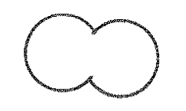

Figure 2.4 Some Representations of Molecules

As we explained in unit 1, the idea of matter being made up of atoms took a long time to develop. In fact some of the ideas were only developed from around the year 1900 , so these ideas are fairly modern. Scientists are still working on these ideas using complicated mathematics and experiments. In the future some of our ideas about the atom may change as a result of this work.

Sub-microscopic representations of solids, liquids and gases
We can imagine and describe the sub-microscopic structure of solids, liquids and gases using our representations of atoms and molecules. In unit 1 we just looked at atoms.

You may ask: Can we draw just one atom or molecule to represent the state of a substance?
No, we can't! If we did, the representation of a solid, liquid or gas would all look the same and we wouldn‘t be able to tell the difference. We have to draw a collection (or number) of atoms or molecules and we must show how these particles are arranged differently in the solid, liquid and gas states.
In a sub-microscopic representation of a solid the atoms (or molecules) are drawn close together and in a ﬁxed (or repeating) pattern or arrangement.
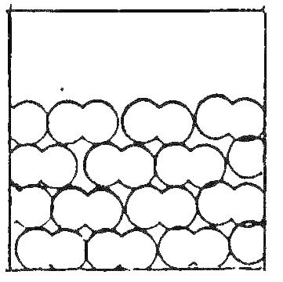
Molecules are close together and arranged in a repeating pattern

Fig 2.5 A sub-microscopic representation of a solid.

In a liquid the atoms (or molecules) are also drawn close together but do not occur in a ﬁxed pattern. Thus there are more spaces between the molecules (or atoms) of a liquid than those of a solid.
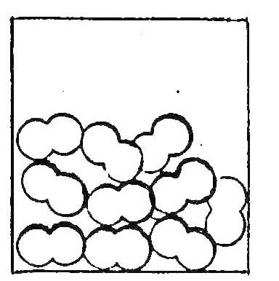
Molecules close together but not in a regular pattern

Fig 2.6 A sub-microscopic representation of a liquid.

In a gas we draw the atoms or molecules far apart and fill the container
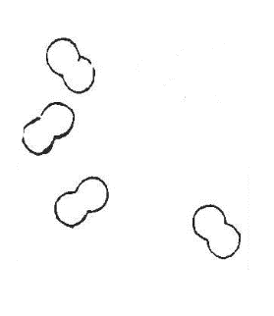
Molecules far apart and fill the container

Fig 2.7 A sub-microscopic representation of a gas.

A representation is just a drawing of what we believe something is like. We cannot really see the atoms and molecules but we have ideas about them from experiments. The atoms or molecules in these representations are not drawn to the correct scale. If we draw molecules say in a beaker, the molecules are drawn much too big in relation to the size of the beaker. As humans, we cannot draw them as their correct size. Even the pencil marks we draw consist of billions of atoms!

In some text books you may find microscopic representations of these states that are not the same as those that we have given you. This is particularly the case with respect to liquids. These representations in books are not correct so don’t use them.

The words homogeneous and heterogeneous are used for macroscopic descriptions only. They cannot be used at the sub-microscopic level because at this level matter is composed of many different structures and everything is heterogeneous.
Below we give you an opportunity to see how well you can draw some of these sub-microscopic representations yourself.

ACTIVITY 2.3: Drawing sub-microscopic representations

Use a triatomic molecule (a molecule made up of 3 atoms) with the structure below to
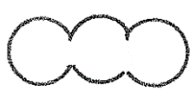

  - Draw sub-microscopic representations of
    - a solid
    - a liquid
    - a gas
  - Show the following changes of state sub-microscopically:
    - Sublimation
    - Vaporisation
    - Melting
Try to do these tasks before looking at the answers below!!! The guided reflection may help you

Guided reflection
Each one of your answers needs to use many of the triatomic molecules together – use about 5 or 6 and arrange them according to whether they are in solid, liquid or gaseous state. For the processes, show one representation for before and one for after the change.

Exemplar answers
- Sub-microscopic representations
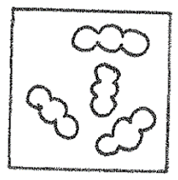
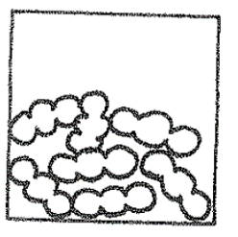
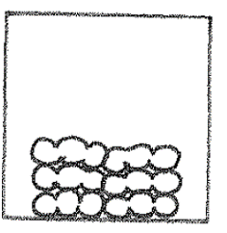

- A gas
Molecules far apart and fill the container
- A liquid
Molecules close (touching) but not in a pattern
- A solid
Molecules close and in a pattern

- Sub-microscopic representations of some changes of state
  - Sublimation
This is the change of state of a solid to a gas
You should show the microscopic representation of the solid first and then its change to a gas, e.g.

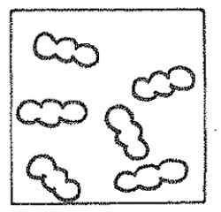
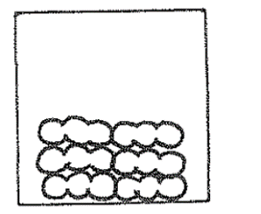

Solid
Gas

  - Vaporisation
This is the change of state of a liquid to a gas, e.g.

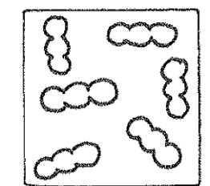
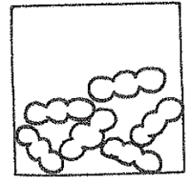

liquid
Gas

- Melting
This is the change of state of a solid to a liquid, e.g.

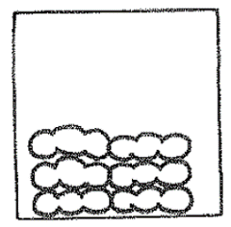
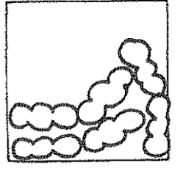

solid
liquid

What are elements and compounds?

You may have heard the words elements and compounds, but what do they mean?
Let us see if we can answer this question.

You won’t be able to tell if a substance is an element or a compound just by looking at it. Experiments have to be conducted on the substance. It is interesting to note that the early chemists did these kinds of experiments and worked out some of the descriptions of elements and compounds before they knew about the existence of atoms and molecules. So the sub-microscopic descriptions of elements and compounds that you will read about below are fairly recent ideas.
Descriptions of Elements

A description of an element often given in textbooks is that an element cannot be changed into a simpler substance by physical methods (e.g. by heating) or by chemical methods (i.e. by reactions).

For many of us this description is rather difficult to understand when we ﬁrst start to study chemistry so we won’t spend time on this now. However later on after you have studied more chemistry you will understand better what this means. The sub-microscopic description of an element is easier to follow: An element is a substance made up of the same kind of atoms.

At present there are about 118 different elements. 90 of these occur naturally - some in large quantities and some in very small quantities. The rest of the elements have been made by scientists in laboratories. Each element has been given a name e.g. carbon, gold or oxygen. (We will study more about elements later. You will learn the names of many elements and also ﬁnd out what makes atoms the same or different.) A sample of carbon contains only carbon atoms, a piece of gold contains only gold atoms and oxygen gas only contains oxygen atoms. The physical and chemical properties of carbon, gold and oxygen will be different because their atoms are different. Some elements exist as separate atoms. Neon gas is such an element. Other elements exist as molecules in which atoms are bonded together.

Click the link below to learn about the latest discoveries of chemical elements:
https://www.youtube.com/watch?v=wswa0NuBbMw

The representations in figure 2.8 may help you understand how some elements may be in atomic form and others as molecules.
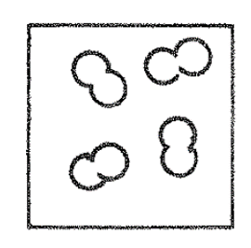
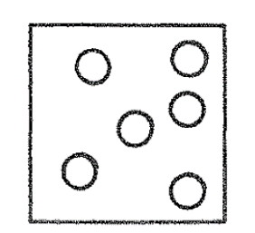

An element composed of diatomic (2-atomed) molecules
An element composed of single atoms, sometimes called monatomic (one-atomed)

Figure 2.8: Sub-microscopic representations of elements

Descriptions of Compounds

A compound is a substance made up of two or more elements chemically bonded together. These elements are not just mixed together. Their atoms have chemically bonded together to form a new substance. For example the elements hydrogen and oxygen which are both gases combine to form a compound water which is a liquid. An important feature of a compound is that the elements are combined in a ﬁxed ratio of masses. For example the mass of any sample of water is 2 parts by mass of hydrogen and 16 parts by mass of oxygen.

Macroscopically a compound can be broken down into something simpler (i.e. the elements which make it up) by means of a chemical reaction. We will study some of these kinds of reactions later.

Sub-microscopically a compound consists of different kinds of atoms joined together. To show that atoms are different in sub-microscopic representations we draw the atoms different sizes or we shade in some atoms as shown in figure 2.9.

Figure 2.9: Sub-microscopic representations of compounds

Now let’s consider what some compounds are like at the sub-microscopic level

Figure 2.10 below shows a representation of one molecule of the compound carbon monoxide (a poisonous gas produced when fuels like coal burn in a reduced supply of oxygen)

Oxygen atom
Carbon atom

Figure 2.10: Sub-microscopic representation of a molecule of carbon monoxide

Molecules of carbon monoxide are composed of one atom of the element carbon bonded to one atom of the element oxygen

Figure 2.11 below shows a representation of one molecule of the compound water which we could technically call by the name of dihydrogen monoxide. This name shows how a complicated name can hide the identity of something very simple. Read this humorous article to show how easy it is to fool the public if they do not know science!!
http://www.dhmo.org/truth/Dihydrogen-Monoxide.html

Oxygen atom

Hydrogen atoms

Figure 2.11: Sub-microscopic representation of a molecule of water

Molecules of water are composed of two atoms of the element hydrogen bonded to one atom of the element oxygen.

So far we have encountered three elements – hydrogen, oxygen and carbon. Watch the videos related to these elements.

Oxygen: http://www.periodicvideos.com/videos/008.htm
Carbon: http://www.periodicvideos.com/videos/006.htm
Hydrogen: http://www.periodicvideos.com/videos/001.htm

These videos will add more to your general knowledge about elements. You will not be expected to answer questions on them. They are just for your general interest and knowledge.

ACTIVITY 2.4: drawing sub-microscopic representations of elements and compounds
Let’s see if you can draw some sub-microscopic representations of elements and compounds.

Draw the following showing just a small number of particles e.g. 3 molecules or atoms as required:
a. An element composed of triatomic molecules.
b. A compound composed of molecules made up of one carbon atom and two oxygen atoms. Can you think of a name for this compound?
Guided reflection
This is a very important activity as the sub-microscopic representation is the best way to understand the difference between an element and a compound.

Exemplar answers

An element made of triatomic molecules. e.g.

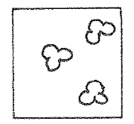

Molecules made of atoms of the same kind

    - A compound made up of molecules consisting of carbon and oxygen
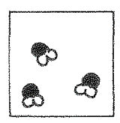

Molecules made of different kinds of atoms. The name we give to this compound is carbon dioxide

Putting it all together
Now we can put together many of the ideas introduced in previous sections to discuss other kinds of situations involving matter.

Pure Substances and Mixtures

A pure substance consists of only one kind of substance which could be an element or a compound. Sub-microscopically it will consist of one kind of molecule (or atom if it exists as atoms).
The above statement can sound confusing as it sounds a bit like the explanation for an element given earlier. It does sound similar but it is not the same! Remember an element consists of only one kind of atom. Thus an element is a pure substance. However a compound can be a pure substance, too. For example, pure water (a compound) consists of only water molecules and these are molecules of a compound which are made up of different atoms, namely of hydrogen and oxygen atoms. The properties of a pure substance are the properties of that particular substance.
In figure 2.12 you can see sub-microscopic representations of 2 pure substances. One is a pure element and the other is a pure compound.

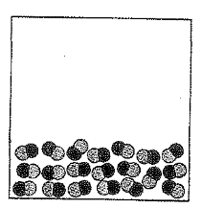
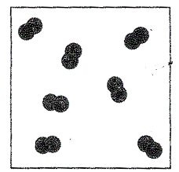
Only 1 kind of molecule present

Figure 2.12: Sub-microscopic representation of some pure substances
A mixture consists of different pure substances which are intermingled (mixed up) but are not chemically bonded. We obtain an example of a mixture if we mix table salt with water. The substances can be mixed in any proportion by mass and they can be separated from each other by physical changes. For example, we can boil off the water in the salt described above to obtain the table salt, as you will do later in this unit. The properties of the mixture will be the properties of the substances which make up the mixture. So the properties of the table salt and water mixture would be the properties of the table salt and the properties of water.
Figure 2.13 below shows sub-microscopic mixtures of some mixtures in the gaseous state.

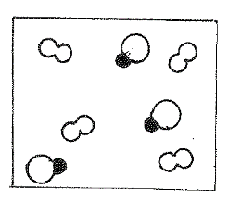
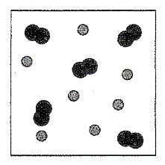

A mixture of a compound and an element
A mixture of two elements

Figure 2.12: Sub-microscopic representations of some mixtures

Macroscopically mixtures may appear homogeneous (uniform) or heterogeneous (non-uniform). Remember you studied these terms in the first section above. In fact, in Activity 2.1 many of the examples used were mixtures. For example, air which is a mixture of mostly nitrogen and oxygen gases appears homogeneous so does table salt dissolved in water. When you look at air, you only see one gaseous phase. When you look at salt dissolved in water you only see one liquid phase. Mixtures which appear homogeneous are also called solutions.

You see only one phase – a liquid phase

Figure 2.13: Diagram showing a homogeneous mixture, e.g. table salt dissolved in water

https://www.google.co.za/search?q=image+salt+water&rlz=1C1GCEA_enZA815ZA815&tbm=isch&tbo=u&source=univ&sa=X&ved=2ahUKEwiMsfumm4HfAhWkLcAKHSRnC9MQsAR6BAgDEAE&biw=1280&bih=610&dpr=1.5#imgrc=zVXEyMv_-ds6uM:

An example of a heterogeneous mixture is a mixture of vinegar and cooking oil is shown in figure 2.14

You see two phases – both liquids

Figure 2.14: Diagram showing a homogeneous mixture, e.g. table salt dissolved in water

https://www.google.co.za/search?q=image+mixture+of+oil+and+water&tbm=isch&tbo=u&source=univ&sa=X&ved=2ahUKEwiF476pnoHfAhVVOMAKHQXQCrEQsAR6BAgDEAE&biw=1280&bih=561#imgrc=BZ034YWOLbmbSM:

ACTIVITY 2.5: Recognising sub-microscopic representations
Look at the microscopic representations a, b, c and d in Figure 2.15 and write short sentences to describe each of the representations. Choose as many words/ phrases from this list to help you in your descriptions:

List of words and terms
solid, liquid, gas
homogeneous mixture, heterogeneous mixture, pure substance,
element, compound

Sub-microscopic representations
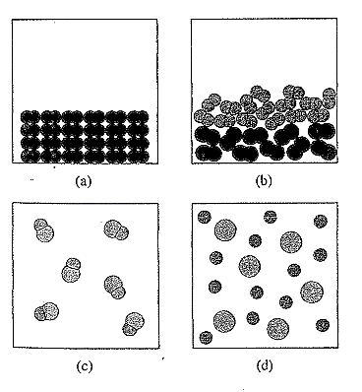

Figure 2.15: sub-microscopic representations for describing

Guided reflection
The three lines of descriptions refer to different ways of describing the representations. Make sure you use them all.

Exemplar answers
Activity 1.7 (The statements in italics are included to help you understand better. They are not necessary in your answer.)
(a) This is a sub-microscopic representation of a solid (the molecules are arranged in a repeating pattern or order and are close together). It is a pure substance (there is only one kind of molecule present). It is an element (the molecules are made up of only one kind of atom).
(b) This is a sub-microscopic representation of the liquid state (the molecules are not arranged in any order but they are close together). It is a heterogeneous mixture (two kinds of molecule are present and macroscopically two liquids would be clearly visible). Both liquids are elements (each liquid is composed of molecules made up of the same kind of atom).
c) This is a sub-microscopic representation of a gas (the molecules are far apart). It is a pure substance (there is only one kind of molecule present). It is a compound (each molecule is made up of two different kinds of atoms).
(d) This is a sub-microscopic representation of a gas (the molecules are far apart). It is a homogeneous mixture of two elements (two kinds of unbonded atoms of different elements are present and macroscopically it would appear as a single gas).

Separating Mixtures
Up to now in this unit, we have looked at elements, compounds and mixtures in a theoretical way. This section looks more closely at mixtures. In real life very few naturally occurring substances are pure and one of the most important skills that chemists have is to separate mixtures to create pure or nearly pure substances. The most important example in everyday life is the purification of drinking water and the manufacture of medicines. Drinking water is not completely pure, but it is a good example of removing unwanted substances to make water safe to drink. In this section you will carry out an activity where you will try to separate mixtures at home. Because you are limited in the equipment you can use, you will not end up with completely pure substances but you will get some idea of how mixtures can be separated.

ACTIVITY 2.6: Separating mixtures
In this activity you will separate a number of homogeneous and heterogeneous mixtures using household equipment. You will be separating the following mixtures:
- Salt and sand
- Iron filings and sand
- Oil and water
- Salt and water
By now you would be able to decide which of these are heterogeneous and which are homogenous mixtures.

What you will need:
You will find the following substances in your kitchen, or if not, they are available from supermarkets. You will need only small quantities of each:
- Table salt - about 2 teasponfuls
- Cooking oil – about 10 ml (two teaspoonfuls)
You will find the following substances outdoors
- Fine sand - about 2 teaspoonfuls – use dry builders’ sand, not soil. If the sand has a lot of chunks it, you should sift those out first using a tea strainer or sieve
- Water – about 100 ml (about a half a cup)
You will also need:
- Iron filings: look in a workshop where people are working with metal. You will find small particles of metal that drop on the floor. Ask for about a matchbox full
- A magnet: You can find magnets in many places – in old speakers, fridge magnets, magnetised screwdrivers or old car alternators. They are also available in toy shops.
- A funnel. If you don’t have one in your home, it is very easy to make one from an old plastic bottle ( see https://www.youtube.com/watch?v=RXcBvSmq5QU )
- You will need a source of heat and a pot. Possibly a stove or a small gas or paraffin stove.

Suggested time
Once you have the required materials, this activity will take about an hour

What you will do
Separating Salt and Sand: Start by making the mixture by combining about 2 teaspoonfuls of salt with 2 teaspoonfuls of sand in a bowl. Examine the mixture carefully. Can you see the white salt particles mixed up with the darker sand particles? The photograph below in figure 2.16 has large grains of salt so you can see them. You can look at your mixture with a magnifying glass if you have one. Alternatively if your phone has a camera you can point the camera at your sample and magnify it.
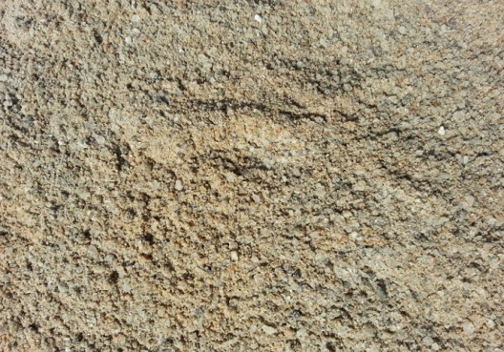

Figure 2.16: Salt and sand mixture
http://www.maple85.com/salt-sand/

Now transfer the mixture to a small jug or glass. Now take about 100ml of water (about half a cup full) and add it to the glass. Stir well with a spoon. Once the sand and salt mixture has been well stirred, leave the glass to stand for about 30 minutes. The sand will sink to the bottom of the glass as shown in figure 2.17
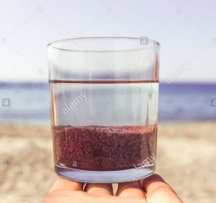

Figure 2.17: Glass with water and sand
https://www.google.co.za/search?q=image+glass+with+sand+and+water&rlz=1C1GCEU_enZA823ZA824&tbm=isch&tbo=u&source=univ&sa=X&ved=2ahUKEwibsMrNxZzfAhWNL1AKHYXABEIQsAR6BAgEEAE&biw=1366&bih=657#imgrc=LrQcoWSyb-w4SM:

If you are very careful, you will be able to pour the water into an empty glass while leaving the sand in the glass. This technique is called decanting.
If your sand is very fine, or it doesn’t sink well to the bottom of the glass, you may need to filter it. To filter the sand, you will need a funnel.
You may either use a funnel if you have one, or one made from a plastic bottle as shown above. You will need to put a filter in the funnel. You may use a coffee filter if you have one or cut a round piece of roller towel and fold it so that it fits in the funnel. See figure 2.18 below.
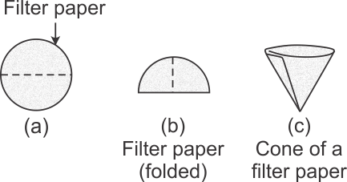

Figure 2.18: Folding Filter paper
https://www.google.co.za/search?q=filter+paper+in+funnel;&tbm=isch&tbo=u&source=univ&sa=X&ved=2ahUKEwih6-myypLfAhUQ2qQKHZIaAQwQsAR6BAgDEAE&biw=1280&bih=610#imgrc=pcSleFRgmP_NIM:

Once you have put the filter paper in the funnel, put the funnel above an empty glass and then you can pour the mixture carefully into the funnel so that the water and salt solution can drip into the glass.

After decanting or filtering, the last step is to remove the water from the salt solution. To do this, pour the salt solution into a frying pan. Put the frying pan on a stove and turn on the stove to heat the mixture. After some time, the water will boil, leaving behind the salt on the pan.
Can you think of a way to trap some of the water vapour?

Separating oil and water:
There are many situations in everyday life where oil is mixed with water and we need to separate them. Car oil can cause pollution when it enters drinking water, so knowing how to separate them is important. There are a number of ways we can try with small quantities.

Make a mixture of cooking and oil and water in a glass. Once they are mixed, can you tell which is the oil and which is the water?
Most oils we use such as car oil and cooking oil is less dense than water. This means that when they mix the water sinks to the bottom. Here are 3 different ways you can try.
- Put the mixture in a plastic drink bottle and make a hole in the bottom of the bottle. Pour the mixture into the bottle while holding your finger over the hole. Hold the bottle over a bowl and release your finger from the hole. Watch carefully as the water comes out and when the water has all run out, close the hole with your finger and turn the bottle upside down and empty the oil into another bowl.
- Freeze the mixture in a freezer (below 0⁰ C). the oil will remain in a liquid state and can easily be separated
- Add salt to the mixture. The salt will dissolve in the water layer. You can then use method number 1 and the separation will work even better. We will find out why in one of the later units.
Click the link below to watch a video which shows how rain water can be removed from car oil.

https://www.youtube.com/watch?v=NagbV9V5ivM

Iron Filings and sand: Make a mixture of the iron filings with sand. Again if the sand is light in colour you may be able to see the iron filings in the mixture. Make a mixture of your iron filings with the sand. We cannot use water to separate these two substances because neither sand nor iron filings dissolve in water. But iron has a property that only some metals have. It is attracted to a magnet. Take a magnet and put it inside a plastic bag. Carefully move the magnet over the mixture and you will see the iron flings start to stick to the magnet. Move the magnet over another container and carefully wipe the iron filings off the plastic bag. Use the link below to see how this is done.

https://www.youtube.com/watch?v=anaCLlmBSzg

Guided Reflection
As you did the activity above you should have seen the relationship between the mixtures you were handling and the sub-microscopic representations done earlier. Some of the mixtures you made were homogeneous (solution of salt and water) and some were heterogeneous (salt and sand and oil with water). Most homogenous mixtures in the liquid state are solutions. On the other hand, gases always form homogeneous mixtures when they mix because their particles are far apart from each other as you found out in unit 1. Finally notice that when we separate mixtures we make use of differing physical properties. For example salt dissolves in water but sand does not. You can therefore see that separating sugar and salt may be a bigger challenge and we may have to find a liquid that would dissolve the sugar but not the salt.

Check your progress
In this unit you have learnt about several different ways of describing and representing matter. You are probably feeling a bit overwhelmed and confused about them all. Don’t worry, you will be using most of these descriptions from time to time as you go through this module of chemistry. As time passes, you will start to feel more conﬁdent about these terms. You may ﬁnd it helpful to start making a glossary to help you understand these words. (A glossary is a simple dictionary or alphabetical list of words and their meanings.) Go back through the unit and identify the terms or words you need to include in your glossary. It would be nice if you could work out a way of keeping the words in an alphabetical list. Maybe you could write the terms on small cards or pieces of paper which you can arrange alphabetically. An example of the way you could describe a term is shown below.

Pure substance - consists of only one kind of substance which could be an element or a compound. Sub-microscopically it will consist of one kind of molecule

Don’t try to memorise these explanations that you have written in your glossary word for word (like a parrot!). Rather make sure you understand the meaning and can explain the terms in your own words even if you need more sentences and words to do so.

The questions that follow will give you more practice in some of the ideas and concepts that you have encountered in this unit. You may be pleasantly surprised to discover how much you have learned already! Detailed feedback is provided at the end of this unit to help you. Don’t peep at these answers too quickly. Rather struggle with the problem for a while (even a couple of days) and check the answer when you have made a real effort to answer the question. If you use answers wisely they can be a valuable tool in learning but if you rely on them too much you won’t be able to think with conﬁdence when there are no answers available (e.g. in an exam).

Summary assessment: Units 1 & 2
Task 1
Look at the following images and say whether the matter they are illustrating is homogeneous or heterogeneous. In each case, explain your decision

d. a mixture of nitrogen gas and oxygen gas
c. a mixture of salt & water
a. A piece of wood
b. a mixture of solid iodine & water

Wood link:
https://www.google.co.za/url?sa=i&source=images&cd=&cad=rja&uact=8&ved=2ahUKEwiuobfEpJrfAhUSbBoKHSJhBzUQjRx6BAgBEAU&url=https%3A%2F%2Fwww.shutterstock.com%2Fsearch%2Fpiece%2Bof%2Bwood&psig=AOvVaw2v6hEO82LVhkbjmlUpz1Jf&ust=1544703875162836

Iodine link:
https://www.google.co.za/url?sa=i&source=images&cd=&cad=rja&uact=8&ved=2ahUKEwi4s96wpprfAhUQnRoKHY_-AMEQjRx6BAgBEAU&url=http%3A%2F%2Fdl.clackamas.edu%2Fch105-03%2Fexamples1.htm&psig=AOvVaw0VKc1GkI4M5OHviFhYhNK7&ust=1544704380511985

Salt water link:
https://www.google.co.za/url?sa=i&source=images&cd=&cad=rja&uact=8&ved=2ahUKEwj0-tqEpprfAhUoxIUKHXwgA0YQjRx6BAgBEAU&url=https%3A%2F%2Fwww.slideshare.net%2Falice_leung%2Fsolution-suspension&psig=AOvVaw3M-k6dUDOLv6c6EL5WwiN1&ust=1544704257652099

test tube link
https://www.google.co.za/url?sa=i&source=images&cd=&cad=rja&uact=8&ved=2ahUKEwiMov-op5rfAhUGx4UKHRCGCCUQjRx6BAgBEAU&url=https%3A%2F%2Fwww.shutterstock.com%2Fsearch%2F%2522empty%2Btest%2Btube%2522&psig=AOvVaw0-FypuGior_bW_M9N21S2j&ust=1544704612970595

Task 2
Draw microscopic representations for each of the following:
- “Dry ice", used by ice-cream sellers to prevent melting is solid carbon dioxide (a compound). Hint: Use this representation for a molecule of carbon dioxide

- The element iodine, which consists of diatomic molecules, sublimes.
- Neon gas, which exists as separate atoms, condenses
- Liquid nitrogen, which is an element consisting of diatomic molecules, evaporates

Task 3
In the following passage, say which statements (labelled a, b, c etc.) relate to physical properties and which relate to chemical properties of the element magnesium?

Magnesium, the eighth most abundant element on earth, is found in rocks, seawater and all living things.

- Magnesium is one of the elements found in the green pigment (called chlorophyll) plants.
- Freshly cut magnesium has a silver coloured shine but becomes dull in air because magnesium reacts with the oxygen
- Magnesium melts at 649°C and boils at 1105°C.
- Magnesium ﬁres cannot be put out with water because the hot metal reacts with water to form hydrogen gas, which is ﬂammable.
- Magnesium produces dazzling white sparks in fireworks
- Magnesium has a density of 1.738 g cm⁻³

Task 4
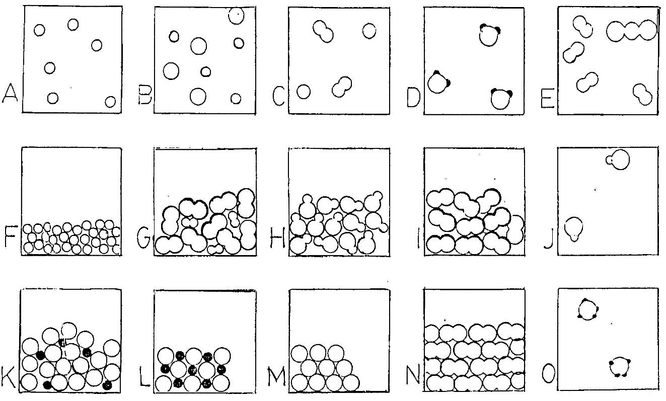
The diagram below shows 15 different sub-microscopic representations. Study them carefully and answer the questions below. For each question, there may be more than one representation that fits.

- Which diagram(s) consist(s) of only one element?
- Which diagram(s) consist(s) of only one compound?
- Which diagram(s) represent(s) a mixture?
- Which diagram(s) represent(s) a pure solid?
- Which diagram(s) represent(s) a pure liquid?
- Which diagram(s) represent(s) a gas?
- Which diagram(s) represent a pure substance?
- Which diagram(s) represent molecules only?

Task 5
We can draw a diagram to show how ideas or concepts are linked or related to each other. These diagrams are called ﬂow diagrams, mind maps or concept maps. These diagrams often help us to organise our ideas and understanding of topics. They help us to construct a framework of knowledge about a topic.

Here is an example of a concept map constructed from a short paragraph. You will notice that the ideas/ concepts are written in boxes (or ovals) and linked with lines. We then write a few words to explain the link between the concepts. We usually start from the more general concepts and move towards the more detailed or specific concepts.

Here is the paragraph:
Animals all have systems. Higher animals and lower animals use systems to perform life activities. Some life activities that both higher and lower animals have are respiration, circulation and digestion. A system found in higher animals is an internal skeletal system. Lower animals do not have bones.

Fig 2.19 shows a possible concept map constructed from this paragraph.
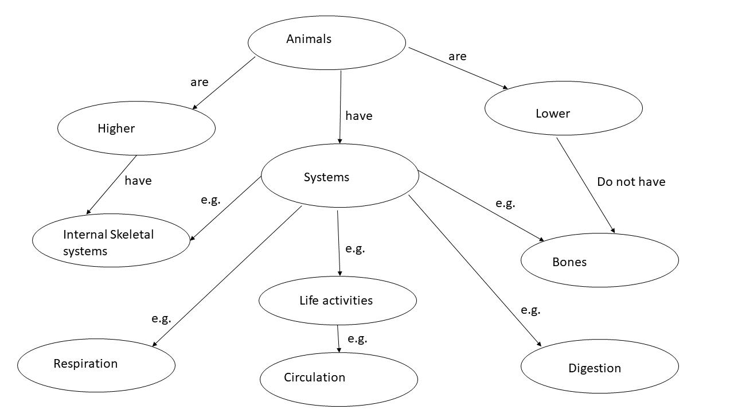
Fig 2.19: A possible concept map

Now try to construct your own concept map showing how you think the following concepts are linked. There is no paragraph this time because these are concepts that you have learnt about in this unit and you should now be able to show a framework of how these concepts are related to each other.

Elements, pure substances, matter, compounds, homogeneous matter, heterogeneous matter, solutions

Key learning points from unit 1 and 2
Now that you have completed the study of units 1 and 2 you should be able to:
- understand broadly what the study of chemistry is about.
- describe matter on a sub-macroscopic scale using the terms homogeneous and heterogeneous.
- recognise the three states of matter (solids, liquids and gases.)
- understand the meaning of the term property and in particular what is meant by physical and chemical properties
- Differentiate between atoms and molecules
- describe and represent matter on a sub-microscopic scale using atoms and molecules.
- understand and use the terms element and compound, pure substances and mixtures.
- construct concept maps to provide the framework of topics and show the interrelationship of concepts in the topic.

Feedback for summary assessment

Answer for task 1

- Heterogeneous. The wood does not appear the same or uniform throughout. Different parts can be seen.
- Heterogeneous. Two distinct phases (states) are clearly visible. Therefore the matter in the test tube is not uniform throughout.
- Homogenous. The salt has dissolved in the water so that only one phase is visible in the test tube and the contents of the test tube appear uniform throughout. This kind of homogeneous mixture can also be called a solution.
- Homogeneous. The gases mix so that the contents of the test tube appear uniform throughout. We only see one phase - a gas. We can also call this homogeneous mixture at solution.

Answer for task 2
Microscopic representations of:
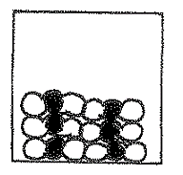

Solid Carbon dioxide

Notice in each of the process shown below there are the same number of particles in the left hand and right hand square
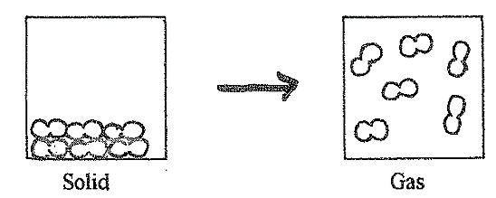

The element iodine subliming

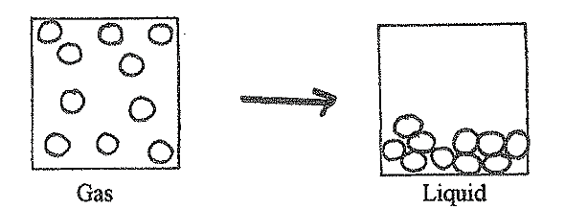
Neon gas condenses

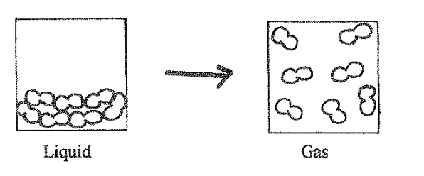

Liquid nitrogen evaporates
Answer for task 3
An explanation is given in italics to help you with your answers.

- A chemical property. (Magnesium will undergo a change or reaction with other substances to form the substance chlorophyll.)
- This sentence describes a physical property (magnesium has a silver shine) and a chemical property (..... becomes dull because magnesium reacts with oxygen). The magnesium on the surface has formed a new substance — a compound - with oxygen. It is called magnesium oxide. (You may not know this at this stage but you will understand it as you continue with this module.)
- These are both physical properties. Although magnesium melts and boils it is still the substance magnesium.
- Two chemical properties of magnesium are described. A magnesium ﬁre is caused when magnesium burns and combines with oxygen. “The hot metal reacts with water etc.” also describes a chemical change or reaction of magnesium to form new substances - magnesium oxide and hydrogen.
- This is a description of a chemical change. The magnesium reacts with oxygen in the air to form a new substance (a compound) called magnesium oxide. During this reaction a lot of bright white light is produced.
- This is a physical property of magnesium. It describes the relationship between the mass of magnesium and the volume it occupies. The magnesium is not changing into a new substance. It remains as magnesium.

Answer for task 4
The questions are shown together with the answers
- Which diagram(s) consist(s) of only one element? A, F,I,M,N
- Which diagram(s) consist(s) of only one compound? D,H,J,L,O
- Which diagram(s) represent(s) a mixture? B,C,E,G,K
- Which diagram(s) represent(s) a pure solid? L,M,N
- Which diagram(s) represent(s) a pure liquid? F,G,H,I,K
- Which diagram(s) represent(s) a gas? A,B,C,D,E,J O
- Which diagram(s) represent a pure substance? A,D,F, H,I,J,L,M,N,O
- Which diagram(s) represent molecules only? D, E, G, H, I, J, N, O

You may find L confusing. It represents a compound in the solid state. The Black and white shaded atoms are regularly arranged and they are there in equal numbers so it represents a compound and a pure substance

Answer for task 5
There are usually a number of different concept maps that can be drawn for a topic, s more than one answer may be correct. Here is a suggestion for a concept map for the topic
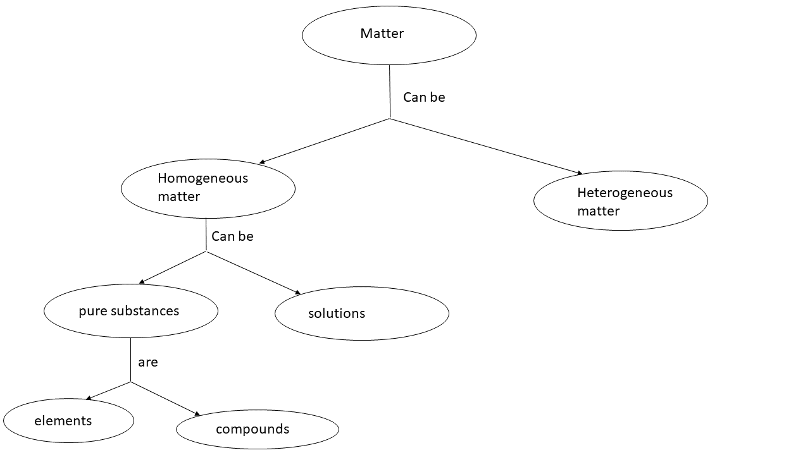

Unit 3: Atomic Structure

Outcomes
By the end of this unit, you should be able to
- Explain the arrangement of elements on the periodic table in terms of metals, metalloids and non-metals;
- Give an account of the history of atomic theory
- List the subatomic particles (electrons, protons and neutrons), their charges and location within an atom;
- Draw simple atomic models to represent atoms in terms of their subatomic particles.

Not all Tony Lelliott’s revisions included

Introduction to unit 3
In Unit 2, we focused on the nature of matter. We discussed elements and compounds and looked at the nature of matter sub-microscopically dealing with atoms and molecules. In this unit, we will look at the structure of atoms in more detail and try to ﬁnd out in what way atoms of the elements are different. You will also learn the names of some elements and their symbolic representations.

Elements aren’t what they used to be!
The names and symbols for the elements that we use today are very different from those used in the early days. Ancient Greek philosophers believed that there were four elements, namely earth, air, fire and water! The philosophers thought that everything was made up of these four elements For instance when a substance burned and ﬂames became visible, they thought that the fire part of the object was escaping! hey believed that ﬁre was a substance. Figure 3.1 shows the symbols used to represent the four elements at about 400 BCE.
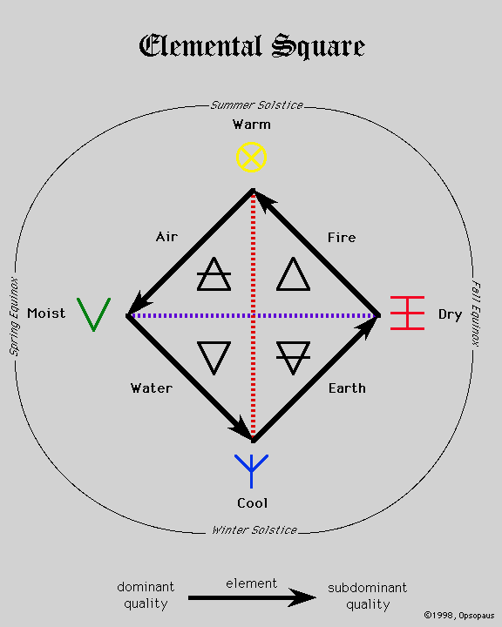

Figure 3.1 symbols used to represent the four elements
http://opsopaus.com/OM/BA/AGEDE/images/elemsquare.gif

We can laugh at the Greek philosophers’ ideas about elements but in those days, they did not have the knowledge that we have today. They tried to make sense of what they saw around them but they did not carry out any experiments and based all their ideas on reasoning or thinking. From about 1 BCE and for about 1 500 years, early chemists or alchemists as they were called, inﬂuenced ideas about the nature of matter. Alchemists tinkered around carrying out all sorts of experiments mostly in an effort to try and ﬁnd a potion (or medicine) that would make it possible to stay young forever! They also searched for ways of converting everything around them into gold. This was because there was a common belief at that time that everything in life should tend towards perfection. Some of them probably blew themselves to bits causing explosions or poisoned themselves with toxic gases, as they did not understand what they were doing! Alchemists caused lots of confusion and promoted ideas of magic, which were difficult to replace but they did begin the process of experimentation.
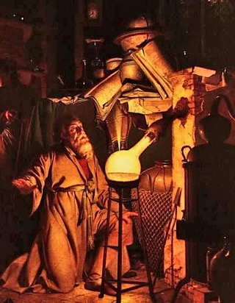

Figure 3.2: an Alchemist at work
(http://www.wikiwand.com/en/Thomas_de_Ashton_(alchemist) )

The alchemists developed processes such as the separation of substances and they designed pieces of apparatus that are still in use today. It was only about 200 years ago that the nature of the elements and the structure of atoms and molecules began to emerge because of experiments involving measurements. Scientists began to agree on the names and symbols for the elements as we know them today. You learnt the symbols for some elements in unit 2. In the “Nature of Science” section of this Natural Sciences course, you learnt that science involves experiments and ideas develop through agreement between scientists. Scientists do not always have the correct ideas and their understanding of matter and events develops with time. You may like to try to read and ﬁnd out more about the alchemists either in a library or on the internet.

Use the text above and some of your understanding from unit 2 in the next activity.

Activity 3.1: Elements

1. The Greek philosophers thought that earth and air were elements. How would you describe earth and air?
2. The alchemists spent a lot of time doing things that hindered the progress of chemistry. Write a few sentences describing some of the futile (time-wasting activities) performed by alchemists.
3. Write a few sentences describing some of the activities of the alchemists that were of value to modern day chemistry

Guided Reflection
Do not worry if you have not used exactly the same words or order of points as given in the suggested answer below. There are many different ways of writing correct answers. The important thing is to mention most of the same ideas.
1. Today we would consider the earth and the air as mixtures of substances. In unit 2, we discussed that air was a homogeneous mixture of substances, mainly the elements nitrogen and oxygen.
The earth is a mixture of many substances e.g. sand, remains of old vegetation etc. These substances are probably mostly compounds which are made up of many different elements such as carbon, silicon etc. (There may be many other good ideas that you have mentioned here.)
2. The alchemists wasted their time trying to ﬁnd a medicine that would provide eternal youth. They also wasted time trying to ﬁnd a way of turning everything into gold.
3. Alchemists started the idea of experimentation, which is crucial to chemistry nowadays. They also designed some of the kinds of apparatus that are still in use today. In addition, some of the processes for separating substances are still used by chemists in modern times.

A closer look at the elements
You may remember that in Unit 2 we said that elements are the simplest kinds of substances and that each element is made up of the same kind of atoms. We also said there are about 118 different elements. We say about because scientists are making new elements in laboratories although they do not last long and break up easily into other more stable elements. It is interesting to note that most elements are metals which we usually recognise by being shiny and hard (e.g. gold and copper). Far fewer elements are non-metals such as oxygen or carbon. Very few elements exist as free elements - most of them have combined with each other to form millions of different compounds. We can regard the elements as being like the letters of the alphabet. There are only 26 letters in the alphabet but millions of words that can be made from these letters. Compounds are like the words. Although there are 118 elements, millions of compounds can be made from them.

You may be interested to find the names of all the elements and learn more about them. The link below will take you to a periodic table of the elements (more about this below). If you click on the link below, you will reach a page where you can see all the elements. If you are using a computer, you will be able to run your mouse over the element symbol (e.g. Na) and see its name. If you are using a mobile device such as a tablet or a phone, you can click on the element and you will reach a video. Without opening the video, you will be able to see the name of the element, so no need to waste data! If you want to click on an element, you will learn lots about it, as in unit 3 where we referred you to carbon, hydrogen and oxygen.

http://www.periodicvideos.com/

Here is a list of all 118 elements showing their symbols and names in order of atomic number (you will learn what this means later).

Numbers 1-30 | Numbers 31-60 | Numbers 61-90 | Numbers 91-118
1 - H - Hydrogen  2 - He - Helium  3 - Li - Lithium  4 - Be - Beryllium  5 - B - Boron  6 - C - Carbon  7 - N - Nitrogen  8 - O - Oxygen  9 - F - Fluorine  10 - Ne - Neon  11 - Na - Sodium  12 - Mg - Magnesium  13 - Al - Aluminium  14 - Si - Silicon  15 - P - Phosphorus  16 - S - Sulfur  17 - Cl - Chlorine  18 - Ar - Argon  19 - K - Potassium  20 - Ca - Calcium  21 - Sc - Scandium  22 - Ti - Titanium  23 - V - Vanadium  24 - Cr - Chromium  25 - Mn - Manganese  26 - Fe - Iron  27 - Co - Cobalt  28 - Ni - Nickel  29 - Cu - Copper  30 - Zn - Zinc | 31 - Ga - Gallium  32 - Ge - Germanium  33 - As - Arsenic  34 - Se - Selenium  35 - Br - Bromine  36 - Kr - Krypton  37 - Rb - Rubidium  38 - Sr - Strontium  39 - Y - Yttrium  40 - Zr - Zirconium  41 - Nb - Niobium  42 - Mo - Molybdenum  43 - Tc - Technetium  44 - Ru - Ruthenium  45 - Rh - Rhodium  46 - Pd - Palladium  47 - Ag - Silver  48 - Cd - Cadmium  49 - In - Indium  50 - Sn - Tin  51 - Sb - Antimony  52 - Te - Tellurium  53 - I - Iodine  54 - Xe - Xenon  55 - Cs - Caesium  56 - Ba - Barium  57 - La - Lanthanum  58 - Ce - Cerium  59 - Pr - Praseodymium  60 - Nd - Neodymium | 61 - Pm - Promethium  62 - Sm - Samarium  63 - Eu - Europium  64 - Gd - Gadolinium  65 - Tb - Terbium  66 - Dy - Dysprosium  67 - Ho - Holmium  68 - Er - Erbium  69 - Tm - Thulium  70 - Yb - Ytterbium  71 - Lu - Lutetium  72 - Hf - Hafnium  73 - Ta - Tantalum  74 - W - Tungsten  75 - Re - Rhenium  76 - Os - Osmium  77 - Ir - Iridium  78 - Pt - Platinum  79 - Au - Gold  80 - Hg - Mercury  81 - Tl - Thallium  82 - Pb - Lead  83 - Bi - Bismuth  84 - Po - Polonium  85 - At - Astatine  86 - Rn - Radon  87 - Fr - Francium  88 - Ra - Radium  89 - Ac - Actinium  90 - Th - Thorium | 91 - Pa - Protactinium  92 - U - Uranium  93 - Np - Neptunium  94 - Pu - Plutonium  95 - Am - Americium  96 - Cm - Curium  97 - Bk - Berkelium  98 - Cf - Californium  99 - Es - Einsteinium  100 - Fm - Fermium  101 - Md - Mendelevium  102 - No - Nobelium  103 - Lr - Lawrencium  104 - Rf - Rutherfordium  105 - Db - Dubnium  106 - Sg - Seaborgium  107 - Bh - Bohrium  108 - Hs - Hassium  109 - Mt - Meitnerium  110 - Ds - Darmstadtium  111 - Rg - Roentgenium  112 - Cn - Copernicium  113 - Nh - Nihonium  114 - Fl - Flerovium  115 - Mc - Moscovium  116 - Lv - Livermorium  117 - Ts - Tennessine  118 - Og - Oganesson

Many of the names are quite complicated but RELAX - you do not need to learn all of them! Later on, we will show you the names you should know and remember. If you look at the list, you will see that scientists use symbols (one or two letters) to represent each element. You will remember at the beginning of unit 1 we introduced you to symbolic representations. Here we are beginning to learn about symbolic representations. Symbols make the writing of the names of substances easier. For example, the element hydrogen is represented by the symbol H, and the element phosphorus is represented by the symbol P. Often the symbol is the ﬁrst letter of the name we use for the element. However, the symbols for some elements come from their Greek or Latin names. For example, the element potassium is represented by the symbol K from the Greek name for potassium which is kalium. Sometimes two letters are used for an element e.g. the symbol for calcium is Ca and the symbol for mercury is Hg from the Latin name hydragyrum which means liquid silver. When we use two letters for an element, the ﬁrst letter is written as a capital (upper case) and the second letter as a small letter (lower case).

Activity 3.2 will give you some practice in using the list of elements.

Activity 3.2: symbols and names of the Elements
- Write the symbol for each of the following elements:
Nitrogen, neon, nickel, gold, lead, tin
- Write the names for the following elements represented by the symbols below:
Ag, I, Br, Si, Fe, Cs

Guided Reflection
If you looked carefully through the list above, you will have found the following answers:
- Symbols are shown in brackets for the following elements:
Nitrogen (N), neon (Ne), nickel (Ni), gold (Au), lead (Pb), tin (Sn)
- The names are shown in brackets for the following symbols:
Ag (silver), I (iodine), Br (bromine), Si (silicon), Fe (iron), Cs (caesium)

You may find some of the elements with American spelling but we will use the spelling agreed by the International Union of Pure and Applied Chemistry (IUPAC). This is an example of how scientists establish agreement, which we talked about earlier in this unit.

The Periodic Table of the Elements
To make working with all these elements easier, scientists have classiﬁed the elements into a table known as the Periodic Table of the Elements. In this table, the elements are represented by their symbols. We will study this table more carefully in Unit 4 of this module but we can use it now to look at the names and symbols of the elements. Textbooks have slightly different versions of this table but we will use the table in the form shown below in Fig. 3. 3

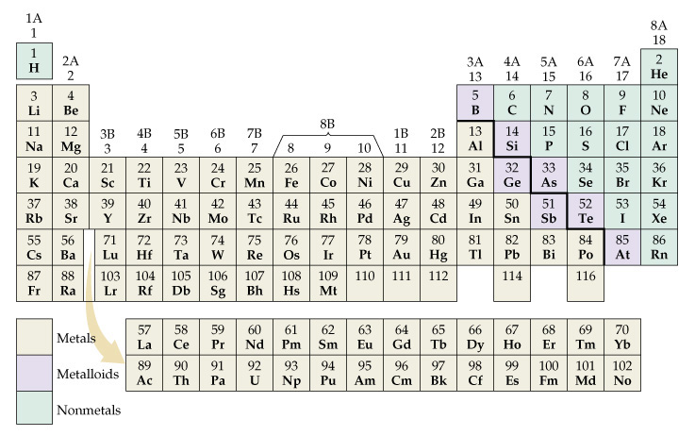

Figure 3.3: The Periodic Table of the Elements
https://www.google.co.za/search?q=periodic+table+of+elements+showing+metals+and+nonmetals&tbm=isch&tbo=u&source=univ&sa=X&ved=2ahUKEwjtkpXHhKTfAhUCxhoKHcNSDdUQsAR6BAgCEAE&biw=1920&bih=969#imgrc=dOx4E64Z0Adz4M:

You can see a stepped dark line on this table, which divides the elements broadly into metals and non-metals. The elements in the table to the left of the line are the metals and those to the right are the non-metals. There is a third group called metalloids. Metalloids are close to the dark line and on both sides of it, for example, boron (B), silicon (Si) and germanium (Ge). These elements may show behaviour of both metal and non-metals. Use the table and the list of elements given above for activity 3.3.

Activity 3.3: Identifying metals and non-metals
Are the following elements metals or non-metals?
strontium, fluorine, aluminium, sodium, sulfur, manganese, cadmium

Guided Reflection
The metals lie on the left hand side of the dark line. An important reason for this exercise is to get you used to the names and position of some of the elements as well as their names and symbols. See if you got these answers right.
Metals: strontium, aluminium, sodium, manganese, cadmium
Non-metals: fluorine, sulfur

The Structure of atoms

Some History about the Discovery of Atoms
Earlier in this unit, you learnt about Aristotle’s four elements. There was another group of Greek philosophers in ancient times led by Leucippus and Democritus, before Aristotle in the 5th century BCE who believed in the philosophy of atomism, meaning they believed and reasoned that matter was made of atoms. Aristotle disagreed with the idea of atomism and his ideas dominated for another 2000 years until a scientist named Dalton put forward his theory in the early 1800s.
Dalton who lived from I766 - I844, was the son of a poor weaver; he attended a small country school in England, and by the age of 12 became a teacher of mathematics. You can read more about him by downloading a little booklet about his life from
https://www.stem.org.uk/resources/elibrary/resource/26850/dalton-and-atomic-theory
You will need to register at the download site.
From many experiments that he conducted, he suggested the following ideas about atoms:
- All matter consists of atoms, which are small indivisible particles.
- Atoms cannot be created or destroyed
- Atoms of a particular element are alike
- Atoms of different elements are not the same
- A chemical reaction involves the bonding together or separation of atoms
- Compounds result from the combination or bonding of atoms of different elements in different ratios

Some of these ideas have changed a little and we will discuss that later. However, Dalton put some fundamental ideas about atoms into place. Dalton pictured the atom in his mind as a solid sphere. In other words, Dalton proposed a model of the atom as being like a solid sphere. A model is a mental picture of what we believe something (e.g. an atom) is like, based on the interpretation of experimental results. We often make drawings or representations of these mental pictures.

In this unit, we will use a simple model of the atom, but one which is a little more recent than Dalton’s atom. In the “Nature of Science” module, you learnt that the ideas of science are constantly changing. After Dalton’s important suggestion of the atom as the building block of matter, ideas about the atom began to change quite quickly over the next 100 years based on experiments done by different scientists. Some of the most important discoveries were:

- Atoms were not solid spheres but were made of smaller particles.
- JJ Thomson discovered one of those smaller particles about 60 years after Dalton. The particle was a small negatively charged particle called an electron. You can see that the word electron is similar to the word electricity and in fact, the two ideas are very closely connected.
- Once scientists realised that atoms contained electrons they realised that there should be a positively charged particle in the atom to balance the negative charge of the electron, they named this positively charged particle, the proton.
- After the discovery of the proton and the electrons there was a lot of debate about how the electrons and protons were arranged in the atom. Thomson put forward a theory known as the plum pudding theory. He pictured the atom as shown in figure 3.4 below:
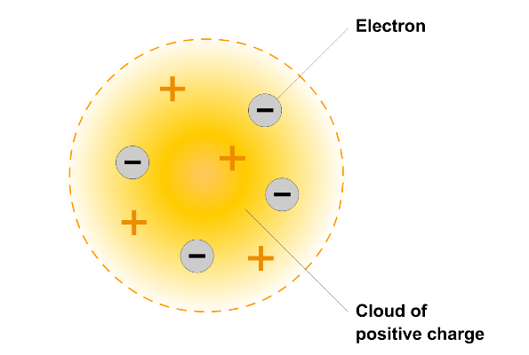

Figure 3.4 Thomson’s plum pudding model of the atom
https://www.absorblearning.com/chemistry/demo/units/fullscreen.html?src=media/LR301301c.swf&title=undefined&w=320&h=256
Thomson’s theory was quite popular but it had to compete with other theories. At that time, no one could prove which one was correct, as there were no experiments done. About 10 years later Ernest Rutherford and two of his students conducted a historical experiment that changed ideas at the time to provide a general picture of the structure of the atom.
Rutherford and his students made a very thin sheet of gold foil and used positively charged particles (called alpha particles) as bullets which they fired at a piece of gold foil. If the plum pudding theory had been correct, they would expect the particles to go straight through the positive charge spread through the atom. However, they were very surprised to find that some of the alpha particles when straight through but a few of them bounced right back as if they had hit something solid. They concluded that atoms were mostly empty space with a solid positively charged nucleus in the centre of the atom and electrons orbiting around the outside.

Activity 3.4: Simulation of Rutherford’s experiment
Try the simulation below to see how the experiment worked.
https://phet.colorado.edu/en/simulation/rutherford-scattering

When you open the simulation, you will find two options as shown in figure 3.5. The right hand option shows the plum pudding model that was the atomic model accepted by most scientists at the time. The left hand option, called the Rutherford atom in the simulation shows the new model of the atom constructed by Rutherford and his team. The simulation allows you to see what happens to the alpha particles as they pass through the two options.
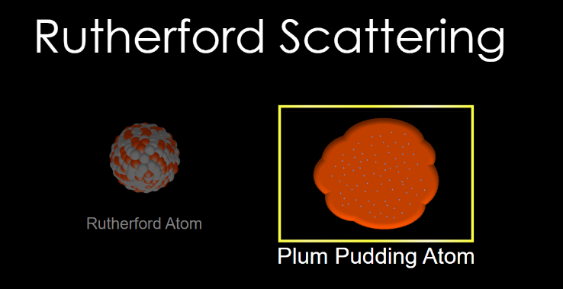

Figure 3.5: Screen shot of opening screen of the Rutherford scattering simulation
Begin by selecting the plum pudding atom and tick the box labelled traces to the right of the atom. Click on the blue button above Alpha Particles (on the left). Watch the traces and then pause the simulation. You should see the image in figure 3.6:
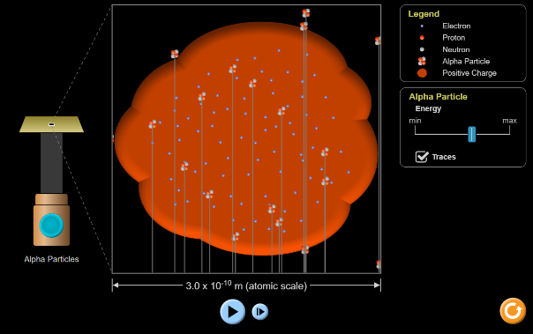

Figure 3.5: Screen shot of simulation of alpha particles going straight through the plum pudding atom

Notice the alpha particles going straight through the atom.

Now click on the Rutherford atom at the bottom of the screen. Again, tick the box traces under alpha particle. On the top left corner select atomic scale. Press the blue button for alpha particles. Watch the traces and then pause the simulation. You should see the image in figure 3.6.

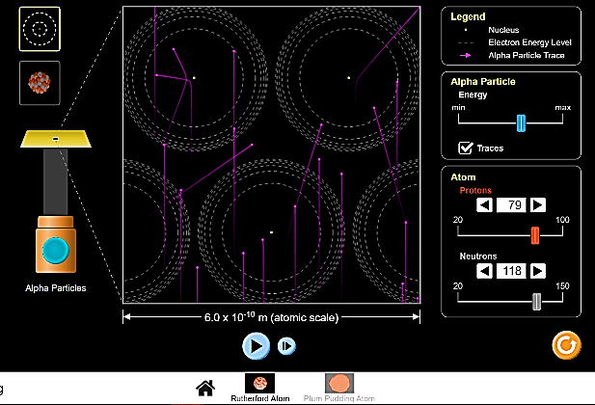

Figure 3.5: Screen shot of simulation of alpha particles going straight through the Rutherford atom

You can spend some time changing the options in the simulation to learn more.
For example, try using the nuclear scale which only shows the nucleus (choose the traces option)

Guided Reflection
The simulation using the plum pudding atom shows a very different pattern to the Rutherford atom. In the case of the plum pudding atom, the alpha particles go straight through showing no effect from the charges in the atom. This was not what Rutherford’s team observed.
In the case of the Rutherford atom, many of the alpha particles pass through the atom but some are bending back. This suggests that there is mostly empty space in the atom with a large positively charged nucleus. The large positively charged nucleus repels the alpha particles because they are both positively charged and like charges repel each other. The repulsion causes the alpha particles to bounce back. The alpha particles that go straight through are entering the empty space in the atom.
When Rutherford’s team detected the particles that bounced back, they were very surprised. Their results led them to create a new model for the atom, called the Rutherford model in this simulation.
When you choose the nuclear scale option, any alpha particles that go near the nucleus are diverted.

You can also watch a video by clicking on the link below to see how the experiment was done.
https://www.youtube.com/watch?v=XBqHkraf8iE

The Structure of the Atom based on Rutherford’s ideas
You will see later that Rutherford’s ideas were modified further after more experiments, but the basic structure and location of the charges are still useful. According to Rutherford, an atom is an incredibly small, spherical particle with a mass of about 1 x 10⁻²⁶ kg. If I write that number as a decimal it looks like this:
0.00000000000000000000000001 kg
A very small number! It is such a small number that for convenience we call it 1 atomic mass unit (amu).
The diameter of the atom is about 1 x 10⁻¹⁰m, also very small. In the centre of the atom there is a hard core called the nucleus. Around the nucleus there are smaller particles called electrons, which move like planets around the sun. The path of these electrons gives the atom its volume. The electrons have a negative electrical charge and we represented it as e⁻. The nucleus itself consists of particles called protons and neutrons. Protons have a positive electrical charge equal in size but opposite in sign (or nature) to the charge on the electron. The size of the charge on an electron (or proton) is 1.6 x 10⁻¹⁹ C. The C stands for coulomb, which is the unit of charge, which you should have seen in the physics module. We represent protons as p⁺. In chemistry, we consider this charge as 1+ for the proton and 1- for the electron. In a neutral atom, the number of protons and electrons must be equal. The neutrons are the same size as the protons but have no charge. We represent them as n⁰. The number of neutrons in an atom is not necessarily the same as the numbers of protons or electrons as we will see a little later. We use the term sub-atomic particles when referring to protons, neutrons and electrons.
As you saw in the simulation, the nucleus of an atom is very small in relation to the total volume of the atom. If you look at figure 3.6, which shows the general structure of an atom, you will see that the diameter of the nucleus is about 10,000 times smaller than the diameter of the atom. When we draw an atom on paper, we cannot show the relative sizes correctly. Even a small dot made with a very sharp pencil is too large in relation to the circles we draw to show the diameters of atoms.

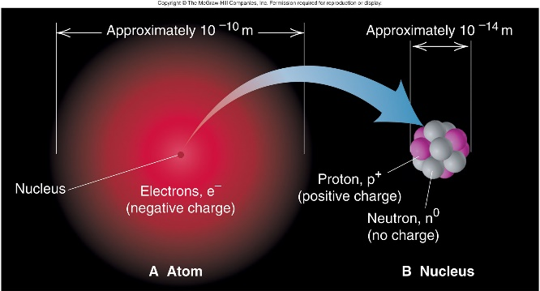

Figure 3.6: General features of the atom today
From Silberberg, M.S. Chemistry, the molecular nature of matter and change, Boston: McGraw-Hill
Fig 2.7 page 52
(This picture is definitely copyright but I cannot find a similar illustration through googling which does quite what this one does)

If you want to get an idea of the relationship between the diameter of the nucleus and the diameter of an atom, imagine a little insect called a ladybird whose length is about 1 cm, shown in figure 3.7.

Figure 3.7: a ladybird
https://www.google.com/search?rlz=1C1GCEA_enZA815ZA815&biw=1920&bih=969&tbm=isch&sa=1&ei=on0XXJ-eBMTxxgP6wYDICA&q=image+ladybird&oq=image+ladybird&gs_l=img.3..0j0i8i30l4.803372.806069..808825...0.0..0.211.1615.0j3j5......0....1..gws-wiz-img.......0i30j0i5i30.rMqGE-FanQQ#imgrc=bqrWovE6UmkaWM:

Now imagine this insect sitting in the middle of a soccer ﬁeld, which is 100 m long. This is more or less the relationship between the diameters of the nucleus (ladybird) and the atom (soccer field).

The density of the nucleus is 1 x 10¹³ g cm⁻³ !
To get an idea of how enormous this density is, imagine that if the nucleus were the size of a full stop (.) on this page, then it would have the mass of equal to that of 50 medium sized motor cars! Imagine a full stop that has the mass of 50 cars!
You don’t have to remember all these values numbers for mass, charge etc., you will be given these values if you need them in calculations.
So now, you will realise that the atom consists of mostly space in which small electrons move around a very small, very hard and very dense central nucleus. (In physics, you may learn about all sorts of other particles that make up the atom. However, for most of the situations faced by the chemist it is usually sufﬁcient just to consider the protons, neutrons and electrons.)
We will ﬁnd out more about the masses of the protons, neutrons and electrons in the following activity.

Activity 3.5: masses of sub-atomic particles
Use the data (information) given to you below to answer the questions that follow.
Data:
Mass of a proton = 1.673 x 10⁻²⁷ kg
Mass of a neutron = 1.675 x 10⁻²⁷ kg
Mass of an electron = 9.109 x 10⁻³¹ kg

- How do the masses of the proton and the neutron compare?
- How do the masses of an electron and proton compare?

Guided Reflection
When looking at such small numbers you need to remember that 10⁻³ means 1/10³ which is 0.001. Look back at the mass of an atom written out in full. This means that the bigger the negative number in the power of 10, the smaller the number. Therefore, the mass of an electron is much smaller than the masses of the proton and the neutron.
- The masses of the proton and the neutron are almost the same. They differ only in the last number quoted. (We call this last number a significant figure)
- The proton has a much bigger mass than the electron; Infant fact if we divide the mass of the proton by the mass of the electron we find the mass of a proton is 1837 times bigger than that of an electron. Therefore, when we consider the mass of an atom we will only take into account the masses of the protons and the neutrons. We will ignore the masses of the electrons.

Using the idea of atomic mass units and charge you will find the table below useful to summarise what we have learnt above about the atom.

Table 3.1 Summary of information about the atom
Sub-atomic particle | Mass (amu) | Charge (Number of charges) | Location
Proton | 1 | 1+ | Nucleus of atom
Neutron | 1 | 0 | Nucleus of atom
Electron | 1/1837 (0.00054) | 1- | Outside nucleus

So you can see that the masses of the neutron and protons are similar while the charges of the proton and electron are equal and opposite.
You will find a revision exercise after unit 4

Key learning points from unit 3
Now that you have completed the study of unit 3, you should be able to:
- Find the names and numbers of 118 elements from a list and the periodic table
- Identify metals, non-metals and metalloids on the periodic table
- Tell the story of how the modern atom evolved from the ancient Greeks to Rutherford.
- Describe how experimental evidence helps us change ideas in science
- Explain how models help us understand objects we cannot see with our eyes
- List the subatomic particles (electrons, protons and neutrons), their charges and location within an atom;
- Draw simple atomic models to represent atoms in terms of their subatomic particles.

Relevant parts of:
https://opentextbc.ca/chemistry/chapter/2-3-atomic-structure-and-symbolism/
https://opentextbc.ca/chemistry/chapter/2-5-the-periodic-table/

Unit 4: Periodic Table

Outcomes
By the end of this unit, you should be able to
- Explain mass number and atomic number
- Explain the term isotope
- Calculate the number of neutrons in atoms of different elements, using the mass and atomic numbers of each element.
- Explore the history of the periodic table
- Explain the arrangement of elements on the periodic table in terms of increasing atomic number and number of valence electrons from left to right across a period; increasing number of shells from top to bottom down a group;
- State the chemical symbol when given the name, or the name when given the symbol, for the first 20 elements of the periodic table as well as some transition metal elements;
- State the names given to group 1 and 2 metals and groups 17 and 18 non-metals in the periodic table;
- Draw Lewis dot diagrams and aufbau diagrams for the first 20 elements of the periodic table;
- Given a particular aufbau diagram or Lewis dot diagram, identify the specific element(s)
- Represent the first 20 elements of the periodic table using spectroscopic electron configurations;
- Identify the specific element(s) represented by a particular spectroscopic electron configuration;

Introduction to unit 4
In the last unit, you learnt about the elements and their arrangement on the periodic table. You also learn the names of some of the elements. You also learnt about the history of the development of the atom and the major discovery made by Rutherford leading to the basic structure of the atom. In this unit, we will open up the atom further and see how the structure of atoms is linked to the arrangement of different elements on the periodic table. We will also learn more about the periodic table and how its structure helps us learn more about the behaviour of the elements.

Atomic Number
In unit 3, you learnt about Dalton and how he worked out that all matter was made of atoms and that atoms of different elements were not the same. Dalton believed that all atoms of the same element had had the same mass. He called this mass, atomic mass. Dalton was able to measure atomic mass but he could not explain what was inside the atom and so he came to some wrong conclusions about how atoms combined to form molecules. For example, he thought a molecule of water was composed of one atom of hydrogen combined with one atom of oxygen and gave its formula as HO. Today everybody knows that water is H₂O. Do you remember our joke about dihydrogen monoxide in unit 2?
After learning about the structure of the atom, we are now able to answer the question, what makes the elements different from one another?
It is the number of protons in the nucleus of the atoms of each element that makes them different. Atoms of different elements have different numbers of protons in their nuclei. For example, an atom of the element hydrogen has 1 proton in its nucleus and an atom of oxygen has 8 protons in its nucleus. In a neutral atom of an element, the number of electrons will be the same as the number of protons. This is because protons and electrons have equal but opposite charges.
In chemistry, the behaviour of the electrons in the atoms of elements is very important. The arrangement of the electrons determine much of the chemistry of the elements. Their behaviour is affected by how many electrons there are, how they are arranged and how strongly they are attracted by the nucleus. This is what makes the properties of the elements different.
The number of protons in an atom of an element is called the atomic number of that element. If you look back at the Periodic Table figure 3.3 of unit 3, you will notice that the atomic number for each element is above the symbol for each element in the table. You will also notice that in the periodic table the elements are arranged according to increasing atomic number, e.g.
Atomic Number
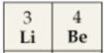
symbol

So Li is the symbol for the element lithium and its atomic number is 3. Be is the symbol for beryllium and its atomic number is 4. The atomic number tells you which element we are talking about.

Charged Atoms or Ions
In an electrically neutral atom, the number of protons equals the number of electrons so that there is no overall charge. For example if we look at the periodic table we can work out that in a neutral lithium atom (the symbol for lithium is Li) there are 3 protons (or 3p⁺) and 3 electrons (or 3e⁻). Therefore, the overall charge on the Li atom is 0. If an electron leaves the neutral lithium atom there will be a proton in the nucleus whose positive charge is not balanced or cancelled out by an electron. Therefore, the atom will have an overall positive charge. We call an atom that has a positive charge a cation (pronounced like two separate words, cat ion). We can show these ideas mathematically by adding the charges like this:

Charges for Neutral Li Atom  3 + (3 protons)  3 - (3 electrons)  0 (no overall charge) | Charges for Li Cation  3 + (3 protons)  2 – (2 electrons)  1 + (overall positive charge of 1)
We represent the neutral atom as Li and the cation with a positive charge as Li⁺.

If a neutral atom gains an electron there will be an extra negative charge that is not balanced by the positive charges of the protons in the nucleus. Therefore, the atom will have an overall negative charge. We call an atom that has a negative charge an anion (pronounced like two separate words, an ion). Let’s consider a neutral ﬂuorine atom and a negatively charged ﬂuorine ion. First, we have to use the periodic table (figure 4.1 below) to check how many protons the ﬂuorine atom (symbol F) should have. If you look at figure 4.1, the atomic number of fluorine is 9.

Then we can show these ideas mathematically by adding the charges like this:
Charges for Neutral F Atom  9 + (9 protons)  9 - (9 electrons)  0 (no overall charge) | Charges for F Anion  9 + (3 protons)  10 – (10 electrons)  1 - (overall negative charge of 1)
We represent the neutral fluorine atom as F and the anion with a negative charge as F⁻.
Atoms of elements may gain or lose more than one electron. For example, a sulfur anion S²⁻ has gained 2 extra electrons and an aluminium cation Al³⁺ has lost 3 electrons.
You may wonder whether atoms can also gain and lose protons.
The answer is that protons cannot be lost and gained during a chemical reaction. Electrons are involved in chemical reactions. Electrons can leave atoms or be gained by atoms (or later on, you’ll see that they can even be shared by atoms). But the numbers of protons and neutrons are not changed during these chemical reactions. The numbers of protons and neutrons can change during a nuclear reaction. These reactions do take place but not under the conditions in ordinary chemistry laboratories. Nuclear reactions have to be done in special laboratories where great care is taken to protect people from the harmful energies that are released during such reactions.

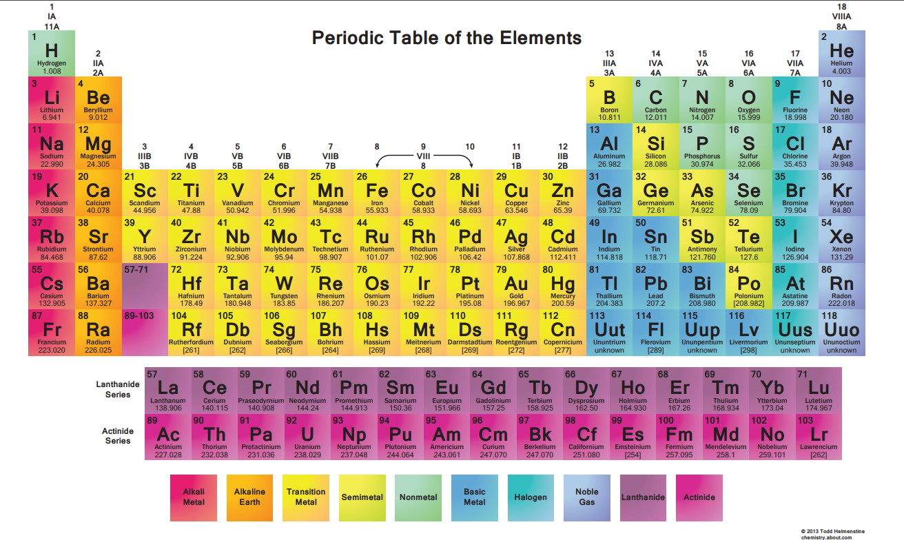
Now let’s give you some more practice working out how many protons and electrons there are in various ions. You will need to look at the Periodic Table to check the symbols and atomic numbers for the elements. Figure 4.1 shows a new periodic table with more detail than you had in unit 3.
Figure 4.1: Periodic table with atomic masses
https://0.tqn.com/z/g/chemistry/od/homeschool-chemistry/l/PeriodicTable.pdf

Activity 4.1
Complete the following table:
Name of element | Symbol of ion or atom | Number of protons | Number of electrons
helium | He
bromine | Br⁻
sodium | Na⁺
oxygen | O²⁻
calcium | Ca²⁺
 | N³⁻
 |  | 12 | 12
 |  | 13 | 10
Remember there is a table in unit 3 that tells you the names of the elements with their symbols

Guided Reflection
For the first 5 rows you have the name of the element and the symbol with the correct charge. Only helium is not an ion. If you look on the periodic table, the atomic number is on the top left hand corner of the block. So helium has atomic number of 2. You can see it on the top left corner. So the number of protons is 2 and so is the number of electrons.
For an example of a cation (positive ion) let us look at Ca²⁺. You will find Ca at number 20, so its atomic number is 20. Calcium has a 2+ charge so it has lost 2 electrons, it will have 20 protons and 18 electrons.
For an example of an anion (negative ion) let is look at O²⁻. You will find O at number 8 on the right hand side of the periodic table. Its atomic number is 8 so it has 8 protons. O has a 2- charge so it has gained 2 electrons, so it will have 8 protons and 10 electrons.
Now check your answers against the filled out table below:
Name of element | Symbol of ion or atom | Number of protons | Number of electrons
helium | He | 4 | 4
bromine | Br⁻ | 35 | 36
sodium | Na⁺ | 23 | 22
oxygen | O²⁻ | 8 | 10
calcium | Ca²⁺ | 20 | 18
nitrogen | N³⁻ | 7 | 10
magnesium | Mg | 12 | 12
aluminium | Al³⁺ | 13 | 10

We have spoken a lot about protons and electrons. The next section deals with more information about neutrons in atoms of elements.

Isotopes
Mass Number
The number of protons and neutrons in an atom is called the mass number of an atom. If we need to know all this detail about an atom of an element we can represent this information as

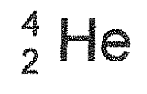

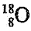
Using all this information we can work out how many neutrons there are in atoms of elements. For example we can draw diagrams as shown in figure 4.2 to represent the structure of atoms with the following representations and

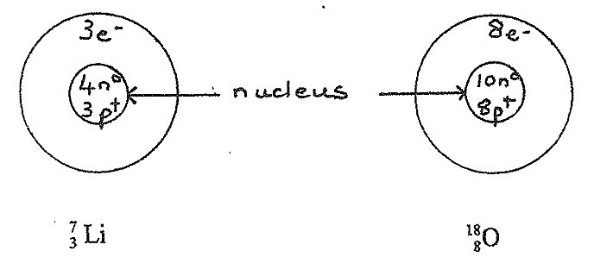

Figure 4.2: Some representation of the structure of atoms
Isotopes
Although we say that the atoms of elements are all the same we really mean they have the same number of protons. However, the number of neutrons in atoms of the same element can vary.
Atoms of the same element with different mass numbers have different numbers of neutrons and are called isotopes. Elements occur in nature as a mixture of their isotopes. We cannot predict which isotopes will exist nor how plentiful they will be. Scientists have to analyse naturally occurring elements to ﬁnd out which isotopes exist and how plentiful (or how abundant) these isotopes are. Table 4.1 below shows you the abundance of isotopes of some elements. The term percentage abundance, that is used in this table, means what percentage of atoms that particular isotope is in a naturally occurring sample of the element.

Table 4 .1 The percentage abundance of some isotopes
Isotopes | Percentage Abundance
 | 99.985
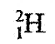 | 0.015
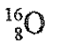 | 99.762
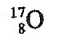 | 0.038
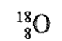 | 0.200
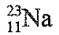 | 100

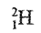
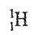
Referring to this table, we see that the element hydrogen consists of two isotopes. One of these isotopes, is very plentiful. In fact, this isotope comprises 99.985%° of all atoms of the element hydrogen. Only a very small percentage, 0.015%, of all atoms of hydrogen are the isotope. Similarly, the element oxygen is made up of 3 different isotopes whereas the element sodium is made up of only one type of atom - the abundance of the isotope Na is 100%. The percentage abundance of the isotopes of each element must add up to 100%.
Often when we refer to an isotope of an element, we just give the mass number because we know that we can look up the atomic number in the periodic table. So we may write ¹²C or ¹⁶O etc.

Activity 4.2
Draw diagrams like those given to you in Figure 4.2 above, to represent the structure of the following isotopes of elements:
- ²⁰Ne, ²¹Ne and ²²Ne
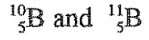

Guided reflection
In the case of neon (symbol Ne), if you look at the periodic table in figure 4.1, you will see that the atomic number of neon is 10. Remember the top number tells you how many protons plus neutrons which is the mass number of the isotope so we have to subtract the atomic number from the mass number to get the number of neutrons. The answers are shown below:

1.
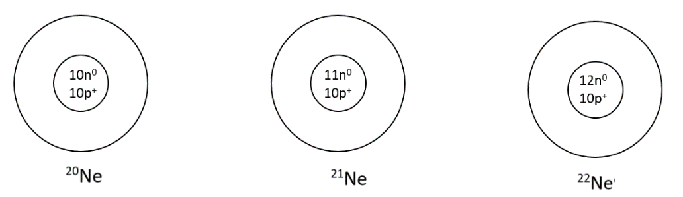

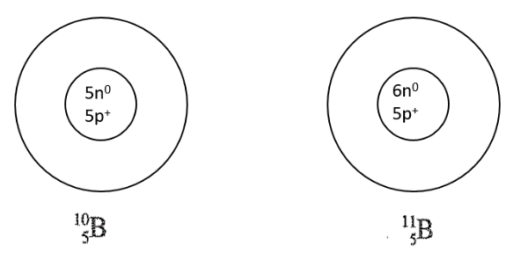
2.

The Mass of Atoms
When you look at the numbers at the bottom of the periodic table in figure 4.1, you will see that the numbers at the bottom of each block look similar to the mass number that you used in the section on isotopes above, but they are not whole numbers. For example if you look at neon, you can see that the number in the bottom of the block for neon is 20.180. So you may ask, why the masses of elements given in the periodic table are not whole numbers. To answer this question we will need to find out more about the mass of atoms.
Scientists in the 19th century knew nothing about atoms being made up of protons, neutrons and electrons but they did realise that atoms of different elements have different masses. Earlier in this unit, you read that Dalton believed that all atoms of the same element had the same mass. Now that you have learnt about isotopes, you can see that not all atoms of the same element have the same mass.
Dalton was able to get rough measurements of the mass of each element and he worked out the masses by comparison or relative to the mass of atoms of an element, which was chosen as the standard. First hydrogen was chosen as the standard (probably because it was the lightest element) and given a value of 1. Oxygen was found to be 16 times heavier than hydrogen so oxygen was given a relative atomic mass of 16. Later oxygen was used as the standard. Nowadays scientists use 1/12 of a ¹²C atom (also referred to as C -12) as the standard. By agreement among scientists an atom of ¹²C has been given an atomic weight (or relative atomic mass) of exactly 12. Isotopes of other elements are measured relative to this. For example the relative atomic mass (or atomic weight) of an atom of ¹H is 1.00783 times heavier than one-twelfth of a ¹²C atom. Similarly, a ²⁴Mg atom is 23.98504 times heavier than one-twelfth of a ¹²C atom. Relative atomic masses (or atomic weights) do not have any units because these values come from a comparison (or ratio) of masses.

The relative atomic mass quoted in the periodic table is the average relative atomic mass, which is calculated taking into account all the isotopes of carbon and their abundance. Below we are going to do some calculations to see where the values on the periodic table come from. This can be confusing, so before we do this calculation we will do a simpler example to help you understand.

Example
A group of 10 students has the following masses: 2 students have a mass of 50 kg each, 3 students have a mass of 60 kg each and 5 students have a mass of 70 kg each.
If we want to find the average mass of a student into the group, we have to take into account the number of students of each mass.
So the average mass of a student = (2 x 50kg) + (3 x 60 kg) + (5 x 70 kg)/ 10
= (100kg + 180kg + 350 kg)/10
= 630kg/10
= 63 kg
To calculate the average relative atomic mass of an atom of an element e.g. carbon, we can perform a very similar calculation. We know (from textbooks) that the percentage abundance of ¹²C (with a relative atomic mass of 12.00000) is 98.90%. The percentage abundance of ¹³C (with a relative atomic mass of 13.00335) is 1.10%.
We assume that we have a sample of 100 atoms of carbon. We then consider, that 98.90 atoms of carbon have a relative atomic mass of 12.000 00 and 1.10 atoms have a mass of 13.003 35. The average relative atomic mass of a carbon atom will be calculated by adding together the masses of the 100 atoms and dividing by 100. Of course, it seems a bit strange to have a decimal fraction of an atom. We should really consider 10 000 atoms so that out of this number 9890 atoms will be ¹²C isotopes and 110 will be ¹³C isotopes. However mathematically it comes to the same answer and it is easier to work with a sample of 100 atoms. (You may even ﬁnd that in some textbooks they work with fractions less than 1 instead of 100. Mathematically you get the same answer. )

The average relative atomic mass of carbon = (98.90 x 12.00000) + (1.10 x 13.00335)/ 100
= (1187 + 14.3)/100
= 1201.3/100
= 12.013
to 5 significant figures as given in the periodic table in figure 4.1
The average relative atomic masses of all the elements can be calculated in a very similar way taking into account their naturally occurring isotopes and how abundant they are.

Now let’s see if you can do one of the calculations in the activity that follows.

Activity 4.3
The element nitrogen has two naturally occurring isotopes. One of these has a relative atomic mass of 14.00308 and a percentage abundance of 99.635%. The other isotope has a mass of 15.00011 and a percentage abundance of 0.365%. Calculate the relative atomic mass of nitrogen.

Guided reflection
When you do calculations, it is very important to look at the numbers and work out what sort of answer you expect. More than 99% of the element is composed of the isotope with relative atomic mass of just over 14 and a very small percentage has a relative atomic mass of just over 15. You would expect the answer to be much closer to 14 than to 15. Look at the working below and see what answer we get.

As in the example above, assume there are 100 atoms in the sample of nitrogen.
The average relative atomic mass of nitrogen = (99.635 x 14.00308) + (0.365x 15.00011)/ 100
= (1395.2 + 5.475)/100
= 1400.671/100
= 14.0067
As you can see, the answer is very close to 14, so we are likely to be correct!

Although we are dealing with atomic mass here, we must mention that the relative molecular mass of a substance can also be calculated using relative atomic masses. For example, a molecule of hydrogen, H₂, is made up of 2 hydrogen atoms. Therefore we can calculate the relative molecular mass of H₂ as 2 x relative atomic mass of hydrogen = 2 x 1.008 = 2.016

Nowadays scientists can measure the mass of atoms accurately in units of mass like the gram. Scientists have gone a bit further and worked out a unit called the atomic mass unit (1 amu) which is
1 amu = 1.66054 x 10⁻²⁴ g.
The mass of a carbon-12 isotope is assigned a value of 12 amu. Assigned means that scientists decide to fix the value at exactly 12. In other words, they are setting a standard.

Back to the periodic table
You have now been introduced to the periodic table several times. In unit 3 you found out about the periodic table of the elements as a way of listing all the elements. In this unit, you learnt about some of the numbers on the periodic table such as relative atomic mass and atomic number. But the periodic table helps us in a lot of different ways. It is regarded as one of the biggest ideas in science. The periodic table is a good example of how scientists look for patterns.
In the days of Dalton, scientists knew about elements, they also knew about relative atomic mass. In other words, they know that some elements were heavier than others. Dalton also said that all atoms of the same element had the same mass. As you can see, he was not quite correct since there are different isotopes of the same element. However, one way of arranging the elements would be in order of their relative atomic mass.
Some scientists started to notice that different elements behaved in a similar way. For example, some elements reacted very quickly with water or air. This caused these scientists to group similar elements together.
The scientist who is best known for the development of the periodic table was a Russian scientist by the name of Dmitri Mendeleev. At the time, only 65 out of the 118 elements were known. Mendeleev made groups of these elements and arranged them in a table in increasing order of atomic mass (remember that protons and atomic number were not known yet). When Mendeleev arranged the elements, he noticed that there were missing elements. He also noticed that with some of the heavier elements it made more sense to change the order even if the elements were not in order of atomic mass. Figure 4.3 shows a picture of Mendeleev
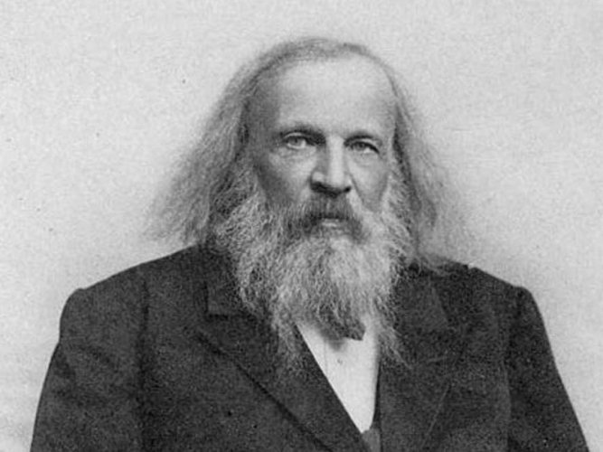

Figure 4.3: Picture of Dmitri Mendeleev
https://www.google.co.za/search?q=mendeleev+image&tbm=isch&source=iu&ictx=1&fir=ZGCvzaYcEV197M%253A%252CAI5-ja9lK3L7FM%252C_&usg=AI4_-kRGHqmIWHtpHZ-pEnhzRhWwx8erKw&sa=X&ved=2ahUKEwiA4cLXlcDfAhVRyqQKHXHSCicQ9QEwC3oECAEQGg#imgrc=ZGCvzaYcEV197M:
Mendeleev was a very interesting character. They say he cut his hair only once a year in the spring!! Looking at his picture, this certainly seems to be the case.
Below we will look at two missing pieces that Mendeleev was able to find.
The first thing that Mendeleev did was he predicted the discovery of a new element. If you look at the periodic table in figure 4.1, you will see the element silicon, which has atomic number 14. In Mendeleev’s time silicon was known (it is one of the most common elements in the earth, as sand is a compound of silicon and oxygen. If you look at the element below silicon, it is called germanium and has atomic number 32. Germanium was not known at the time of Mendeleev.
Mendeleev arranged the elements in columns and he realised there was a missing element which he called Ekasilicon (E). Table 4.2 below shows the properties of the element as predicted by Mendeleev and the properties of germanium when it was discovered in 1886.

Property | Predicted properties of Ekasilicon (E) | Actual properties of Germanium (Ge)
Atomic mass | 72 | 72.61
Appearance | grey metal | grey metal
Specific heat capacity | 0.31 J/gK | 0.32 J/gK
Oxide formula | EO₂ | GeO₂
Oxide density | 4.7 g/cm³ | 4.23 g/cm³
Formula of chloride | ECl₄ | GeCl₄
Boiling point of chloride | Less than 100⁰ C | 84⁰ C

It is amazing how close he was to the correct numbers. This is why it is important for scientists to study patterns.

Mendeleev also noticed that iodine (number 53) was similar to elements fluorine, chlorine and bromine but it had a lower relative atomic mass than its neighbour tellurium (number 52). The atomic mass of iodine is 126.9 and the atomic mass of tellurium is 127.8. Remember, in Mendeleev’s day atomic numbers were not known, so he had to work with relative atomic mass. Even though tellurium had a greater atomic mass, Mendeleev decided to place iodine after tellurium, under fluorine, chlorine and bromine. We will see below why the vertical and horizontal arrangement of the periodic table is so important.
If you want to know more about the periodic table, you will find an interesting booklet by clicking on the hyperlink below.
https://www.stem.org.uk/resources/elibrary/resource/26845/periodic-table
You may have to register on the site but registration is free and the site has many interesting materials.
This repetition of chemical properties is known as the periodic law.
The structure of the periodic table
The modern periodic table places the elements in neat horizontal rows called periods and in vertical columns called groups. You will ﬁnd that different books may have slightly different forms of the table. For now we will use the table in figure 4.1.
There are many alternative forms of the periodic table. You can see some by clicking on the link below:
https://en.wikipedia.org/wiki/Periodic_table

In units 2 and 3 we introduced you to a special periodic table to leads to videos. It is worth clicking on it from time to time. Here is the link again.
http://www.periodicvideos.com/

If you look at the periodic table in figure 4.1, you will see that you can identify both the periods and the groups. Both are important. Generally, the elements on the left of each period are metals and as we move across the period, the elements on the right are non-metals. The periodic table in unit 3 (figure 3.3) had a solid stepped line showing an approximate boundary between the metals and non-metals.

Periods
The periods help us to see how the electrons are arranged in the atom. Since the periodic table is organised by atomic number (the number of protons in the atom), we can also tell the number of electrons. Remember that in a neutral atom the number of protons is equal to the number of electrons. Earlier we commented that the arrangement of electrons in each atom is important. We are now going to see how the electrons build up as the atom gets bigger for each element.

In your physics module, you learnt about coulomb’s law, which explains how to calculate the force between positive and negative charges. Remember that positive and negative charges attract each other. The closer they are to each other, the more strongly they attract each other. On the other hand, the further apart they are, the weaker the attraction. Another important factor is the magnitude (or the size) of the charge. We learnt that the charge on the electron is equal but opposite to the charge on the proton. But as the atomic number increases, there are more protons in the nucleus so the force of attraction on the electron gets stronger.

Each period starts a new energy level, sometimes called a shell. Each new shell is further away from the nucleus. The ﬁrst period (which is split in the middle) contains only 2 elements, hydrogen and helium. This is because the first shell in an atom can hold a maximum of 2 electrons. Hydrogen has 1 electron in its outer shell and helium has 2 electrons. Hydrogen and helium are both gases at room temperatures and pressures. Each atom of helium has a full shell, is not very reactive and does not form bonds with other atoms of itself or atoms of other elements to form compounds. It is called a noble gas.
The electronic arrangements of the atoms of hydrogen and helium are shown below in figure 4.4

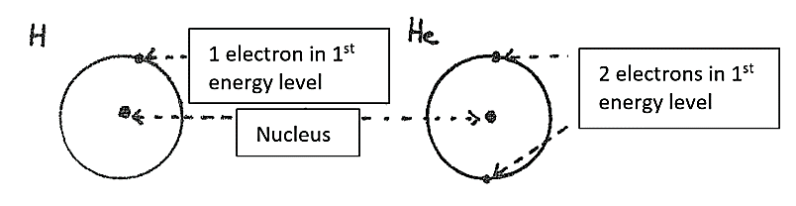

Figure 4.4: Arrangements of electrons of hydrogen and helium.

Elements in the 2nd period have their outer electrons in the 2nd energy level. This energy level can hold 8 electrons and so there are 8 elements in this period, from lithium to neon. The electron arrangements for elements in the second period are shown below in figure 4.5. Each dot shows an electron.
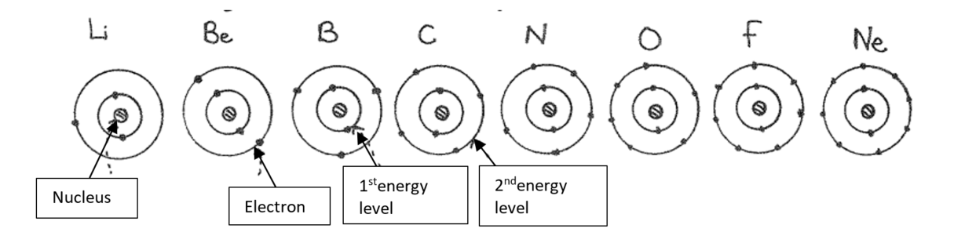
Figure 4.5: Arrangements of electrons of period 2
Elements In the 3rd period have their outer electrons in the 3rd energy level. There are also 8 elements in this period. The electron arrangements for period 3 elements are shown in figure 4.6. Again, each dot indicates an electron.

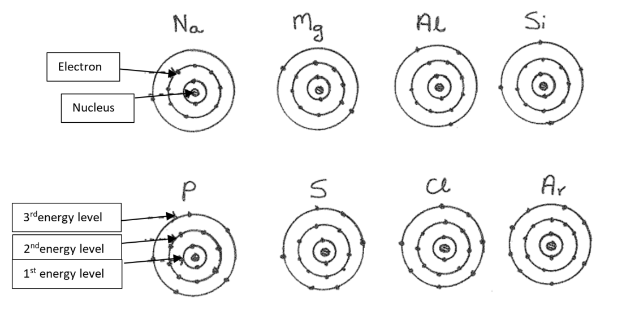

Figure 4.6: Arrangements of electrons of period 3

The 4th period gets a bit more complicated and we won’t go into the details of the electron arrangement of all the elements in this period. We need you to know the electron arrangements of the ﬁrst two elements, potassium and calcium which are shown below in figure 4.7.
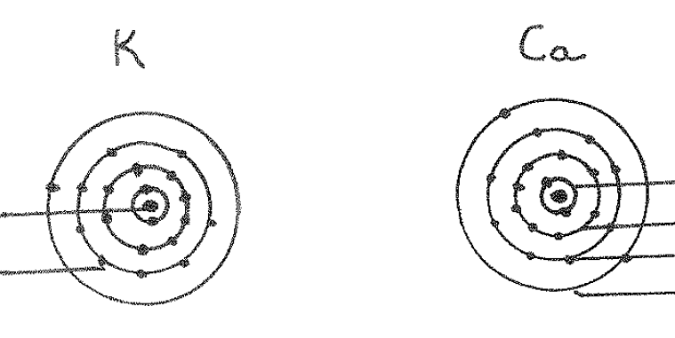
1stenergy level
2ndenergy level
3rdenergy level
4thenergy level
Nucleus
Electron

Figure 4.7: Arrangements of electrons of period 4
By now you should realise that you can work out the electron arrangements (also called electron conﬁgurations) of the ﬁrst 20 elements just by looking at the position of the element in the periodic table. You don’t need to memorise them!!!

Groups
The groups are numbered in different ways in different forms of the periodic table in different books. You must understand the form of the table that we are using. The latest way of numbering groups is to number them ordinary numbers (1, 2, 3, 4 etc. to 18). Some tables use Roman numerals (I, II etc. through to VIII). The periodic table in figure 4.1 uses ordinary numbers and roman numerals. We will use ordinary numbers. The elements in groups 1, 2, 13, 14, 15, 16, 17, 18 (with hydrogen and helium) are called main group elements. Elements in the groups numbered 3 to 12 are called the transition elements. The last two horizontal rows are called the inner transition elements or the lanthanides and actinides. To make it clearer for you, this division of the Periodic Table into these 3 main regions is shown in the figure 4.8 below

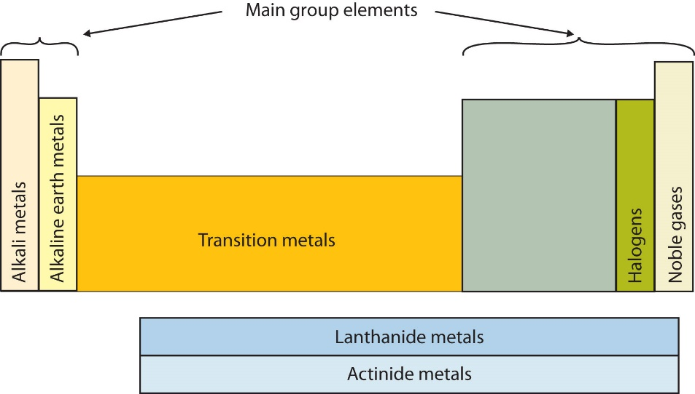

Figure 4.8: Regions of the periodic table
https://www.google.co.za/search?q=regions+of+the+periodic+table+image&tbm=isch&tbo=u&source=univ&sa=X&ved=2ahUKEwi2-a-k08LfAhVI_aQKHTfZBT8QsAR6BAgCEAE&biw=1280&bih=610&dpr=1.5#imgrc=0OJjj-U5D3VYIM:

You have done a lot of reading, so let’s give you a bit of practice in using the table.
Activity 4.4
- Write down the symbol (and the name of the element) that is in period 3 and group 15
- What is the Period and Group number of elements with the following atomic numbers: 3, 17 and 52?
- Say in which region of the table (i.e. main group elements, transition elements or inner transition elements the following elements are found:
Ag, Fr, U, As, Rn, Tc, Pt

Guided reflection
This activity is just to help you find your way round the table. The only elements you are expected to get to know well are the first 20 elements of the periodic table as well as iron, cobalt, nickel, copper, zinc, palladium, silver, platinum, gold and mercury.
Here are the answers to the questions in the activity
- As which is arsenic
- Element 3 is in period 2, group 1 (Li); Element 17 is in period 3 group 17 (Cl); element 52 is period 5 group 16 (Te)
- Main group elements: Fr, As, Rn; Transition elements: Ag, Tc, Pt; Inner transition elements: U

More details about the main group elements
Let’s spend some time ﬁnding out more about these elements. We will describe them in their groups. Remember we said that Mendeleev placed elements in the same vertical columns in his original table, because he observed that they had similar properties. By using the diagrams given above for the arrangement of electrons in atoms, you are going to notice that elements that are in the same group have the same number of outer (valence) electrons. It is this similarity in electron arrangement in atoms that gives elements similar chemical (and some physical) properties.

Group 1 (Li, Na, K, Rb, Cs, Fr)
As you can see from figure 4.8, this group has a name. The group is called the alkali metals. Atoms of these elements all have 1 outer electron. We should also include hydrogen (although its outer electron is in the 1st energy level). Hydrogen is a gas and a non-metal. The rest of the Group 1 elements are soft, solid metals. They are called alkali metals because they react vigorously with water to form alkali or basic solutions (You will learn more about these solutions in Unit 17 of this module). The alkali metals are the most reactive of the metals and form compounds with all the non-metals except the noble gases.

Group 2 (Be, Mg, Ca, Sr, Ba, Ra)
Figure 4.8 also shows that this group has a name – alkaline earth metals. Atoms of these elements all have 2 outer electrons. They are harder metals than the Group 1 metals. Oxides of some of these elements also react with water to form basic (alkaline) solutions. The word “earth” was included in their name because these elements were discovered by the early chemists as oxides of these metals (compounds which they referred to as “earths”).

Group 13 (B, Al, Ga, In, Tl)
Atoms of these elements all have 3 outer electrons. Boron is a semi-metal and the rest are metals. Aluminium is the most abundant of these elements.

Group 14 (C, Si, Ge, Sn, Pb)
Atoms of these elements all have 4 outer electrons. Carbon is a non-metal. Silicon and germanium are semi metals and tin and lead are metals. Carbon and silicon are very abundant – in fact, apart from oxygen, silicon is the most abundant element on earth.

Group 15 (N, P, As, Sb, Bi)
Atoms of these elements all have 5 outer electrons. Nitrogen and phosphorus are non-metals, arsenic and antimony are semi- metals and bismuth is a metal. Nitrogen is a major component of the air and phosphorus compounds are found in all living cells.

Group 16 (O, S, Se, Te, Po)
Atoms of these elements all have 6 outer electrons. Oxygen, sulphur and selenium are non-metals Tellurium and polonium are semi-metals. Elements in this group are also called the chalcogens from the Greek word chalx (meaning copper) because compounds of copper often contained two elements in this group, namely oxygen and sulphur.

Group 17 (F, Cl, Br, I, At)
Figure 4.8 shows that this group has a name – halogens meaning salt formers because they form salts with metals. Atoms of these elements all have 7 outer electrons. They are all very reactive elements. Fluorine and chlorine (both gases) are the most abundant. Bromine (a liquid) and iodine (a solid) are less abundant but very important elements. Astatine, a semi-metal, is very rare.

Group 18 (sometimes also called Group 0) (Ne, Ar, Kr, Xe, Rn)
Figure 4.8 shows that this group is called the noble gases(or sometimes the inert gases). Atoms of these elements all have 8 outer electrons. Helium from Period 1 is usually included (although it has only 2 outer electrons) with these elements. They are very unreactive elements because the outer shell is full of electrons. A few compounds of krypton, xenon and radon with oxygen or ﬂuorine have been prepared. No compounds of helium, argon or krypton have been discovered or prepared. Most of these elements are rare with the exception of argon which forms 1% of the atmosphere.
We have tried to give you some background information about the Periodic Table. You may like to read more about it on your own. We have given you links to some interesting websites. There is even a song about the periodic table – listen to it on
https://www.youtube.com/watch?v=VgVQKCcfwnU
The Periodic Table is a very important part of Chemistry and you will ﬁnd that you return to it time after time during your studies in Chemistry.

You have done a lot of reading so try the next activity to see how well you understand this section.

Activity 4.5
- Say whether the following statements about the Periodic Table are true or false. Give a reason for your decision.
- Elements are arranged according to their mass numbers.
- Metals and non-metals never occur in the same group.
- The second period contains only main group elements but the third period contains main group elements and transition elements.
- All periods contain the same number of elements.
- Which of the following elements are not alkali metals? Rb, Na, Ca, Ga, Cs
- Which of these elements have/has atoms with full outer energy levels?
magnesium, hydrogen, neon, boron
- Which of these elements are semi-metals? arsenic, aluminium, copper, silicon
Guided reflection
The responses are below:
- Statement a is false. Elements are arranged according to their atomic number which is the number of protons in the atom.
Statement b is false. Groups 1 and 2 consist entirely of metals but Groups 13, 14, 15 and 16 consist of metals, semi-metals and non-metals. For example carbon is a non- metal but tin (Sn) is in the same group and it is a metal.
Statement c is false. The third period also contains only main group elements.
Statement d is false. Period 1 contains only two elements, periods 2 and 3 contain 8 elements and periods 4 — 7 contain more than 8 elements.
- Ca and Ga are not alkali metals.
- Only neon has a full outer energy level.
- Arsenic and silicon are semi-metals.

Different ways of representing the main group elements
In the section below will be looking at three different ways of representing the first 20 main group elements. These are Lewis diagrams, aufbau diagrams and spectroscopic electron configurations. Don’t worry if these names sound complicated at this stage. You will see below that they are closely related and not too difficult.

A useful and important concept in chemistry that helps you describe how the atom of the element might behave is the word valence. The word refers to the outer electrons of the atom. The word valence is used to describe the outer electrons in an atom. For example of you look back at the structure of the element carbon, you will see that there are 2 inner electrons in the first energy level and 4 valence electrons in the second energy level. We refer to inner electrons as core electrons. These terms will become useful when we study bonding in later units. In chemistry, the valence electrons are the most important electrons for chemical reactions.

In this course, we will focus mainly on the main group elements because the electron conﬁgurations (arrangements) of these elements are easier to understand. To understand the design of the periodic table and the electron conﬁguration of the other elements we will need another more complicated model of the atom, which you will study in more advanced chemistry courses. The model of the atom that we have been using in this unit for the ﬁrst 20 elements in the periodic table is called the Bohr model of the atom (developed by a Danish Scientist Niels Bohr). Bohr’s model pictures the electrons moving around the central nucleus in paths or orbits (or energy levels) like planets around the Sun. Bohr’s discovery of energy levels was very important for the development of the model of the atom and is very important for us to see the link between the structure of the atom and the periodic table.

We will now look at a very useful way of representing the elements, which considers only the valence electrons, known as Lewis dot diagrams.

Lewis (Dot) Diagrams for Elements
A scientist named Lewis thought of a simple way to represent the valence electrons of elements. This method is very useful to chemists. He wrote the symbol of the element and around it drew dots for the valence electrons. He drew the first four electrons separately and then paired them up. So the Lewis diagrams for the elements sodium, magnesium, carbon and chlorine would be:

Let’s see if you can draw some more Lewis diagrams
Activity 4.6
Complete the following table for the elements of the second period
Group | 1 | 2 | 13 | 14 | 15 | 16 | 17 | 18
Element symbol
Number of valence electrons
Lewis diagram

Guided reflection
Refer to figure 4.1 for the periodic table. These are elements starting from lithium to neon.
The correct answers are as follows:
Group | 1 | 2 | 13 | 14 | 15 | 16 | 17 | 18
Element symbol | Li | Be | B | C | N | O | F | Ne
Number of valence electrons | 1 | 2 | 3 | 4 | 5 | 6 | 7 | 8
Lewis diagram |  | 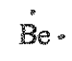 | 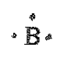 | 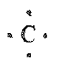 |  | 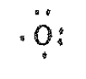 | 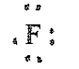 | 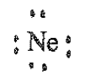

Aufbau diagrams
Later models of the atom using theories that are more complex were worked out by an Austrian scientist called Schrὅdinger. We will only be using a small part of his theory. Schrὅdinger sub-divided the energy levels of the atoms into atomic orbitals which described regions where electrons were likely to be found around an atom. We talk about where electrons are likely to be found because they are always moving and we cannot say where they are at any particular moment. In the first 20 elements we find two types of orbitals – s orbitals and p orbitals. Within each energy level, the s orbital has a lower energy than a p orbital. In each energy level there is one s orbital but three p orbitals. Each orbital can have 2 electrons. When 2 electrons are in an orbital, they are called an electron pair. An single electron in an orbital is called unpaired.
There are many ways of representing orbitals and their energies but we will be using a simple representation known as an aufbau diagram. Aufbau is German word meaning building up. Since each orbital has 2 electrons we only need to learn about the first 10 orbitals. The overall aufbau diagram showing the names and energies of these orbitals is shown in figure 4.9.

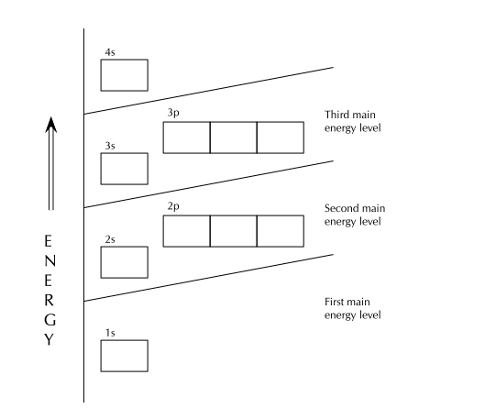

Figure 4.9: Aufbau diagram showing energy levels
Siyavula science grade 10 (https://www.siyavula.com/read/science/grade-10)

There are rules for drawing aufbau diagrams to show the electron configuration for each element. Here they are:
- Each orbital can only hold two electrons. Electrons that occur together in an orbital are called an electron pair.
- An electron will always first occupy an orbital with the lowest possible energy.
- An electron will first occupy an orbital on its own, rather than share an orbital with another electron. This is Hund’s rule. This is rather like passengers who do not know each other when they board a bus. They first choose to sit alone.
- An electron would also rather occupy a lower energy orbital with another electron, before occupying a higher energy orbital. In other words, within one energy level, electrons will ﬁll an s orbital before starting to ﬁll p orbitals.
- The s subshell can hold 2 electrons.
- The p subshell can hold 6 electrons – there are three different p orbitals which each can hold 2 electrons.
- Electrons have a property called spin and two electrons in the same orbital may not spin the same way. So we show electrons differently in the same orbital, one pointing up and other pointing down. (This is called Pauli’s exclusion principle)
All this sounds very complicated but it is not so difficult. You will see this as we do an example.

Example
Let us draw the aufbau diagram for fluorine (F).
You first need to look at the periodic table in figure 4.1 to find out the atomic number of fluorine. This will tell you the number of protons and therefore the number of electrons.
Fluorine’s atomic number is 9, so fluorine has 9 electrons.
It will help you to remember the other two representations we have done so far – the Bohr diagram and the Lewis diagram. They are shown below.
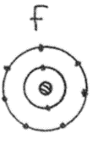
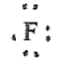

You can see that the Bohr drawing shows all the electrons but the Lewis diagram shows only the valence electrons. For the aufbau diagram, we place the 9 electrons as follows:
- The first electron is shown as an arrow facing up in the lowest energy orbital, the 1s.
- The second electron is shown as an arrow facing down in the lowest energy orbital, the 1s.
- The third and fourth electrons are similarly placed in the next highest energy orbital, the 2s.
- The fifth, sixth and seventh electrons are each placed facing upward in the 2p orbital according to Hund’s rule.
- Lastly the eighth and ninth electrons pair up with two of the 2p electrons.

The final aufbau diagram for fluorine is shown in figure 4.11

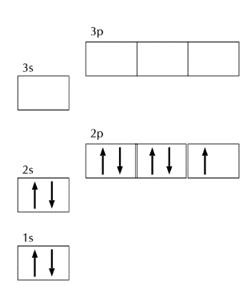

Figure 4.11: Aufbau diagram for fluorine

Activity 4.7
Draw the Aufbau diagram for sulfur

Guided reflection
Look up the atomic number on the periodic table in figure 4.1. It is 16 for sulfur.

For the aufbau diagram, we place the 16 electrons as follows:
- The first electron is shown as an arrow facing up in the lowest energy orbital, the 1s.
- The second electron is shown as an arrow facing down in the lowest energy orbital, the 1s.
- The third and fourth electrons are similarly placed in the next highest energy orbital, the 2s.
- The fifth, sixth and seventh electrons are each placed facing upward in the 2p orbital according to Hund’s rule.
- The eighth, ninth and tenth electrons pair up with the 2p electrons.
- Now the second energy level is full and we need to start using the third energy level.
- So we follow the same process as we did for the second energy level and final diagram appears as below.

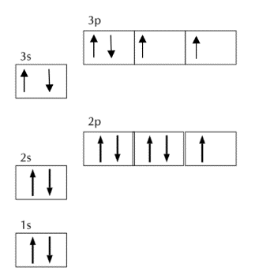

Aufbau diagram for sulfur

Spectroscopic electron conﬁguration notation
This very long name refers to a shorthand (or abbreviated form) of the aufbau diagram. For example, in the case of fluorine in the example above we can write the electron configuration as 1s²2s²2p⁵.
Written in words, this means 2 electrons in the 1s orbital, 2 electrons in the 2s orbital and 5 electrons in the 2p orbital.
Here is a short activity to give you practice
Activity 4.8
Write the spectroscopic electron conﬁgurations for aluminium and chlorine.
Guided reflection
Look up the atomic number on the periodic table in figure 4.1. It is 13 for aluminium and 17 for chlorine.
So for aluminium the configuration is 1s²2s²2p⁶3s²3p¹
For chlorine, the configuration is 1s²2s²2p⁶3s²3p⁵

Why do we have so many representations and how do they relate to each other?
We now have four different ways of representing the arrangements of electrons in an atom.
They show different parts of the atom in different detail and they are useful in different situations, as we will see in future units of this module. It is worth taking a little time to look at the different representations and what the show, and what they leave out.

Let us look at a single atom of an element and see what we can tell from each of the representations.

Let us take nitrogen as an example, using the most common isotope with atomic mass of 14:
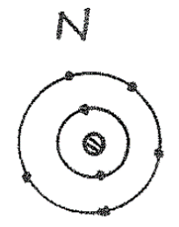
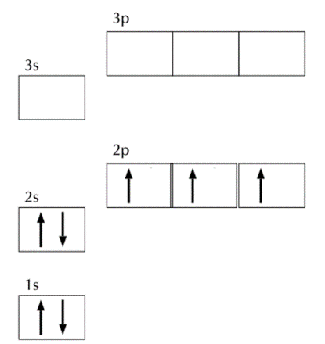
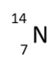
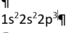

Figure 4.12: Five different representations of an atom of nitrogen
The table below summarises what the five representations do and do not tell us.

Representation | What it tells us | What it does not tell us
Bohr model | How many electrons there are in each energy level | What is in the nucleus and how the electrons are paired
Lewis diagram | The arrangement of the valence electrons and the symbol of the element | What is in the nucleus and the inner electrons
Isotope | How many protons, how many neutrons and the symbol of the element | How the electrons are arranged
Spectroscopic configuration | How many electrons there are and in which orbitals they are | What is in the nucleus and the symbol of the element
Aufbau | The arrangement of the electrons in each orbital | What is in the nucleus and the symbol of the element

Of course, chemists who know their work will be able to tell all the representations if they are given just one! Can you? We will find out below where we check your progress in the last two units.

Summary assessment for units 3 and 4
Task 1
Explain the difference between Cs and CS

Task 2
Which of the following statements is incorrect?
- Protons and electrons have charged equal in magnitude but opposite in sign
- Electrons exist outside the nucleus and have negative charges
- The number of protons in the nucleus is the atomic number
- Atoms of an element possessing different numbers of neutrons are called isotopes
- Neutrons have much smaller masses than protons

Task 3
Which one of the following is the correct conventional representation of an isotope of copper?
Task 4
Which of the following are pairs of isotopes?
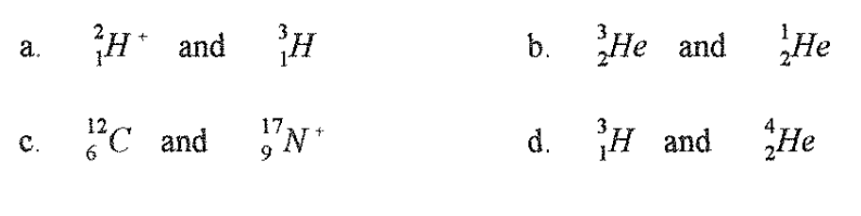

Task 5
The loss of a neutron from the nucleus of an atom
- Converts the atom into one of a different element
- Produces a negatively charged ion
- Produces a positively charged ion
- Changes the mass of the atom
- Reduces the atomic number of the atom

Task 6
Complete the following table by filling in the missing information
Symbol | 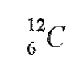 | 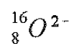
Protons |  |  | 12 | 11 | 9
Neutrons |  |  | 13 | 12 | 10
Electrons |  |  |  | 10 | 10
Nett charge |  |  | 0 | 1+ | 1-

Task 7
A certain element has a relative atomic mass of 20.18. This element occurs in two isotopic forms with relative atomic masses of 20.00 and 22.00 respectively. Without doing any calculations say which of the isotopes is the most abundant. Explain your reasoning.

Task 8
- Which one of the following elements are metals? Se, Br, Hg, Sr, Au. P
- Which one of the following elements are metalloids? Ge, S, F, Pb, C
- Which one of the following elements are likely to have chemical and physical properties similar to fluorine? S, Ne, O, Cl

Task 9
Identify the parts of the periodic table to which the following labels apply: You should use different shading for the various parts and a key to identify each part.

- Group 2
- Period 3
- the alkali metals
- the inert or noble gases
- the transition elements
- the inner transition elements

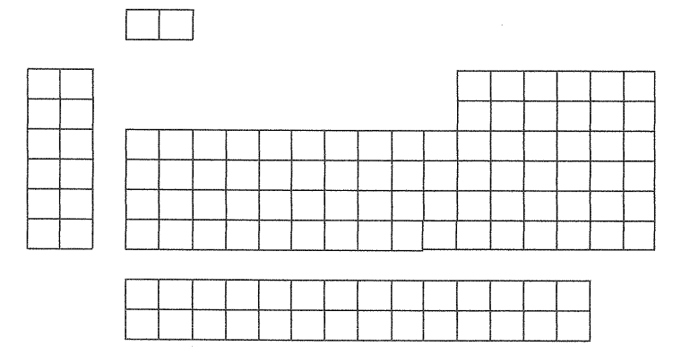

Task 10
Draw a diagram showing clearly the arrangement of electrons in an atom of calcium. Label the nucleus, the energy levels and the valence electrons.

Task 11
For the element potassium, draw the following representations
- Bohr model
- Lewis diagram
- Isotope
- Spectroscopic configuration
- Aufbau diagram

Answer Key for summary Assessment

Task 1
Cs refers the element Caesium (element number 55) and CS refers to a compound between carbon (C) and sulfur (S)

Task 2
- Protons and electrons have charges equal in magnitude but opposite in sign: True. They are different in mass and where they are in the atom
- Electrons exist outside the nucleus and have negative charges: True
- The number of protons in the nucleus is the atomic number : True
- Atoms of an element possessing different numbers of neutrons are called isotopes: True
- Neutrons have much smaller masses than protons: False – protons and neutrons have almost the same mass

Task 3
Which one of the following is the correct conventional representation of an isotope of copper?
B is the correct answer. The mass number must go to the top on the left and all the numbers must be whole numbers. The atomic number is shown on the bottom left.

Task 4
Which of the following are pairs of isotopes?
a is the only correct answer. Isotopes are the same element, so c and d are incorrect. b is incorrect because the mass number cannot be smaller than the atomic number.
Task 5
The correct answer is d. the loss of a neutron does not change the number of protons which decides which element is involved, so a and e are incorrect. No electrons are lost or gained so band c are not correct.

Task 6
The full table is shown below:
Symbol |  |  | 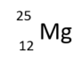 | 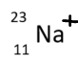 | 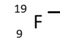
Protons | 6 | 8 | 12 | 11 | 9
Neutrons | 6 | 8 | 13 | 12 | 10
Electrons | 6 | 10 | 12 | 10 | 10
Nett charge | 0 | -2 | 0 | 1+ | 1-
Task 7
The isotope with mass 20.00 is more abundant because the overall relative atomic mass is very close to 20. This means most of the atoms have relative atomic mass of 20

Task 8
- The metals are Hg, Sr, Au
- The only metalloids is Ge
- Cl

Task 9
Answers below:
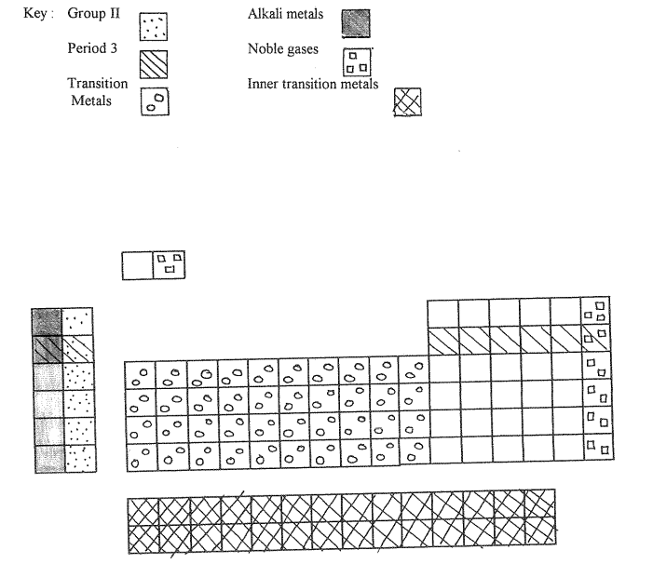

Task 10
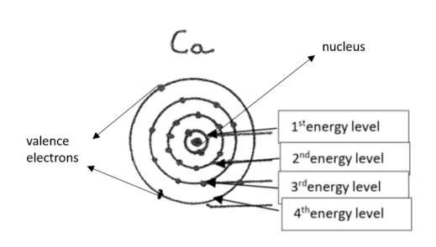
Task 11
For the element potassium, draw the following representations
- Bohr model
- Lewis diagram
- Isotope
- Spectroscopic configuration
- Aufbau diagram
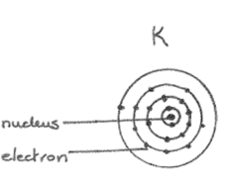
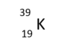
a b c

- e.
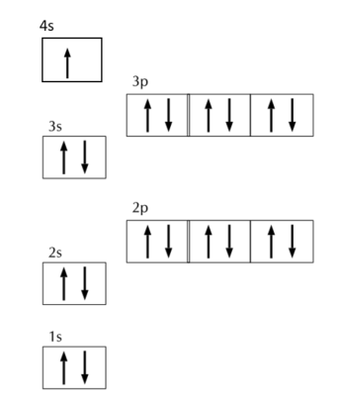
1s²2s²2p⁶3s²

Key learning points from unit 4
Now that you have completed the study of unit 3, you should be able to:
- Explain mass number and atomic number
- Explain the term isotope
- Calculate the number of neutrons in atoms of different elements, using the mass and atomic numbers of each element.
- Explore the history of the periodic table
- Explain the arrangement of elements on the periodic table in terms of increasing atomic number and number of valence electrons from left to right across a period; increasing number of shells from top to bottom down a group;
- State the chemical symbol when given the name, or the name when given the symbol, for the first 20 elements of the periodic table as well as some transition metal elements;
- State the names given to group 1 and 2 metals and groups 17 and 18 non-metals in the periodic table;
- Draw Lewis dot diagrams and Aufbau diagrams for the first 20 elements of the periodic table;
- Given a particular Aufbau diagram or Lewis dot diagram, identify the specific element(s)
- Represent the first 20 elements of the periodic table using spectroscopic electron configurations;
- Identify the specific element(s) represented by a particular spectroscopic electron configuration;

Unit 5: Particles substances are made of

Outcomes
By the end of this unit, you should be able to
- Differentiate between individual atoms, ions, molecules and networks;
- State the octet rule;
- Apply the octet rule to describe the formation of cations by metal atoms, and anions by non-metal atoms;
- State the name of compound ions such as hydroxide, ammonium, nitrate, nitrite, sulfate, sulfite and carbonate.
- Write formulae of ionic compounds given a list of ions
- Write the names of compounds given the formulae

Introduction to unit 5
In the last unit, you learnt more about the periodic table and explored the link between the periodic table and atomic structure. In this short unit, we will learn how the atom breaks up to form other particles, some of which you learnt about briefly in the last unit. You will also learn the very important skill of naming more complicated compounds. This unit also has important links to unit 2 where you explored the difference between atoms and molecules and looked at the arrangement of atoms.

Atoms, Molecules and networks
This section is about how atoms become the building blocks of matter. In the last unit, we learnt that there are 118 different elements but you already know there are millions of different types of substances. At this point, you need to remember the model we used in unit 1 to think about chemistry. To remind you, we revisit it here. It refers to the three levels of representation of matter:

Figure 5.1: The three levels of representation of matter
(Source: http://www.mstworkbooks.co.za/natural-sciences/gr9/gr9-mm-02.html )

For the last four units, we have been moving between the three levels of representation but concentrating mostly on the sub-microscopic level. We have looked at the atom in quite a bit of detail and we have seen how many atoms (sub-microscopic level) combine to give elements (macroscopic level) and we have used the symbols for the elements (symbolic level). One of the most important things we learnt in unit 2 was the difference between atoms and molecules (sub-micro level) and elements and compounds (macroscopic level). As we go forward in this section, we have to understand how atoms, molecules, elements and compounds are related. Here is a brief reminder.

- All matter is made of atoms.
- Atoms join together to form molecules. These molecules may be from the same kinds of atoms in which case they form elements at the sub-microscopic level or they may be from different kinds of atoms in which case they form compounds. Here are some examples to remind you.
You may remember from unit 2 that a diatomic molecule is a molecule made from 2 atoms. Below are representations of two diatomic molecules, hydrogen and carbon monoxide. One is an element (hydrogen) and the other is a compound (carbon monoxide).

Figure 5.2: sub-microscopic representations of carbon monoxide (left) and hydrogen (right)

So, molecules can be formed and many of them together can make elements (if the atoms are all the same) or compounds (if the atoms are different).

There is are different ways that atoms can come together to form compounds. They can form large molecules and networks.

Different types of compounds and elements
Above we made a distinction between elements and compounds. Formally, we can define a compound as a group of two or more different atoms which are attracted to each other by different forces or bonds. The atoms are combined in definite proportions.

Elements and compounds can be considered together according the way the atoms combine as shown in Figure 5.3
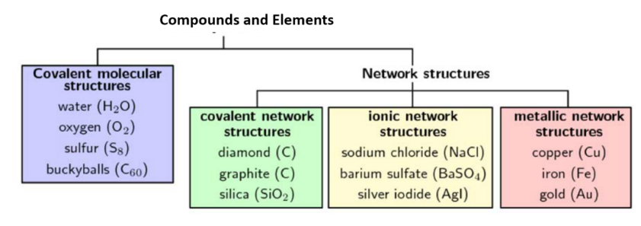

Figure 5.3: different structures of compounds and elements
Corrected from: Siyavula science (https://www.siyavula.com/read/science/grade-10/the-particles-that-substances-are-made-of ). Note: Original diagram is incorrect
Before we look at the boxes in Figure 5.3, try the following activity

Activity 5.1
There are four boxes in figure 5.3. For all the substances mentioned in the boxes, classify them according to whether they are elements or compounds.

Guided Reflection
To decide whether the substances are elements or compounds, you need to decide if they are made of the same or different types of atoms. Remember a compound is made of different types of atoms. Using that rule, you can see that the following substances contain only one type of atom. Therefore they are elements:
Buckyballs (C₆₀), Oxygen (O₂), sulfur (S₈), diamond (C), graphite (C), copper (Cu) iron (Fe) and gold (Au)
The remainder contain more than one type of atom and are therefore compounds: water (H₂O), Silica (SiO₂), sodium chloride (NaCl), barium sulfate (BaSO₄), silver iodide (AgI)

Molecular structures
We are going to look at models for the molecular structures in figure 5.3. We are then going to see how you can make your own. Figure 5.4 shows representations of structures for the molecules shown.

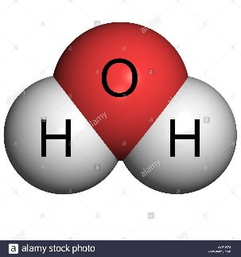
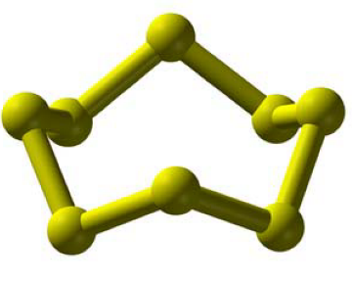
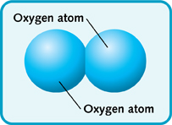

Figure 5.4:Molecules of Buckminsterfullerene (Buckyball, C₆₀), oxygen (O₂) Sulfur (S₈) & water (H₂O)
Images:
Buckminsterfullerene molecule: https://www.google.co.za/search?q=buckminsterfullerene+image&tbm=isch&tbo=u&source=univ&sa=X&ved=2ahUKEwjM9-qo5cnfAhW3SxUIHeafCMYQsAR6BAgFEAE&biw=1024&bih=488#imgrc=1TrUsV9IOTtm-M:
oxygen molecule: https://www.google.co.za/search?q=oxygen+molecule+image&tbm=isch&tbo=u&source=univ&sa=X&ved=2ahUKEwj66KDf5cnfAhWgTxUIHbHGAmoQsAR6BAgFEAE&biw=1024&bih=488#imgrc=Doiwqc7zbyMe8M:
sulfur : Siyavula science (https://www.siyavula.com/read/science/grade-10/the-particles-that-substances-are-made-of
water molecule: https://www.google.co.za/search?q=water+molecule+image&hl=en-ZA&authuser=0&tbm=isch&source=iu&ictx=1&fir=2hzgCb1kTp_I7M%253A%252CYTwuC9zeuFIquM%252C_&usg=AI4_-kTS2Dxh2-1UrvvSX6m5n5KX-zAcSA&sa=X&sqi=2&ved=2ahUKEwii74no5snfAhWHS5AKHWC7C8UQ9QEwAHoECAAQBA#imgrc=2hzgCb1kTp_I7M:
The most interesting of these four molecules is buckminsterfullerene or the buckyball, for short. It is made of 60 carbon atoms arranged like a soccer ball. It was discovered in 1985 and can be found in soot. See more about it by clicking on
https://www.youtube.com/watch?v=lYXoEzHtPGo
https://www.youtube.com/watch?v=ljF5QhD5hnI

Most molecular substances are low melting. For example, sulfur melts at 115.2⁰C, water melts at 0ºC and oxygen melts at -218.8⁰C. Sulfur is crystalline or powder like and can be brittle.

Activity 5.2
The first of the two videos above shows you how you can make a model of C₆₀. In this activity, you will make models of molecules of two of the smaller molecules – water and sulfur.
You can use plasticene and toothpicks or jelly tots and toothpicks.
For water – use one colour jelly tot or plasticene ball to represent the oxygen atom. Usually people use red for oxygen. This does not mean the oxygen atom is red, but it is a convention that scientists use. This means everybody does the same thing to make communication easier. For the same reason, white is used for hydrogen. Connect two white pieces of plasticene to a red ball of plasticene to make the model look like the picture above. Take a picture of your model.
For sulfur – use yellow plasticene or jelly tots and try to copy the angles in the picture using 8 balls to represent 8 sulfur atoms. Yellow is the conventional colour to represent sulfur atoms. Take a picture of your model and compare it to the picture above

Guided Reflection
It is very important to remember that when you make a model, it can only help you with some aspects of the real thing. Some parts of your representation may be in accurate. We have already referred to the colour of the material we use. Also bonds are not sticks – we will learn more about bonding in unit 6.
The other issue is the relative size of the atoms. Since the oxygen atom is bigger than the hydrogen atom, you can make the red ball bigger than the white ones. Notice from the picture that the molecule has a V shape. We will be learning more about that in the future.

Network structures
Another class of substances is a collection of structures with infinite repeating patterns. They are however very different in the way they are held together and therefore the way they behave.
They are covalent networks, ionic substances and metals. All these networks include some of the most important substances in our everyday life.
Covalent networks include two forms of carbon – diamond and graphite as well as silica, which is basically sand, a compound of silicon and oxygen. Diamond and graphite are particularly interesting as they are both pure carbon but one is the hardest substance known to humans while graphite is so soft that it is used as a lubricant. You may know graphite as pencil lead, the grey material which is used in pencils. It is called pencil lead but it is not made of lead. Graphite also conducts electricity but diamonds do not. Both melt at very high temperatures – it is very difficult to melt graphite and diamond.
Figure 5.5 show representations of their structures.
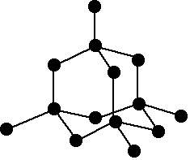
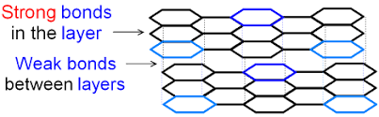

Figure 5.5: structure of graphite (left) and diamond (right)
Graphite:
https://www.google.co.za/search?q=graphite+structure+image&hl=en-ZA&authuser=0&tbm=isch&source=iu&ictx=1&fir=gGgO_Qld3bdbfM%253A%252CBDP7S747LjlueM%252C_&usg=AI4_-kQx-ZU54EBzY3dbmWRvJroh97M1ow&sa=X&ved=2ahUKEwio76qKhcrfAhUF3KQKHaGgDbsQ9QEwCXoECAUQFg#imgrc=gGgO_Qld3bdbfM:
diamond: https://www.google.co.za/search?q=diamond+structure+images&hl=en-ZA&authuser=0&tbm=isch&tbo=u&source=univ&sa=X&ved=2ahUKEwj32I7YhcrfAhUwsaQKHWBMBawQsAR6BAgDEAE&biw=1024&bih=488#imgrc=ubpeG7r75PO4qM:
The corners are where the carbon atoms are and the lines show the bonds between the atoms. These bonds are held together by sharing electrons. You will learn more about these in unit 6.

Ionic networks - In unit 4 you learnt about how ions are formed when atoms gain or lose electrons, forming cations and anions. Ionic networks are held together but the attraction of ions and are usually crystalline (made of crystals). The crystals break easily and are said to be brittle. The most familiar example is NaCl, or table salt but there are many others, such as magnesium chloride (MgCl₂) and potassium chloride (KCl). Figure 5.6 shows the arrangement of ions and salt as we see it with our naked eyes.
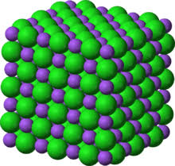
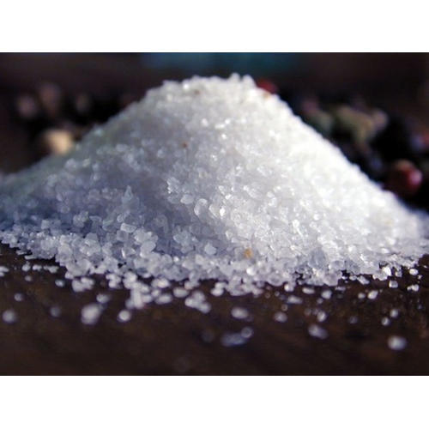

Figure 5.6: Sodium chloride model and salt
Model of NaCl: https://www.google.co.za/search?q=sodium+chloride+structure+images&hl=en-ZA&authuser=0&tbm=isch&tbo=u&source=univ&sa=X&ved=2ahUKEwj0g7KyisrfAhUPMewKHfdbC0kQsAR6BAgFEAE&biw=1024&bih=488#imgrc=GUBfq-VOHaq_DM:
Salt: https://www.indiamart.com/proddetail/common-salt-sodium-chloride-15281678155.html

I am sure you know that salt dissolves in water. Another interesting property of salt is that it will conduct electricity if it is dissolved in water or if we heat it up to a very high temperature until it melts. Sodium chloride melts at 801ºC.

Metals – Now that you have learnt about the periodic table, you should be aware that most of the elements are metals, some very common and others very rare. Unless they are mixed, metals are usually in an elemental form. Metals melt at varying temperatures for example iron melts at 1538⁰C but lead melts at 327.5⁰ C. However compared to ionic and covalent networks, they are low melting. Metals are good conductors of electricity.

Figure 5.7 shows a representation of iron, one of the most common metals.
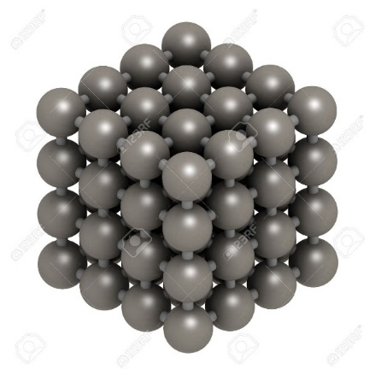

Figure 5.7: Structure of iron
https://www.google.co.za/search?q=iron+crystal+structure+image&hl=en-ZA&authuser=0&tbm=isch&tbo=u&source=univ&sa=X&ved=2ahUKEwjF65CHjsrfAhWqNOwKHbyIA0wQsAR6BAgGEAE&biw=1024&bih=488#imgrc=WNAbHTnsS0cwZM:

We have gone through quite a lot of material. Let us see if you can extract the important information in the following activity.
Activity 5.3
Read through the paragraphs above and use them to help you complete the table below. All the missing information you need is in the text.

Substance | Formula | Is it a compound or an element? | Is it Network or molecular? | If it is network, what kind of network is it? | Does it conduct electricity? | Is it hard, soft or brittle?
Lead
Sulfur
Potassium chloride
Buckyball
Graphite
Silica

Guided Reflection
Most of the information you need is in the text above and this activity is to see if you can find the information from the text. The answers are given in the complete table below:
Substance | Formula | Is it a compound or an element? | Is it Network or molecular? | If network, what kind of network is it? | Does it conduct electricity? | Is it hard, soft or brittle?
Lead | Pb | element | network | Metallic | yes | Soft
Sulfur | S₈ | element | molecular | Not network | no | Brittle
Potassium chloride | KCl | compound | network | ionic | Only when molten (in liquid form) or when dissolved in water | Brittle
Buckyball | C₆₀ | element | molecular | Not network | No | Brittle
Graphite | C | element | network | Covalent | Yes | Soft
Silica | SiO₂ |  | network | covalent | no | Brittle

Ions
In unit 4, we learnt that atoms can gain or lose electrons to form ions. When an atom gains electrons it becomes negatively charged (an anion) and when it loses electrons it becomes positively charged (a cation).
Ions on their own are not very stable, meaning that a positive ion can form a neutral compound itself by combining with a negatively charged ion. For example in unit 4, we saw that lithium loses an electron to become Li⁺ and fluorine generally gains an electron to become F⁻. The two ions can become stable by joining together to become LiF, a compound called lithium fluoride. From the section above, you may be able to guess that lithium fluoride is like sodium chloride.
Now that we have learnt about the periodic table and the arrangement of electrons in an atom, we can use the periodic table to predict how many electrons an atom is likely to gain or lose to become and ion.
The way we can do this is to refer to the noble gases which are very stable and do not easily gain or lose electrons. Atoms of elements will generally lose or gain electrons until they have a noble gas electron configuration. For example in the case of lithium above, losing an electron will leave lithium with 2 electrons, like helium. The difference is that helium is neutral because it has 2 protons but lithium has 3 protons.
In unit 4 we learnt about core and valence electrons. The core electrons are the inner electrons in the full energy levels and the valence electrons are the outer electrons. In most cases stable ions are formed by losing or gaining electrons until there are eight electrons in the outermost energy level. This rule is known as the octet rule and is a useful guideline to understand ion formation.
If you look at the periodic table, you can see that elements in the same groups generally have the same number of valence electrons. For groups 1 and 2, the number of valence electrons are the same as the number of the group. Groups 3-12 only apply to the transition elements. You will study the structure of the atoms of these elements if you study chemistry further. After group 2, we are interested in groups 13-18 and you can see that the number of valence electrons in these groups are exactly 10 less than the number of the group. For example, elements in group 13 have 3 valence electrons.
Elements on the left hand side of the periodic table are more likely to lose electrons to form ions whereas elements on the right hand side are more likely to gain electrons. Elements in the middle, like carbon, may lose of gain electrons but as you will see later, they are less likely to form ions at all.
The following activity will help you understand better.

Activity 5.4
Try to fill in the following table using what you have learnt so far. You will also need to refer to the periodic table in figure 4.1 in the previous unit. The first one has been done for you.

Element | Spectroscopic electron configuration | Number of core electrons | Number of valence electrons | Formula of most common ion
Magnesium (Mg) | 1s²2s²2p⁶3s² | 10 | 2 | Mg²⁺
Oxygen (O)
Potassium (K)
Chlorine (Cl)
Carbon (C)
Aluminium (Al)
Hydrogen (H)

Guided Reflection
You will see on the filled in table that carbon has been included and that it is written as a C⁴⁺ ion. In fact, it is not a very stable ion because of the energy needed to remove electrons, which we will discuss below. After doing this table, you will see that the periodic table is very helpful for working out the formation of the ions.

Element | Spectroscopic electron configuration | Number of core electrons | Number of valence electrons | Formula of most common ion
Magnesium (Mg) | 1s²2s²2p⁶3s² | 10 | 2 | Mg²⁺
Oxygen (O) | 1s²2s²2p⁴ | 2 | 6 | O²⁻
Potassium (K) | 1s²2s²2p⁶3s²3p⁶4s¹ | 18 | 1 | K⁺
Chlorine (Cl) | 1s²2s²2p⁶3s²3p⁵ | 10 | 7 | Cl⁻
Carbon (C) | 1s²2s²2p² | 2 | 4 | C⁴⁺ more likely
Aluminium (Al) | 1s²2s²2p⁶3s²4s¹ | 10 | 3 | Al³⁺
Hydrogen (H) | 1s¹ | 0 | 1 | H⁺

Energy changes in formation of the ions
In unit 4 we learnt about how coulomb’s law tells us about the forces between charges and how strongly they attract each other. The protons are positively charged and their charge is equal but opposite to the charge on the electron. If we think about a hydrogen atom, there is one proton and one electron some distance away. In order to form a hydrogen ion (H⁺) work needs to be done on the electron to remove it from the atom. This work requires energy, known as ionization energy. The more protons there are in the nucleus, the stronger the positive charge, so it will be require more energy to remove one of the outer electrons from helium, which has 2 protons.
Another thing to bear in mind is that when charges are further way from each other, the force between the charges will be weaker. This is according to coulomb’s law. So for example, it will require less energy to remove the valence electron from lithium because the electron is in the second energy level and further away from the nucleus. On the other hand, when an atom gains an electron energy is released. This information will be important when we study bonding in unit 6.
Writing formulae for elements and compounds
As the heading of this section suggests we will be looking at symbolic representations of matter as explained in figure 5.1
Representing the Elements
Chemists use the chemical symbols to write chemical formulae for substances. As we saw in unit 2, some of the non-metal elements exist as diatomic molecules. For example, the element oxygen is made up of diatomic molecules so we represent oxygen as 0₂ to show that 2 oxygen atoms bond together to form an oxygen molecule. (You will remember that we drew some of these molecules in Unit 2.) Other elements which exist as diatomic molecules are nitrogen (N₂), hydrogen (H₂), ﬂuorine (F₂), chlorine (Cl₂), bromine (Br₂) and iodine (I₂). You saw earlier in this unit that sulfur exists as molecules composed of 8 atoms so we write a formula for sulphur as S₈. Phosphorus exists as molecules composed of 4 atoms thus we write the formula for the element phosphorus as P₄. (However sometimes you may ﬁnd the formulae for sulfur and phosphorus given simply as S and P.) The formulae for most of the other elements are the same as their symbols. (You will understand why this is so after you have studied more about the ways atoms bond together in unit 6.
Thus
- the metals are presented by writing just the symbol, e.g. the formula for copper is the same as its chemical symbol, Cu.
- a few non-metals are also represented in this way, e.g. C and Si
- the gases helium, neon, argon, krypton, xenon and radon are represented as He, Ne, Ar, Kr, Xe and Ra.

Representing Compounds using Formulae
Very few elements in nature occur uncombined. Most of them combine with each other to form compounds. You will have to know how to write the formulae for many of these compounds using the symbols for the elements.
Table 1 below gives you a list of many of the common cations and anions. Some of them are elements but others are groups of elements. You will use these ions to help you write formulae for compounds. This list includes some of the elements beyond the first 20 elements. We include these because they are very common. For the first 20 elements, you can work out the ions using the periodic table and the octet rule. You will notice that on this list there are some more complicated ions consisting of several elements, e.g. the nitrate ion, N0₃⁻. This kind of ion is called a polyatomic ion, which means an ion made up of many atoms. There are very few things you will be required to memorise in chemistry but this is one of them. You must be able to remember the names of the ions, their symbols and their charges! Try to learn this list just before you go to sleep each night for about a week and you will be surprised how quickly you can remember them. As you use them more and more it also will become easier to remember them. You will need to be able to write the formulae for compounds very quickly.
Table 1: Formulae of common ions and their charges

Charges on some common cations (Positive ions) |  |  | Charges on some common anions (Negative ions)
Ions with a charge of +1 | Ions with a charge of +2 | Ions with a charge of +3 | Ions with a charge of -1 | Ions with a charge of -2 | Ions with a charge of -3
H⁺ - Hydrogen | Ca²⁺ - calcium | Al³⁺-aluminium | F⁻ - fluoride | O²⁻- oxide | PO₄³⁻- phosphate
Li⁺- lithium | Ba²⁺ - barium | Fe³⁺- Iron (III) or ferric | Cl⁻ - chloride | S²⁻
Na⁺ - sodium | Pb²⁺- lead (II) | Cr³⁺chromium (III) or chromic | Br⁻ - bromide | SO₃²⁻- sulfite
K⁺ - potassium | Fe²⁺ - iron (II) or ferrous |  | I⁻- iodide | SO₄²⁻ - sulfate
Ag⁺ - silver | Cu²⁺- copper (II) or cupric |  | OH⁻ - hydroxide | CO₃²⁻- carbonate
Cu⁺ - copper (I) or cuprous | Zn²⁺ - zinc |  | NO₃⁻- nitrate
Hg⁺- mercury (I) or mercurous | Mg²⁺ - magnesium |  | NO₂⁻ - nitrite
NH₄⁺ - ammonium | Hg²⁺- mercury (II) or mercurous |  | HCO₃⁻- hydrogen carbonate (bicarbonate)
Au⁺⁻ silver | Ni²⁺ - nickel |  | HSO₄⁻ - bisulfate or hydrogen sulfate
 |  |  | MnO₄⁻ - permanganate

As you look at this table, find the elements you can deduce just by looking at the periodic table. For example, sodium is in group 1. It has one valence electron, which it will lose in order to form a stable ion.
We are going to teach you a system for writing formulae although many of the ideas here will only become clearer to you as you progress through this module.
Let’s start with a few simple formulae. For example, write the formula for sodium chloride.
This one is very easy. Sodium forms a single positive ion (Na⁺) and chlorine forms a single negative ion (Cl⁻) so for a neutral sodium chloride compound the formula contains one of each – NaCl.
The same goes for whenever the charges are the same. For example, the formula for calcium carbonate is CaCO₃
If the charges on the ions are not the same you have to make sure that the total number of positive charges is the same as the number of negative charges. Let us try writing the formula for sodium oxide.
If we look at the list, we see that sodium is Na⁺ oxide is 0²⁻ . To write the formulae we try to balance the charges on the 2 ions so we can think about it like this:
Na⁺ has one positive charge and 0²⁻ has two negative charges. Therefore, we need 2 sodium ions to make 2+ and balance the 2- charge on the oxide ion. See below:

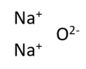
So we write the formula as Na₂O The subscript 2 refers to how many sodium ions there are in the formula. There is really a subscript of 1 next to the oxygen ion but we don’t write the subscript of 1 in.

The polyatomic ions may look difficult but you just treat the group of atoms in the ion as a single object and then it is easy. For example, write the formula for aluminium sulphate. The aluminium ion has a 3+ charge and the sulfate ion has a 2- charge. If we take 2 aluminium ions and 3 sulfate ions, then both will add up to 6 (2x 3+) and (3 x 2-). See below:
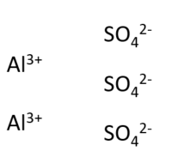

So the formula is Al₂(SO₄)₃. We write a bracket around the SO₄ to show that there are 3 sulphate ions in the formula. If we write the formula without the bracket, it will look like this Al₂SO₄ ₃ which is very confusing. It looks as though we mean 43 oxygen atoms are present.

When you look at table 1, you will notice that some elements like copper have differing charges. How do you decide which one to use? The name of the compound should show you which one to use. For example the instruction will say write the formula for copper(I)sulphate. The Roman numeral indicates that you use a charge of 1+ on the copper ion. So the formula will be: Cu₂S0₄.

If you are given a formula, and asked to name the compound, you can work out from the formula what the charge of the copper atom is. For example, if you are given the instruction, Write the name for the compound CuSO₄, then you can work out that the charge on the copper in this compound must be 2+ to balance the charge on the sulphate ion which is 2-. Thus, the name will be copper (ll) sulphate.

You will notice that on the table we have included some of the old-fashioned names in case you come across them. For example, cuprous and cupric or ferrous and ferric. The –ous always refers to the lower charge.
The endings “-ide", "-ite" and "-ate" can also be confusing. The ending -ide is used when an element has combined with another element or ion. For example, when chlorine combines with another element, e.g. sodium, we name the compound sodium chloride. The -ate ending refers to a complex ion with one more oxygen than the -ite form of the complex ion. For example, the SO₄²⁻ ion is named sulphate which has one more oxygen atom than the SO₃²⁻ or sulphite ion. Similarly the nitrate ion NO₃⁻ has one more oxygen atom than the NO₂⁻ or nitrite ion.
Try to write the names or formulae for some substance in the next activity.

Activity 5.5
1. What are the names of the following compounds?
a. CuSO₄ b. Ca(NO₃)₂ c. BaCl₂
d. ZnI₂ e. NH₄Cl f. Pb(OH)₂
g. FeS h. KMnO₄ i. Mg(OH)₂
j. Fe(HSO₄)₃

2. Write the formulae for the following compounds
Write the formulae for the following compounds:
- copper(I) nitrite b. iron(III) permanganate
c. ammonium sulfate d. potassium carbonate
e. aluminium sulfate f. magnesium hydrogencarbonate
g. chromium (Ill) oxide h. silver phosphate
i. iron(III) nitrate j. magnesium phosphate
k. aluminium sulfate l. copper(II) hydroxide
m. ammonium bromide n. sodium oxide
o. lead(Il) hydroxide p. iron(III) hydrogencarbonate
q. copper (I) hydrogensulfite

Guided Reflection
Suggested answers are below. If you have made a mistake, make sure you can see what your problem was. Writing correct formulae and names is a very important part of chemical language but there is a system to it that you need to understand.
1. a. copper (II) sulfate b. calcium nitrate c. barium chloride
d. zinc iodide e. ammonium chloride f. lead (II) hydroxide
g. iron sulphide h. potassium permanganate i. magnesium hydroxide
j. iron (III) hydrogen sulfate

2. a. CuNO₃ b. Fe (MnO₄)₃ c. (NH₄)₂SO₄
d. K₂CO₃ e. Al₂(SO₄)₃ f. Mg(HCO₃)₂
g.Cr₂O₃ h.Ag₃PO₄ i. Fe(NO₃)₃
j. Mg₃(PO₄)₂ k. Al₂(SO₄)₃ l. Cu(OH)₂
m. NH₄Br n. Na₂O o. Pb(OH)₂
p. Fe(HCO₃)₃ q.CuHSO₄

Key learning points from unit 5
Now that you have completed the study of unit 5, you should be able to:
- Differentiate between individual atoms, ions, molecules and networks;
- State the octet rule;
- Apply the octet rule to describe the formation of cations by metal atoms, and anions by non-metal atoms;
- State the name of compound ions such as hydroxide, ammonium, nitrate, nitrite, sulfate, sulfite and carbonate.
- Write formulae of ionic compounds given a list of ions
- Write the names of compounds given the formulae

Unit 6: Types of chemical bonding

Outcomes
By the end of this unit, you should be able to
- Describe the three main kinds of bonds between atoms
- Describe metallic bonding and explain the hardness/softness of metals, electrical and thermal conductivity in terms of metallic bonding;
- Identify the types of bonding in various everyday materials.
- Describe the formation of molecules of elements (the 7 diatomic gases) and molecules of compounds (covalent bonding) in words and using Lewis dot diagrams
- Describe ionic bonding in words and using Lewis dot diagrams;
- Define electronegativity and explain the trend in electronegativity on the periodic table;
- Identify whether simple diatomic molecules will be polar or non-polar based on the relative electronegativities of the atoms involved;
- Define polar and non-polar molecules;
Introduction to Unit 6
Most atoms do not exist on their own but are bonded to other atoms. In this unit, we will try to understand how atoms join or bond together. The main reason that atoms bond together is because bonding lowers the potential energy of the atoms. (You dealt with the concept of potential energy in the physics module, but we will later discuss how it applies to chemistry). The bonds between atoms are not all the same. Some of the properties of atoms we studied in Units 3 – 5 inﬂuence the kind of bonds formed between atoms. Therefore, you have to interrelate many ideas from earlier units in this unit.
How is bonding related to the world around us?
The properties of a substance are determined to a large extent by the bonds that hold atoms together in that substance. For example, the state (solid, liquid or gas) of a substance at room temperatures and pressures (approximately 1 atm and 25°C) depends on the kinds of bonds in that substance. There is a branch of engineering called materials engineering where scientists use their understanding of bonding to design materials (or substances) with specific properties that they require. For example, when the space shuttle re-enters the Earth‘s atmosphere, it could burn up because of the extremely high temperatures caused by the friction (or rubbing) of the air particles amidst the shuttle. To prevent this, the space shuttle is covered by a substance which scientists have designed that is extremely hard, has a very high melting point and won‘t combust (catch ﬁre). Special materials are used to insulate (prevent heat being transferred to) the inside of the space shuttle.
A diamond (one of the forms of the element carbon you learnt about in unit 5) is also an extremely hard substance with a very high melting point. Diamonds are used to cut other substances e.g. glass, and are even used at the tip of drills that penetrate deep into the earth through rocks. Again, the diamond has these properties because of the way the carbon atoms are bonded together in this element. As we saw in unit 5, this form of carbon is very different from the lead (or graphite) in your pencil which in fact is not lead but another form of carbon in which the atoms are bonded in a rather different way from that in a diamond. As you write with your pencil, layers of carbon atoms rub off onto your paper.
As you go through this unit, you will learn some of the fundamental principles of bonding between atoms and how they are related to the properties of substances.
An overview of the kinds of bonds between atoms
First, we will try to classify the types of the bonds that can form between atoms. You know how to distinguish between metals and non-metals from the position of the elements on the periodic table. You also know about the differences in the properties such as number of valence electrons between the metals and the non-metals. These ideas will be very important in helping you understand bonding.

Let’s recap them in the next activity to make sure you remember them before we go further.

Activity 6.1
Complete the following sentences by choosing the correct word/phrase from those in the brackets:
1. Metals have (fewer, more, the same number of) valence electrons than/as non-metals.
2. Metal atoms most often form (positive/negative) ions.
3. Metals form ions by (gaining/losing) electrons.
4. Metals are (good/poor) conductors of electricity.
Guided Reflection
All the above four sentences are about what you have learnt in previous units. Try not to look back when responding. The correct answers are given below:
1. Metals have fewer valence electrons than non-metals.
2. Metal atoms most often form positive ions
3. Metals form ions by losing electrons.
4. Metals are good conductors of electricity.

Broadly, speaking, metals and non-metals can combine in. 3 different ways:
1. Metal with metal. This bond is called a metallic bond.
2. Metal with non-metal. Generally, this bond is called an ionic bond.
3 Non-metal with non-metal. This bond is called a covalent bond.
In all these kinds of bonds, the valence electrons are involved in the bond formation.
Metallic Bonds
Metal atoms are relatively large and have few valence electrons. In addition, metals tend to lose their valence electrons easily. These valence electrons move around among the metal nuclei and their core electrons. Thus, all the metal atoms in a piece metal share their valence electrons with the other atoms. This results in sea of electrons that ﬂows among all the metal nuclei (and their core electrons) as shown in ﬁgure 6.1 below. We say that the valence electrons are delocalised or move throughout the metallic structure. The valence electrons are conﬁned to the piece of metal by the electrostatic forces of attraction of the nuclei of the metal atoms. The attraction of the metal nuclei for this sea of mobile electrons gives rise to the metallic bond. It is a relatively strong bond. Most metals are solids at room temperatures and pressures and have relatively high melting and boiling points. However mercury is a liquid at room temperatures.

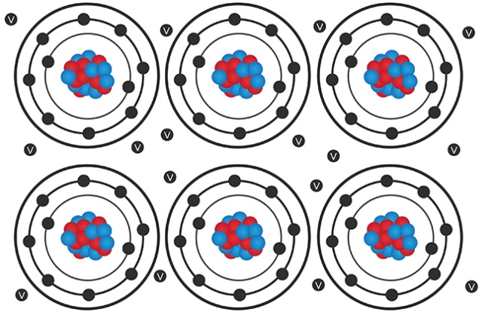
Valence electrons
Core electrons
Nucleus

Figure 6.1: Diagram Showing Metal Atoms Held Together by a Metallic Bond
https://www.google.com/search?q=image+metallic+bonding&rlz=1C1GCEA_enZA815ZA815&tbm=isch&tbo=u&source=univ&sa=X&ved=2ahUKEwja1LrXrNHfAhVy1-AKHdklAsoQsAR6BAgBEAE&biw=1920&bih=969#imgrc=vY59S8XWV3JTYM:

Thus, no separate molecules exist in the metallic structure. The whole lump of metal can be considered as a giant or macromolecule which we see with our eyes. When we write formulae for the metals e.g. Zn or Na etc., we are writing empirical formulae which represent the lowest ratio of atoms in the metal (you will learn more about this later). Because there are no separate molecules in each piece of metal, we cannot write molecular formulae for metals.
The metallic bond accounts for many of the properties of metals:
- Metals conduct electricity well. Because of the mobility of the valence electrons, extra electrons are able to pass through metals.
- Metals are good conductors of heat because of the mobility of the valence electrons in the metallic bond. If you place a piece of metal and a piece of wood in your hand, the metal feels colder. However, both the metal and the wood are at the same temperature. Your hand is warmer than both, but the metal feels colder because it conducts heat away from your hand faster than the wood.
- Metals are malleable. This means that they can be hammered and beaten into ﬂat sheets. Because the metallic bond is strong, the atoms slide over each other as the metal is hammered. The metallic structure does not shatter the sea of valence electrons keeps the nuclei and core electrons together. This also accounts for the fact that metals can be bent.
- Metals are ductile. This means that metals can be pulled into long thin wires. Again, this is because of the strength of the metallic bond.
- The interaction of the sea of electrons with light, gives metals their characteristic shine or lustre.
Different metals do not bond with each other to form compounds. We regard these rather as mixtures or alloys of different metals. These mixtures of metals are used in many activities e.g. the manufacture of cars, aeroplanes and jewellery, and in dental work. Bronze and brass are examples of alloys of metals.

Ionic Bonds
lonic bonds form when metals from Groups 1 and 2 in the periodic table bond with non-metals from group 17 and the upper part of Group 16. These metals easily lose valence electrons whereas the non-metals more easily gain electrons. The metal atoms thus tend to lose their valence electrons to the non-metal atoms. This transfer of electrons results in the metal atoms forming cations and the non-metals atoms forming anions. Strong electrostatic forces of attraction hold these cations and anions together. This gives rise to the ionic bond. This type of bonding is illustrated in the figure 6.2 below.
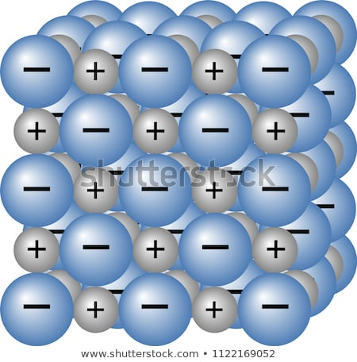
Large array of cations and anions forms ionic crystal

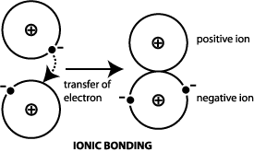

Figure 6.2 Formation of lonic Bonds
https://www.google.com/search?rlz=1C1GCEA_enZA815ZA815&biw=1920&bih=969&tbm=isch&sa=1&ei=4uMtXObRM4e_UrqShKgB&q=image+ionic+crystal&oq=image+ionic+crystal&gs_l=img.3...49172.51130..51443...0.0..0.357.1684.2-6j1......1....1..gws-wiz-img.......0i8i30.uVTi6C7Srd4#imgrc=l1Iwsy3QI1qoaM:
small image
https://www.google.com/search?rlz=1C1GCEA_enZA815ZA815&biw=1920&bih=969&tbm=isch&sa=1&ei=ntwtXMTdMtaDjLsPxfC5yAw&q=image+ionic+bonding&oq=image+ionic+bonding&gs_l=img.3..0i8i30.1855547.1858628..1859229...0.0..0.221.1299.2-6......1....1..gws-wiz-img.......0i8i7i30.Nuf-KmET9Hc#imgrc=yq0szf-FMQ4p6M:

- Once again there are no separate small molecules. The whole piece of ionic compound (or crystal) can be regarded as a giant or macro molecule that we can see. When we write formulae for the ionic compounds e.g. KF or CaBr₂, we are writing empirical formulae which represent the lowest ratio of atoms in the compound. Because there are no separate molecules in ionic crystals, we cannot write molecular formulae for ionic compounds. Ionic bonds are very strong. Thus, ionic substances (also referred to as salts) tend to be solids at room temperature and pressure, and have high melting and boiling points.
Ionic substances have the following properties:
- They are hard substances but are brittle (or break up into small pieces) if they are hammered.
- They do not conduct electricity in the solid state. This is because the ions are held ﬁrmly in place by the ionic bond. However, ionic substances do conduct electricity when they have been melted. This is because the ionic bonds have been weakened somewhat and the ions are able to move over each other. Aqueous solutions of ionic compounds also conduct electricity because the ions become separated from each other in the water and are able to move freely.
We encounter many of these ionic compounds in our day-to-day activities. For example, sodium chloride or NaCl is an ionic compound that we sprinkle over our food to enhance the taste. Many of these ionic substances or salts are vital to the healthy functioning of our bodies.

Covalent Bonds
Atoms that are non-metals tend to share electrons when they bond. This kind of bond is called a covalent bond. The valence electrons are involved in the bonding. The shared electrons are ﬁrmly under the control of the nuclei of the atoms that are bonding and are not free to move around the substance as they do in a metal. We say the electrons are localised between the bonded atoms. Figure 6.3 below shows a covalent bond forming between two hydrogen atoms.

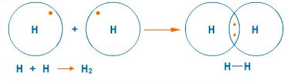

Fig 6.3 Covalent Bond Formation between two Non-metals
https://www.google.com/search?rlz=1C1GCEA_enZA815ZA815&biw=1920&bih=969&tbm=isch&sa=1&ei=cectXNrxF-KN1fAP_qy7mAI&q=image+covalent+bonding+hydrogen&oq=image+covalent+bonding+hydrogen&gs_l=img.3...1312771.1320888..1321232...0.0..0.341.6572.2-17j8......1....1..gws-wiz-img.......0j0i30j0i5i30j0i8i30j0i24.Z5FcwYKfxCQ#imgrc=dxSeLu8JN4QwtM:

Many substances in which covalent bonding occurs, form separate, extremely small molecules which we are not able to see. We call these substances covalent molecular substances. We can write molecular and empirical formulae for such covalently bonded substances. Thus if we write the formula for water as H₂O, we mean that each molecule of water consists of 2 atoms of hydrogen and 1 atom of oxygen.
However, there are some substances like the diamond, in which atoms are bonded covalently to form a ‘giant’ or macromolecule. Such substances can only be represented by empirical formulae. Thus the formula for carbon (diamond) is C(s). These substances are extremely hard and have very high melting and boiling points.
Many covalent molecular substances are gases at room temperatures and pressures but they can be liquids and solids, too. They have relatively low melting and boiling points. Covalently bonded substances do not conduct electricity, as the electrons are ﬁrmly under the control of the nuclei and are not free to move.
Covalently bonded substances by far out-number ionic substances. Covalent molecules range from simple diatomic molecules like hydrogen, H₂, or Oxygen, O₂, to complex biological molecules which are made up of hundreds of atoms.
We will now do two activities. The first is to see if you understand the three main kinds of bonding we have discussed in this section. The second one is a home experiment to explore a property of the three types of bonding.

Activity 6.2
State the kind of bonding (metallic, ionic or covalent) that you would expect in each of the following substances: (g) for gases; (s) for solids
a. N₂(g) b. Li(s)
c. NO(g) d. CaO (s)
e. HBr (g) f. Al (s)

Guided Reflection
Before you decide what kind of bonding each has, you need to look at the periodic table to decide whether the element is a metal or non-metal. Pure metals will have metallic bonding. Here are the answers:
a. N₂(g) covalent b. Li(s) - metallic
c. NO(g) - covalent d. CaO (s) - ionic
e. HBr (g) - covalent f. Al (s) - metallic

Activity 6.3
Looking at the effect of heat on substances with three types of bonding:
Put a small quantity of the following three substances on a pan and turn on the stove on a low heat.
The three substances are wax (covalent bonding), aluminium foil (metallic bonding) and salt (ionic bonding).
You should observe that only the wax will melt. The wax is made of a compound that contains a chain of carbon and hydrogen covalently bonded. You will learn about similar substances in a later unit. The salt crystals may jump off the pan but the aluminium will just absorb the heat.
We will now spend most of the rest of this unit learning more about covalent bonding
Using Lewis Diagrams in Bonding
In Unit 4, we used representations called Lewis electron dot diagrams to show the valence electrons in atoms. We can use these diagrams again to show what happens to the valence electrons during ionic and covalent bonding

Using Lewis Diagrams to Show Ionic Bonding
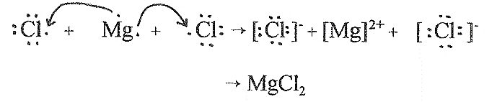
We can easily represent the transfer of electrons during ionic bond formation, for example during the formation of an ionic bond between lithium and fluorine and secondly between magnesium and chlorine. See figure 6.3 below.
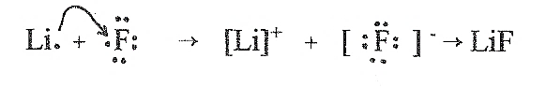
Figure 6.4: Use of Lewis diagrams for formation of lithium fluoride (left) and magnesium chloride (right)
Notice that two chlorine atoms are needed for one magnesium atom. You learnt about this in unit 5.
Let‘s see if you can use these Lewis representations in the next activity
Activity 6.4
Use Lewis electron-dot diagrams to show the ionic bonding for the following: (In each case, write the formula tor the compound below your Lewis representation)
1. sodium bonding with oxygen
2. calcium bonding with oxygen
Guided Reflection
Do these examples exactly as in figure 6.4. Remember that calcium has 2 valence electrons and oxygen has 6. Sodium has 1 valence electron. Answers are below
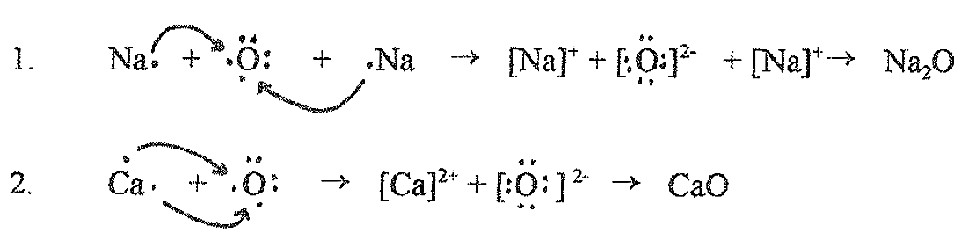
Using Lewis Diagrams to Show Covalent Bonding
Lewis electron-dot diagrams also work very well to represent covalent bonding. For example, in a molecule of hydrogen, H₂, a covalent bond is formed between the two hydrogen atoms.
We can show this as
When a covalently bonded molecule of fluorine. F₂, forms, we can show this as
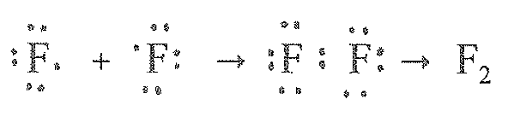
The shared pair of electrons is sometimes called the bonding pair of electrons. Those pairs of electrons which are not involved in the bonding are called the lone pairs of electrons. H₂ has no lone pairs but F₂ has 6 lone pairs of electrons (3 lone pairs on each ﬂuorine.)

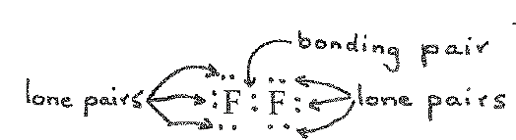

The bonds shown H₂ and F₂ above are called single bonds because only 1 pair of electrons is shared between the two atoms.
Sometimes we draw a line between the two atoms to show the shared pair of electrons instead of showing the electrons themselves, e.g. For H₂ and F₂
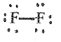
H—H and

Let’s consider the covalent bond formation in oxygen, O₂,
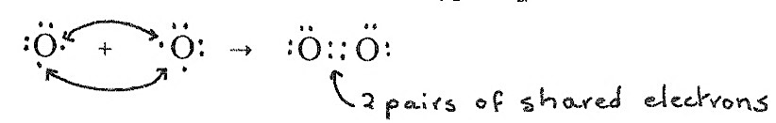

Thus 2 pairs of electrons are shared between the oxygen atoms. This is called a double bond. We can also show it like this by drawing lines between the two atoms instead of bonding electron pairs.
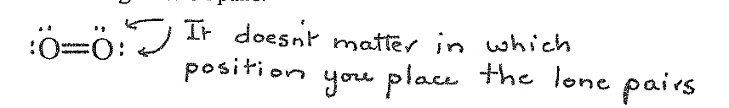

The element nitrogen, N₂, forms nearly 80% of our atmosphere. The covalent bond formation in this element can be shown like this:
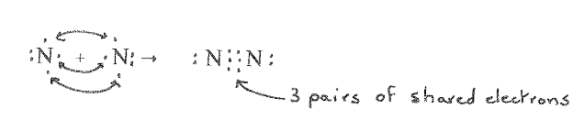

Thus, a triple bond forms between nitrogen atoms. We can also represent this as:
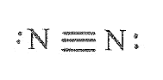

In general, the strength of single bonds is less than the strength of double bonds and the strength of double bonds is less than the strength of triple bonds.
In addition, the length of single bonds is less than the length of double bonds and the length of double bonds is less than the length of triple bonds.
Now you need to try and draw some Lewis electron dot diagrams.
Activity 6.5
Draw Lewis electron dot diagrams showing covalent bonding for the following molecules. Some of the more complex molecules are represented by projection formulae, which show how the atoms are linked but not the true shape. Lone pairs have not been included so you must make sure you remember to include them in your drawings.
1. Cl₂
2. H₂O
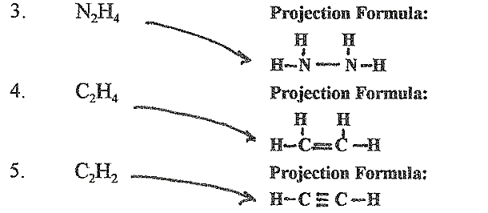

Guided Reflection
Remember to start by drawing the valence electrons around the atom and then looking for single electrons to share in order to make the bond. For double bonds, 2 pairs of electrons need to be shared.
1. Cl₂ is very similar to F₂ above – the Lewis diagram is shown below
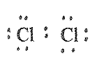

2. The Lewis diagram for H₂O needs a little more thought because the O has to form a bond with two atoms of H. Remember O has 6 valence electrons, two are paired and two are unpaired, so each H will bond with one of the single electrons making the Lewis diagram below. There are two possibilities as it doesn’t matter which way you draw the diagram.
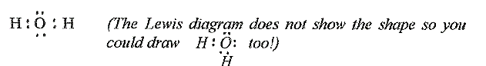

To do numbers 3, 4 and 5 you need to start with the projection formula. See if you can match the answers to the question above.
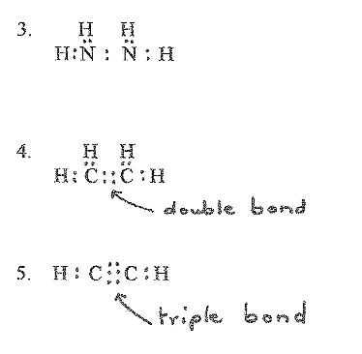

The Octet Rule applied to bonding
You may have noticed that when atoms bond, they lose or gain electrons (in ionic bonding) or share electrons (in covalent bonding) until they have a ﬁlled outer shell containing 8 electrons (except in the case of hydrogen which has only 2 electrons). This is referred to in many text books as the octet rule. However, this rule is broken more than it is obeyed! In fact, as you continue your studies with chemistry you will ﬁnd that very few elements (only carbon, nitrogen, oxygen and fluorine) always obey this rule. So as you encounter more molecules in this course don‘t be surprised if atoms sometimes have less than or more than 8 electrons in their valence energy level.
Far more important is the rule of two! It appears to be an underlying principle in bonding that the electrons become paired.

Electrons are not always shared equally
Electronegativity
Although a covalent bond involves sharing of electrons, atoms do not always share electrons equally. The attraction of atoms involved in covalent bonding is not always identical and so the pulling force (or force of attraction) of the nuclei of the atoms on the shared electrons will not always be the same. (It's a bit like sharing a blanket with someone on a cold winter’s night! During the course of the night, you might ﬁnd you are left shivering as the other person pulls the blanket towards himself/herself!)
The relative ability of an atom in a molecule to attract shared electrons towards itself is called the electronegativity of the atom. This a very important concept in chemistry. Electronegativity is really the overall effect of the size of the atom, and its overall charge, in relation to those same properties on the other atom it is bonded to in a molecule. Because electronegativity is in relation to a chemical bond, it always has to be compared to something. A scale of relative electronegativity values was developed by a scientist named Linus Pauling who was awarded two Nobel prizes, one for chemistry and the other for peace. Read more about him by clicking on the link below:
https://cosmosmagazine.com/chemistry/linus-pauling-the-man-who-won-two-nobel-prizes

Figure 6.4: Linus Pauling
https://www.google.co.za/search?q=linus+pauling&tbm=isch&source=iu&ictx=1&fir=6jdHKp00ZB9VNM%253A%252Ch_QZ3-0-RPE25M%252C_&usg=AI4_-kQz0832PCJue63w4MpMIPpp1gPsSg&sa=X&ved=2ahUKEwio6PbK6dPfAhXE1-AKHV46BmQQ_h0wGHoECAQQEg#imgrc=gEy2udcSTWytiM:
Linus Pauling allocated the most electronegative element, fluorine a value or 4 and then worked out all the other values in relation to 4. There are no units for electronegativity. This is because the values are relative or in comparison to one another. Thus, the electronegativity of nitrogen is 3.0 and that of lithium is 1.0, it means that the electrostatic force of attraction on a shared pair of electrons by nitrogen is 3 times greater than the electrostatic force of attraction by lithium.
The electronegativity (EN) values for the elements are shown in figure 6.5 below.
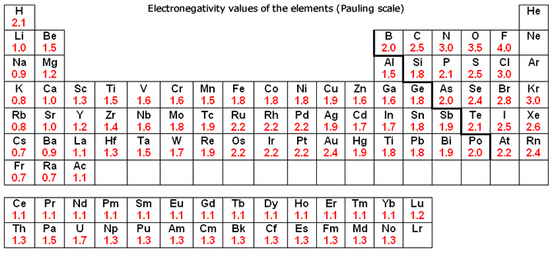

Figure 6.5: Electronegativities of the elements
https://www.google.com/search?q=image+electronegativities+of+the+elements&rlz=1C1GCEA_enZA815ZA815&tbm=isch&tbo=u&source=univ&sa=X&ved=2ahUKEwiCzIPc6tbfAhWvUxUIHYDuDyoQsAR6BAgEEAE&biw=1920&bih=969#imgrc=lVesUMlWfauM-M:
Use figure 6.5 to help you with the next activity.

Activity 6.6
- Which element is the most electronegative?
- Why are there no electronegativity values for the noble gases (Group 18)?
- In general, what is the trend in electronegativity as we move, from left to right, across a period in the periodic table? Explain.
- In general, what is the trend in electronegativity as we move down a group in the periodic table? Explain.
Guided reflection
- Fluorine (symbol F) is the most electronegative element.
- There are no electronegativity values for the noble gases, as they do not combine with other elements to form molecules of compounds. (However, we have already mentioned earlier that it is possible to form compounds of krypton and xenon).
- As we move across a period in the periodic table, in general, electronegativity increases. This is because the charges on the nuclei are increasing but the electrons are in the same energy level. Therefore, according to coulomb’s law, the force on the valence electrons is increasing and then the radii of the atoms decreases. Thus, the force of attraction of the nuclei on a shared pair of electrons will increase.
- As we move down a group in the periodic table, in general, electronegativity decreases. The radii of the atoms increase down a group because the atoms are getting bigger. Thus, the force of attraction on the shared pair of electrons will decrease.

Equal and Unequal Sharing of Electrons
Equal Sharing of electrons
When two atoms of the same kind of element are covalently bonded together, the electronegativities of the atoms sharing the electrons will be equal. Thus the bonding pair of electrons will be equally shared between the two atoms as in the example of F₂ below.

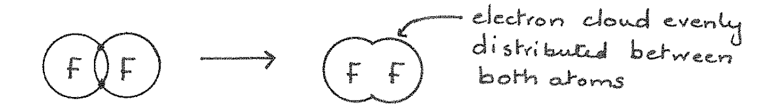
The difference in electronegativity for the 2 atoms, Δ E.N. = 4.0 - 4.0 = 0. So then we say the bond in F₂, is a non-polar covalent bond.
Unequal Sharing of electrons
When two different atoms are covalently bonded' together, the electronegativities of the atoms sharing the electrons may be different. Thus the bonding pair of electrons will be unequally shared between the two atoms as in HF below:

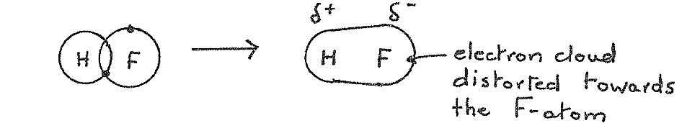

The difference in electronegativity for the 2 atoms, ΔE.N. = E.N. (F) – E.N. (H) = 4.0 – 2.1 = 1.8.

Thus, the F-atom will pull the shared electrons towards itself so that these electrons spend more of their time near the fluorine atom. The ﬂuorine atom has a partial (small) negative charge which is shown as δ - (δ is a Greek letter, delta] while the hydrogen has a partial positive charge δ+. We say the bond in HF is polar covalent.

Very unequal sharing of electrons
When atoms with extremely different electronegativities bond together, there is very unequal “sharing” of the bonding pair of electrons which results in the transfer of an electron to the more electronegative atom, an ionic bond forms.

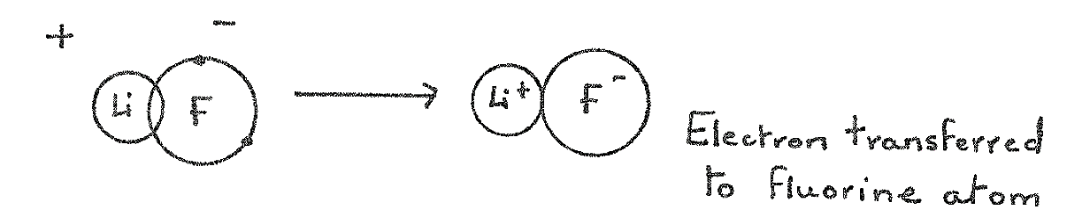

In this case, ΔE.N. = E.N. (F) – E.N. (Li) = 4.0 – 1.0 = 3.0.

We could really consider an ionic bond as the result of very unequal sharing of electrons. So ionic and covalent bonds are not very different!

Making Predictions Using Electronegativity

We can develop a scale of ΔEN (the difference in electronegativities of atoms) to help us predict whether a bond between two atoms is non-polar, polar or ionic. Figure 6.6 can help you.
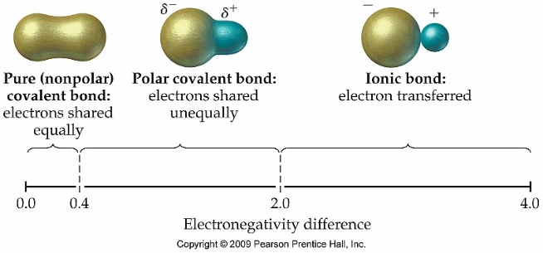

Fig. 6.6 Scale of electronegativity differences.
https://www.google.co.za/search?q=scale+of+difference+in+electronegativities+image&tbm=isch&tbo=u&source=univ&sa=X&ved=2ahUKEwiar7jctdTfAhXB34UKHZF9B2UQsAR6BAgCEAE&biw=1536&bih=736#imgrc=p3LtQ5_vox13wM:
(Definitely, copyright but I like the representation)

So
if ΔE.N. is 0.0 - 0.4, the bond can broadly be classiﬁed as non-polar.
if ΔE.N. is 0.4 - 2.0, the bond can broadly be classiﬁed as polar covalent.
if ΔE.N. is 2.0 - 4.0, the bond can broadly be classiﬁed as ionic.

You ﬁnd the above scales with slightly different values from these quoted above, in different textbooks. There are slightly different ranges for the classiﬁcation of the bonds.

This scale shows us that there are trends in bonds from non-polar, through polar to ionic. But remember this scale is just a guide! There will be exceptions. Other properties such as melting points, solubilities, etc. should be taken into account when deciding about the nature of the bonds in a substance. Now try the next activity in which you use this scale.
Activity 6.7
1. Which of the following molecules has bonds which are the most polar?
N₂, CO, H₂S, H₂O
2. Say whether the bonds in the following molecules are non-polar covalent, polar covalent or ionic. Explain your decisions.
- Cl₂
- NCl₃
- KCl
- ClF
- BaCl₂

Guided Reflection
For this whole exercise, use the values of electronegativities for individual atoms from figure 6.5.
1. Here, we must look at the electronegativity difference. You need to look for electronegativity values for each atom in the bond and find the difference in electronegativity (ΔE.N.)
N₂ - ΔE.N. = 0
CO - ΔE.N. = 3.5 -2.5 = 1.0
H₂S – (Just use one of the H-S bonds) H-S ΔE.N. = 2.5-2.1 = 0.4
H₂O – (Just use one of the H-O bonds) H-O ΔE.N. = 3.5-2.1 = 1.4
Thus, the molecule with the most polar bond is H₂O
2. Use the scale in fig 6.6 to help you.
a. The bond is non-polar covalent, 2 different atoms with the same electronegativity, therefore ΔE.N. = 0
b. NCl₃: this molecule has 3 N-Cl bonds – they are all the same. ΔE.N. for each bond = 3.0 – 3.0 = 0. This is an interesting situation – N and Cl are different elements with different properties but the attraction they exert on an electron in a bond is the same. Therefore, the bond is non-polar.
c. The KCl bond is ionic; the bond is between a metal and a non-metal,
ΔE.N. = 3.0 - 0.8 = 2.2
d. ClF, the bond is polar covalent, both non-metals
ΔE.N. = 4.0 - 3.0 = 1.0
e. BaCl₂, each bond is ionic, metal bonded to non-metal, again working out for just one bond
ΔE.N. = 3.0 – 0.9 = 2.1

Are molecules with polar bonds, polar molecules?
The terms polar bond and polar molecule do not mean the same thing! A molecule may have polar bonds and yet be a non-polar molecule. For diatomic molecules like HF, in the example above, if the bond between the two atoms is polar, the molecule as a whole will be polar. However, if the molecule is made up of more than 2 atoms, it is not so simple! The shape of the molecule will play an important role, too.
For example. Let’s consider the molecule, CO₂.
You have learnt how to calculate polarity of the C-O bond by finding the difference between the electronegativities using the values in figure 6.5. For the C-O bond,
ΔE.N. = 3.5 –2.5 = 1.0
According to the scale in figure 6.6, C-O is a polar bond.
Scientists have methods to find out the shape of molecules and according to their experiments, CO₂ has a linear shape, like this:
O = C = O
We say it is a linear molecule because all 3 atoms lie in a straight line. The O - atoms are more electronegative than the carbon atom and so each O - atom will pull the electrons towards itself as shown below.
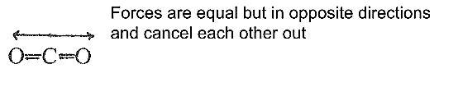

This means there are two equal but opposite forces pulling away from the carbon. As you know from your physics module, forces are vectors meaning they have both magnitude and direction and they are added using a graphical method.
The forces are equal but act in the opposite direction. Thus, the sum of these vectors will be zero. The pulling force of the O- atom on the shared electrons in one direction is cancelled out by the pulling force of the O- atom acting the other direction. Therefore, although the bonds in CO₂ are polar, the molecule as a whole is non-polar.

Now let’s consider the molecule, H₂O. Again, it can be shown that the water molecule has the following shape
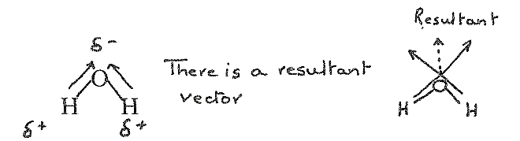

We describe the water molecule as angular or bent. Each of the O-H bonds is polar with the O-atom pulling the electrons towards itself. This time the sum of the vectors is not zero. Again, you need to refer to the physics module here. There is a resultant vector so that the O-atom has a negative partial charge and the two H-atoms each have positive partial charges. Thus in the water molecule, the bonds are polar and the molecule as a whole is polar.
Therefore, to make decisions, then, as to whether or not a molecule is polar we have to consider not only the electronegativity of the atoms in the molecule but also the shape of the molecule.

Summary Assessment Units 5 & 6
We have covered many aspects in this unit on bonding. Now let's see how much you understand You may need to refer to the Periodic Table in Figure 4.1 of unit 4, to help you with some of the answers.

Task 1
Below are formulae for ionic compounds. To which groups in the periodic table could the elements X, Y and Z belong?
a. XF₂
b. MgY
c. Z₂SO₄
Task 2
A student suggests the following dot diagram for acetone, C₃H₆0.
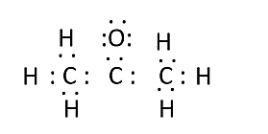

Do you agree with this representation? If not, explain what is wrong with it and draw the correct dot-diagram.
Task 3
Which of the elements in each list below has the largest electronegativity? Explain. Do this by using the periodic table figure 4.1 of unit but don’t look at the table of electronegativities that was given in this figure 6.5 of this unit. The idea is to use the periodic trends we learnt about above.
a. Si, Mg, P, S, Na
b. Si, Cl, Rb, Ca, S
Task 4
The COS molecule is linear. Will this molecule be polar or non-polar? Explain.

Answer Key for Summary Assessment
Task 1
Below are formulae for ionic compounds. To which groups in the periodic table could the elements X, Y and Z belong?
a. X needs to belong to group 2 as it bonds with 2 atoms F which is in group 17. Elements in group 17 are missing a single electron to fill their energy level. Therefore, X must have 2 valence electrons
b. Y must belong to group 16 as it requires 2 more valence electrons for a full energy level, Mg has two valence electrons.
c. The sulfate ion as a double negative charge and therefore would need to bond with an atom that has 2 valence electrons. This means Z would be in group 2.
Task 2
The dot diagram suggested by the student is wrong. The carbon atom in the middle has only 6 electrons in its outer energy level. According to the octet rule, carbon accommodates 8 electrons in its outer energy level.
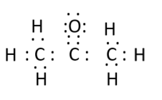
There needs to be a double bond between the carbon and oxygen atoms.

Task 3
Which of the elements in each list below has the largest electronegativity? Explain. Do this by using the periodic table figure 4.1 of unit but don’t look at the table of electronegativities that was given in this figure 6.5 of this unit. The idea is to use the periodic trends we learnt about above.
a. S has the highest electronegativity. The given elements are all in the same period of the periodic table. Electronegativity increases across a period.
b. Cl has the greatest electronegativity. The given elements are all in the same period of the periodic table. Electronegativity increases across a period.
Task 4
The COS molecule is polar. The molecule is linear and the electronegativities of the atoms are shown above each atom
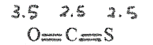

The pulling force of the O atom is greater than that of the S atom. Thus the vectors do not cancel each other out. The O side will have a slightly negative charge and the S atom will have a small positive charge.
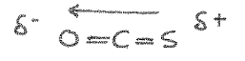

Key learning points from unit 6
Now that you have completed the study of unit 6, you should be able to:
- Describe the three main kinds of bonds between atoms
- Describe metallic bonding and explain the hardness/softness of metals, electrical and thermal conductivity in terms of metallic bonding;
- Identify the types of bonding in various everyday materials.
- Describe the formation of molecules of elements (the 7 diatomic gases) and molecules of compounds (covalent bonding) in words and using Lewis dot diagrams
- Describe ionic bonding in words and using Lewis dot diagrams;
- Define electronegativity and explain the trend in electronegativity on the periodic table;
- Identify whether simple diatomic molecules will be polar or non-polar based on the relative electronegativities of the atoms involved;
- Define polar and non-polar molecules;

