Mathematics

Topic 2: Functions, Graphs and Algebra
NASCA Mathematics

Sub-Topic 3: Functions 3
Unit 1: What Are Functions? 3
Activity 1: Discovering Functions 3
Activity 2: Functions and Relations 16
Activity 3: Ways to Represent Functions 19
Unit 2: Linear Functions 22
Activity 1: Sketching Linear Functions Part 1 22
Activity 2: The Gradient of the Straight Line Graph 27
Activity 4: Sketching Linear Functions Part 2 29
Activity 5: Domain and Range 32
Activity 6: Interpreting Linear Functions 34
Activity 7: End of Section Questions 36
Unit 3: Quadratic Functions 37
Activity 1: Sketching Quadratic Functions Part 1 39
Activity 2: The Effects of $a$ and $c$ in $y=ax2+c$ 43
Activity 3: The Turning Point Form 45
Activity 4: Quadratic Marbleslides 50
Activity 5: Sketching Quadratic Functions Part 2 51
Activity 6: Transformations 57
Activity 7: A Very Special Transformation 64
Activity 8: Inverses of Functions 68
Activity 9: Finding Equations of Quadratic Functions 71
Activity 10: Applications of Quadratic Equations and Review 73
Unit 4: Hyperbolic Functions 76
Activity 1: Introducing the Hyperbolic Function 76
Activity 2: The General Form of the Hyperbolic Function 87
Activity 3: Finding the Equations of Hyperbolas 91
Activity 4: Average Gradient 95
Unit 5: Exponential Functions 100
Activity 1: Introducing the Exponential Function 100
Activity 2: Exponential Functions of the Form $y=abx+q$ 105
Activity 3: What does $b$ do in $y=abx+q$? 108
Activity 4: Sketching Exponential Functions 113
Activity 5: Finding the Equations of Exponential Functions 118
Activity 6: All Together Now 120
Unit 6: Trigonometric Functions 121
Activity 1: The Sine Function 122
Activity 2: Periods and Amplitudes 127
Activity 3: $y=a.sinx+q$ and $y=a.cosx+q$ 132
Activity 4: The Effect of $p$ 139
Activity 5: Periods 143
Activity 6: The Tangent Function 150
Activity 7: Transforming the Tangent Function 153
Activity 8: Trigonometric Functions 156
Activity 9: Interpreting Functions! 163

Sub-Topic 3: Functions
Functions are one of the primary reasons Maths is so important and useful. Functions let us describe and explore the relationships between different things. They let us design and build real things like buildings, planes, computers and cell phones. They help us predict changes in populations and the economy. They even help to fight diseases like cancer and HIV.
In fact, everything we have done so far in Topic 2 is really just so that we can understand how functions work and use them to do useful things.
So, the R1,000,000 question is “what are functions?” Let’s find out.

Unit 1: What Are Functions?

Learning Outcomes
By the end of this unit, you should be able to:
- Define what a function is;
- Explain the difference between a function and a relation; and
- Represent functions in different ways, including function notation.

Introduction
The best way to start to answer the question “what are functions?”, is to do some investigating.

Activity 1: Discovering Functions

Purpose
This activity will help you to discover what functions are.

Suggested Time
You will need about 60 minutes.

What You Will Need
- A pen or pencil
- Bottle tops and jar lids
- Ruler
- String
- Calculator
- Set square
- Some blank paper or a notebook
- An Internet connection

Tasks
- Collect a few bottle tops and jar lids of different sizes (basically circles of different sizes). Now, carefully use your ruler to measure the diameter of each top or lid (that is the straight line distance from one side to the other through the centre) and use the string to measure the circumference (the distance around each top or lid) by tightly wrapping the string around the lid and then measuring the length of string needed to go once all the way around. NOTE: If you cannot get real lids, then just draw a few circles of different sizes on a piece of paper using a compass.
Record your measurements for each top or lid in a table like this one:
 | Lid 1 | Lid 2 | Lid 3 | Lid 4
Diameter
Circumference
$$\frac{Circumference}{Diameter}$$

Now, in the last row, calculate the circumference divided by the diameter for each lid to 2 decimal places
  - What do you notice about your answers?
  - Do you recognise this number? What number is it?
  - If you knew the diameter of a lid, how could you predict its circumference? Why?
  - If the diameter of a certain lid is 12cm, what is its circumference be?
  - If the circumference of a certain lid is 15.24cm what is its diameter?
  - If you know the diameter is there any chance that there is more than one corresponding circumference?
- Use a set square (or anything else that has a 90° or right angle) to draw a series of at least 4 right-angled triangles that all have the same angles but are different sizes. Your triangles might look like these.
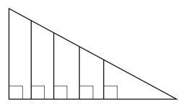
Pick one of the two non-right angles as your reference angle and measure the length of the side next to this angle (the adjacent side) as well as the length of the hypotenuse (the side opposite the right angle) for each triangle. Enter your measurements into a table like this one.
 | Triangle 1 | Triangle 2 | Triangle 3 | Triangle 4
Length of side next to the angle (adjacent)
Length of hypotenuse
$$\frac{Adjacent}{Hypotenuse}$$

Now, in the last row, calculate the length of the adjacent side divided by the length of the hypotenuse.
  - What do you notice about your answers?
  - If you knew the length of the adjacent side, how could you predict its circumference?
  - If the adjacent side of a triangle with your angles is 45km, what is the length of its hypotenuse?
  - If the hypotenuse of a triangle with your angles is 13m, what is the length of its adjacent side?
  - If you know the length of the adjacent side, is there any chance there is more than one corresponding length of hypotenuse?
- Visit https://www.thecalculatorsite.com/conversions/area/hectares-to-acres.php. It has a calculator that converts between hectares and acres. Draw a table similar to this one.
Hectares | 1 |  | 5
Acres |  | 5 |  | 12

  - Use the calculator to complete the table.
  - Write an equation that shows the relationship between hectares and acres in the form of hectares = ….
  - Use this equation to work out what 150 hectares are in acres.
  - Can you ever get more than one answer when converting between hectares and acres?
  - Plot each of the points in the table above on a Cartesian Plane. Let acres be $x$ and hectares by $y$. What kind of line do all the points seem to fall on? If you joined these points with a solid line, how could you use this line to work out how many hectares 10 acres is? How many hectares is this?
- In South Africa, electricity costs 170c per kWh (kilowatt hour) with a basic delivery charge of R485 per month.
  - How much will a household pay if they use 50kWh in a month?
  - How much will a household pay if they use 75kWh in a month?
  - How much will a household pay if they don’t use any electricity in a month?
  - Write an equation that describes the relationship between the amount of electricity a household uses and the amount they have to pay.
  - How much electricity can a household use in a month if they can only spend R600 on electricity?
  - Plot the relationship between cost and kWh on a Cartesian Plane. Let kWh be $x$. You can use any points you like.
  - Use your graph to work out how many kWh a household would use if their bill was R1,000.
  - Can you think of any other relationships between variables that are similar to this one?
- In South Africa, we measure temperature in degrees Celsius (°C). In the United States, temperature is measured in degrees Farenheit (°F). Since both are measures of temperature, we need a way to convert from one to the other.
Here is a table that shows the same temperatures in °C and °F.
°C | -20 | -10 | 0 | 10 | 20 | 30 | 40
°F | -4 | 14 | 32 | 50 | 68 | 86 | 104

  - If the equation that converts °C into °F is of the form $y=ax+q$ where $x$ is °C, $y$ is °F, $a$ is a fraction and $q$ is a whole number, from the conversion table above, work out what this equation is. Hint: Start with the case for 0°C to find the value of $q$.
  - Using this equation, what is the temperature in °F when it is 32°C?
  - What is the temperature in °C when the temperature is 90°F?
  - For every temperature in °C, how many corresponding temperatures are there in °F.
  - Draw a graph to represent the relationship between °C and °F.
  - Use your graph to work out what 35°C is in °F.
- When a ball is thrown up into the air, it follows a path that can be described using the equation $h=-16t^{2}+64t+8$ where $h$ is the height of the ball above the ground in metres and $t$ is the time since the ball was thrown, in seconds.
  - How high is the ball after 3 seconds?
  - When will the ball hit the ground again?
  - What is the ball’s greatest height above the ground?
  - Can the ball be at more than one height at any particular time?
  - Are there any times when the ball is at the same height?

Guided Reflection
- In this part of the activity, you measured the diameter and circumference of various differently sized circles.
  - You should have noticed that all the answers in the bottom row of your table were about 3.14; in other words, in each case, the circumference was about 3.14 times the diameter. Here is a table with the values someone measured
 | Lid 1 | Lid 2 | Lid 3 | Lid 4
Diameter | 2cm | 2.4cm | 5.2cm | 10.7cm
Circumference | 6.3cm | 7.5cm | 16.4cm | 33.9cm
$$\frac{Circumference}{Diameter}$$ | 3.15 | 3.13 | 3.15 | 3.14

All the answers are more or less the same and are all about 3.14.
  - This number is more or less pi ($π$).
  - Because the ratio of the length of the circumference and the diameter of a circle is a constant number, we could predict the circumference of a lid if we know its diameter.
  - We know that $\frac{circumference}{diamter}≈3.14$. Therefore, $circumference≈3.14×diameter$. Therefore, if the diameter is 12cm, the circumference will be $circumference≈3.14×12cm=37.68cm$.
  - We know that $\frac{circumference}{diamter}≈3.14$. Therefore, $diameter≈\frac{circumference}{3.14}$. Therefore, if the circumference is 15.24cm, the diameter will be$diameter≈\frac{circumference}{3.14}=\frac{15.24}{3.14}=4.85cm$.
  - No. There is only one possible corresponding circumference for each diameter.
- In this part of the activity, we worked in right-angled triangles. Now the angles in the triangles you drew were probably different to the angles in the triangles we drew but this does not matter, as you will see.
  - Here is the table we completed for the triangles we drew. Our triangle had a 60° angel and we used this one as our reference angel.
 | Triangle 1 | Triangle 2 | Triangle 3 | Triangle 4
Length of side next to the angle (adjacent) | 4cm | 6cm | 10cm | 14cm
Length of hypotenuse | 8cm | 12cm | 20cm | 28cm
$$\frac{Adjacent}{Hypotenuse}$$ | 0.5 | 0.5 | 0.5 | 0.5

No matter what angles were in your triangles, you should have noticed that all the answers in the bottom row of your table were the same.
  - We can express the relationship between the length of the side adjacent to our reference angle and the length of the hypotenuse as $\frac{adjacent}{hypotenuse}=some constant$. In our case, that constant was 0.5.
  - If the length of the adjacent side is 45km, we can work out the length of the hypotenuse by rearranging our equation.
$$\frac{adjacent}{hypotenuse}=some constant$$
$$∴hypotenuse=\frac{adjacent}{some constant}$$
$$∴hypotenuse=\frac{45km}{some constant}$$
In our case, this constant was 0.5. In your case it was probably something different.
$$∴hypotenuse= \frac{45km}{0.5}=90km$$
  - In the same way, we can use the equation for the relationship between the length of the adjacent side and the hypotenuse to work out the length of the adjacent side if we know the length of the hypotenuse.
$$\frac{adjacent}{hypotenuse}=some constant$$
$$∴adjacent=hypotenuse×some constant$$
In our case, this constant was 0.5. In your case it was probably something different.
$$∴adjacent=13m×0.5=7.5m$$
  - Based on the equation that relates adjacent and hypotenuse, for every length of the adjacent side, there is only one length of hypotenuse.
In this example and the previous one, we discovered a relationship between two different variables – between diameter and circumference and between the lengths of the side adjacent to an angle and the hypotenuse in any right-angled triangle with the same angles. In the first example, this ratio is always the same and is always equal to pi. In the second example, this ratio depended on the size of the angles in the triangles.
These are both examples of functions – an equation that relates one variable to another and that allows us to predict what one of the variables will be if we know the other. But this is not all there is to functions as we will see.
- In this part of the activity, we used an online calculator to help us convert between hectares and acres both of which are measures of area.
  - Here is the completed table. Your table should have the same values in it.
Hectares | 1 | 2.02 | 5 | 4.86
Acres | 2.47 | 5 | 12.36 | 12

  - To work out this equation, we could see if there was a constant ratio between hectares and acres. It turns out that $\frac{acres}{hectres}$ is always equal to 2.47. Therefore, we can say that
$hectares=\frac{acres}{2.47}$.
  - 150 acres in hectares: $hectares=\frac{150}{2.47}=60.73 hectares$.
  - No. you can only ever get one answer when converting from one unit to the other.
  - Here is an image of all the points plotted.
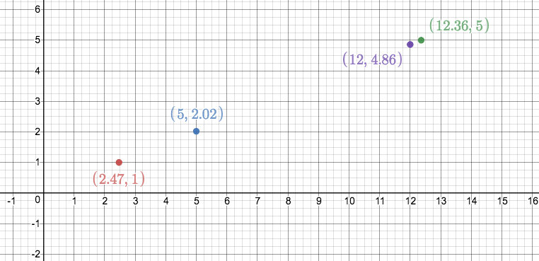
Image source: https://www.desmos.com/calculator/ewotofu5ow
All the points line on a straight line as shown in the image below.
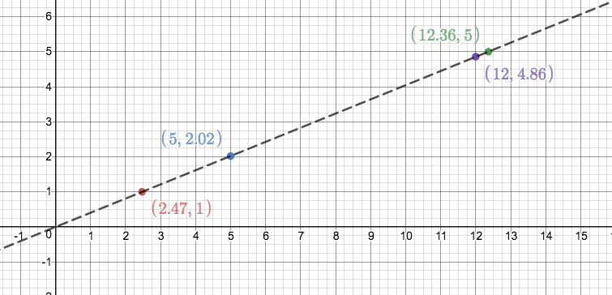
To work out how many hectares 10 acres is, you need to find 10 on the x-axis, go up to the graph and then move sideways to find the corresponding $y$ value as shown in the image below. Ten acres is about 4 hectares.
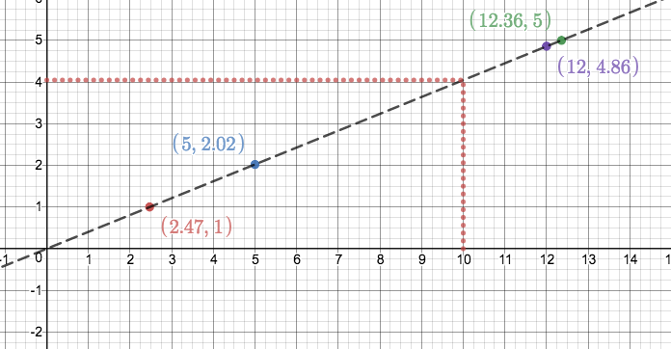
- This question was all about the relationship between the amount of electricity a household uses and how much they then need to pay. In South Africa, electricity costs 170c per kWh (kilowatt hour) with a basic delivery charge of R485 per month.
  - We know that for every kWh, they will have to pay 170c. Therefore, they will have to pay $\frac{170c}{kWh}×50kWh=8500c=R85$. But there is also a basic delivery charge of R485 per month. So their total bill will be $R85+R485=R570$ for the month.
  - We know that for every kWh, they will have to pay 170c. Therefore, they will have to pay $\frac{170c}{kWh}×75kWh=12750c=R127.50$. But there is also a basic delivery charge of R485 per month. So their total bill will be $R127.50+R485=R612.50$ for the month.
  - If they don’t use any electricity, they will still have to pay R485 per month.
  - If we let the amount of electricity used be $A$ and the total cost (in Rands) for a month be $C$ then the equation will be $C=1.70A+485$.
  - If they can only spend R600 on electricity, then $C=600$ and we need to solve for $A$.
$$C=1.70A+485$$
$$∴1.70A=C-485$$
$$∴A=\frac{C-485}{1.70}$$
But $C=600$.
$$∴A=\frac{600-485}{1.70}=\frac{115}{1.70}=67.6kWh$$
  - Here is the graph of the relationship between cost and kWh. To draw the graph, we used three points – when $x=0$, $x=250$ and $x=500$. All these points fell on a straight line so we joined them with a solid line to represent all the possible relationships between amount of electricity and cost.
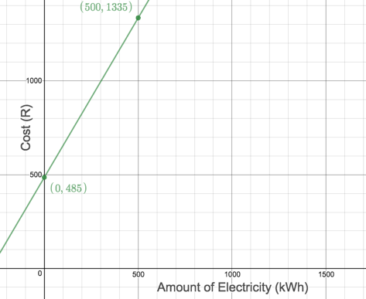
  - To work out how many kWh a household would use if their bill was R1,000, we start on the y-axis at R1,000 and move across to the graph and then down to see how much electricity this is. This is about 300kWh.
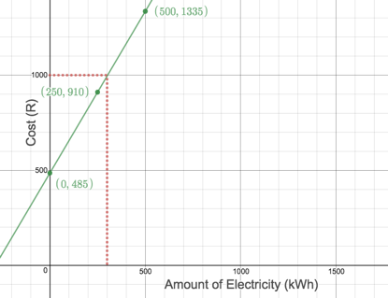
  - Here, we had a slightly more complicated relationship between our variables. We were able to express total cost as a function of the amount of electricity used. There are other functions that are similar like the cost of using a mobile phone. The more data you use, the more you pay. Or the amount of petrol you buy. The more you buy the more you pay. Or the distance you can travel on a tank of petrol. The more petrol you have, the further you can travel.
- Functions are used every day to do simple conversions between different units.
  - From the table of values, we can see that 0°C = 32°F. So, if our equation is of the form $y=ax+q$ it means that
$$32=a×0+q$$
$$∴q=32$$
So, we know that our equation is $y=ax+32$. We can insert any pair of °C and °F values into the equation to find $a$. Let’s use 10°C and 50°F.
$$50=a10+32$$
$$∴10a=50-32$$
$$∴a=\frac{50-32}{10}=\frac{18}{10}=\frac{9}{5}$$
Therefore, the equation is $y=\frac{9}{5}x+32$.
  - When it is 32°C, it is $\frac{9}{5}×32+32=89.6℉$.
  - $y=\frac{9}{5}x+32$
$$∴\frac{9}{5}x=y-32$$
$$∴x=\frac{5}{9}×(y-32)$$
When $y=90℉$, then $x=\frac{5}{9}×\left(y-32\right)=\frac{5}{9}×58=32.2℃$.
  - As with all the examples we have looked at so far, there is only one answer for each °C temperate we plug into the equation.
  - Here is the graph that represents the relationship between °C and °F.
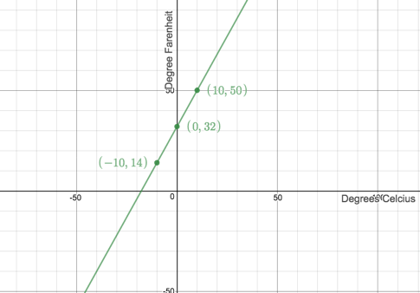
  - 35°C is 95$℉$.
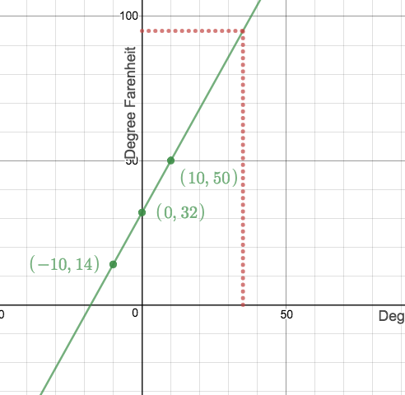
- Sometimes that relationships between different variables can be quite complicated.
  - To find out the height of the ball after 3 seconds, we have to substitute $t=3$ into the equation.
$$h=-16t^{2}+64t+8$$
So when $t=3:h=-16{(3)}^{2}+64\left(3\right)+8$
$$h=-16×9+64×3+8=56$$
After three seconds, the ball is 56m above the ground.
  - To work this out, we need to realise that when the ball hits the ground, its height is zero i.e. $h=0$.
$$∴0=-16t^{2}+64t+8$$
$∴2t^{2}-8t-1=0$ (divide through by $-8$)
$∴t=\frac{-(-8)±\sqrt{{(-8)}^{2}-4(2)(-1)}}{2(2)}$ (because the quadratic does not factorise nicely, we use the quadratic formula – we could have also used the completing the square method)
$$∴t=\frac{8±\sqrt{64+8}}{4}$$
$∴t=\frac{8+\sqrt{72}}{4}$ or $t=\frac{8-\sqrt{72}}{4}$
$∴t=4.12$ or $∴t=-0.12$
The negative answer does not make sense in our context, so we can ignore it. The ball will hit the ground again 4.12 seconds after being thrown.
  - One way to try and answer this question is through trial and error. If we know that the ball hits the ground after about 4 seconds, that means it is probably at its greatest height at about 2 seconds. So, we can create a table of values to see what this height is.
$t$ (s) | 1.8 | 1.9 | 2 | 2.1 | 2.2
$h$ (m) | 71.36 | 71.84 | 72 | 71.84 | 71.36

It looks like the ball reaches it maximum height at 2 seconds and this maximum height is 72m.
  - At any particular time, the ball can only be at one height. This makes sense if you think about it. The ball can never be, say, 25m AND 30m above the ground at the same time.
  - We can see from the table above that the ball can reach the same height at different times. Again, this makes sense if you think about it. If you throw a ball up in the air, there will be two times when the ball is at the same height -once on the way up and once on the way down.
In each of the examples in Activity 1, we saw that we had a relationship between two variables. Here is a summary.
Variable 1 | Variable 2 | Function
Circumference (c) | Diameter (d) | $$c=πd$$
Adjacent (a) | Hypotenuse (h) | $a=kh$, where $k=a constant$
Degrees Fahrenheit (F) | Degrees Celsius (C) | $$F=\frac{9}{5}C+32$$
Cost (C) | Usage (U) | $$C=1.7U+485$$
Height (h) | Time (t) | $$h=-16t^{2}+64t+8$$

In each example, we can see that there is a dependent variable and an independent variable. For example, in the example of the height of the ball, we can see that the height of the ball depends on the amount of time that has passed. The height is the dependent variable and the time is the independent variable (the time does not depend on the height – it is independent of height).
In the electricity example, the cost depends on how much you use. The cost is the dependent variable and the usage is the independent variable.
In these examples we say that height is a function of time and that cost is a function of usage.
From our examples, we can say that circumference is a function of diameter (the circumference depends on the diameter) and so circumference is the dependent variable and diameter is the independent variable. Or, we can say that °F is a function of °C - °F is the dependent variable and °C is the independent variable.
We can think of functions as special number machines that take inputs and give back outputs. The function number machine for circumference and diameter, takes the input of diameter, multiplies this by $π$ and returns the circumference.
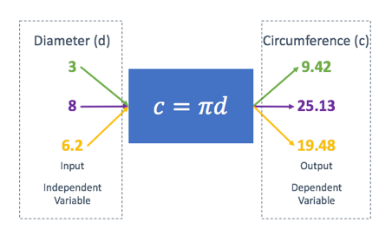
The function number machine for the ball’s height and time, takes the input of time, does lots of calculations with it and gives back the height of the ball.
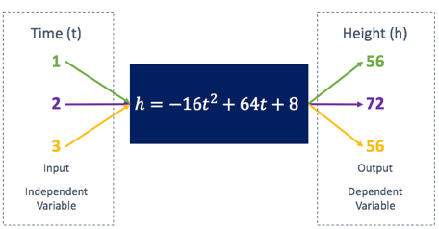
Each machine is different, but they do the same thing – they take independent variables (or inputs) and give back dependent variables (or outputs). We call the diagrams above mapping diagrams.
Activity to help learners understand that the graph of a function is a picture of all the points that satisfy the equation of the function. When we are dealing with all real numbers, there are an infinite number of these points and they are infinitesimally close to each other that the appearance is a solid line.

Activity 2: Functions and Relations

Purpose
This activity will help you to understand the difference between functions and relations.

Suggested Time
You will need about 15 minutes.

What You Will Need
- A pen or pencil
- Some blank paper or a notebook

Tasks
- The relationship between $x$ and $y$ is given by $y=x^{2}-9$. Use this equation to complete the following table.
Inputs ($x)$ | -3 | -2 | -1 | 0 | 1 | 2 | 3
Outputs ($y$)

- How many output values ($y$) does each input value ($x$) generate?
- Draw the mapping diagram for this relation using the same inputs as in the table.
- The relationship between $x$ and $y$ is given by $x^{2}+y^{2}=9$. Use this equation to complete the following table.
Inputs ($x)$ | -3 | -2 | -1 | 0 | 1 | 2 | 3
Outputs ($y$)

- How many output values ($y$) does each input value ($x$) generate?
- Draw the mapping diagram for this relation using the same inputs as in the table.
- What is the difference between these two relationships between $x$ and $y$?

Guided Reflection
- Here is the completed table.
$$y=x^{2}-9$$
Inputs ($x)$ | -3 | -2 | -1 | 0 | 1 | 2 | 3
Outputs ($y$) | 0 | -5 | -8 | -9 | -8 | -5 | 0

- Each input value ($x$) generates only a single output value ($y$).
- Here is the mapping diagram.
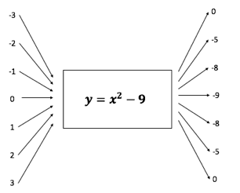
- Here is the completed table.
$$x^{2}+y^{2}=9$$
Inputs ($x)$ | -3 | -2 | -1 | 0 | 1 | 2 | 3
Outputs ($y$) | 0 | $$±\sqrt{5}$$ | $$±\sqrt{8}$$ | $$±3$$ | $$±\sqrt{8}$$ | $$±\sqrt{5}$$ | 0

- Most of the input values generated two output values.
- It is not possible to draw a mapping diagram because some inputs produce more than one output.
- The first relationship only ever gave a single answer or output value for each input value. The second relationship often gave two different answers or output values for each input value.
In Activity 2 we saw that the relationship between $x$ and $y$ given by $y=x^{2}-9$ only ever produced a single output from every input. However, the $x^{2}+y^{2}=9$ sometimes produced two outputs from certain inputs. Getting two outputs for a single input can be confusing. Which answer do we choose? We prefer to always only get a single definite output for each input.
It is for this reason that we say that $x^{2}+y^{2}=9$ is NOT a function. It is a relation because it still describes the relationship between $x$ and $y$. Only those relations that only ever give a single output for each input are called functions. This means that every function is a relation but not every relation is a function.
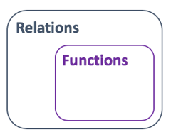
We can now fully define functions.
A function is a mathematical relationship between two variables (the independent and the dependent variable), where every input variable only has a single output variable.
Look back at the examples form Activity 1. Are all of these relations functions?
You will see that they are all functions. In no case does an input ever result in more than one output. It does not matter that more than one input can produce the same output. It only matters that there is only one answer every time we put an input into the machine.
Now that we know what a function is, let’s see the different ways we can represent them.
We have a very simple test to check if a relation is a function or not. It is called the vertical line test and we apply it to the picture or graph of the relation. Move a ruler or any other vertical line across the graph form left to right. It, at any point, the vertical line cuts the graph more than once, it means that for at least one input ($x$ value), the relation gives more than one output ($y$ value). Here are some examples.
[Examples of vertical line test]

Activity 3: Ways to Represent Functions

Purpose
This activity will help you to understand the different ways we have of representing functions.

Suggested Time
You will need about 15 minutes.

What You Will Need
- A pen or pencil
- Some blank paper or a notebook

Tasks
Have a look at this relation: $y=x-5$.
- It this relation a function?
- Draw a mapping diagram using the variables $-3;0;5$.
- Complete the table with these same input variables.
Input variable ($x)$
Output variable ($y$)

- Write each input and output pair as ordered pairs.
- Plot these ordered pairs on a Cartesian plan and join the points with a line.
- What kind of graph is this?
- What kind of equation is $y=x-5$? Why do you think it is called this?

Guided Reflection
- Each input will only ever produce a single output. Therefore, the relation is a function.
- Here is the completed mapping diagram.
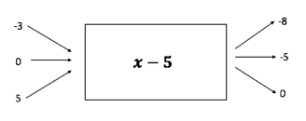
- Here is the completed table.
Input variable ($x)$ | -3 | 0 | 5
Output variable ($y$) | -8 | -5 | 0

- Here are the three ordered pairs.
$$\left(-3;-8\right), \left(0;-5\right), (5;0)$$
- Here is a Cartesian plan with these three points plotted and joined with a line.
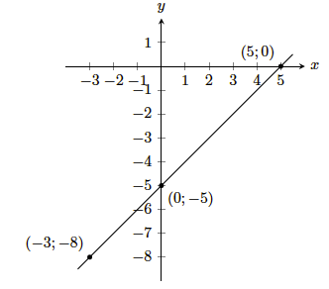
Image source: Everything Maths Grade 10 page 148
- This is a straight line.
- $y=x-5$ is a linear equation. It is called a linear equation because it produces a straight-line graph. Linear is another word for straight line.
All the representations of $y=x-5$ in Activity 3 are possible ways to represent a function. Of these, the most important and useful is probably the graph (the graphical representation).
However, there is one more way we have of representing functions. It is called function notation. We can represent $y=x-5$ as $f(x)=x-5$. We read this “f of x is equal to x minus 5”.
Function notation is really useful because it allows us to name different functions different things. For example, we could have
$$f\left(x\right)=x-5$$
$$g\left(x\right)=x^{2}-3x+2$$
$$h\left(x\right)=\frac{4}{x}+4$$
Now, when we say “the function g” or “the function h of x” we know exactly which function we are referring to. This is much better than having all these functions written as $y=$ and us not being able to tell them apart. We are like parents giving their children names!
Function notation is also great for representing different function values. Take the function $f$ above. We can write $f(3)$ (f of three). All this means is “what is the value of the function when $x=3$?”
$$f\left(3\right)=3-5=-2$$
In the same way
$$g\left(-2\right)={(-2)}^{2}-3\left(-2\right)+2$$
$$∴g\left(-2\right)=4-6+2=0$$
Also $g\left(a\right)=a^{2}-3a+2$.
Watch the video What is a Function (04:30) for a great summary of everything we have learnt.
(https://www.youtube.com/watch?v=GbQl0Ve_cH4)

Unit 2: Linear Functions

Learning Outcomes
By the end of this unit, you should be able to:
- Define what a linear function is;
- Sketch linear functions of the form $y=ax+q$;
- Explain the effects on the shape of the graphs of linear functions of $a$ and $q$;
- Describe the various characteristics (e.g. domain and range) of graphs of linear functions;
- Determine the equation of linear functions from their graphs; and
- Interpret the graphs of linear functions to make arguments or predictions.

Introduction
We already know what linear equations are. Remember, these are equations where the highest power on the unknow is one. Linear functions are simply the relationships between input and output variables described by a linear equation. They have the general form of $y=ax+q$ or $y=mx+c$ where $a, m, q$ and $c$ are constants.
In the previous unit, we saw that linear functions result in straight-line graphs.
The best way to learn about linear functions is to play with them.

Activity 1: Sketching Linear Functions Part 1

Purpose
This activity will help you to understand the different ways we have of representing functions.

Suggested Time
You will need about 25 minutes.

What You Will Need
- A pen or pencil
- Some blank paper or a notebook
- An Internet connection

Tasks
Have a look at the following linear functions:
$$f\left(x\right)=2x+1$$
$$g\left(x\right)=-2x+1$$
$$h\left(x\right)=x+1$$
- Complete the following table of values for each function.
$$x$$ | $$-1$$ | $$-\frac{1}{2}$$ | $$0$$ | $$\frac{1}{2}$$ | $$1$$
$$f(x)$$
$$g(x)$$
$$h(x)$$

- What is the least number of points you need in order to plot a linear function?
- Which do you think are the easiest and most convenient points from the table of values with which to plot each function?
- On the same set of axes, plot all three functions. You can choose any points from the table to plot each function.
- What is the same about each function and what is the same about each graph? Remember that the general form of the linear function is $y=mx+c$.
- What is different about each function and what is different about each graph?
- Now visit https://www.desmos.com/calculator/anmz0bgkes. Here you will find a linear function in its general form with sliders that let you change the values of $m$ and $c$.
  - Change the value of $c$. What effect does this have on the graph?
  - What can you say about the value of $c$ in $y=mx+c$?
  - Change the value of $m$. What effect does this have on the graph?
  - What is the difference between a large value of $m$ like 5 and a small value of $m$ like $\frac{1}{5}$?
  - What is the difference between positive and negative values of $m$?
  - What does a value of $m=0$ mean? Why is this?

Guided Reflection
- Here is the completed table.
$$x$$ | $$-1$$ | $$-\frac{1}{2}$$ | $$0$$ | $$\frac{1}{2}$$ | $$1$$
$$f(x)$$ | $$-1$$ | $$0$$ | $$1$$ | $$2$$ | $$3$$
$$g(x)$$ | $$3$$ | $$2$$ | $$1$$ | $$0$$ | $$-1$$
$$h(x)$$ | $$0$$ | $$\frac{1}{2}$$ | $$1$$ | $$\frac{3}{2}$$ | $$2$$

- To plot a straight line, you need at least two different points.
- The easiest points to use are those where either the $x$ or $y$ value of the point is zero. These points lie on an axis and are where the graph cuts or intercepts the axis. For example, for $f(x)$, the point $(-\frac{1}{2};0)$ is the point where the graph intercepts the x-axis.
- Here are all three functions plotted on the same set of axes. The black crosses indicate the points where the graphs cut or intercept each axis.
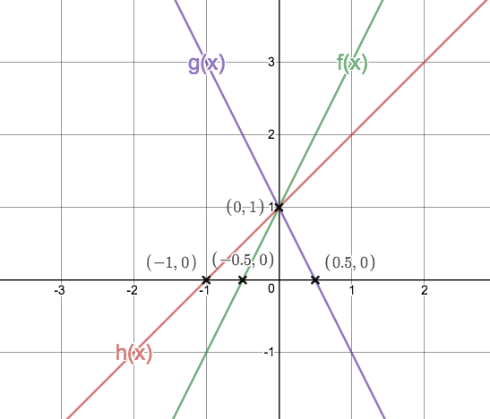
https://www.desmos.com/calculator/hrxfkhkq7l
- Each function has the same value of $c$ which is $1$. Each graph intercepts the y-axis at this same value.
- Each function has a different value of $m$. Each graph has a different slope or gradient.
- Changing the variables in a function and seeing what affect they have on the shape and position of the graph of the function is a great way of getting to know a function better.
  - As we change the value of $c$, the graph moves up and down. When we increase the value of $c$, we move the graph up. When we decrease the value of $c$, we move the graph down.
  - The value of $c$ in $y=mx+c$ is the point where the graph cuts or intercepts the y-axis. We call this point the y-intercept.
  - As we change the value of $m$, we change the slope or gradient of the graph.
  - A large value of $m$ gives a graph with a very steep slope. A small value of $m$ gives a graph with a very shallow slope.
  - When $m$ is positive, the graph slopes up from left to right. When $m$ is negative the graph slopes down from left to right.
  - When $m=0$, the graph is a flat horizontal line. When $m=0$, the function becomes $y=c$. In other words, it makes no difference what input value we choose, the output value will always be $c$. Thus, all the points on the graph will have a $y$ coordinate of $c$.
We learnt quite a lot from that last activity. Let’s recap.
- Sketching a linear function:
One way we have of sketching a linear function is to find and plot any two points. We can do this by choosing any two values of $x$ and then finding out what the corresponding function values are. For example, if we had $q\left(x\right)=2x-1$, we might choose $x=1$ and $x=2$. Then $q\left(1\right)=2\left(1\right)-1=1$ and $q\left(2\right)=2\left(2\right)-1=3$. We would then plot the points $\left(1;1\right)$ and $(2;3)$ and join them with a straight line.
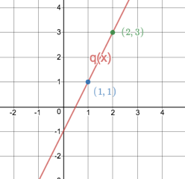
https://www.desmos.com/calculator/w3g3bbkta2
- The dual-Intercept method:
However, we also saw that we can make our lives a bit easier if we chose to plot the points where the graph intercepts with the axes. Where the graph crosses the x-axis, this is the x-intercept and the y-coordinate of the point is zero and where the graph crosses the y-axis, this is the y-intercept and the x-coordinate of the point is zero.
So, plotting $q\left(x\right)=2x-1$:
x-intercept (choose $y=0$): $0=2x-1 ∴2x=1∴x=\frac{1}{2}$. Therefore, the point is $\left(\frac{1}{2};0\right)$.
y-intercept (choose $x=0$): $q\left(0\right)=2\left(0\right)-1=-1$. Therefore, the point is $\left(0;-1\right)$.
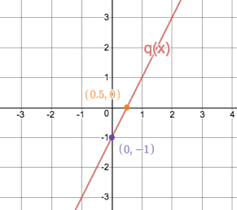
https://www.desmos.com/calculator/gxjbcceor3
Can you see why see can just look at the value of $c$ as a short-cut for finding the y-intercept? Can you also see why it is called the dual-intercept method for sketching a linear function? We find both intercepts.
- The values of $m$ and $c$
We have already seen that when the linear function is in the form $y=mx+c$ the value of $c$ immediately tells us what the y-intercept of the graph is.
The value of $m$ tells us what the slope or gradient of the graph is. The bigger the value of $m$, the steeper the graph.
Here is a summary of what we know so far:
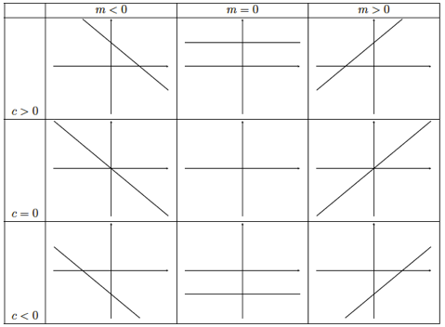
Image source: Everything Maths Grade 10 page 152
Remember, that we sometimes write the standard for of the linear function as $y=ax+q$. In this case $q$ tells us what the y-intercept is and the value of $a$ gives us the gradient of the graph.
Let’s take a closer look at the gradient.

Activity 2: The Gradient of the Straight Line Graph

Purpose
This activity will help you to better understand what the gradient of a straight line is and how to measure it.

Suggested Time
You will need about 30 minutes.

What You Will Need
- A pen or pencil
- Some blank paper or a notebook
- An Internet connection

Tasks
Open the interactive simulation at https://www.desmos.com/calculator/nmfwlna6jp. Here you will find a linear function in the form $y=mx+c$ with sliders so that you can change the values of $m$ and $c$. You will also see two points on the graph that you can drag with dotted lines that meet to form a right-angled triangle.
- Set the graph to represent the linear function $y=2x-1$. Now move the red point to $(2;3)$ and the blue point to $(4;7)$. You may need to click and graph on the Cartesian Plane to move these points into view.
  - Measure the length of the horizontal purple line. How does this length relate to the values of the $x$ coordinates of the two points?
  - Measure the length of the vertical green line. How does this length relate to the values of the $y$ coordinates of the two points?
  - Calculate the value of $\frac{length of green line}{length of purple line}$. What characteristic of the graph does this value measure?
  - Now, move the red and blue points to any other parts of the graph and recalculate the value of $\frac{length of green line}{length of purple line}$. What do you notice? What do you notice about this value and the value of $m$? What do we already know about $m$.
  - Change the value of $c$. Does this change the value of $m$ or $\frac{length of green line}{length of purple line}$?
- Now set the graph to represent the function $y=\frac{1}{2}x-1$. Move the red point to $(2;0)$ and the blue point to $(4;1)$.
    - What do you expect the value of $\frac{length of green line}{length of purple line}$ to be? Measure the length of the lines and calculate the value. Is it what you expected?
- Set the graph to represent $y=-2x+1$ and move the red point to $(-1;3)$ and the blue point to $(1;-1)$.
- What do you expect the value of $\frac{length of green line}{length of purple line}$ to be? Measure the length of the lines and calculate the value. Is it what you expected?
- What changes to your calculations did you have to make to arrive at the answer of $-2$ for $\frac{length of green line}{length of purple line}$?
- Move the green and purple points to any other parts of the graph to check your calculations for the gradient.
- Change the value of $m$ to any other value you like and verify that you are able to use the same method as above to measure or calculate the gradient.
- Write a general expression that will allow you to measure the gradient of any straight-line graph.

Guided Reflection
- We were first asked to set up the linear function so that it was $y=2x-1$.
- The length of the horizontal purple line is 2 units. This is really just the difference in the $x$ coordinates of the two points ($4-2=2)$.
- The length of the vertical green line is 4 units. This is just the difference in the $y$ coordinates of the two points ($7-3=4)$.
- $\frac{length of green line}{length of purple line}=\frac{4}{2}=2$. This is a measure of how steep the graph is; in other words, the gradient.
- No matter where we move the red and blue points to on the graph, the value of $\frac{length of green line}{length of purple line}=2$. For example, if we moved the red point to $(0;-1)$ and the blue point to $(3;5)$, the value of $\frac{length of green line}{length of purple line}=\frac{5-(-1)}{3-0}=\frac{6}{3}=2$.
The value of $\frac{length of green line}{length of purple line}$ is the same as the value of $m$. We know that $m$ describes the gradient of the graph. Therefore $\frac{length of green line}{length of purple line}$ is a measure of the gradient of the graph as well.
- Changing the value of $c$, only moves the graph up and down. It does not change the value of $\frac{length of green line}{length of purple line}$ or, therefore, the gradient of the graph.
- The next linear function we investigated was $y=\frac{1}{2}x-1$.
- Based on part 1), we expect the value of $\frac{length of green line}{length of purple line}=m$. Therefore, we expect it to be $\frac{1}{2}.$ If we measure this value we get $\frac{length of green line}{length of purple line}=\frac{1-0}{4-2}=\frac{1}{2}=m$, just what we expected.
- The next function we investigated was $y=-2x+1$.
- We expect the value of $\frac{length of green line}{length of purple line}=m=-2$. If we do the calculations, we get $\frac{length of green line}{length of purple line}=\frac{3-(-1)}{-1-1}=\frac{4}{-2}=-2$, just what we expected.
- No changes were necessary. We still just subtracted the $y$ coordinates of the two points and divided this by the difference between the $x$ coordinates of the two points.
- If we use the points $\left(-3;7\right)$ and $(-\frac{1}{2};2)$, we get $\frac{length of green line}{length of purple line}=\frac{7-2}{-3-(-1/2)}=\frac{5}{-21/2}=-2$.
- Let’s use the function $y=-3x-\frac{1}{2}$ and the points $(-2;5\frac{1}{2})$ and $(0;-\frac{1}{2})$.
$$\frac{length of green line}{length of purple line}=\frac{5\frac{1}{2}-(-\frac{1}{2})}{-2-0}=\frac{6}{-2}=-3=m$$
- If we have any two points on a straight line, say $(x_{1};y_{1})$ and $(x_{2};y_{2})$, then we can calculate the gradient of the straight line as follows:
$$m=\frac{y_{2}-y_{1}}{x_{2}-x_{1}}$$
It does not matter which is point 1 and which is point 2, so long as you subtract the coordinates in the same order.
The expression for the gradient of a straight line above is important and you will need to use it often in many different scenarios. Other ways you may see the gradient of a straight line expressed are
$\frac{rise}{run}$ or $\frac{change in y}{change in x}$ or $\frac{vetical change}{horizontal change}$
All these mean the same thing. When moving from left to right between any two points, how much does the graph goes up (or down) from the one point to the next, divided by how far the graph has to move to the right to achieve this up or down change.
Now that we know what gradient is and how to measure it, we can look at another way to sketch linear functions.

Activity 4: Sketching Linear Functions Part 2

Purpose
This activity will help you to sketch linear functions using the gradient-intercept method.

Suggested Time
You will need about 20 minutes.

What You Will Need
- A pen or pencil
- Some blank paper or a notebook
- An Internet connection
Tasks
- Sketch the function $t\left(x\right)=1-2x$ using the gradient-intercept method i.e. starting at the y-intercept, measuring out the gradient to find another point on the line and then join these points with a straight line.
- Sketch the linear function that has a y-intercept at $(0;3)$ and a gradient of $\frac{3}{2}$.
- A straight line is parallel to the line $3y+4x-7$ and passes through the point $(0;-2)$. What is the equation of the line? Sketch the line.
Guided Reflection
- We were asked to sketch the function $t\left(x\right)=1-2x$ using the gradient-intercept method. First, we need to get our function into standard form.
$$t\left(x\right)=-2x+1$$
Now we can see that the y-intercept is at 1 and the gradient is $-2$ (or $\frac{-2}{1}$). Starting at the y-intercept, we measure out the gradient – one unit right and then two units down.
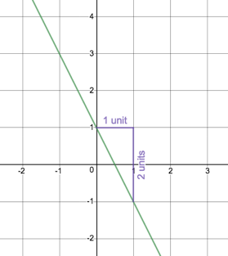
Image source: https://www.desmos.com/calculator/b8spbmgrln
- We know that the gradient of the line is $\frac{3}{2}$. In other words, if we move two units to the right, we have to move three up. Th y-intercept is the point $(0;3)$ so this is a good place to start measuring the gradient from. Here is what your graph should look like.
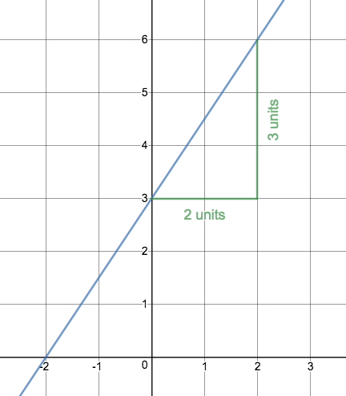
Image source: https://www.desmos.com/calculator/5yz9hzidai
- We are told that our graph is parallel $3y+4x-7=0$. Therefore, it has the same gradient. We are also told that our graph passes through the point $(0;-2)$.
To find the gradient, we have to get the parallel line into standard form.
$$3y+4x-7$$
$$∴3y=-4x+7$$
$$∴y=\frac{-4}{3}x+\frac{7}{3}$$
The gradient of our graph is $\frac{-4}{3}$. Starting at the point $(0;-2)$ (which is the y-intercept but could really be any point on the line), we measure out the gradient – three units to the right and then then 4 units down.
The graph looks like this.
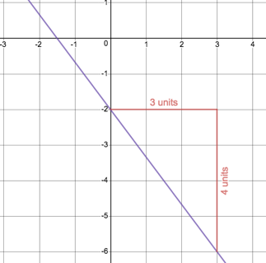

Activity 5: Domain and Range

Purpose
This activity will help you understand what domain and range are and how to read them from a straight-line graph.

Suggested Time
You will need about 25 minutes.

What You Will Need
- A pen or pencil
- Some blank paper or a notebook
- An Internet connection
Tasks
Open the interactive simulation at https://www.desmos.com/calculator/gt7jvcqd3w. Here you will find the linear function $j(x)=x$ with sliders so that you can change the values of $m$ and $c$. By now, you know exactly what effect changing these sliders will have on the graph.
But there are two extra sliders as well - for $a$ and $b$. In this activity we are going to find out what these do.
- At the moment, the graph looks like a normal straight line. Now zoom out. You can either use your mouse or fingers or the + and – buttons on the right. At some point, you will see that the graph stops. At what $x$ value does it stop on the left? At what $x$ value does it stop on the right? Why do you think this is?
- Now move the $a$ slider to be -20. What happens to the graph? Move the $b$ slider to be 15. What happens to the graph?
- Now change the value of $c$ to 2. What happens to the graph? Change the value of $m$ to $-\frac{1}{2}$. What happens to the graph?
- Change the sliders so that the graph exists between $x=-10$ and $x=35$. Work out between what corresponding $y$ values the graph exists.
- You may have noticed that after the linear function we have the expression $a≤x≤b$. This tells us that the graph may only exist where $x$ is between the values of $a$ and $b$. Write this expression for the current values of $a$ and $b$. Write a similar expression for the $y$ values. What do these expressions mean?
- Now click the empty circle in row 6 on the left-hand side of the screen. The shaded area shows the $x$ or input values the graph is allowed to take. We call this the Domain. Now click on the empty circles in row 7 and 8. The shaded area shows the corresponding $y$ or output values the function can generate. We call this the Range. For the function $y=2x+3$, Set up the Domain so that the Range is [$-30≤y≤20]$. Write the Domain as $[a≤x≤b]$.
Guided Reflection
- The graph stops at $x=-30$ on the left and at $x=30$ on the right. These are the same values as $a$ and $b$. Therefore, $a$ and $b$ are limiting the extent of the graph somehow.
- If we change the value of $a$ to -20, the graph changes to stop at -20. If we change the value of $b$ to 15, the graph changes to stop at 15.
- Changing the values of $m$ and $c$ change the gradient and y-intercept of the graph as expected but the graph still stops at -20 and 15.
- To make the graph exist between -10 and 35, we have to make $a=-10$ and $b=35$.
- $-10≤x≤35$. This means that $x$ has to be greater than or equal to -10 and at the same time less than or equal to 35. In other words, $x$ has to be between -10 and 35.
$-15\frac{1}{2}≤y≤7$. This means that $y$ is always greater than or equal to $-15\frac{1}{2}$ and at the same time less than or equal to 7. In other words, $y$ can only be between $-15\frac{1}{2}$ and 7.
- The Domain needed to create this Range is -$16\frac{1}{2}≤x≤8\frac{1}{2}$.
We saw in this last activity that we can restrict the input values a function is allowed to have and, in so doing, to restrict the output values that a function can produce. We call the set of allowed input values the Domain and the corresponding set of possible output values the Range.
Sometimes the nature of the function itself, automatically restricts what input or $x$ values are allowed. Look at this example:
$$t\left(x\right)=\frac{x+3}{x-1}$$
We know that we are never allowed to divide by zero which means the denominator in this function may never be zero. This means that $x≠1$. In this case, the function is allowed to take any number as an $x$ value except 1. We can write this Domain formally like this:
Domain: $\{x:x∈R, x≠1\}$
This is called set notation and this expression is says that the domain is the set of $x$ values where $x$ can be any real number but $x$ may not by 1.
The Domain from part 6) of Activity 4 above, would be written formally like this:
Domain: $\{x:x∈R, -16\frac{1}{2}≤x≤8\frac{1}{2}\}$
This says that the domain is the set of $x$ values where $x$ can be any real number between and including $-16\frac{1}{2}$ and $8\frac{1}{2}$. We could also write this slightly less formally using interval notation as
Domain: [$-16\frac{1}{2}; 8\frac{1}{2}]$
The square brackets tell us that the domain includes the end values. This method is slightly less formal and complete, because it does not explicitly tell us that $x$ can be any real number within this range.
Generally, though, unless there is a specific restriction imposed, linear functions can take any real number as an input and it is possible to generate any real number as an output. Therefore, the Domain and Range of linear functions is always
- Domain: $\left\{x:x∈R\right\}$ or $\left(-∞;∞\right)$ - the round brackets, indicate that the Domain does not include $-∞$ or $∞$.
- Range: $\left\{y:y∈R\right\}$ or $\left(-∞;∞\right)$ - the round brackets, indicate that the Range does not include $-∞$ or $∞$.

Activity 6: Interpreting Linear Functions

Purpose
This activity will help you gain experience interpreting linear functions.

Suggested Time
You will need about 25 minutes.

What You Will Need
- A pen or pencil
- Some blank paper or a notebook
- An Internet connection
Tasks
Simultaneous equations
Finding equations - https://www.youtube.com/watch?v=rzUJatVndcY, https://www.youtube.com/watch?v=3IPXiZQt6Ug
General interpretation

Activity 7: End of Section Questions

Purpose
This activity will help you consolidate your knowledge and understanding of linear functions.

Suggested Time
You will need about 25 minutes.

What You Will Need
- A pen or pencil
- Some blank paper or a notebook
- An Internet connection
Tasks
Questions from Everything Maths Grade 10 Exercise 6-2 (pg 156)

Unit 3: Quadratic Functions

Learning Outcomes
By the end of this unit, you should be able to:
- Define what a linear function is;
- Sketch quadratic functions of the form $y=ax^{2}+q$, $y=a{\left(x-p\right)}^{2}+q$ and $y=ax^{2}+bx+c$;
- Explain the effects on the shape of the graphs of quadratic functions of $a$, $p$and $q$;
- Describe the various characteristics (e.g. domain and range) of graphs of quadratic functions;
- Determine the equation of quadratic functions from their graphs; and
- Interpret the graphs of quadratic functions to make arguments or predictions.

Introduction
You may remember when we first came across quadratic trinomial expressions in Sub-Topic 1, we said they are everywhere. Remember that quadratic trinomial expressions are expressions where the highest power on the variable is 2 and that they have the general form of $ax^{2}+bx+c$ where $a$, $b$, and $c$ are constants.
We also spent quite a bit of time in Sub-Topic 2 learning how to solve quadratic equations. All of that work was largely to allow us to work with quadratic functions.
The general form of a quadratic function that you will most often see is $f\left(x\right)=ax^{2}+bx+c$. But there are two other, simpler forms that we will also work with in this unit.
Of all the functions we will look at, quadratic functions are probably the most important. They produce graphs that we call parabolas. Parabolas crop up everywhere. If you cut a satellite dish in half through the centre, you get a parabola. The same is true for nearly all mirrors used in telescopes, headlamps and some light bulbs.
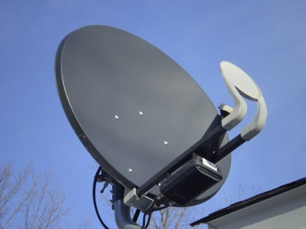
https://cdn.pixabay.com/photo/2012/12/17/15/22/satellite-70409_960_720.jpg
The ropes or chains hanging from the pillars of suspension bridges follow a parabolic curve. When you throw a ball (or any object) through the air, its path is a parabola.
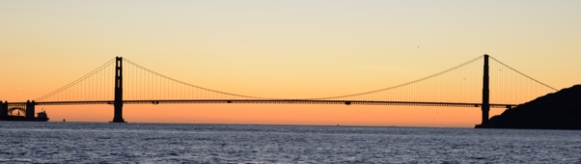
https://upload.wikimedia.org/wikipedia/commons/2/2a/Golden_Gate_Bridge_Dec_15_2015_by_D_Ramey_Logan.jpg

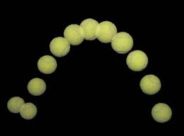
https://encrypted-tbn0.gstatic.com/images?q=tbn:ANd9GcQLlWdFfCDTqj6qNQIg4uksD2RJWk-bKUa05D9TMfoCEWgzF8Yt

All of these examples show us the general shape of the parabola. There are two important characteristics of parabolas. The one is that they have a turning point – a point where they turn or change direction. The other is that they are symmetrical about the vertical line that goes through their turning point. This means that, if you folded a parabola along this vertical line, the two arms would be exactly on top of each other. We call this line the axis of symmetry.
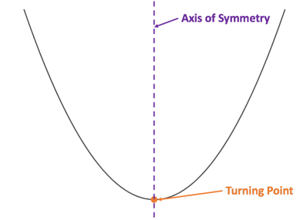

Watch the video Parabolas Intro (08:15) for a good introduction to parabolas.
(https://www.khanacademy.org/math/algebra/quadratics/parabolas-intro-alg1/v/parabolas-intro)
Just a note – in the video the turning point is called the vertex. Turning point and Vertex mean the same thing when we are talking about parabolas.

Activity 1: Sketching Quadratic Functions Part 1

Purpose
This activity will help you to sketch simple quadratic functions to start to understand some of their basic properties.

Suggested Time
You will need about 40 minutes.

What You Will Need
- A pen or pencil
- Some blank paper or a notebook
- An Internet connection

Tasks
- Have a look at these two functions:
$$h(x)=2x-3$$
$$k(x)=2x^{2}-3$$
  - Which function is the linear function? Why?
  - Which function is the quadratic function? Why?
  - Plot both functions on the same set of axes. You can see any method you like to plot the linear function. Use the following table of values to help you plot the quadratic function. Plot the points and then join them with as smooth a curve as possible.
$$x$$ | -3 | -2 | -1 | 0 | 1 | 2 | 3
$$y$$
  - What is the same about each function? What is the same about each graph?
  - What is different about each function? What is different about each graph? Think particularly about the intercepts and what you know about the number of roots we get for linear and quadratic equations.
  - If vertical lines have the general form of $x=k$ where $k$ is a constant, what line is the axis of symmetry of the quadratic function?
  - What is the turning point of the quadratic function?
  - What is the Domain and Range of the linear function?
  - What is the Domain and Range of the quadratic function?
- Visit the interactive simulation at https://www.desmos.com/calculator/ylpnsabdg4. Here is a quadratic function in the form of $y=ax^{2}+c$.
- How is this form different from the general form of the quadratic function $y=ax^{2}+bx+c$?
- Change the value of $c$. What effect does this have on the graph? How does this relate to how $c$ affects the function $y=mx+c$?
- Change the value of $a$. What effect does this have on the graph? How does this relate to how $m$ affects the function $y=mx+c$?
- What is the difference between a large value of $a$ like 5 and a small value of $a$ like $\frac{1}{5}$?
- What is the difference between positive and negative values of $a$?
- What does a value of $a=0$ mean? Why is this?

Guided Reflection
- We were given two similar looking but different functions.
- $h(x)$ is the linear function. The highest power on $x$ is 1. The function is in the form of a linear equation.
- $k(x)$ is the quadratic function. The highest power on $x$ is 2. The function is in the form of a quadratic equation.
- Here is the completed table of values for $k(x)$.
$$x$$ | -3 | -2 | -1 | 0 | 1 | 2 | 3
$$y$$ | 15 | 5 | -1 | -3 | -1 | 5 | 15

Here are the two functions sketched.
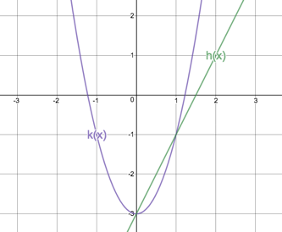
- Each function has a constant term of $-3$ and each graph has a y-intercept of $-3$. Each graph also has a coefficient on the leading term of 2.
- $h(x)$ is a linear function with a highest power of 1. It has one intercept with the x-axis (when $y=0)$ corresponding to the fact that linear equation only have one root or answer. However, $k(x)$ is a quadratic function with a highest power of 2. It has two intercepts with the x-axis (when $y=0)$ corresponding to the fact that quadratic equation has two roots or answers.
- The parabola is symmetrical about the y-axis. All the $x$ values on the y-axis are zero. Therefore, the axis of symmetry is the line $x=0$.
- The turning point (or TP) of the quadratic function is the point $(0; -3)$.
- The domain and range of the linear function are both unrestricted. They are both all real numbers.
Domain: $\{x:x∈R\}$
Range: $\{y:y∈R\}$
- The domain of the quadratic function is all real numbers. There are no input values (values of $x$) that we cannot use.
The range, however, is different. We can see from the graph that the $y$ values are never less than $-3.$ $-3$ is the minimum value of the graph. At this point the graph turns.
So, we can write the domain and range as follows:
Domain: $\{x:x∈R\}$
Range: $\{k(x):k(x)∈R, k(x)≥-3\}$
- Here we looked at a simpler form of the quadratic function.
- The form $y=ax^{2}+c$ is the same as $y=ax^{2}+bx+c$ except that the coefficient, $b$, of the $x$ term is zero, so this whole term falls away.
- If we change the value of $c$, we move the graph up and down. The value of $c$ is also where the graph cuts the y-axis. In other words, $c$ tells us the y-intercept.
This is exactly the same as the effect of $c$ in the linear equation ($y=mx+c$), where $q$ is also the y-intercept.
- Changing the value of $a$, changes the steepness of the graph. This is very similar to how $a$ affects the gradient of the straight-line graph ($y=mx+c$). Although, it must be said that, because the parabola is not a straight line, “steepness” is a little bit different.
- The larger the value of $a$ in $y=ax^{2}+c$, the steeper or narrower the graph becomes. The smaller the value of $a$, the less steep or wider the graph becomes.
- When $a$ is a positive number, the graph bends upwards. It is like a “smiley face”. When $a$ is negative, the graph bends downwards into a “sad face”.
- When $a=0$, the graph is a flat horizontal line. This is because when $a=0$, $y=ax^{2}+c$ becomes just $y=c$, a constant. No matter what the input value is, the output will always be this same constant.
In this last activity we saw that the value of $c$ in $y=mx+c$ and the simple form of the quadratic function $y=ax^{2}+c$ do the same thing – they tell us where the graph cuts the y-axis. This makes sense though. Remember that one of the ways to sketch a linear function is the dual-intercept method where we find where the graph intercepts both axes.
- x-intercept (let $y=0)$
- y-intercept (let $x=0)$
Well the same principle applies to the quadratic function. We can find the y-intercept by letting $x=0$ and we can find the x-intercept by letting $y=0$. Have a look at this example.
Suppose we have $y=3x^{2}-1$. Let’s find the intercepts with the axes.
- y-intercept (let $x=0)$: $y=3{\left(0\right)}^{2}-1=-1$. As we expected, the y-intercept is simply the value of $q$.
- x-intercept (ley $y=0)$: $0=3x^{2}-1∴3x^{2}=1∴x^{2}=\frac{1}{3}∴x=±\frac{1}{\sqrt{3}}$. As we expected, we have two points where the graph intercepts the x-axis. Can you see why we spent all that time learning how to solve quadratic equations?
We also learnt from the last activity that the value of $a$ in the simplified form of the quadratic function $y=ax^{2}+c$, determines whether the graph bends up into a smiley face or down into a sad face and how steep or shallow the curve is. Here is a summary.
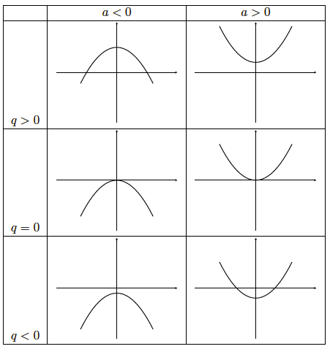
Image source: Everything Maths Grade 10 (pg 161)
Here’s a short activity to make sure you understand how the values of $a$ and $q$ affect the graph of $y=ax^{2}+q$.

Activity 2: The Effects of $a$ and $c$ in $y=ax^{2}+c$

Purpose
This activity will help to make sure you understand how the values of $a$ and $c$ affect the graph of $y=ax^{2}+c$.

Suggested Time
You will need about 10 minutes.

What You Will Need
- A pen or pencil
- Some blank paper or a notebook
- An Internet connection

Tasks
Visit the interactive simulation at https://www.desmos.com/calculator/z1vvti3zv8. Here you will find $f(x)=x^{2}+1$ and several other parabolas.
- Change the values of $a$ and $q$ for $f(x)$, so that it matches each of the other parabolas and write down the what each of these functions are.
- Write down the domain and range of each function.
- Write down the axes of symmetry (AS) and the turning point (TP) of each function?
- What relationship exists between the y-intercept and the TP of each function? Why is this the case?
- What relationship exists between the TP and the range of each function? How does this change when $a>0$ and when $a<0$?

Guided Reflection
- $a(x)$: We know that the value of $q$ in this function must be $-1$ because this is where the graph cuts the y-axis. So, we change $f\left(x\right)$ to be $f(x)=x^{2}-1$ and see that it fits perfectly. So $a\left(x\right)=x^{2}-1$
$b(x)$: We know that the value of $q$ must be $-2$. So, we change $f\left(x\right)$ to be $f(x)=x^{2}-2$. But $b(x)$ is steeper so the value of $a$ must be greater than 1. So, let’s make $f\left(x\right)={2x}^{2}-2$. It fits. Therefore, $b\left(x\right)={2x}^{2}-2$.
$c(x)$: We know that the value of $q$ must be $0$. So, we change $f\left(x\right)$ to be $f(x)=x^{2}$. But $c(x)$ is steeper and bends down. Therefore $a$ must be negative and have an absolute value (its value ignoring its sign) greater than 1. So, let’s make $f\left(x\right)={-2x}^{2}$. $c(x)$ is still steeper so, let’s try $f\left(x\right)=-3x^{2}$. It fits. Therefore, $c\left(x\right)={-3x}^{2}$.
$d(x)$: We know that the value of $q$ must be $2$. So, we change $f\left(x\right)$ to be $f\left(x\right)=x^{2}+2$. But $d(x)$ bends down. Therefore $a$ must be negative. So, let’s make $f\left(x\right)={-x}^{2}+2$. It fits. Therefore, $d\left(x\right)={-x}^{2}+2$.
- $f\left(x\right):$ Domain: $\{x:x∈R\}$ Range: $\{f(x):f(x)∈R, f(x)≥1\}$
$a\left(x\right):$ Domain: $\{x:x∈R\}$ Range: $\{a(x):a(x)∈R, a(x)≥-1\}$
$b\left(x\right):$ Domain: $\{x:x∈R\}$ Range: $\{b(x):b(x)∈R, f(x)≥-2\}$
$c\left(x\right):$ Domain: $\{x:x∈R\}$ Range: $\{c(x):c(x)∈R, c(x)≤0\}$ – Remember that because the graph bends down, 0 is the maximum value the graph can reach.
$d\left(x\right):$ Domain: $\{x:x∈R\}$ Range: $\{d(x):d(x)∈R, d(x)≤2\}$ – Remember that because the graph bends down, 2 is the maximum value the graph can reach.
- $f(x)$: AS: $x=0$ TP: $(0;1)$
$a(x)$: AS: $x=0$ TP: $(0;-1)$
$b(x)$: AS: $x=0$ TP: $(0;-2)$
$c(x)$: AS: $x=0$ TP: $(0;0)$
$d(x)$: AS: $x=0$ TP: $(0;2)$
- For each function, the y-intercept and the $y$ value of the TP are the same. This means that for each function, the y-intercept and the TP are the same point. This is because each parabola has the y-axis as its AS.
- For each function, the TP is the limit of its range. If $a>0$ and the graph bends up, then the TP is a minimum TP and the range is the $y$ value of the TP to positive infinity. If $a<0$ and the graph bends down, the TP is a maximum and the range is negative infinity to the $y$ value of the TP.
All the quadratic functions we have looked at so far have had the y-axis as their AS and the TP and the y-intercept have always been the same point. All the functions we have looked at have been of the form $y=ax^{2}+c$. In other words, $b=0$. Do you think that if $b≠0$ the parabola might shift left or right? Let’s find out.

Activity 3: The Turning Point Form

Purpose
This activity will help you to better understand what the axis of symmetry and turning point of a quadratic function are and how to find them.

Suggested Time
You will need about 45 minutes.

What You Will Need
- A pen or pencil
- Some blank paper or a notebook
- An Internet connection

Tasks
Visit the interactive simulation at https://www.desmos.com/calculator/nrlhtce2tc. Here you will find a quadratic function $f(x)$ with the general form of $y=ax^{2}+bx+c$ and sliders to change the values of $a$, $b$ and $c$.
- Write down the current equation of the function $f(x)$ (where $a=1$, $b=0$ and $c=0$).
- What is the y-intercept, AS, TP, domain and range of $f(x)$? Is the TP a minimum or a maximum TP?
- When $b=0$, what is the relationship between $b$ the AS, the TP and the y-intercept?
- What would we need to do to $f\left(x\right)$ to make the y-intercept the point $(0;2)$? Make the change to see if you are right.
- What do we need to do to make the TP of $f(x)$ the point $(-1;1)$. Make whatever changes you need to, ensuring that the y-intercept remains the point $(0;2)$ and that the TP remains a minimum. Write down the new equation for $f(x)$.
- What is the new expression for $f\left(x\right)$? Does this expression still correctly predict the value of the y-intercept? Does it still correctly predict the fact that the TP is a minimum? Is there a clear and obvious relationship between the value of $b$ and the AS and TP when $b≠0$?
- What is the domain and range of this function?
- Now complete the square of this quadratic equation to get $f(x)$ into the form $f\left(x\right)=a{\left(x-p\right)}^{2}+q$. We call this the turning point form. What are the values of $a$, $p$ and $q$?
If you need help with completing the square watch the video Completing the Square – Quadratics (03:45) to get you started. If you need more help, you should look back at Sub-Topic 2, Unit 2 Activity 2.
- What do you notice about the coordinates of the TP and the values of $p$ and $q$ in your new expression of $f(x)$? Does it make sense why we call this form the turning point form?
- What is the new AS of $f(x)$? How could we write the AS in terms of $p$ or $q$?
- How can we write the range in terms of $p$ or $q$?
- Using the turning point form of the quadratic function $y=a{\left(x-p\right)}^{2}+q$ as a start, write a new expression for $f(x)$ that would have a TP of $(3;1)$ and would have a maximum TP. Is there only one expression you can write?
- Now expand your new expression for $f(x)$ back into the $y=ax^{2}+bx+c$ form and alter the values of $a$, $b$ and $c$ in the interactive simulation to see if you are correct.
- Without changing the values of $a$, $b$ and $c$ in the interactive simulation, work out what the TP of $y=-\frac{1}{2}x^{2}-2x-1$ is. Is this a maximum or minimum TP? What is the AS?
Now change the values of, $b$ and $c$ on the simulator to see if you are correct.

Guided Reflection
- $f\left(x\right)=x^{2}$.
- y-intercept: $(0;0)$
AS: $x=0$
TP: $(0;0)$
Domain: $\left\{x:x∈R\right\}$
Range: $\left\{f\left(x\right):f\left(x\right)∈R, f(x)≥0\right\}$
The TP is a minimum.
- When $b=0$, the AS is the line $x=0$. The TP is on the y-axis and, therefore, also the same as the y-intercept.
- We have to change the expression of the function to $f\left(x\right)=x^{2}+2$.
- Because the TP is now no longer on the y-axis, we should start by changing the value of $b$. If we change the value of $b$ to 2, we get the desired TP while keeping the TP a minimum and keeping the y-intercept the point $(0;2)$.
- The new expression for the function is $f\left(x\right)=x^{2}+2x+2$. The value of $c$ is still the y-intercept. The value of $a>0$ and the TP is still a minimum. There is no clear relationship between the TP and the value of $b$ now that $b≠0$.
- $f\left(x\right):$ Domain: $\{x:x∈R\}$ Range: $\{y:y∈R, y≥1\}$
- Completing the square is a technique we learnt to solve quadratic equations. When we complete the square, we add whatever is necessary to the quadratic expression in order to create a perfect square when we factorise. If you would like to revise the process of completing the square, go back to Sub-Topic 2, Unit 2 Activity 2.
Our function is $f\left(x\right)=x^{2}+2x+2$.
$∴f\left(x\right)=x^{2}+2x+1+2-1$ (if we add 1 then the first three terms of the quadratic will factorise as ${(x+1)}^{2}$, a perfect square. But we must remember to keep the function the same by subtracting 1 as well.)
$$∴f\left(x\right)={(x+1)}^{2}+1$$
In relation to the general form $y={\left(x-p\right)}^{2}+q$, we can see that $a=1$, $p=-1 (-\left(-1\right)=+1)$ and $q=1$.
- The coordinates of the TP are the same as the value of $p$ and $q$. The coordinates of the TP are $(p;q)$.
- The new AS is the line $x=-1$. It is still the same as the $x$ coordinate of the TP. We can also say that the AS is the line $x=p$.
- Because the TP is a minimum, we know that the range is all values of $y$ which are greater that the $y$ coordinate of the TP. Therefore, we can write general expressions for the range as follows:
Range: $\{y:y∈R, y≥q\}$ or $[q; ∞)$
- The turning point form of the quadratic function is $y={\left(x-p\right)}^{2}+q$ and the TP we want is $(3;1)$. Therefore $p=3$ and $q=1$. So, our function is of the form $y={\left(x-3\right)}^{2}+1$. But the TP is a maximum. Therefore, $a<0$. Our function is thus $y={-\left(x-3\right)}^{2}+1$.
Our function might also be $y={-2\left(x-3\right)}^{2}+1$ or $y={-\frac{3}{7}\left(x-3\right)}^{2}+1$. In fact, $a$ could be any number less than zero. All these functions would still have a maximum TP at $(3;1)$.
- Let’s take the simplest version of $y={-\left(x-3\right)}^{2}+1$.
$$y={-\left(x-3\right)}^{2}+1$$
$$∴y=-(x^{2}-6x+9)+1$$
$$∴y=-x^{2}+6x-9+1=-x^{2}+6x-8$$
This is what this function looks like.
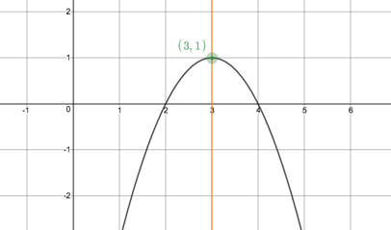
https://www.desmos.com/calculator/gny8z8y7pu
- In order to find the TP of the given function, we need to complete the square.
$$y=-\frac{1}{2}x^{2}-2x-1$$
$∴y=-\frac{1}{2}(x^{2}+4x)-1$ (if the value of $a$ is not 1, it is always best to start by taking it out as a common factor from the $ax^{2}+bx$ terms.
$∴y=-\frac{1}{2}\left(x^{2}+4x+4\right)-1+2$ (be careful here. To balance out what we added inside the bracket, we need to multiply it by the common factor outside the bracket and then change the sign. $-\frac{1}{2}×4=-2$. This is why we have to balance the function with +2.
$$∴y=-\frac{1}{2}{\left(x+2\right)}^{2}+1$$
The function is now in the turning point form. $x=-\frac{1}{2}, p=-2, q=1$. The TP is the point $(p;q)$ which is the point $(-2;1)$. $a<0$ so, the TP is a maximum. The AS is the line $x=p$ which is the line $x=-2$.
- Here is the graph of this function.
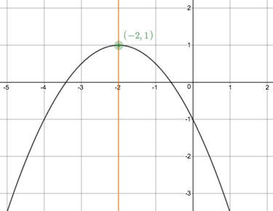
https://www.desmos.com/calculator/gny8z8y7pu
We can clearly see that the TP is the point $(-2;1)$, that it is a maximum TP and that the AS is the line $x=-2$.
Wow, we learnt so much in that activity. Let’s quickly recap what we know.
- The general form of the quadratic function is $f\left(x\right)=ax^{2}+bx+c$.
- The value of $c$ is the y-intercept of the graph.
- If $a>0$, the graph has a minimum TP; if $a<0$, the graph has a maximum TP.
- When $b=0$, the AS is the line $x=0$ and the TP and the y-intercept are the same point.
- When $b≠0$, the graph is shifted left or right so that the AS is no longer the y-axis and the TP and y-intercept are no longer the same point.
- If we complete the square, we can convert the general form ($f\left(x\right)=ax^{2}+bx+c$) into the TP form ($f\left(x\right)=a{(x-p)}^{2}+q$).
- The TP form tells us that the TP is the point $(p;q)$ and that the AS is the line $x=p$.
- The TP form also tells us that the range can we written as
- Range: $\{y:y∈R, y≥q\}$ or $[q; ∞)$ if $a>0$ (a minimum TP)
- Range: $\{y:y∈R, y≤q\}$ or $[-∞; q]$ if $a<0$ (a maximum TP)
- The TP form tells us that $p$ shifts the graph left and right (horizontal shift) and $q$ shifts the graph up and down (vertical shift).
How about a quick game to consolidate all we know?

Activity 4: Quadratic Marbleslides

Purpose
This activity will help you consolidate your knowledge of the quadratic function.

Suggested Time
You will need about 45 minutes.

What You Will Need
- A pen or pencil
- Some blank paper or a notebook
- An Internet connection

Tasks
- Visit https://student.desmos.com/?prepopulateCode=c7ysax. Click the Join button (you do not need to sign in) and complete all the screens.

Guided Reflection
- Here are some answers to some of the screens.
Fix It #1: On this screen we had to change the value of $a$ from $0.1$ to $-0.1$. The function became $y=-0.1{\left(x-2\right)}^{2}+8$.
Fix It #2: Here we had to make two changes. We had to decrease the value of $a$ from 2 to about 0.5 and we had to extend the domain of the function to include values of $x$ up to 7. The new function became $y=0.5{\left(x-4\right)}^{2}+2, \{x<7\}$.
Fix It #3: Here we had to make two changes. We had to move the TP to the point $(7;2)$ and then increase the domain to include values of $x$ up to 8. The new function became $y=0.5{\left(x-7\right)}^{2}+2, \{x<8\}$.
Fix It #4: We were asked to only change one number. Changing the domain to $(-∞;2.8]$ did the trick.
Verify #4: You would need an expression similar to $y=-0.06{\left(x-2\right)}^{2}+11$.
Challenge Slide #1: Here is one possible solution. What did you get?
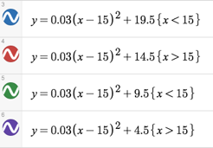
Challenge slide #2: Here is one possible solution - $y=0.01{\left(x-5\right)}^{2}+5.6 \{x<3\}$.
We now know enough about quadratic functions to be able to plot any quadratic function.

Activity 5: Sketching Quadratic Functions Part 2

Purpose
This activity will help you consolidate your knowledge of the quadratic function.

Suggested Time
You will need about 75 minutes.

What You Will Need
- A pen or pencil
- Some blank paper or a notebook

Tasks
- Have a look at this function: $p\left(x\right)=2-10x+5x^{2}$.
- Find the y-intercept.
- Find the x-intercepts.
- Find the TP and the AS. Is the TP a maximum of a minimum?
- Make a neat sketch of $p(x)$, using the above points.
- If $f\left(x\right)=ax^{2}+bx+c$, show, by completing the square, that the AS and the x coordinate of the TP are given by $-\frac{b}{2a}$.
- By finding the intercepts, TP and AS, make neat sketches of the following functions on the separate sets of axes.
- $f\left(x\right)=x^{2}-6x+8$
- $h\left(x\right)={18+6x-3x}^{2}$
- $j\left(x\right)={-2[(x+1)}^{2}-2]$
- $k\left(x\right)={-\frac{1}{2}(x+1)}^{2}-3$
- State the domain and range of each of the functions in question 3).
- $l\left(x\right)=x^{2}-2x-3$ and $m\left(x\right)$ is the same shape as $l(x)$ except that it is shifted 1 unit to the right and 3 units down. What is the equation of $m(x)$? Hint: This means that the TP of $m(x)$ is 1 unit to the right and 3 units down from the TP of $l(x)$.

Guided Reflection
- We were given the function $p\left(x\right)=-2-9x+5x^{2}$. We can rewrite this as $p\left(x\right)=5x^{2}-9x-2$.
- We know that the y-intercept is the value of $c$. Therefore, the y-intercept is the point $(0;-2)$.
- To find the x-intercepts, we need to set $p\left(x\right)=y=0$.
$$0=5x^{2}-9x-2$$
$$∴\left(5x+1\right)\left(x-2\right)=0$$
$∴x=-\frac{1}{5}$ or $x=2$
The x-intercepts are the points ($-\frac{1}{5};0)$ and $(2;0)$.
- To find the TP, we have to get the function into the TP form.
$$p\left(x\right)=5x^{2}-9x-2$$
$∴p\left(x\right)=5(x^{2}-\frac{9}{5}x)-2$ (take out the common factor from the $ax^{2}+bx$ terms.
$∴p\left(x\right)=5\left(x^{2}-\frac{9}{5}x+\frac{81}{100}\right)-2-\frac{81}{20}$ (add whatever is necessary to complete the square. In this case ${(\frac{9/5}{2})}^{2}=\frac{81}{100}$. Remember to balance this correctly.)
$$∴p\left(x\right)=5{\left(x-\frac{9}{10}\right)}^{2}-\frac{40}{20}-\frac{81}{20}$$
$$∴p\left(x\right)=5{\left(x-\frac{9}{10}\right)}^{2}-\frac{121}{20}$$
The TP is the point $(\frac{9}{10}; -\frac{121}{20})$ or $(0.9; -6.05)$ and the AS is the line $x=0.9$. The value of $a$ is positive, therefore, the TP is a minimum.
- Here is a sketch of $p\left(x\right)=-2-9x+5x^{2}$.
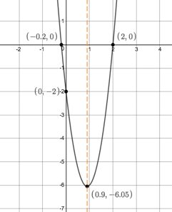
https://www.desmos.com/calculator/35f3ghoa67
- Completing the square in question 1) was a bit of a mission. It would be nice if we had a more general expression for the TP that we could use. Let’s complete the square of the general for of the quadratic function.
$$f\left(x\right)=ax^{2}+bx+c$$
$$∴f\left(x\right)=a(x^{2}+\frac{b}{a}x)+c$$
$$∴f\left(x\right)=a\left(x^{2}+\frac{b}{a}x+\frac{b^{2}}{4a^{2}}\right)+c-\frac{b^{2}}{4a}$$
$$∴f\left(x\right)=a{\left(x+\frac{b}{2a}\right)}^{2}+\frac{4ac}{4a}-\frac{b^{2}}{4a}$$
$$∴f\left(x\right)=a{\left(x+\frac{b}{2a}\right)}^{2}+\frac{4ac-b^{2}}{4a}$$
If the TP form is $y=a{\left(x-p\right)}^{2}+q$, this means that $p=-\frac{b}{2a}$ and $q=\frac{4ac-b^{2}}{4a}$.
We could also find the value of $q$ by calculating $f(-\frac{b}{2a})$ i.e. substitute the value of $p$ into the function to find the corresponding output value.
- We were asked to sketch four quadratic functions.
- Sketch
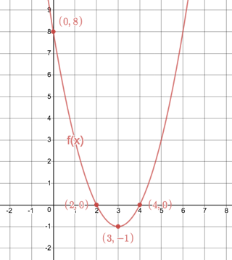
https://www.desmos.com/calculator/ndu6is12ik
- Sketch
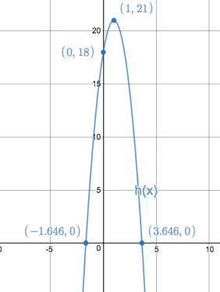
https://www.desmos.com/calculator/ndu6is12ik
- Sketch
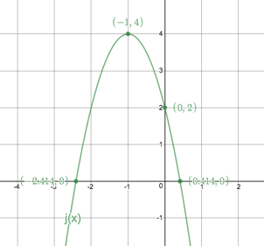
https://www.desmos.com/calculator/ndu6is12ik
- The function we were given was $k\left(x\right)={-\frac{1}{2}(x+1)}^{2}-3$. Because it is already in TP form, we can immediately tell what the TP and AS are. The TP is $(-1; -3)$ and the AS is the line $x=-1$. We also know that the TP is. Maximum because $a=-\frac{1}{2}$.
However, we might have a problem finding the x-intercepts. The TP is a maximum AND it is below the x-axis. Therefore, the graph does not cut the x-axis at all. Let’s confirm this by solving for $x$ when $y=0$.
$k\left(x\right)={-\frac{1}{2}(x+1)}^{2}-3$ (let $k\left(x\right)=0)$
$$∴{-\frac{1}{2}(x+1)}^{2}-3=0$$
$∴{(x+1)}^{2}+6=0$ (multiply through by $-\frac{1}{2}$)
$$∴{(x+1)}^{2}=-6$$
We know that whenever we square any real number, the answer is always positive ($+×+=+$ and $-×-=+$. So, we cannot take the square root of a negative number. This confirms that there are no real solutions and, hence, no x-intercepts.
To help us get the shape of the parabola right, we need to find any two other points that the graphs goes through. Let’s use $x=-3$.
$f\left(-3\right)={-\frac{1}{2}(-3+1)}^{2}-3=-\frac{1}{2}×4-3=-2-3=-5$. So, we have the point $(-3; -5)$.
Because we know the graph is symmetrical about the line $x=-1$, let’s use the symmetrical point 2 units to the right of the AS i.e. $x=1$.
$f\left(1\right)={-\frac{1}{2}(1+1)}^{2}-3=-\frac{1}{2}×4-3=-2-3=-5$. So, we have the point $(1; -5)$. This confirms that the graph is symmetrical about the AS.
We can now sketch the function.
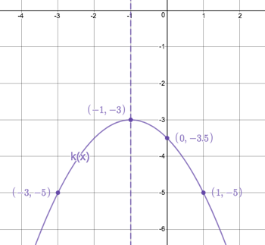
https://www.desmos.com/calculator/ndu6is12ik
- We were asked to state the domain and range of each function in question 3). We can either read these off the sketches, or use our knowledge of the TPs.
- Domain: $\{x:x∈R\}$ or $(-∞; ∞)$ Range: $\{f(x):f(x)∈R, y≥-1\}$ or $[-1;∞)$
- Domain: $\{x:x∈R\}$ or $(-∞; ∞)$ Range: $\{h(x):h(x)∈R, y≤21\}$ or $(-∞;21]$
- Domain: $\{x:x∈R\}$ or $(-∞; ∞)$ Range: $\{j(x):j(x)∈R, y≤4\}$ or $(-∞;4]$
- Domain: $\{x:x∈R\}$ or $(-∞; ∞)$ Range: $\{k(x):k(x)∈R, y≤-3\}$ or $(-∞;-3]$
- There are two ways of answering this question. We can find the TP of $l\left(x\right)$ and then work out the TP and equation of $m\left(x\right)$ or we can make some clever substitutions into $l(x)$.
By finding the TP:
$l\left(x\right)=x^{2}-2x-3$: $a=1;b=-2;c=-3$
AS: $x=-\frac{b}{2a}=-\frac{\left(-2\right)}{2\left(1\right)}=1$. This is also the x-coordinate of the TP.
$l\left(1\right)=1^{2}-2\left(1\right)-3=-4$. Therefore, the TP of $l\left(x\right)$ is the point $(1; -4)$.
The TP of $m(x)$ is $(2; -7)$ but the shape is the same, therefore $a=1$.
$$∴m\left(x\right)={\left(x-2\right)}^{2}-7$$
$$∴m\left(x\right)=x^{2}-4x-3$$
By making substitutions:
We know that $m(x)$ is the same shape as $l(x)$ but has been moved 1 unit to the right and 3 units down. That means that every point on the graph of $l(x)$ has been moved 1 unit to the right and 3 units down. Here is a table of some corresponding points on $l(x)$ and $m(x)$.
$$l(x)$$ | $$(0;-3)$$ | $$(-1;0)$$ | $$(4;5)$$ | $$(-2;5)$$
$$m(x)$$ | $$\left(0+1; -3-3\right)$$  $$(1; -6)$$ | $$\left(-1+1; 0-3\right)$$  $$(0; -3)$$ | $$\left(4+1; 5-3\right)$$  $$(5; 2)$$ | $$\left(-2+1; 5-3\right)$$  $$(-1; 2)$$

We can see from the table that every x coordinate has had 1 added to it and every y coordinate has had 3 subtracted from it.
To shift the y coordinate of every point on the graph of $l(x)$ down by 3 units is easy. We can just say that $m\left(x\right)=l\left(x\right)-3$ because we know that $l\left(x\right)=y$. When we input, say 1, into $l(x)$ we would still need to subtract 3 from the answer to find the corresponding point on $(m(x)$.
To shift the x coordinate of every point on the graph of $l(x)$ to the right by 1 unit, we can say that $m\left(x+1\right)=l\left(x\right)$. In other words, if we input, say 1, into $l(x)$ we would need to input $x+1$ into $m(x)$ to get the same answer.
But we don’t know the equation of $m(x)$ so we have to write this relationship the other way around i.e. $m\left(x\right)=l\left(x-1\right)$. For every $x$ we input into $m(x)$ we would need to input ($x-1)$ into $l(x)$ to get the same answer.
Putting these two shifts together we get that $m\left(x\right)=l\left(x-1\right)-3$.
$$∴m\left(x\right)={[\left(x-1\right)}^{2}-2\left(x-1\right)-3]-3$$
$$∴m\left(x\right)=x^{2}-2x+1-2x+2-3-3$$
$$∴m\left(x\right)=x^{2}-4x-3$$
These kinds of transformations of graphs can be quite tricky so let’s do another activity to make sure we understand how they work.

Activity 6: Transformations

Purpose
This activity will introduce you to the various ways we can transform graphs and how these transformations can be done.

Suggested Time
You will need about 80 minutes.

What You Will Need
- A pen or pencil
- Some blank paper or a notebook
- An Internet connection

Tasks
- Visit the interactive simulation at https://www.desmos.com/calculator/uzlou9sehc. Here you will find three functions, $f\left(x\right)=x^{2}-3x-4$ and $g\left(x\right)=f\left(x\right)+a$ and $h\left(x\right)=f\left(x-a\right)$ along with sliders to change the values of $a$ and $b$. Currently $a=0$ so $g\left(x\right)=f\left(x\right)$ and $b=0$ so $h\left(x\right)=f\left(x\right)$.
- Without doing anything, what do you think will happen to the graph of $g(x)$ if you made $a=3$? What do you think would happen to the graph of $g(x)$ if you made $a=-2$?
- Make the changes to see if you are right.
- Without doing anything, what do you think will happen to the graph of $h(x)$ if you made $b=2$? What do you think would happen to the graph of $h(x)$ if you made $a=-5$?
- Make the changes to see if you are right.
- If $f(x)$ is moved 3 units down, write down the equation of the new function $j(x)$ in terms of $f(x)$.
- If $f(x)$ is moved 3 units to the right, write down the equation of the new function $k(x)$ in terms of $f(x)$.
- If $f(x)$ is moved 4.5 units to the left, write down the equation of the new function $l(x)$ in terms of $f(x)$.
- If $f(x)$ is moved 3 units right and 4 unit down, write down the equation of the new function $m(x)$ in terms of $f(x)$. Also, write the new function in full.
- Now watch the video called Transformations of Graphs: Translations (03:15) for a great summary of these translation transformations and some extra practice questions.
(https://www.youtube.com/watch?v=7qj4kWrxTuY)
- Take the function $f\left(x\right)=x^{2}-3x-4$. Make a quick sketch of the function on a piece of paper.
- Now multiply the y coordinate of a few points on the graph by $-1$, plot these new points and sketch the resulting graph. What has this done to the original graph?
- Write an expression for your new function $g(x)$ in terms of $f(x)$. Remember, every y coordinate was multiplied by $-1$.
- Now multiply the x coordinate of a few points on the graph by $-1$, plot these new points and sketch the resulting graph. What has this done to the original graph?
- Write an expression for your new function $h(x)$ in terms of $f(x)$. Remember, every x coordinate was multiplied by $-1$.
- Visit the interactive simulation at https://www.desmos.com/calculator/bssf8tgxwd to check that your sketches of $g(x)$ and $h(x)$ are correct and have been expressed in terms of $f(x)$ correctly.
- Now watch the video called Transformations of Graphs: Reflections (01:55) for a great summary of these reflection transformations (reflect graphs about the x- and y-axes).
(https://www.youtube.com/watch?v=r74cyHCUZQs)
- Visit the interactive simulation at https://www.desmos.com/calculator/vtf19d1aer. Here you will find three functions, $f\left(x\right)=x^{2}-3x-4$ and $g\left(x\right)=af\left(x\right)$ and $h\left(x\right)=f\left(bx\right)$ along with sliders to change the values of $a$ and $b$. Currently $a=1$ so $g\left(x\right)=f\left(x\right)$ and $b=1$ so $h\left(x\right)=f\left(x\right)$.
- Without doing anything, what do you think will happen to the graph of $g(x)$ if you made $a=3$? Remember, making $a=3$ will multiply the y-coordinate of every point on $f(x)$ by 3? What do you think would happen to the graph of $g(x)$ if you made $a=\frac{1}{2}$?
- Make the changes to see if you are right.
- Without doing anything, what do you think will happen to the graph of $h(x)$ if you made $b=2$? Remember, making $b=2$ will multiply the x-coordinate of every point on $f(x)$ by 2. What do you think would happen to the graph of $h(x)$ if you made $a=\frac{1}{3}$?
- Make the changes to see if you are right.
- $A(2;-3)$ is a point on $t\left(x\right)=-2x^{2}+2x+1$. What will the corresponding point on $s(x)$ be if $s\left(x\right)=2t(x)$?
- $A(2;-3)$ is a point on $t\left(x\right)=-2x^{2}+2x+1$. What will the corresponding point on $s(x)$ be if $s\left(x\right)=t(\frac{1}{4}x)$?
- $A(2;-3)$ is a point on $t\left(x\right)=-2x^{2}+2x+1$. What will the corresponding point on $s(x)$ be if $s\left(x\right)=t(3x)$?
- $A(2;-3)$ is a point on $t\left(x\right)=-2x^{2}+2x+1$. What will the corresponding point on $s(x)$ be if $s\left(x\right)=\frac{1}{2}t(x)$?
- Watch the video called Graph Transformations (3:40) for a great summary of these “stretch” and “squash” transformations.
(https://www.youtube.com/watch?v=MLIgFdxGM-o)
- $f(x)$ has been transformed by $y=-\frac{1}{2}f\left(x-4\right)+3$. If the point $B$ was $(2; 2)$, where is it now?

Guided Reflection
- The transformations that we look at in this question are called translations – where we move a graph around the Cartesian plane without changing its shape.
- If we made $a=3$ we would move the whole graph 3 units up. This is because we would be adding 3 to every output value generated by $f(x)$.
If we made $a=-2$ we would move the whole graph 2 units down. This is because we would be subtracting 2 to every output value generated by $f(x)$.
- Here are pictures of the translated graphs.
$$a=3:g\left(x\right)=f\left(x\right)+3$$ | $$a=-2:g\left(x\right)=f\left(x\right)-2$$
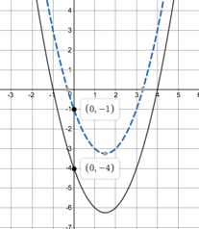 | 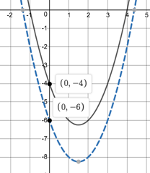

- If we made $b=2$ we would move the whole graph 2 units to the right. This is because to get the same output out of both $f$ and $h$, we would need to subtract 2 from the input before we fed it into $f$.
If we made $b=-5$ we would move the whole graph 5 units to the left. This is because to get the same output out of both $f$ and $h$, we would need to add 5 from the input before we fed it into $f$. $f\left(x-\left(-5\right)\right)=f(x+5)$.
- Here are pictures of the translated graphs.
$$b=2:h\left(x\right)=f\left(x-2\right)$$ | $$b=-5:h\left(x\right)=f\left(x+5\right)$$
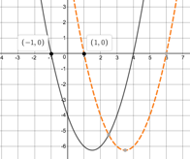 | 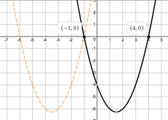

- This is a vertical (up or down) shift so, in general, $j\left(x\right)=f\left(x\right)+a$. $f(x)$ is moved 3 units down, so $j\left(x\right)=f\left(x\right)-3$.
- This is a horizontal (left or right) shift so, in general, $k\left(x\right)=f\left(x-b\right)$. $f(x)$ is moved 3 units to the right, so $k\left(x\right)=f\left(x-3\right)$.
- This is a horizontal (left or right) shift so, in general, $l\left(x\right)=f\left(x-b\right)$. $f(x)$ is moved 4.5 units to the left, so $l\left(x\right)=f\left(x-\left(-4.5\right)\right)=f\left(x+4.5\right)$.
- This is a both a vertical and horizontal shift so, in general, $m\left(x\right)=f\left(x-b\right)+a$. $f(x)$ is moved 3 units right and 4 units down, so $m\left(x\right)=f\left(x-\left(2\right)\right)-4=f\left(x-2\right)-4$.
If $f\left(x\right)=x^{2}-3x-4$, we can write the new function $m(x)$ as
$$m\left(x\right)={[(x+2)}^{2}-3\left(x+2\right)-4]+1$$
$$∴m\left(x\right)=x^{2}+4x+4-3x-6-4+1$$
$$∴m\left(x\right)=x^{2}+4x-5$$
For a full worked solution of this question watch the video called Shifting parabolas (04:40).
(https://www.khanacademy.org/math/algebra/quadratics/transforming-quadratic-functions/v/example-translating-parabola)
- The transformations that we look at in this question are called reflections – where we reflect the graph about a line (in this case the x- and y-axes). Here is a picture of the graph of $f\left(x\right)=x^{2}-3x-4$.
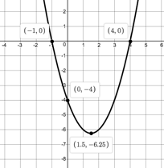
- If we take the x- and y-intercept and the TP and multiply these y-coordinates by $-1$, we get four new points - $\left(-1;0\right), \left(4;0\right), \left(0;4\right), \left(1\frac{1}{2};6\frac{1}{4}\right).$ Plotting these points and joining them gives a graph which has been flipped around horizontally, or is reflected about the x-axis.
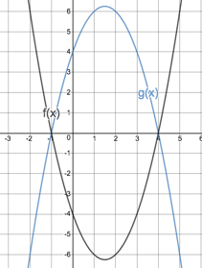
- If the y-coordinate of every point has been multiplied by $-1$ then $g\left(x\right)=-1×f\left(x\right)=-f(x)$.
- If we take the x- and y-intercept and the TP and multiply these x-coordinates by $-1$, we get four new points - $\left(1;0\right), \left(-4;0\right), \left(0;-4\right), \left(-1\frac{1}{2};-6\frac{1}{4}\right).$ Plotting these points and joining them gives a graph which has been flipped around vertically, or is reflected about the y-axis.
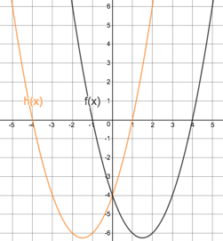
- If the x-coordinate of every point has been multiplied by $-1$ then $g\left(x\right)=f\left(-1×x\right)=f(-x)$.
- The transformations that we look at in this question are called scaling transformations – where we stretch or squeeze the graph without moving it anywhere.
- If we made $a=3$, the y-coordinate of every point on $f$ would be multiplied by 3. This would stretch the graph out and make it “longer and thinner”.
If we made $a=\frac{1}{2}$, the y-coordinate of every point on $f$ would be divided by 2. This would squash the graph and make it “shorter and fatter”.
- Here are pictures of the transformed graphs.
$$a=3:g\left(x\right)=3f\left(x\right)$$ | $$a=\frac{1}{2}:g\left(x\right)=\frac{1}{2}f\left(x\right)$$
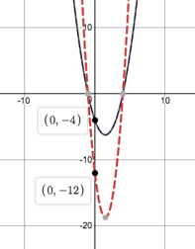 | 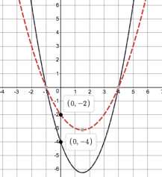

- If we made $b=2$, the x-coordinate of every point on $f$ would have to be divided by 2 to get the same output. This would squash the graph horizontally and make it “thinner”.
Note: Horizontal transformations also seem a bit counter-intuitive. They are not what you might at first think. Remember how $y=2x^{2}$ was a thinner graph than $y=x^{2}$? Well, if $h\left(x\right)=f\left(2x\right)$, then $h$ will be thinner than $f$.
If we made $b=\frac{1}{3}$, the x-coordinate of every point on $f$ would have to be multiplied by 3 to get the same output. This would stretch the graph out horizontally and make it “fatter”.
- Here are pictures of the transformed graphs.
$$b=2:h\left(x\right)=f\left(2x\right)$$ | $$b=\frac{1}{3}:h\left(x\right)=f\left(\frac{1}{3}x\right)$$
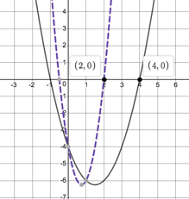 | 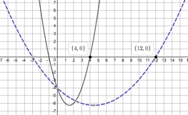

- If$s\left(x\right)=2t(x)$ we are dealing with a vertical scaling and every y-coordinate will be multiplied by 2. Therefore, the transformed point would be $A(2;-6)$.
- If$s\left(x\right)=t(\frac{1}{2}x)$ we are dealing with a horizontal scaling and every x-coordinate will be multiplied by 2. Therefore, the transformed point would be $A(4;-3)$.
- If$s\left(x\right)=t(\frac{1}{4}x)$ we are dealing with a horizontal scaling and every x-coordinate will be multiplied by 4. Therefore, the transformed point would be $A(8;-3)$.
- If$s\left(x\right)=t(3x)$ we are dealing with a horizontal scaling and every x-coordinate will be divided by 3. Therefore, the transformed point would be $A(\frac{2}{3};-3)$.
- If$s\left(x\right)=\frac{1}{2}t(x)$ we are dealing with a vertical scaling and every y-coordinate will be divided by 2. Therefore, the transformed point would be $A(2;-\frac{3}{2})$.
- We know that $f(x)$ has been transformed by $y=-\frac{1}{2}f\left(x-4\right)+3$. It has undergone various transformations. Let’s work from the inside out.
We know that $f(x-4$) shifts the graph 4 units to the right. So $B$ moves from $(2; 2)$ to $(6; 2)$.
We know that the $\frac{1}{2}f(x)$ squashes the graph vertically (all the y-coordinates are divided by 2). So $B$ moves from $(6; 2)$ to $(6; 1)$.
We know that $-f(x)$, reflects the graph about the x-axis by multiplying all the y-coordinates by $-1$. So $B$ moves from $(6; 1)$ to $(6; -1)$.
Finally, we know that $f\left(x\right)+3$, translates the graph up by 3 units by adding 3 to all the y-coordinates. So $B$ moves from $(6; -1)$ to $(6; 2)$.
In that last activity we learnt about three different types of transformations that we can make to graphs:

Translations
These move the graph vertically (up or down) or horizontally (left or right) without changing the shape of the graph.
- Vertical Shift: $g\left(x\right)=f\left(x\right)+a$: If $a>0$ the graph moves up. If $a<0$, the graph moves down.
- Horizontal Shift: $g\left(x\right)=f\left(x+b\right)$: If $b>0$ the graph moves left. If $b<0$, the graph moves right.

Reflections
We looked at reflecting graphs about the x- and y-axes.
- Vertical Reflection (about the x-axis or the line $y=0$): $g\left(x\right)=-f(x)$.
- Horizontal Reflection (about the y-axis or the line $x=0$): $g\left(x\right)=f(-x)$.

Scaling
We looked at vertical and horizonal scaling that makes the graph fatter or thinner.
- Vertical Scaling: $g\left(x\right)=af\left(x\right)$: If $a>1$ the graph is stretched out vertically. If $0<a<1$, the graph is squashed in vertically.
- Horizontal Scaling: $g\left(x\right)=f\left(bx\right)$: If $b>0$ the graph gets thinner. If $0<b<1$, the graph gets fatter.
So far, we have learnt how to reflect graphs about the lines $x=0$ (the y-axis) and $y=0$ (the x-axis), but what about reflections about the line $y=x$? Let’s investigate.

Activity 7: A Very Special Transformation

Purpose
This activity will introduce you to reflections of graphs about the line $y=x$ and the concept of inverse functions.

Suggested Time
You will need about 35 minutes.

What You Will Need
- A pen or pencil
- Some blank paper or a notebook

Tasks
Have a look at these graphs.
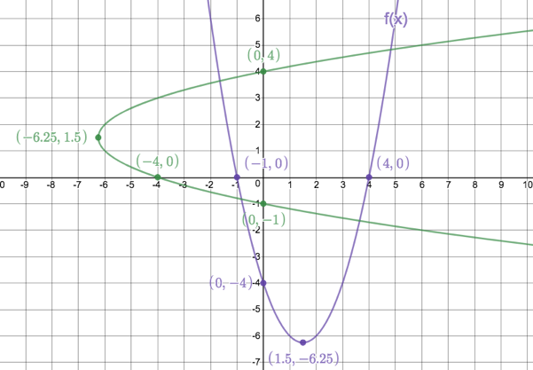
Image source: https://www.desmos.com/calculator/4i0rocwco0
One is the graph of $f\left(x\right)=x^{2}-3x-4$.
- What do you notice about each of the labelled points on $f$ in relation to their counterparts on the other graph? Think about the TP and intercepts with the axes.
- Draw a straight line on the graph that is the line that reflects $f$ onto the other graph. What is the equation of this line?
- What is the AS of $f$?
- What is the AS of the other graph?
- What is the domain and range of $f$?
- What is the domain and range of the other graph?
- Is $f$ a function? How do you know?
- Is the other graph a function? How do you know.
- If the other graph is not a function, what could you do to make it a function?
- If the other graph is a reflection of $f$ about the line $y=x$, write down the equation of the other graph.
- Find the value of $f(2)$ then input this answer for $x$ into the equation of your other graph. What do you notice?

Guided Reflection
- Each of the corresponding points on $f$ and the other graph have been swopped around i.e. what was the x-coordinate is now the y-coordinate and visa versa - $\left(x; y\right)⟹y;x)$. For example, the TP of $f$ is $(1.5;-6.25)$ and the turning point of the other graph is $(-6.25;1.5)$.
- The equation of the line that reflects $f$ onto the other graph is $y=x$.
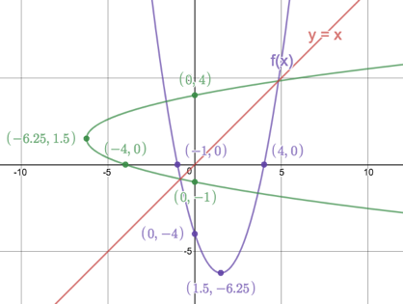
- The AS of $f$ is $x=1.5$.
- The AS of the other graph is $y=1.5$.
- Domain: $\{x:x∈R\}$ Range: $\{y:y∈R, y≥-6.25\}$
- Domain: $\{x:x∈R, x≥6.25\}$ Range: $\{y:y∈R\}$
- $f$ is a function. For every input of $x$ there is only ever one output of $y$. This can be confirmed with the vertical line test. A vertical line will only every cut the graph once.
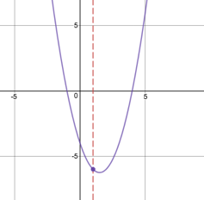
- The other graph is NOT a function because there are many times when a single input generates more than one output as show by the vertical line test.
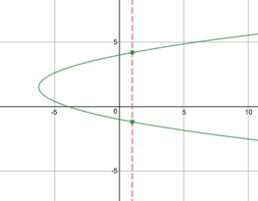
- To make this other graph a function, we would have to get rid of one of the “arms” of the parabola. We could do this by restricting the domain of the original function $f$ to only those values of $x≥1.5$ or $x≤1.5$. The excluded part of the graphs are shown with dotted lines below.
Domain of $f$ | $$x≥1.5$$ | $$x≤1.5$$
Graph of $f$ and other graph | 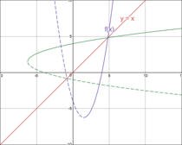 | 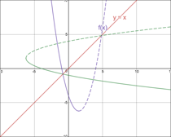

- If $f\left(x\right)=x^{2}-3x-4$ and we have swopped all the $x$’s and $y$’s around, then the equation of the other graph is $x=y^{2}-3y-4$.
- $f\left(2\right)={(2)}^{2}-3\left(2\right)-4=-6$
Let $x=-6$ in $x=y^{2}-3y-4$:
$$∴-6=y^{2}-3y-4$$
$${∴y}^{2}-3y+2=0$$
$$∴(y-2)(y-1)=0$$
$∴y=2$ or $y=1$
We get back our original input value as one of the answers.

From this last activity we saw that if we reflect a graph about the line $y=x$, we create a graph whose equation undoes what the original function did. We call such equations inverses. If $f\left(x\right)=x^{2}-3x-4$, the inverse of $f$ has the equation $x=y^{2}-3y-4$.

Watch the video Intro to inverse functions (09:05) to learn more about inverses.

(https://www.khanacademy.org/math/algebra2/manipulating-functions/introduction-to-inverses-of-functions/v/introduction-to-function-inverses)

Here is a quick summary of inverses:
- The inverse of a function undoes what the original function does.
- We can find the inverse of a function by swopping all the $x$’s with $y$’s in the original function equation.
- The inverse of a function e.g. $f(x)$ is denoted by $f^{-1}(x)$.
- The domain of $f(x)$ becomes the range of $f^{-1}(x)$ and the range of $(x)$ becomes the domain of $f^{-1}(x)$.
- The graphs of $f\left(x\right)$ and $f^{-1}(x)$ are symmetrical about the line $y=x$.
- It is important to remember that the inverse of a function is not always a function itself, as we saw in the last activity.
- Sometimes, we have to restrict the domain of the original function to make sure that its inverse is also a function.

Get some practice working with inverses of functions by doing the next activity.

Activity 8: Inverses of Functions

Purpose
This activity will give you practice working with the inverses of functions.

Suggested Time
You will need about 35 minutes.

What You Will Need
- A pen or pencil
- Some blank paper or a notebook

Tasks
- Given $h\left(x\right)=2x-7$.
- Write down the equation for $h^{-1}(x)$.
- Draw sketches of $h(x)$ and $h^{-1}(x)$ on the same system of axes. Also draw the line of reflection, $y=x$.
- Write down the domain and range of $h(x)$ and $h^{-1}(x)$.
- Is $h^{-1}(x)$?
- Given $j\left(x\right)={(x-3)}^{2},x≥3$
- Write down the equation for $j^{-1}(x)$.
- Write down the domain and range of $j(x)$ and $j^{-1}(x)$.
- Draw sketches of $j(x)$ and $j^{-1}(x)$ on the same set of axes. Also draw the line of reflection, $y=x$.
- Is $j^{-1}(x)$ a function?
- Given $q^{-1}\left(x\right)=\frac{3}{x-1}-2$.
- Write down the equation for $q(x)$.
- Write down the domain and range of $q(x)$ and $q^{-1}(x)$.

Guided Reflection
- $h\left(x\right)=2x-7$.
- To find the inverse of $h(x)$ we need to write the equation as $y=2x-7$ and swop all the $x$’s and $y$’s.
So $x=2y-7$
$$∴x+7=2y$$
$$∴y=\frac{1}{2}x+\frac{7}{2}$$
$$∴h^{-1}\left(x\right)=\frac{1}{2}x+\frac{7}{2}$$
- Here is the sketch of $h(x)$ and $h^{-1}(x)$.
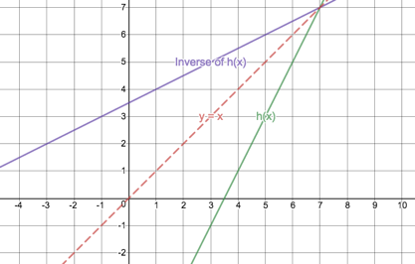
Image source: https://www.desmos.com/calculator/2c5nxzqkh1
- $h(x)$ Domain: $\{x:x∈R\}$ Range: $\{y:y∈R\}$
$h^{-1}(x)$ Domain: $\{x:x∈R\}$ Range: $\{x:x∈R\}$
- $h^{-1}(x)$ is a function.
- $j\left(x\right)={\left(x-3\right)}^{2},x≥3$
- To find the inverse of $j(x)$ we need to write the equation as $y={(x-3)}^{2}$ and swop all the $x$’s and $y$’s.
So $x={(y-3)}^{2}$ but $x≥3$
$∴y-3=\sqrt{x}$ (because $x≥3$, we know that we only need to worry about $\sqrt{x}$ and can ignore $-\sqrt{x}$)
$$∴y=\sqrt{x}+3$$
$$∴j^{-1}(x)=\sqrt{x}+3$$
- $j(x)$ Domain: $\{x:x∈R,x≥3\}$ Range: $\{y:y∈R, y≥0\}$
$j^{-1}(x)$ Domain: $\{x:x∈R,x≥0\}$ Range: $\{x:x∈R,y≥3\}$
- Here are sketches of $j(x)$ and $j^{-1}(x)$. Notice how the original restriction of the domain of $j(x)$ means that we only draw one arm of the parabola. This then also means that we only draw one arm of the inverse.
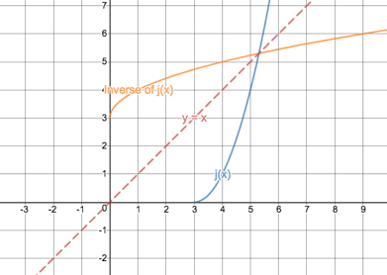
- $j^{-1}(x)$ is a function.
- $q^{-1}\left(x\right)=\frac{3}{x-1}-2$.
- To write down the equation of $q(x)$, we can follow the same steps as finding the inverse of a function. Start by writing the inverse as $y=\frac{3}{x-1}-2$ and then swop the variables.
So, $x=\frac{3}{y-1}-2$
$$∴x+2=\frac{3}{y-1}$$
$$∴y-1=\frac{3}{x+2}$$
$$∴y=\frac{3}{x+2}+1$$
$$∴q(x)=\frac{3}{x+2}+1$$
- $q^{-1}(x)$
Domain: $\{x:x∈R,x≠1\}$ (remember that we can never of zero in a denominator)
Range: $\{y:y∈R, y≠-2\}$ ($\frac{3}{x-1}$ can never equal zero so $y$ can never equal $-2$)
$q(x)$ Domain: $\{x:x∈R,x≠-2\}$ Range: $\{x:x∈R,y≠1\}$

Activity 9: Finding Equations of Quadratic Functions

Purpose
This activity will help you consolidate your knowledge of quadratic functions by finding the equations of quadratic functions from their graphs.

Suggested Time
You will need about 45 minutes.

What You Will Need
- A pen or pencil
- Some blank paper or a notebook

Tasks
- The following is a sketch of the function $t(x)$.
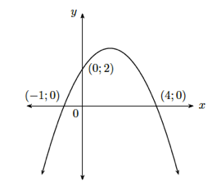
- What kind of fuction is $t(x)$?
- If the x-intercepts are $-1$ and $4$, set up an equation in the form of $t(x)=a(x-x_{1})(x-x_{2})$.
- Use the fact that the fact that the y-intercept is 2, to solve for $a$ in the equation above.
- Write down the equation of $t(x)$.
- Find the equation of the parabola below.
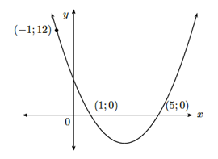
- The followig graph is of the function $v(x)$.
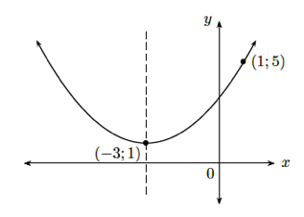
- Set up an equation of the form of $v\left(x\right)=a{\left(x-p\right)}^{2}+q$ to using the TP.
- Use the point $(1;5)$ to solve for $a$.
- Write down the equation for $v(x)$.
- A parabola has an AS of $x=-2$ and a TP on the x-axis. It passes through the point $(1;6)$. Find the equation of the parabola.
- A parabola has a AS of $x=2\frac{1}{2}$ and passes through the point $(-1;3)$. One of its x-intercepts is $(5;0)$. Find the equation of the parabola.
- $f\left(x\right)=3x-4$ shares a y-intercept with $g(x)$ and $g(x)$ has a TP of $(\frac{1}{2};-4\frac{1}{2})$. Where else do $f\left(x\right)$ and $g(x)$ intersect?

Guided Reflection

Activity 10: Applications of Quadratic Equations and Review

Purpose
This activity will help you review and consolidate your knowledge of the quadratic functions.

Suggested Time
You will need about 45 minutes.

What You Will Need
- A pen or pencil
- Some blank paper or a notebook

Tasks
- A farmer needs to divide up his square plot for each of his children. He decides to give his youngest child a plot of ground which was divide by decreasing the original plot on one side by 60m and the on the other sides by 80m. This plot is 2,400m². Was were the original dimensions of the plot?
- A warehouse has the shape of a rectangle 21m long and 10m wide. Determine the thickness of its walls if the inside area, is 180m².
- Given the function $k\left(x\right)=-\frac{1}{3}x+3, x≤0$.
- Write down the domain and range of $k(x)$.
- Draw a sketch of $k(x)$.
- Find the equation of $k^{-1}(x)$.
- Where do $k(x)$ and $k^{-1}(x)$ intersect?
- A target is a horizontal distance of 20m from a cannon but is on an inclined plane (like on the side of a hill) with a gradient of 0.15. The cannon fires a cannon ball up the plane such that the cannon ball’s path can be described by $y=2+0.12x-0.002x^{2}$. Will the cannon ball hit the target?
- A javelin thrower makes a throw. It lands 150m away and reaches a maximum height of 45m. If the javelin’s flight follows a parabola, work out the equation of this parabola. Assume that the path goes through the point $(0;0)$.

Guided Reflection
- .
- .
- .
- Here is a diagram illustrating the situation.
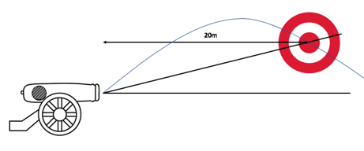
The inclined plane can be described by a straight line with the equation $y=0.15x$. We also know that the flight of the cannon ball is given by $y=2+0.12x-0.002x^{2}$. We need to see where these two graphs intersect by solving these equations simultaneously. If one of the points of intersection has an x-coordinate of 20, then we know that the target is hit.
$$y=0.15x=2+0.12x-0.002x^{2}$$
$$∴0.002x^{2}-0.12x+0.15x-2=0$$
$$∴0.002x^{2}+0.03x-2=0$$
$∴x^{2}+15x-1000=0$ (multiply through by 500)
$$∴\left(x+40\right)\left(x-25\right)=0$$
$∴x=-40$ or $x=25$
We can ignore the negative root. Because the cannon ball will land a horizontal distance of 25m away from the cannon, it will not hit the target.
- In

Unit 4: Hyperbolic Functions

Learning Outcomes
By the end of this unit, you should be able to:
- Define what a hyperbolic function is;
- Sketch hyperbolic functions of the form $y=\frac{a}{x-p}+q$
- Explain the effects on the shape of the graphs of hyperbolic functions of $a$, $p$ and $q$;
- Describe the various characteristics (e.g. domain and range) of graphs of hyperbolic functions;
- Determine the equation of hyperbolic functions from their graphs; and
- Interpret the graphs of hyperbolic functions to make arguments or predictions.

Introduction
We said when introducing the quadratic function that the graphs they make, parabolas, were widely used in satellite dishes and mirrors in telescopes.
The hyperbolic function, whose graph we call a hyperbola, is also widely used in lenses and mirrors because it also focuses light to a single point.
In this unit, we will explore the hyperbolic function in more detail and discover some very important properties that make it special.

Activity 1: Introducing the Hyperbolic Function

Purpose
This activity will introduce you to the basic features of the hyperbolic function.

Suggested Time
You will need about 75 minutes.

What You Will Need
- A pen or pencil
- Some blank paper or a notebook
- An Internet connection

Tasks
- A scientist was doing some experiments with helium gas. He measured the volume a gas occupied (in m³) under different pressures (in kPa), all the while making sure to keep the temperature of the gas constant at 25$℃$. Here are his results.
Pressure (kPa) | 50 | 100 | 150 | 200 | 250 | 300 | 400
Volume (m³) | 320 | 160 | 106.67 | 80 | 64 | 53.3 | 40

  - Plot these points on a Cartesian Plane and join them with a smooth curve. Let pressure be $x$.
  - What happens to the volume as the pressure increases?
  - What happens to the pressure as the volume increase?
  - Can you write a Mathematical expression that relates the pressure and volume of this gas at this temperature?
  - Is the graph symmetrical? About what line is the graph symmetrical?
  - Is there a piece of the graph that is missing? What happens when $x$ is negative? Can you plot this missing piece of the graph?
- Have a look at this expression: $xy=3$.
- Complete the following table using this expression
$$x$$ | $$-3$$ | $$-2$$ | $$-1$$ | $$0$$ | $$1$$ | $$2$$ | $$3$$
$$y$$

- Plot these points and join them with a smooth curve.
- What happens when $x=0$?
- What happens to $y$ when the value of $x$ gets very large or very small?
- Will the graph ever touch or cross either of the axes? Why or why not?
- Why does the graph have two separate curves?
- Is $xy=3$ a function? If so, write it in function notation.
- What are the domain and range of this function?
- About which two lines is the graph symmetrical?
- Here are three hyperbolic functions: $f\left(x\right)=\frac{1}{x}+1$, $g\left(x\right)=\frac{1}{x}-2$ and $h\left(x\right)=\frac{1}{x}$.
- If all of these functions are in the form $y=\frac{1}{x}+q$, using your previous knowledge of the effect of $q$, describe how these three functions will differ.
- Use a table of values to sketch each of these functions on the same set of axes to test your prediction in a).
- If an asymptote is a straight line that a graph gets ever closer to but never touches or crosses, what are the horizontal and vertical asymptotes of each of these functions? How do these asymptotes compare to the equation of each function? Can you write a general expression for the horizontal asymptote?
- Write down the domain and range of each function. How do these relate to the equations of the functions? Can you write a general expression for the range?
- About which lines is each function symmetrical. Can you write a general expression for these axes of symmetry based on the equation of the function?
- Now visit the interactive simulation at https://www.desmos.com/calculator/guac8xfeks and change the value of $q$to confirm and consolidate your understanding of the effect of $q$ in $y=\frac{1}{x}+q$.
- Here are three hyperbolic functions: $j\left(x\right)=\frac{1}{x}$, $k\left(x\right)=\frac{2}{x}$ and $l\left(x\right)=\frac{-1}{x}$.
- If all of these functions are in the form $y=\frac{a}{x}+q$, using your previous knowledge of the effect of $a$, describe how these three functions will differ.
- Use a table of values to sketch each of these functions on the same set of axes to test your prediction in a).
- If an asymptote is a straight line that a graph gets ever closer to but never touches or crosses, what are the horizontal and vertical asymptotes of each of these functions? How do these asymptotes compare to the equation of each function? Can you write a general expression for the horizontal asymptote?
- Write down the domain and range of each function. How do these relate to the equations of the functions? Can you write a general expression for the range?
- About which lines is each function symmetrical. Can you write a general expression for these axes of symmetry based on the equation of the function?
- Now visit the interactive simulation at https://www.desmos.com/calculator/guac8xfeks and change the value of $a$ to confirm and consolidate your understanding of the effect of $q$ in $y=\frac{1}{x}+q$.
- $d\left(x\right)=\frac{-2}{x}+1$
- Using any method, draw a sketch of $d(x)$.
- What is the domain and range of $d(x)$.
- Use the interactive simulation at https://www.desmos.com/calculator/guac8xfeks to confirm that you sketch is correct.

Guided Reflection
- The relationship between the volume and pressure of a gas in this question is called Boyle’s Law.
- If we plot these points and join them with a smooth curve, we get a graph that looks like this.
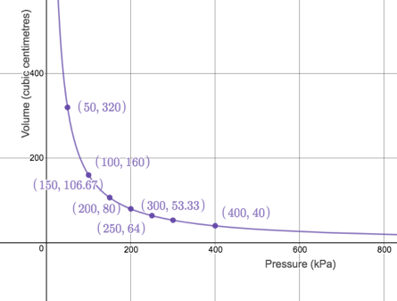
Image source: https://www.desmos.com/calculator/te2jtk5nnt
- As the pressure increase, the volume gets smaller and smaller.
- As the volume increases, the pressure gets smaller and smaller.
- If we multiply the x- and y-coordinates of each point, the answer is always equal to 16,000. So, we can say that the expression is $xy=16000$ or $y=\frac{16000}{x}$.
- The graph is symmetrical about the line $y=x$. This makes perfect sense from what we know about the inverses of functions. If we reflect a graph about the line $y=x$, we just swop the variables. If we do this to this graph, we get back the very same graph. We can write the relationship between $x$ and $y$ either as$y=\frac{16000}{x}$ or $x=\frac{16000}{y}$.
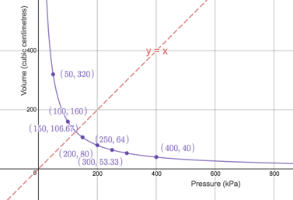
- Even through it makes no physical sense in terms of the pressure and temperate of a gas, if $xy=16000$ and we know that the point $(400;40)$ satisfies this equation, then the point $(-400; -40)$ will also satisfy the equation. This is true for each of the points we plotted. Here is the rest of the graph plotted.
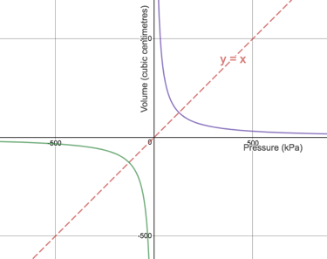
- We were given the expression $xy=3$.
- Here is the completed table. Note that we don’t know what happens when $x=0$.
$$x$$ | $$-3$$ | $$-2$$ | $$-1$$ | $$0$$ | $$1$$ | $$2$$ | $$3$$
$$y$$ | $$-1$$ | $$-\frac{3}{2}$$ | $$-3$$ | ? | $$3$$ | $$\frac{3}{2}$$ | $$1$$

- Here is the graph of the expression.
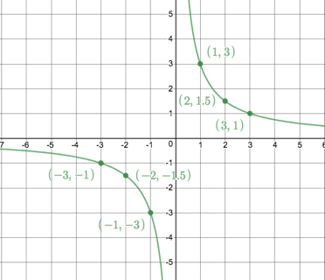
Image source: https://www.desmos.com/calculator/5qsirdkvva
- We don’t know what happens when $x=0$. The expression $xy=3$ or $y=\frac{3}{x}$ is undefined because we are never allowed to divide by zero.
- When $x$ gets very small, then the value of $y$ in $y=\frac{3}{x}$ gets very big. When $x$ gets very big, then the value of $y$ in $y=\frac{3}{x}$ gets very small. We can see this clearly in the sketch of the graph in both arms of the graph.
- $y=\frac{3}{x}$ tells us that $x≠0$. Therefore, the graph will never touch or cross the y-axis. We can also right the expression as$x=\frac{3}{y}$. This tells us that the graph will never touch or cut the x-axis either. In this case the x- and y-axes are called asymptotes. These are straight lines that a graph can get closer and closer to without ever touching or crossing.
- There are two arms to the graph because a $+×+=+$ and a $-×-=+$.
- $xy=3$ is a function. At no point will we ever get more than one output for any given input. We can check this with the vertical line test. We know that the graph will never touch or cross the y-axis so, even though it might look like it, $x=0$ does not give two outputs. In fact, $x=0$, gives no output because it is undefined.
- Domain: $\left\{x:x∈R, x≠0\right\}$ – $x$ can be any real number so long as it is not zero.
Range: $\left\{y:y∈R, y≠0\right\}$ – we can produce any real output except zero.
- The graph is symmetrical about $y=x$ and $y=-x$.
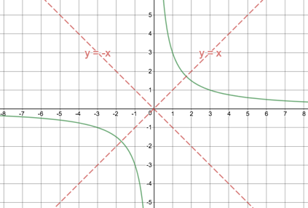
- Here are three hyperbolic functions: $f\left(x\right)=\frac{1}{x}$, $g\left(x\right)=\frac{1}{x}-2$ and $h\left(x\right)=\frac{1}{x}+1$.
- From $y=ax+q$ and $y=a{\left(x-p\right)}^{2}+q$ we expect the value to $q$ to move the whole graph vertically up or down. We expect that $h(x)$ will be shifted 1 unit up from $f(x)$ and that $g(x)$ will be shifted 2 units down from $f(x)$.
- Here is a completed table of values.
$$x$$ | $$-3$$ | $$-2$$ | $$-1$$ | $$0$$ | $$1$$ | $$2$$ | $$3$$
$$f(x)$$ | $$-\frac{1}{3}$$ | $$-\frac{1}{2}$$ | $$-1$$ | ? | $$1$$ | $$\frac{1}{2}$$ | $$\frac{1}{3}$$
$$g(x)$$ | $$-2\frac{1}{3}$$ | $$-2\frac{1}{2}$$ | $$-3$$ | ? | $$-1$$ | $$-1\frac{1}{2}$$ | $$-1\frac{1}{3}$$
$$h(x)$$ | $$\frac{2}{3}$$ | $$\frac{1}{2}$$ | $$0$$ | ? | $$0$$ | $$1\frac{1}{2}$$ | $$\frac{4}{3}$$

Here are the three functions sketched. We can see that $h\left(x\right)$ has been shifted 1 unit up and that $g(x)$ has been shifted 2 units down.
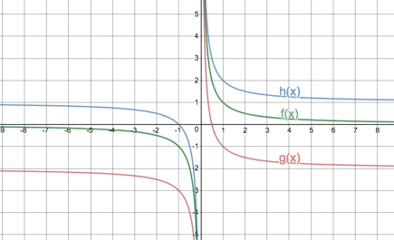
- The vertical asymptote of all three functions is the y-axis or the line $x=0$. Each graph has a different horizontal asymptote.
$f\left(x\right):$ horizontal asymptote is $y=0$.
$g\left(x\right):$ horizontal asymptote is $y=-2$.
$h\left(x\right):$ horizontal asymptote is $y=1$.
The value of each horizontal asymptote is the same as the value of $q$. In general, the horizontal asymptote is the line $y=q$.
- Here is the domain and range of each function.
$f\left(x\right):$ Domain: $\{x:x∈R,x≠0\}$ Range: $\{y:y∈R,y≠0\}$
$g\left(x\right):$ Domain: $\{x:x∈R,x≠0\}$ Range: $\{y:y∈R,y≠-2\}$
$h\left(x\right):$ Domain: $\{x:x∈R,x≠0\}$ Range: $\{y:y∈R,y≠1\}$
In each case, the domains are the same, but the ranges are different and reflect the position of the asymptote and the value of $q$. In general, the range can be given as $\{y:y∈R,y≠q\}$.
- $f\left(x\right):$ is symmetrical about the lines $y=x$ and $y=-x$.
$g\left(x\right):$ is symmetrical about the lines $y=x-2$ and $y=-x-2$.
$h\left(x\right):$ is symmetrical about the lines $y=x+1$ and $y=-x+1$.
We can, therefore, write a general expression for the AS’s of these hyperbolic functions as
AS: $y=x+q$ and $y=x-q$
- Here are all three functions with their asymptotes and axes of symmetry.
$$f\left(x\right)=\frac{1}{x}$$
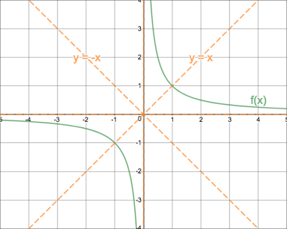
$$g\left(x\right)=\frac{1}{x}-2$$
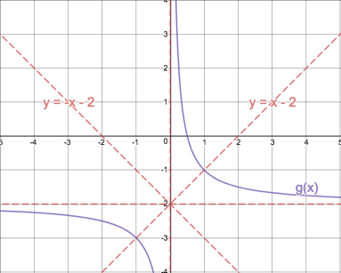
$$h\left(x\right)=\frac{1}{x}+1$$
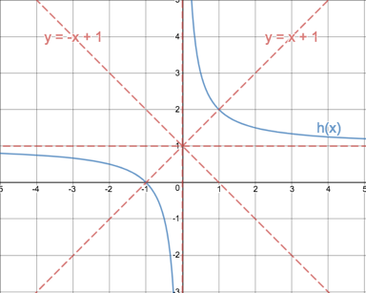
- Here are three hyperbolic functions: $j\left(x\right)=\frac{1}{x}$, $k\left(x\right)=\frac{2}{x}$ and $l\left(x\right)=\frac{-1}{x}$.
- Based on $y=a\left(x-p\right)+q$ and $y=ax^{2}+bx+c$, we expect the value of $a$ to change the shape and orientation of the graph. Therefore, we expect $g$ to be wider than $f$ and $h$ to be flipped around.
- Here is a completed table of values.
$$x$$ | $$-3$$ | $$-2$$ | $$-1$$ | $$0$$ | $$1$$ | $$2$$ | $$3$$
$$j(x)$$ | $$-\frac{1}{3}$$ | $$-\frac{1}{2}$$ | $$-1$$ | ? | $$1$$ | $$\frac{1}{2}$$ | $$\frac{1}{3}$$
$$k(x)$$ | $$-\frac{2}{3}$$ | $$-1$$ | $$-2$$ | ? | $$2$$ | $$2$$ | $$\frac{2}{3}$$
$$l(x)$$ | $$\frac{1}{3}$$ | $$\frac{1}{2}$$ | $$1$$ | ? | $$-1$$ | $$-\frac{1}{2}$$ | $$-\frac{1}{3}$$

Here are the three functions sketched. We can see that $l\left(x\right)$ is now in the other two quarters of the Cartesian Plane (where the coordinates are always opposite in sign) and that $k(x)$ is a wider, flatter graph than $j\left(x\right).$
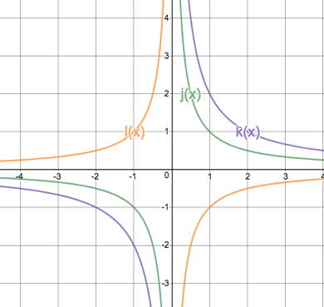
- The vertical asymptote of all three functions is the y-axis or the line $x=0$. The horizontal asymptote of each graph is the x-axis. None of the graphs have been shifted up or down because in each case the value of $q$ was zero. Again, we can say that the horizontal asymptote is the line $y=q$.
- Here is the domain and range of each function.
$j\left(x\right):$ Domain: $\{x:x∈R,x≠0\}$ Range: $\{y:y∈R,y≠0\}$
$k\left(x\right):$ Domain: $\{x:x∈R,x≠0\}$ Range: $\{y:y∈R,y≠0\}$
$l\left(x\right):$ Domain: $\{x:x∈R,x≠0\}$ Range: $\{y:y∈R,y≠0\}$
In each case, the domains and ranges are the same. In general, the range can be given as $\{y:y∈R,y≠q\}$ but as $q=0$ in each case, this is $\{y:y∈R,y≠0\}$.
- $j\left(x\right):$ is symmetrical about the lines $y=x$ and $y=-x$.
$k\left(x\right):$ is symmetrical about the lines $y=x$ and $y=-x$.
$l\left(x\right):$ is symmetrical about the lines $y=x$ and $y=-x$.
We can, therefore, write a general expression for the AS’s of these hyperbolic functions as
AS: $y=x+q$ and $y=x-q$. For each of these functions, the value of $q$ was zero.
- Here are all three functions shown with their asymptotes as well as their axes of symmetry.
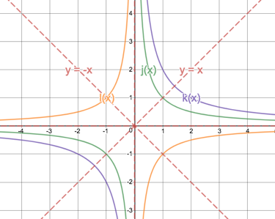
- $d\left(x\right)=\frac{-2}{x}+1$
- To sketch the graph of $d(x)$ we can make use of what we already know rather than a table of values. The value of $a$ is negative which means the graph exists in the two quarters (or quadrants) when the coordinates have different signs. The graph has also been shifted 1 unit up so there is a horizontal asymptote at $y=1$. The vertical asymptote is still the line $x=0$. We really just need one point on each arm. If we chose the points $x=±2$ we get coordinates $2; 0)$ and $\left(-2;2\right)$. Our sketch looks like this.
- Domain: $\{x:x∈R,x≠0\}$ Range: $\{y:y∈R,y≠1\}$
Let’s summarise what we learnt in that last activity.
- We know that the hyperbolic function can be written in the form $y=\frac{a}{x}+q$.
- When in this form, the value of $q$ tells us how much the graph has been sifted vertically up or down.
- This means that the horizontal asymptote is given by $y=q$.
- This means that the range can be written as $\{y:y∈R,y≠q\}$.
- This means that the axes of symmetry are the lines $y=x+q$ and $y=-x+q$.
- When in this form, we know that the domain is $\left\{x:x∈R,x≠0\right\}$ and the vertical asymptote is the line $x=0$.
- The value of $a$ tells us how flat and in what quadrants the graph exists.
- If $a>0$, then the graph is in the first and third quadrants (where the signs of the coordinates are always the same).
- If $a<0$, then the graph is in the second and fourth quadrants (where the signs of the coordinates are always opposite).
- The bigger $a$ is, wider and flatter the graph is.
Here is a summary of these effects.
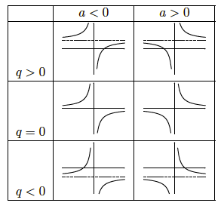
Image source: Everything Maths Gr10 pg170
We know the effects of $a$ and $q$ on the position and shape of the hyperbolic function. You are probably wondering what has happened to the general variable of $p$ like we had in the TP form of the quadratic function $y=a{\left(x-p\right)}^{2}+q$? If, in both cases, $a$ is responsible for the shape and orientation of the graph and $q$ is responsible for vertical shifts, then maybe we can shift the hyperbolic function horizontally (left and right), if we have it in the form $y=\frac{a}{x-p}+q$.
Let’s investigate.

Activity 2: The General Form of the Hyperbolic Function

Purpose
This activity will consolidate your understanding of the hyperbolic function by examining the general form $y=\frac{a}{x-p}+q$

Suggested Time
You will need about 30 minutes.

What You Will Need
- A pen or pencil
- Some blank paper or a notebook
- An Internet connection

Tasks
- Look back at the functions we explored in Activity 1. If all of them were rewritten in the general form of $y=\frac{a}{x-p}+q$, what was the value of $p$ in each case. How does this value relate to the graphs’ vertical asymptotes, domain and axes of symmetry?
- What do you think the graph of $f\left(x\right)=\frac{2}{x+1}-2$ looks like?
- In which quadrants with the graph exist?
- What will the horizontal asymptote be?
- What will the vertical asymptote be?
- What will the axes of symmetry be?
- Find any two points on the graph.
- Make a quick sketch of $f(x)$.
- Visit the interactive simulation at https://www.desmos.com/calculator/f4dskzapvy and check that your sketch from question 2) was correct.
- In which quadrants does the graph exist?
- What is the horizontal asymptote?
- What is the vertical asymptote?
- What are the axes of symmetry?
- Write a general expression for the axes of symmetry in terms of $p$ and $q$. Hint: What do you notice about the values of $p$ and $q$ and the y-intercepts of the axes of symmetry?
- Where do the axes of symmetry intersect and how does this point relate to $p$ and $q$.
- What are the domain and range?
- Write a general expression for the domain and range in terms of $p$ and $q$.
- Make a sketch of $g\left(x\right)=\frac{-2}{x-1}+3$ drawing in the asymptotes and the axes of symmetry. You can check that your sketch is correct using the interactive simulation at https://www.desmos.com/calculator/f4dskzapvy.

Guided Reflection
- If all the functions in Activity 1 were written in the form $y=\frac{a}{x-p}+q$, the value of $p$ in all cases would be zero. In all cases we saw that the vertical asymptote of each function was the line $x=0$ and that the domain of each function was $\left\{x:x∈R,x≠0\right\}$. So perhaps, if the value of $p≠0$, these would change to be $x=p$ and $\left\{x:x∈R,x≠p\right\}$ respectively.
We also saw that the axes of symmetry in all cases were the lines $y=x+q$ and $y=-x+q$. Because we think that the value of $p$ determines a function’s horizontal shift, the equations of these axes of symmetry will change but it is not clear yet how.
- $f\left(x\right)=\frac{2}{x+1}-2$
- Because the value of $a>0$, the graph will be in the first and third quadrants. Also, $a=2$ so the graph will be a bit flatter than one with the equation $y=\frac{1}{x}$.
- The horizontal asymptote will be the line $y=-2$. This means the graph is shifted 2 units down.
- The vertical asymptote might be the line $x=-1$ because the function can be rewritten as$f\left(x\right)=\frac{2}{x-(-1)}-2$. This means the graph is shifted 1 unit to the left.
- The one AS (without the horizontal shift) would be $y=x-2$. But we think the whole graph will be shifted 1 unit to the left. This would increase the y-intercept of the line by 1 unit. So, we think the one AS will be $y=x-1$.
The other AS (without the horizontal shift) would be $y=x--2$. But we think the whole graph will be shifted 1 unit to the left. This would decrease the y-intercept of the line by 1 unit. So, we think the one AS will be $y=-x-3$.
- To find any two points on the graph you can try and find the intercepts.
x-intercept (let $y=0)$: $∴0=\frac{2}{x+1}-2$
$$∴\frac{2}{x+1}=2$$
$$∴2=2x+2$$
$$∴x=0$$
So, the graph goes through the origin $(0; 0)$. Therefore, the y-intercept is also zero. We need to find one other point. Ideally, this point should be on the other arm of the graph i.e. on the other side of the vertical asymptote. We can choose any convenient value for $x$, say $x=-2$.
$$f\left(-2\right)=\frac{2}{x+1}-2=-2-2=-4$$
Therefore, the point $(-2;-4)$ also lies on the graph.
- Here is the graph of $f\left(x\right)=\frac{2}{x+1}-2$.
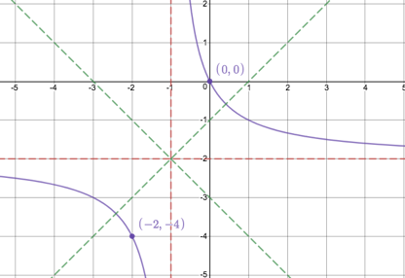
- The graph exits in quadrants one and three as expected for $a>0$.
- The horizontal asymptote is the line $y=-2$ in keeping with the general rule of $y=q$.
- The vertical asymptote is the line $x=-1$ as we expected where $p=-1$ in $f\left(x\right)=\frac{2}{x+1}-2$ and the equation of the vertical asymptote being $x=p$.
- The axes of symmetry are the lines $y=x-1$ and $y=-x-3$.
- We know that the axes of symmetry are the lines $y=x-1$ and $y=-x-3$. They have y-intercepts of $-1$ and $-3$ respectively, which are one greater and one less than the value of $q$. But the value of $p=-1$. Therefore, we can write the equations for the axes of symmetry as follows:
$y=x-2-(-1)$ and $y=-x-2+(-1)$ or more generally as
$y=x+q-p$ and $y=-x+q+p$
- The axes of symmetry intersect at the point $(-1; -2)$. This is the point $(p;q)$.
- Domain: $\left\{x:x∈R,x≠-1\right\}$ Range: $\left\{y:y∈R,y≠-2\right\}$
- General expressions for the domain and range are:
Domain: $\left\{x:x∈R,x≠p\right\}$ Range: $\left\{y:y∈R,y≠q\right\}$
- We need to sketch $g\left(x\right)=\frac{-2}{x-1}+3$.
$a<0$: the graph exists in quadrant two and four.
$q=3$: the graph is shifted 3 units up. Therefore, the horizontal asymptote is $y=3$.
$p=1$: the graph is shifted 1 unit to the right. Therefore, the vertical asymptote is $x=1$.
The axes of symmetry are $y=x+q-p$ and $y=-x+q+p$ or $y=x+2$ and $y=-x+4$. As a second check, the axes of symmetry always intersect at the point $\left(p;q\right)=(1;3)$.
x-intercept (let $y=0)$: y-intercept (let $x=0)$:
$0=\frac{-2}{x-1}+3$ $y=\frac{-2}{0-1}+30=\frac{-2}{x-1}+3$ $y=5$
$$∴\frac{-2}{x-1}=-3$$
$$∴-2=-3x+3$$
$$∴x=-\frac{5}{3}=-1\frac{2}{3}$$
Here is a sketch of $g\left(x\right)=\frac{-2}{x-1}+3$. Notice again, how the axes of symmetry intersect at the point $\left(p;q\right)=(1;3)$.
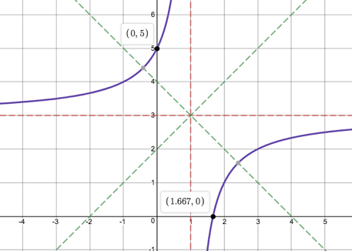

Activity 3: Finding the Equations of Hyperbolas

Purpose
This activity will help you to find the equations of hyperbolic functions from their graphs as well as solve other problems involving hyperbolas.

Suggested Time
You will need about 45 minutes.

What You Will Need
- A pen or pencil
- Some blank paper or a notebook
- An Internet connection

Tasks
- A hyperbola of the form $k(x)=\frac{a}{x-p}+q$ pases through the point $(4; 3)$. If the axes of symmetry intersect at $(1;2)$, determine the equation of $k(x)$.
- Find the equation of the hyperbolic function represented in this graph.
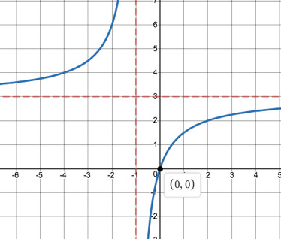
Image source: https://www.desmos.com/calculator/16vokigzgl
- A hyperbolic function, $v(x)$, has axes of symmetry of $y=x-2$ and $y=-x+2$ and a y-intercept of $\frac{1}{2}$.
- Find the equation of $v$.
- What is the equation of the straight line, $s(x)$, intersecting with $v$ and the points where $x=-1$ and $x=1\frac{3}{4}$?
- What is the average gradient of $v$ between the points of intersection of $v$ and $s$? Illustrate this with a graph.
- Is the gradient of $v$ at $(\frac{9}{5};5)$ greater than or less than this average gradient? Illustrate this with a graph.

Guided Reflection
- We are told that $k(x)=\frac{a}{x-p}+q$ and that the axes of symmetry intersect at $(1;2)$. That means that $p=1$ and $q=2$. Therefore $k(x)=\frac{a}{x-1}+2$
We are also told that the graph passes through $(4; 3)$ so we have values for $x$ and $y$ to substitute into the equation of $k(x)$ to find $a$.
$$k\left(4\right)=\frac{a}{x-1}+2=3$$
$$∴3=\frac{a}{4-1}+2=\frac{a}{3}+2$$
$$∴1=\frac{a}{3}$$
$$∴a=3$$
$$k(x)=\frac{3}{x-1}+2$$
- We can see from the graph that the horizontal asymptote is the line $y=3$. That means that $q=3$. We can also see that the vertical asymptote is the line $x=-1$. Therefore, $p=-1$.
So, the equation of the hyperbola is of the form $y=\frac{a}{x-(-1)}+3=\frac{a}{x+1}+3$.
We can also see that the graph passes through the point $(0;0)$. If we substitute these values for $x$ and $y$ into the equation, we get
$$0=\frac{a}{0+1}+3$$
$$∴a=-3$$
Therefore, the equation of the function is $y=\frac{-3}{x+1}+3$. The negative value of $a$ makes sense given that the graph exists in quadrant two and four.
- We are told that $v(x)$, has axes of symmetry of $y=x-2$ and $y=-x+2$ and a y-intercept of $\frac{1}{2}$.
- We know that the point where the axes of symmetry meet is the point $(p;q)$. To find where the axes of symmetry intersect, we need to solve their equations simultaneously.
$y=x-2$ (1)
$y=-x+2$ (2)
$$\left(1\right)=\left(2\right):x-2=-x+2$$
$$∴2x=4$$
$$∴x=2$$
Substitute $x=2$ into (1): $y=2-2=0$
The axes of symmetry intersect at $(2; 0)$. Therefore $p=2$ and $q=0$.
So, $v\left(x\right)=\frac{a}{x-2}$. Substitute the point $(0; \frac{1}{2})$ (the y-intercept) into the equation to find $a$.
$$\frac{1}{2}=\frac{a}{0-2}=-\frac{a}{2}$$
$$∴a=-1$$
Therefore $v\left(x\right)=\frac{-1}{x-2}$.
- We are given the x-coordinates of two points of intersection. We need to use $v(x)$ to first find the y-coordinates.
$v\left(-1\right)=\frac{-1}{\left(-1\right)-2}=\frac{1}{3}$. So, the point is $(-1; \frac{1}{3})$.
$v\left(1\frac{3}{4}\right)=\frac{-1}{\left(\frac{7}{4}\right)-2}=\frac{-1}{\frac{7}{4}-\frac{8}{4}}=\frac{-1}{-\frac{1}{4}}=4$. So, the point is $(1\frac{3}{4}; 4)$.
Now we can find the gradient of the straight line between these two points using $m=\frac{y_{2}-y_{1}}{x_{2}-x_{1}}$.
$$m=\frac{4-\frac{1}{3}}{1\frac{3}{4}-(-1)}=\frac{3\frac{2}{3}}{\frac{7}{4}+\frac{4}{4}}=\frac{\frac{11}{3}}{\frac{11}{4}}=\frac{11}{3}×\frac{4}{11}=\frac{4}{3}$$
The gradient of the straight line is $\frac{4}{3}$. Therefore, it has an equation $s\left(x\right)=\frac{4}{3}x+c$. We can substitute either of out points into this equation to find $c.$ Let’s use $(-1; \frac{1}{3})$.
$$\frac{1}{3}=\frac{4}{3}(-1)+c$$
$$∴\frac{1}{3}=-\frac{4}{3}+c$$
$$∴\frac{1}{3}+\frac{4}{3}=c$$
$$∴c=\frac{5}{3}=1\frac{2}{3}$$
The equation of the straight line is $s\left(x\right)=\frac{4}{3}x+1\frac{2}{3}$.
- If the gradient of the straight line between these points of intersection is $\frac{4}{3}$, then it means that the average gradient of the hyperbola between these points is also $\frac{4}{3}$. Here is a graph showing what this means.
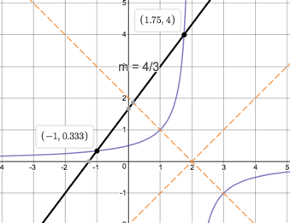
- The gradient of $v$ is greater than the average gradient between the points $(-1; \frac{1}{3})$ and $(1\frac{3}{4};4)$. In order for a line to pass through $(-1; \frac{1}{3})$ and this new point $(\frac{9}{5};5)$, it would need to have a gradient of $\frac{5}{3}$. If the average gradient between these two points is greater than the average gradient between the original two points, it must mean that the gradient at $(\frac{9}{5};5)$ is greater than the original average gradient.
Here is the situation illustrated graphically.
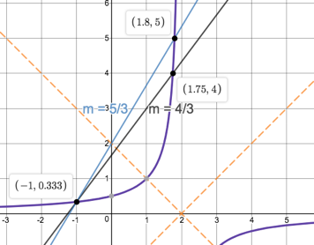
The concept of average gradient we encountered in the previous activity is a new one. In simple terms,
the average gradient between any two points on any graph is simply the gradient of the straight line between these two points.
Let’s explore average gradient a little more.

Activity 4: Average Gradient

Purpose
This activity will help you explore and formalise the concept of average gradient of a curve.

Suggested Time
You will need about 45 minutes.

What You Will Need
- A pen or pencil
- Some blank paper or a notebook

Tasks
- Given $f\left(x\right)=-2x^{2}$:
- Draw a sketch of $f(x)$.
- Determine the average gradient of $f(x)$ between the points where $x=1$ and $x=3$.
- Given the curves $p\left(x\right)=x(x+3)$ and $h\left(x\right)=\frac{1}{x-1}+3$:
- What is the average gradient of $f(x)$ between $x=3$ and $x=5$?
- What is the average gradient of $h(x)$ between $x=3$ and $x=5$?
- Are $f(x)$ and $h(x)$ increasing or decreasing between these points?
- Between which point and the point $(\frac{1}{2};1)$ is the average gradient of $h(x)$ equal to $-1$?
- What is the equation of this average gradient straight line, $t(x)$?
- Sketch $h(x)$ and $t(x)$ on the same set of axes?
- What point is half-way between the points of intersection of $h(x)$ and $t(x)$? What do you think we can say about the gradient of $h(x)$ at this point?

Guided Reflection
- We are given $f\left(x\right)=-2x^{2}$.
- Firstly, $f(x)$ is a quadratic function. We know from the value of $a$ that the graph has a minimum TP. We also know that $a=-2$, $b=0$ and $c=0$.
$c=0$: The graph has a y-intercept at $(0;0)$.
We can work out the AS using $x=\frac{-b}{2a}=\frac{0}{-4}=0$.
Because the graph is symmetrical about the y=axis, we know that the TP and y-intercept are the same point.
x-intercepts (let $y=0$): $0=-2x^{2}∴x=0$.
Find one other point for shape: $f\left(1\right)=-2{\left(1\right)}^{2}=-2$.
Here is the sketch.
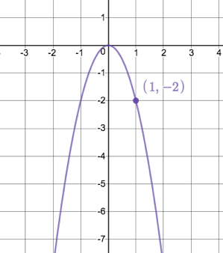
Image source: https://www.desmos.com/calculator/edgbhgsdig
- We know that the average gradient of the curve between any two points is the same as the gradient of the straight line between those to points. We are asked to find the average gradient between $x=1$ and $x=3$.
$$m=\frac{y_{2}-y_{1}}{x_{2}-x_{1}}=\frac{f\left(3\right)-f(1)}{3-1}=\frac{\left[-2{\left(3\right)}^{2}\right]-[-2{(1)}^{2}]}{2}=\frac{-18+2}{2}=\frac{-16}{2}=-8$$
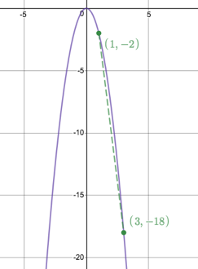
- We are given the curves $p\left(x\right)=x(x+3)$ and $h\left(x\right)=\frac{1}{x-1}+3$.
- The average gradient between $x=3$ and $x=5$ of $f(x)$ is given by
$$m=\frac{y_{2}-y_{1}}{x_{2}-x_{1}}=\frac{f\left(5\right)-f(3)}{5-3}=\frac{\left[5(5+3)\right]-[3(3+3)]}{2}=\frac{40-18}{2}=\frac{22}{2}=11$$
- The average gradient between $x=3$ and $x=5$ of $h(x)$ is given by
$$m=\frac{y_{2}-y_{1}}{x_{2}-x_{1}}=\frac{h\left(5\right)-h(3)}{5-3}=\frac{\left[\frac{1}{5-1}+3\right]-[\frac{1}{3-1}+3]}{2}=\frac{\frac{13}{4}-\frac{14}{4}}{2}=\frac{-\frac{1}{4}}{2}=-\frac{1}{8}$$
- The average gradient of $f(x)$ is positive which means that the function is increasing – as $x$ gets bigger, $y$ gets bigger.
The average gradient of $h(x)$ is negative which means that the function is decreasing- as $x$ gets bigger, $y$ gets smaller.
- We know we are looking for an average gradient of $-1$. Therefore, we know that
$$m=\frac{y_{2}-y_{1}}{x_{2}-x_{1}}=-1$$
We also know that one of the points is the point $(\frac{1}{2};1)$.
So, $m=\frac{1-y_{1}}{\frac{1}{2}-x_{1}}=-1$
$$∴\frac{1-\left[\frac{1}{x-1}+3\right]}{\frac{1}{2}-x}=-1$$
$$∴\frac{1-\left[\frac{1+3(x-1)}{x-1}\right]}{\frac{1}{2}-x}=-1$$
$$∴1-\left[\frac{1+3(x-1)}{x-1}\right]=x-\frac{1}{2}$$
$$∴-\left[\frac{1+3\left(x-1\right)}{x-1}\right]=x-\frac{3}{2}$$
$$∴\left[\frac{1+3\left(x-1\right)}{x-1}\right]=\frac{3}{2}-x$$
$$∴1+3x-3=(\frac{3}{2}-x)(x-1)$$
$$∴3x-2=\frac{3}{2}x-\frac{3}{2}-x^{2}+x=-x^{2}+\frac{5}{2}x-\frac{3}{2}$$
$$∴x^{2}-\frac{5}{2}x+\frac{3}{2}+3x-2=0$$
$$∴x^{2}+\frac{1}{2}x-\frac{1}{2}=0$$
$$∴{2x}^{2}+x-1=0$$
$$∴\left(2x-1\right)(x+1)=0$$
$∴x=\frac{1}{2}$ or $x=-1$
The point where $x=\frac{1}{2}$ is the one we already know of. Therefore, we need to find the other point where $x=-1$.
$$h\left(-1\right)=\frac{1}{-1-1}+3=-\frac{1}{2}+3=2\frac{1}{2}$$
So, the other point is $(-1;2\frac{1}{2})$
- We know that the gradient of $t(x)$ is 1. Therefore $t\left(x\right)=-x+c$. We can substitute either point we have on the graph to find the value of $c$. Let’s use $(\frac{1}{2};1)$.
$$1=-\frac{1}{2}+c$$
$$∴c=\frac{3}{2}$$
Therefore $t\left(x\right)=-x+\frac{3}{2}$
- Here are the sketches of $h(x)$ and $t(x)$.
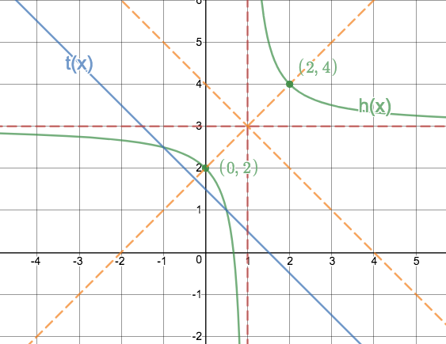
- The point $(0;2)$ is half-way between the points of intersection of $h(x)$ and $t(x)$? Because this point is half-way and because $h(x)$ is symmetrical about the line $y=x+2$ and this point lies on $y=x+2$, we can say that the gradient at this point is equal to the average gradient between the points of intersection of $h(x)$ and $t(x)$ i.e. the gradient at $\left(0;2\right)=-1$.

Unit 5: Exponential Functions

Learning Outcomes
By the end of this unit, you should be able to:
- Define what an exponential function is;
- Sketch exponential functions of the form $y=ab^{x-p}+q$;
- Explain the effects on the shape of the graphs of exponential functions of $a$, $b$, $p$ and $q$;
- Describe the various characteristics (e.g. domain and range) of graphs of exponential functions;
- Determine the equation of exponential functions from their graphs; and
- Interpret the graphs of exponential functions to make arguments or predictions.
Introduction
You have probably heard the term “exponential growth” before. Often, however, the word “exponential” is used incorrectly to just refer to something that happens very quickly. In Mathematics, exponential has a very specific meaning and exponential functions are specific kinds of functions.
The good news is that these functions behave quite similarly to the other functions we have explored so most of what we know about linear, quadratic and hyperbolic functions can be applied to exponential functions as well.
There are many processes in nature and finance where the relationship between the inputs and outputs is exponential. One example is how bacteria reproduce. Bacteria reproduce by simply splitting into two new bacteria. There is no sex involved.
So, if one bacterium splits into two and then each of these splits into two and then each of these splits into two etc. pretty soon we have a whole lot of bacteria!

Activity 1: Introducing the Exponential Function

Purpose
This activity will introduce you to the basic features of the exponential function.

Suggested Time
You will need about 75 minutes.

What You Will Need
- A pen or pencil
- Some blank paper or a notebook
- An calculator

Tasks
- There is a story about the inventor of chess. When he presented the game to the king, the king was so impressed, we wanted to reward the inventor. The inventor asked for rice. He asked that one grain of rice be placed on the first square of the board and that the number of grains on each successive square be double the previous square. So, the second square would have 2 grains, the third square 4 grains, the fourth square 8 grains and so on.
The king thought the inventor silly for asking for such a small reward and so agreed.
  - How many grains of rice would there be on the 4th, 5th and 6th squares?
  - Complete this table for the number of squares and the number of grains of rice.
Square $(x)$ | $$1$$ | $$2$$ | $$3$$ | $$4$$ | $$5$$ | $$6$$
Grains of rice $(y)$

  - Plot these points and join them with a smooth curve.
  - Write an expression that describes the relationship between the inputs and outputs. Hint: the outputs increase in powers of 2. Look at the value of $x$ needed to give each output and compare this with the power of 2 that the output is.
  - If there are 64 squares on a chess board, how many grains of rice would be on the last square?
  - What happens when $x=0$?
  - What happens when $x<0$? Try a few values of $x$ to find out.
  - Does the graph have a horizontal asymptote? If so, what is this asymptote?
  - Does the graph have a vertical asymptote? If so, what is this asymptote?
  - What is the domain and range of this graph?
  - Complete the sketch of your graph using this new information.
  - Is the relationship between $x$ and $y$ a function? Why?
- Imagine for a moment that the inventor of chess asked that the number of grains of rice on each successive square of the board be tripled instead of doubled.
- Complete this table of values for this case.
Square $(x)$ | $$1$$ | $$2$$ | $$3$$ | $$4$$ | $$5$$ | $$6$$
Grains of rice $(y)$

- Write an expression for this relationship. Is it a function?
- Sketch this function on the same set of axes as question 1).
- What is the domain and range of this function?
- What is the same about this function and the one from question 1)?
- What is different about this function and the one from question 1)?

Guided Reflection
- We are dealing with a relationship between the number of the chess board square and the number of grains of rice on each square.
- On the first square there is 1 grain.
One the second square there are 2 grains.
On the third square there are 4 grains.
On the fourth square there are 8 grains.
On the fifth square there are 16 grains.
On the sixth square there are 32 grains.
- Here is the completed table.
Square $(x)$ | $$1$$ | $$2$$ | $$3$$ | $$4$$ | $$5$$ | $$6$$
Grains of rice $(y)$ | $$1$$ | $$2$$ | $$4$$ | $$8$$ | $$16$$ | $$32$$

- Here are the points in the table plotted and joined with a smooth curve.
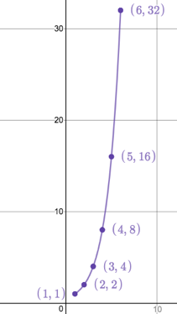
Image source: https://www.desmos.com/calculator/zbgupglpal
- Here is the table of values re-written with the output values as powers of 2.
Square $(x)$ | $$1$$ | $$2$$ | $$3$$ | $$4$$ | $$5$$ | $$6$$
Grains of rice $(y)$ | $$2^{0}$$ | $$2^{1}$$ | $$2^{2}$$ | $$2^{3}$$ | $$2^{4}$$ | $$2^{5}$$

Each time, the exponent on the base is one less than the input value so the expression is
$$y=2^{x-1}$$
- The number of grains on the 64th square will be $y=2^{64-1}=2^{63}$. This is more than 9 million billion – a very big number!
- When $x=1$, $y=2^{0-1}=2^{-1}=\frac{1}{2}$.
- When $x<0$, the y-values are fractions because the base is raised to a negative power.
$$x=-1⇒y=2^{-1-1}=2^{-2}=\frac{1}{4}$$
$$x=-2⇒y=2^{-2-1}=2^{-3}=\frac{1}{8}$$
$$x=-5⇒y=2^{-5-1}=2^{-6}=\frac{1}{64}$$
- No matter how negative we let $x$, the y-values will still always be positive. Therefore, the x-axis or line $y=0$ is a horizontal asymptote.
- The graph rises very steeply but there is nothing stopping $x$ getting bigger and bigger. Also, there is nothing stopping $x$ getting more and more negative either. Therefore, there is no vertical asymptote.
- Domain: $\{x:x∈R\}$ Range: $\{y:y∈R, y>0\}$
- Here is a sketch of the whole graph.
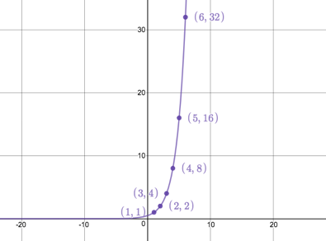
- This relationship is a function. For every input, we only ever get a single output. A vertical line will never cut the graph more than once.
- Now the number of grains of rice on each successive square is tripled.
- Here is the completed table of values for this case.
Square $(x)$ | $$1$$ | $$2$$ | $$3$$ | $$4$$ | $$5$$ | $$6$$
Grains of rice $(y)$ | $$1$$ | $$3$$ | $$9$$ | $$27$$ | $$81$$ | $$243$$

- This expression is the same as the one in question 1) except that we are now dealing with powers of three. Therefore $y=3^{x-1}.$ Like the other relation, this one is also a function.
- Here is a sketch of both functions but only for values near the origin.
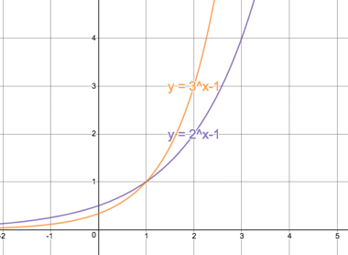
- Domain: $\{x:x∈R\}$ Range: $\{y:y∈R, y>0\}$
This is exactly the same as the other function.
- We have just seen that the domain and range are the same. The line $y=0$ is also a horizontal asymptote for both functions. Both graphs go through the point $(1;1)$. This makes sense as at both points the exponent is zero and any base to the power of zero is defined as $1$.
- The function $y=3^{x-1}$ rises more steeply than $y=2^{x-1}$. It also has a y-intercept of $\frac{1}{3}$ instead of $\frac{1}{2}$. It also approaches its horizontal asymptote more quickly.
So far, we know the general shape that exponential functions have. They increase very rapidly as the values of $x$ get bigger and they approach a horizontal asymptote as the values of $x$ get smaller and smaller.
Let’s investigate exponential functions some more.

Activity 2: Exponential Functions of the Form $y=ab^{x}+q$

Purpose
This activity will introduce you to the basic features of the exponential function.

Suggested Time
You will need about 45 minutes.

What You Will Need
- A pen or pencil
- Some blank paper or a notebook
- An Internet connection

Tasks
- Visit the interactive simulation at https://www.desmos.com/calculator/u0itwiodvc. Here you will find the exponential function $f\left(x\right)=2^{x}$.
- If the general form of this function is $f\left(x\right)=ab^{x}+q$, What are the current values of $a$, $b$ and $q$?
- Based on your knowledge of the effect of $q$ in $y=ax+q$, $y=a{\left(x-p\right)}^{2}+q$ and $y=\frac{a}{x-p}+q$, what do you think the graphs of the functions $g\left(x\right)=2^{x}+1$ and $h\left(x\right)=2^{x}-2$ will look like. Use the interactive simulation to test your hypothesis and then sketch $f$, $g$, and $h$ on the same set of axes making sure that you include the horizontal asymptote, y-intercept and one other point of each function.
- Write down the domain and range of each function.
- Write general expressions for the domain, range and the horizontal asymptote in terms of $q$.
- Are all these functions increasing? Why do you say so?
- Given $f\left(x\right)=2^{x}$, $q\left(x\right)={3.2}^{x}$ and $r\left(x\right)={-\frac{1}{2}.2}^{x}$.
- How will the graphs of $f$, $q$ and $r$ differ? Create a table of values like this one to prove your prediction.
$$x$$ | $$-2$$ | $$-1$$ | $$0$$ | $$1$$ | $$2$$
$$f(x)$$
$$q(x)$$
$$r(x)$$

- Draw sketches of these three functions showing the horizontal asymptotes, y-intercepts and one other point.
- Write down the domain and range of each function.

Guided Reflection
- We are dealing with exponential functions of the form $y=ab^{x}+q$.
- The current values are $a=1$, $b=2$ and $c=0$.
- $g\left(x\right)=2^{x}+1$. Therefore, $q=1$. Based on how $q$ affects other functions, we expect $g(x)$ to be shifted 1 unit up.
$h\left(x\right)=2^{x}-2$. Therefore, $q=-2$. Based on how $q$ affects other functions, we expect $h(x)$ to be shifted 2 units down.
Here is a sketch of all three functions.
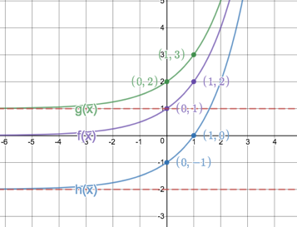
Image source: https://www.desmos.com/calculator/f0owx8bf7c
- $f(x)$: Domain: $\{x:x∈R\}$ Range: $\{y:y∈R, y>0\}$
$g(x)$: Domain: $\{x:x∈R\}$ Range: $\{y:y∈R, y>1\}$
$h(x)$: Domain: $\{x:x∈R\}$ Range: $\{y:y∈R, y>-2\}$
- The domain is not affected by the value of $q$ and so is always $\{x:x∈R\}$.
The range depends on the value of $q$ such that the range is $\{y:y∈R, y>q\}$.
The horizontal asymptote is given by $y=q$.
This is all exactly the same as with hyperbolic functions.
- Each of these functions is increasing. As $x$ gets bigger, $y$ gets bigger.
- We have the following functions:
$f\left(x\right)=2^{x}$ ($a=1$)
$q\left(x\right)={3.2}^{x}$ ($a=2)$
$r\left(x\right)={-\frac{1}{2}.2}^{x}$ ($a=-\frac{1}{2}$)
- Based on our knowledge of how $a$ affects other functions, we expect $q(x)$ to have a wider shape than $f(x)$. We expect the graph of $r(x)$ to be narrower than $f(x)$and flipped upside down because it is negative.
Here is the completed table of values.
$$x$$ | $$-2$$ | $$-1$$ | $$0$$ | $$1$$ | $$2$$
$$f(x)$$ | $$\frac{1}{4}$$ | $$\frac{1}{2}$$ | $$1$$ | $$2$$ | $$4$$
$$q(x)$$ | $$\frac{3}{4}$$ | $$\frac{1}{2}$$ | $$3$$ | $$6$$ | $$12$$
$$r(x)$$ | $$-\frac{1}{8}$$ | $$-\frac{1}{6}$$ | $$-\frac{1}{2}$$ | $$-1$$ | $$-2$$

We can see from the table of values that $a$ performs a transformation of the function. For $q(x)$, each output value is $3×f(x)$ i.e. $q\left(x\right)=3×f(x)$. For $r(x)$, each output value is $-\frac{1}{2}×f(x)$ i.e. $r\left(x\right)=-\frac{1}{2}f(x)$.
This means that $q(x)$ will be a stretched-out version of $f(x)$ and $r(x)$ will be a squashed and inverted version of $f(x)$.
- Here are sketches of all three functions showing these transformations. Notice how all three functions have the same horizontal axis of symmetry because none of them have been shifted up or down. In all cases $q=0$.
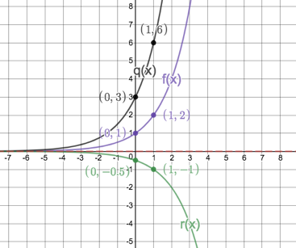
- $f(x)$: Domain: $\{x:x∈R\}$ Range: $\{y:y∈R, y>0\}$
$q(x)$: Domain: $\{x:x∈R\}$ Range: $\{y:y∈R, y>0\}$
$r(x)$: Domain: $\{x:x∈R\}$ Range: $\{y:y∈R, y<0\}$
Notice that, because $r(x)$ is inverted, its range is also inverted i.e. $y<0$.
From Activity 1, we already have a sense of how the value of $b$ affects the shape of the graph. But let’s investigate further because things may not be as simple as we think.

Activity 3: What does $b$ do in $y=ab^{x}+q$?

Purpose
This activity will give you insight into the effect that changing the value of $b$ has on the exponential function and why we need to restrict what values $b$ have to make sure that the function is well behaved.

Suggested Time
You will need about 50 minutes.

What You Will Need
- A pen or pencil
- Some blank paper or a notebook
- An Internet connection

Tasks
- Visit the interactive simulation at https://www.desmos.com/calculator/h40txbfcnz. Here you will find three functions, $f(x)=2^{x}$, $g(x)=4^{x}$ and $h(x)={\left(\frac{1}{2}\right)}^{x}$as well as the general function $y={ab}^{x}+q$, with the $a=1$, $q=0$ and with a slider to change the value of $b$.
- What is the y-intercept of $f$, $g$ and $h$? Why is this? What can we do to change the y-intercept of an exponential function?
- What happens to the exponential function $y=b^{x}$ when $b=1$? Why? What is the domain and range of the function?
- What happens to the exponential function $y=b^{x}$ when $b=0$? Why? What is the domain and range of the function?
- What happens to the exponential function $y=b^{x}$ when $b<0$? Think about the cases when $b=-\frac{1}{2}$ and $b=-3$. Create a table of values of each of these cases. When $b<0$ is $y=b^{x}$ actually still a function? Can we represent the function as a single continuous curve like the other functions we have been dealing with?
- Draw in neat little sketches in each block to indicate the general position and orientation of the exponential function in each case.
 | $$a>0$$ | $$a<0$$
$$b>1$$
$$0<b<1$$

- What is the equation of the function which is a reflection of $h\left(x\right)={\left(\frac{1}{2}\right)}^{x}$ about the y-axis? Use the general function $y=b^{x}$ and the slider for $b$ to experiment if you need to.
- What is the equation of the function which is a reflection of $h\left(x\right)={\left(\frac{1}{2}\right)}^{x}$ about the x-axis? Use the general function $y=b^{x}$ and the slider for $b$ to experiment if you need to.
- What is the equation of the inverse of $h\left(x\right)={\left(\frac{1}{2}\right)}^{x}$? Is this relation a function? Use the general function $y=b^{x}$ and the slider for $b$ to experiment if you need to.

Guided Reflection
- We are working with the functions $f(x)=2^{x}$, $g(x)=4^{x}$ and $h(x)={\left(\frac{1}{2}\right)}^{x}$.
- The y-intercept of all three functions is the point $(0; 1)$. This is because any base raised to the power of zero is equal to 1. Therefore, it does not matter what the value of $b$ is in $y=b^{x}$. The output value when the input value is zero will always be 1.
In order to change this y-intercept, we can either shift the graph up or down by making the value of $q≠0$ or we can transform the graph by making the value of $a≠1$.
- When $b=1$, the value of $b^{x}$ is always equal to 1 irrespective of the value of $x$. One raised to any power is always equal to one. Therefore, if the value of $a=1$ and $q=0$, $y=ab^{x}+q$ is simply the straight line $y=1$.
The domain can be any real number, but the range is restricted to a single output value. So, the domain and range of $y=b^{x}$ are:
Domain: $\{x:x∈R\}$ Range: $\{y:y=1\}$
- When $b=0$, the value of $b^{x}$ is always equal to 0 irrespective of the value of $x$. Zero raised to any power is always equal to zero. Therefore, if the value of $a=1$ and $q=0$, $y=ab^{x}+q$ is simply the straight line $y=0$.
But, the domain of the function also has to be restricted. We cannot allow any values of $x≤0$. This is because, by definition, $0^{-x}=\frac{1}{0^{x}}$ and we can never have a zero denominator and the fact that $0^{0}$ is also undefined.
The range is also restricted to the single value of zero. So, the domain and range of $y=b^{x}$ are:
Domain: $\{x:x∈R, x>0\}$ Range: $\{y:y=0\}$
- If $b=-\frac{1}{2}$ or $b=-3$ we have these values:
$$x$$ | $$-2$$ | $$-1$$ | $$0$$ | $$1$$ | $$2$$
$$y={\left(-\frac{1}{2}\right)}^{x}$$ | $$4$$ | $$-2$$ | $$1$$ | $$-\frac{1}{2}$$ | $$\frac{1}{4}$$
$$y={\left(-3\right)}^{x}$$ | $$\frac{1}{9}$$ | $$-\frac{1}{3}$$ | $$1$$ | $$-3$$ | $$9$$

From this table, we can see that the output values jump around and alternate from positive to negative. This makes sense, because a negative base to an even power will be positive but the same negative base to an odd power will be negative.
Therefore, the function is not a smooth curve.
Also, the domain has to be restricted. Take $y={\left(-\frac{1}{2}\right)}^{\frac{1}{2}}$ for example. By definition, this is the same as $y=\sqrt{-\frac{1}{2}}$ and we cannot take the square. Any value of $x$ that would need us to take the square (or fourth or sixth or any even) root cannot be part of the domain. So, when $b<0$, $y=b^{x}$ is not a solid curve and is discontinuous. However, it is still a function because we will only ever get a single output for every input.
- Here is the completed table showing the general shape and position of $y=b^{x}$ in each case. We can see that when $a>0$, the graph lies above the horizontal asymptote and when $a<0$, the graph lies below the horizontal asymptote.
 | $$a>0$$ | $$a<0$$
$$b>1$$ | 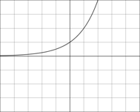  Above the asymptote  The function is increasing | 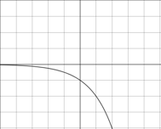  Below the asymptote  The function is decreasing
$$0<b<1$$ | 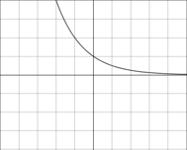  Above the asymptote  The function is decreasing | 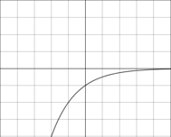  Below the asymptote  The function is increasing

- We know that when we reflect a function about the y-axis, we basically have to replace every $x$ with a $-x$. Remember the reflected function of $f(x)$ about the y-axis will be $f(-x)$.
If we are reflecting $h\left(x\right)={\left(\frac{1}{2}\right)}^{x}$ about the y-axis, then the reflected function will have the equation $y={\left(\frac{1}{2}\right)}^{-x}$ or $y=2^{x}$. If we set the slider for $b=2$, we can see that the created function is a mirror image of $h(x)$ about the y-axis.
- We know that when we reflect a function about the x-axis, we basically have to replace every $y$ with a $-y$. Remember the reflected function of $f(x)$ about the x-axis will be $-f(x)$.
If we are reflecting $h\left(x\right)={\left(\frac{1}{2}\right)}^{x}$ about the x-axis, then the reflected function will have the equation $-y={\left(\frac{1}{2}\right)}^{x}$ or $y={-\left(\frac{1}{2}\right)}^{x}$. If we set the slider for $b=\frac{1}{2}$ and the slider for $a=-1$, we can see that the created function is a mirror image of $h(x)$ about the x-axis.
- We know that to find the inverse of a function we have to swop the variables around. Therefore, to find the inverse of $h\left(x\right)={\left(\frac{1}{2}\right)}^{x}$:
$y={\left(\frac{1}{2}\right)}^{x}$. So, the inverse is $x={\left(\frac{1}{2}\right)}^{y}$. We know from our work in Topic 1 on logarithms that we can rewrite this as $y=\log_{1/2}x$.
Here is a sketch of $h(x)$ and its inverse showing that the inverse is also a function.
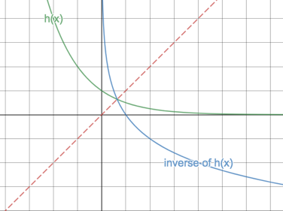
We saw in question 3) that for certain values of $b$ the exponential function is very badly behaved. When dealing with the exponential function, we almost always place restrictions on the values of $b$ to make sure that the function is well behaved. We say that
$f\left(x\right)=a.b^{x}+q$, for $b≠1$ and $b>0$
We also saw that the inverse function of the exponential function is the logarithmic function.
So far, we have dealt with the effects of $a$, $b$ and $q$ on the function $f\left(x\right)=ab^{x}+q$. Based on your knowledge of the other functions we have studied, you should be able to predict the effect of $p$ in $f\left(x\right)=ab^{x-p}+q$. Let’s see if you are right.

Activity 4: Sketching Exponential Functions

Purpose
This activity will consolidate your understanding of the exponential function in order to be able to sketch their graphs.

Suggested Time
You will need about 50 minutes.

What You Will Need
- A pen or pencil
- Some blank paper or a notebook

Tasks
- Here are two exponential functions: $f\left(x\right)=2^{x}$, $g(x)=2^{x-1}$ and $h\left(x\right)=2^{X+1}$.
- Complete this table.
$$x$$ | $$-2$$ | $$-1$$ | $$0$$ | $$1$$ | $$2$$
$$f\left(x\right)=2^{x}$$
$$g(x)=2^{x-1}$$
$$h\left(x\right)=2^{X+1}$$

- Plot each function on the same set of axes.
- What is the domain and range of each function?
- What is the horizontal asymptote of each function?
- What is the y-intercept of each function?
- What is the effect of $p$ on the exponential function $y=ab^{x-p}+q$?
- Give the domain and range of each of the following functions:
- $y={\left(\frac{3}{2}\right)}^{x+3}$
- $g\left(x\right)=d+3^{\left(x-m\right)}$
- $y+3=2^{\left(x+1\right)}$
- $\frac{y}{2}=3^{(x-1)}-1$
- $j\left(x\right)=2x^{2}+4x+1$
- Sketch the following functions by determining the intercepts, horizontal asymptote, domain and range and general shape and position.
- $f\left(x\right)=2^{\left(x+1\right)}-8$
- $g\left(x\right)-5=5^{(x+2)}$
- $q\left(x\right)=\frac{1}{2}{\left(\frac{3}{2}\right)}^{(x+3)}-0.75$

Guided Reflection
- We were given the functions $f\left(x\right)=2^{x}$, $g(x)=2^{x-1}$ and $h\left(x\right)=2^{x+2}$.
- Here is the completed table of values.
$$x$$ | $$-2$$ | $$-1$$ | $$0$$ | $$1$$ | $$2$$
$$f\left(x\right)=2^{x}$$ | $$\frac{1}{4}$$ | $$\frac{1}{2}$$ | $$1$$ | $$2$$ | $$4$$
$$g(x)=2^{x-1}$$ | $$\frac{1}{8}$$ | $$\frac{1}{4}$$ | $$\frac{1}{2}$$ | $$1$$ | $$2$$
$$h\left(x\right)=2^{x+2}$$ | $$1$$ | $$2$$ | $$4$$ | $$8$$ | $$16$$

- Here is a sketch of all three functions.
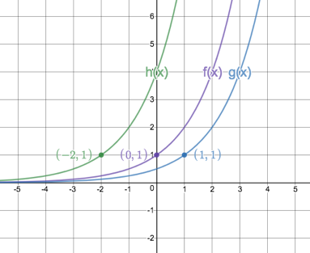
Image source: https://www.desmos.com/calculator/ho3zf3yagg
- $f(x)$: Domain: $\{x:x∈R\}$ Range: $\{y:y∈R, y>0\}$
$g(x)$: Domain: $\{x:x∈R\}$ Range: $\{y:y∈R, y>0\}$
$h(x)$: Domain: $\{x:x∈R\}$ Range: $\{y:y∈R, y<0\}$
- Each function has the same horizontal asymptote, the line $y=0$.
- $f(x)$: y-intercept is the point $(0;1)$.
$g(x)$: y-intercept is the point $(0;\frac{1}{2})$.
$h(x)$: y-intercept is the point $(0;4)$.
- $p$ shifts the graph horizontally left and right. The graph of $g(x)$ (where $p=1$) is shifted 1 unit to the right. The graph of $h(x)$ (where $p=-2$) is shifted 2 units to the left.
- We needed to find the domain and range of each function.
- Given $y={\left(\frac{3}{2}\right)}^{x+3}$. This is an exponential function where the value of $q=0$. Therefore, there is no vertical shift. $a>0$, so, the graph exists above the horizontal asymptote.
Domain: $\{x:x∈R\}$ Range: $\{y:y∈R, y>0\}$
- Given $g\left(x\right)=d+3^{\left(x-m\right)}$. This can be rewritten as $g\left(x\right)=3^{\left(x-m\right)}+d$. $a>0$ so, the graph exists above the asymptote but $q=d$ so there is a vertical shift of $d$ units.
Domain: $\{x:x∈R\}$ Range: $\{y:y∈R, y>d\}$
- Given $3=y+2^{\left(x+1\right)}$. This can be rewritten as $y=-2^{\left(x+1\right)}+3$. $a<0$ so, the graph exists below the asymptote and $q=3$ so there is a vertical shift of up of $3$ units.
Domain: $\{x:x∈R\}$ Range: $\{y:y∈R, y<3\}$
- Given $\frac{y}{2}=3^{(x-1)}-1$. This can be rewritten as $y=2.3^{(x-1)}-2$. $a>0$ so, the graph exists above the asymptote and $q=-2$ so there is a vertical shift of down of $2$ units.
Domain: $\{x:x∈R\}$ Range: $\{y:y∈R, y>-2\}$
- Given $j\left(x\right)=2x^{2}+4x+1$. This is not an exponential function. It is a quadratic. $a>0$ so, the TP is a minimum. We can either complete the square and get the function into the TP form to find the TP or we can use AS: $x=\frac{-b}{2a}$ to find the AS and then use this value to find the y-coordinate of the TP. Both methods are shown.
TP form:
$$j\left(x\right)=2x^{2}+4x+1$$
$$∴j\left(x\right)=2\left(x^{2}+2x\right)+1$$
$$∴j\left(x\right)=2\left(x^{2}+2x+1\right)+1-2$$
$$∴j\left(x\right)=2{\left(x^{2}+1\right)}^{2}-1$$
Therefore, the TP is the point $(-1;-1)$
Domain: $\{x:x∈R\}$ Range: $\{y:y∈R, y>-1\}$
AS:
$$x=\frac{-b}{2a}=\frac{-4}{2(2)}=-1$$
$$j\left(-1\right)=2{(-1)}^{2}+4\left(-1\right)+1=-1$$
Domain: $\{x:x∈R\}$ Range: $\{y:y∈R, y>-1\}$
- We need to sketch the given functions.
- Given $f\left(x\right)=2^{\left(x+1\right)}-8$.
x-intercept (let $y=0$): y-intercept (let $x=0$):
$0=2^{\left(x+1\right)}-8$ $y=2^{\left(0+1\right)}-8$
$∴8=2^{\left(x+1\right)}$ $∴y=2-8=-6$
$$∴2^{3}=2^{\left(x+1\right)}$$
$$∴3=x+1$$
$$∴x=2$$
$q=-8$. Therefore, horizontal asymptote is $y=-8$
$a=1$. Therefore, graph exists above the asymptote.
$b>1$. Therefore, graph is increasing.
Domain: $\{x:x∈R\}$ Range: $\{y:y∈R, y>-8\}$
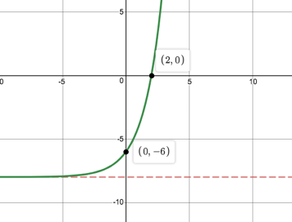
Image source: https://www.desmos.com/calculator/3oeuox8ns5
- Given $g\left(x\right)-5=5^{(x+2)}$. Therefore $g\left(x\right)=5^{(x+2)}+5$
x-intercept (let $y=0$): y-intercept (let $x=0$):
$0=5^{(x+2)}+5$ $y=5^{(0+2)}+5$
$∴{5(5}^{(x+1)}+1)=0$ $∴y=5^{2}+5$
$∴5^{(x+1)}+1=0$ $∴y=30$
$$∴5^{(x+1)}=-1$$
No solution
$q=5$. Therefore, horizontal asymptote is $y=5$
$a=1$. Therefore, graph exists above the asymptote (hence no x-intercepts)
$b>1$. Therefore, graph is increasing.
Domain: $\{x:x∈R\}$ Range: $\{y:y∈R, y>5\}$
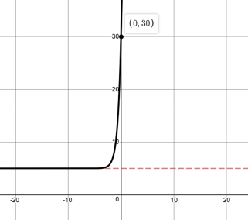
- Given $q\left(x\right)=\frac{1}{2}{\left(\frac{3}{2}\right)}^{(x+3)}-0.75$
x-intercept (let $y=0$): y-intercept (let $x=0$):
$0=\frac{1}{2}{\left(\frac{3}{2}\right)}^{(x+3)}-0.75$ $y=\frac{1}{2}{\left(\frac{3}{2}\right)}^{(0+3)}-0.75$
$∴\frac{1}{2}{\left(\frac{3}{2}\right)}^{(x+3)}=\frac{3}{4}$ $∴y=\frac{1}{2}{\left(\frac{3}{2}\right)}^{3}-0.75$
$∴{\left(\frac{3}{2}\right)}^{(x+3)}=\frac{6}{4}=\frac{3}{2}$ $∴y=\frac{1}{2}×\frac{27}{8}-\frac{3}{4}$
$∴x+3=1$ $∴y=\frac{27}{16}-\frac{12}{16}=\frac{15}{16}=0.938$
$$∴x=-2$$
$q=-\frac{3}{4}$. Therefore, horizontal asymptote is $y=-\frac{3}{4}$.
$a=1$. Therefore, graph exists above the asymptote
$0<b<1$. Therefore, graph is decreasing.
Domain: $\{x:x∈R\}$ Range: $\{y:y∈R, y>-\frac{3}{4}\}$
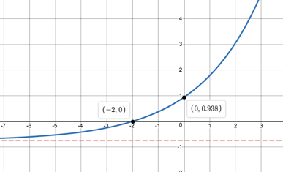

Activity 5: Finding the Equations of Exponential Functions

Purpose
This activity will help you to find the equations of exponential functions from graphs or other information.

Suggested Time
You will need about 45 minutes.

What You Will Need
- A pen or pencil
- Some blank paper or a notebook
- An Internet connection

Tasks
- If $y=-2×3^{\left(x-p\right)}+q$, use the graph to find the values of $p$ and $q$.
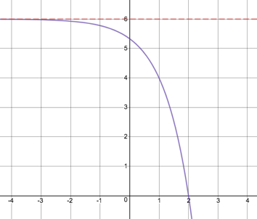
Image source: https://www.desmos.com/calculator/jh4ojbqkbt
- Given $Q\left(x\right)=a^{x}$ and its graph, answer the following questions.
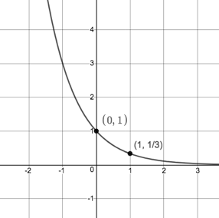
- Show that $a=\frac{1}{3}$.
- Find the value of $p$ if the point $(-2;p)$ lies on $Q(x)$.
- Calculate the average gradient of $Q(x)$ between $x=-2$ and $x=1$.
- Determine the equation of the new function if $Q\left(x\right)$ Is shifted 2 nits down and 2 units to the left.
- Find the equations of $f$ and $g$ if $f\left(x\right)=2^{x}+q$.
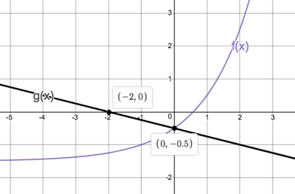

Guided Reflection
TBC

Activity 6: All Together Now

Purpose
This activity will help you to consolidate all the knowledge you have gained about functions so far and to start learning how to interpret functions.

Suggested Time
You will need about 60 minutes.

What You Will Need
- A pen or pencil
- Some blank paper or a notebook
- An Internet connection

Tasks
Everything Maths Ex5-19 pg193 Q1, 2, 3, 4, 6a, 6c, 9

Unit 6: Trigonometric Functions

Learning Outcomes
By the end of this unit, you should be able to:
- Define what the sine, cosine and tangent functions are;
- Sketch sine functions of the form $y=a\sin{kx}$, $y=a\sin{x+q}$ and $y=a\sin\left(x-p\right)$;
- Sketch cosine functions of the form $y=a\cos{kx}$, $y=a\cos{x+q}$ and $y=a\cos\left(x-p\right)$
- Sketch tangent functions of the form $y=a\tan{kx}$, $y=a\tan{x+q}$ and $y=a\tan\left(x-p\right)$
- Explain the effects on the shape of the graphs of trigonometric functions of $a$, $k$, $p$ and $q$;
- Describe the various characteristics (e.g. domain and range) of graphs of trigonometric functions;
- Determine the equation of trigonometric functions from their graphs; and
- Interpret the graphs of trigonometric functions to make arguments or predictions.
Introduction
All modern music is produced with the aid of computers at some stage in the recording and mastering process. Computers are used to manipulate, transform and blend the sounds made by instruments of various kinds. These computer programmes use trigonometric functions to help them model and change sounds.
When sound travels through the air, the energy of the sound creates pockets of air molecules at slightly different pressures. In some of these areas the air is slightly compressed. In others, it is at a lower pressure.
Image source: https://commons.wikimedia.org/wiki/File:CPT-sound-physical-manifestation.svg

These sound waves can be thought of in the same way as waves travelling across a smooth pond, where the areas of compression corresponding to the crests and the areas of low pressure correspond to the troughs.
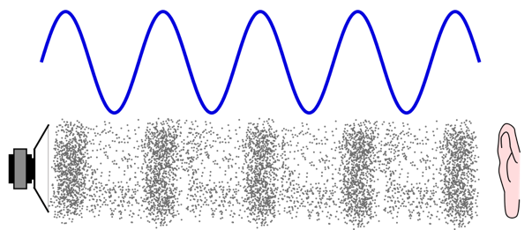

The “water” waves can be modelled mathematically using the trigonometric function called sine. If we can model the wave using a function, it means we can manipulate it in all sorts of ways. Computers, being particularly good at maths, can make very complicated changes to very complex waves quickly and easily.
This is just one example of where trigonometric functions are used in real life. Other examples include anytime an engineer or architect needs to calculate forces or angles of forces that will be experienced by physical structures like buildings or bridges.
In this unit, we will not cover the basic theory behind the trigonometric functions of sine, cosine and tangent. If you need to learn about this or would like to revise it, please visit [reference] first.

Activity 1: The Sine Function

Purpose
This activity will introduce you to one of the most widely used of the three trig functions – the sine function.

Suggested Time
You will need about 40 minutes.

What You Will Need
- A pen or pencil
- Some blank paper or a notebook
- A calculator

Tasks
- Draw a graph of $y=\sin{x}$.

  - Make a copy of this table and use your calculator to calculate the values for $y=\sin{x}$. If you need help using your calculator watch the video called Calculating Trig Ratios on your Calculator (mm:ss).
$$x$$ | $$0°$$ | $$45°$$ | $$90°$$ | $$135°$$ | $$180°$$ | $$225°$$ | $$270°$$ | $$315°$$ | $$360°$$
$$\sin{x}$$

  - Plot each of the points on a Cartesian plane and join them with a smooth curve.
  - In order to get the smoothness of the curve correct, work out additional points by working out the value of $y=\sin{x}$ for angles between the angles given in the table above.
  - What is the greatest value of $y=\sin{x}$? What is the smallest value of $y=\sin{x}$. What are the turning points of $y=\sin{x}$?
  - What do you notice about the value of $y=\sin{x}$ when $x=0°$ and when $x=360°$? What do you think will happen to the graph if we calculate $y=\sin{x}$ for angles bigger than $360°?$ What does an angle greater than 36$0°$ mean?
  - What do you think will happen to the graph if we calculate $y=\sin{x}$ for angles less than $0°$? What does an angle less than $0°$ mean?
  - Is $y=\sin{x}$ a function? Why?
- Draw a graph of $y=\cos{x}$.
- Copy and complete this table. Again, use your calculator to calculate the value of $y=\cos{x}$.
$$x$$ | $$0°$$ | $$45°$$ | $$90°$$ | $$135°$$ | $$180°$$ | $$225°$$ | $$270°$$ | $$315°$$ | $$360°$$
$$\cos{x}$$

- Plot each of the points on a new Cartesian plane and join them with a smooth curve. In order to get the smoothness of the curve correct, work out additional points by working out the value of $y=\cos{x}$ for angles between the angles given in the table above.
- What is the greatest value of $y=\cos{x}$? What is the smallest value of $y=\cos{x}$. What are the turning points of $y=\cos{x}$?
- What do you notice about the value of $y=\cos{x}$ when $x=0°$ and when $x=360°$? What do you think will happen to the graph if we calculate $y=\cos{x}$ for angles bigger than $360°?$
- What do you think will happen to the graph if we calculate $y=\cos{x}$ for angles less than $0°$? What does an angle less than $0°$ mean?
- Is $y=\cos{x}$ a function? Why?
- Draw over your graph of $y=\sin{x}$with a thick black pen. Place your graph of $y=\cos{x}$ over this graph so that the graph of $y=\sin{x}$ is visible through the paper.
- How is the graph of $y=\cos{x}$ the same as $y=\sin{x}$?
- How is the graph of $y=\cos{x}$ different from $y=\sin{x}$?
- Write an equation that describes the relationship between $\sin{x}$ and $\cos{x}$.

Guided Reflection
- We need to draw a graph of $y=\sin{x}$.
- Here is the completed table of values.
$$x$$ | $$0°$$ | $$45°$$ | $$90°$$ | $$135°$$ | $$180°$$ | $$225°$$ | $$270°$$ | $$315°$$ | $$360°$$
$$\sin{x}$$ | $$0$$ | $$0.7$$ | $$1$$ | $$0.7$$ | $$0$$ | $$-0.7$$ | $$-1$$ | $$-0.7$$ | $$0$$

- This is what your graph may have looked like without any additional points
Image source: ASECA Unit 2 (pg 60)
- This is what the smoother curve looks like with some additional points.
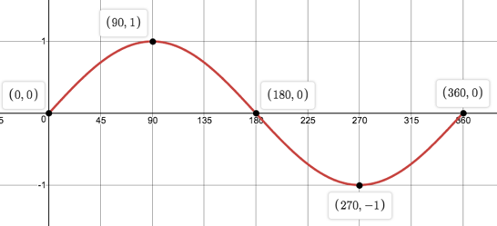
Image source: https://www.desmos.com/calculator/tarywidnyv
- The graph of $y=\sin{x}$ is never greater than 1. The point $(90°;1)$ is its maximum. The graph is also never less than $-1$. The point $(270°;-1)$ is its minimum. Therefore, $y=\sin{x}$ has two turning points – a maximum TP at $(90°;1)$ and a minimum TP at $(270°;-1)$.
- The value of $y=\sin{x}$ when $x=0°$ and when $x=360°$ are the same. They are both zero. If we calculate the value $y=\sin{x}$ for values of $x>360°$ the graph will repeat the same pattern as it did between $0°$ and $360°$. An angle greater than $360°$ means that we have gone through one full revolution and are back where we started and starting another revolution.
For example, take the angle $394°$. This is the same angle as $34°$ except that we have already made one full revolution of $360°$. $394°=360°+34°$.
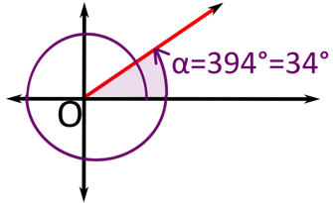
Image source: https://upload.wikimedia.org/wikipedia/commons/thumb/1/18/Angle_bigger_360.svg/2000px-Angle_bigger_360.svg.png

- The graph will repeat the same pattern as it did between $0°$ and $360°$. An angle less than $0°$ means that we are turning in the opposite direction as before. So, if positive angles mean we turn in a counter-clockwise direction, negative angles are measured in a clockwise direction.
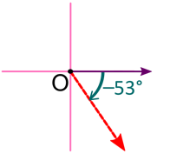
Image source: https://upload.wikimedia.org/wikipedia/commons/thumb/6/63/Angles_negative_big.svg/1280px-Angles_negative_big.svg.png

- $y=\sin{x}$ is a function. For every value of $x$ (input) there is one and only one value of $y$ output.
- We need to draw a graph of $y=\cos{x}$.
- Here is a completed table of values.
$$x$$ | $$0°$$ | $$45°$$ | $$90°$$ | $$135°$$ | $$180°$$ | $$225°$$ | $$270°$$ | $$315°$$ | $$360°$$
$$\cos{x}$$ | $$1$$ | $$0.7$$ | $$0$$ | $$-0.7$$ | $$-1$$ | $$-0.7$$ | $$0$$ | $$0.7$$ | $$1$$

- This is what the smoother curve looks like with some additional points.
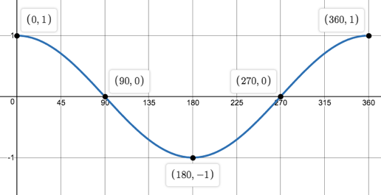
- The graph of $y=\cos{x}$ looks like it is never greater than 1. The points $(0°;1)$ and $(360°;1)$ are its maximum. The graph is also never less than $-1$. The point $(180°;-1)$ is its minimum. Therefore, $y=\cos{x}$ has maximum turning points at $(0°;1)$ and $(360°;1)$ and a minimum TP at $(180°;-1)$.
- The value of $y=\cos{x}$ when $x=0°$ and when $x=360°$ are the same. They are both one. If we calculate the value $y=\cos{x}$ for values of $x>360°$ the graph will repeat the same pattern as it did between $0°$ and $360°$. An angle greater than $360°$ means that we have gone through one full revolution and are back where we started and starting another revolution.
- The graph will repeat the same pattern as it did between $0°$ and $360°$. An angle less than $0°$ means that we are turning in the opposite direction as before. So, if positive angles mean we turn in a counter-clockwise direction, negative angles are measured in a clockwise direction.
- $y=\cos{x}$ is a function. For every value of $x$ (input) there is one and only one value of $y$ output.
- We need to compare the graphs of $y=\sin{x}$ and $y=\cos{x}$. Here are both graphs on the same set of axes.
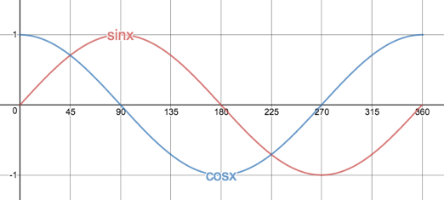
- Both graphs are in the shape of waves. Both graphs have a maximum value of $1$ and a minimum value of $-1$. Both graphs seem to repeat themselves for values of $x<0°$ and $x>360°$.
- Even though both graphs have the same y-values of their turning points, the x-values of the turning points are different. It looks like the graph of $y=\cos{x}$ is just the graph of $y=\sin{x}$ shifted $90°$ to the left. $y=\sin{x}$ starts at zero but $y=\cos{x}$ starts at one.
- If $y=\cos{x}$ is the same as $y=\sin{x}$ shifted $90°$ to the left, then we can say that $\cos\left(x-90°\right)=\sin{x}$ or that $\cos{x=\sin{(x+90°)}}$.
From this last activity we have seen that $y=\sin{x}$ and $y=\cos{x}$ are both functions and are both very similar to each other. In fact, we saw that the cosine function is the same as the sine function except that it has been shifted $90°$ to the left.
We also saw that the graphs seem to repeat themselves for angles that are outside the domain of {$x:x∈R, 0°≤x≤360°$}.
Let’s double check that this is the case and investigate the sine and cosine functions a bit more.

Activity 2: Periods and Amplitudes

Purpose
This activity will help you to understand what we mean by the period and amplitude of the sine and cosine functions.

Suggested Time
You will need about 45 minutes.

What You Will Need
- A pen or pencil
- Some blank paper or a notebook
- An Internet connection

Tasks
- Visit the interactive simulation at https://www.desmos.com/calculator/xuivyb2swn. Here you will find a circle with a radius of 1 and a slider with which you can change the size of angle $a$ from $-720°$ to $720°$. At the moment, the angle is at $-720°$.
- If $360°$ is one full turn around, the circle, how many turns can you make between $-720°$ and $720°$?
- Increase the angle from $-720°$ to $-360°$. How many revolutions or turns around the circle is this? How many repeats of the sine function pattern has the graph made?
- Now continue to increase the angle to $0°$. How many complete revolutions around the circle have you made in total so far? How many patterns has the graph repeated?
- Increase the angle to $720°$. How many complete turns around the circle have you made? How many repeats of the pattern has the graph made?
- After how many degrees does the graph repeat itself?
- What function is this a graph of?
- Does the graph exist for angles smaller than $-720°$ and bigger than $720°$? Are there any x-values that we cannot input into the sine function? Therefore, what is the domain of the sine function?
- What is the range of the graph that has been produced?
- What are the turning points between $-720°≤x≤720°?$Are these maximum or minimum turning points or both? How far apart are the maximum turning points? How far apart are the minimum turning points?
- What are the x-intercepts?
- What are the y-intercepts?
- Visit the interactive simulation at https://www.desmos.com/calculator/wj129wvrjw. Again, you will find a circle with a radius of one and a slider with which to change the size of angle $a$.
- Change the size of angle $a$. What function is graphed now?
- Is it possible for the graph to keep repeating outside the interval $-720°≤x≤720°$ that has been shown?
- What is the domain of function? How does this relate to the domain of the sine function?
- What is the range of the function?
- After how many degrees does the graph repeat itself?
- What are the turning points of the graph? How far apart are they?
- What are the x-intercepts?
- What are the y-intercepts?
- In both the sine and cosine functions above, the range is $y∈[-1;1]$.
- Look at the graphs of both functions again. What horizontal line is the “middle” of each graph?
- What is the maximum distance away from this “middle” line that both graphs get?
- How could we change the functions of $y=\sin{x}$ and $y=\cos{x}$ to have a range of $[-2;2]$ and what would the maximum distance away from the “middle” line be then?
- Make a rough sketch of these graphs for the interval $\{-360°≤x≤360°\}$.

Guided Reflection
- The interactive simulation shows us the relationship between the size of the angle in circle and the angle that is being used as the input for a trigonometric function.
- If we start at $-720°$ and turn one whole revolution or $360°$, then we get to $-360°$. Another revolution will get us to $0°$. A further two revolutions will get us to $720°$. So, in total, it will take us 4 revolutions to get from $-720°$ to $720°$.
- From $-720°$ to $-360°$ is one revolution around the circle. We can see that the graph completes one full pattern and starts another repeat of the same pattern.
- From $-720°$ to $0°$ requires two revolutions around the circle. By $0°$, the function has completed two patterns.
- If we increase the angle to $720°$ we will have made a total of four revolutions around the circle and the graph will have repeated its pattern four times.
- The graph repeats its pattern after $360°$.
- This is the sine function.
- The graph will keep on repeating itself every $360°$ forever for angles smaller than $-720°$ and larger than $720°$. There are no values of $x$ that we cannot input into the function. Therefore, the domain of the sine function is all real numbers or $\{x:x∈R\}$.
- The range of the graph is all real numbers between $-1$ and $1$ or $y∈[-1;1]$ or $\{y:y∈R, -1≤y≤1\}$.
- The graph has infinitely many turning points, both maximum and minimum. In the interval $-720°≤x≤720°$, the graph has maximum turning points at $\left(-630°;1\right), \left(-270°;1\right), \left(90°;1\right)$ and $(450°;1)$. The graph has minimum turning points at $\left(-450°;-1\right), \left(-90°;-1\right), \left(270°;-1\right)$ and $(630°;-1)$. All the maximum turning points are $360°$ apart. All the minimum turning points are also $360°$ apart.
- The x-intercepts are $\left(-720°;0\right), \left(-540°;0\right), \left(-360°;0\right), \left(-180°;0\right), \left(0°;0\right), \left(180°;0\right), \left(360°;0\right), (540°;0)$ and $(720°;0)$.
- There is only one y-intercept at $(0;0)$.
- This interactive simulation graphs another trigonometric function.
- This time, the graph is of the cosine function.
- The graph will repeat its pattern for angle less than $-720°$ and greater than $720°$.
- The domain of the cosine function is the same as the sine function. It is all real numbers or $\{x:x∈R\}$.
- The range of the cosine function is the same as the sine function. It is all real numbers between $-1$ and $1$ or $y∈[-1;1]$ or $\{y:y∈R, -1≤y≤1\}$.
- Just like the sine function, the graph of the cosine function repeats itself every $360°$.
- The graph has infinitely many turning points, both maximum and minimum. In the interval $-720°≤x≤720°$, the graph has maximum turning points at $\left(-720°;1\right), \left(-360°;1\right), \left(0°;1\right), (360°;1)$ and $(720°;1)$. The graph has minimum turning points at $\left(-540°;-1\right), \left(-180°;-1\right), \left(180°;-1\right)$ and $(540°;-1)$. All the maximum turning points are $360°$ apart. All the minimum turning points are also $360°$ apart.
- The x-intercepts are $\left(-630°;0\right), \left(-450°;0\right), \left(-270°;0\right), \left(-90°;0\right), \left(90°;0\right), \left(270°;0\right), \left(450°;0\right)$ and $(630°;0)$.
- There is only one y-intercept at $(0;1)$.
- Here are images of the sine and cosine functions for the interval $[-360°;360°]$.
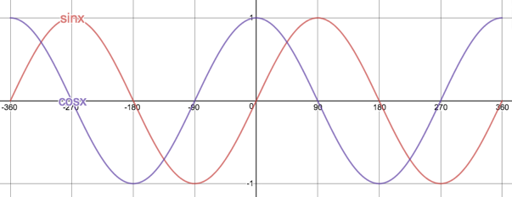
Image source: https://www.desmos.com/calculator/lqbgox4miq
- For both functions, the horizontal line $y=0$ is the “middle” of the graph. Here is the same image but, this time, with this horizontal “middle’’ also shown. See how this line is exactly half way between the maximum and minimum turning points?
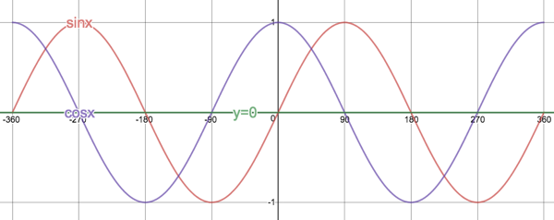
- Both graphs get a maximum distance of one unit away from this middle line.
- We know from earlier work on functions that we can vertically stretch (or squash) a graph by multiplying every output value by some constant. In other words, to stretch the function $f(x)$ we could multiply every output value by two to get a new function $g\left(x\right)=2f(x)$. In the case of the sine and cosine functions, the new stretched functions will be $y=2\sin{x}$ and $y=2\cos{x}$. Because every output or y-value will be multiplied by 2, the turning point will all have y-value of $2$ or $-2$. This means that the range will be $y∈[-2;2]$ and the maximum distance the graphs will get from their “middle” lines will be two units.
- This is what the graphs of $y=2\sin{x}$ and $y=2\cos{x}$ look like.
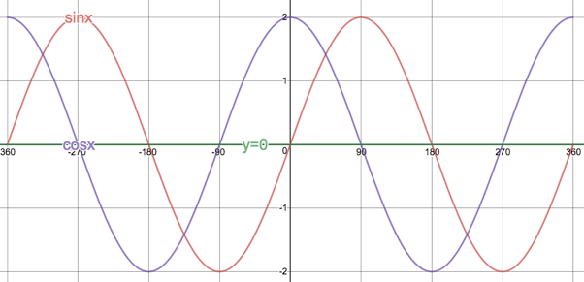
We saw in the last activity that the functions $y=\sin{x}$ and $y=\cos{x}$ repeat themselves every $360°$. We call this their period. Both functions have a period of $360°$. The period of a sine or cosine function is the number of degrees it takes for the function to start repeating its pattern. You can measure the period of a sine or cosine function by measuring the difference in the x-values of any two sequential repeated points.
We also saw that both functions always exist within the range $[-1;1]$. In other words, they never get further than 1 unit away from the x-axis (the line $y=0$). We say that they each have an amplitude of 1. The amplitude is the maximum distance the function gets from its “middle”. In the case of $y=\sin{x}$ and $y=\cos{x}$ this “middle” is the x-axis.
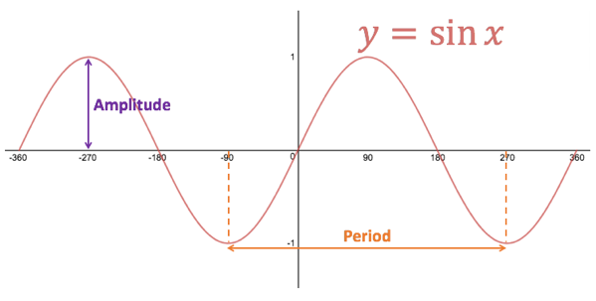

Activity 3: $y=a.\sin{x}+q$ and $y=a.\cos{x}+q$

Purpose
This activity will explore the effects of $a$ and $q$ on the functions $y=a.\sin{x}+q$ and $y=a.\cos{x}+q$.

Suggested Time
You will need about 60 minutes.

What You Will Need
- A pen or pencil
- Some blank paper or a notebook
- An Internet connection

Tasks
- Draw a sketch of $f(x)=\sin{x}$ on a piece of paper for $-360°≤x≤360$.
- Mark in the turning points and show the amplitude and period of the function.
- Now think about the function $g(x)=2\sin{x}$ for $-360°≤x≤360$? What will its turning points be? What will its amplitude be? What will its period be?
- Think about the function $h(x)=\frac{1}{3}\sin{x}$ for $-360°≤x≤360$? What will its turning points be? What will its amplitude be? What will its period be?
- Draw sketches of $g$ and $h$ on the same set of axes as $f$, showing the amplitude and period of $g$ and $h$ as well.
- Now visit the interactive simulation at https://www.desmos.com/calculator/jj1awz5vfg to check that your sketches are all correct.
- What would the graph of $j\left(x\right)=-\sin{x}$ look like? Check using the interactive simulation by changing the value of $a$ in $y=a.\sin{x}$.
- Based on what you learnt in question 1), draw the following functions on the same set of axes - $p\left(x\right)=\cos{x}$, $q\left(x\right)=3\cos{x}$ and $r\left(x\right)=-\frac{1}{4}\cos{x}$ for $-360°≤x≤360$.
- Write down the domain and range of each function.
- What is the amplitude and period of each function?
- What are the turning points of each function?
- Look at the following functions.
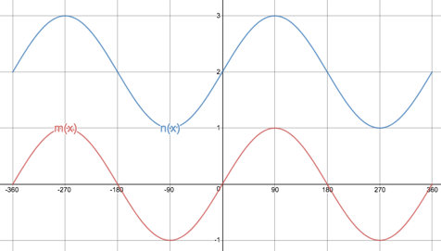
Image source: https://www.desmos.com/calculator/3ekzjhnqrv
- What is the equation of $m$?
- What is the amplitude of $m$?
- What are the turning points and y-intercept of $m$?
- What are the turning points and y-intercept of $n$?
- Write down the equation for $n$.
- What is the amplitude of $n$?
- Make neat sketches of the following functions on the same set of axes for $-360°≤x≤360$. For each function, write down the domain, range, amplitude, period and list the turning points and y-intercept. Hint: It might help to make light sketches of the basic sine and cosine functions and then to transform these are required by each of the functions.
- $f(x)=2\sin{x}$
- $g(x)=\frac{1}{2}\cos{x}$
- $h(x)=\cos{x-1}$
- $j(x)=-2\cos{x+1}$

Guided Reflection
- We needed to make a sketch of $y=\sin{x}$ for the interval $-360°≤x≤360$.
- Here is the graph of $y=\sin{x}$ with its turning points, period and amplitude shown.
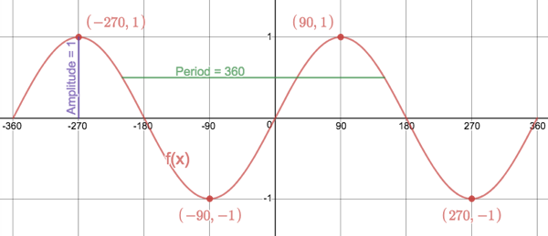
Image source: https://www.desmos.com/calculator/hsomsg5wo0
- The function $g(x)=2\sin{x}$ for $-360°≤x≤360$ is really the function $2f(x)$. Therefore, its turning points will be:
Max: $(-270°;2)$ and $(90°;2)$
Min: $(-90°;-2)$ and $(270°;-2)$
The amplitude of the graph will thus be 2 but its period will be unchanged i.e. $360°$.
- The function $h(x)=\frac{1}{3}\sin{x}$ for $-360°≤x≤360$? Is really the function $\frac{1}{3}f\left(x\right)$. Therefore, its turning points will be:
Max: $(-270°;\frac{1}{3})$ and $(90°;\frac{1}{3})$
Min: $(-90°;-\frac{1}{3})$ and $(270°;-\frac{1}{3})$
The amplitude of the graph will thus be $\frac{1}{3}$ but its period will be unchanged i.e. $360°$.
- Here is a sketch of $f, g$ and $h$.
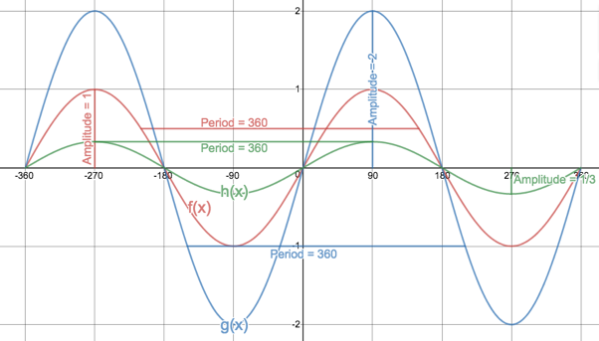
- Here are sketches of $p, q$ and $r$.
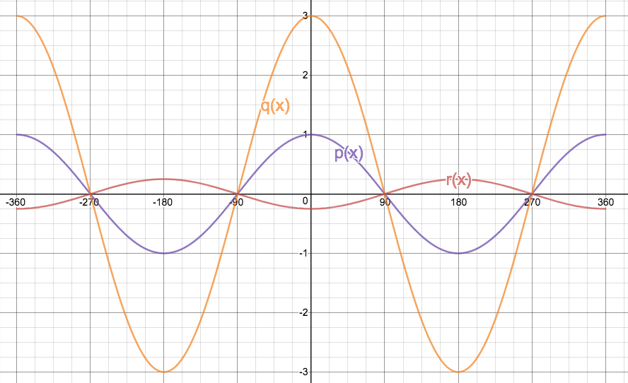
Image source: https://www.desmos.com/calculator/l4yhruehjf
- $p(x)$: Domain $\{x:x∈R, -360°≤x≤360°\}$ Range: $\{p(x):p(x)∈R, -1≤x≤1\}$
$q(x)$: Domain $\{x:x∈R, -360°≤x≤360°\}$ Range: $\{q(x):q(x)∈R, -3≤x≤3\}$
$r(x)$: Domain $\{x:x∈R, -360°≤x≤360°\}$ Range: $\{r(x):r(x)∈R, -\frac{1}{4}≤x≤\frac{1}{4}\}$
- $p(x)$: Amplitude: 1 Period: $360°$
$q(x)$: Amplitude: 3 Period: $360°$
$r(x)$: Amplitude: $\frac{1}{4}$ Period: $360°$
- $p(x)$: $\left(-360°;1\right), \left(-180°; -1\right), \left(0°;1\right), (180°; -1)$ and $(360°;1)$
$q(x)$: $\left(-360°;3\right), \left(-180°; -3\right), \left(0°;3\right), (180°; -3)$ and $(360°;3)$
$r(x)$: $\left(-360°;-\frac{1}{4}\right), \left(-180°; \frac{1}{4}\right), \left(0°;-\frac{1}{4}\right), (180°; \frac{1}{4})$ and $(360°;-\frac{1}{4})$
- We were given two functions, $m(x)$ and $n(x)$.
- The function $m$ is the basic sine function i.e. $m\left(x\right)=\sin{x}$.
- The amplitude of $m$ is 1.
- The turning points of $m$ are $\left(-270°;1\right), \left(-90°; -1\right), \left(90°;1\right)$ and $(270°; -1)$. The y-intercept is $(0°;0)$.
- The turning points of $n$ are $\left(-270°;3\right), \left(-90°; 1\right), \left(90°;3\right)$ and $(270°; 1)$. The y-intercept is $(0°;2)$.
- The graph of $n$ has been shifted vertically up by 2 units. Therefore, we know that $n\left(x\right)=m\left(x\right)+2$. In other words, $n\left(x\right)=\sin{x}+2$.
- The amplitude of $n$ is 1. The middle of the graph (the point half way between the min and max turning points) is the line $y=2$. The maximum distance the graph gets from this “middle” is one unit.
- Here are sketches of each of the functions.
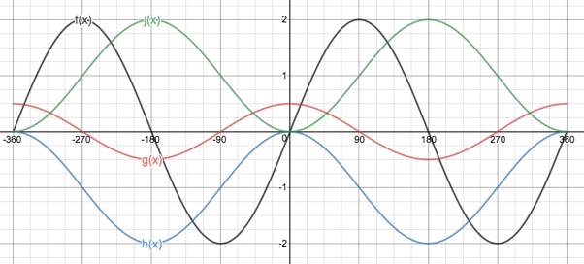
Image source: https://www.desmos.com/calculator/ofvsuep3l2
The function $f(x)=2\sin{x}$ is the same basic shape as $y=\sin{x}$, except that it has an amplitude of 2. Therefore, the graph is stretch out vertically so that the turning points have y-coordinates of 2 and -2.
The function $g(x)=\frac{1}{2}\cos{x}$ is the same basic shape as $y=\cos{x}$, except that the graph has been vertically squashed. Instead of the turning points having y-coordinates of 1 and -1, they now have y-coordinates of $\frac{1}{2}$ and $-\frac{1}{2}$.
The graph of $h(x)=\cos{x-1}$ is the graph of $y=\cos{x}$ shifted down by 1 unit. Therefore, the y-coordinates of the turning points are all going to be one less than before i.e. the turning point of $(-360°;1)$ is now going to be $(-360°;0)$ and the turning point $(-180°;-1)$ is now going to be $(-180°;-2)$.
The graph of $j(x)=-2\cos{x+1}$ has undergone three different transformations. Firstly, the graph will have an amplitude of 2 units. But, secondly, the graph ill also be upside down because the value of $a$ is negative i.e. what was a maximum turning point is not going to be a minimum turning point and visa verse. Thirdly, the graph has been shifted 1 unit up. So, all the y-coordinates of the transformed turning points are also going to be 1 unit greater.
For example, the turning point that was at $(-180°;1)$ is going to be transformed in the following ways:
$(-180°;-1)⟹(-180°;-2)$ because the absolute value of $a=2$.
$(-180°;-2)⟹(-180°;2)$ because $a<0$.
$(-180°;2)⟹(-180°;3)$ because $q=1$
domain, range, amplitude, period and list the turning points and y-intercept.
- $f(x)$: Domain: $\{x:x∈R, -360°≤x≤360°\}$ Range: $f\left(x\right)∈[-2;2]$
Amplitude: 2 Period: $360°$
Turing points: $\left(-270°;2\right), \left(-90°; -2\right), \left(90°;2\right), (270°;-2)$
Y-intercept: $(0°;0)$
- $g(x)$: Domain: $\{x:x∈R, -360°≤x≤360°\}$ Range: $g\left(x\right)∈[-\frac{1}{2};\frac{1}{2}]$
Amplitude: $\frac{1}{2}$ Period: $360°$
Turing points: $\left(-360°;\frac{1}{2}\right), \left(-180°; -\frac{1}{2}\right), \left(0°;\frac{1}{2}\right), \left(180°;-\frac{1}{2}\right), (360°; \frac{1}{2})$
Y-intercept: $(0°;\frac{1}{2})$
- $h(x)$: Domain: $\{x:x∈R, -360°≤x≤360°\}$ Range: $h\left(x\right)∈[-2;0]$
Amplitude: $1$ Period: $360°$
Turing points: $\left(-360°;0\right), \left(-180°; -2\right), \left(0°;0\right), \left(180°;-2\right), (360°; 0)$
Y-intercept: $(0°;0)$
- $j(x)$: Domain: $\{x:x∈R, -360°≤x≤360°\}$ Range: $j\left(x\right)∈[-1;3]$
Amplitude: $2$ Period: $360°$
Turing points: $\left(-360°;-1\right), \left(-180°; 3\right), \left(0°;-1\right), \left(180°;-3\right), (360°; 1)$
Y-intercept: $(0°;1)$
The last activity showed us that the values of $a$ and $q$ in $y=a.\sin{x+q}$ and $y=a.\cos{x+q}$ affect the shape and position of the graphs in very much the same way as they do in other functions we have studied like $y=a{\left(x-p\right)}^{2}+q$, $y=\frac{a}{x-p}+q$ and $y=a.b^{(x-p)}+q$.
The value of $q$ determines the vertical (up or down) shift of the graph and, therefore, its y-intercept. If we increase the value of $q$, we shift the graph up. If we decrease the value of $q$, we shift the graph down. Shifting the graph up and down affects the range of the functions.
Here is a summary of the effect of $q$ of the vertical position of the cosine function.
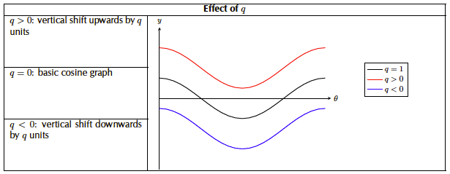
Image source: Everything Maths Gr10 (pg 194)
The value of $a$ determines the shape and orientation of the graph. In the case of the sine and cosine functions, this is expressed in terms of changes in the amplitude of the graphs. The bigger the absolute value of $a$ gets (i.e. ignoring the sign), the greater the amplitude. When $a<0$, the graphs are flipped upside down.
Here is a summary of the effect of $a$ on the sine function.
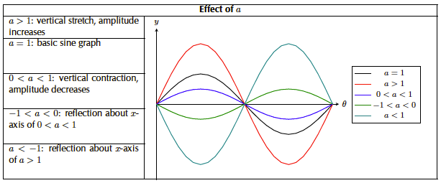
Image source: Everything Maths Gr10 (pg190)

Activity 4: The Effect of $p$

Purpose
This activity will explore the effects of $p$ on the functions $y=a.\sin{(x-p)}$ and $y=a.\cos{(x-p)}$.

Suggested Time
You will need about 45 minutes.

What You Will Need
- A pen or pencil
- Some blank paper or a notebook

Tasks
- Have a look at these graphs of $f\left(x\right)=a.\sin{x}$ and $g\left(x\right)=b.\cos{x}$.
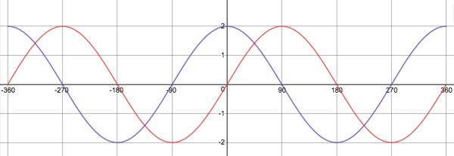
Image source: https://www.desmos.com/calculator/kvrbn4xrbe
- Which graph is $f(x)$? Why?
- What are the values of $a$ and $b$?
- What is the domain and range of each function?
- What would we have to do to the sine function so that it produces the same graph as the cosine function?
- Now visit the interactive simulation at https://www.desmos.com/calculator/qbmsi5x12d and write down two possible equations for a transformed sine function, $h(x)$, that has the same graph as the cosine function. Describe the transformations that would be necessary in each case.
- Write down the domain, range, amplitude and period of these transformed sine functions. Are they different to the original sine function, $f(x)$?
- If the following is a graph of a cosine function of the form $j(x)=a.\cos{(x-p)}$, what are the values of $a$ and $p$. If you need to, draw this graph and the basic cosine function $y=\cos{x}$ on the same set of axes.
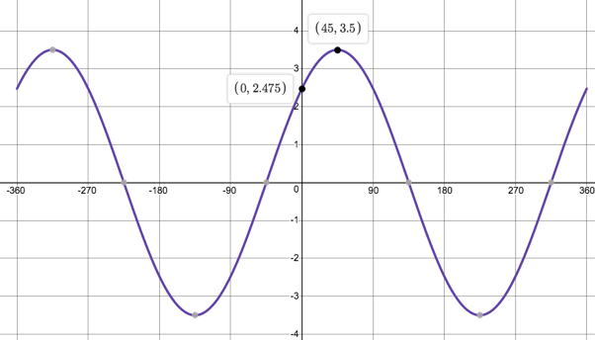
Image source: https://www.desmos.com/calculator/ygszjpmnxr
- Have a look at the graph of the function $q(x)$.
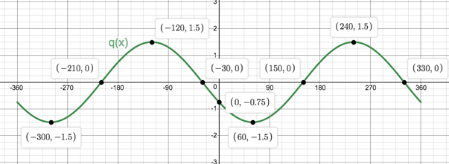
- What is the domain and range $q$?
- What is the period of $q$?
- What is the amplitude of $q$?
- Write down three possible equations for the function $q(x)$ giving reasons for each.
- If you were told that $q\left(x\right)=a.\sin{(x-p)}$ and that $a<0$, write down the equation of $q$.

Guided Reflection
- We were given $f\left(x\right)=a.\sin{x}$ and $g\left(x\right)=b.\cos{x}$.
- Based on the fact that the red graph is the one with a y-intercept of $(0°;0)$, it is the graph of $f(x)$.
- Both graphs have an amplitude of 2. Therefore, the values of both $a$ and $b$ are 2.
- The domain of both functions is $\{x:x∈R,-360°≤x≤360°\}$. The range of both functions is $\{y:y∈R,-2≤y≤2\}$.
- We could do two things. Either we could shift the sine function to the left by $90°$ or we could shift it to the right by $270°$.
- $h\left(x\right)=2\sin{(x-90°)}$ – the original sine function has been shifted $90°$ to the left.
$h\left(x\right)=2\sin{(x+270°)}$ – the original sine function has been shifted $270°$ to the right.
- $h\left(x\right)=2\sin{(x-90°)}$:
Domain: $\{x:x∈R,-360°≤x≤360°\}$ Range: $\{y:y∈R,-2≤y≤2\}$
Amplitude: 2
Period: $360°$
$h\left(x\right)=2\sin{(x+270°)}$:
Domain: $\{x:x∈R,-360°≤x≤360°\}$ Range: $\{y:y∈R,-2≤y≤2\}$
Amplitude: 2
Period: $360°$
In both cases, these are the same as the original function, $f(x)$.
- Here are the graphs of $y=\cos{x}$ and $y=a.\cos{(x-p)}$ on the same set of axes.
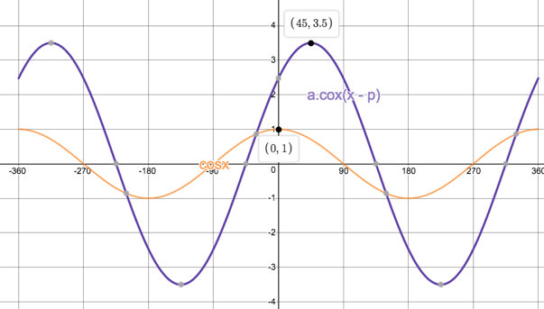
We can see that the amplitude of $y=a.\cos{(x-p)}$ is $3\frac{1}{2}$ times higher than the amplitude of $y=\cos{x}$. Therefore, $a=3\frac{1}{2}$.
The TP of $y=\cos{x}$ at $(0°;1)$ has been shifted to $(45°;3.5)$ i.e. it has been shifted $45°$ to the right. Therefore, $p=45°$.
- We have been given the function $q(x)$.
- Domain: $\{x:x∈R,-360°≤x≤360°\}$ Range: $\{y:y∈R,-1.5≤y≤1.5\}$
- Period: $360°$
- Amplitude: 1.5
- $q\left(x\right)=\frac{3}{2}\cos{(x+120°)}$ – the amplitude of the graph is $\frac{3}{2}$ so $a=\frac{3}{2}$. There is no vertical shift so $q=0$. The basic cosine function $y=\cos{x}$ normally cuts the y-axis and has a TP at $(0°;1)$. But this TP has been shifted $120°$ to the left. Therefore $p=-120°$.
$q\left(x\right)=\frac{3}{2}\cos{(x-240°)}$ – the amplitude of the graph is $\frac{3}{2}$ so $a=\frac{3}{2}$. There is no vertical shift so $q=0$. The basic cosine function $y=\cos{x}$ normally cuts the y-axis and has a TP at $(0°;1)$. But this TP has been shifted $240°$ to the right. Therefore $p=240°$.
$q\left(x\right)=\frac{3}{2}\sin{(x-150°)}$ – the amplitude of the graph is $\frac{3}{2}$ so $a=\frac{3}{2}$. There is no vertical shift so $q=0$. The basic sine function $y=\sin{x}$ normally has a TP at $(90°;1)$. However, the TP is now at $(240°;1.5)$ which means that the graph has been shifted $150°$ to the right. Therefore, $p=150°$.
- We are told that $q\left(x\right)=a.\sin{(x-p)}$ and that $a<0$. Therefore, $a=-\frac{3}{2}$ which means that the graph has been flipped upside down. What used to be maximum turning points, will now be minimum turning points and visa verse.
The basic sine function $y=\sin{x}$ has a maximum TP at $(90°;1)$. The graph of $q(x)$ has a minimum TP at $(60°; -\frac{3}{2})$. The difference in the y-coordinates is due to $a=-\frac{3}{2}$. The horizontal shift of $30°$ to the left must be due to $p$. Therefore, $p=-30°$ and $q\left(x\right)=-\frac{3}{2}\sin\left(x-30°\right)$.
As you probably expected, the effect of $p$ in $y=a.\sin{(x-p)}$ and $y=a.\cos{(x-p)}$ is to shift the graph horizontally (left and right). Once again, this is exactly the same as the effect of $p$ in other functions like $y=a{\left(x-p\right)}^{2}+q$, $y=\frac{a}{x-p}+q$ and $y=a.b^{(x-p)}+q$.
- For $p<0$: The graphs are shifted to the left.
- For $p>0$: The graphs are shifted to the right.
However, we have also discovered that there are multiple sine and cosine functions that can generate the very same graphs. For example
$$y=-\frac{3}{2}\sin\left(x-30°\right)$$
$$y=\frac{3}{2}\sin{(x-150°)}$$
$$y=\frac{3}{2}\cos{(x-240°)}$$
$$y=\frac{3}{2}\cos{(x+120°)}$$
all produce the same graph. This means that, for every input, each of these functions will produce the very same output. We will learn more about this in Topic 3.

Activity 5: Periods

Purpose
This activity will help you to understand the periods of the sine and cosine functions in more detail.

Suggested Time
You will need about 75 minutes.

What You Will Need
- A pen or pencil
- Some blank paper or a notebook

Tasks
- Here are three sine functions, $a(x)$, $b(x)$ and $c(x)$ for the domain $[-360°;360]$ with the coordinates of their maximum turning points.
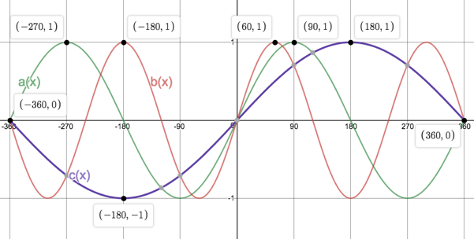
Image source: https://www.desmos.com/calculator/8ptmdmayli
- Which function has the equation $y=\sin{x}$?
- What is the amplitude of each function?
- What is the period of each function?
- Write the periods of $b$ and $c$ in terms of the period of $a$ e.g. the period of $b=$ some number $×$ the period of $a$.
- Now write the period of $a$ in terms of the periods of $b$ and $c$ e.g. e.g. the period of $a=$ some number $×$ the period of $b$.
- If $a\left(90°\right)=1=b\left(60°\right)=c(180°)$, what are the values of $k$ and $l$ if $b\left(x\right)=\sin{kx}$ and $c\left(x\right)=\sin{lx}$?
- Write the periods of $b(x)$ and $c(x)$ in terms of the period of the basic sine function ($360°$) and the values of $k$ or $l$.
- Complete the following table for $d\left(x\right)=\sin{3x}.$
$$x$$ | $$0°$$ | $$30°$$ | $$60°$$ | $$90°$$ | $$120°$$
$$d(x)$$

- Sketch the graph of $d(x)$ for $[0°≤x≤120°]$
- What is the period of $d(x)$?
- If $d\left(x\right)$ is in the form $y=\sin{kx},$express the period in terms of $360°$ and $k$.
- For $[-180°≤x≤360°]$, sketch the functions $f\left(x\right)=\cos{x}$, $g\left(x\right)=2\cos{\frac{1}{2}x}$ and $h\left(x\right)=-\frac{1}{2}\sin{\frac{3}{2}x}$ on the same set of axes. Write down the domain, range, amplitude and period of each function.

Guided Reflection
- We were given the graphs of $a(x)$, $b(x)$ and $c(x)$.
- $a\left(x\right)=\sin{x}$. It is the only one that increases to a maximum TP at $(90°;1)$.
- Each function has an amplitude of 1.
- The period of $a(x)$ is $360°$.
The period of $b(x)$ is $240°$. The x-axis distance between, for example, the two successive maximum turning points $(-180°;1)$ and $(60°;1)$ is $240°$.
The period of $c(x)$ is $720°$. The x-axis distance between the two x-intercepts where the graph is increasing, $(-360°;0)$ and $(360°;0)$ is $720°$
- Period of $b$ / period of $a$ is $\frac{240}{360}=\frac{2}{3}$. Therefore, the period of $b=\frac{2}{3}×$ the period of $a$.
Period of $c$ / period of $a$ is $\frac{720}{360}=2$. Therefore, the period of $b=2×$ the period of $a$.
- From our equations in d), we can say that
Period of $a=\frac{3}{2}×$ the period of $b$.
Period of $a=\frac{1}{2}×$ the period of $c$.
- We know that $a(90°)$, $b(60°)$ and $c(180°)$ all give the same output. We also know that
$\frac{90°}{60°}=\frac{3}{2}∴90°=\frac{3}{2}×60°$. Therefore $\sin{90}°=\sin{\frac{3}{2}×60°}$ so the value of $k$ in $b\left(x\right)=\sin{kx}$ must be $\frac{3}{2}$.
$\frac{90°}{180°}=\frac{1}{2}∴90°=\frac{1}{2}×180°$. Therefore $\sin{90}°=\sin{\frac{1}{2}×180°}$ so the value of $l$ in $c\left(x\right)=\sin{lx}$ must be $\frac{1}{2}$.
- Period of $b=240°=\frac{360°}{3/2}$ or $\frac{360°}{k}$
Period of $c=720°=\frac{360°}{1/2}$ or $\frac{360°}{l}$
- $d\left(x\right)=\sin{3x}.$Here is the completed table.
$$x$$ | $$0°$$ | $$30°$$ | $$60°$$ | $$90°$$ | $$120°$$
$$d(x)$$ | $$0$$ | $$1$$ | $$0$$ | $$-1$$ | $$0$$

- Here is a sketch of $d(x)$.
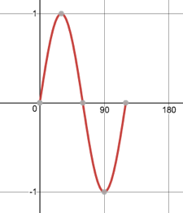
Image source: https://www.desmos.com/calculator/s4lubpjiqa
- The period of $d(x)$ is $120°$.
- The period of $d\left(x\right)=\frac{360°}{3}$.
- We were asked to sketch $f\left(x\right)=\cos{x}$, $g\left(x\right)=2\cos{\frac{1}{2}x}$ and $h\left(x\right)=-\frac{1}{2}\sin{\frac{3}{2}x}$ on the same set of axes for the domain $[-180°≤x≤360°]$.
Whenever we need to sketch a sine or cosine function, it is best to start with the basic function and then transform it as required by the values of $a, p, q$ or $k$.
Here is a sketch of $f\left(x\right)=\cos{x}$, the basic cosine function. Notice that we stop drawing at $x=-180°$ and $x=360°$.
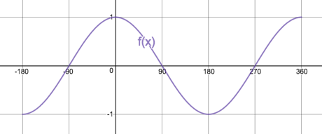
Now $g\left(x\right)=2\cos{\frac{1}{2}x}$. $a=2$ so, the graph will have an amplitude of 2. The values of $p$ and $q$ are zero, so there are no vertical or horizontal shifts.
$k=\frac{1}{2}$. This means that the period of $g(x)$ will be $\frac{360°}{1/2}=720°$. So, the turning point of $f(x)$ at $(180°; -1)$ is now going to be twice as far from the y-axis at $(360°; -1)$. The x-intercept of $f(x)$ at $(-90°;0)$ is now going to be twice as far away from the y-axis at $(-180°;0)$.
Here is a sketch of $f$ and $g$.
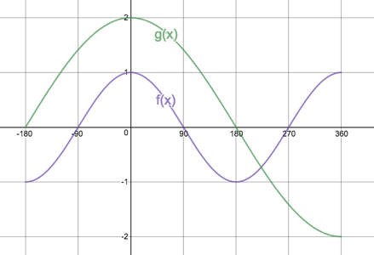
$h\left(x\right)=-\frac{1}{2}\sin{\frac{3}{2}x}$ is a sine function. It is a good idea to draw the basic sine function (even if just as a light or dotted line) to help you figure out what $h(x)$ looks like.
Here is a sketch of the basic sine function for the interval.
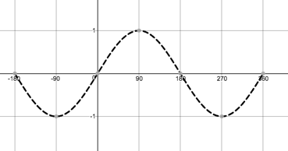
Now $h\left(x\right)=-\frac{1}{2}\sin{\frac{3}{2}x}$. $a=-\frac{1}{2}$ so, the graph will have an amplitude of $\frac{1}{2}$ but will also be flipped over (maximum turning points will become minimum turning points).
$p=0$ and $q=0$ so there are no vertical or horizontal shifts.
$k=\frac{3}{2}$. This means that the period of $h$ will be $\frac{360°}{3/2}=360°×\frac{2}{3}=240°$. Therefore, the maximum turning point at $(90°;1)$ will become a minimum turning point at $(60°; -\frac{1}{2})$. Remember $a=\frac{1}{2}$ has changed the amplitude and the orientation and $k=\frac{3}{2}$ has changed the period. A point that was at $90°$ is now going to be at $\frac{90°}{3/2}=90°×\frac{2}{3}=60°$.
This also means that the x-intercepts at $(-180°;0)$ $(180°;0)$ and $(360°;0)$will become $(\frac{-180°}{3/2};0)$, $(\frac{180°}{3/2};0)$ and $(\frac{360°}{3/2};0)$ or $(-120°;0)$, $(120°;0)$ and $240°;0)$.
Here is a sketch of the basic sine function and $h(x)$.
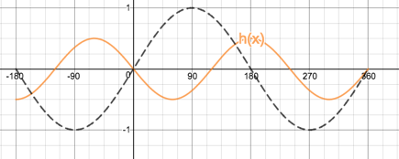
Finally, here is a sketch of all three functions.
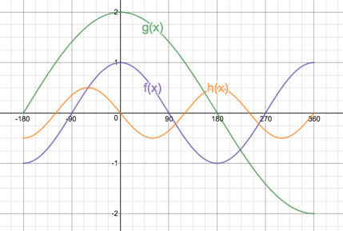
We were also asked to note the domain, range, amplitude and period of each function.
The domain of all three functions is the same as the specified interval i.e. domain is $\{x:x∈R,-180°≤x≤360°\}$.
Range:
$$\{f\left(x\right):f(x)∈R, -1≤f(x)≤1\}$$
$$\{g\left(x\right):g(x)∈R, -2≤f(x)≤2\}$$
$$\{h\left(x\right):h(x)∈R, -1≤f(x)≤1\}$$
Amplitude:
$f(x)$: 1 $g\left(x\right)$: 2 $h(x)$: $\frac{1}{2}$
Period:
$f(x)$: $360°$ $g\left(x\right)$: $720°$ $h(x)$: $240°$
So far, we have investigated the sine and cosine functions of the following forms:
$y=a.\sin{x}+q$ $y=\cos{x}+q$
$y=a.\sin\left(x-p\right)$ $y=a.\cos\left(x-p\right)$
$y=a.\sin{kx}$ $y=a.\cos{kx}$
We have seen that these two functions are very similar. In fact, we saw right at the start of this unit that $\sin{x}=\cos{(x-90°)}$. The fact that these two functions are so closely related is one of the reasons for how they have been named – sine and COsine. Cosine is the co-function of sine.
But there is a third trigonometric function that behaves quite differently from sine and cosine. It is called tangent (tan for short). $\tan{x}=\frac{\sin{x}}{\cos{x}}$ but the graph of $\tan{x}$ looks nothing like the other two. Let’s take a closer look.

Activity 6: The Tangent Function

Purpose
This activity will introduce you to the graph of the tangent function.

Suggested Time
You will need about 35 minutes.

What You Will Need
- A pen or pencil
- Some blank paper or a notebook

Tasks
- We are going to try and make a sketch of $y=\tan{x}$.
- Using a calculator, complete the following table. Does anything seem strange to you?
$$x$$ | $$0°$$ | $$45°$$ | $$90°$$ | $$135°$$ | $$180°$$ | $$225°$$ | $$270°$$ | $$315°$$ | $$360°$$
$$\tan{x}$$

- Plot these points on a Cartesian Plane. Can you join them with a smooth curve.
- The graph may seem to be a strange shape so calculate the following points and use them to help you draw the graph.
$$x$$ | $$30°$$ | $$60°$$ | $$120°$$ | $$150°$$ | $$210°$$ | $$240°$$ | $$300°$$ | $$330°$$
$$\tan{x}$$

- Use your calculator to try and work out what happens to the value of $\tan{x}$ as you let $x$ get closer and closer to $90°$ from the left and the right of $90°$. What happens when $x=90°$. For what other functions have you seen this kind of behaviour? What did we call this line?
- Why is $\tan{90°}$ undefined? Think about the fact that $\tan{x}=\frac{\sin{x}}{\cos{x}}$.
- For what other inputs do you see the same behaviour as you do for $x=90°$?
- Add any lines you need to complete your sketch of $y=\tan{x}$
- What is the period of $y=\tan{x}?$
- What is the amplitude of $y=\tan{x}$?
- Is $y=\tan{x}$ a function? Why?
- What is the domain and range of $y=\tan{x}$?

Guided Reflection
- We need to make a sketch of $y=\tan{x}$.
- Here is the completed table of values. The value of $y=tan{x}$ is undefined for $x=90°$ and $x=270°$. The graph does not exist at these points.
$$x$$ | $$0°$$ | $$45°$$ | $$90°$$ | $$135°$$ | $$180°$$ | $$225°$$ | $$270°$$ | $$315°$$ | $$360°$$
$$\tan{x}$$ | $$0$$ | $$1$$ | $$?$$ | $$-1$$ | $$0$$ | $$1$$ | $$?$$ | $$-1$$ | $$0$$

- Here are the points plotted. Joining them is hard because they don’t all seem to line on the same line
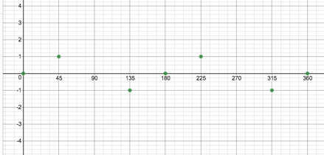
Image source: https://www.desmos.com/calculator/bkged06usn
We could join them like this to make shark teeth.
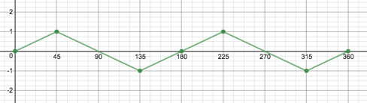
- Here is the second table of values.
$$x$$ | $$30°$$ | $$60°$$ | $$120°$$ | $$150°$$ | $$210°$$ | $$240°$$ | $$300°$$ | $$330°$$
$$\tan{x}$$ | $$0.58$$ | $$1.7$$ | $$-1.7$$ | $$-0.58$$ | $$0.58$$ | $$1.7$$ | $$-1.7$$ | $$-0.58$$

If we add these new points, we get
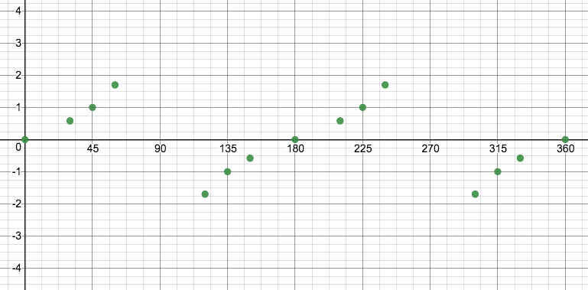
But it is still not clear exactly how they need to be joined, especially the points either side of $90°$ and $270°$.
- As we let $x$ get closer and closer to $90°$ from the left, $y=\tan{x}$ gets huge. For example, $\tan{89.99=5729.6}$. When we let $x$ get closer and closer to $90°$ from the right, $y=\tan{x}$ gets hugely negative. $\tan{90.0001°=-572957.8}$.
We cannot let $x$ ever actually equal $90°$ because then $y=\tan{x}$ is undefined.
We saw similar behaviour with the hyperbolic and exponential functions. Both of these functions had asymptotes – values that the graph could get closer and closer to but was never allowed to reach. The hyperbolic function has a vertical and horizontal asymptote while the exponential function had a horizontal asymptote.
It looks like the tangent function has a vertical asymptote at $x=90°$.
- If $\tan{x}=\frac{\sin{x}}{\cos{x}}$ then $\tan{90°}=\frac{\sin{90°}}{\cos{90°}}=\frac{1}{0}$ and we know that we cannot divide by zero. That means that $\tan{x}$ is undefined whenever $\cos{x=0}$.
- The same asymptotic behaviour happens at $x=270°$.
- If we draw in the asymptotes, we get a much clearer picture of the shape of the graph.
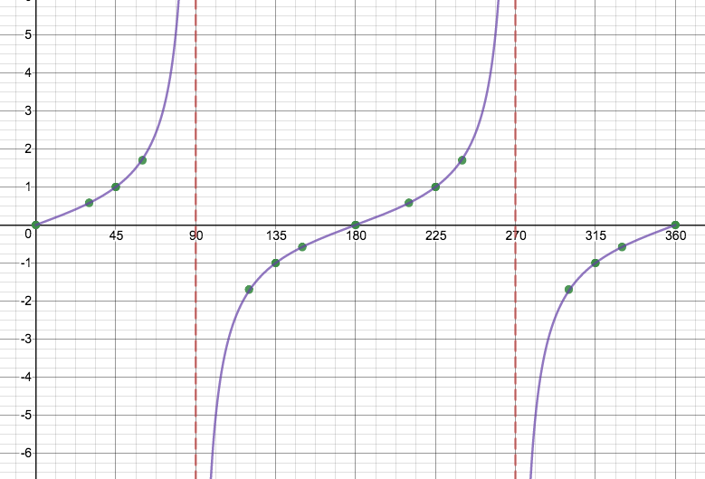
- We can see that the graph repeats itself after $180°$. Therefore, the period of $y=\tan{x}$ is $180°$.
- Because the graph does not have a maximum or minimum value, it does not have an amplitude. The concept of amplitude does not apply to $y=\tan{x}$.
- $y=\tan{x}$ is a function. There is no input that ever produces more than one output. The vertical line test shows this.
- The tangent function can take any real value for $x$ except the values where it has a vertical asymptote. From our graph, these asymptotes appear every $180°$. We can write the domain as $\{x:x∈R, x≠90°+k.180°, k∈Z\}$. This means that $x$ can be any real number except $90°+0.180°$, $90°±1.180°$, $90°±2.180°$ and so on.
The range of the function is any real number i.e. $\{y:y∈R\}$.

Activity 7: Transforming the Tangent Function

Purpose
This activity will investigate the effect of the variables $a, p, q$ and $k$ on the function $y=a.\tan{(kx-p)}+q$.

Suggested Time
You will need about 75 minutes.

What You Will Need
- A pen or pencil
- Some blank paper or a notebook
- An Internet connection

Tasks
- Visit the interactive simulation at https://www.desmos.com/calculator/umnukoayzm. Here you will find the graph of the basic tangent function in the form of $f\left(x\right)=a.\tan\left(kx-p\right)+q$ and sliders to change the values of $a$, $k$, $p$ and $q$. Also shown are the graph’s vertical asymptotes as well as the some points where the value of $f\left(x\right)=±1$(in blue) and the x-intercepts (in purple).
- If $f\left(x\right)=\tan{x}$, what are the values of $a$, $k$, $p$ and $q$?. What is the period of the function now?
- From your knowledge of the sine and cosine functions, which variable do we need to change to change the period of $f(x)$? What is the value of this variable that changes the period of $f(x)$ to $360°$?
- When we make the period of $f\left(x\right)=$ $360°$, how far apart are the asymptotes? How far apart are the x-intercepts.
- What value of the variable would make the period of $f\left(x\right)=240°$. Write down an expression that links the period of $f(x)$ with this variable.
- Make the period of $f\left(x\right)=180°$ again. From your knowledge of the sine and cosine graphs, what will be the effect of changing the value of $a$ in $f\left(x\right)=a.\tan{x}$?
- What happens to the graph of $f(x)$ if you make the value of $a=2$? Which points on the graph change? Which points do not change?
- Change the value of $a$ to 0.3. What happens to the graph?
- What will happen to the graph if $a=-2$? Predict the coordinates of these special points and then change the value of $a$ in the interactive simulation to see if you are right.
- Make $a=1$ again. From your knowledge of the sine and cosine graphs, what will be the effect of changing the value of $q$ in $f\left(x\right)=\tan{x+q}$?
- What happens to the graph of $f(x)$ if you make the value of $q=-2$? Which points on the graph change and how?
- Make $q=0$ again. From your knowledge of the sine and cosine graphs, what will be the effect of changing the value of $p$ in $f\left(x\right)=\tan{(x-p)+q}$?
- What happens to the graph of $f(x)$ if you make the value of $p=45°$? Which points on the graph change?
- What else changes when you change the value of $p$ in $f\left(x\right)=\tan{(x-p)+q}$? Write an expression that links the value of $p$ with this change.
- If the points $(45°;1)$ and $\left(-45°; -1\right)$ are points on $f\left(x\right)=a.\tan{x}+q$, what do the values of $a$ and $q$ need to be to make these points $(45°;2\frac{1}{2})$ and $(-45°; -\frac{1}{2})$ respectively. Use the interactive simulation to check.
- If the point $(180°;0)$ is a point on $f\left(x\right)=2.\tan\left(x-p\right)+q$, what do the values of $p$ and $q$ need to be to make this the point $(160°;-3)$. Use the interactive simulation to check.
- Sketch the graph of $l\left(x\right)=-2\tan{x+2}$.
- Sketch the graph of $g\left(x\right)=\frac{1}{3}.\tan{\frac{1}{3}x}$.
- Sketch the graph of $h\left(x\right)=2.\tan{(x-60°)}$.

Guided Reflection
- The interactive simulation at https://www.desmos.com/calculator/umnukoayzm allowed us to manipulate $f\left(x\right)=a.\tan\left(kx-p\right)+q$.
- When $f\left(x\right)=\tan{x}$, then $a=1$, $k=1$, $p=0$ and $q=0$. The period of $f\left(x\right)$ is $180°$.
- We know that the value of $k$ in, for example, $y=a.sin\left(kx-p\right)+q$ changes the period of the graph. Therefore, it is the value of $k$ in $y=a.\tan\left(kx-p\right)+q$ that will change the period of the tangent function. We know that if we make $k=2$ in $y=a.sin\left(kx-p\right)+q$, we will halve the period of the basic sine function from $360°$ to $180°$ because the period is given by $\frac{360°}{|k|}$ (remember, the sign of $k$ does not matter). So, if we want to double the period of the basic tangent function from $180°$ to $360°$, we need to make $k=\frac{1}{2}$.
- The asymptotes and x-intercepts are now $360°$ apart. This is because the graph repeats itself only every $360°$.
- To make the period of $f\left(x\right)$ equal to $240°$, the value of $k=0.75$ because $\frac{180}{0.75}=240$. Therefore, in general we can say that the period of the tangent function is given by $\frac{180}{|k|}$.
- Changing the value of $a$ will stretch (or squash) the graph vertically, making it longer and thinner or shorter and fatter.
- When $a=2$, all the points that used to have y-coordinates of $±1$ now have y-coordinates of $±2$, The graph has been stretched out. The x-intercepts do not change at all.
- When we make $a=0.3$ we squash the graph vertically. All the points that used to have y-coordinates of $±1$ now have y-coordinates of $±0.3$.The x-intercepts do not change at all.
- If we make $a=-2$, two things will happen. The y-coordinate of these special points will change from $±1$ in the basic tangent function to $±2$ but they will all, also change sign. In other words, the point $\left(45°;+1\right)$, for example, will become the point $(45°; -2)$. The point $(-225°; -1)$ will become $(-225°; +2)$.
- We know that changing the value of $q$ shifts the graph vertically up or down.
- If we make $q=-2$, we will shift the whole graph 2 units down. All the y-coordinates will be 2 units less. This includes the special points as well as the x-intercepts. Obviously, these points, being 2 units further down then before, are no longer x-intercepts.
- Changing the value of $p$ shifts the graph horizontally left or right.
- If we make $p=45°$, we shift the whole graph $45°$ to the right. The x-coordinate of every point on the graph moves $45°$ to the right. For example, the point $(0°;0)$ becomes the point $(45°;0)$.
- The vertical asymptotes also shift $45°$ to the right. The asymptote at $y=90°$ becomes an asymptote at $y=90°+45°=135°$. In general, this asymptote becomes the line $y=90°+p$. The other asymptotes, like $y=270°$ shift in the same way i.e. $y=270°+p$.
- We know that $f\left(x\right)=a.\tan{x}+q$. Therefore, $k=1$ and $p=0$. So, the period is $180°$ and there is no horizontal shift happening. We know that, normally, the points $(45°;1)$ and $\left(-45°; -1\right)$ are the same distance from the x-axis but our new points are not. This tells us that there is a vertical shift. We know that for $y=\tan{x}$, the vertical distance between these points is 2. However, now the vertical distance is 3. This means that the value of $a>1$ and that $a=\frac{3}{2}$.
Another way to think about this is that each of these points is 1 unit ($2÷2$) away from the “middle” of the graph (similar to the amplitude of sine and cosine). But the new points are $3÷2$ or $\frac{3}{2}$ units from the “middle” of the graph.
However, the vertical shift has moved this “middle” up. The middle line between the y-coordinates $2\frac{1}{2}$ and $-\frac{1}{2}$ is the line $y=1$. Therefore, the graph has been shifted up by 1 unit so $q=1$. The equation of the function is thus $f\left(x\right)=\frac{3}{2}.\tan{x}+1$.
- We know we are working with the function $f\left(x\right)=2.\tan\left(x-p\right)+q$ where $a=2$ and $k=1$. This means that the period of the graph is $180°$. To move a point from $(180°;0)$ to $(160°;-3)$ requires a vertical shift down of three units and a horizontal shift to the left of $20°$. Therefore, $q=-3$ and $p=-20°$ and the equation is $f\left(x\right)=2.\tan\left(x+20\right)-3.$

Activity 8: Trigonometric Functions

Purpose
This activity will consolidate your knowledge of the trigonometric functions.

Suggested Time
You will need about 60 minutes.

What You Will Need
- A pen or pencil
- Some blank paper or a notebook

Tasks
- Sketch the graph of $g\left(x\right)=\frac{1}{3}.\tan{\frac{1}{3}x}$ for $-360°≤x≤360°$.
- Sketch the graph of $l\left(x\right)=-2\tan{x+2}$ for $-360°≤x≤0°$.
- Sketch the graph of $h\left(x\right)=2.\tan{(x-60°)}$ for $-180°≤x≤360°$.
- $f\left(x\right)=a\sin{kx}$ and $g\left(x\right)=b\tan{x}.$What are the equations of these functions.
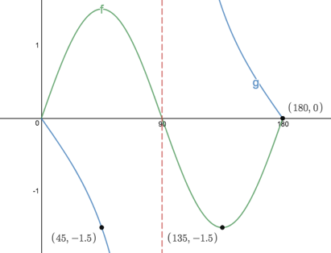
- This is the graph of $f\left(θ\right)=a.\sin{kθ}$ and $g\left(θ\right)=b.\sin{(θ-p)}.$ What are the values of $a$, $b, k$ and $p$?
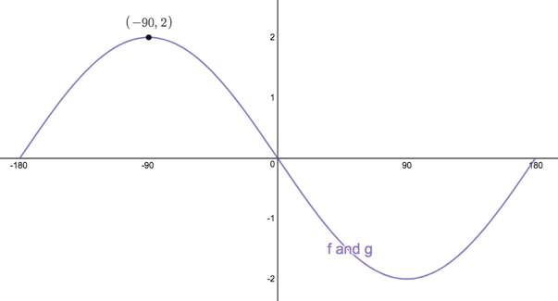
- Given the functions $f\left(x\right)=2\sin{x}$ and $g\left(x\right)=\cos{x}+1$.
- Sketch the functions on the same set of axes for the interval $0°≤x≤360°$.
- What is the period of $f$?
- What is the amplitude of $g$?
- Use your sketch to determine how many solutions there are to the equations $2\sin{x}-\cos{x}=1$ in the interval and give one of these solutions.
- Indicate on your sketch where the solution to $2\sin{x=-1}$ is found.
- Show on your graph where $f(x)>g(x)$?
- For what values $x$ is $f\left(x\right).g(x)<0$?

Guided Reflection
- We were asked to sketch the graph of $g\left(x\right)=\frac{1}{3}.\tan{\frac{1}{3}x}$. Like when sketching sine and cosine graphs, it is best to start out with a light sketch of eth basic tangent function and then transform this graph needed. The x-intercepts, the vertical asymptotes and the points $(45°;1)$ and $-45°; -1)$ are all very useful markers.
In our function, $k=\frac{1}{3}$. That means that the period of the graph is going to be $\frac{180}{1/3}=540°$ or three times greater. So instead of the asymptotes being $180°$ apart they are now going to be $540°$ apart. The vertical asymptote that used to be at $90°$ is now going to be at $90°×3=270°$ and the vertical asymptote that used to be at $-90°$ is now going to be at $-90°×3=-270°$.
Also, the value of $a=\frac{1}{3}$. This means that the graph is going to be squash vertically. Therefore, the point that used to be $(45°;1)$ is now going to have a y-coordinate of $\frac{1}{3}$ and because the period is now three times greater, it will have an x-coordinate of $45°×3=135°$ i.e. it will be the point $(135°; \frac{1}{3}$). The point that was at $(-45°; -1)$ is now going to be at $(-135°; -\frac{1}{3})$.
Here is a sketch of the graph. The basic tangent graph is shown as a dotted line.
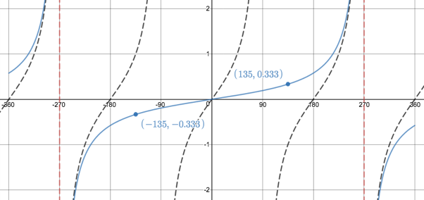
Image source: https://www.desmos.com/calculator/zftcpmc1uc
- We need to sketch $l\left(x\right)=-2\tan{x+2}$ for $-360°≤x≤0°$. As normal, start with a light sketch of the basic tangent function, paying particular attention to the key points in the required interval.
In $l\left(x\right)=-2\tan{x+2}$, the value of $a=-2$. This means that the graph is going to be stretched vertically and is going to be reflected about the y-axis. The value of $k=1$ so the period of the graph is $180°$ as normal and the vertical asymptotes are where they normally are - $-270°$ and $-90°$.
The transformations because of the value of $a$ mean that the point $\left(-135°;1\right)$ becomes the point $(-135°; -2)$ and the point $\left(-45°;-1\right)$ becomes the point $(-45°; 2)$.
But $q=2$ which means that the whole graph has also been shifted 2 units up. Thus, every point, including the x-intercepts is moved 2 units up. So, the x-intercept $(0;0)$ becomes the point $(0;2)$, the x-intercept $(-180;0)$ becomes the point $(-180°;2)$ and the x-intercept $(-360;0)$ becomes the point $(-360°;2)$The transformed points above are also shifted 2 units up and become$(-135°; 0)$ and $(-45°; 4)$.
Here is a sketch of the graph.
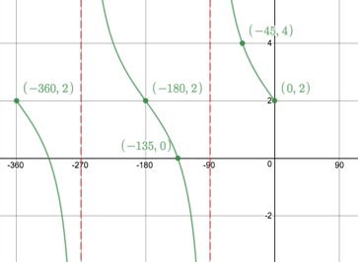
- We need to sketch $h\left(x\right)=2.\tan{(x-60°)}$ for $-180°≤x≤360°$. As normal, start with a light sketch of the basic tangent function, paying particular attention to the key points in the required interval.
In $h\left(x\right)=2\tan{(x-60)}$, the value of $a=2$. This means that the graph is going to be stretched vertically and points that used to have y-coordinates of $±1$ will now have y-coordinates of $±2$.
The value of $k=1$ so the period of the graph is $180°$ as normal and the vertical asymptotes are going to be $180°$ apart as normal.
However, the horizontal shift to the right because $p=60°$ is going to move the vertical asymptotes from $x=-90°$ to $x=-30°$, from $x=90°$ to $x=150°$ and from $x=270°$ to $x=330°$.
The horizontal shift will also move every other point on the graph $60°$ to the right. Therefore, the x-intercepts $(-180°;0)$ will move to $(-120°;0)$, $(0°;0)$ will move to $(-60°;0)$, $(180°;0)$ will move to $(240°;0)$.
Here is a sketch.
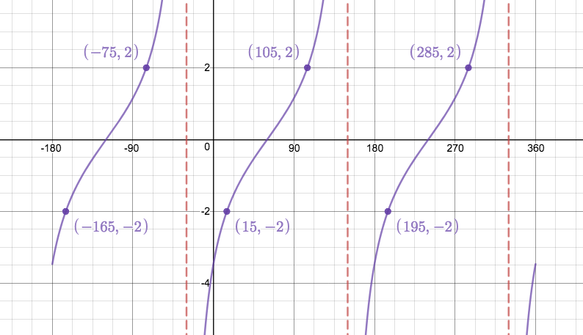
- We are told that $f\left(x\right)=a\sin{kx}$ and $g\left(x\right)=b\tan{x}.$ From the graph, we can see that the period of $f$ is $180°$. Therefore, we know that the value of $k=2$.
The minimum turning point of $f$ has a y-coordinate of $-\frac{3}{2}$ rather than its normal value of 1. So, we know that the graph has been stretched vertically and the value of $a=\frac{3}{2}$. Therefore, $f\left(x\right)=\frac{3}{2}\sin{2x}$.
The graph of $g$ decreases from zero to the vertical asymptote at $x-90°$ instead of increasing as normal. Therefore, we know that the value of $a<0$. The y-coordinate of the point at $45°$ is $-\frac{3}{2}$. We already know that $a<0$ so we can conclude that $a=-\frac{3}{2}$. Therefore, $g\left(x\right)=-\frac{3}{2}.\tan{x}.$
- We are told that the give sketch is of $f\left(θ\right)=a.\sin{kθ}$ and $g\left(θ\right)=b.\sin{(θ-p)}.$ Let’s start by working with the sine function.
The period of the graph is $360°$ so we know that $k=1$. The sine function normally increases between $0°$ and $90°$ but this one is decreasing. This means that $a<0$. There is a turning point at $(-90°;2)$. Thus, the amplitude of the graph is $2$ and $a=-2$.
Working with the cosine function. We know that cosine normally has a maximum turning point and y-intercept at $(0°;1)$. However, the turning point has been shifted to the left by $90°$. This means that $p=-90°$. The fact that the amplitude of the graph is 2 units means that $b=2$.
This result means that $-2\sin{θ}=2\cos{(θ+90°)}$.
- We were given $f\left(x\right)=2\sin{x}$ and $g\left(x\right)=\cos{x}+1:$
- Here are sketches of these functions for the interval $0°≤x≤360°$.
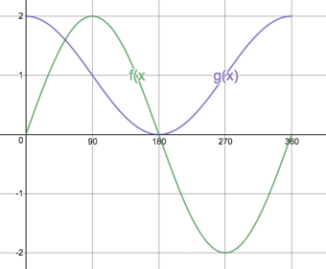
- The period of $f$ is $360°$.
- The amplitude of $g$ is 1.
- We can write $2\sin{x}-\cos{x}=1$ as $2\sin{x}=\cos{x}+1$. In other words, this is $f\left(x\right)=g(x)$. Because the graphs intersect each other twice in this interval, we know that there are two solutions. One of these solutions is the point $(180°;0)$.
- The solution to $2\sin{x=-1}$ is where the graph of $f(x)$ intercepts with the line $y=-1$ as shown on the graph. Another way of saying this is that the solutions to the equation exist wherever $f\left(x\right)=-1$.
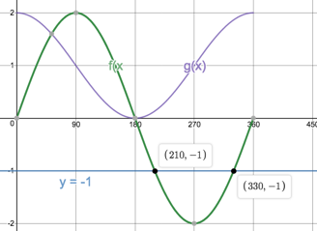
- $f(x)>g(x)$ means that, for a particular value of $x$, the output from the function $f$ is greater than the output from the function $g$. In other words, the graph of $f(x)$ is higher than the graph of $g(x)$. We can see that this is always the case between points A and B but not including these points because this is where $f\left(x\right)=g(x)$.
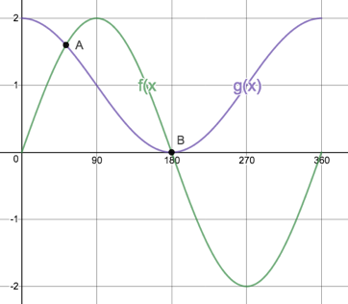
- For $f\left(x\right).g(x)<0$ the outputs of $f$ and $g$ must be opposite in sign i.e. if $f$ is positive, then $g$ must be negative and if $f$ is negative, then $g$ must be positive. The only time this happens in our interval is between $180°<x<360°$ where $f<0$ and $g>0$. $x≠180°$ or $360°$ because at these points one of the functions is zero and so their product will also be zero and we were asked for “less than” zero and not “less than or equal to” zero.

Activity 9: Interpreting Functions!

Purpose
This activity will consolidate your knowledge of all the functions we have explored and give you practice in interpreting what the functions are telling us.

Suggested Time
You will need about 60 minutes.

What You Will Need
- A pen or pencil
- Some blank paper or a notebook

Tasks
Exercises from Everything Maths Gr11 (pg237)

