NASCA Mathematics Materials Draft 1

## Topic 3: Measurement, Euclidean Geometry, Analytical Geometry and Trigonometry

## Measurement

#### Unit Name: Surface area and volume of prisms and cylinders

#### Learning Outcomes

By the end of the unit, learners should be able to:

* Calculate the volume and surface areas of cubes, rectangular prisms, cylinders, triangular  
  prisms and hexagonal prisms;

#### Sub-Topic: Surface area and volume of geometric objects

### Introduction

Across many facets of work, like architecture, engineering, painting, building and packaging, the concepts of polygons, parallelograms, volume and surface area are considered and used widely. A toy manufacturer who needs to figure out how much plastic they need to make balls would need to know the surface area of the ball. An astronomer who wants to calculate how much the sun weighs would need to know its volume. A cartographer who wants to know how much land there is on Earth needs to know its surface area. A pharmaceutical company making round pills needs to know the dosage of medicine in each pill, which is found by its volume

Geometric solids are found all around us. Many household goods are packed in a variety of containers. For example, if you examine the grocery cupboards at home, you will notice that items such as soap powders and breakfast cereals are usually packed in boxes while other items such as coffee, baked beans, etc are packed in cans or cylindrical tins.

Some examples of geometric solids are shown here:

 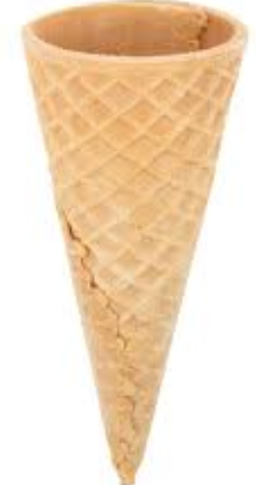

**Cereal in a box Beans in a can Ice-cream cone**

 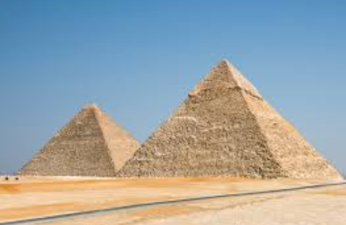

Soccer ball (sphere) The pyramids of Egypt

You may have seen a number of geometric objects or solids over the years. Can you name some of these solids?

**RDP houses: An example of Geometric solids in the environment**

Since 1994, the South African Government has build more than 2,68 million low cost or RDP houses (Housing delivery in SA: How have we fared? available from SAnews.gov.za)

Below is a section of a township in which low-cost or RDP houses have been built.

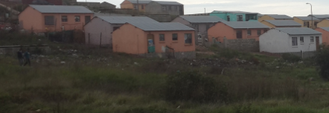

You would notice that the structure of each house is the same. Only the colour of the houses differ. We can draw an outline of the basic structure of the house:

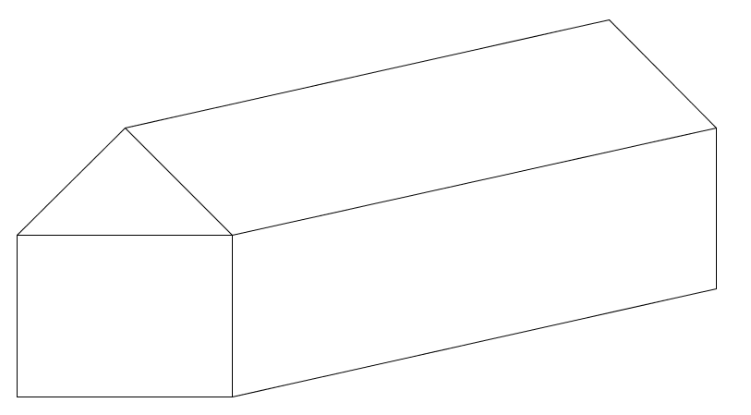

We note that this structure consists of two geometric solids:

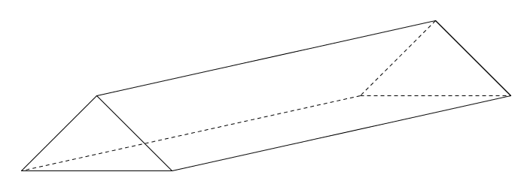 and

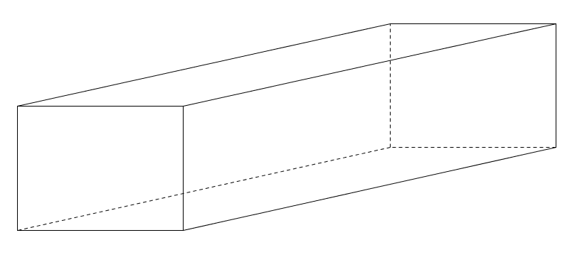

These geometric solids are 3D figures with surfaces that are polygons. In the first case the polygons are triangles and rectangles; in the second case the polygons are rectangles. These geometric solids are called polyhedrons. If we examine these polyhedrans further, we also note that these polyhedrons have faces which are congruent (alike in all respects).

**Volume** is the amount of space contained within an object.

The volume of a solid shape is the amount of space



that it occupies. It is measured by the number of unit

cubes needed to fill the space. For example, a cuboid

measuring 5cm by 3cm by 3cm can be filled by 45 unit

cubes (there are 3 layers each with 5x3 = 15 cubes). Each

unit cube has a volume of one cubic centimeter, so the

cuboid has a volume of 45 cm3

The surface area of any object or 3 dimensional structure (like a rectangular cardboard box) is the sum of areas of all the faces or surfaces that enclose the given object.

**Activity 1 Right Prisms**

**Introduction**

**A right prism**

A right prism is a polyhedron which comprises two congruent polygon faces, called bases which lie in parallel planes. The other faces, called lateral or side faces are rectangles.

Prisms are classified by the kind of polygons they have for bases.

**Examples of prisms**

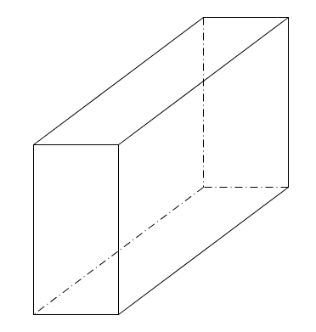 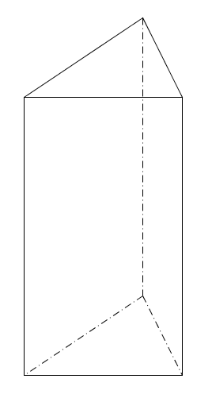 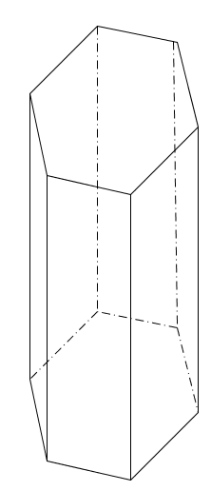

**Rectangular prism Triangular prism Hexagonal prism**

**Purpose:**

* Derive the formula to calculate the surface area (SA) of a prism and adapt it to calculate the SA of rectangular prisms, , triangular prisms and hexagonal prisms
* Derive the formula to calculate the volume (V) of a prism and adapt it to calculate the SA of rectangular prisms, , triangular prisms and hexagonal prisms

**Resources:** A pen or pencil, eraser, ruler, compass and paper

**Suggested time:** 60 minutes

**Task 1: Deriving formulae to calculate surface area and volume of rectangular prisms**

1. **Surface area of rectangular prisms**

The **surface area** of any 3D object (or solid) is the sum of the areas of all the faces or surfaces that enclose the object (or solid). The faces include the solid’s top and bottom (bases) and its remaining surfaces (lateral faces or surfaces)

Given a rectangular prism with length *l*; breadth *b* and height *h.*

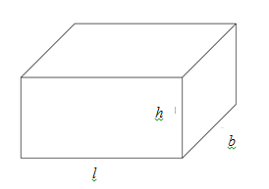

This rectangular prism consists of 3 pairs of congruent rectangles. A very simple way to work out the surface area is to consider the bases and lateral or side faces.

Total Surface Area = Area of the bases + Area of side faces

= 2 (*lb) +* 2 (*l + b*)*h*

= 2 *(lb* + *lh* + *bh*)

Now *lb* is the area of the base and 2 (*l + b*) is the perimeter of the base

We may, in general, state the formula as follows:

Surface area of rectangular prism = 2(Area of Base) + Perimeter of base $×$ height

1. **Volume of rectangular prisms**

To find the volume of a rectangular prism, we multiply the area of the base by the height. For the rectangular prism above, the volume is given by: V = *lbh*

Now the area of the base is *lb*

So we may, in general, state the volume of a rectangular prism as follows:

Volume of rectangular prism = (Area of Base) $×$ (height)

Both general formulas for surface area and volume will apply to any right prism and cylinders

**Cube**

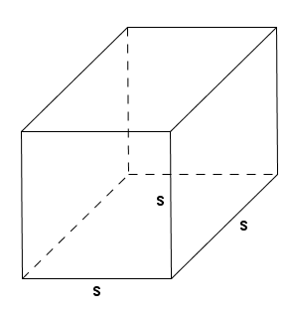

A rectangular prism in which L = B = H is called a cube.

If we let s = L = B = H then the surface area of the cube = 2(s2) + 4s(s) = 2s2 + 4s2 = 6s2

Volume of the cube = s s s = s3

**Examples:**

1. Calculate the surface area and volume of a rectangular prism with dimensions L = 20 cm; B = 8 cm and H = 7 cm

**Solution**

Surface area = 2 (LB + LH + BH)

= 2 [(20 cm) $×$ (8 cm) + (20 cm) $×$ (7 cm) + (8 cm) $×$ (7 cm)]

= 2 [160 cm2 + 140 cm2 + 56 cm2]

= 712 cm2

Volume = L B H = (20 cm) $×$ (8 cm) (7 cm) = 1120 cm3

1. The surface area of a cube is 121,5 cm2. Determine the side of the cube and then its volume

**Solution**

We know that the surface area of a cube with side s is 6s2

So 6s2 = 121,5 cm2

s2 = 20,25 cm2

So s = 4,5 cm

Volume of cube = (4,5 cm)3= 91,125 cm3

1. The base of the triangular prism below is a right angled- triangle. The sides of the triangle are 8 cm and 15 cm and the height of the triangular prism is 30 cm.

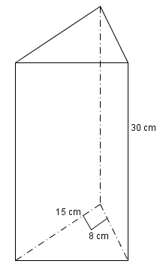

Determine (a) its surface area (b) volume

**Solution**

The base is a right-angled triangle.

Longest side of base = 

We now substitute in the correct formula:

Area of base = ½ (15 cm) (8 cm) = 60 cm2

Area of lateral surfaces = (8 cm)(30 cm) + (15 cm)(30 cm) + (17 cm)(30 cm)

= 240 cm2 + 450 cm2 + 510 cm2

= 1200 cm2

Surface area of triangular prism = 2 (Area of base) + Area of lateral surfaces

= 2 (60 cm2) + 1200 cm2

= 120 cm2 + 1200 cm2

= 1320 cm2

Volume of triangular prism = (Area of base) (height)

= (60 cm2 )(30 cm))

= 1800 cm3

**Guided reflection on Activity (Task 1)**

1. How do you calculate the surface area of any right prism?

Add area of bases to areas of faces

1. How do you calculate the volume of a right prism?

Multiply the area of the base of the prism by its height.

**Task 2: Calculating the surface area and volume of prisms**

NB: Round off your answers to two decimal places where appropriate

For questions 1 – 3 calculate the surface area and volume of the given prisms. Draw your own diagrams in each case)

1. A rectangular prism with length = 5 cm; breadth 4 cm; height = 8 cm
2. A cube with side 4,5 cm
3. A triangular prism, with a (3-4-5) right-angled triangle as base and height 8 cm
4. Given that the volume of a rectangular prism with length 7 cm and breadth 4 cm is 280 cm3. Determine its height and surface area
5. Calculate the surface area and volume of a square prism having its side length of its base equal to 5 cm and its height equal to 15 cm

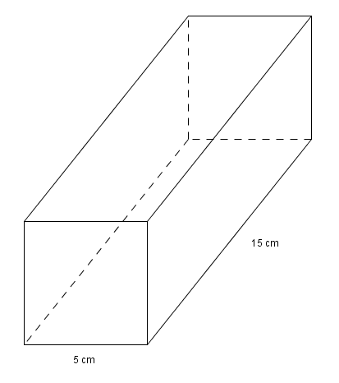

1. Given a triangular prism having an equilateral triangle of side 10 cm as base and the prism height equal to 75 cm.

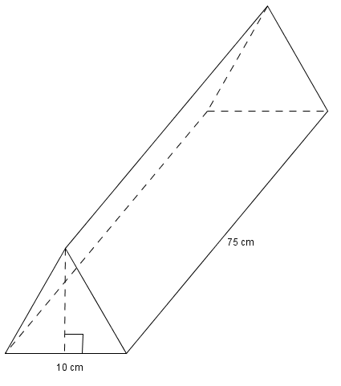

Calculate the volume and surface area of the triangular prism

1. A cube has a volume of 216 cm3. Determine the length of its edge (side) and its surface area
2. The volume of a triangular prism with height 70 cm and an equilateral triangle as a base is 7000 cm3. Determine the dimensions of the base.

#### Guided reflection on Activity (Task 2)

1. Use the answers given for Task 2 to check if your answers were correct.
2. Did you realize why you got some your answers incorrect?
3. Have you been able to correct errors you made?

**Answers to Task 2**

1. Volume = 160 cm3; Surface area = 184 cm2
2. Volume = 91,125 cm3; Surface area = 121,5 cm2
3. Volume = area of base $×$ height = ½ (3 cm)(4 cm) $×$ (8 cm) = 48 cm3; Surface area = sum of the area of all surfaces

= (2)(½) (3 cm)(4cm) + (8 cm)(3 cm) + (8 cm) (4 cm) + (8cm) (5 cm)

= 12 cm2 + 24 cm2 + 32 cm2 + 40 cm2

= 108 cm2

1. Height = 10 cm;

Surface area = 2[( 7 cm $×$ 10 cm) + ( 4 cm $×$ 10 cm) + [( 4 cm $×$ 7 cm)]

= 2[70 cm2 + 40 cm2 + 28 cm2]

= 276 cm2

1. Volume = 375 cm3; Surface area = 350 cm2
2. Height of base = $\sqrt{{10}^{2}-5^{2}}$ = $\sqrt{75}$ cm; area of base = ½ (10 cm)( $\sqrt{75}$ cm)=43,3 cm2

Surface area of prism = (2 43,3 cm2) + 750 cm2 + 750 cm2 +750 cm2 =2336,6 cm2

1. s3 = 216 cm3; s = 6 cm. Surface area = 6s2= 6(6 cm)2=216 cm2
2. Area of base = = 100 cm2

Let the side of the base be s; the height of the base = $\sqrt{s^{2}-{(\frac{1}{2}s)}^{2} }$ = $\frac{\sqrt{3}}{2}s$

Now ½ (s)($\frac{\sqrt{3}}{2}s)$ =100 So s2 = s = 15,196 cm. Each side of the base = 15,196 cm

**Activity 2 Cylinders**

**Introduction**

A cylinder is a solid that is similar to a prism because:

* It also has two identical bases that are parallel to each other
* It has a height

The only difference is that its sides are curved rather than straight. The bases are circles. If you give it a little thought, however, it should come as no surprise that the general formulae for surface area and volume which applies to prisms also apply to cylinder.

radius r

height h

**Purpose:**

* To derive the formula to calculate the surface area of a cylinder and apply it to calculate the surface area of a cylinder
* To derive the formula to calculate the volume (V) of a cylinder and apply it to calculate the a volume of a cylinder

**Resources:** A pen or pencil, eraser, ruler, compass and paper

**Suggested time:** 60 minutes

**Task 1: Deriving formulae to calculate surface area and volume of cylinder**

We notice that the net for the cylinder (below left) is made up of two circles (with the same radius r) and a rectangle. The length of this rectangle is $2πh$ and the breadth of the rectangle is h

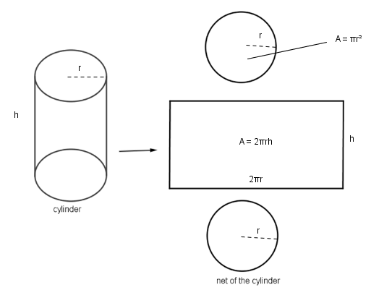

To determine the surface area of the cylinder, we work out the area of the **two** circles

(A = $2πr^{2}$) and the rectangle (A = $2πrh)$ and add these up.

The volume of the cylinder is calculated by multiplying the area of the base (A = $2πr^{2}$) with the height (*h*)

**Surface area and volume of cylinders**

Surface Area = 2(Area of base) + circumference of base $×$ height

Volume = Area of base $×$ height

We can also write these formulae as:

Surface Area = 

Volume = 

**Examples**

1. Calculate the surface area and volume of a cylinder with base diameter 5 cm and height 12 cm.

Radius = 2,5 cm

Surface Area = 

Volume = 

2. The volume of a cylinder with radius 10 cm is 5000 cm3. Determine the height of the cylinder.



**Task 2**

NB: Round off your answers to two decimal places where appropriate

For numbers 1 to 4 calculate the surface area and volumes of the cylinders with the given measurements. Draw your own diagrams in each case)

1. with radius r = 8 cm and height h = 200 mm
2. with radius r = 120 mm and height = 24 cm
3. with diameter d = 460 mm and height = 150 mm
4. with diameter d = 120 mm and height = 18 cm
5. (a) Calculate the radius of the cylinder with height = 30 cm and volume = 600 cm

(b) Now calculate the surface area of this cylinder

1. (a) Calculate the height of the cylinder with radius = 34 cm and surface area = 999 cm

(b) Hence, calculate the volume of this cylinder.

1. In the net of a cylinder, the radius of the base is 70 mm. If the height of the cylinder is 300 mm, what are the dimensions of the rectangle in the net?
2. The areas of the faces of a rectangular prism are 24 cm2, 32 cm2 and 48 cm2. Determine the volume of the prism.

#### Guided reflection on Activity 2

1. Can you explain how you calculated the radius of the cylinder in in Q5(a).

Considered the formula for volume of cylinder: V = .

Substituted 600 cm for V and 30cm for h in in the formula.

Then solved for *r* using the calculator.

1. Can you explain how you calculated the height of the cylinder in in Q6(a).

Considered the formula for Surface area of cylinder: SA = 

Substituted 999 cm for SA and 30cm for r in in the formula.

Then solved for *h* using the calculator.

1. How did you experience Q8?

**Answers to Task 2**

1. Surface area = 1407,84 cm2; Volume = 2136,9 cm3
2. Surface area = 2715,12 cm2; Volume = 10860,48 cm3
3. Surface area = 5491,50 cm2; Volume = 24928,54 cm3
4. Surface area = 904,78 cm2; Volume = 2035,75 cm3
5. (a) Radius = 2,523 cm (b) Surface area = 1454,64 cm2
6. (a) h = 17,487 cm (b) Volume = 63505,84 cm3
7. The length of the rectangle is 2 $π$ r = 2 $π$ (70 cm) = 140 $π$ cm = 439,823 cm

The breadth of the rectangle is the same as the height of the cylinder which is 300 mm**.**

1. Let the L, B and H respectively be the length, breadth and height of the rectangular prism

We can now write down the following statements:

LB = 48 (1)

LH = 32 (2)

BH = 24 (3)

1. $÷$ (2)



Substitute for B in (3)



H = 4 cm; B = 6 cm; L = 8 cm

Volume = (8 cm)(6 cm)(4 cm) = 192 cm3

**Summary Assessment**



1. Find the total surface area of the rectangular prism

with the given dimensions, correct to two decimal places.

1. Find the total surface area of the right triangular prism alongside.



3. A diameter of a base of a right cylinder is 16 cm long.

The height of the cylinder is 5cm.



Find the total surface area of the right cylinder, using $π=3,14$

**Solution:**

Since d = 16cm, r = 8cm

TSA = 2 $πr(r+h)$

= 2(3,14)(8*cm*) (8*cm* + 5*cm*)

= 653,12 *cm*3



1. Calculate the volume of the rectangular box,

which has the following dimensions:

length ($l)$ = 22mm, breadth( $b)$ = 13mm and height $(h)$ = 35mm.

1. Find the volume of a wooden block with the given dimensions



**Guided Reflection Activity**

1. Use the answers given for the Summary Assessment to check if your answers were correct.
2. Did you realize why you got some your answers incorrect in Summary Assessment?
3. Have you been able to correct errors you made?

**Answers to Summary Assessment**

1. From the figure, $l=20,3 cm$, $b=12,4 cm$ and $h=2, 75 cm$.

TSA = $2\left(2,75cm x 20,3cm +2,75cm x 12,4cm+20,3cm x 12,4cm\right)$

= 2(55,825 *cm*2 + 34,1*cm*2 + 251,72 *cm*2)

= 2(341,645 *cm*2)

= 683,29 *cm*2

TSA = 2 *x* area of base + perimeter of base x height of prism

= 2 *x* (½ x*4cm x 3cm*) + (4*cm* + 3*cm* + 5*cm*) *x* 8cm

= 12 *cm*2 + 96*cm*2

= 108 *cm*2

1. Since d = 16cm, r = 8cm

TSA = 2

= 2(3,14)(8*cm*) (8*cm* + 5*cm*)

= 653,12 *cm*3

1. = 22mm 13mm 35mm  
    = 10 010 mm3
2. *V* = area of the triangular base $x$ height of the triangular prism

=

=

= 24 *cm*3



1. A radius of a base of a right cylinder is 6cm long.

The height of the cylinder is 8cm. Find the volume of

the cylinder, using $π=\frac{22}{7}$, correct to two decimal places.

#### Unit Name: Surface area and volume of prisms and cylinders

#### Learning Outcomes

By the end of the unit, learners should be able to:

* Investigate the effect on volume and surface area of right prisms and cylinders, when one  
  or more dimensions are multiplied by a constant factor

#### Sub-Topic: Surface area and volume of geometric objects

**Activity 1 The effect of multiplying dimensions by a constant factor k in a prism**

**Purpose:**

* To Investigate the effect of multiplying dimensions by a constant factor k of a right prism on its volume and surface area

**Resources:** A pen or pencil, eraser, ruler, compass and paper

**Suggested time**: 60 minutes

**Examples:**

**Consider the following:**

1. The dimensions of a rectangular prism are length 10 cm; breadth 6 cm and height 5 cm. Explain the effect on the surface area if
2. The length is doubled

Surface area of **original** rectangular prism

= 2[ (10 cm) $×$ (6 cm) + (10 cm) $×$ (5 cm) + (6 cm ) $×$ (5 cm)]

= 2[60 cm2 + 50 cm2 + 30 cm2]

= 280 cm2

If the length is doubled we have

Surface area of new rectangular prism

= 2[(20 cm) $×$ (6 cm) + (20 cm) $×$ (5 cm) + (6 cm ) $×$ (5 cm)]

= 2[120 cm2 + 100 cm2 + 30 cm2]

= 500 cm2

*We note that when only one dimension is doubled, in this case the length, the areas of the surfaces containing the length are doubled but not the surface area of the entire rectangular prism.*

(b) All dimensions are doubled

If all dimensions are doubled we have:

Surface area of new rectangular prism

= 2[(20 cm) $×$ (12 cm) + (20 cm) $×$ (10 cm) + (12 cm ) $×$ (10 cm)]

= 2[240 cm2 + 200 cm2 + 120 cm2]

= 560 cm2

*We note that when all the dimensions are doubled, the surface area is area is increased by a factor of 4 (or quadrupled).*

1. What would happen to the surface area of this prism if **all** the dimensions are
2. tripled
3. halved?

**Solution**

You may verify these calculations by substituting suitable values in the surface area formula.

1. If all the dimensions are tripled (or multiplied by 3), the surface are increases by a factor of 32 (or 9)
2. If all the dimensions are halved (or multiplied by ½ ) the surface area decreases by a factor of 4 or the surface area is multiplied by ( ½)2 = ¼
3. The dimensions of a rectangular prism are length 10 cm; breadth 6 cm and height 5 cm. Explain the effect on the volume of the prism if
4. The length is doubled

Original volume = 10 cm $×$ 6 cm $×$ 5 cm = 300 cm3

New volume = 20 cm 6 cm 5 cm = 600 cm3

The volume is doubled

1. Both the length and breadth are doubled

Original volume = 10 cm $×$ 6 cm $×$ 5 cm = 300 cm3

New volume = 20 cm $×$ 12 cm 5 cm = 1200 cm3

The volume is quadrupled (multiplied by 4)

1. All the dimensions are doubled

Original volume = 10 cm $×$ 6 cm $×$ 5 cm = 300 cm3

New volume = 20 cm $×$ 12 cm 10 cm = 2400 cm3

The volume is multiplied by 8

We note that volume of a rectangular prism is affected as follows when dimensions are doubled:

1. When one dimension is doubled, the volume is doubled, that is, ( $×$ 2)
2. When two dimensions are doubled, the volume is multiplied by 4, that is, (2 $×$ 2)
3. When three dimensions are doubled, the volume is multiplied by 8, that is, ( $2 ×$ 2 $×$ 2)

What would happen to the volume of this prism if all the dimensions are

1. tripled
2. halved?

**Solution**

You may verify these calculations by substituting suitable values in the volume formula”

1. If all the dimensions are tripled (or multiplied by 3), the volume increases by a factor of 33 (3 3 3 ) or 27.
2. If all the dimensions are halved (or multiplied by ½ ) the volume decreases by a factor of 8 or the volume is multiplied by ( ½ )3  ( ½ ½ ½ ) or .

In general, if the surface area of a rectangular prism = A and the volume = V then if we multiply any dimension in this rectangular prism by a constant factor **k** then we have the following:

**Table 2**

|  |  |  |
| --- | --- | --- |
| **Scale factor** | **New surface area** | **New volume** |
| One dimension multiplied by k | Surface area of prism containing the dimension is multiplied by k | $k×$ V |
| Two dimensions each multiplied by k | Surface area of prism containing both dimensions is multiplied by k2; the other surface areas are multiplied by k | k2V |
| Al three dimensions multiplied by k | k3 A | k3V |

**Task 1: The effect of multiplying dimensions by a constant factor k of a right prism on its volume and surface area**

Round off your answers to two decimal places where appropriate

1. Calculate the surface area and volume of a rectangular prism having length = 7cm , breadth = 3cm and height = 5 cm. Explain what would happen to the volume if all dimensions in this prism were doubled

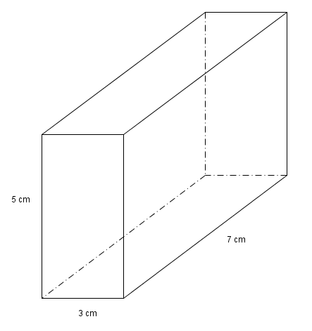

1. Given a triangular prism having a right-angled triangle as base and with the two right-angles sides of the base equal to 5cm and 12cm respectively. The height of the prism is 20 cm.

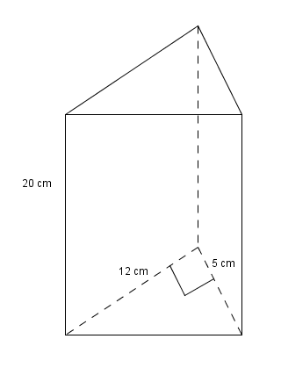

1. Calculate the hypotenuse of the base
2. Calculate the surface area of the prism
3. Calculate the volume of the prism
4. Explain what would happen to the volume of this triangular prism if the height was doubled.
5. Given a cube of side 16 cm

16 cm

What would happen to the volume of the cube if the side was halved?

1. The breadth and height of a rectangular prism remain the same while the length is quadrupled (multiplied by 4). How does this change of length affect the volume of the rectangular prism?
2. The length, breadth and the height of a rectangular prism are each multiplied by ¼ . How do these changes in dimensions affect
3. the surface area?
4. The volume

#### Guided reflection on Activity 1

1. Use the answers given for the Task 1 to check if your answers were correct.
2. Did you realize why you got some your answers incorrect?
3. Have you been able to correct errors you made?

**Answers to Task 1**

1. Volume is multiplied by 8
2. (a) hypotenuse = 13 cm (b) Surface area = 660 cm2 (c) Volume = 600 cm3 (d) volume will be doubled
3. The new volume will be $\frac{1}{8}$ the original volume
4. Let the length be L; breadth be B and the height be H

So original volume = LBH

Now the length is 4L

So new volume = (4L)(B)(H) = 4 LBH

We note that the new volume is quadrupled, that is, multiplied by 4

1. Let the length be L; breadth be B and the height be H

So original surface area = 2 (LB + LH + BH) and original volume = LBH

Now the length is ¼ L; breadth is ¼ B and the height is ¼ H

1. New surface area



The new surface area is one-sixteenth the area of original surface area

So new volume = (L)(B)(H) = 4 LBH



We note that the new volume is one-sixty-fourth the original volume

**Activity 2: The effect of multiplying dimensions by a constant factor k in a cylinder**

**Purpose:** To Investigate the effect of multiplying dimensions by a constant factor k of a right cylinder on its volume and surface area

**Resources:** A pen or pencil, eraser, ruler, compass and paper

**Suggested time:** 60 minutes

**Examples:**

We know that: Surface area of a cylinder = 

1. What will happen to the surface area if we

1. double the radius ? (b) double both the radius and the height ?

**Solution**

1. If we **double** the **radius** then the

New surface area



*We note that when the radius is doubled, the surface area of its bases are quadrupled (multiplied by 4) while the area of curved surface is doubled.*

1. If we **double** both the **radius** and the **height** then the

New surface area



*We note that when both the radius and the height are doubled, the surface area is (2)2 = 4 times the original surface area*

Recall that the volume of a cylinder with radius r and height h is given by V = 

1. What will happen to the volume if we
2. double the radius ? (b) double both the radius and the height ?

**Solution**

1. New volume



*We note that when the radius of the cylinder is doubled, the volume is multiplied by 4*.

1. New volume



*We note that when both the radius and the height of the cylinder are doubled, the volume is multiplied by 8*.

In general, suppose the surface area of a cylinder = A and the volume = V, then if we multiply any dimension in the cylinder by a constant factor **k** then we have the following:

**Table 3**

|  |  |  |
| --- | --- | --- |
| **Scale factor** | **New surface area** | **New volume** |
| The radius is multiplied by k | The surface area of the bases are multiplied by k2 while the area of the curved surface is multiplied by k | k2V |
| The height is multiplied by k | The surface area of the bases remain the same while the area of the curved surface is multiplied by k | kV |
| Both the radius and the height multiplied by k | k2A | k3V |

**Task 2: The effect of multiplying dimensions by a constant factor k in a cylinder**

1. Consider a cylinder with a radius of 14cm and height 40cm
   1. Calculate the volume and the total external area of the cylinder.
   2. What will be the surface area of the cylinder be if all its dimensions are doubled.
   3. What will the volume of the cylinder be if its height is doubled?

1. The radius of a cylinder is 50 mm and its height is 150 mm. Explain what would happen to the surface area and volume if both dimensions are halved.

#### Guided reflection on Activity 2

Why when you double all the dimensions of cylinder, the surface area increases 4 times?

Consider the formula for the surface area of a cylinder, $SA= 2 πr^{2}+2πrh$.

When r is doubled in $2 πr^{2}$, then you get $2 π{(2r)}^{2}=8 πr^{2}$

$When r and h is doubled in 2πrh$, then you get $2π(2r)(2h)$ = $8πrh$

Now, you get a new Surface area = $8 πr^{2}$ + $8πrh$ = 4x $[2 πr^{2}+2πrh]$

This means that when you double all the dimensions of cylinder, the surface area increases 4 times?

**Answers to Task 2**

1. 1.1

* 1. All dimensions are multiplied by a factor of 2. Doubling all dimensions will increase the

area by a factor of .

=

* 1. Height is multiplied by a factor 2. Increasing the length by a factor of 2 will increase the

volume by a factor of 2.

$∴Volume=2 ×24 630,09{ cm}^{3}$

$= 49 260,17{ cm}^{3}$

1. Without working through the problem and using table 3, we may say that the surface area is divided by 4 and the volume is divided by 8.

#### Summary Assessment Task

Round off your answers to two decimal places where appropriate

1. The volume of a cube is 343 cm. Calculate its edge.
2. The cross-section of a teak beam is a square with an edge of 20 cm. The beam is 6 m long. Find the volume of the teak beam volume in m.

X Y

You are given 2 cylinders X and Y with the radius of X double that of Y. Both cylinders have the same height. Calculate the ratio volume X : volume Y.

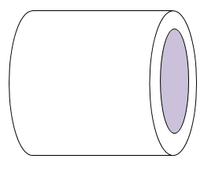

A woodwork machine cuts out a cylindrical block of wood with length 60 cm and radius 30 cm from an even bigger cylindrical block of radius 40 cm. Calculate the volume of the remaining cylindrical part.

1. A rectangular piece of cloth can be rolled into a cylinder in two different directions. If there is no overlapping which cylinder has the greater volume, the one with the long side of the rectangle as its height or the one with the short side of the rectangle as its height or will the volume be the same?

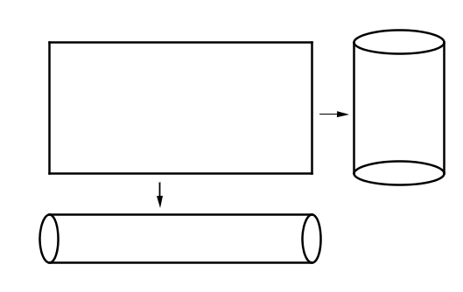

X Y

You are given 2 cylinders X and Y with the radius of X double that of Y. Both cylinders have the same height. Calculate the ratio volume X : volume Y.

#### Guided reflection on Summary Assessment Task

1. Use the answers given for the Task 1 to check if your answers were correct.
2. Did you realize why you got some your answers incorrect?
3. Have you been able to correct errors you made?

**Solutions to Summary Assessment Task**

* + - 1. Its edge (side) is 7 cm
      2. Volume = 0,24 m3

=

4. Volume = = 42000 cm3 = 131946,89 cm3

5. Let the length be L and the breadth be B

**First case (the length becomes the circumference)**

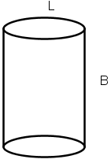

Now 2 $π$ r = L So r = $\frac{L}{2π}$

Volume = ()2B =

**Second case (the breadth becomes the circumference)**

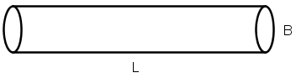

Now 2 $π$ r = B So r = $\frac{B}{2π}$

Volume = ()2L =

Since L > B we have $\frac{L^{2}B}{4π}$ > $\frac{B^{2}L}{4π}$

The volume is greater in the first case