NASCA Mathematics Materials Draft 1

## Topic 3: Measurement, Euclidean Geometry, Analytical Geometry and Trigonometry

## Trigonometry

**Unit 1: Basic trigonometric ratios in a right angled triangle**

**Introduction**

Trigonometry is an important part of mathematics study in grades 10 – 12. The basic building block of trigonometry is the right-angled triangle

#### Learning Outcomes

By the end of the unit, learners should be able to:

* Define the various trigonometric ratios using a right-angled triangle
* Apply the definitions of basic trigonometric ratios to calculate ***sin θ*, *cos θ* and *tan θ*** when given dimensions of a right angled triangle
* Use a calculator to find angles, given the trigonometric ratio

.

Let us examine the various ratios in a right-angled triangle

**Activity 1: Definition of trigonometric ratios**

**Purpose**:

* Define the various trigonometric ratios, using a right-angle triangle
* Calculate the various trigonometric ratios in a right angled triangle
* Use a calculator to find the angle, given the trigonometric ratio

Trigonometric ratios can be defined in terms of the sides of a right-angled triangle.

**Resources:** A pen or pencil, eraser, ruler, compass and paper

**Suggested time:** 60 minutes

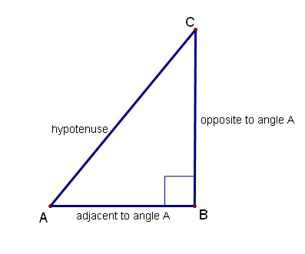



**Example 1**

Given: ∆ABC, which is right-angled at B, with AB = 4 cm and BC = 3 cm. Determine the length of AC and the ratios sin C and tan A

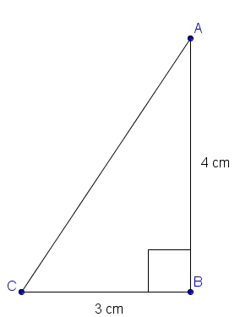

**Solution**



**Example 2**

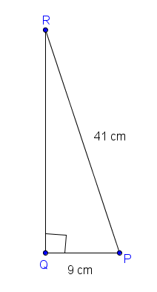

Given ∆PQR which is right-angled at Q with PQ = 9 cm; PR = 41 cm. Determine the length of RQ and the size of angle P.



**Task 1**

1. You are given a right-angled triangle ABC with AB = 7 cm; BC = 24 cm and . Determine the value of:
   1. sin A
   2. cos A
   3. tan A
   4. cos C
2. If  then determine 
3. .

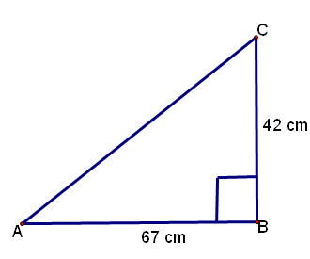

In the above right-angled triangle AB = 67 cm and BC = 42 cm. Determine the size of angle A in the above diagram:

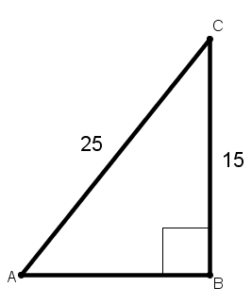

In the above right-angled triangle, BC = 15 units and AC = 25 units. Determine the size of angle C, using a calculator

**Guided reflection on Activity 1**

If ,, then explain how you will determine $\tan{A}$.

We know that sin is positive in the first and second quadrant. Since we are only working in the first quadrant. So I will draw a right angled $∆ABC$, with $\hat{B}=90°$. I will then insert 12 on the side opposite $\hat{A}$ and 15 on the hypotenuse.

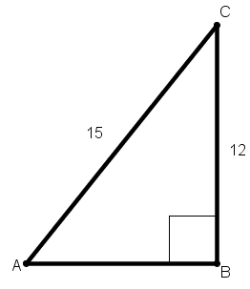

I will then use Pythagoras to calculate the length of the adjacent side, AB. This will then give me AB = 9 units

To calculate $\tan{A}$, I will use the definition: $\tan{A}$ = $\frac{opposite}{Adjacent}$ = $\frac{12}{9}$ = $\frac{4}{3}$

**Answers to Task 1**

**1.**

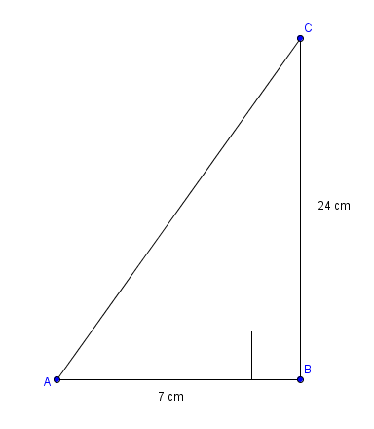

When we look at the above diagram, we note that we have two sides of the triangle. To find the third side (AC), we use the theorem of Pythagoras. In this case, the third side is the hypotenuse (the longest side).

How do we know this? The hypotenuse is always opposite the right angle triangle.

Now let us find AC

We have AC2 = AC2 + BC2 (theorem of Pythagoras)

= (7)2 + (24)2 (you may leave out the units in the calculation)

= 49 + 576

= 625

AC = = 25 cm

We can now answer the four questions:

* 1. sin A = 
  2. cos A = 
  3. tan A = 

In 1.4, the reference angle is angle C. So to find cos C, we look at the adjacent side to angle C which is BC (which is 24 cm). Of course the hypotenuse does not change!

Thus, cos C = 

1. .If  then determine 

We know that sin is positive in the first and second quadrant. Since we are only working in the first quadrant.



The adjacent side is AB.

Now using the theorem of Pythagoras, we have:



We are now in a position to answer our questions. This just involves substitution into the formulas:

Thus,



.

We can also use trigonometric ratios to find angles

1. ..



In the above right-angled triangle AB = 67 cm and BC = 42 cm. Determine the size of angle A in the above diagram:

Using the reference angle A, we note that AB = 67 cm is the adjacent side and BC = 42 cm is the opposite side. We can use the tan definition and our calculator to determine angle A.



4.



In the above right-angled triangle, BC = 15 units and AC = 25 units. Determine the size of angle C, using a calculator

Using the reference angle C, we note that BC = 15 units is the adjacent side and AC = 25 is the hypotenuse. We can use the tan definition and our calculator to determine angle A.



**Summary Assessment**





#### Guided reflection on Summary Assessment

|  |
| --- |
| 1. Use the answers given for the summary assessment to check if your answers were correct. 2. Did you realize why you got some your answers incorrect? 3. Write down the errors you made. 4. Have you been able to correct errors you made? |

**Answers for Summary Assessment**





**Unit 2: Basic trigonometric ratios for the extended domain**

**Introduction**

We have defined our three basic trigonometric ratios (sin; cos; tan) in a right- angled triangle. In this regard, the domain used was 00   900

#### Learning Outcomes

By the end of the unit, learners should be able to:

* Define the various trigonometric ratios for 00 ≤ θ ≤ 3600
* Use diagrams to determine the numerical values of trigonometric ratios in the extended domain 00 ≤ θ ≤ 3600

We will now define our trigonometric ratios in the extended domain for 00 ≤ θ ≤ 3600

**Activity 1: Definition of trigonometric ratios in the extended domain**

**Purpose**:

* Define the various trigonometric ratios, in the four quadrants
* Determine the numerical values of trigonometric ratios in the extended domain

Trigonometric ratios can be defined in terms of the sides of a right-angled triangle.

**Resources:** A pen or pencil, eraser, ruler, compass and paper

**Suggested time**: 60 minutes

Trigonometric ratios can also be defined in terms of the coordinates of a point on a circle and the radius of the circle on the Cartesian plane. We can draw a right-angled triangle as seen in the diagram below. The radius of the circle is the hypotenuse of the right-angled triangle.

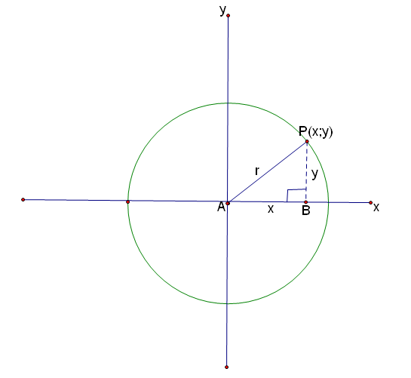

The definition of the trigonometric ratios are now in terms of x, y and r. So we have our ratios, using A as our reference angle as:



The trigonometric ratios sine, cosine and tangent of an angle remains the same if the angle remains the same, no matter how long the sides of the triangle are.

However, the signs change in the different quadrants. The diagram below gives an indication of the signs of the ratios in the various quadrants:

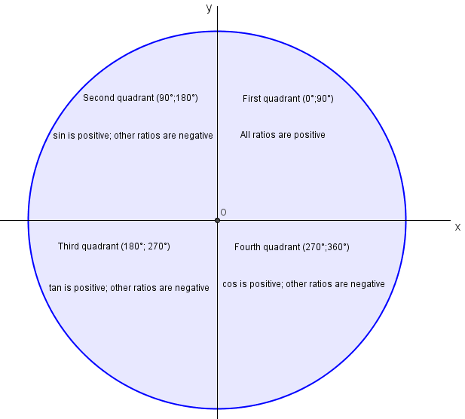

**Example 1**

1. If  then determine 

We note that A is in the second or third quadrant. But sin A is negative in the third quadrant so we draw our diagram in the third quadrant

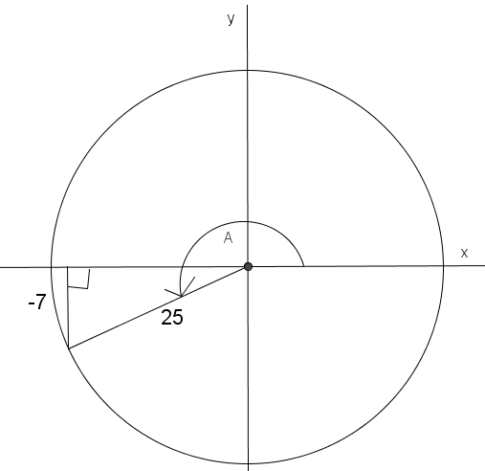



**Task 1**

1. If  then determine 
2. If  then determine 
3. If then determine 
4.  determine

4.1 

4.2 

4.3 

4.4 

#### Guided reflection on Activity 1

|  |
| --- |
| , can you explain in which quadrant $θ$ lies.  Since , we are working in the second, third or fourth quadrant. However, $\tan{θ }$ is negative in the second and fourth quadrant but positive in the third quadrant. So $θ$ lies in the third quadrant. |

**Answers to task 1**

1. We know that sin is positive in the first and second quadrant. Since we are only working in the first quadrant.

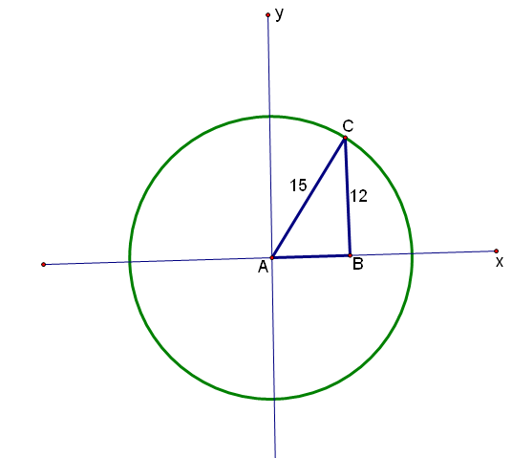

The adjacent side is AB.

Now using the theorem of Pythagoras, we have:



We are now in a position to answer our questions. This just involves substitution into the formulas:

Thus,



1. Since, we are working in the first two quadrants. But cosine is negative in the second quadrant, so our diagram is drawn in the second quadrant. Please note the signs indicated in the triangle.

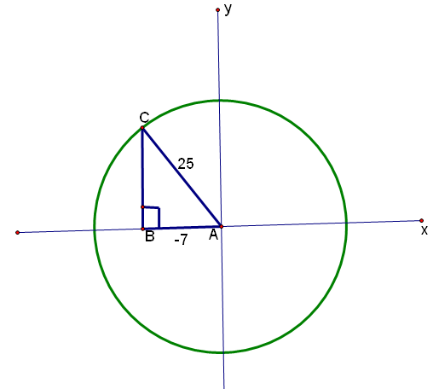

Since AB is moving to the left, we write AB = -7 in the diagram. Please note that the (-) is just used to direction, and not the actual magnitude of AB.

We use the theorem of Pythagoras as follows:



We are now in a position to work out sin A and tan A.



1. Since , we are working in the third and fourth quadrant. However, tan is negative in the fourth quadrant so the diagram is drawn in the fourth quadrant. Note the signs in the triangle.

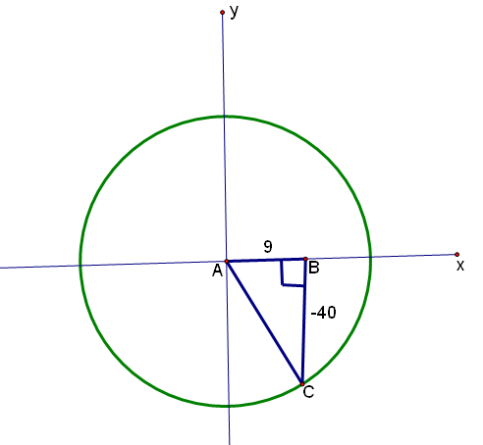



After find AC (the hypotenuse), we just substitute in our definitions for the sine and cosine ratios



**Note**: The negative signs in the diagram are used to show direction. To the left and down are denoted by a negative sign; up and to the right are positive.

1. Since , we are working in the second, third or fourth quadrant. However, tan is negative in the second and fourth quadrant so the diagram is drawn in the third quadrant (where tan is positive). Note the signs in the triangle.

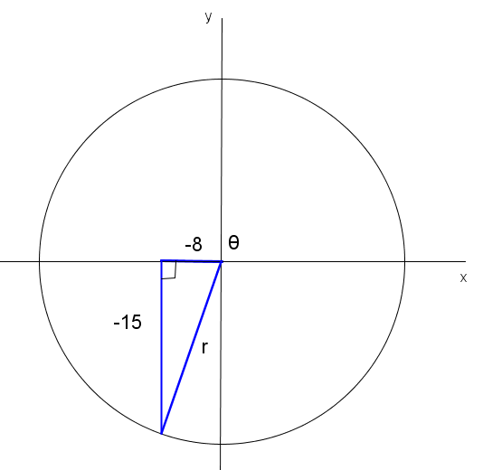

So we need to calculate our hypotenuse r:



We can now answer our questions. In 4.1 and 4.2 it is simple substitution.

4.1 

4.2 

In 4.3 we just substitute our values from 4.1 and 4.2 and do the necessary calculations:

4.3



4.4



**Summary Assessment**





#### Guided reflection on Summary Assessment

|  |
| --- |
| 1. Use the answers given for the summary assessment to check if your answers were correct. 2. Did you realize why you got some your answers incorrect? 3. Write down the errors you made. 4. Have you been able to correct errors you made? |

**Answers to summary assessment**

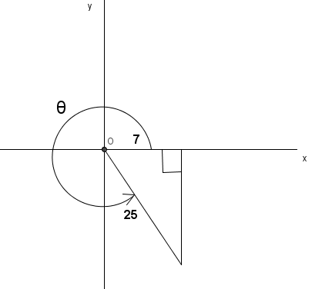





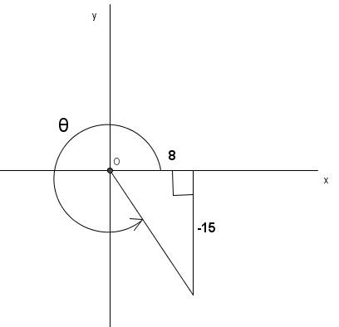



**Unit 3: Trigonometric ratios for Special angles**

#### Learning Outcomes

By the end of the unit, learners should be able to:

* Define the trigonometric ratios for $0° 30°$; $45°;60°$; $90°$
* Extend the trigonometric ratios for $30°$; $45°;60°$ to the second, third and fourth quadrants.
* Use the special angle values to simplify trigonometric expressions

**Activity 1: Trigonometric ratios for 30 $°$** **and 60 $°$**

**Purpose**:

* Establish the trigonometric ratios for $30°$ and $60°$
* Apply special angle values (without using a calculator) to determine the value of a trigonometric ratio

Trigonometric ratios can be defined in terms of the sides of a right-angled triangle.

**Resources:** A pen or pencil, eraser, ruler, compass and paper

**Suggested time**: 30 minutes

Use your calculator to determine the value of . We note that 

We know that in a right angled triangle, using θ as the reference angle that



Thus, for  our side opposite the reference angle of is 1 and our hypotenuse is 2. This can be seen in the diagram that follows:

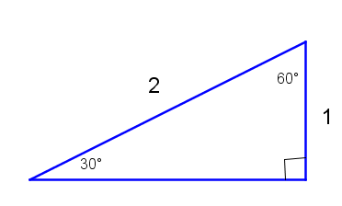

We can use the theorem of Pythagoras to calculate the side adjacent to the 30 degree angle:



We now redraw the above diagram with the measurement of the adjacent side included



Now write down the ratios for  (using your definitions for trigonometric ratios in a right angle triangle)

You should get the following:



Now make the 60 degree angle your reference angle. Now write down the ratios for  (using your definitions for trigonometric ratios in a right angle triangle. You could work directly from the given triangle or you could redraw the diagram as shown below:

 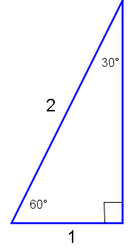

You should get the following ratios:



**Activity 2: Trigonometric ratios for 45 $°$**

**Purpose**:

* Establish the trigonometric ratios for 45 $°$
* Apply special angle values (without using a calculator) to determine the value of a trigonometric ratio

**Resources:** A pen or pencil, eraser, ruler, compass and paper

**Suggested time**: 30 minutes

Use your calculator to determine the value of 

We note the following:



We can draw our right angled-triangle with the adjacent and opposite sides each equal to one unit.

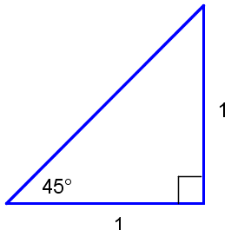

Can you work out the hypotenuse in the above diagram?

Of course, we use the theorem of Pythagoras

(Hypotenuse)2 = (1)2 + (1)2 = 1 + 1 = 2

Thus, hypotenuse = 

Now work out the values for



You should get the following:



**Activity 3: Trigonometric ratios for 0 $°$** **and** **90 $°$**

**Purpose**:

* Establish the trigonometric ratios for 0 $°$ and 90 $°$
* Apply special angle values (without using a calculator) to determine the value of a trigonometric ratio

**Resources:** A pen or pencil, eraser, ruler, compass and paper

**Suggested time**: 30 minutes

We use the unit circle to determine the special trigonometric ratios for 



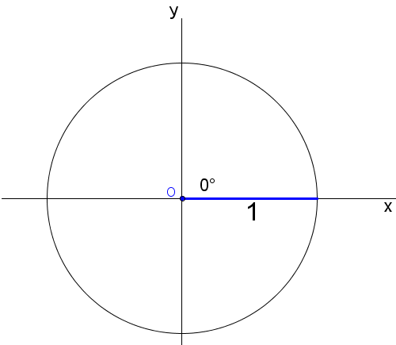

In the above unit circle, x = 1, y = 0 and r = 1. Using the definitions of the basic trigonometric ratios we get the following:





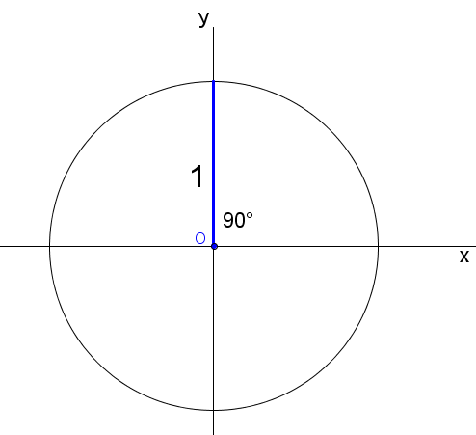

In the above unit circle, x = 0, y = 1 and r = 1. Using the definitions of the basic trigonometric ratios we get the following:



**Activity 4: Extending special trigonometric ratios to the second, third and fourth quadrants**

**Purpose**:

* Extend the special trigonometric ratios to the second, third and fourth quadrants.

**Resources:** A pen or pencil, eraser, ruler, compass and paper

**Suggested time**: 60 minutes

We have worked, thus far, with . In other words, we have worked in the first quadrant. We can extend these to the second, third and fourth quadrant.

We have seen earlier in unit 2 that if θ is our reference angle, we can write any angle in the second, third and fourth quadrants in terms of θ

**Second quadrant: **

If  is our reference angle then the angle in the second quadrant is 

Thus, 

**Third quadrant: **

If  is our reference angle then the angle in the second quadrant is 

Thus, 

**Fourth quadrant: **

If  is our reference angle then the angle in the second quadrant is 

Thus, 

**Examples**





**Task 1**

Without using your calculator, simplify the following:

1. 
2. 
3. 

**Answers to Task 1**







**Task 2**

Study activity 4 and then complete the table below, without using a calculator:

|  |  |  |  |  |  |  |  |  |  |  |  |  |
| --- | --- | --- | --- | --- | --- | --- | --- | --- | --- | --- | --- | --- |
|  |  |  |  |  |  |  |  |  |  |  |  |  |
|  |  |  |  |  |  |  |  |  |  |  |  |  |
|  |  |  |  |  |  |  |  |  |  |  |  |  |
|  |  |  |  |  |  |  |  |  |  |  |  |  |

**Answers to task 2**

|  |  |  |  |  |  |  |  |  |  |  |  |  |
| --- | --- | --- | --- | --- | --- | --- | --- | --- | --- | --- | --- | --- |
|  |  |  |  |  |  |  |  |  |  |  |  |  |
|  |  |  |  |  |  |  |  |  |  |  |  |  |
|  |  |  |  |  |  |  |  |  |  |  |  |  |
|  |  |  |  |  |  |  |  | Not defined |  |  |  |  |

Example

Simplify without using a calculator:



Solution



**Task 3**

Without using your calculator, simplify the following:

1. 
2. 

**Answers to task 3**





**Summary Assessment**

**Simply the following without a calculator:**





#### Guided reflection on Summary Assessment

|  |
| --- |
| 1. Use the answers given for the summary assessment to check if your answers were correct. 2. Did you realize why you got some your answers incorrect? 3. Write down the errors you made. 4. Have you been able to correct errors you made? |

**Answers to Summary Assessment**





**Unit 4: Applying Trigonometric ratios for Special angles to solve simple trigonometric equations**

#### Learning Outcomes

By the end of the unit, learners should be able to:

* Use the special angle values to solve simple trigonometric equations

**Activity 1: Simple trigonometric equations**

**Purpose**:

* Solve simple trigonometric equations (without the use of a calculator)

**Resources:** A pen or pencil, eraser, ruler, compass and paper

**Suggested time**: 45 minutes

In this activity we will work solve simple trigonometric equations, without the use of a calculator. In this regard, we should know our special angle ratios and the signs of the ratios in the four quadrants.

**Examples**

Solve the following equations for *θ* where 

1. 
2. 
3. 

To solve these equations we express each equation with the trigonometric ratio as the subject:







**Task 1**

Solve the following equations for *θ* where 

1. 
2. 
3. 

#### Guided reflection on Activity 1

|  |
| --- |
| 1. When is negative the in which quadrants does $θ$ lie in?   Second and fourth quadrants.   1. How will you find $θ$ if $tan θ$ = $-\frac{1}{\sqrt{3}}$?   I will first find the reference angle. This will be done by finding out for which value of $θ$ in the first quadrant (i.e. between 0 $° and 90°$) gives $tan θ$ = $\frac{1}{\sqrt{3}}$ Using special angles I will then get $30°$.  Since $tan θ$ is negative in the second and fourth quadrants, I will use the reduction formulae: $180°-θ$ or $360°-θ$ to obtain $θ=180°-30°=150° or θ=360°-30°=330°$ |

**Answers to Task 1**







**Summary Assessment**

Solve the following equations for *θ* where 

1. 
2. 
3. 

#### Guided reflection on Summary Assessment

|  |
| --- |
| 1. Use the answers given for the summary assessment to check if your answers were correct. 2. Did you realize why you got some your answers incorrect? 3. Write down the errors you made. 4. Have you been able to correct errors you made? |

**Answers to summary assessment**







**Unit 5: Development and use of trigonometric Identities**

#### Learning Outcomes

By the end of the unit, learners should be able to:

* Prove simple trigonometric identities

**Activity 1: Simple trigonometric identities**

**Purpose**:

* Prove simple trigonometric identities

**Resources:** A pen or pencil, eraser, ruler, compass and paper

**Suggested time**: 45 minutes

We draw our right- angled triangle in the first quadrant

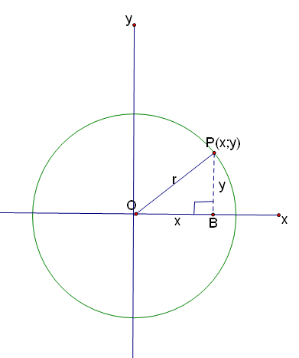



We know from the above diagram that:



Thus:



Also:



The above are called Pythagorean Identities

**Examples:**



In this example we work with the left hand side (LHS) as the right hand side (RHS) is already in simplified form







**Task 1**

**Prove the following identities:**





#### Guided reflection on Activity 1

|  |
| --- |
| 1. Rebeca says $\sin^{2}A+ \cos^{2}A=1$ and Victor says $1- \cos^{2}A=\sin^{2}A$.   Who is correct?  Both are correct   1. Simplify $cosA \left(1+cosA\right)+sinAsinA$  = $cosA+\cos^{2}A+\sin^{2}A$ = $cosA++1$ |

**Answers to task 1**





**Summary Assessment**

Prove the following identities







#### Guided reflection on Summary Assessment

|  |
| --- |
| 1. Use the answers given for the summary assessment to check if your answers were correct. 2. Did you realize why you got some your answers incorrect? 3. Write down the errors you made. 4. Have you been able to correct errors you made? |

**Answers for summary assessment**







**Unit 6: Basic Trigonometric Graphs**

**Learning Outcome**

By the end of this unit, learners should be able to draw and discuss the properties of various trigonometric graphs

**Activity 1: The sine function**

**Purpose**

* Draw the graphs of $y=asinx$
* Discuss the domain of $y=asinx$
* Determine the range and amplitude of $y=asinx$

**Resources:** A pen or pencil, eraser, ruler, compass and graph paper, calculator

**Suggested time:** 45 minutes

We have studied the three key trigonometric ratios in units 1 and 2. We now study the graphs of $y=\sin{x, y=\cos{x}}$ and $y=\tan{x}$. These graphs are now considered in the context of functions. The graphs represent **functions** as every element of the domain is associated with only one of the range

Note that the domain of trigonometric functions is made up of angles.

**Example 1**

Complete the table below by entering the function values for the given angles:

|  |  |  |  |  |  |
| --- | --- | --- | --- | --- | --- |
| ***x*** | **0 $°$** | **90 $°$** | **180 $°$** | **270 $°$** | **360 $°$** |
| $$\sin{x}$$ |  |  |  |  |  |
| $$3\sin{x}$$ |  |  |  |  |  |
| $$-2\sin{x}$$ |  |  |  |  |  |

The table provides the coordinates of turning points and intercepts of the graphs of :

$f\left(x\right)=\sin{x}$

*g $\left(x\right)=3\sin{x}$*

$h\left(x\right)=-2\sin{x}$

These points are plotted below and the graphs drawn.

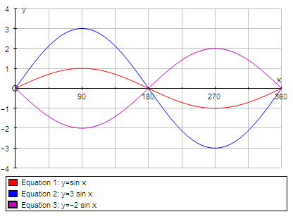

*h*

*f*

*g*

The domain of all three functions is $0°≤x≤360°$. This can also be written in interval notation as $[0° ;360°]$

The range of *f* is $-1≤y≤1$; the range of *g* is $-3≤y≤3$; the range of $h$ is $-2≤y≤2$

The distance between the middle *y*-value and the maximum *y*-value is called the **amplitude** of the graph. The amplitude of $f$ is 1; the amplitude of *g* is 3; the amplitude of $h$ is 2.

The length of the interval needed for a complete cycle of the graph is called the **period** of the graph. The period of the graphs in the diagram is 360 $°$ in each case.

**Task 1**

1. Use the table below to determine the coordinates of intercepts and turning points of $y=-\sin{x}$

|  |  |  |  |  |  |
| --- | --- | --- | --- | --- | --- |
| $$x$$ | **0 $°$** | **90 $°$** | **180 $°$** | **270 $°$** | **360 $°$** |
| $$-sin{x}$$ |  |  |  |  |  |

We use our calculator or special angles to complete the table:

|  |  |  |  |  |  |
| --- | --- | --- | --- | --- | --- |
| $$x$$ | **0 $°$** | **90 $°$** | **180 $°$** | **270 $°$** | **360** |
|  | **0** | **-1** | **0** | **1** | **0** |

2. On the same set of axes and for the domain [0 $°$; 180 $°$] sketch graphs

of and *g*

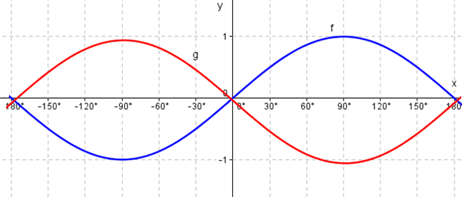

3. Use the graphs (in 2 above ) to answer the following questions:

3.1 Determine the values of  *x* for which *f*(*x*) = *g*(*x*)

*f*(*x*) = *g*(*x*) occurs where the two graphs intersect; we only write down the x values:



3.2 Determine the maximum value of *f*(*x*) $-$*g*(*x*)

This occurs at 

3.3 What is the range of *f* (*x*) if $x∈[0° ;180°]$?



3.4 What is the range of *g*(*x*) if ?



4. Explain why *f* and *g* represent functions.

For each x value, there is only one y-value . Hence, both are functions. The correspondence is many-to-one

#### Guided reflection on Activity 1

|  |
| --- |
| Explain you determine the values of  *x* for which *f*(*x*) = *g*(*x*)  Find the points where the graphs of $f\left(x\right) and g(x)$ intersect each other. Drop perpendiculars from each point onto the $x=axis$ and read off x-values . |

**Activity 2: The graph and properties of the cosine function**

**Purpose**

* Draw the graphs of $y=acosx$
* Discuss the domain of $y=acosx$
* Determine the range and amplitude of $y=acosx$

**Resources:** A pen or pencil, eraser, ruler, compass and graph paper, calculator

**Suggested time:** 45 minutes

**Example 1**

Complete the table below by entering the function values for the given angles:

|  |  |  |  |  |  |
| --- | --- | --- | --- | --- | --- |
| $$x$$ | **0 $°$** | **90 $°$** | **180 $°$** | **270 $°$** | **360 $°$** |
| $$\cos{x}$$ |  |  |  |  |  |
| $$2\cos{x}$$ |  |  |  |  |  |

We can use special angles or our calculator to complete the table:

|  |  |  |  |  |  |
| --- | --- | --- | --- | --- | --- |
| $$x$$ | **0 $°$** | **90 $°$** | **180 $°$** | **270 $°$** | **360 $°$** |
| $$\cos{x}$$ | **1** | **0** | **-1** | **0** | **1** |
| $$2\cos{x}$$ | **2** | **0** | **-2** | **0** | **2** |

The table provides the coordinates of turning points and intercepts of the graphs of :

$f\left(x\right)=\cos{x}$

*g $\left(x\right)=2\cos{x}$*

These points are plotted below and the graphs drawn.

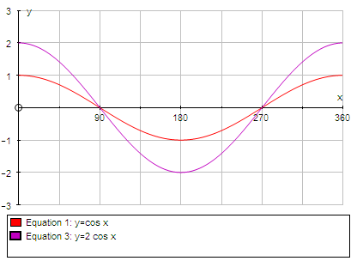

*g*

*f*

Note the following :

* the amplitude of *f* is 1
* the range of *f* is $-1≤y≤1$
* the period of *f* is 360.

**Task 2**

1. The above graph is redrawn below.



State the period, amplitude and range of g

* the amplitude of *g* is 2
* the range of *f* is $-2≤y≤2$
* the period of *f* is 360.

1. Sketch the graph of $y=- cos{x}$ for the interval $[0°;90°]$ and state the range of this function

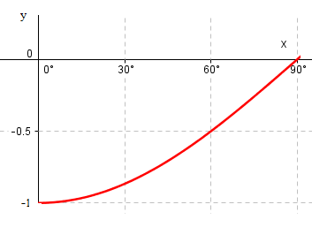

The range of the function is $-1≤y≤0$

**Activity 3: The graph and properties of the tangent function**

**Purpose**

* Draw the graphs of $y=atanx$
* Discuss the domain of $y=atanx$
* Determine the range and amplitude of $y=atanx$

**Resources:** A pen or pencil, eraser, ruler, compass and graph paper, calculator

**Suggested time:** 45 minutes

**Example 1**

Complete the table below by entering the function values for the given angles:

|  |  |  |  |  |  |  |
| --- | --- | --- | --- | --- | --- | --- |
| $$x$$ | **0 $°$** | **45 $°$** | **90 $°$** | **180 $°$** | **270 $°$** | **360 $°$** |
| $$\tan{x}$$ | **0** | **1** |  | **0** |  | **0** |
| $$-\tan{x}$$ | **0** | **-1** |  | **0** |  | **0** |

The table provides the coordinates of turning points and intercepts of the graphs of :

$f\left(x\right)=\tan{x}$

*g $\left(x\right)=-\tan{x}$*

These points are plotted on the next page and the graphs drawn.

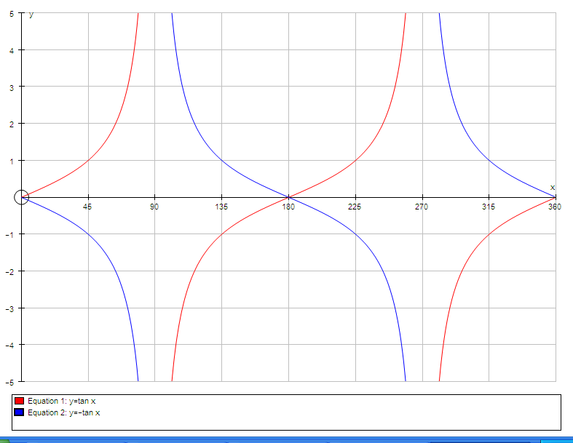

Notice that

* the period of the graphs is 180 $°$
* the range spans the real numbers and is written $y∈R$
* $f\left(x\right)$ and *g $\left(x\right)$* are undefined for *x* = 90 $°$ and *x* = 270 $°$
* *x* = 90 $°$ and *x* = 270 $°$ are **asymptotes** of the graphs
* the graphs follow the pattern *y*-value 0, asymptote, *y*-value 0, asymptote, *y*-value 0 as the *x*-values equal 0 $°$, 90 $°$, 180 $°$, 270 $°$ and 360 $°$.
* *g* is the reflection of *f* in the *x*-axis
* *f* (*x*) = g(*x*) for *x* = 0 $°$, 180 $°$ or 360 $°$
* *f* (45 $°$) – *g*(45 $°$) = 2

**Task 3**

1. A(45 is a point on the graph of $h\left(x\right)=2\tan{x}$.

1.1 Calculate the value of *y*.

y = 2

1.2 Sketch the graph of *h* for $x∈[0° ;180°]$. Indicate A on your graph.

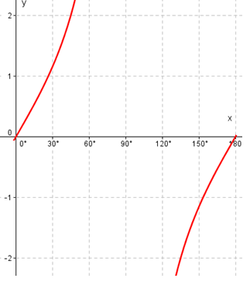

1.3 Write down the equation of the asymptote.

$x=90°$

1.4 What is the period of *h*?

Period is $180°$

1.5 What would the range of *h* be if it were drawn only for [0 $°$; 90 $°$]?

The range of *h* will be

2. Determine which of $y=\sin{x}$, $y=\cos{x}$ or $y=\tan{x}$ fit each of

the descriptions below.

* 1. the graph has a period of 180 $°$
 $$y=\tan{x}$$

 2. the period of the graph is 360 $°$ and it passes through (0 $°$; 0)
 $$y=\sin{x}$$

 3. the graph has a turning point at (180 $°$; $-$ 1)
 $$y=\cos{x}$$

 4. the range of the graph is .

3. Given that $p\left(θ\right)=\sin{θ}$ and $q\left(θ\right)=\cos{θ}$

3.1 Show that B( $45°;\frac{1}{\sqrt{2})}$ lies on the graphs of both *p* and *q*.

$$sin45°=cos45°=\frac{1}{\sqrt{2})}$$

3.2 Sketch the graphs of *p* and *q* for $0°≤θ≤90°$.

Indicate B on the graph.

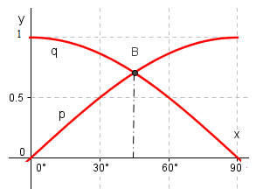

3.3 Use the graph to determine the values of *x* for which

3.3.1 $p\left(x\right)=q(x)$

$x=45°$

3.3.2 $q\left(x\right)-p\left(x\right)=1$

$x=90°$

**Activity 4: The effect of $a$ in $y=asin x$ or $y=acos x$**

**Purpose**

* Determine the effect of a in $y=asinx$
* Determine the effect of a in $y=acosx$

**Resources:** A pen or pencil, eraser, ruler, compass and graph paper, calculator

**Suggested time:** 45 minutes

As the maximum value of sin *x* is 1 and the minimum value of sin *x* is $-$ 1, the maximum and minimum values of *a* sin *x* are *a*(1) = *a* and *a*($-$ 1) = $-$*a.* The examples in Unit 4.1 indicate that the amplitude of

*y* = sin *x* is 1, the amplitude of *y* = 3 sin *x* is 3 and of *y* = $-$ 2 sin *x* is 2.

In the same way, the maximum and minimum values of cos *x* are 1 and $-$ 1 and hence the maximum and minimum values of *a* cos *x* are *a* and $–$*a*. The examples in Unit 4.2 illustrate this.

The effects of *a* in *y* = *a* sin *x* or *y* = *a* cos *x* can be summarised as

the amplitude of *y* = *a* sin *x* is the positive value of *a*.

* the range becomes $-a≤y≤a$
* the *y*-coordinates of the turning points are *a* or $–$*a*
* if *a* is negative, the graphs are reflected in the *x*-axis

**Example 1**

Sketch the graph of $y=\frac{1}{2}cosx$ for $0°≤x≤180°$

**Solution**

The amplitude is $\frac{1}{2}$ and the range is $-\frac{1}{2}≤y≤\frac{1}{2}$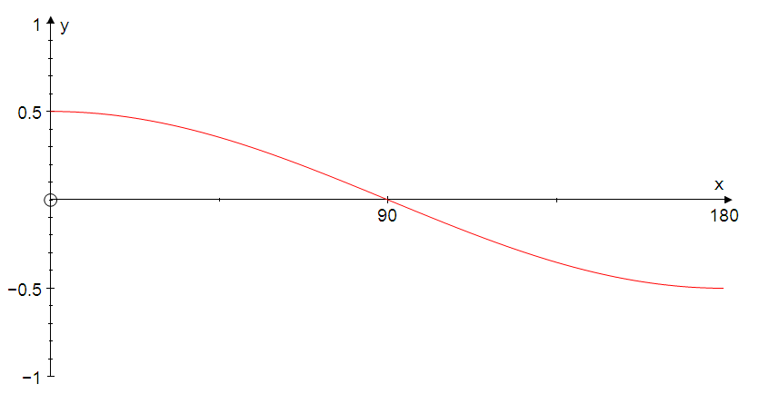

$$θ$$

**Task 4**

1. Sketch the graphs of each of the following on separate sets of axes:

Use [0 $°$; 360 $°$] as the domain in each case.

* 1. 1.2 1.3

1.4 $y= -\sin{x}$ 1.5 $y=3\cos{x}$ 1.6 $y=-2\cos{x}$

1. State the amplitudes of each of the graphs in 1.1-1.6.

3. Which graph has a maximum turning point at (90 $°$; 4)?

4, Which graph has a minimum turning point at (180 $°$; $-$ 3)?

**Answers to Task 4**

1.1 $y=2\sin{x}$

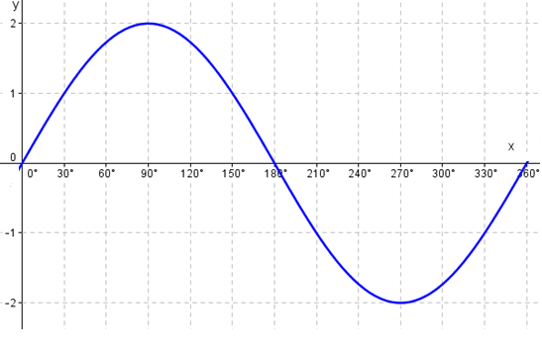

**2.1 Amplitude = 2**

1.2 $y=4\sin{x}$

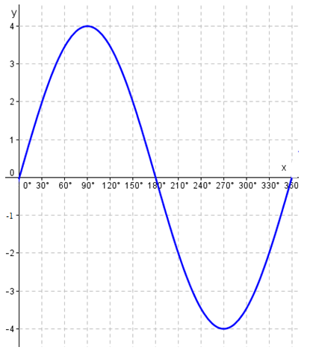

**2.2 Amplitude = 4**

1.3 $y=\frac{1}{2}\sin{x}$

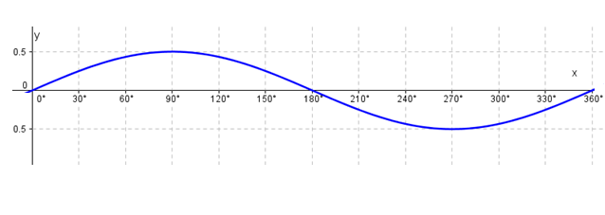

**2.3 Amplitude = ½**

1.4 $y= -\sin{x}$

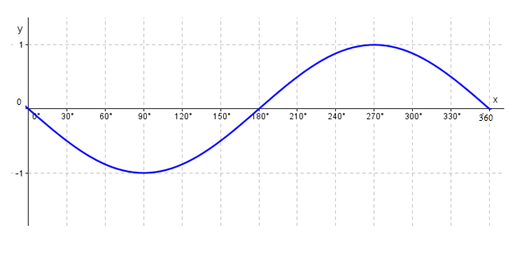

**2.4 Amplitude = 1**

1.5 $y=3\cos{x}$

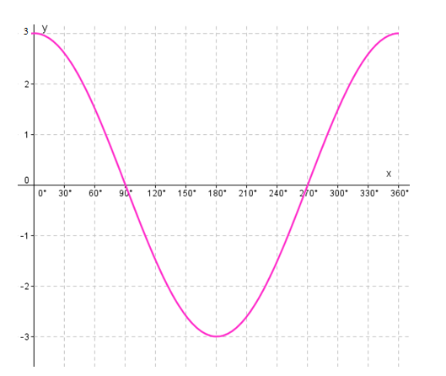

**2.5 Amplitude = 3**

1.6 $y=-2\cos{x}$

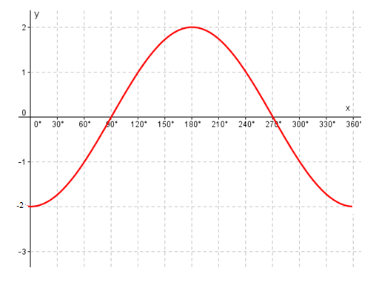

**2.6 Amplitude = 2**

1. Which graph has a maximum turning point at (90 $°$; 4)?

$y=4\sin{x}$

1. Which graph has a minimum turning point at (180 $°$; $-$ 3)?

$$y=3 cosx$$

**Activity 5: The effect of $a$ in $y=a.tan x$**

**Purpose**

* Determine the effect of a in $y=atanx$

**Resources:** A pen or pencil, eraser, ruler, compass and graph paper, calculator

**Suggested time:** 45 minutes

**Example 1**

Complete the table below by entering the function values for the given angles:

|  |  |  |  |  |  |  |
| --- | --- | --- | --- | --- | --- | --- |
| ***x*** | **0 $°$** | **45 $°$** | **60 $°$** | **80 $°$** | **89 $°$** | **90 $°$** |
| $$2 tan{x}$$ | **0** | **2** | **3,46** | **11,35** | **114,57** | $$∞$$ |
| $$5\tan{x}$$ | **0** | **5** | **8,66** | **28,36** | **296,45** | $$∞$$ |

It is difficult to indicate very large values on a sketch graph. To distinguish between graphs of *f* (*x*) = 2 tan *x* and *g*(*x*) = 5 tan *x* on sketches, therefore give the coordinates of the point with *x*-coordinate of 45 $°$ as in the graphs below.

Notice that as tan 45 $°$ is 1, the value of *a* tan 45 $°$ is *a*

The graph of *y* = *a* tan *x* passes through (45 $°$; *a*)

The table is used to draw graphs of $p\left(x\right)=2\tan{x}$ and $q\left(x\right)=5\tan{x}$

for [0 $°$; 90 $°$]

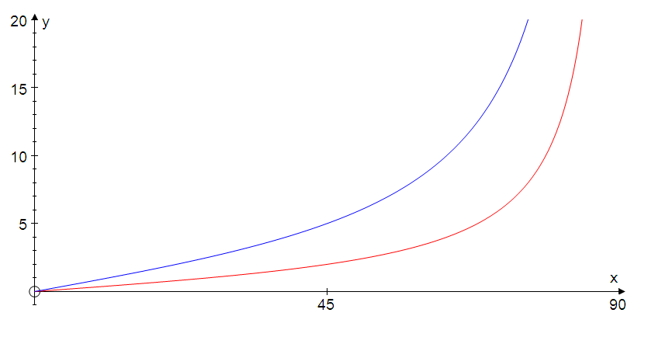

asymptote

*q*

●(45 $°;2)$

●(45 $°;5)$

*p*

**Task 5**

1. On separate sets of axes and for $x∈[0° ;180°]$ draw sketch graphs of each of the following:

1.1 $y=\frac{1}{2}\tan{x}$ 1.2 $y=-2\tan{x}$

**Answers to Task 5**

$y=\frac{1}{2}\tan{x}$

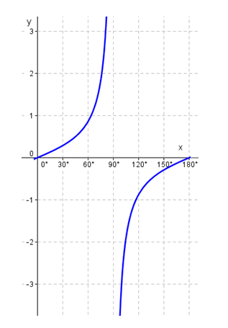

**1.2 $y=-2\tan{x}$**

**Answer**

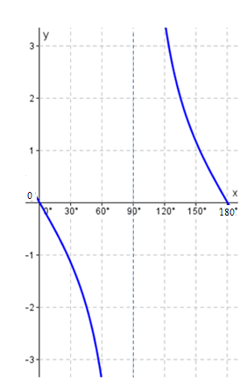

2. On the same set of axes for the interval [0 $°$; 90 $°$], sketch graphs of

*f* ($x$) = $-$ tan $x$ and *g*($x$) = $-$ 4 tan $x$

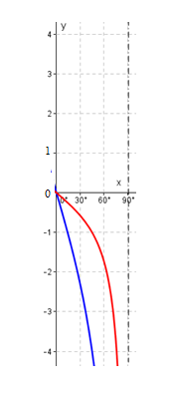

**Activity 6: Graphs of the type $y=a.f\left(x\right)+b$**

**Purpose**

* Draw graphs of the type $y=a.f\left(x\right)+b$
* Determine properties of graphs of the type $y=a.f\left(x\right)+b$

**Resources:** A pen or pencil, eraser, ruler, compass and graph paper, calculator

**Suggested time:** 45 minutes

We are going to draw graphs of the type $y=a.f\left(x\right)+b$

Please note that *b* fills the same role it does in other functions we come cross in Algebra.

* if *b* is negative the curve is moved *b* units down
* if *b* is positive the curve is moved *b* units up

The tables below illustrate the effect for some trigonometric functions.

For example, if *b* = $-$ 2, function values decrease by 2. This has the effect of moving the curve 2 units down. If *b* = 1, function values are increased by 1. This has the effect of moving the curve up 1 unit.

|  |  |  |  |  |  |
| --- | --- | --- | --- | --- | --- |
| $$x$$ | **0 $°$** | **90 $°$** | **180 $°$** | **270 $°$** | **360 $°$** |
| $$\cos{x}$$ | **1** | **0** | **-1** | **0** | **1** |
| $$\cos{x-2}$$ | **-1** | **-2** | **-3** | **-2** | **-1** |

|  |  |  |  |  |  |  |
| --- | --- | --- | --- | --- | --- | --- |
|  | **0 $°$** | **45 $°$** | **60 $°$** | **90 $°$** | **135 $°$** | **180 $°$** |
| $$\tan{x}$$ | **0** | **1** | **0,866** | $$∞$$ | **-1** | **0** |
| $$tan x +1$$ | **1** | **2** | **1,866** | $$∞$$ | **0** | **1** |

The graphs of *y* = cos *x $–$* 2 for [0 $°$; 180 $°$] and *y* = tan *x* + 1 for [0 $°$; 180 $°$] are shown. 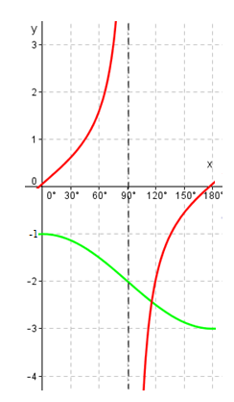

Notice that the coordinates of the *y*-intercept for *y* = cos *x $–$* 2 is now (0 $°$; $-$ 1) and that the minimum turning point is at (180 $°$; $-$ 3)

Notice that the *y*-intercept *y* = tan *x* + 1 is (0 $°$; 1) and that the graph approaches, but does not reach the asymptote as *x* approaches 90 $°$.

Now consider sketching the graph of *y* = *a* sin *x* + *b*. The *a* sets the amplitude, while the *b* moves the entire curve up or down.

#### Guided reflection on Activity 6

|  |
| --- |
|  |

**Activity 7 Graphs of the type $y=2sinx+b$**

**Purpose**

* Draw graphs of the type $y=2sinx+b$
* Determine properties of graphs of the type $y=y=2sinx+b$

**Resources:** A pen or pencil, eraser, ruler, compass and graph paper, calculator

**Suggested time:** 30 minutes

**Example 1**

Sketch the graph of *y* = 2 sin *x* + 1 for the interval [0 ; 360]

**Solution**

The “2” implies that the amplitude will be 2, while the “+ 1” moves the entire curve up 1 unit. The maximum value therefore becomes 2 +1 = 3 and the minimum value $-$ 2 + 1 = $-$ 1. When *x* = 0, *y* = 0 + 1 = 1.

In order to label the *x*-intercepts, notice that as, $2 sin x + 1 = 0$ then $\sin{x= -}$ $\frac{1}{2}$. The solution of this equation is not required for grade 10, but as sin 30 $°$ = $\frac{1}{2}$ and $\sin{x}$ is negative in the 3rd and 4th quadrants it is possible to deduce that $x=180°+30°$ = $210°$ or $360°-30°$ = $330°$

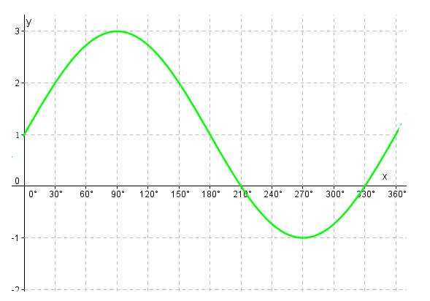

**Activity 8 Graphs of the type $y=2tan x+b$**

**Purpose**

* Draw graphs of the type $y=2tan x+b$
* Determine properties of graphs of the type $y=y=2tanx+b$

**Resources:** A pen or pencil, eraser, ruler, compass and graph paper, calculator

**Suggested time:** 20 minutes

**Example 1**

Sketch the graph of $y=2tan x+1$ for [ 0 $°$; 360 $°$]

**Solution:**

If *x* = 0 $°$, *y* = 2 tan 0 $°$ + 1 = 1

If *x* = 45 $°$, *y* = 2 tan 45 $°$ + 1 = 3

The asymptotes are defined by *x* = 90 $°$ and by *x* = 270 $°$

To determine the *x*-intercepts, make *y* = 0

$∴2\tan{x+1=0}$

$∴\tan{x}= -$ $\frac{1}{2}$. The solution of this equation is not required for grade 10, but it is possible to deduce that $x=180°-26,6°=153,4°$ or $x=360°-26,6°=333,4°$ as tan 26,6 $°$ = 0,5 and tan *x* is negative in the 2nd and 4th quadrants.

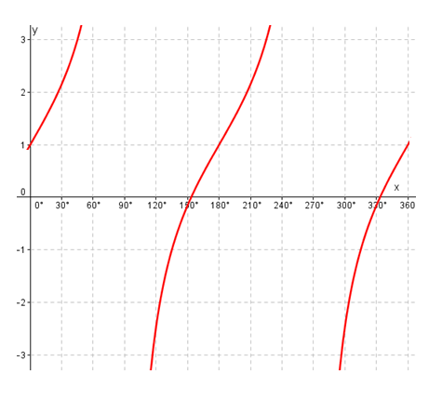

**Task 6**

1. Determine the values of *a* and *b* in y = *a* cos *x* + *b* if the graph has *y*-intercept at

(0 $°$; 2) and a *x*-intercept at (90 $°$; 0).

**Answers**

The amplitude of the graph is 2 – 0 = 2 $∴a$ = 2

The *x*-intercept is at 90

2. The diagram shows the graphs of *f* (*x*) = cos *x* + 1 and *g*(*x*) = sin *x* for [ 0 $°$; 360 $°$]

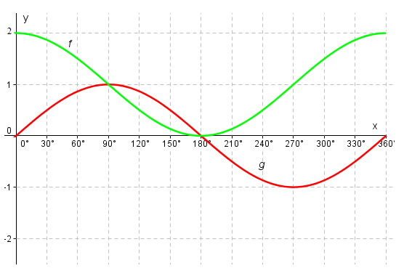

Determine the values of *x* for which

2.1 *f* (*x*) = *g*(*x*)

2.2 *f* (*x*) – *g*(*x*) = 0

2.3 *f* (x) – *g*(*x*) = 2

2.4 *f* (*x*) > *g*(*x*)

2.5 *f* (*x*) . *g*(*x*) > 0

2.6 *f* is an increasing function

#### Guided reflection on Activity 7

|  |
| --- |
|  |

**Answers**

Note that *f* (*x*) and *g*(*x*) are the function values (*y*-values) at *x*

2.1 *f* (*x*) = *g*(*x*) at the points where the graphs intersect. The *x*-values at

these points are 90 $°$ and 180 $°$

2.2 *f* (*x*) – *g*(*x*) = 0 implies that *f* (*x*) = *g*(*x*) and so the answer is the same

as in question 2.1

2.3 look where the graph of *f* is above that of *g* and the gap between

the *y*-values is 2 units. This occurs when *x* = 0 $°$ or *x* = 270 $°$ or *x* = 360 $°$

2.4 *f* (*x*) > *g*(*x*) when the graph of *f* is above that of *g*.

This occurs for $0°≤x<90°$ or $180°<x≤360°$

2.5 *f* (*x*) . *g*(*x*) > 0 implies that the product of the *y*-values is positive.

This means that the *y*-values of *f* and of *g* must either both be

negative or both positive as the product of 2 positives or 2

negatives is positive. This occurs when the graphs of *f*  and *g* are

either both above the *x*-axis( points have positive *y*-coordinates) or

both below the *x*-axis (points have negative *y*-coordinates).

This occurs here for $0°<x<180°$.

2.6 A function is **increasing** if the *y*-values increase as the *x*-values

increase. Here *f* (*x*) gets bigger as *x* gets bigger for $180°<x<360°$

**Summary Assessment**



2**.** The graph of f(x) = cos 2x is drawn below for the domain 

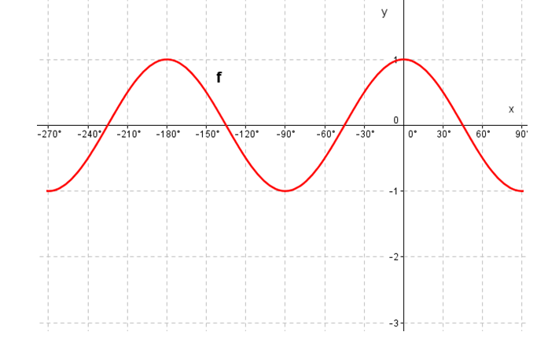

2.1 Redraw the above graph on graph paper Then draw the graph of g(x) = 2sinx – 1 for the interval  on the same system of axes as that for f. show all intercepts on the axes as well as the turning points

2.2 Let A be the point of intersection of the graphs of f and g. Show that the x-coordinate of A satisfies the equation 

2.3. Hence, calculate the points of intersection of the graphs of f and g for the interval 

#### Guided reflection on Summary Assessment

|  |
| --- |
| 1. Use the answers given for the summary assessment to check if your answers were correct. 2. Did you realize why you got some your answers incorrect? 3. Write down the errors you made. 4. Have you been able to correct errors you made? |

**Answers for Summary Assessment**

1.1

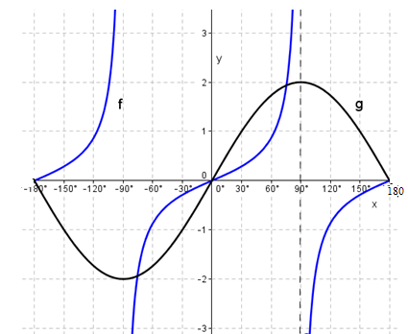





2.1

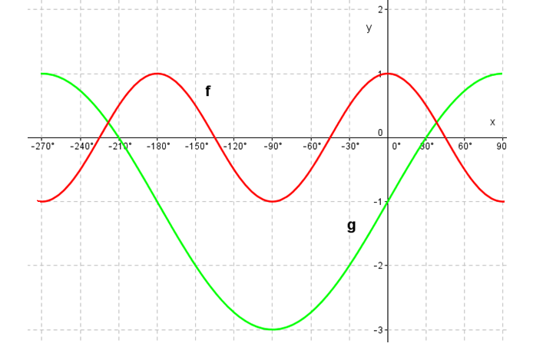

2.2



2.3



**Unit 7: Reduction Formulae**

#### Learning Outcomes

By the end of the unit, learners should be able to:

* Derive reduction formulae
* Use reduction formulae to:  
  a. Reduce a trigonometric ratio of any angle to the trigonometric ratio of an acute angle;  
  b. Simplify trigonometric expressions;  
  c. Solve trigonometric equations for angles in the interval[-360°; 360°].
* Work through the various reduction formulae

**Activity 1: Reduction formulae**

**Purpose**:

* Derive reduction formulae

**Resources:** A pen or pencil, eraser, ruler, compass and paper

**Suggested time**: 60 minutes

We can write any angle in the second, third and fourth quadrant can be expressed in terms of an angle in the first quadrant.

Second Quadrant

For example:



Here, is the angle in the second quadrant. It is related to the in the first quadrant.

We note, using our calculator, that .

Thus,



We also note, using our calculator, that 



We note, using our calculator, that 



Third Quadrant

For example:



Here, is the angle in the second quadrant. It is related to the in the first quadrant.

We note, using our calculator, that .

Thus,



We also note, using our calculator, that 



We note, using our calculator, that 



Fourth Quadrant

For example:



Here, is the angle in the second quadrant. It is related to the in the first quadrant.

We note, using our calculator, that .

Thus,



We also note, using our calculator, that 



We note, using our calculator, that 



**Other reduction formulae**

**Negative angles**

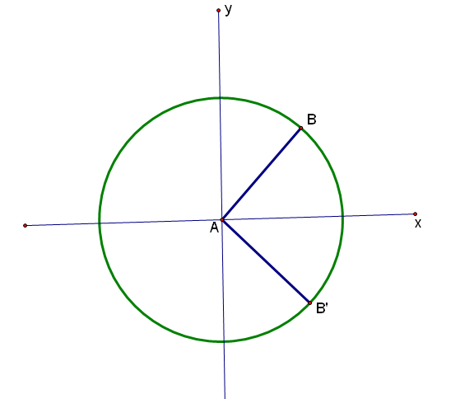





Note:





**Co-terminal angles**

These angles have the same starting point and end point - ratios are the same

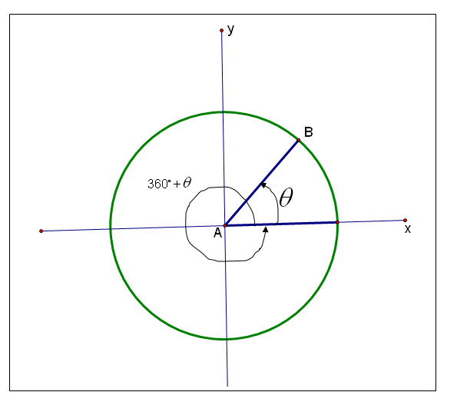

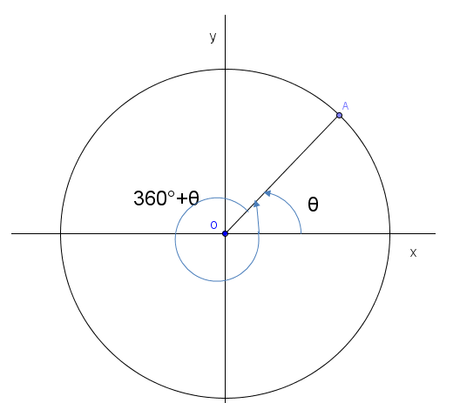



**Complementary ratios**

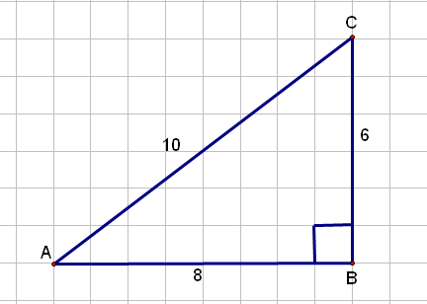





**Task 1**

**Simplify the following**



#### Guided reflection on Activity 1

|  |
| --- |
| 1. Express in terms of.   = .   1. Show that $\frac{1}{tanx}= \frac{cosx}{\sin{x}}$ $$\frac{1}{tanx}= \frac{1}{\frac{sin x}{\cos{x}}}=1×\frac{cosx}{\sin{x}}= \frac{cosx}{\sin{x}}$$ |

**Answers to task 1**





**Summary Assessment**

**Simplify**

1. 
2. 
3. 

#### Guided reflection on Summary Assessment

|  |
| --- |
| 1. Use the answers given for the summary assessment to check if your answers were correct. 2. Did you realize why you got some your answers incorrect? 3. Write down the errors you made. 4. Have you been able to correct errors you made? |

**Answers for summary assessment**







**Unit 8 Trigonometric equations – general and specific solutions**

**Learning Outcomes**

By the end of the unit, learners should be able to:

* Solve equations with one ratio in the interval [$0;360°]$, using trigonometric ratios, sinθ , cosθ and tanθ , reduction formulae and trigonometric identities.
* Develop the concept of general solution of a trigonometric equation through solving it in a restricted interval.
* Use the general solution to trigonometric equation with one ratio to determine the specific values of the equation in a specified interval. A calculator should be used unless stated otherwise.
* Determine the general solution to trigonometric equation with more than one ratio, using trigonometric ratios, sinθ , cosθ and tanθ , reduction formulae and trigonometric identities.
* Use the general solution to trigonometric equation with more than one ratio one ratio to determine the specific values of the equation in a specified interval.

**Activity 1: Simple trigonometric equations**

**Purpose**:

* Solve simple trigonometric equations with one ratio in the interval [$0;360°]$,

**Resources:** A pen or pencil, eraser, calculator

**Suggested time**: 60 minutes

**Examples**

Solve the following equations for the given variable in the interval [$0;360°]$. Use a calculator where necessary



Let us examine the solutions to these questions











**Activity 2: General solution of a trigonometric equation**

**Purpose**:

* Solve simple trigonometric equations with one ratio in the interval [$0;360°]$,

**Resources:** A pen or pencil, paper and calculator

**Suggested time**: 30 minutes

**Examples**

We will use some of the questions from the previous section:

Determine the general solution of the equations below.









**Task 2**

Determine the general solution of the following equations



**Answers to task 2**







**Activity 3: General solution of a trigonometric equation (with more than one ratio)**

**Purpose**:

* Solve simple trigonometric equations with more than one ratio in the interval [$0;360°]$,

**Resources:** A pen or pencil, paper and calculator

**Suggested time**: 60 minutes

**Examples**

Determine the general solution of the equations below.









**Task 3**

Determine the general solution of the equations below.



**Answers to Task 3**





**Activity 4: Determining specific solutions of trigonometric equations**

**Purpose**:

* Solve trigonometric equations with one or more ratios for different intervals

**Resources:** A pen or pencil, paper and calculator

**Suggested time**: 60 minutes

**Examples**

Let us use the same examples we used in activity 3



**Let us work through these questions:**







**Task 4**

Determine the solution of the trigonometric equations below for the given intervals.



**Answers to Task 4**





**Summary assessment**



#### Guided reflection on Summary Assessment

|  |
| --- |
| 1. Use the answers given for the summary assessment to check if your answers were correct. 2. Did you realize why you got some your answers incorrect? 3. Write down the errors you made. 4. Have you been able to correct errors you made? |

**Answers for Summary Assessment**









**Unit 9: Sine; Cosine and Area Rule**

**Learning Outcomes**

By the end of the lesson the learner should be able to

* Prove, state and apply the sine rule
* Prove, state and apply the cosine rule
* Prove, state and apply the area rule

**Activity 1: The Sine Rule**

**Purpose:**

* Proof of the sine rule
* State the sine rule
* Apply the sine in the solution of triangles

**Resources**: A pen or pencil, eraser, ruler, compass, paper and calculator

**Suggested time**: 60 minutes

Study the diagram below, where ∆ABC is given, with AD perpendicular to BC.

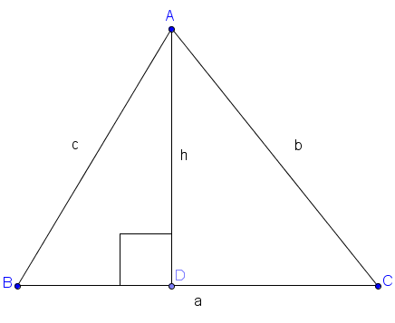

We apply the sine ratio (for right-angled triangles) to the above diagram



We use the sine rule to solve a triangle when the following information is given:

* Two angles and a side
* Two sides and an angle opposite one of the sides

**Activity 2: The area rule**

Purpose:

* Proof of the area rule
* State the area rule
* Use the area rule to find the area of triangles

**Resources**: A pen or pencil, eraser, ruler, compass, paper and calculator

**Suggested time**: 60 minutes

Study the diagram below, where ∆ABC is given, with AD perpendicular to BC.





**Example 1**

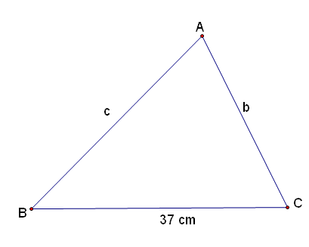





Calculate b and c and the area of ∆ABC in the triangle above.

We are given two angles and a side. We can use the sine rule.



**Example 2**

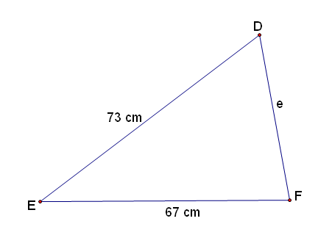



Calculate  in the above diagram.

We are given two sides and an angle opposite one of the sides. Thus, we can use the sine rule.

Please note that we are working with ∆DEF so DF = e; EF = d and DE = f



The sine rule can only solve certain examples. In a case where all sides of a triangle are given, the sine rule cannot be used to calculate angles of the triangle.

In this case we need the cosine rule.

**Activity 3: The cosine rule**

**Purpose:**

* Proof of the cosine rule
* State the cosine rule
* Apply the cosine in the solution of triangles

**Resources**: A pen or pencil, eraser, ruler, compass, paper and calculator

**Suggested time**: 60 minutes

Study the diagram below where ∆ABC with A at the origin.. The coordinates of the vertices of ∆ABC are A(0;0); C (b;0). BD is drawn perpendicular to AC

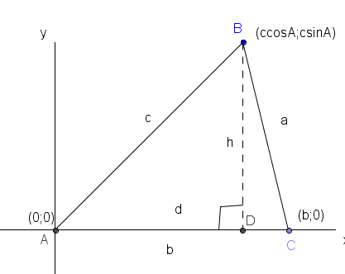

We determine the coordinates of B as follows:



We use the cosine rule to solve a triangle when:

* Three sides are given
* Two sides and the angle included by these two sides are given

**Example 3**

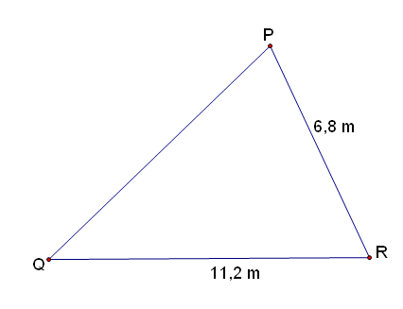



Calculate PQ and  in the above diagram.

We can only use the cosine rule to calculate PQ as two sides and the included angle are given. We may let PQ = r; PR = q and QR = p



To find angle P we need not use the cosine rule. The sine rule will be easier to use as we now have two sides and an angle opposite one of the sides.



**Example 4**

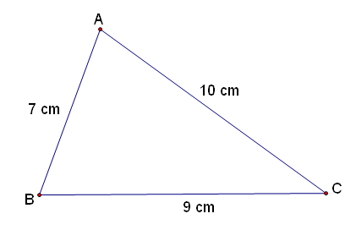

Calculate the largest angle in the above diagram.

We can only use the cosine rule to find the largest angle.





**Task 1**

1.

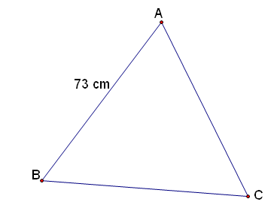





Calculate AC and the area of ∆ABC

2.

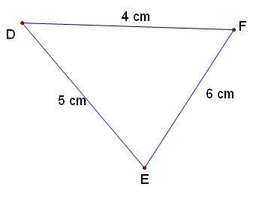

Calculate the smallest angle and the area of ∆DEF.

3.

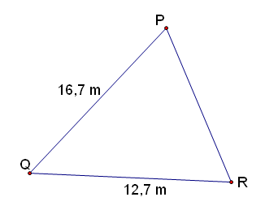



Calculate PR and .

#### Guided reflection on Activity (Task 1)

|  |
| --- |
| 1. When is the sine rule used?   When the measure of two angles and a side of a triangle are given  When the measure of two sides and one angle opposite one of them are given.   1. When is the cosine rule used?   When the measure of three sides of a triangle are given  When the measure of two sides and the included angle is given.   1. To use the area rule, what measurements you need?   Measure of two sides and the included angle. |

**Answers to Task 1**

**1.**



2.

Please note that d = EF = 6 cm; e = DF = 4 cm; f = DE = 5 cm



3.



**Summary Assessment**

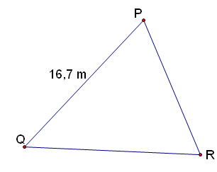





Calculate PR and the area of ∆PQR.

2.

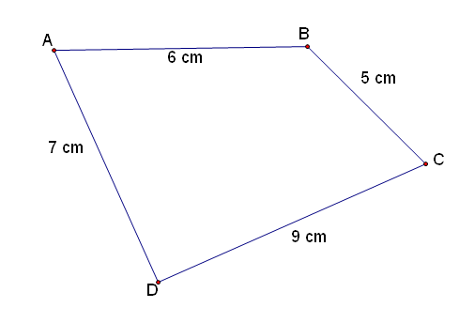



Calculate AC,  and the area of quad ABCD.

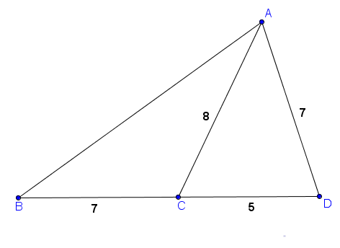

In the diagram AC = 8; AD = 7; CD = 5 and BC = 7

Calculate

3.1 

3.2 the area of ∆ABD

#### Guided reflection on Summary Assessment

|  |
| --- |
| 1. Use the answers given for the summary assessment to check if your answers were correct. 2. Did you realize why you got some your answers incorrect? 3. Write down the errors you made. 4. Have you been able to correct errors you made? |

**Answers for summary assessment**







3.1



* 1. Area of ∆ABD = Area of ∆ABC + Area of ∆ACD



**Unit 10: Compound angle identities**

**Learning Outcomes**

By the end of the lesson the learner should be able to prove the compound angle identity  and then deduce the following:

* 
* 
* 

**Activity 1:** 

**Purpose:**

* Proof of 

**Resources**: A pen or pencil, eraser, ruler, compass, paper

**Suggested time**: 60 minutes

**Proo**f of the identity: 

In the diagram below, we have drawn a unit circle (radius = 1), with angle A in the third quadrant and angle B in the second quadrant. Now A – B is an acute angle and we have drawn it in the first quadrant. Please check that you know how to get the coordinates of points A1; B1; A and B in the diagram

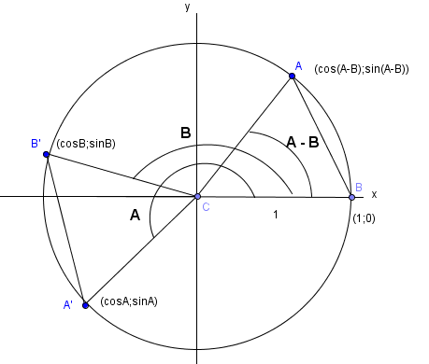



**Activity 2: Deducing other compound angle formulae**

**Purpose:**

Use the proof of  to deduce the following:

* 
* 
* 

**Resources**: A pen or pencil, eraser, ruler, compass, paper

**Suggested time**: 60 minutes

We start with 

Replace B by –B





Replace B by –B in the above identity:



In summary we have:

* 
* 
* 
* 

We may now consolidate our understanding of these identities by looking at the following examples:

**Examples**

1. Without using a calculator, prove that cos 75 = 

**Solution**



1. Find the value of sin 105 without using a calculator. Leave your answer in simplest surd form

**Solution**



1. Simplify without the use of a calculator:



**Solution**

This example is of the form sin A cos B – cos A sin B which is sin (A – B)



**Task 1**

Simplify numbers 1 to 4



$sinxcosy-cosxsiny$

$cos2xcosx+sin2xsinx$

$\sin{140°\cos{40°+cos140°sin40°}}$

$cos6xcos3x-sin6xsin3x$

#### Guided reflection on Activity 1 (Task 1)

|  |
| --- |
| 1. Expand cos $(6x+3x)$ $= cos6xcos3x-sin6xsin3x$ [use $Cos \left(A+B\right)=Cos ACosB-SinASinB$]  If you look backwards, can you see that: $cos6xcos3x-sin6xsin3x=Cos (6x+3x)$ $=Cos (9x)$ |

**Answers to task 1**

$sinxcosy-cosxsiny$

= $sin⁡(x-y)$

$cos2xcosx+sin2xsinx$

= $\cos\left(2x-x\right)$

= $\cos{x}$

$\sin{140°\cos{40°+cos140°sin40°}}$

$=$ sin($140°+40°)$

= sin($180°)$

$$= 0$$

$cos6xcos3x-sin6xsin3x$

= $cos⁡(6x+3x)$

= $cos⁡(9x)$



**Task 2**

Show that



**Answers to Task 2**





**Summary Assessment**

1. Use the compound angle formulae to simplify each expression to one term only:

1.1 

1.2 

2. Evaluate each of the following without using a calculator:

2.1 

* 1. 

1. Without using a calculator, determine the value of 
2. Simplify the following:



#### Guided reflection on Summary Assessment

|  |
| --- |
| 1. Use the answers given for the summary assessment to check if your answers were correct. 2. Did you realize why you got some your answers incorrect? 3. Write down the errors you made. 4. Have you been able to correct errors you made? |

**Answers for summary assessment**

1.1 

1.2



2.1



2.2







**Unit 11: Double angle identities**

**Learning Outcomes**

By the end of the lesson the learner should be able to use the compound angle identities for  and to deduce the following:

* 
* 

**Activity 1:** The identities for and 

**Purpose:**

* Show 
* Show 

**Resources**: A pen or pencil, eraser, ruler, compass, paper

**Suggested time**: 40 minutes









**Examples**



**Solutions**



 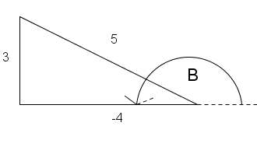

**Task 1**

1. Reduce  to a single trigonometric function of x
2. Prove  –  =  . For which value/s of x in the interval [-180; 180] is the identity not defined?
3. Prove that  Which values can b not assume in the interval [0; 360] ?



#### Guided reflection on Activity 1

|  |
| --- |
| 1. Simplify $(cosx-sinx)(cosx+sinx)$ to $cos2x$ $$\left(cosx-sinx\right)\left(cosx+sinx\right)= \cos^{2}x-\sin^{2}x$$ = $cos2x$ |

**Answers to task 1**







1. We know that





**Summary assessment**

**Prove the following:**



#### Guided reflection on Summary Assessment

|  |
| --- |
| 1. Use the answers given for the summary assessment to check if your answers were correct. 2. Did you realize why you got some your answers incorrect? 3. Write down the errors you made. 4. Have you been able to correct errors you made? |

**Answers for Summary Assessment**









**Unit 12: Problems in two and three dimensions**

**Lesson outcomes**

By the end of the lesson the learner should be able to

* Solve two dimensional problems
* Solve three dimensional problems

**Activity 1: Problems in two dimensions**

**Purpose:**

* Solution of problems in right angled triangles

**Resources**: A pen or pencil, eraser, ruler, compass, paper and calculator

**Suggested time**: 60 minutes

The sine, cosine and area rule can help us solve problems in two dimensions.

The following diagrams show you how to identify angles of elevation and depression.

**Angle of elevation**

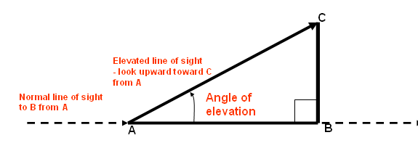

Angle of depression

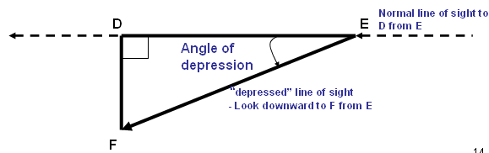

**Some points to consider**



**Examples**



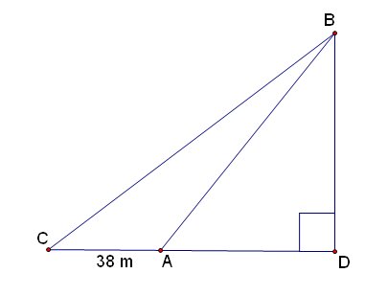





**Solution**



2.

Given quadrilateral EFGH

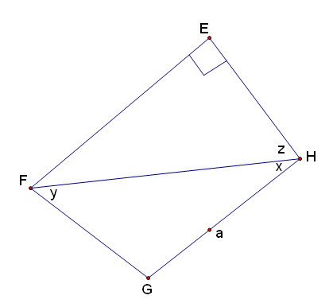

Prove that



Solution

NB: 

**Solutions**



**Task 1**

1.

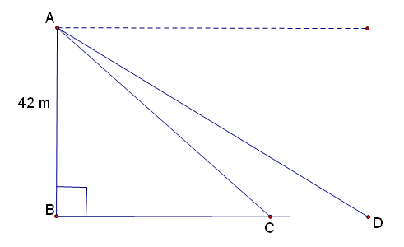





From the top of a cliff 42 m high the angle of depression of two ships at C and D are  respectively. B, C and D are in the same horizontal plane. Calculate the distance CD.

2.

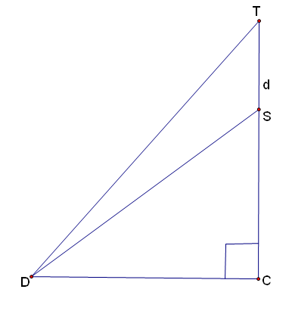

y

x

T is the top of a tower and S is a point d metres lower. From D, a point on the ground, the angles of elevation of T and S are  respectively.



3.

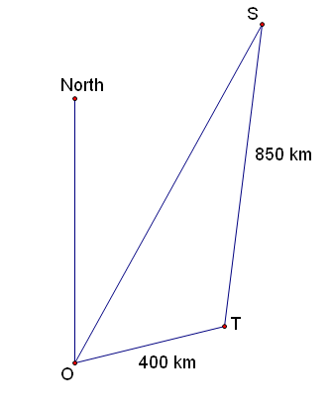





The sketch above shows the relative positions of Osaka (O); Tokyo (T) and Sapporo (S) in Japan. ST = 850 km; TO = 400 km and .

3.1 Calculate OS to the nearest metre

3.2 Find the size of to the nearest degree

3.3 The bearing of S from O is . Find the bearing of O from T

3.4 A plane flew from S to T at an airspeed of 550 km/h. It left at 06:30. What time did it arrive at T?

4.

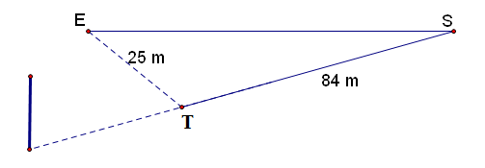



Peter hits a golf ball at distance of 84 m in direct line with the hole. His partner

hits the ball further but  off course. If the distance between the golf balls is

25 m, how far did his partner hit the ball? (Calculate SE in the diagram)

#### Guided reflection on Activity 1

|  |
| --- |
| 1. In Q1, why is $A\hat{C}B=65°$  Eye level is parallel to ground: Alternate angles are equal |

**Answers to Task 1**





3.1



3.2



3.3



3.4



1. We find angle S first



**Activity 2: Problems in three dimensions**

**Purpose:**

* Solution of problems in three dimensions

**Resources**: A pen or pencil, eraser, ruler, compass, paper and calculator

**Suggested time**: 60 minutes

**Recognising three-dimensional diagrams**:

(1)

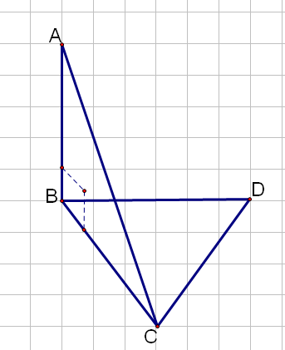

In the figure alongside, ∆BCD is on the horizontal plane. ∆ABC is on the vertical plane with AB BC. When solving a problem of this type, we work with one triangle at a time. We note that BC is common to both triangles. Thus, if BC is known then we will be able to link both triangles using BC and relevant angles of elevation.

(2)

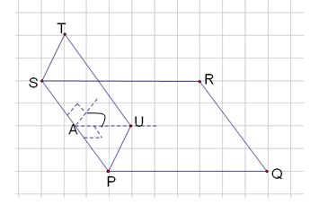

In the diagram alongside, planes PQRS and TSUP intersect with SP the line of intersection. The angle indicated in the diagram is the angle between the two planes.

**Recognising three-dimensional diagrams**:

(1)



In the figure alongside, ∆BCD is on the horizontal plane. ∆ABC is on the vertical plane with AB BC. When solving a problem of this type, we work with one triangle at a time. We note that BC is common to both triangles. Thus, if BC is known then we will be able to link both triangles using BC and relevant angles of elevation.

(2)



In the diagram alongside, planes PQRS and TSUP intersect with SP the line of intersection. The angle indicated in the diagram is the angle between the two planes.

**Some points to consider**



**Examples**

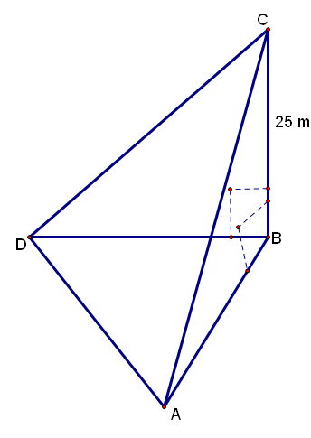





In the diagram, ∆ABD is on the horizontal plane and ∆ABC is on the vertical plane. If the angle of elevation of C from B is  and the angle of elevation of C from D is calculate the area of ∆ABC if  and CB = 25 m.



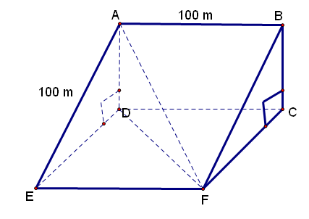



ABFE represents a section of a ski run that has a uniform inclination of to the horizontal. AE = 100 m and AB = 100 m. A skier traverses the slope from A to F.

Calculate:

2.1 the distance the skier has travelled.

2.2 the inclination of the skier’s path to the horizontal.



2.2

The inclination is given by .



**Task 2**

1.

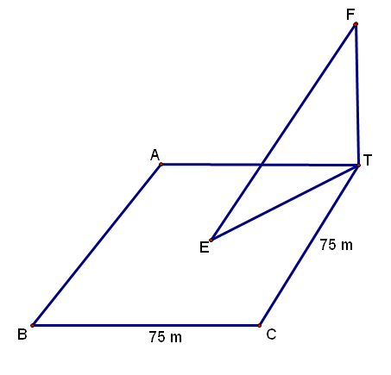



tree

A tree stands at the corner of a square playing field, each side being 75 m. The tree subtends an angle of at the centre of the field. What angle does it subtend at B and C?

Hint: First find the height of the tree (FT in the diagram).

2.

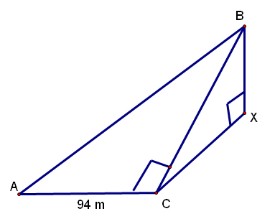





A, C and X are three points in a horizontal plane and B is vertically above X. If AC = 94 m and  then find:

2.1 the distance CB

2.2 the height XB.

3.

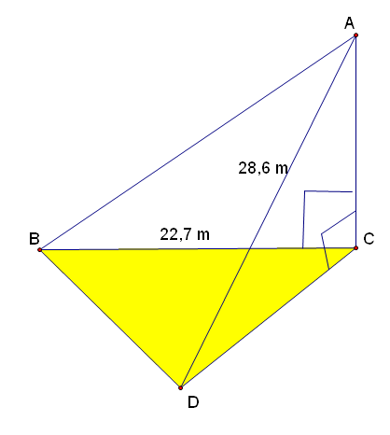

CA is a vertical mast. B, C and D are in the same horizontal plane. AB and AD are cables. AD = 28,6 m and BC = 22,7 m. The angle of elevation of A from B is . .

3.1 Calculate the length of AB

3.2 Calculate the length of BD

3.3 Calculate the area of ∆BCD

**Answers to task 2**

**1.**

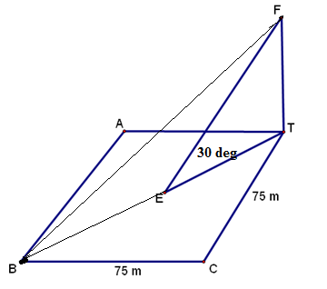



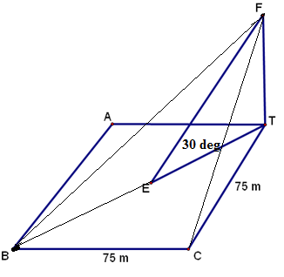



2.



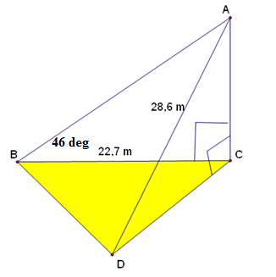







**Summary assessment**

1.

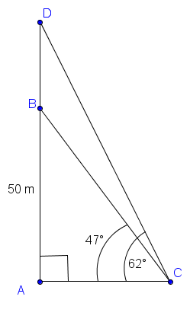

In the diagram above, AB is a building with a height of 50 metres. DB is a radio mast on top of the building. . Determine the length of DB.

2.

In the diagram below, D, B and C are points in the same horizontal plane. AC is a vertical flagpole to which cables AD and AB are attached. AD = p metres, 

. 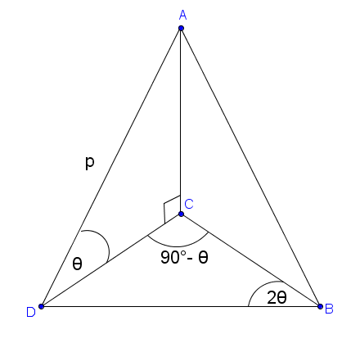

2.1 Prove that: 

2.2 Calculate the height of the flagpole if  and p = 3 metres.

2.3 Calculate the length of cable AB if it is further given that 

#### Guided reflection on Summary Assessment

|  |
| --- |
| 1. Use the answers given for the summary assessment to check if your answers were correct. 2. Did you realize why you got some your answers incorrect? 3. Write down the errors you made. 4. Have you been able to correct errors you made? |

**Answers for Summary Assessment**

1. We use the basic trigonometric ratio of sine in the right-angled ∆ABC to find the length of BC. We then use the sine rule in ∆DBC to calculate the length of DB after first finding  and . DB = 37, 69 m
2. 2.1 is a proof
   1. AC = 1,5 m
   2. We know p = 3 m; we can show DB = . We can use the cosine rule in ∆ADB to work out the length of AB. Thus, AB = 3,23 m