# Section 1: Basic scientific skills

#### Introduction

The basic scientific skills that you learn in this section will be applied in all of the other sections of the Physics component of this course. You should try to spend enough time on this section at the beginning of your studies, to make sure that you are confident in the basic skills needed to be able to tackle the rest of the course.

In the curriculum, this topic is assigned 6 ½ hours of learning time. However, if you are very unfamiliar with these basic scientific skills, you might need to spend more time on this topic than is shown in the curriculum.

## Sub-topic 1: Physical quantities, units and measurement

## Unit 1: Scientific notation

#### Learning Outcomes

By the end of the unit, you should be able to:

* display numerical values in scientific notation.

#### Introduction

It is helpful for you to check your prior knowledge of the skill of using scientific notation to see how much time you should spend on this unit. The following questions will help you to do this:

* How would you say the number 2 × 103 in words?
* How would you write the number 12 500 in scientific notation?
* How would you write the number 0,015 in scientific notation?

If you have some basic skills in scientific notation, you should have got the following answers:

1. The number 2 × 103 in words is two thousand.
2. The number 12 500 in scientific notation is 1,25 × 104.
3. The number 0,015 in scientific notation is 1,5 × 10-2.

If you found this exercise difficult, or if you did not get these answers, you will need to spend some time working through the activities in this unit.

#### Exponents

An *exponent* is the small raised integer that is written after a number to tell you how many times the number is multiplied by itself, e.g. *y***2** = *y* ×y.

For example, the number 1 000 can be written in three ways:

1 000 = 10 × 10 × 10 = 103.

The small 3 written after the 10 is the exponent, and tells you how many times the number 10 has been multiplied by itself.

#### Scientific notation

*Scientific notation* is a way of writing very large or small numbers so that they are more readable. In scientific notation, the number is written as a number between 1 and 10 multiplied by a power of 10.

For example, if you want to write the number 750 000 in scientific notation, you follow these steps:

750 000 = 7,5 × 100 000

= 7,5 × 105

*HINT:* You can work out the exponent by counting how many places the decimal comma needs to move to the *left* to go from 750 000 to 7,5. In this example the decimal comma needs to move 5 spaces to the left, so this is your exponent:

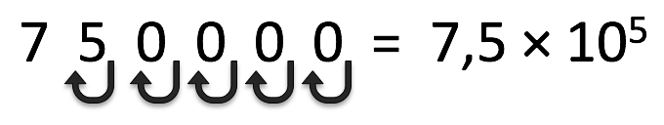

Figure The decimal comma moves to the left for a large number

You can also write a very small number, such as 0,001, as a power of ten:

$$0,001=\frac{1}{1000}=\frac{1}{{10}^{3}}={10}^{-3}$$

For example, if you want to write the number 0,0005 in scientific notation, you follow these steps:

$$0,0005=\frac{5}{10000}=\frac{5}{{10}^{4}}=5×{10}^{-4}$$

*HINT:* Another way of working out the exponent is to work out how many places the decimal comma needs to move to the *right* to go from 0,0005 to 5. In this example the decimal comma needs to move 4 spaces to the right, so this is your exponent:

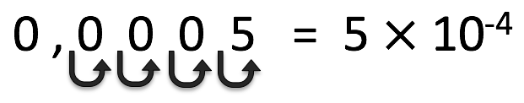

Figure The decimal comma moves to the right for a small number

In Science, you also use exponents when you describe units. For example, the units for velocity are “metres per second” or m/s or m.s-1. In this way, you treat units like any other algebraic variables.

From these examples, you can see that a large number (e.g. 10 000) always has a positive exponent when it is written in scientific notation, and a small number (e.g. 0,0004) always has a negative exponent.

#### Activity 1: Practise scientific notation

Purpose

In this activity, you will practise using scientific notation to write different numbers.

Suggested time**:** [15 minutes]

What you will do:

Answer the following questions:

1. Convert the following numbers into scientific notation:
   1. 22
   2. 8100
   3. 26 550 000
   4. 5,5
   5. 0,1
   6. 0,00068
2. Write the following numbers out fully:
   1. 6,5 10-2
   2. 7 101
   3. 1,693 106
   4. 2,78 10-5

#### Solutions:

1. The scientific notation of the numbers is shown below:

Remember to count the number of times that the decimal moves to give a number between 1 and 10. If it moves to the *left*, and this tells you the positive exponent for the 10. If it moves to the *right*, and this tells you the negative exponent for the 10.

a. 22 = 2,2 × 101

b. 8 100 = 8,1 × 103

c. 26 550 000 = 2,655 × 107

d. 5,5 = 5,5 × 100

e. 0,1 = 1 × 10-1

f. 0,00068 = 6,8 × 10-4

1. The numbers written out fully are shown below:

a. 6,5 10-2 = 0,065

b. 7 101 = 70

c. 1,693 106 = 1 693 000

d. 2,78 10-5 = 0,0000278

#### Scientific notation using a calculator

If you use your scientific calculator to enter a number that is written in scientific notation, you use the EXP button (on some calculators this is labelled “EE”). For example, to enter the number 6,5 104 on your calculator you will push the following buttons:

6 . 5 EXP 4

OR 6 . 5 EE 4

To enter the number 3 10-2 you will push the following buttons on your calculator:

3 EXP 2 +/-

OR 3 EE 2 +/-

You can use your calculator to convert numbers directly into scientific notation. Different calculators have different ways of doing this. Some calculators do this conversion if you push the button that looks like this: F-E or ENG. This button will help you to convert backwards and forwards between ordinary numbers and scientific notation.

Take some time to explore your calculator, and make sure that you can enter numbers in scientific notation, and convert between scientific notation and ordinary numbers.

[WORDBOX: MAIN IDEAS:

Numbers can be written in scientific notation, e.g. the number 1 500 can be written as 1,5 × 103. ]

#### More resources to help you:

You can see a YouTube video that shows examples of writing numbers in scientific notation: *Scientific notation examples:*

<https://www.khanacademy.org/math/pre-algebra/pre-algebra-exponents-radicals/pre-algebra-scientific-notation/v/scientific-notation-old> (Duration: 12.48)

You can practise using scientific notation at this website: <https://www.khanacademy.org/math/pre-algebra/pre-algebra-exponents-radicals/pre-algebra-scientific-notation/e/scientific_notation>

This is a very helpful website that tells you when your answer is correct, and gives you hints if you are stuck.

## Unit 2: Physical quantities, SI units and conversions

#### Learning Outcomes

By the end of the unit, you should be able to:

* write physical quantities as a numerical magnitude and a unit;
* recall the following base quantities and their SI units: mass (kg), length (m), time (s), current (A), temperature (K);
* convert between various scales of measurement: temperature (Celsius and Kelvin), length (km, m, cm, mm), mass (kg, g), pressure (kPa, atm);
* use the following prefixes and their symbols: nano (n), micro (μ), milli (m), centi (c), deci (d), kilo (k), mega (M), giga (G);
* relate the different orders of magnitude to the sizes and masses of common objects, ranging from an atom to the Earth.

#### Introduction

Reflect on your previous understanding of scientific units by thinking about the following questions, or discussing them with a fellow student:

* Why do you think units are important when you write numbers in science?
* Give examples of some of the units that you use in your everyday life.

In reflecting on the units that you use in everyday life, you would have come up with various examples, such as kilometres, which you use for measuring distance; grams, which you use for measuring mass; millilitres, which you use for measuring volume.

In Science, whenever you measure a physical quantity, for example mass, length or temperature, it is important that you use the correct units to show exactly what the measurement means. In this course you will use *SI units*.

[Word box: **SI** **units:** the international system of unit measurements, from “*Le Systeme International d’Unites*”]

The table below shows some of the SI units for different scientific quantities. Some of these should be familiar, while others such as Pascal and Kelvin might not be.

|  |  |  |
| --- | --- | --- |
| **Quantity** | **SI unit** | |
| **Name** | **Symbol** |
| Length | metre | m |
| Mass | kilograms | kg |
| Time | seconds | s |
| Force | newton | N |
| Pressure | pascal | Pa |
| Current strength | ampere | A |
| Temperature | Kelvin | K |

#### Activity 1: Practise writing the correct units for scientific quantities

Purpose

In this activity, you will practise expressing scientific quantities using the correct units.

Suggested time**:** [10 minutes]

What you will do:

For each of the measurements below, fill in the correct *symbol* for the SI units:

1. Thembi’s mass is 90 _____.
2. The temperature of the air outside is 300 ______.
3. The length of a plank is 6 _______.
4. The force that pulls Mandla toward the earth is 980 _________.
5. The time for an egg to boil is 600 _________.
6. The air pressure is 101 000 _________.
7. The current is 0,5 ______.

#### Solutions:

The correct units are shown underlined below:

1. Thembi’s mass is 90 kg
2. The temperature of the air outside is 300 K
3. The length of a plank is 6 m
4. The force that pulls Mandla toward the earth is 980 N
5. The time for an egg to boil is 600 s
6. The air pressure is 101 000 Pa
7. The current is 0,5 A

[WORDBOX: MAIN IDEAS:

Physical quantities are measured using *SI units*, e.g. meters (m), seconds (s) and newtons (N). ]

#### Conversion of units

Sometimes the SI units as they stand are not the most suitable units for measurements that are very large, or very small. It is therefore sometimes necessary to convert them into more appropriate units.

For example, if you measure the diameter of a nail to be 0,002 meters, this can be written more neatly as 2 millimeters (mm). Here “milli‑” is called a *prefix*. It is a short way of saying “1000 times smaller”, or “×10-3”. You call this way of writing numbers *prefix notation*.

[Word box: **prefix:** part of a word that is added at the beginning of a word.]

Another example is the measurement of the distance between Gauteng and Cape Town. Instead of writing this as 1 400 000 meters, you could rather express it as 1 400 kilometres (km), where the prefix is “kilo-”, which means “1000 times bigger”, or “×103”.

The following table shows some of the prefix conversions that are often used by scientists.

|  |  |  |  |
| --- | --- | --- | --- |
| **Name (prefix)** | **Prefix Symbol** | **Meaning** | **Exponent** |
| giga | G | 1 000 000 000 times bigger than the SI unit | 109 |
| mega | M | 1 000 000 times bigger than the SI unit | 106 |
| kilo | k | 1 000 times bigger than the SI unit | 103 |
| deci | d | 10 times smaller than the SI unit | 10-1 |
| centi | c | 100 times smaller than the SI unit | 10-2 |
| milli | m | 1 000 times smaller than the SI unit | 10-3 |
| micro | µ | 1 000 000 times smaller than the SI unit. | 10-6 |
| nano | n | 1 000 000 000 times smaller than the SI unit | 10-9 |

#### Activity 2: Practise converting scientific units

Purpose

In this activity you will study two examples with conversion of scientific units, and then solve some problems on your own.

Suggested time**:** [20 minutes]

What you will do:

Study the following examples of scientific unit conversions carefully, and try to make sure that you understand each step. Then answer the questions that follow.

**Example:**

Convert the following scientific quantities to the units shown:

1. 600 mm = ______ m

2. 5 m = ______ cm

Solutions

1. The conversion factor from mm to m is × 10-3.

So 600 mm = 600 ×10-3 m = 0,6 m.

2. The conversion factor from cm to m is × 10-2. Therefore to convert from m to cm the conversion factor will be × 102.

So 5 m = 5 × 102 cm = 500 cm.

Now try doing these conversions yourself:

(a) 80 cm = ________ m (b) 0,25 m = _________ mm

(c) 1 kg = _________ g (d) 2 500 mg = _________ g

(e) 1500 Pa = __________ kPa (f) 150 000 000 nm = __________ m

(g) 8 10-7 m = _________ nm (h) 5 108 µm = __________ m

(i) 15 nm = _________ m (j) 3 000 nm = __________ µm

#### Solutions:

Remember that there are 100 cm in 1 m, so the conversion factor from cm to m is × 10-2

The answers are shown below:

(a) 80 cm = 80 × 10-2 m

= 0,8 m

(b) 0,25 m = 0,25 × 103 mm

The conversion factor from mm to m is × 10-3, so for the reverse the conversion factor from m to mm is × 103

= 250 mm

(c) 1 kg = 1 × 103 g

= 1000 g

(d) 2 500 mg = 2 500 × 10-3 g

= 2,5 g

(e) 1500 Pa = 1500 × 10-3 kPa

The conversion factor from kPa to Pa is × 103, so for the reverse the conversion factor from Pa to kPa is × 10-3

= 1,5 kPa

(f) 150 000 000 nm = 150 000 000 × 10-9 m

= 0,15 m

The conversion factor from nm to m is × 10-9, so for the reverse the conversion factor from m to nm is × 109

(g) 8 × 10-7 m = 8 × 10-7 × 109 nm

= 800 nm

(h) 5 × 108 µm = 5 × 108 × 10-6 m

The conversion factor from µm to m is × 10-6

= 500 m

(i) 15 nm = 15 × 10-9 m

= 1,5 × 10-8 m

First convert nm to m, with the conversion factor of × 10-9, then convert from m to µm with the conversion factor of × 106

(j) 3 000 nm = 3 000 × 10-9 m

= 3 000 × 10-9 × 106 µm

= 3 µm

[WORDBOX: MAIN IDEAS:

You use prefix notation to write small or large numbers, e.g.

* 1 *milli*meter = 1×10-3 m, meaning “1000 times smaller”
* 1 *kilo*pascal = 1×103 Pa, meaning “1000 times bigger”. ]

#### Units of area and volume

Area describes the size of a surface, and is calculated by multiplying two lengths together. For a rectangle, area = length $×$ breadth. Since the SI units of length are m, the SI units of area are m2.

For example, if you want to calculate the area of the soccer field shown in the picture below, you find: Area = length $×$ breadth

= 100 m $×$ 75 m

= 7500 m2

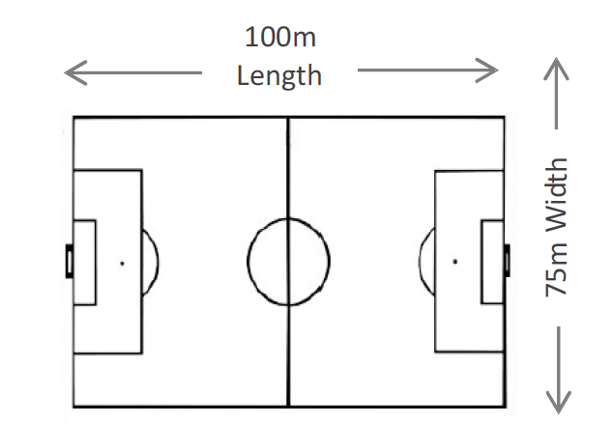

Figure Length and breadth of a soccer field

Volume describes the amount of space an object takes up. The volume of a box like the one in the diagram below is measured as: volume = length × breadth × height.

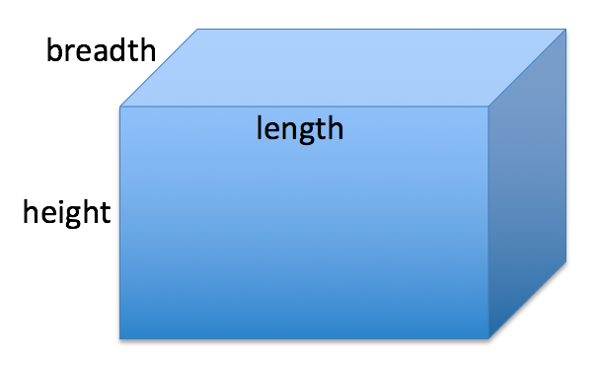

Figure Length, breadth and height of a rectangular box

Each of these is a length, measured in m, so volume is measured in m × m × m = m3.

The units of area (m2) and volume (m3) are *derived* units, since they are formed from base SI units (m).

#### Other scientific units

When working in certain fields, scientists have sometimes found it useful to derive a new unit that is very specific for the quantity that is being described. One example of this is *temperature*. In your everyday language, you express temperature in units of degrees Celsius (oC). In Science, the SI unit for temperature is Kelvin (K). The temperature of 0 K is defined as *absolute zero*, and is equal to ‑273 oC. (Scientists cannot physically reach this temperature.)

To convert from degrees Celsius into Kelvin you write:

Temperature (K) = Temperature (oC) + 273.

The example below shows how to convert between units of degrees Celsius and Kelvin.

**Example**: *(Try to solve this problem* ***on your own******or with a fellow student*** *while covering the solution, and then check your work using the solution below).*

1. Convert the temperature 25 oC into units of Kelvin.

2. Convert the temperature 200Kelvin into units of oC.

Solution

1. Temperature = 25 oC + 273 = 298 K.

2. Temperature = 200 K – 273 = -73 oC.

Another example of a quantity that uses derived units is *pressure*. In Science, the SI unit for pressure is Pascal (Pa). In some applications, for example atmospheric science, pressure is measured in units of atmospheres (atm). 1 atm = 101 325 Pa = 101,325 kPa.

**Example:** *(Try to solve this problem* ***on your own******or with a fellow student*** *while covering the solution, and then check your work using the solution below).*

a. What is a pressure of 15 atm in Pa?

In science and maths you can use the symbol ∴ as a short way of writing “therefore”.

b. What is a pressure of 100 Pa in atm?

Solution:

1. 1 atm = 101 325 Pa

∴ 15 atm = 15 × 101 325 Pa

= 1 519 875 Pa

b. 1 atm = 101 325 Pa

$∴1 Pa=\frac{1}{101325}atm$

$$∴100 Pa=\frac{100}{101325}atm=9,87×{10}^{-4}atm$$

When recording *time* measurements in science, the SI units are seconds (s). Sometimes you measure time in minutes (min) or hours (hr). There are 60 seconds in 1 minute, and 60 minutes in 1 hour. Using units, you write this as 60 min/hour, or as 60 min.hr-1. In this course you will use both ways of writing these units so that you become familiar with different ways of writing scientific numbers.

When converting between different units, if you keep a record of the units through all steps of a problem, then if you haven’t made a mistake, your final answer should have the correct units for the kind of quantity that it is. In this way you can use your units as a guide when trying to work out how to solve a problem. This is called *dimensional analysis*. The following example shows how to use dimensional analysis when converting time units.

**Example:** *(Try to solve this problem* ***on your own******or with a fellow student*** *while covering the solution, and then check your work using the solution below).*

Work out how many minutes there are in 1 day.

**Solution**:

There are 60 minutes in 1 hour. Using units, you can write this as 60 min/hr.

There are 24 hours in one day. You can write this as 24 hours/day.

To work out how many minutes there are in 1 day, you do the following calculation:

60 min/hr × 24 hours/day

Here you can treat the units as variables, and cancel them using the rules of algebra:

60 min/~~hr~~ × 24 ~~hrs~~/day = 1440 min/day

You can also use dimensional analysis to convert from units of km/hr to m/s:

**Example:** *(Try to solve this problem* ***on your own******or with a fellow student*** *while covering the solution, and then check your work using the solution below).*

A taxi travels with a speed of 72 km/hr. Write this speed in units of m/s.

**Solution**:

The conversion factor from km to m is × 103

∴ speed = 72 km/hr × 103 = 7,2 × 104 m/hr

There are 60 minutes in 1 hour, and 60 seconds in 1 minute

∴ 1 hour = 3600 seconds, which you can write as 3600 sec/hr

$$∴speed=\frac{7,2×{10}^{4} m/hr}{3600 sec/hr}=20 m/s$$

#### Activity 3: Test your understanding of physical quantities, units and measurement

Purpose

In this activity you will test your understanding of physical quantities, units and measurement by doing conversions between different kinds of units.

Suggested time**:** [20 minutes]

What you will do:

Answer the following questions.

1. The length of a pencil is 12 cm. Write this length in mm and m.
2. The mass of a cup of tea is 220 g. What is this mass in mg and in kg?
3. The diameter of a hydrogen atom is 0,1 nm. What is this diameter in m? (Write your answer in scientific notation).
4. The distance between the Earth and the Sun is 1,5 × 1011 m. What is this distance in km?
5. If the mass of a grain of sand is 2 × 10-6 g, what is this mass in µg?
6. The mass of the Earth is 5,97 × 1027 g. What is this mass in kg?
7. Convert the temperature 27 oC into units of Kelvin.
8. Convert the temperature 200Kelvin into units of oC.
9. How old is someone whose age is 7 776 023 minutes?
10. The pressure inside a balloon is 22 atm. What is this pressure in Pa, and in kPa?
11. The earth travels around the sun at a speed of 1,08 × 106 km/hr. How fast does the earth travel around the sun in m/s? Show how you get your answer using dimensional analysis.

#### Solutions:

The conversion factor from cm to mm is × 10, and from mm to m is × 10-3

1. 12 cm = 12 × 10 mm = 120 mm

120 mm = 120 × 10-3 m= 0,12 m

2. 220 g = 220 × 103  mg = 220 000 mg

The conversion factor from g to mg is × 103, and from g to kg is × 10-3

220 g = 220 × 10-3  kg = 0,22 kg

3. 0,1 nm = 0,1 × 10-9 m = 1 × 10-10 m

4. 1,5 × 1011 m = 1,5 × 1011 × 10-3 km = 1,5 × 108 km

5. 2 × 10-6 g = 2 × 10-6 × 106 µg = 2 µg

6. 5,97 × 1027 g = 5,97 × 1027 × 10-3 kg = 5,97 × 1024 kg

7. Temperature = 27 oC + 273 = 300 K.

8. Temperature = 200 K – 273 = -73 oC.

9. There are 60 minutes in 1 hour, so if you divide the total number of minutes by 60 this will give you the total number of hours.

∴7 884 000 minutes ÷ 60 minutes/hour = 1,314 × 105 hours

There are 24 hours in 1 day, so if you divide the total number of hours by 24 this will give you the total number of days.

∴1,314 × 105 hours ÷ 24 hours/day = 5,475 × 103 days

There are 365 days in 1 year, so if you divide the total number of days by 365 this will give you the total number of years.

∴ 5,475 × 103 days ÷ 365 days/year = 15 years

10. 1 atm = 101 325 Pa

∴22 atm = 22 × 101 325  Pa/atm

= 2,2292 × 106 Pa

= 2,2292 × 103 kPa

11. The conversion factor from km to m is × 103

∴ speed = 1,08 × 106 × 103 = 1,08 × 109 m/hr

There are 60 minutes in 1 hour, and 60 seconds in 1 minute

∴ 1 hour = 3600 seconds, which you can write as 3600 sec/hr

= 3 × 105 m/s

## Sub-topic 2: Problem solving techniques

## Unit 1: Problem-solving strategies

#### Learning Outcomes

By the end of the unit, you should be able to:

* use diagrams as problem solving tools;
* apply steps in problem solving procedures to solve single- and multi-step problems;
* reflect on and interpret answers to calculations.

#### Introduction

When you are trying to solve a problem in science, the solution will not always be obvious straight away. It is therefore useful to have a strategy that you follow which will help you in tackling a difficult problem. Take some time to reflect on your own strategies for solving problems in Science, or word problems in Maths:

* When you read a difficult question in an activity or an exam, what strategies do you use to try to solve the problem?
* As you reflect on your strategies, make a list of the steps that you follow.

When you are faced with a difficult problem, you might not realise that you are following certain steps until you take some time to reflect on your approach to problem solving. In your reflections, some of you might have noticed that you don’t really have a strategy, but rather just leave out difficult problems because you feel intimidated by them. It is therefore useful to learn helpful problem solving steps, so that you don’t feel intimidated by challenging problems.

#### Useful steps in problem solving

The list of steps below describes some possible strategies that you could try which will help you in tackling a difficult problem.

1. Draw a diagram of the scenario
2. Write a list of the given information
3. Read the question carefully to decide what is being asked
4. Select an appropriate equation or scientific concept for solving this problem
5. Do the calculation carefully
6. Reflect on your answer, making sure that the value you obtained is sensible, and that you have answered the question identified in Step 3. Check that the units of your answer are correct.

You will not always need to use all of these steps, but you will find some of these strategies useful at different times. In the following section you will see some examples of how you could use these strategies.

#### Using scientific formulae

Scientific formulae that are not just recipes that you follow to find an answer, they tell you important information about the mathematical relationship between scientific concepts that they represent. For example, for an object moving with a constant speed, the mathematical relationship between speed (*s*), distance (*D*) and time (Δ*t*) is that the speed of an object is the distance travelled divided by the time. This is given by the scientific formula:

$$s=\frac{D}{Δt}$$

If you know the speed and the time, you can calculate the distance covered by changing the subject of the formula to D:

*D* = *s* × Δ*t*

If you know the distance travelled and the speed, you can calculate the time by changing the subject of the formula to t:

$Δt=\frac{D}{s}$

**Example** *(Try to solve this problem on your own or with a fellow student while covering the solution, and then check your work using the solution below).*

The mathematical relationship between current (*I*), potential difference (*V*) and resistance (*R*) for a resistor in an electric circuit is:

$R=\frac{V}{I}$

Calculate the potential difference across the resistor if it has a resistance of 3 Ω and a current of 0,1 A through it.

**Solution**:

R = 3Ω

**Step 1 – Draw a diagram**

Figure Circuit diagram of the electric circuit

**Step 2 – Given:** *R* = 3 Ω

*I* = 0,1 A

**Step 3 – Work out what is being asked:**

You are asked to calculate the potential difference (V) across the resistor.

**Step 4 – Select equation or concept:**

The equation that you need to use in this case is:

$R=\frac{V}{I}$

**Step 6 – Do the calculation:**

To change the subject of the formula to *V*, you multiply both sides of the equation by *I*.

$R×I=\frac{V}{I}×I$

The *I*’s on the RHS cancel, and you can rewrite this as:

*V* = *R* × *I*

=3 Ω × 0,1 A

= 0,3 V

**Step 7 – Reflect on your answer:**

This is a very important step in problem solving, since it is easy to make a mistake when entering numbers into your calculator. Study the answer that you have found, and check that your value for the voltage looks reasonable. If it is, write down your final answer:

The potential difference across the resistor is 0,3 V.

You might not always need to use all the steps, for example drawing a diagram may not be appropriate for all problems.

#### Activity 1: Apply your knowledge of solving scientific problems

Purpose

In this activity, you will apply your knowledge of using problem solving strategies and working with scientific formulae by answering questions using the formula that links density, mass and volume.

Suggested time**:** [20 minutes]

What you will do:

The relationship between the density (*d*), mass (*m*) and volume (*V*) for an object is given by the formula:

$d=\frac{m}{V}$

Use this formula to answer the following questions:

1. Ayanda measures the mass of a stone to be 15 g, and its volume is 5 cm3. What is the stone’s density?
2. Fizile measures a cup of flour (250 cm3) and wants to know its mass. She looks up the density of flour, and finds that it is 0,4 g/cm3. What is the mass of the flour?
3. Fizile now wants to measure a mass of 500 g of flour. How many cups of flour does she need?

Note that you don’t always need to use all of the problem solving steps. In this case you don’t need a diagram since the problem is not too complicated.

#### Solutions:

1. **Given**: *m* = 15 g

*V* = 5 cm3

**What is being asked**: you are asked to calculate the density *d*

**The equation that you need to use is**:

$d=\frac{m}{V}$

**Calculation**:

$∴d=\frac{15g}{5cm^{3}}=3 g/cm^{3}$

**Reflection:** Does the answer 3 g/cm3 sound about right? Since the density of water is 1 g/cm3, you do expect the density of stone to be greater than this, so the answer looks about right.

1. **Given**: *d* = 0,4 g/cm3

*V* = 250 cm3

**What is being asked**: you are asked to calculate the mass *m*

**The equation that you need to use is**:

$d=\frac{m}{V}$

To make *m* the subject of the formula you multiply both sides of the equation by *V*:

$$∴d×V=\frac{m}{V}×V$$

The *V*’s on the right cancel, and you can rewrite this with m on the left of the equation:

$∴m=d×V$

**Calculation**:

$m=d×V$

$∴m=0,4 g/cm^{3}×250 cm^{3}=100 g$

**Reflection**: Does 100g sound about right? The mass of a cup (250 cm3) of water is 250 g, and since flour feels lighter than water, you expect the mass of 250 cm3 of flour to be less than the mass of 250 cm3)of water, so the answer does sound about right.

1. **Given**: *m* = 500 g

*d* = 0,4 g/cm3

**What is being asked**: you are asked to calculate the volume *V* in units of cups

**The equation that you need to use is**:

$d=\frac{m}{V}$

To make *V* the subject of the formula you multiply both sides of the equation by *V* and divide both sides by *d*:

$$\frac{d×V}{d}=\frac{m}{V}×\frac{V}{d}$$

The *d*’s on the left cancel and the *V*’s on the right cancel, leaving V as the subject of the formula:

$$∴V=\frac{m}{d}$$

**Calculation**:

$V=\frac{m}{d}$

$$∴V=\frac{500 g}{0,4 cm^{3}}=1250 cm^{3}$$

There are 250 cm3 in 1 cup, which you can write as 250 cm3 / cup. Therefore to find the number of cups of flour you divide:

Number of cups = 1 250 cm3 ÷ 250 cm3 / cup = 5 cups

**Reflection**: Does 5 cups sound about right? Think about this for yourself.

## Sub-topic 3: Graph drawing, analysis and interpretation

## Unit 1: Constructing and analysing straight line graphs

#### Learning Outcomes

By the end of the unit, you should be able to:

* select appropriate variables and scales for graph plotting;
* accurately construct a straight-line graph from given data;
* analyse a graph to extract meaningful information, namely:
  + value and physical meaning of the gradient of a straight-line graph;
  + value and physical meaning of the intercepts of a straight-line graph;
  + physical interpretation of the shape of a non-linear graph.

#### Introduction

Many relationships in science can be represented using graphs. It is therefore important to be able to draw clear and accurate graphs, as well as being able to read and interpret graphs. Take some time to reflect on the different types of graphs that you have learnt about before this course. Make a list of all of the kinds of graphs that you can think of.

From your reflections you should recall that there are many different types of graph which can be used in science, for example straight line graphs, curved graphs, pie graphs and bar graphs (or histograms). In this unit you will learn about how to draw and analyse straight-line graphs in the context of Physics, and in the second unit you will learn how to interpret graphs with different shapes.

#### Properties of a straight line graph

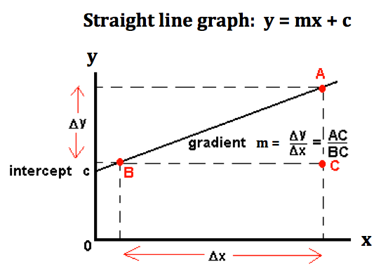A straight line graph in science shows that there is a clear mathematical relationship between the two quantities that you are showing on the graph. You can use the mathematical equation to represent the straight line:

Figure Labelled diagram of a straight line graph

*y* = *mx* + *c*

Here *m* is the gradient of the graph, and *c* is the y-intercept. You plot the dependent variable on the y-axis, and the independent variable on the x-axis.

(If you are unsure about this equation, revise the section of your mathematics course on straight line graphs).

When finding the gradient of a straight line, choose two points that lie on the line, but which are quite far apart. Then the gradient is found in the following way:

$$gradient=\frac{Δy}{Δx}=\frac{y_{2}-y_{1}}{x_{2}-x_{1}}$$

In science, once you have calculated the gradient, the units give you an idea of the quantity that this is describing.

#### Drawing a straight line graph using experimental readings

When you plot a graph in science, it is important to choose a set of axes that allows you to plot the data points accurately. Here are some hints for choosing your axes:

* Determine a *scale* (the value for each square on your x- and y-axis) that best fits the range of each variable.
* Use a scale that lets you plot your data *as large as possible* in the space you have.
* The range of each axis might be different, but each one must have *evenly numbered steps*. If one box represents one metre at the beginning of the graph, then one box must always represent one metre for that axis.
* Number and label each axis, including the units of measurement.



On this axis 4 divisions are equal to 2 amperes.

Notice that the spacing between each axis number is even – for this axis 4 divisions are equal to 1 volt.

Figure Graph with a set of numbered axes with labels

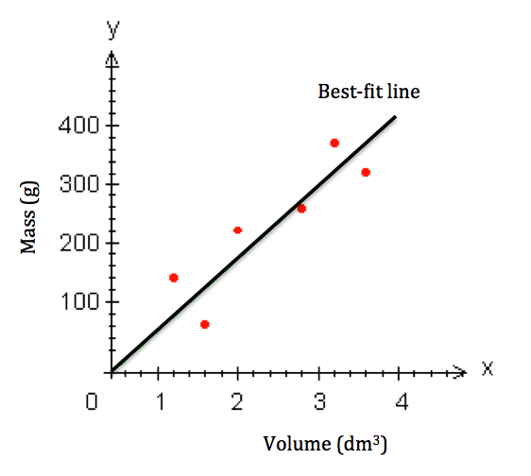

Figure Straight line graph with a best fit line

When you draw a graph in science, you are plotting experimental (measured) values on your graphs. In other words, the readings are not always exactly accurate, but contain some uncertainty. As a result, when you plot a graph the points will not always lie in a perfect straight line. For this reason, you do not connect the dots exactly as they lie, but you draw a *best-fit line*, which is your best estimate of the line that is represented by these points. In drawing the best fit line, you should try to recognise the trend that the line is showing you, and try to have an equal number of points above the line as below the line.

#### Activity 1: Apply your knowledge of solving scientific problems

Purpose

In this activity, you will apply your knowledge of straight line graphs by drawing a graph from a set of data in a table, and then calculate and interpret the gradient of the graph.

Suggested time**:** [20 minutes]

What you need:

A piece of graph paper, a sharp pencil and a ruler. (If you do not have graph paper you will find some printed at the end of this unit).

What you will do:

Read the information below and then answer the questions that follow:

Nathi measured the voltage across a resistor and the current through that resistor. The table below contains the data from his measurements.

|  |  |
| --- | --- |
| **Voltage (V)** | **Current (A)** |
| 0,0 | 0,0 |
| 1,0 | 0,18 |
| 2,0 | 0,42 |
| 3,0 | 0,60 |
| 4,0 | 0,79 |

1. On your piece of graph paper, plot a graph of the values of the voltage (on the y-axis) and current (on the x-axis). Draw a best-fit line through the points.
2. Calculate the gradient of this line.
3. What physical quantity does this gradient tell you about?

You can check your graph plotting by going to the following web address:

<http://skipper.physics.sunysb.edu/~physlab/doku.php?id=phy133:plottingtool>

Enter the current values as the x values, and the voltage values as the y values, as the diagram below shows:

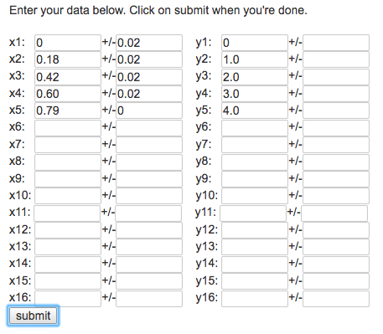

Figure Screenshot of x and y data values for the graph

Once you have entered all of the values form the table, press the submit button to see the graph. You can check your gradient calculation by looking at the values labelled “a”.

#### Solution:

1. Your graph of the voltage plotted against current for the resistor should look something like the graph shown below. The best fit line is also shown on the graph.

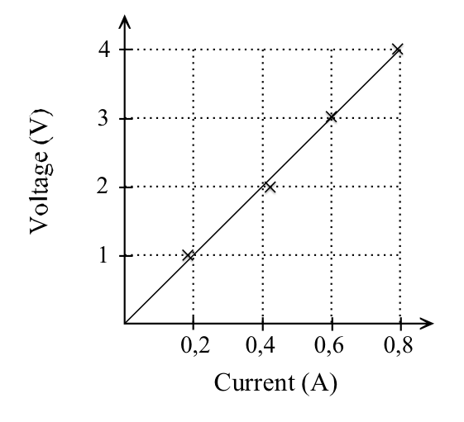

Figure Straight line graph of voltage plotted against current

1. To find the gradient of this line, you choose two points that lie exactly on the line.

In this case you could choose the points:

(x1, y1) = (0 A, 0 V) and (x2, y2) = (0,8 A, 4 V).

1. The gradient tells you that the resistance of the resistor is 5 $Ω$.

A straight line graph that goes through the origin, such as the one you drew in this activity, tells you that the values that you have plotted on the x- and y-axis are *directly proportional* to each other. In the example from Activity 1, you can write this as “*voltage is proportional to current*”, or

$$V∝I$$

Another way of writing this is:

$$\frac{V}{I}=k$$

Here *k* is the *constant of proportionality*. In Activity 1 the constant of proportionality is the resistance of the resistor.

Some straight line graphs don’t go through the origin, but have an intercept on the x- or y-axis. This intercept can give you useful information. For example, in the graph below, the y-intercept tells you that the starting position of the person was 1 m at time t = 0 seconds.

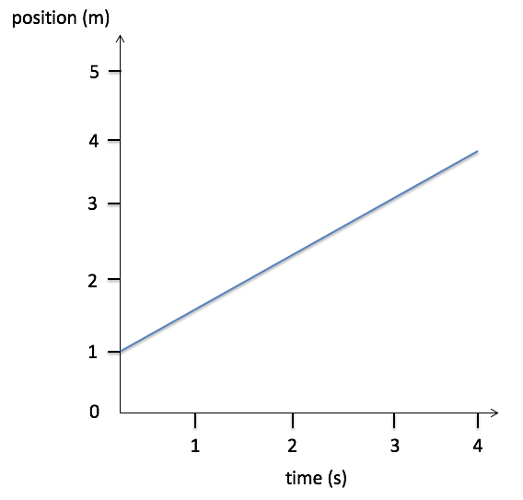

Figure Graph of a person's position plotted against time

In the following graph, the x-intercept tells you that the temperature was 0oC at a time of 1 second.

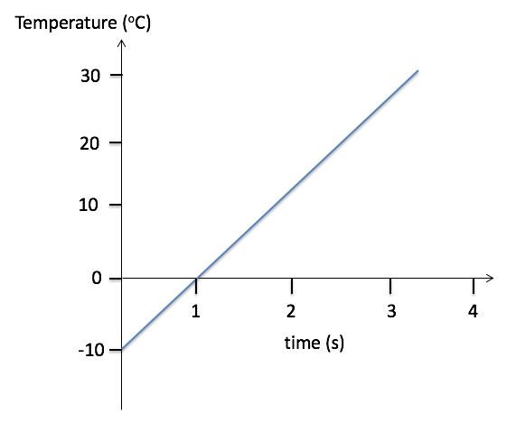

Figure Graph of temperature plotted against time for a liquid that is heated

#### More resources to help you:

The following website has a YouTube teaching video on straight line graphs: *Graphs for Physics and Maths - Linear graphs:*

<https://www.youtube.com/watch?v=soz4MbtvZp0> (Duration: 5.29)

In this video, the section from 1.10 to 2.50 shows how to plot experimental data points and draw a best fit line through them.

On the following page there is a copy of graph paper for you to use for Activity 1.



Figure Graph paper for drawing graphs

## Unit 2: Interpreting the shapes of non-linear graphs

#### Learning Outcomes

By the end of the unit, you should be able to:

* analyse a graph to extract meaningful information, namely:
  + physical interpretation of the shape of a non-linear graph.

#### Introduction

In the first unit you learnt how to draw and analyse straight-line graphs in the context of Physics. Not all scientific graphs are straight line graphs. In this unit you will be introduced to the shape and meaning of some of the different kinds of graphs.

#### Curved graphs

Sometimes the y-values of a graph don’t rise linearly with the x-values, but form a curve instead. You need to look carefully at the shape of the curve to see how the relationships between the y and x values change. For example, in the graph below, the y-values rise more quickly at the beginning, and more slowly at the end. You will work with graphs like this in the Mechanics section of this course.

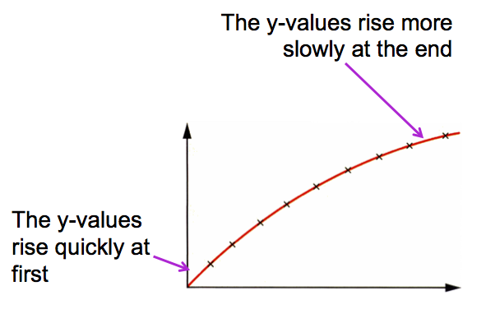

Figure A curved graph

#### Periodic graphs

There are many situations in nature where a quantity changes periodically with time, in other words there is a regular repeated pattern. An example is when a ball attached to a rope swings backwards and forwards repeatedly. The graph below is an example of a periodic graph. You will work with graphs like this in the Waves section of this course.

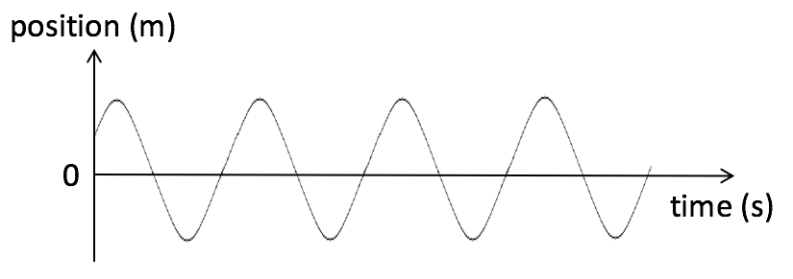

Figure A periodic graph

#### Inverse proportion graphs

The graph on the right has a hyperbola shape, and this shows that the quantities on the graph are inversely proportional to each other. What this means is that, as the x-value increases, the y-value decreases in value.

For the graph shown on the right, A is *inversely proportional* to B.

Figure A is inversely proportional to B

You can write this mathematically as:

$A∝\frac{1}{B} OR B∝\frac{1}{A}$

#### Activity 1: Consolidate your learning of basic scientific skills

In this activity you will consolidate your learning of basic scientific skills by answering the questions below and then assessing your own understanding using the solutions provided. Give yourself a mark out of the total of 30 marks, which will give you an idea of how well you understand this section of the work.

Suggested time**:** [40 minutes]

What you will do**:**

Answer the following questions:

1. The diameter of a needle is 0,1 mm. What is this length in the following units (write your answers in scientific notation): (6)
   1. nm
   2. µm
   3. km
2. Use the steps in the problem solving strategy to answer the following question: A glass container has a mass of 0,12 kg. This container is filled with 250 cm3 of water. A teaspoon of salt (5 cm3) is added to the water. The density of water is 1 g.cm-3, and the density of salt is 2 g.cm-3. What is the total mass of the water, the salt and the container together? Give your answer in g and in kg. (Use the equation $d=\frac{m}{V})$. (6)
3. Sandile did an experiment with an electric circuit consisting of a variable power supply, a resistor and an ammeter. He attached the voltmeter in parallel to the resistor. He took the current reading on the ammeter for different settings on the power supply. His results are shown in the table below:

|  |  |
| --- | --- |
| **Voltage across R (V)** | **Current through R (A)** |
| 1,5 | 4,2 |
| 2,0 | 5,3 |
| 2,5 | 6,7 |
| 3,0 | 8,3 |
| 3,5 | 9,3 |

* 1. Plot these points on a set of axes like the one below. (5)



Figure Axes for the graph of voltage vs current

* 1. Draw a best-fit line through your points. (1)
  2. Find the gradient of the best-fit line. (5)
  3. What physical quantity does this gradient tell us about? (1)

1. In your own words, describe the relationship between the two variables shown in the following graphs.
   1. (2)

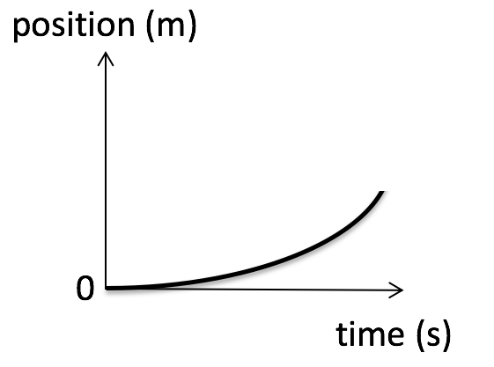

Figure Graph of position vs time

* 1. (2)

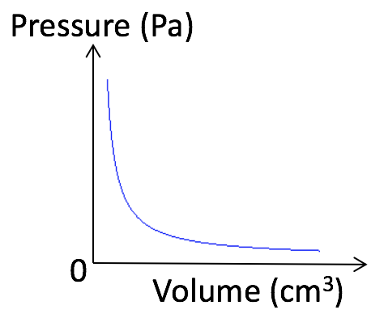

Figure Graph of pressure vs volume

* 1. (2)

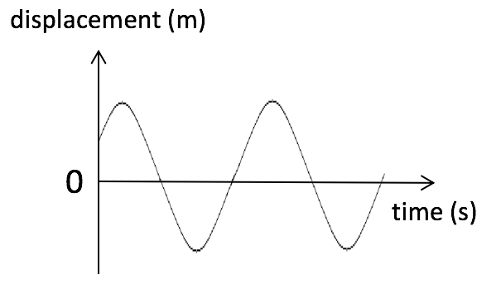

Figure Graph of displacement vs time

#### Solutions:

1. To find the length in the different units, first convert mm to m:

0,1 mm = 0,1 × 10-3 m = 1 × 10-4 m

* 1. To find the length in nm, the conversion factor from m to nm is × 109

1 × 10-4 m = 1 × 10-4 × 109 nm = 1 × 105 nm (2)

* 1. To find the length in µm use the conversion factor from m to µm of × 106

1 × 10-4 m = 1 × 10-4 × 106 nm = 1 × 102 µm (2)

* 1. To find the length in km use the conversion factor from m to km of × 10-3

1 × 10-4 m = 1 × 10-4 × 10-3 nm = 1 × 10-7 km (2)

1. The steps in the problem solving strategy are shown below: (6)

**Step 1 – Draw a diagram**

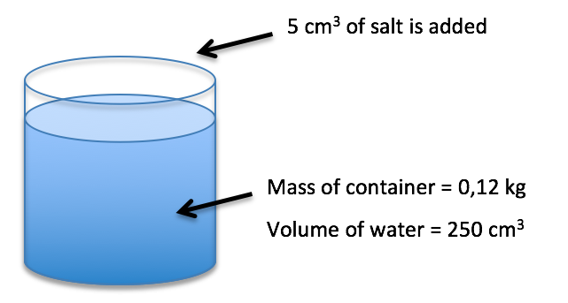

Figure Diagram with information (1)

**Step 2 – Given:** Mass of container = 0,12 kg = 0,12 × 103 g = 120 g **(1)**

Volume of water = 250 cm3

Density of water = 1 g.cm-3

Volume of salt = 5 cm3

Density of salt = 2 g.cm-3

**Step 3 – Work out what is being asked:**

You are asked to calculate the total mass, i.e. mass of water + mass of container + mass of salt.

**Step 4 – Select equation or concept:**

The equation that you need to use in this case is:

$d=\frac{m}{V}$

To make *m* the subject of the formula you multiply both sides of the equation by *V*:

$$∴d×V=\frac{m}{V}×V$$

The *V*’s on the right cancel, and you can rewrite this with m on the left of the equation:

$∴m=d×V$**(1)**

**Step 5 – Do the calculation:**

Mass of water: m = d × V = 1 g/cm3 × 250 cm3 = 250 g

Mass of salt: m = d × V = 2 g/cm3 × 5 cm3 = 10 g

Total mass = mass of water + mass of container + mass of salt

= 250 g + 120 g + 10 g = 380 g **(1)**

In kg, total mass = 380 × 10-3 kg = 0,38 kg **(1)**

**Step 6 – Reflect on your answer:**

The total mass of the container, the water and the salt is 380 g, which is 0,38 kg.  **(1)**

1. a. and b. The plotted points and best fit line are shown on the diagram below:

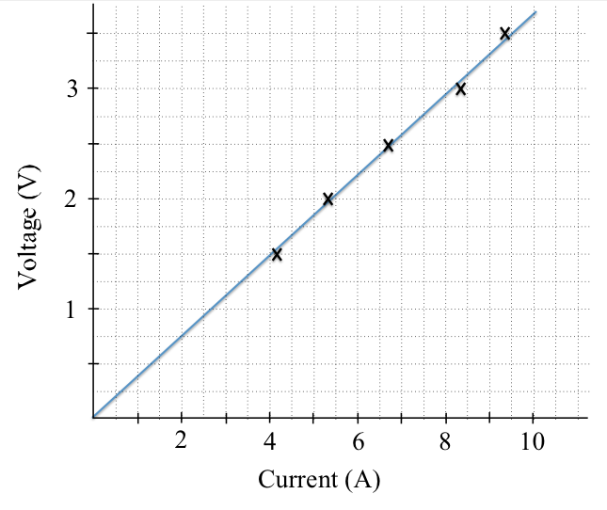

Figure Straight line graph of voltage vs current

**(1)** mark for each correctly plotted point = (5)

**(1)** mark for the best-fit line = (1)

c. $gradient=\frac{Δy}{Δx}=\frac{y_{2}-y_{1}}{x_{2}-x_{1}}$

$$∴gradient=\frac{3,5 V-0 V}{9,5A -0 A}=0,37 Ω$$

(1) mark for each correct current and voltage reading + (1) for correct answer (between 0,35 $Ω$ and 0,4 $Ω$) (5)

d. The gradient tells us that the resistance of the resistor is 0,37 . (1)

* 1. As time increases, position rises more slowly at the beginning, and more quickly at the end (**OR** speed of movement is increasing) (2)
  2. As volume increases, pressure decreases (**OR** volume is inversely proportional to pressure) (2)
  3. As time increases, displacement changes periodically from positive to negative values in a regular repeated pattern. (2)