# Section 3: Waves

You experience waves all the time in the world around you, whenever you see or hear anything. You can represent waves using simple diagrams that show their structure and characteristics. By understanding waves you can predict their behaviour in different conditions, and you can put them to use in many helpful ways.

In this topic you will learn about the two different types of waves, namely transverse and longitudinal waves, and how you experience these in everyday life. You will also learn about geometrical optics, which looks at the behaviour of light as it reflects and bends, and how this can be applied in everyday life.

## Sub-topic 1: Transverse and longitudinal waves

### Unit 1: Transverse waves

#### Learning Outcomes

By the end of the unit, you should be able to:

* describe wave motion as a vibration in a medium, resulting in the transfer of energy without matter being transferred;
* define frequency, wavelength, period and amplitude;
* draw a diagram of a transverse wave and indicate the wavelength, amplitude, particle movement and direction of propagation of the wave;
* give examples of transverse waves;
* define the wave speed as the product of the frequency and wavelength of a wave $v=fλ$ (the wave equation);
* apply the wave equation to solve problems involving transverse waves, in familiar and novel contexts.

#### Introduction

What images come to mind when you hear the word “wave”? Write down a list of words that you can think of that are linked with waves.

Some of you might think about a hand waving backwards and forwards when you hear the word “wave”. This gives us a clue about what a wave is – it involves a regular, repeated movement, like a hand that is waving. Some others of you might think about waves in water when you hear the word “wave”. If you think about water waves that reach the edge of a pool or lake, they arrive in regular time intervals. This regular movement is an important characteristic of waves, and can be seen in the photograph of water waves below.

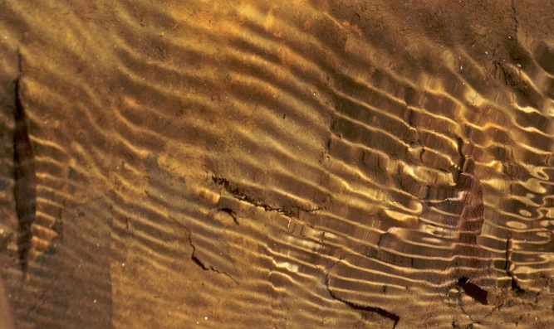

Figure 1 Photograph of a wave in water

In science you describe a wave as a regular disturbance that takes place in a medium, resulting in a transfer of energy through the medium. [Word box: *medium* - the substance that a wave travels through] In other words, a wave is a repeated movement, where the particles of the medium move backwards and forwards in a regular rhythm.

Water waves are just one example of waves from everyday life. Other examples are light waves and sound waves. In this unit you will learn about what is meant by the term transverse waves, and you will explore the characteristics of these, and how to calculate scientific properties such as wave speed and frequency.

#### Activity 1: Observe the movement of a transverse wave

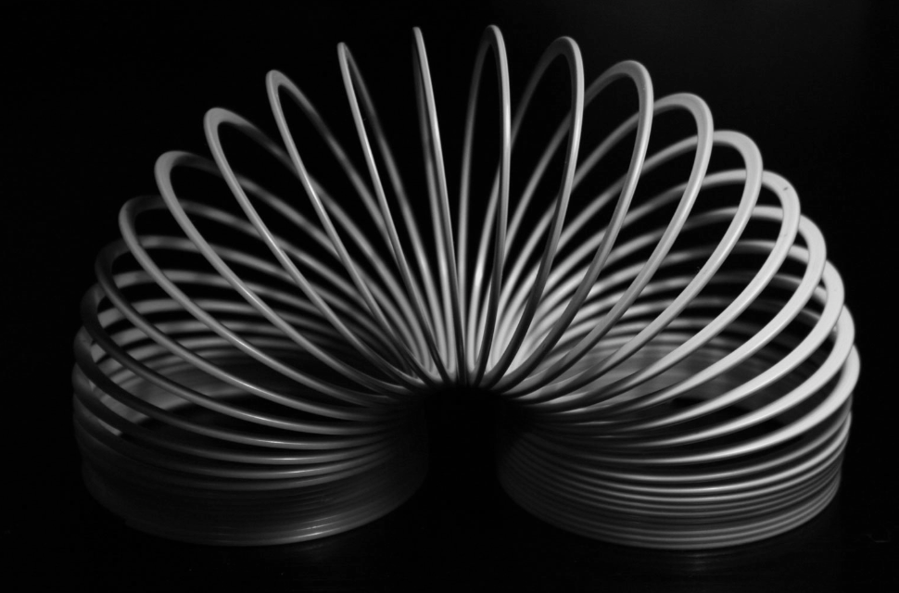

Figure 2 Photograph of a slinky

Purpose

In this activity you will create a wave on a rope or a slinky so that you can become familiar with some of the characteristics of transverse waves. A slinky is a long stretchy spring (shown in the photograph on the right).

What you need:

* A long slinky, or a rope
* A piece of coloured cloth

Suggested time: [20 minutes]

What you will do:

* Put the slinky or rope on a smooth floor or on a large desk top.
* Two students should hold the ends of the slinky so that it is slightly stretched. If you are using a rope, make sure that the rope is quite loose and free to move.
* Move the end of the slinky up and down quickly to make a wave.
* What do you observe?
* Tie a piece of coloured cloth or wool somewhere in the middle of your slinky or rope. This will represent a particle.
* Now send a wave along the slinky and observe what happens to the coloured cloth. Did the piece of cloth move forwards with the wave?
* Explain the movement of the piece of cloth in your own words.

NOTE: If you do not have the equipment you can see a YouTube video that shows a transverse wave: *Transverse Waves on a Slinky:* <https://www.youtube.com/watch?v=y66PSaiGH7Y> (Duration: 1.12)

#### Guided reflection

In this activity you should have noticed that as your hand moves backwards and forwards (or up and down), a wave moves along the slinky in a regular movement. The movement of the piece of cloth in the activity shows how the particles of the medium move as the wave passes through the slinky or rope. You would have observed that the piece of cloth moves from side to side, and does not move forward in the direction of the wave.

The wave that you have created on your rope or slinky is an example of a *transverse wave*, which is the type of wave where the particles of the medium move at right angles (transverse) to the movement of the wave through the medium.

#### Characteristics of transverse waves

The wave shown in the diagram below is a *transverse wave*. (There is another type of wave, called a longitudinal wave, which you will learn about in Unit 2.)



Rest position

Figure 3 A transverse wave

From this diagram, you will notice that the wave has a regular pattern. Some of the key characteristics of a transverse wave are described in the following points:

* The sections of the wave that are at a maximum displacement above the rest position are called “*peaks*”. [Word box: *rest position* – the position that the particles of a medium would have if there was no wave]
* The sections that are at a maximum displacement below the rest position are called “*troughs*”.
* The *amplitude* of the wave is the distance between the peak of a wave and its rest position, or the distance between the trough and the rest position.
* Positions on a wave that have a whole number of wavelengths between them are *in phase* with each other. For example, the troughs of a wave are in phase with each other. In the diagram below, points A, B and C are in phase with each other.

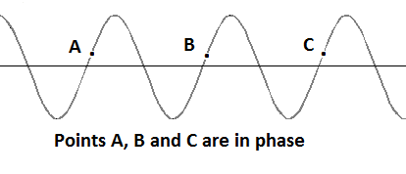

Figure 4 Points that are in phase on a transverse wave

* The *wavelength* is the horizontal distance between any two consecutive points on a wave that are in phase. For example, the wavelength is the horizontal distance between two consecutive troughs, or two consecutive peaks, or the distance from A to B, or B to C in the above diagram. In Physics the symbol $λ$ (called “lambda”) is used for the wavelength, measured in metres (m).
* The *particles* of the medium vibrate from *side-to-side*, at right angles (transverse) to the direction of the movement of the wave. They do not move forward with the wave, it is the energy that moves forward through the medium.



Figure 5 Particle movement and wave movement for a transverse wave

* Examples of transverse waves are water waves and light waves.

[Wordbox: MAIN IDEAS:

* *Wavelength*($λ$) is the distance between two parts of a wave that are in phase
* *Amplitude* is the distance between the peak of a wave and its rest position (or between the trough of a wave and its rest position)
* The *particles* of the medium move from side-to-side, *transverse* to the direction of the movement of the wave.]

#### Frequency, period and speed of a wave

The *frequency* (*f*) of a wave is the number of full wavelengths that pass a fixed point *in one second* (per second). Frequency is measured in units of *per second* (/s or s‑1), which is also be called *hertz* (Hz).

The *period* (*T*) of a wave is the time that it takes for a full wavelength to pass a fixed point, measured in *seconds* (s). The period is mathematically related to the frequency in the following way:

*T* = 1 ÷ f (which you can write as T = 1/f)

The *wave equation* links the speed of a wave with the frequency and wavelength:

v = f × λ

where v is the speed of the wave, measured in metres per second (m.s-1)

f is the frequency, measured in hertz (Hz) or (s-1)

λ is the wavelength, measured in metres (m).

Here is an example of the kind of wave problem that you need to know how to solve.

***Example:*** *(Try to solve this problem on your own or with a fellow student while covering the solution, and then check your work using the solution below).*

Six full wavelengths of a wave that has wavelength of 20 cm pass by a fixed point in a time of 3 seconds. Calculate the following for this wave:

1. frequency
2. period
3. speed.

Remember that the conversion factor from cm to m is × 10-2.

***Solution:***

Given: λ= 20 cm = 20 × 10-2 m = 0,2 m

6 full wavelengths pass a point in 3 seconds

Calculation:

1. To find the frequency you need to find the number of wavelengths in 1 second.

You are told that 6 full wavelengths pass a point in 3 seconds

∴ in 1 second there are 6÷3 = 2 wavelengths

Therefore the frequency f = 2 s-1 = 2 Hz.

You can write the units for frequency as Hz or s-1. In calculations it is helpful to use s-1 so that you can keep track of what happens to the units.

1. To find the period you use the equation:

T = $\frac{1}{f}$

= $\frac{1}{2 s^{-1}}$

= 0,5 seconds

1. To find the period you use the wave equation:

v = f

= 2 s-1 0,2 m

= 0,4 m.s-1

#### Activity 2: Identify the properties of a wave

Purpose

In this activity you will identify the properties of a wave using a diagram of a transverse wave.

Suggested time: [20 minutes]

What you will do:

Some students create a wave on a rope. The shape of the wave is shown in the diagram below. Study this diagram and answer the questions that follow.

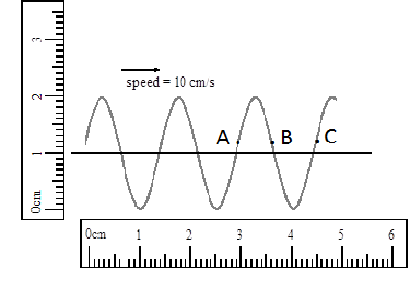

Figure 6 A transverse wave on a rope

1. What is the wavelength of this wave?
2. What is the amplitude of the wave?
3. You are given that the wave speed is 10 cm.s-1. Calculate the wave’s frequency.
4. Calculate the period of the wave. Try to do this in two ways.
5. Which of the points is in phase with point A?
6. Describe the movement of a particle at point A.

#### Solutions

1. The wavelength is the distance between two parts of a wave that are in phase. Using the ruler you measure that the wavelength of this wave is 1,5 cm.
2. The amplitude is the distance between the peak of a wave and its rest position (or between the trough of a wave and its rest position). Using the ruler you measure that the amplitude of this wave is 1 cm.

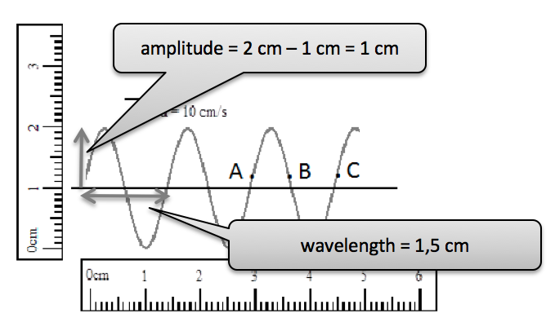

Figure 7 A transverse wave showing amplitude and wavelength measurements

Remember to always write down the information that you are given when you are solving a problem.

1. Given: v = 10 cm.s-1

= 10 × 10-2 m.s-1 = 0,1 m.s-1

λ = 1,5 cm

When you convert from cm to m you divide by 100, which is the same as multiplying by 10-2

= 1,5 × 10-2 m = 0,015 m.

Calculation:

The wave equation that links the wave speed with frequency and wavelength is: v = f x $λ$

Using this equationyou can find the frequency by making f the subject of the formula:

To make f the subject of the formula, you divide both sides of the wave equation by $λ$*:*

$\frac{v}{λ}$*= $\frac{f×λ}{λ}$* which gives you f = $\frac{v}{λ}$

f = $\frac{v}{λ}$

= $\frac{0,1 m∙s^{-1}}{0,015 m}$

= 6,7 Hz

1. To find the period, you use the equation that links the period of the wave with the frequency:

T = $\frac{1}{f}$

= $\frac{1}{6,7 s^{-1}}$

= 0,15 seconds

1. Two points are in phase when they are separated by a whole number of wavelengths. Therefore Point C is in phase with point A, since it is separated from point A by one whole wavelength.
2. Point A moves up and down as the wave passes, at right angles to the speed of movement of the wave.

#### Activity 3: Explore a simulation of a wave

Purpose

In this activity you will explore on online (internet) simulation of making waves on a string.

Suggested time: [30 minutes]

What you will do:

* Go to the following web address: <https://phet.colorado.edu/sims/html/wave-on-a-string/latest/wave-on-a-string_en.html>
* Choose the following settings for the simulation:
  + Choose the *oscillate* setting at the top left of the screen.
  + Choose the *No End* setting at the top right of the screen.
  + Move the slider for *Damping* to the left (None)
* Observe the wave that is formed. Observe the movement of the green dot – this shows the movement of the particles as a wave passes.
* Now click the button that is labelled Rulers. Try to work out the amplitude of the wave using the ruler, and compare your answer to the amplitude value shown on the screen.
* Click on the Pause button (it looks like this: ). With the wave paused, measure its wavelength using the ruler. Use this value together with the frequency value shown on the screen to work out the speed of the wave. Try this for a few different values of the frequency (don’t forget to click the play button  each time you adjust the frequency). As you adjust the frequency, what do you notice about the wavelength?
* Have fun playing with some of the other settings of the simulation.

#### Guided reflection

If the frequency of the wave is decreased, the wavelength will increase. When you calculate the speed of the wave, you should find the same answer each time. An example calculation is shown below:

With the frequency set to 1,50 Hz, you should find a wavelength of 4,2 cm. You can then calculate the speed using the wave equation:

v = f $×$ $λ$

= 1,50 Hz $×$ 4,2 cm

= 6,3 cm.s-1

#### Activity 4: Test your understanding of the characteristics of a wave

Purpose

In this activity you will test your understanding of the characteristics of waves.

Suggested time: [20 minutes]

What you will do:

Reflect on the following scenario, and answer the questions that follow:

Ntombi is sitting in a boat watching water waves. She observes that 4 wavelengths of a wave pass the front of her boat in 6 seconds, and that the distance between three consecutive peaks is 60 cm. She notices a leaf floating on the surface of the water.

1. Describe the movement of the leaf as the wave passes it.
2. Calculate the wavelength of the wave.
3. Calculate the wave’s frequency.
4. Calculate the period of the wave.
5. Calculate the wave’s speed.

#### Solutions

1. As the wave passes, the leaf moves up and down. It does not move forward in the direction of the speed of the wave.
2. If the distance between three consecutive peaks is 60 cm, this means that two full wavelengths have a length of 60cm.

Therefore the length of one wavelength is

$λ$ = 60 cm $÷$ 2 = 30 cm.

1. To find the frequency you need to find the number of wavelengths in 1 second. If 4 full wavelengths pass the boat in 6 seconds, this means that the number of wavelengths in 1 second are:

frequency =

=

= 0,67 s-1

Therefore the frequency is f = 0,67 Hz.

1. To find the period you use the equation:

T = $\frac{1}{f}$

= $\frac{1}{0,67 s^{-1}}$

= 1,55 seconds

1. To find the wave’s speed you use the wave equation:

v = f $×$ $λ$

= 0,67 Hz $×$ 0,3 m

= 0,2 m.s-1

### Unit 2: Longitudinal waves

#### Learning Outcomes

By the end of the unit, students should be able to:

* differentiate between transverse and longitudinal waves, and give examples of longitudinal waves;
* define frequency, wavelength, period and amplitude for a longitudinal wave;
* apply the wave equation to solve problems involving longitudinal waves, in familiar and novel contexts.

#### Introduction

Recall from the previous unit what a transverse wave is.

* Can you describe the shape of a transverse wave?
* How do the particles of the medium move as the wave passes?
* Recall the wave equation that you used to find the wave speed.

In this unit you will learn about a different kind of wave, called a longitudinal wave, and you will learn the characteristics of this kind of wave.

#### Activity 1: Observe the movement of a longitudinal wave

Purpose

In this activity you will create a longitudinal wave on a slinky so that you can become familiar with some of the characteristics of longitudinal waves.

What you need:

* A long slinky
* A piece of coloured cloth or wool

Suggested time: [20 minutes]

What you will do:

* Put the slinky on a smooth floor or on a large desktop.
* Two students should hold the ends of the slinky so that the slinky is slightly stretched.
* One student should hold their end of the slinky steady while the other moves theirs to create the wave. This student should move this end of the slinky forward (towards the other student) and then backward (away from the other student) in a continual movement.
* What do you observe about the longitudinal wave? Write a description of this wave in your workbooks.
* Can you identify the wavelength of the wave? Discuss your ideas with other students.
* Tie a piece of coloured cloth or wool to some point along the slinky. This represents a particle on the slinky. Create a longitudinal wave, and observe the movement of the cloth. What does this tell you about the movement of a particle as a result of a longitudinal wave? Discuss your observations with other students.
* Recall that the amplitude of a wave is the maximum displacement of a particle from its rest position. By observing your piece of coloured cloth, can you identify the amplitude of this longitudinal wave?

NOTE: If you do not have the equipment you can see a YouTube video that shows a longitudinal wave: *Longitudinal Waves on a Slinky:* <https://www.youtube.com/watch?v=GIkeGBXqWW0> (Duration: 1.25)

#### Guided reflection

In this activity you should have observed the following:

* When you quickly move the end of the slinky forward and then backward again, you will notice a compression (a group of tightly packed coils) that moves along the length of the slinky.
* When you create a longitudinal wave by moving the free end of the slinky forward and backward continuously, a longitudinal wave will travel along the slinky. This wave has a series of compressions which travel along its length. In between the compressions there are areas where the coils of the slinky are most widely spaced. These are called rarefactions.

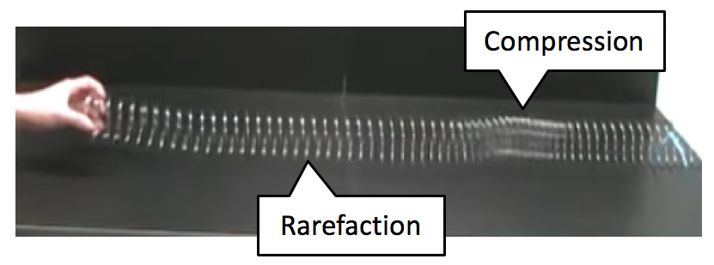

Figure 8 Photograph of a longitudinal wave on a slinky

* The wavelength of the longitudinal wave is the distance between consecutive compressions (or between consecutive rarefactions).
* When you tie a piece of coloured cloth to some point along the slinky, you will notice that this cloth does not move forward with the wave, but vibrates backwards and forwards as the wave passes along the slinky. This demonstrates the movement of particles caused by a longitudinal wave.
* The direction of the particle movement is sometimes parallel with the direction of the wave speed, and sometimes it is opposite to this direction (since it vibrates backward and forward, whereas the wave travels steadily forward).
* The amplitude of the longitudinal wave is the maximum distance that the piece of string moves away from its rest position. You need to observe the movement of the string carefully to be able to identify this.

[Wordbox: MAIN IDEAS:

* In a longitudinal wave, the *particles* of the medium *vibrate* backwards and forwards around a fixed position.
* The direction of the movement of the wave is away from the source.
* The *wavelength* of a longitudinal wave is the distance between two successive compressions, or two successive rarefactions.]

#### Activity 2: Draw a longitudinal wave

Purpose

In this activity you will use what you learnt in Activity 1 to draw a longitudinal and label its characteristics.

Suggested time: [15 minutes]

What you will do:

* Draw a diagram showing what a longitudinal wave looks like on a slinky.
* On your diagram, show and label the following:

1. the compressions and rarefactions of the wave
2. the wavelength of the wave
3. the direction of motion of the wave
4. the direction in which a particle of the medium moves

#### Guided reflection

Your diagram should look similar to the one below:

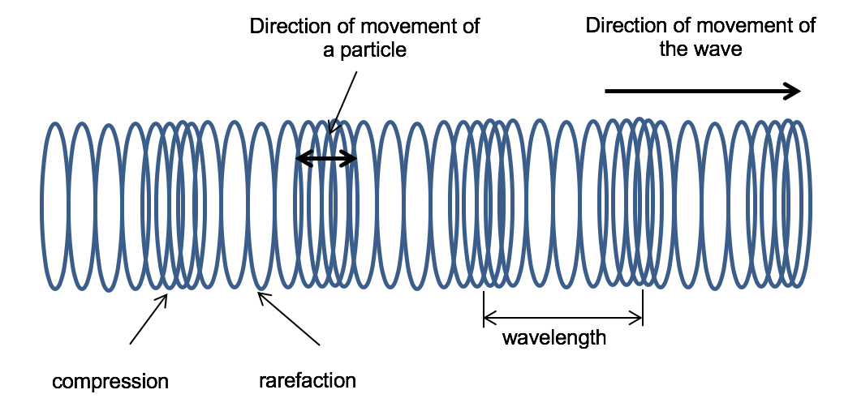

Figure 9 Labelled diagram of a longitudinal wave

#### Properties of longitudinal waves

Similar to transverse waves, the *frequency* (f) of a longitudinal wave is the number of complete wavelengthsthat pass an observer in one second. The *period* (T) of a longitudinal wave is the time that it takes for one complete wavelength to pass by a fixed point. You can again express the period in terms of the frequency:

T = $\frac{1}{f}$

The *amplitude* of a longitudinal wave is the maximum displacement of a particles from their rest position.

The *speed* of a longitudinal wave is the distance travelled by a wave compression or rarefaction divided by the time taken. The wave equation can be applied to longitudinal waves:

v = f $×$ $λ$

where v is the speed of the wave, measured in metres per second (m.s-1)

f is the frequency, measured in hertz (Hz) or (s-1)

is the wavelength of the wave, measured in metres (m).

The example below shows how you apply this wave equation to longitudinal waves.

**Example:** *(Try to solve this problem on your own or with a fellow student while covering the solution, and then check your work using the solution below).*

A longitudinal wave is formed on a slinky so that it travels along the slinky with a speed of 15 cm.s-1. The distance between two consecutive rarefactions is 0,1 m. What is the frequency of this wave?

**Solution:**

Given: λ = 0,1 m

v = 15 cm.s-1 = 15 10-2 m.s-1 = 0,15 m.s-1

Calculation:

From the wave equation v = f × $λ$ you can solve for the frequency:

f = $\frac{v}{λ}$

To make f the subject of the formula, you divide both sides by $λ$*:*

$\frac{v}{λ}$*= $\frac{f×λ}{λ}$* which gives you  *f =*

=

= 1,5 s-1 = 1,5 Hz

#### Activity 3: Test your understanding of longitudinal waves

Purpose

In this activity you will test your understanding of the characteristics of longitudinal waves.

Suggested time: [20 minutes]

What you will do:

Reflect on the following scenario, and answer the questions that follow.

A longitudinal wave is formed on a slinky so that it travels along the slinky with a speed of 20 cm.s-1. The distance between three successive compressions is 1,6 × 10‑2 m.

1. What is the wavelength of this wave?
2. What is the frequency of the wave?
3. What is the period of the wave?
4. If a particle of the medium moves a total distance of 1 × 10-3 m between its maximum vibrations backwards and forwards, what is the amplitude of the wave?

Remember that when you convert from cm to m you divide by 100, which is the same as multiplying by 10-2

#### Solutions

1. Given: v = 20 cm.s-1 = 20 × 10-2 m.s-1 = 0,2 m.s-1

The distance between three successive rarefactions of a longitudinal wave is 2 times the wavelength.

So the wavelength is:

= ½ ×1,6 × 10‑2 m

= 8 × 10‑3 m

= 0,008 m

1. From the wave equation v = f × $λ$ you can find the frequency by making f the subject of the formula:

*f =*

=

= 25 s-1

= 25 Hz

1. T =

=

= 0,04 s

1. Amplitude = maximum vibrations from rest position (middle)

= half of full vibration (backwards and forwards)

= ½ × 1 × 10-3 m = 5 × 10-4 m

[Wordbox: **MAIN IDEAS:**

* The *frequency*of a longitudinal wave is the number of *complete wavelengths*(a compression and a rarefaction) that pass an observer **in** *one second*.
* The *period* of a longitudinal wave is the time that it takes for a complete wavelength to pass by a fixed point.
* The period is the *inverse* of the frequency: T = 1/f
* The *amplitude* of a longitudinal wave is the maximum displacement of a particle from its rest position
* The *wave speed* of a longitudinal wave is the distance travelled by a wave compression divided by the time taken.
* The speed (v) of a wave can be found using the *wave equation*: v = f $×$ $λ$]

#### Sound waves as examples of longitudinal waves

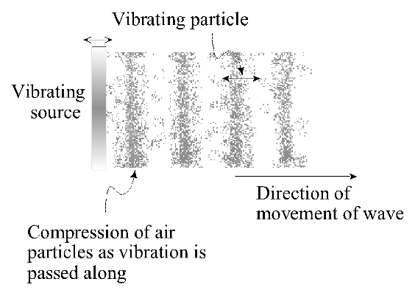

Figure 10 Representation of a sound wave

Sound waves are longitudinal waves that are created by a vibrating source, which causes the air particles closest to the source to vibrate. These particles then bump the ones next to them, passing energy on to them. As a result, the vibrations are sent outwards from the source of the sound as a pressure wave.

#### Activity 4: Observe the effect of a sound wave

Purpose

In this activity you will observe the effect of a sound wave.

Suggested time: [15 minutes]

What you need:

* A bowl
* Some plastic cling film
* Some table salt

What you will do:

* Pull the cling film over the opening of the bowl so that it is very tight.
* Pour some salt onto the cling film.
* Make a loud noise by clapping your hands, or playing loud music nearby. Watch what happens to the grains of salt on the cling film.
* Can you explain the process that has happened, from the source of the sound to the effect it has had on the salt grains?
* Your ear drums have a tight covering over them, just like this cling film. From your observations in this experiment, can you explain what happens to your ear drum when a sound reaches your ears?

#### Guided reflection

In this activity you would have observed the grains of salt vibrating with the sound. This shows that sound causes a change in the air pressure, which sends out vibrations in the air particles. The way that you hear sound is that the eardrums in your ears vibrate when they receive the pressure vibrations, and send a message to your brain.

#### Activity 5: Construct a simple tin can telephone

Purpose

In this activity you will construct a simple telephone that carries sound waves from one place to another.

Suggested time: [20 minutes]

What you need:

* Two empty tin cans
* A nail
* A long piece of string

What you will do:

* Make a hole in the bottom of each of the tin cans using the nail
* Push one end of the piece of string through the bottom of one can, and tie a knot on the inside.
* Do the same with the other end of the string in the other can.
* Take one of the cans and ask a friend to take the other one, and move apart from each other until the string is tight.
* Put the can to your ear while your friend talks into the other can.
* Now swop around and talk into your can while your friend hold their can to their ear. Discuss what you notice.
* Can you explain what is happening?

You can see a YouTube video that demonstrates how to make a tin can telephone: *How To Guides – Tin Can Telephone*: <https://www.youtube.com/watch?v=LjLiQ_DlFNY> (Duration: 1.28)

#### Guided reflection

In this activity you would have heard the sound of your friend’s voice coming from inside the can you were holding. When your friend speaks into their can, their voice makes vibrations. These vibrations travel through the air in the form of a longitudinal wave, causing the air particles to vibrate backwards and forwards, passing the wave along as they vibrate against each other. This causes the bottom of the can to vibrate as it receives or “catches” the sound wave. When the string is stretched tight enough, these vibrations travel from the bottom of the can, along the string, and vibrate the bottom of the second can. This second can then causes the vibrations to travel through the air in the form of a sound wave, and this sound wave travels through the air to your ear.

[Wordbox: MAIN IDEAS:

* Sound waves are *longitudinal waves* that are created by vibrations in a medium in the direction of propagation.
* The vibrations cause a regular variation in the pressure of the medium. Sound waves are therefore *pressure waves*. ]

#### Activity 6: Consolidate your learning of waves

Purpose

In this activity you will consolidate your learning of transverse and longitudinal waves by answering the questions below and then assessing your own understanding using the solutions provided. Give yourself a mark out of the total of 50 marks, which will give you an idea of how well you understand this section of the work.

Suggested time: [60 minutes]

What you will do:

Answer the following questions:

1. Give an example of a transverse wave, and of a longitudinal wave. (2)
2. Draw a diagram of a transverse wave and label the following on your diagram (6)
   1. The rest position
   2. The wavelength
   3. The amplitude
   4. The peak
   5. The trough
   6. Use the letters P and Q to label two points on the wave that are in phase with each other.
3. Five full wavelengths of a wave that has a wavelength of 25 mm pass by a fixed point in a time of 2 seconds. Calculate the following for this wave:
   1. frequency (4)
   2. period (3)
   3. speed. (3)
4. The diagram below shows a longitudinal wave that is formed on a spring. The wave is moving from left to right.

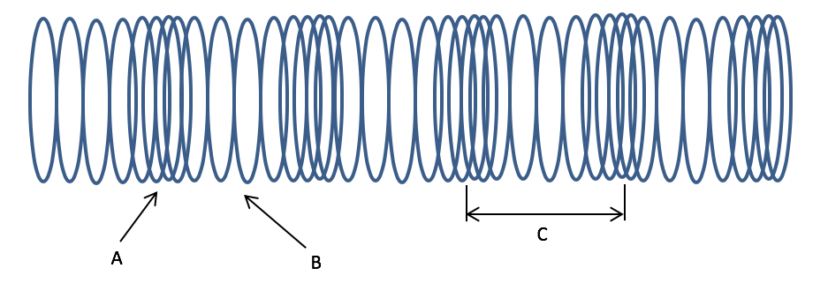

Figure 11 A longitudinal wave on a spring

* 1. Provide labels for the letters A to C. (3)
  2. Describe the movement of the particles of the medium as the wave travels through it. (2)
  3. Describe the movement of energy as the wave travels through the medium. (2)

1. Khaya and Thembi formed a longitudinal wave on a 2m long slinky. The wave took 1,6 seconds to move from one end of the slinky to the other. They tied a piece of string to the slinky, and observed that it moved a total distance of 5 mm backwards and forwards. They also observed that the distance between four successive compressions is 60 cm.
2. Explain how they should move the slinky to create this wave. (2)
3. Find the speed of the wave. (3)
4. What is the wavelength of the wave? (2)
5. Work out the number of complete wavelengths that pass the piece of coloured string in one second. (3)
6. Find the time that it takes for one complete wavelength to pass a fixed point. (3)
7. What is the amplitude of the wave? (2)
8. A sound wave with a frequency of 500 Hz travels 2,04 km through air in 6 seconds.
9. Calculate the speed of sound in air. (3)
10. Calculate the period of this sound wave. (3)
11. Calculate the distance between two successive rarefactions of the sound wave. (4)

#### Solutions

1. Example of a transverse wave: light or water wave

Example of a longitudinal wave: sound wave (2)

1. Give yourself (1) mark for each correct label on the diagram as shown below (6) 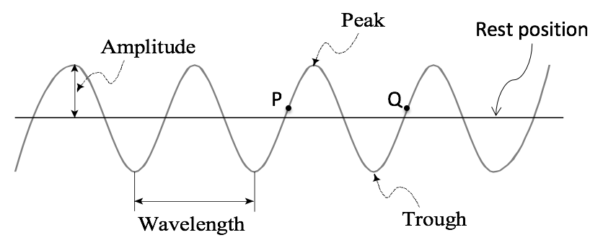

Figure 12 Labelled diagram of a transverse wave

1. Given: $λ$ = 25 mm = 0,025 m
   1. 5 full wavelengths pass a point in 2 seconds, so to find the frequency you find the number of wavelengths in 1 second:

f =

= = 2,5 s-1

Therefore the frequency f = 2,5 Hz. (4)

* 1. T =

=

= 0,4 seconds (3)

* 1. v = f

= 2,5 Hz 0,025 m

= 0,0625 m.s-1 (3)

1. 1. A = rarefaction B = compression C = wavelength (3)
   2. The particles of the medium vibrate backwards and forwards (1) around a fixed position, parallel to the direction of movement of the wave (1) (2)
   3. The direction of the movement of energy is away from the source as the wave travels through the medium. (2)
2. Khaya should hold his end of the spring steady while Thembi moves hers to create the wave. Thembi should move her end of the spring forward and then backward in a continual movement. (2)
3. Given: length D = 2 m; $∆$ t = 1,6 s

v = = = 1,25 m.s-1 (3)

1. Distance between four successive compressions (3 full wavelengths) = 60 cm

Therefore $λ$ = 60 cm ÷ 3 = 20 cm = 0,2 m (2)

1. f = = = 6,25 s-1 = 6,25 Hz (3)
2. T = $\frac{1}{f}$ = $\frac{1}{6,25 s^{-1}}$ = 0,16 seconds (3)
3. amplitude = ½ $×$ 5mm = 2,5 mm = 0,0025 m (2)
4. Given: f = 500 Hz ; D = 2,04 km = 2040 m ; $∆$ t = 6 seconds.
   1. v = = = 340 m.s-1 (3)
   2. T = = = 0,002 seconds (3)
   3. To find the distance between two successive rarefactions of the sound wave you need to calculate the wavelength:

= = = 0,68 s-1 = 0,68 Hz (4)

## Sub-topic 2: Geometrical optics

### Unit 1: Reflection

#### Learning Outcomes

By the end of the unit, you should be able to:

* describe reflection of light;
* define normal, angle of incidence and angle of reflection;
* state that, for reflection, the angle of incidence is equal to the angle of reflection;
* apply the concept of reflection in various familiar and novel contexts.

#### Introduction

Reflect on or discuss these questions with fellow students:

* What do you understand about light?
* When you look in a mirror, what do you think happens that enables you to see your reflection?

Light is everywhere around you. You would not be able to see anything if it was not for light. Light is another example of a wave. It is a special kind of wave (called an electromagnetic wave), since it does not reply on the movement of particles, but can travel through empty space. This is the reason that light from the sun can reach us here on Earth, even though there are no air particles in outer space. Nearly all of the energy on earth is caused by light that comes from the sun. In your modern society you have found many ways of making use of the properties of light, for example in microscopes, telescopes and eye-glasses.

In this unit you will start with learning about the properties of light, and then you will discover what happens to light to enable you to see your reflection in a mirror.

#### Activity 1: Observing shadows

Purpose

In this activity you will explore your shadow and reflect on what causes this.

What you need:

* A patch of sunlight
* Objects made from different materials, including glass, clear plastic, metal, wood and cloth

Suggested time: [15 minutes]

What you will do:

* Stand in the sunlight, and observe your shadow. Move around and watch how your shadow moves.
* What is the relationship between the position of your shadow and the direction from which the sunlight is shining?
* Observe your shadow for the next few days to see how the shape and length of your shadow compares at different times of the day. Try to explain your observations.
* Hold each of your objects in the sunlight and look at its shadow.
* In a table like the one below, make a list of the objects that make a clear dark shadow, and those that do not.

|  |  |
| --- | --- |
| Objects that make a dark shadow | Objects that do not make a dark shadow |
|  |  |

* Can you explain your observations?

#### Guided reflection

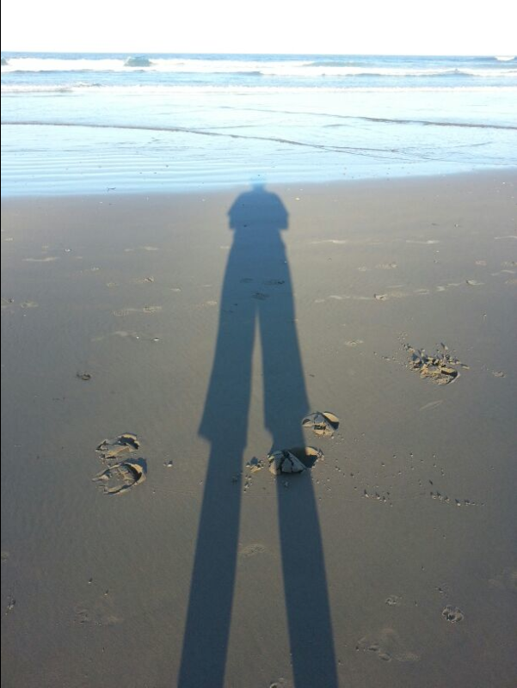In this activity you should have observed that if the sun shines from behind you, your shadow forms in front of you. Your shadow is always on the opposite side of you to the sun. This is because light travels in straight lines. When the light strikes your body, it is blocked, so that a shadow is formed where these rays have been stopped from reaching the ground.

Figure 13 Photograph of a shadow

In the activity you may have noticed that the objects that do not form a dark shadow are made of glass or clear plastic. These objects allow light to pass through them, and so they are described as *translucent*. The objects which cast a dark shadow do not allow light to pass through them. These are called *opaque* objects.

#### Properties of light

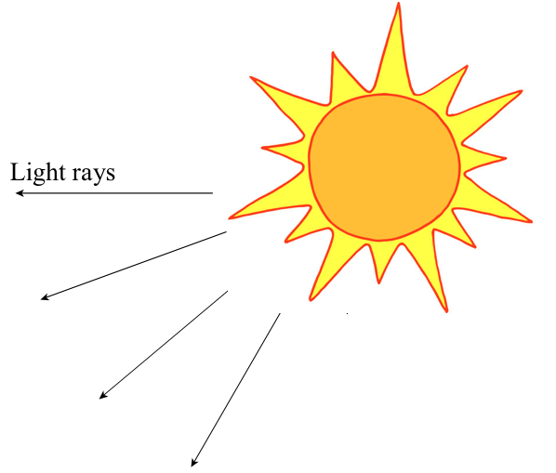As you noticed in the last activity, light travels in straight lines. Sound waves can bend around corners, but light rays cannot. This is why you can hear somebody that is around the corner but not be able to see them.

When light is given off by the sun or by a light bulb, the light waves are sent out in all different directions. You can never actually see a single light wave. In science the term “*light ray*” is used to describe a group of light waves which are all travelling in the same direction. You can use arrows to show the direction of these light rays.

Figure 14 Representation of light rays from the sun

Light travels with a constant speed as it travels through a medium. When light travels through a vacuum, it has a speed of 3  108 m.s-1. This is the maximum speed that light can have. The speed of light in air is slightly less, as it is 2,998  108 m.s-1, but in this course we will round this off to 3  108 m.s-1.

[Wordbox: *Medium*– the substance that a wave travels through

*Vacuum* - a space that is empty of matter]

Before proceeding with the next activity you need to understand a few terms:



Figure 15 The normal to the surface

When you shine light rays onto a surface, you can measure the angle that these light rays make by constructing a line that is at right angles to a surface (or perpendicular to it). This line is called the *normal to the surface*. For an example of this, see the diagram on the right.

[Wordbox: *Normal to the surface*- at a right angle to the surface, or perpendicular to the surface.]

The normal to the surface is important because when you observe the behaviour of light at surfaces, you always measure angles from the normal. In other words, you put the zero line of your protractor along the normal, and measure the angle of the light ray from this line.

Figure 16 Incident ray with angle of incidence

You call any ray that falls onto a surface an *incident ray*. The angle that this ray makes with the normal is called the *angle of incidence*.

[Wordbox: *Incident*- falling on, or striking something]



Figure 17 Reflected ray with angle of reflection

A ray that is reflected off a surface is called a *reflected ray*. The angle that this ray makes with the normal is called the *angle of reflection*.

#### Activity 2: Explore the reflection of a ray of light

Purpose

In this activity you will explore the relationship between the angle of incidence and the angle of reflection.

What you need:

* a torch, a piece of cardboard, scissors
* a piece of clean white paper, a mirror
* a pencil, a protractor, a pin

Suggested time: [20 minutes]

What you will do:

(NOTE TO STUDENTS: If you need help with doing the diagrams in this activity, you will see some hints after the activity.)

* Cut a narrow slit in the cardboard.
* Place your piece of white paper on a table top, and shine your torch through the slit in the cardboard. Can you see the light ray coming through the slit?
* Position your mirror so that the light ray shines onto it. This is your *incident ray*.
* Now move the mirror from side to side. Can you see the reflection of the light ray? This ray that is reflected from the mirror is called the *reflected ray.*

Figure 18 Ray diagram showing incident ray and reflected ray

* Can you notice any relationship between the angle that the incident ray makes with the normal to the surface of the mirror, and the angle that the reflected ray makes with the normal? (This angle is called the *angle of reflection*). Write down your observations.
* Fix your mirror in one position on the page where you see a clear incident and reflected ray. Draw a line along the surface of the mirror.
* Remove your mirror, and construct a normal to the surface. Put the mirror back into place as accurately as possible, making sure that you can see the incident and reflected rays clearly. Adjust your torch and cardboard slightly so that the incident ray hits the surface of the mirror at the same point where the normal to the surface meets the surface. (Look at the diagram if you are unsure about this.)
* Use your pin to make three dots that lie along the path of the incident ray, and three dots that lie along the path of the reflected ray.
* Remove your mirror again, and use your ruler to draw in the incident ray by connecting the three dots that you have made with your pin. Do the same for the reflected ray. You have just constructed what is called a “*ray diagram*”.
* Measure the angle of incidence and the angle of reflection using a protractor. (Remember to measure these angles from the normal). Record your readings.
* What can you conclude from your measurements?
* Repeat this experiment for 3 different angles of incidence, and record your results in a table.
* Write a conclusion to this activity based on your observations.

You can see a YouTube video that demonstrates reflection of light: *Law of Reflection Practical Activity for Students:* <https://www.youtube.com/watch?v=ETF2-Zz3J18> (Duration: 2.56)

#### Guidance for doing ray diagrams

To construct a line that is the ***normal*** to a surface, do the following:

* Draw a straight line along the surface
* Make a mark on this line where the incident ray will strike the surface.
* Position a protractor so that its zero line is along the surface line, and its centre is on this mark that you have made on the surface.
* Make a mark on the page at the 90o line of the protractor (see the diagram).

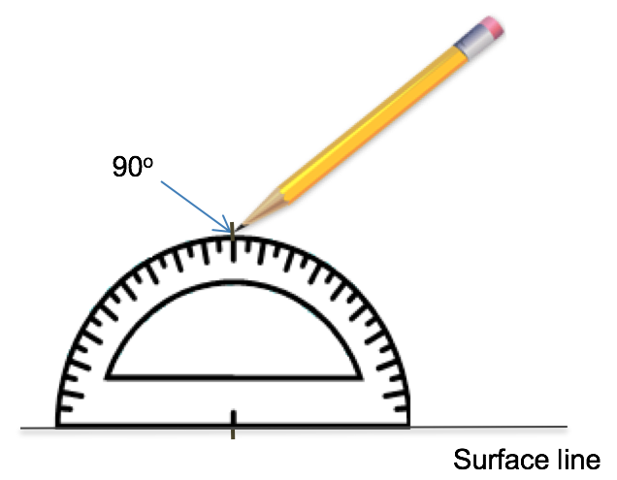

Figure 19 Making a mark at 90o using a protractor

* Remove the protractor and use a ruler to join the mark that is on the surface with the mark that you have made at the 90o line of the protractor.
* Extend this line a little bit. This line is the normal to the surface.

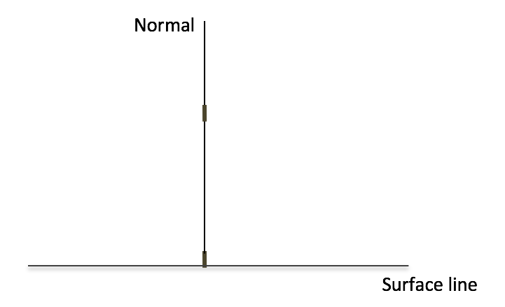

Figure 20 Drawing the normal line

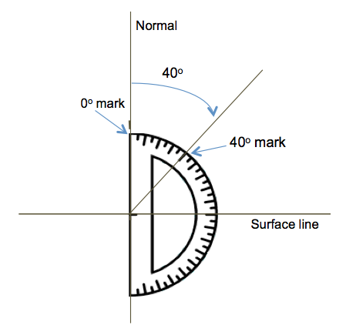

Figure 21 How to measure an angle on a ray diagram

* When you are measuring the angles of incidence and reflection, make sure that you position your protractor with the zero line along the normal, and the centre of the protractor at the point where the ray strikes the surface.
* The diagram on the right shows how an angle of 40o is measured.

#### Guided reflection

In Activity 2 you may have observed that, when light is reflected (bounced) off a surface, the angle of reflection is always equal to the angle of incidence.This is called the *law of reflection*.

[Wordbox: MAIN IDEAS:

* The normal to a surface is a line that is at right angle to the surface.
* The angle that an incident ray of light makes with the normal to the surface is called the *angle of incidence*.
* The angle that a reflected ray of light makes with the normal to the surface is called the *angle of reflection*.
* The law of reflection states that for a light ray that is reflected off a surface:

angle of incidence = angle of reflection. ]

#### How the eye sees an image formed by reflection

Rays that are reflected do not necessarily need to come from a ray box or torch. If you stand an object in front of a mirror and look into the mirror, you will see a reflection of that object. Here light rays come from the sun and are reflected off the object into the mirror. They are then reflected from the mirror into your eyes.



Figure 22 How the eye sees an image in a mirror

#### Activity 3: Explore your reflection in a mirror

Purpose

In this activity you will explore your reflection that is made when you look in a mirror.

What you need:

* A mirror
* A piece of paper with writing on it

Suggested time: [10 minutes]

What you will do:

* Stand in front of a mirror and look at your reflection.
* Where does your reflection appear to be?
* How do you think this reflection is formed? Discuss your ideas with a fellow student.
* Hold up your left hand. Does your reflection appear to be holding up the left hand or the right hand?
* Hold up your piece of paper with writing on it. How does the writing look in the mirror? Can you explain this?

#### Guided reflection

The image is formed at the *same distance* behind the mirror as the distance between the object and the mirror. The ray diagram shown below should help you to see this.

Light does not actually pass through the image that is formed. For this reason you call it a virtual image. This virtual image is upright, but is laterally inverted (in other words, the left and right hand sides are swapped around). This is why the writing that you held up in the activity looked backwards.



Figure 23 An image is formed behind the mirror

#### Activity 4: Test your understanding of reflection

Purpose

In this activity you will test your understanding of the concept of reflection of light.

Suggested time: [10 minutes]



Figure 24 Nosipho and Gareth looking into a mirror

What you will do:

Answer the following questions:

1. Nosipho is standing 2m from a mirror, reading her book. Gareth is standing 3m behind Nosipho.
   1. If Nosipho looks at Gareth’s reflection in the mirror, where will she see his image formed?
   2. If Gareth looks at Nosipho’s image in the mirror, where will he see her image formed?



Figure 25 An ambulance sign written backwards

1. The front of an ambulance has the word written backwards, as shown in the diagram on the right. Can you explain this?

#### Solutions

* 1. Nosipho will see Gareth’s image formed 5 m behind the mirror, which is 7 m away from Nosipho.
  2. Gareth will see Nosipho’s image formed 2 m behind the mirror, which is 7 m away from Gareth. (The distances are shown on the diagram below)



5 m

7 m

7 m

Figure 26 Images of Nosipho and Gareth formed in a mirror

1. When writing is reflected in a mirror, it is inverted, and so it looks like it is written backwards. So when a car sees the ambulance label (which is written backwards) in its mirror, the writing will be inverted, and will look like it is written forwards to the driver of the car.



Figure 27 Inversion of writing as a result of reflection

[Wordbox: MAIN IDEA:

When the eye sees a reflection in a mirror, the image is formed at the same distance behind the mirror as the distance between the object and the mirror, and is laterally inverted (the left and right hand sides are swapped around). ]

#### More resources to help you:

The following website has helpful explanations on the Law of Reflection, and questions that you can use to test your understanding: <https://www.physicsclassroom.com/class/refln/Lesson-1/The-Law-of-Reflection>

### Unit 2: Refraction and total internal reflection

#### Learning Outcomes

By the end of the unit, you should be able to:

* define refraction as a change of wave speed in different media, while the frequency remains constant;
* define angle of refraction, refractive index and optical density;
* draw ray diagrams to show the path of light as it travels between mediums with different optical densities;
* apply the concept of refraction in various familiar and novel contexts;
* explain critical angle and total internal reflection;
* apply the concepts of critical angle and total internal reflection in various familiar and novel contexts.

#### Introduction

Recall from the previous unit what you learnt about light and reflection.

* Why can you hear somebody who is around the corner but not see them?
* How are shadows formed?
* Is it possible to see somebody’s face in a mirror without them seeing yours?

In the last unit you learnt what happens when light is reflected off a surface, but what happens when it moves through the surface into a different medium? Does anything about the light change? In this unit you will explore this question, and see some of the ways in which this is applied in everyday life.

#### Activity 1: Observe the path of light through a different medium

Purpose

In this activity you will observe what happens to light as it moves from one medium into another.

What you need:

* A glass of water
* A pen or pencil

Suggested time: [10 minutes]

What you will do:

* Stand the pen or pencil in the glass of water.
* Move your head from side to side. Do you see anything strange about the pencil? Write down your observations.
* What do you think is causing this? Discuss this with another student.

#### Guided reflection

In this activity you would have noticed that as you moved your head side to side, at some positions the pen would have looked like it was broken at the point where it enters the water. The reason for the observation that you have made is that, when light enters a new medium its speed changes (you will explore this further later in the unit). This change in speed causes the light to bend. In this case, the light rays from the part of the pencil that is in the water (marked X in the diagram below) travel through the water, and then pass into the air. As they pass into the air, they are bent. As they enter your eye, your brain thinks that the light must have travelled in a straight line, so it forms an image by following these light rays back along their path, and forms an image in a different place to where the pencil actually is (marked Y in the diagram below).

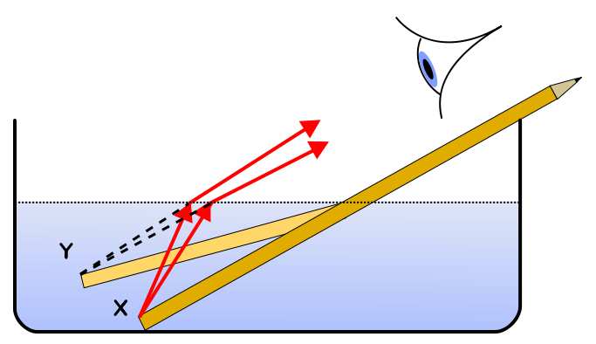

Figure 28 Refraction of light through water

(Source: Wikipedia commons)

#### Activity 2: Construct ray diagrams for refraction

Purpose

In this activity you will construct ray diagrams for light that passes from one medium into another.

What you need:

* a rectangular block of Perspex or glass
* a ray box (OR a torch shining through a slit in a piece of cardboard)
* a clean sheet of A4 paper
* a pencil
* a ruler
* a protractor

Suggested time: [20 minutes]

What you will do:

(NOTE TO STUDENTS: If you need help with doing the diagrams in this activity, you will see some hints after the activity.)

* Place your Perspex block on the A4 paper, and position your ray box so that a light ray shines onto one of the surfaces of your Perspex block at an angle (as shown in the diagram). Draw a line around your rectangular block to mark its position on the paper.

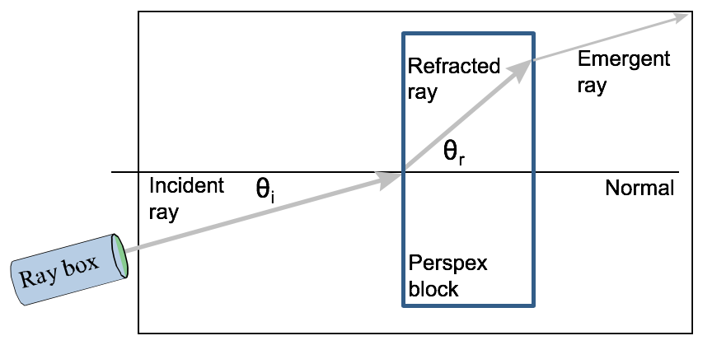

Figure 29 Refraction of light through a rectangular block

* What do you observe about the direction of the refracted ray inside the block? Is it bent towards or away from the normal to the surface? Write down your observations.
* Now look carefully at the ray that comes out on the other side of the block, as it shines back into the air (this is called the emergent ray). Is it bent towards or away from the normal?
* Use your pencil to make some marks on your piece of paper along the incident ray.
* Make a mark at the position where the refracted ray comes out of the Perspex block. Remove the block and use your ruler to draw in the incident ray, the refracted ray, and the emergent ray on your piece of paper.
* Construct the normal to the surface at the position where the incident ray strikes the surface, and at the position where the refracted ray strikes the opposite surface before emerging into the air again.
* Use your protractor to measure the angle of incidence and the angle of refraction. Remember to measure your angles *from the normal*.
* How does the angle of incidence compare with the angle of refraction?

You can see a YouTube video that demonstrates light refracted through a glass block: *Refraction Ray Diagram*: <https://youtu.be/XTMbYDrMr0w>(Duration: 3.27).

#### Guidance for doing ray diagrams of refraction

In a similar way to what you learnt in Unit 1 (Reflection), whenever you work with light rays shining onto a surface, you construct the normal to the surface. You therefore do this when light shines onto the surface between one medium and another different medium.



Figure 30 The normal to the surface of a rectangular block

The angle that the incident ray makes with the normal is called the *angle of incidence*.



Figure 31 The angle of incidence at the surface of a rectangular block

The light ray that has entered the new medium is called the refracted ray. The angle that this ray makes with the normal is called the *angle of refraction*.



Figure 32 The angle of refraction inside a rectangular block

#### Guided reflection

In this activity you would have noticed the following:

* When light is shone onto a surface along the normal to that surface, it is transmitted into the new medium without bending, as the diagram below shows.



Figure 33 Light that is incident along the normal does not bend

In the activity you would have observed that when the light ray hits the surface at an angle to the normal, this ray is bent as soon as it travels into the new medium. If the ray is moving from a medium with a low optical density (like air) to a medium with higher optical density (like glass), it is bent *towards the normal*. In other words, the angle of refraction is smaller than the angle of incidence.

Normal

Incident ray

Refracted ray

Glass

Air

Figure 34 A light ray moving from a medium with lower optical density to a higher optical density bends towards the normal (e.g. from air to glass)

If the ray is moving from a medium with a high optical density (like glass) to a medium with lower optical density (like air), it is bent *away from the normal*. In other words, the angle of refraction is greater than the angle of incidence.

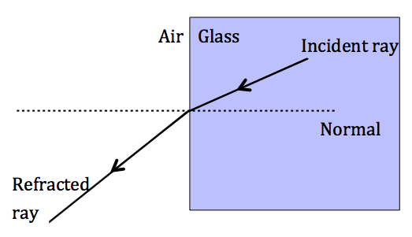

Figure 35 A light ray moving from a medium with higher optical density to a lower optical density bends away from the normal (e.g. from glass to air)

#### Activity 3: Test your understanding of refraction

Purpose

In this activity you will test your understanding of the concept of refraction of light.

Suggested time: [10 minutes]

What you will do:

Answer the following questions.

1. Explain in your own words why a pencil looks broken when it is standing in a glass of water.
2. Complete the ray diagrams shown below to show the path of light as the ray enters the new medium.

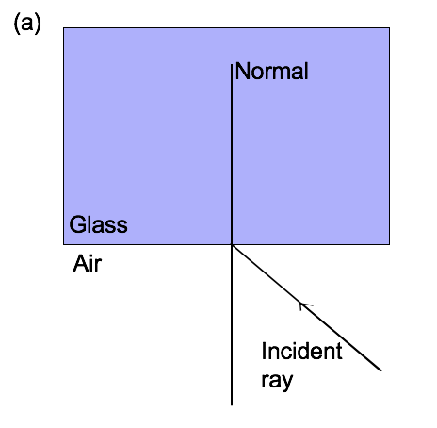

Figure 36 Light is incident on a surface from air to glass

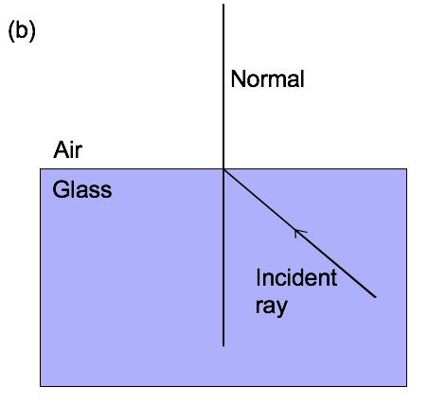

Figure 37 Light is incident on a surface from glass to air

#### Solutions

1. Your answer should contain the following key points, but expressed in your own words:

* When light enters a new medium its speed changes. This causes the light to bend.
* The light rays from the part of the pencil that is in the water travel through the water, and then bend as they pass into the air.
* As these rays enter your eye, your brain thinks that the light must have travelled in a straight line, so it forms an image by following these light rays back along their path, and forms an image in a different place to where the pencil actually is.

1. The completed ray diagrams are shown below:

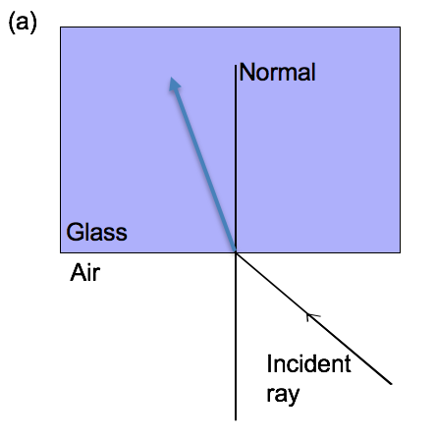

Figure 38 Light is incident on a surface from air to glass bends *towards* the normal

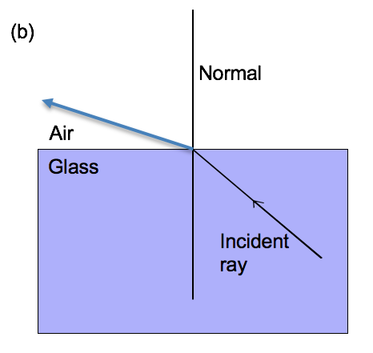

Figure 39 Light is incident on a surface from glass to air bends *away from* the normal

[Wordbox: MAIN IDEAS: When a light ray moves from one medium into a different medium:

* if it is incident at right angles to that surface (along the normal), it is transmitted into the new medium *without bending*
* if it is moving from a medium with a low optical density to a medium with higher optical density, it is bent *towards the normal*
* if it is moving from a medium with a high optical density to a medium with lower optical density, it is bent *away from the normal* **]**

#### Refractive index

When light moves from one medium into a different medium, its speed changes. This change of speed is called *refraction*. Each medium changes the speed of light by a different amount. The measure of the speed of light in a medium is called the *refractive index* of the medium. You can calculate the refractive index of a medium using the following equation:

n = $\frac{c}{v}$

where n is the refractive index of the medium (it has no units)

c is the speed of light in a vacuum = 3  108 m/s

v is the speed of light in the new medium, measured in units of m/s

This refractive index is linked with the *optical density* of the medium. The optical density is defined as “a measure of the extent to which a substance transmits light or other electromagnetic radiation”. In other words, it is a measure of how much of the light is absorbed by the substance. The more light the substance absorbs, the greater its optical density. Also, the more optically dense a substance is, the slower a wave will move through the material. So a substance with a high optical density has a high refractive index, because it slows the light wave down more than a substance with a low optical density. [Wordbox: *absorbed* – taken in, or sucked in]

As light enters a new medium and is refracted, although the speed of the light waves has changed, their *frequency is not changed*, and remains constant. The wave equation tells us that the relationship between wave speed, frequency and wavelength is v = f $×$ $λ$. So if the speed changes, and the frequency is unchanged, this means that the *wavelength is changed* as the wave enters a new medium.

The following example shows how to solve problems involving the refractive index.

**Example**: *(Try to solve this problem on your own or with a fellow student while covering the solution, and then check your work using the solution below).*

The speed of light in Perspex is 2,04  108 m.s-1. What is the refractive index of Perspex?

**Solution**:

Given: v = 2,04  108 m.s-1

c = 3  108 m.s-1

Solution:

To find the refractive index you use the equation:

nPerspex =

=

= 1,47

Therefore the refractive index of Perspex is 1,47.

#### Activity 4: Test your understanding of refractive index

Purpose

In this activity you will test your understanding of refractive index and how to calculate this.

Suggested time: [20 minutes]

What you will do:

Answer the following questions:

1. Explain in your own words what you mean by the term “refractive index”.
2. The speed of light in water is 2,25  105 km.s-1. Calculate the refractive index of water.
3. A light wave with a frequency of 7,5  1014 Hz enters glass that has a refractive index of 1,5. Find the following:
   1. The speed of the light wave in glass.
   2. The frequency of the light wave in glass.
   3. The wavelength of the light wave in glass.
4. The speed of a ray of red light in Substance X is greater than the speed of a ray of red light in Substance Y. Answer the following questions, and explain your reasoning in each case.
   1. Which substance has a greater refractive index, Substance X or Y?
   2. In which substance is the wavelength of the red light the longest, in Substance X or Y?
   3. In which substance is the frequency of the red light the highest, in Substance X or Y?

#### Solutions:

1. You could answer this question in any of the following ways, using your own words:

* The refractive index of a medium as a measure of the speed of light in a medium compared to a vacuum.
* The higher the refractive index of a medium, the more the medium will slow light down
* The higher the refractive index, the lower the speed of light in that medium.

1. Given: In water v = 2,25  105 km.s-1 = 2,25  108 m.s-1.

Remember that when you convert from km to m you multiply by 103, so 105 km.s-1 becomes 108 m.s-1

Solution:

To find the refractive index you use the equation:

nwater =

=

= 1,33

1. Given: f = 7,5  1014 Hz

nglass = 1,5

* 1. From the equation nglass =

To make v the subject of the formula, you multiply both sides by v, and divide both sides by nglass*:*

*=*

which gives you

v = $\frac{c}{n_{glass}}$

you can make v the subject of the formula:

v =

=

= 2  108 m.s‑1

* 1. The frequency of the light does not change,

so f = 7,5  1014 Hz in glass.

* 1. From the equation v = f $λ$ you can make $λ$ the subject of the formula:

$λ$ = $\frac{v}{f}$

To make $λ$ the subject of the formula, you divide both sides of the wave equation by f*:*

$\frac{v}{f}$*= $\frac{f×λ}{f}$* which gives you  =

=

= 2,67  10-7 m.

1. Given: vX > vY.
   1. Substance Y has the greater refractive index, since it slows light down more.
   2. $λ ∝$ v (you read this as $λ$*is proportional to* v), so the red light has the longest wavelength in Substance X, since its speed is highest in substance X.
   3. The frequency of the red light stays the same in both cases, since frequency does not change as light enters a new medium.

[Wordbox: MAIN IDEAS:

* When light enters a new medium, its speed changes. This is called *refraction*.
* The *refractive index* of a medium is the measure of the speed of light in the medium.
* The refractive index of a medium can be calculated using the equation:

n = $\frac{c}{v}$

* The *optical density* is defined as a measure of the extent to which a substance transmits light or other electromagnetic radiation.
* When light enters a new medium its speed and wavelength changes, but its frequency stays the same. ]

#### The critical angle

As you have just seen, a light ray that shines from a more dense to a less dense medium is bent away from the normal.

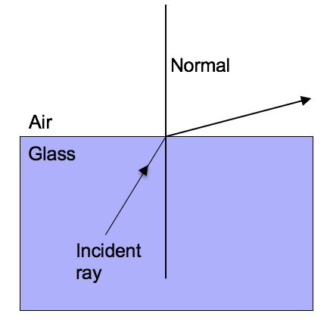

Figure 40 Light moving from a medium with higher optical density to a lower optical density bends away from the normal

If you keep increasing the angle of incidence, at some point the refracted ray that emerges into the less dense medium disappears. The angle of incidence for which the refracted ray just disappears (or shines along the surface of the incident medium) is called the *critical angle*(c).

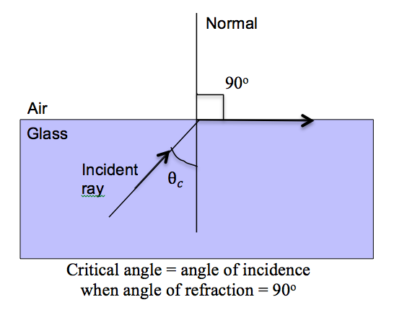

Figure 41 When the angle of refraction is 90o, the angle of incidence is called the *critical angle*

In other words, the critical angleis the minimum angle of incidence for which there is no emergent ray. This only happens for light shining from a more optically dense to a less optically dense medium. The greater the optical density of the medium, the smaller the critical angle in that medium.

#### Total internal reflection

When the angle of incidence is bigger than the critical angle (i > c), there is no ray emerging into the air, and as a result there is *total internal reflection* inside the glass block. This means that all of the light that shines onto the boundary between two media is reflected, and none is refracted.

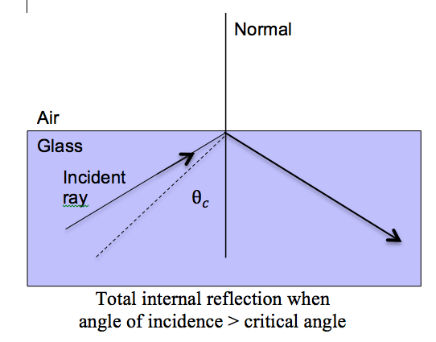

Figure 42 When the angle of incidence is greater than the critical angle, *total internal reflection* takes place in the glass

#### Activity 5: Observe total internal reflection

Purpose

In this activity you will observe what happens to light when it is reflected inside a stream of water.

What you need:

* A 2-litre plastic bottle filled with water
* A torch
* Sellotape

Suggested time: [10 minutes]

What you will do:

* Make a small hole in the juice bottle, about a third of the way from the bottom of the bottle. Cover this hole with sellotape.
* Fill the bottle with water.
* In the darkest place you can find, shine the torch into the bottle so that the light from the torch falls onto the hole that you made.
* Remove the sellotape and look at the stream of water that comes out of the bottle. The diagram below shows the set-up for this experiment.

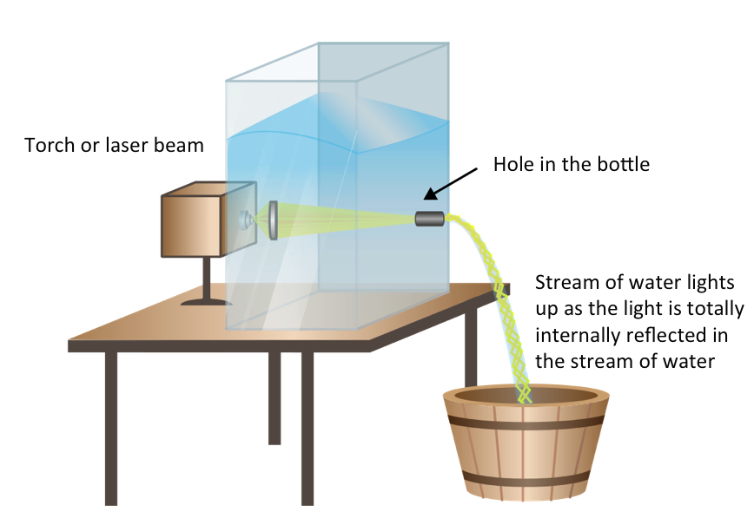

Figure 43 Total internal reflection of light inside a stream of water

You can see a YouTube video that demonstrates this experiment of total internal reflection: *Total Internal Reflection*: <https://www.youtube.com/watch?v=Z9O5xY3Z1WE> (Duration: 0.18).

#### Guided reflection

In this activity you would have seen that the stream of water was able to bend the light, so that the light shone inside the stream of water even though it was not moving in a straight line. This is because the light was reflected inside of the stream of water. This is an example of *total internal reflection****.***

The light from the torch shone through the water, and when it hit the surface between the stream of water and the air, it was totally internally reflected inside the water stream. This happened each time the light hit the surface between the stream of water and the air, causing the light to “bend” with the stream of water.

You can see a YouTube video that demonstrates the critical angle and total internal reflection: *light refraction in a glass air surface, varying incidence angle*: <https://www.youtube.com/watch?v=8VZHym6HqVU>(Duration: 3.22).

The conditions that you need for total internal reflection to take place are:

* light must be incident from the medium that has a higher optical density, and must be approaching the medium that has a lower optical density
* the angle of incidence must be bigger than the critical angle (i > c)

[Wordbox: MAIN IDEAS:

* The *critical angle*is the minimum angle of incidence for which there is no emergent ray. This only happens for light shining from a more optically dense to a less optically dense medium.
* *Total internal reflection*occurs when the angle of incidence is larger than the critical angle (i > c).
* Total internal reflectioncan only occur when light is incident from the medium with the greater optical density, and is approaching the medium that has a lower optical density. ]

#### Applications of total internal reflection

An optic fibre is made of glass that can be bent to any shape. The light is totally internally reflected inside the optic fibre. In this way, light can be transmitted from one place to another without any loss in the strength of the light, since none of the light is absorbed or refracted at the edges.

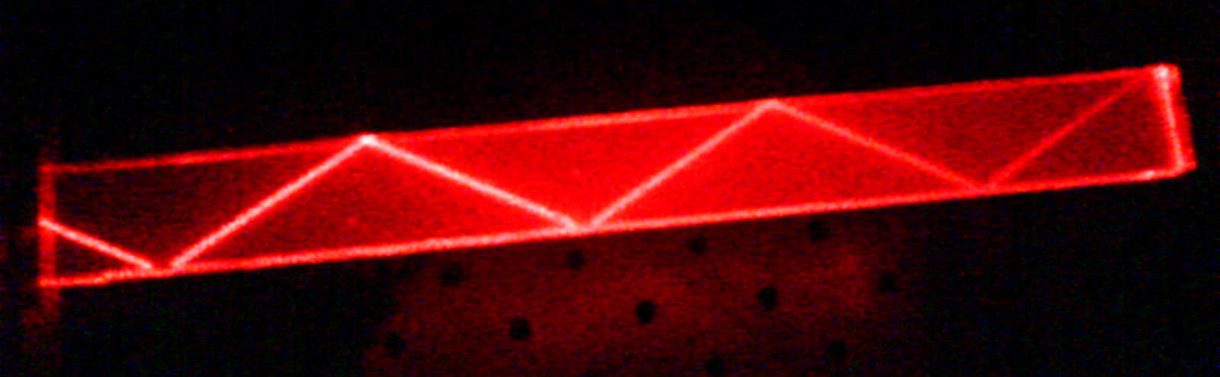

Figure 44 Total internal reflection inside an optic fibre

(Source: Wikimedia commons)

This principle of total internal reflection in optic fibres is applied in medicine, in an instrument called an *endoscope* that is used by doctors to examine parts of the body that cannot be seen by the human eye.

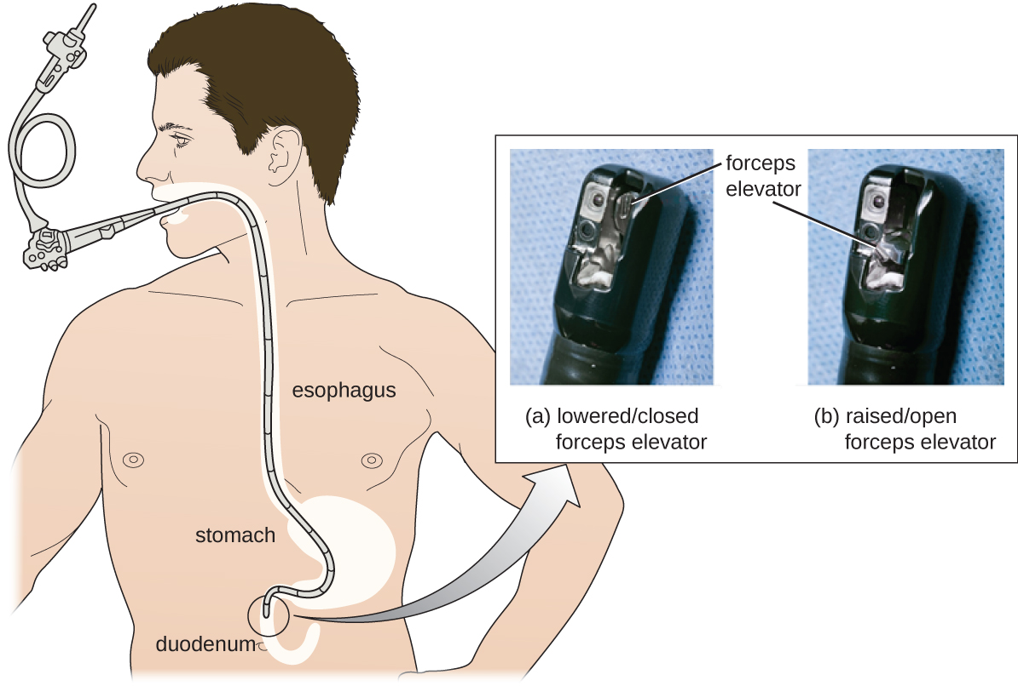

Figure 45 An endoscope is used to examine internal organs

(Source: Wikipedia.com)

#### Activity 6: Explore a simulation of reflection and refraction of light

Purpose

In this activity you will explore on online (internet) simulation of reflection and refraction.

Suggested time: [30 minutes]

What you will do:

* Go to the following web address: <https://phet.colorado.edu/sims/html/bending-light/latest/bending-light_en.html>
* Choose the *Intro* simulation.
* Start with *Air* as the top medium, and *Water* is the bottom medium. Push the red button to turn on the light beam.

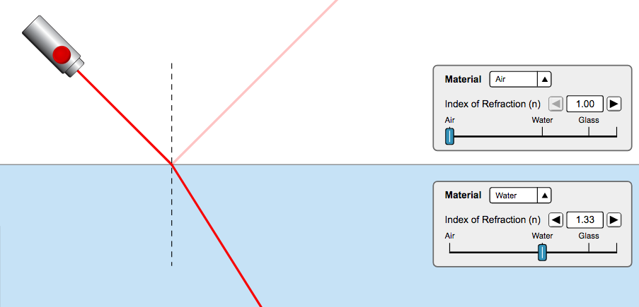

Figure 46 Simulation with incident, reflected and refracted rays

(Source: phet.colorado.edu)

* 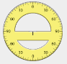Move the light source around and observe the incident ray, the reflected ray and the refracted ray.
* Drag the protractor from the block at the bottom left of the screen to measure the angles. (The diagram on the right shows what this looks like).

Figure 47 Diagram of the protractor on the simulation screen

* Do the angles that you measure follow the rules that you have learnt about for reflection and refraction of light?
* Change the top medium to *Water* and the bottom medium to *Air*. Begin with the light source very near to the normal, and gradually widen the angle. Observe the reflected and refracted beam.
* Find the position where the refracted beam disappears. Use the compass to measure the angle of incidence. What is the name that you give to this angle of incidence?
* Notice what happens when the angle of incidence is greater than this angle. What is the name that you give to this phenomenon?
* Have fun with changing some of the settings and seeing what happens as you change the angle of incidence. You can use this simulator to check some of your calculations in previous exercises.

#### Guided reflection

For the light shining *from air into water*:

* You should find that all of the angles you measure obey the law of reflection and refraction, i.e.:
  + for a light ray that is reflected off a surface, angle of incidence = angle of reflection
  + When a light ray moves from one medium into a different medium:
* if it is incident at right angles to that surface (along the normal), it is transmitted into the new medium *without bending*
* if it is moving from a medium with a low optical density to a medium with higher optical density, it is bent *towards the normal*
* if it is moving from a medium with a high optical density to a medium with lower optical density, it is bent *away from the normal*

For the light shining *from water into air*:

* When measuring the angle of incidence for the position where the refracted beam disappears, you should find an angle of around 50o. This is called the critical angle.
* When the angle of incidence is greater than this angle there is no refracted beam, there is only a reflected beam. This is called total internal reflection.

#### More resources to help you:

The following website has a YouTube video that explains refraction of light: *GCSE Science Revision - Refraction*: <https://youtu.be/7aU8sX8cFNs> (Duration: 4.34).

The following website has helpful explanations on refraction: <https://www.physicsclassroom.com/class/refrn/Lesson-3/Boundary-Behavior-Revisited>

The following website has helpful explanations about total internal reflection, and questions that you can use to test your understanding:

<https://www.physicsclassroom.com/class/refrn/Lesson-3/Total-Internal-Reflection>

#### Activity 7: Consolidate your learning of geometrical optics

Purpose

In this activity you will consolidate your learning of reflection and refraction of light by answering the questions below and then assessing your own understanding using the solutions provided. Give yourself a mark out of the total of 40 marks, which will give you an idea of how well you understand this section of the work.

Suggested time: [60 minutes]

**Multiple choice questions:**

Choose the correct answer for the questions below:

1. Kefilwe is running towards a mirror with a speed of 4 m.s-1. To Kefilwe it appears that her image in the mirror is moving: (2)

A. towards her with a speed of 4 m.s-1  
B. towards her at a speed of 8 m.s-1

C. away from her with a speed of 4 m.s-1  
D. away from her with a speed of 8 m.s-1

1. Which of the following is correct for a light ray moving from medium X into medium Y? (2)

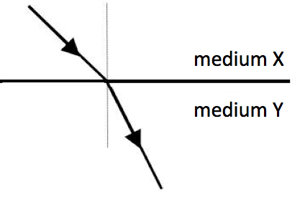

Figure Ray moving from medium X to medium Y

|  |  |  |
| --- | --- | --- |
|  | **Optical density** | **Speed of light** |
| A. | medium X < medium Y | speed in X < speed in Y |
| B. | medium X > medium Y | speed in X < speed in Y |
| C. | medium X < medium Y | speed in X > speed in Y |
| D. | medium X > medium Y | speed in X > speed in Y |

1. Which of the following statements is true for medium X and medium Y in the diagram shown above: (2)
2. A light ray moving from medium X into medium Y will be totally internally reflected if the angle of incidence is greater than the critical angle.
3. A light ray moving from medium X into medium Y will be totally internally reflected if the angle of incidence is less than the critical angle.
4. A light ray moving from medium Y into medium X will be totally internally reflected if the angle of incidence is greater than the critical angle.
5. A light ray moving from medium Y into medium X will be totally internally reflected if the angle of incidence is less than the critical angle.

**Written response questions:**

1. The diagram below shows reflection and refraction of a light ray. Choose the correct label from the phrases in the box for each letter A to F. (6)

Incident ray Critical angle Angle of refraction

Refracted ray Angle of incidence Reflected ray

Refractive index Angle of reflection Total internal reflection

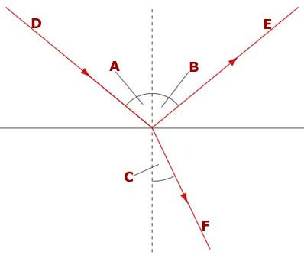

Figure Unlabelled diagram of ray of light incident on a surface

A = _________________________________

B = _________________________________

C = _________________________________

D = _________________________________

E = _________________________________

F = _________________________________

1. Write a sentence that describes what the following terms mean:
   1. Normal to the surface (1)
   2. Angle of incidence. (1)
   3. Angle of reflection. (1)
   4. Angle of refraction. (1)
   5. Critical angle. (1)
2. The diagram shows a ray of light that is incident on a mirror.

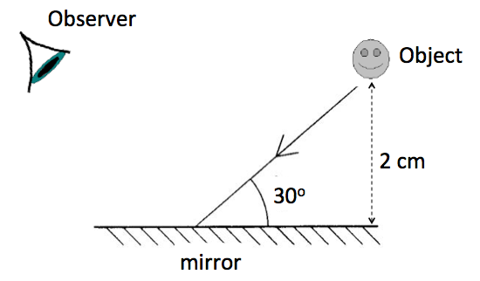

Figure Light ray incident on a mirror

* 1. What is the angle of incidence? (1)
  2. What is the angle of reflection? (1)
  3. What is the angle that the reflected ray makes with the surface of the mirror? (1)
  4. If the object is 2 cm away from the mirror, describe how and where an image will be formed by an observer. (2)

1. Tumelo sits in a chair, looking into a mirror, which is 1,5 m away from him. There is a soccer poster on the wall, which is 60 cm behind him. How far away from his eyes does the poster appear to be? Show your working clearly. (3)
2. A light wave has a frequency of 5  1014 Hz and a speed of 3 x 108 m.s‑1 in air. When this wave enters diamond, its speed changes to 1,25 x 108 m.s‑1. Find the following:
   1. The refractive index of the diamond. (3)
   2. The frequency of the light wave in diamond. (1)
   3. The wavelength of the light wave in diamond. (3)
3. Study the information in the table and answer the questions that follow:

|  |  |
| --- | --- |
| **Medium** | **Refractive index** |
| ice | 1,31 |
| ethanol | 1,37 |
| ruby | 1,54 |

1. Which of these mediums has the smallest critical angle for a light ray traveling from the medium into air? (1)
2. In which of these mediums does light slow down the most? (1)
3. If a light ray travels from ethanol into ruby, does it bend towards or away from the normal? Explain your answer. (3)
4. Calculate the speed of light in ruby. (3)

#### Solutions:

**Multiple choice questions:**

The correct answers are shown below, with the explanation:

1. B. If Kefilwe is running towards the mirror, then her image appears to be running towards the mirror from the opposite side, so it will appear to be running towards her. To Kefilwe her image will seem to be approaching her with double the speed with which she is approaching the mirror. (2)
2. C. As the light moves from medium X into medium Y it is bent towards the normal. This tells you that medium Y has a higher optical density than medium X, which also means that medium Y will slow the light down more than medium X. Therefore the speed of light in medium Y is lower than the speed of light in medium X. (2)
3. C. Total internal reflection only occurs for light moving from a medium of higher optical density to a medium of lower optical density, not the other way around, and total internal reflection only occurs when the angle of incidence is greater than the critical angle. (2)

**Written response questions:**

1. (6)

A = Angle of incidence B = Angle of reflection

C = Angle of refraction D = Incident ray

E = Reflected ray F = Refracted ray

* 1. A line that is at 90o to a surface (1)
  2. The angle between the incident ray and the normal. (1)
  3. The angle between the reflected ray and the normal. (1)
  4. The angle between the refracted ray and the normal. (1)
  5. The angle of incidence for which the angle of refraction is 90o

**OR** the minimum angle of incidence for which the refracted ray disappears. (1)

1. 1. 60o (1)
   2. 60o  (1)
   3. 30o (1)
   4. The image will be formed 2 cm behind the mirror, in a straight line with the object. (2)
2. Distance between poster and Tumelo = 60 cm = 0,6 m

Distance between poster and mirror = 0,6 m + 1,5 m = 2,1 m

The image of the poster is therefore formed 2,1m behind the mirror.

Distance from Tumelo = 1,5 m + 2,1 m = 3,6 m. (3)

1. Given: f = 5  1014 Hz ; vair = 3108 m.s‑1 ; vdiamond = 1,25  108 m.s‑1
2. ndiamond =

=

= 2,4 (3)

1. The frequency of the light wave in diamond doesn’t change, so

f = 5  1014 Hz. (1)

1. =

=

= 2,5  10-7 m. (3)

1. Ruby (1)
2. Ruby (1)
3. It bends towards the normal, since it is moving from a less to a more optically dense medium. (3)
4. From nruby = you can solve for v:

vruby =

=

= 1,95  108 m.s‑1 (3)

Copyright © Saide 2018

Attribution 4.0 International (CC BY 4.0)

