## 

# Section 4: Electricity and Magnetism

#### Introduction

Electricity and magnetism are very important aspects of Physics, because they underlie many of the daily tools and instruments that you rely on. The ability to understand and harness electricity has resulted in the development of lights, televisions and other electrical devices. An understanding of the relationship between electricity and magnetism has led to the development of motorcars and other machines.

In this topic you will learn about electrostatics, which is about the force between electrical charges. You will also learn about electrical circuits, and how to solve problems with these. You will be introduced to magnets and the magnetic field, and then explore the relationship between electricity and magnetism (electromagnetism).

## Sub-topic 1: Electrostatics

### Unit 1: Coulomb’s Law

#### Learning Outcomes

By the end of the unit, you should be able to:

* describe charge as either positive or negative, and measured in coulombs;
* state that unlike charges attract and like charges repel;
* explain the attraction between a charged object and a neutral object (polarization);
* state Coulomb’s Law in words and mathematically: *F* = $\frac{kQ_{1}Q_{2}}{r^{2}}$;
* solve problems using Coulomb’s Law to calculate the force exerted on a charge by one or more charges in 1-dimension.

#### Introduction

Reflect on the following questions, either on your own or with a fellow student:

* Have you experienced a small shock when you touch a metal object? Or maybe you have noticed sparks when you take your jersey off. What do you think causes these?
* Have you ever observed lightning, and heard the sound of the thunder clap? What do you think causes this?

Your experiences of the small sparks when you take your jersey off or the power of lightning are caused by the same thing – electrostatics. Electrostatics is the study of charges, and the effects of the forces between them. In this unit you will explore the interactions between different kinds of charges, and you will learn about how this links with some of your everyday experiences.

* Think about what you remember about the two kinds of charges in atoms from the Chemistry component of this course.
* What is the name of the part of the atom that has a positive charge?
* What is the name of the part of the atom that has a negative charge?

#### Two types of charge

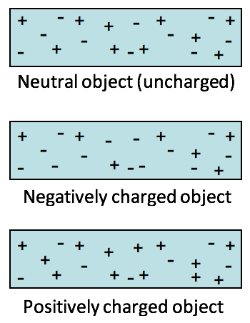In the Chemistry component of this course you learnt that all objects are made of atoms, which have got two different types of charge, positive charges called protons, and negative charges called electrons. Objects usually have an equal number of positive and negative charges, and so the object is *neutral*.

An object can be charged by friction, for example by rubbing the object. The process of rubbing causes electrons to be added to, or removed from, an object. This causes an unbalanced number of positive and negative charges, and as a result the object becomes *charged*.

* When there are more electrons than protons, the object becomes *negatively charged*.
* When there are fewer electrons than protons, the object becomes *positively charged*.

#### Activity 1: Investigate charge

Purpose:

In this activity, you will learn how to create a charge on an object, and you will observe the effects of this charge.

What you need:

* a plastic ruler or a Perspex rod
* a piece of paper that has been torn into small pieces

Suggested time: [10 minutes]

What you will do:

1. Rub the ruler or Perspex rod with a piece of cloth.
2. Bring this ruler near to your small pieces of torn paper. What do you observe?
3. Rub the other objects that you have collected in the same way, and hold each of them near to the pieces of paper.
4. Do they all have the same effect on the pieces of paper?

#### Guided reflection

When you rub a ruler with a piece of cloth, it becomes charged. The process of rubbing causes the small negatively charged electrons to be moved from one object to the other. These electrons are not created by the rubbing process, they already exist in all objects, and when surfaces come into contact with each other the electrons sometimes move to the object that attracts electrons most strongly.

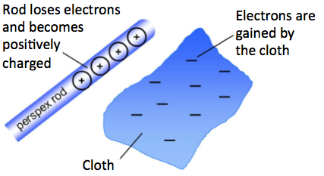

Figure 1 When a Perspex rod is rubbed by a piece of cloth, this causes the rod to be positively charged

From your investigation you will notice that there is a force of *attraction* between the charged ruler and the bits of paper.

[Wordbox: MAIN IDEA:

* There are *two types of charge*: positive charges, and negative charges.
* When there is an unbalanced number of positive and negative charges on an object, the object becomes *charged*.
* When there are more electrons than protons, the object is *negatively charged*.
* When there are fewer electrons than protons, the object is *positively charged*.]

#### Interactions between charges

When two charged objects are brought near to each other, there is a force between them. This can either be a force of attraction or repulsion, depending on the types of charges on the objects.

#### Activity 2: Investigate the interaction between two objects with the same charge

Purpose:

When two charged objects are brought near to each other, there is a force between them. In this activity, you will investigate the forces between objects that have the same kind of charge on them.

What you need:

* A piece of paper that has been torn into small pieces
* Some “Scotch magic tape” (you can use normal sellotape but it is a bit more difficult to work with)

Suggested time: [15 minutes]

What you will do:

* Stick a length of magic tape to your desktop, and pull it up very quickly.
* With the sticky side facing upwards, bring this magic tape close to the bits of paper. What do you notice?
* Stick two lengths of magic tape to your desktop.
* Pull them up very quickly, and hold them close to one another, and look carefully to see how they move. What do you observe?

1. When two objects made from the same material are charged in the same way, they must have the same type of charge on them (either both positive, or both negative). You say that they have *like charges*. From your investigation, what can you infer about the effect that objects with like charges have on each other?

#### Guided reflection

In this investigation, you would have observed that a piece of tape that is pulled up quickly from the desktop attracts the small bits of paper. This tells you that it has become *charged*.

When two objects made from the same material are charged in the same way, they must have the same type of charge on them (like charges). In this investigation, you would have observed that two objects that are charged in the same way push each other apart, or repel one another. You can therefore conclude that **like charges repel one another**.

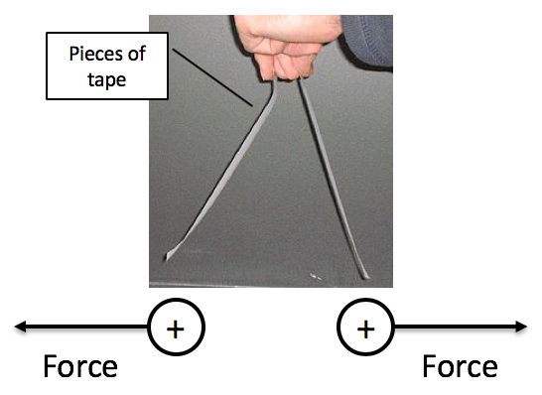

Figure 2 There is a force of repulsion between objects with like charges

#### Activity 3: Investigate the interaction between two objects with opposite charge

Purpose:

In the previous activity you observed the forces between objects that have the same kind of charge on them. In this activity you will explore the forces between objects that have opposite kinds of charge on them.

What you need:

* A piece of paper that has been torn into small pieces
* Some Scotch magic tape

Suggested time: [15 minutes]

What you will do:

* Stick two lengths of tape on top of one another, so that the sticky side of one is placed onto the non-sticky side of the other.
* Remove any excess charges that might be on this combination of tape by rubbing the non-sticky side against your lips.
* Test that there is no charge on this combination of tape by bringing them close to your torn pieces of paper.
* Now pull these two lengths of tape apart very quickly.
* Bring each of them near to your pieces of paper. You will notice that they are both charged by pulling them apart.
* Stick your lengths of tape together again, rub them against your lips, and then charge them by pulling them apart again.
* Bring them near to one another, and look carefully to see how they move. What do you observe?

1. When you pull two pieces of tape away from each other, you will notice that they each become charged. Recall that objects are charged by either having electrons added to them, or removed from them. Since the combination of tapes had no charge, pulling them apart must have caused one of them to gain electrons, and the other to lose electrons. They therefore have **opposite charges** to one another. From your observations, what can you infer about the effect that objects with opposite charges have on each other?

#### Guided reflection

In this investigation you would have observed that when you pull two pieces of tape away from each other, they each become charged. Recall that objects are charged by either having electrons added to them, or removed from them. Since the combination of tapes had **no charge** (neutral), pulling them apart must have caused one of them to gain electrons (becoming negatively charged), and the other to lose electrons (becoming positively charged). They therefore have **opposite charges** to one another. You would have observed that two objects that have opposite charges are pulled towards each other, or attract one another. You can therefore conclude that **unlike charges attract one another**. In the diagram, the force on each piece of charged tape is shown by an arrow labelled “F”.

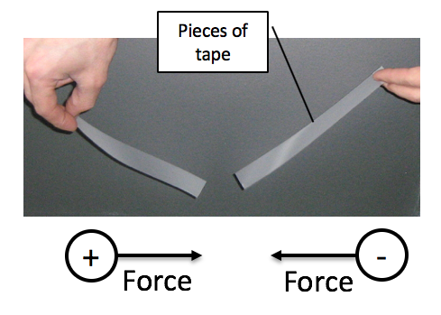

Figure 3 There is a force of attraction between objects with unlike charges

#### Activity 4: Test your knowledge of forces between charges

Purpose:

In this activity, you will reinforce the learning you have done to now by testing your knowledge of forces between charges.

Suggested time: [15 minutes]

What you will do:

Answer the following questions:

1. A ruler is negatively charged by rubbing it.
   1. Were electrons added to the ruler or removed from it when it was charged?
   2. If a charged piece of tape is *attracted* to the ruler, what is the charge on the tape
   3. If a charged piece of tape is *repelled* by the ruler, what is the charge on the tape?
   4. What will you observe when you bring the two pieces of tape from (b) and (c) above close to each other? Explain your answer.
2. Object A is charged, and as a result it is attracted to Object B. When Object B is brought close to Object C there is a force of repulsion. If Object C is negatively charged, what is the charge on Object A? Explain how you get your answer.

#### Solutions

* 1. Electrons were added to the ruler to make it negatively charged. This is because electrons carry negative charges.
  2. If a charged piece of tape is attracted to the ruler, this means it has the *opposite* charge to the ruler, so the charge on the tape is *positive*.
  3. If a charged piece of tape is repelled by the ruler, this means it has the *same* charge to the ruler, so the charge on the tape is *negative*.
  4. when you bring the two pieces of tape from (b) and (c) above close to each other, they will *attract* each other, since they have *unlike* charges.

1. You are given that Object C is negatively charged. It repels Object B, so this means that Object B is also negatively charged (repulsion means they have like charges). Since Object A is attracted to Object B, this means that *Object A is positively charged* (attraction means unlike charges).

**[Wordbox: MAIN IDEA:**

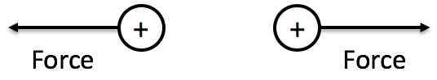

Figure 4 Like charges repel one another

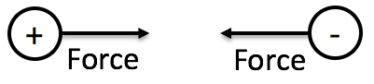

Figure 5 Unlike charges attract one another. ]

#### Polarisation

A charged object can attract an object that is uncharged. This is caused by a process called *polarisation*.

#### Activity 5: Investigate charge polarisation

Purpose:

A charged object can attract an object that is uncharged. This is caused by a process called *polarisation*. In this activity you will investigate polarisation.

What you need:

* A balloon
* A stream of smooth flowing water (e.g. from a tap)

Suggested time: [15 minutes]

What you will do:

1. Blow up the balloon and tie it so that it stays inflated.
2. Rub the balloon against your hair or a piece of material. This will charge the balloon.
3. Open a tap so that a very thin but smooth stream of water is flowing. (This is called laminar flow).
4. Bring the charged balloon near to the stream of water. What do you observe?
5. In your chemistry module you learn that water is made up of *polar molecules*, which are positively charged on the one side, and negatively charged on the other. If the balloon is negatively charged, can you explain why it attracts the stream of water, which is neutral?

#### Guided reflection

In this activity you should notice that the stream of water is bent towards the charged balloon. This is because water is a polarsubstance. When a positively charged object is brought near to a polar substance, it causes the particles to turn around so that their negative end is nearer to the charged object, and their positive end is further away.

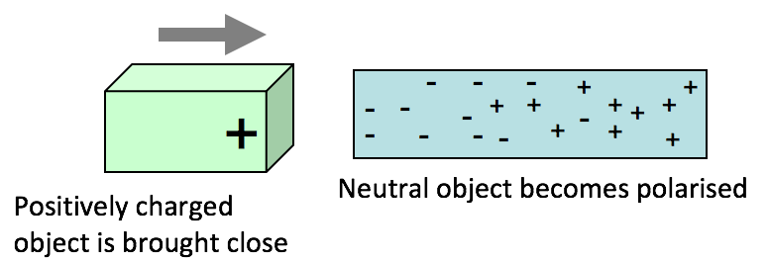

Figure 6 Polarisation of a neutral object

In the process of polarization, a positively charged object attracts the negative charges in a neutral object, causing the part of the neutral object that is nearby to be negatively charged, and the part that is further away to be positively charged.

In the Chemistry module you learn that some substances, such as water, are made up of particles that have a positive end and a negative end. These are called *polar*substances. When a positively charged object is brought near to a polar substance, it causes the particles to turn around so that their negative end is nearer to the charged object, and their positive end is further away.

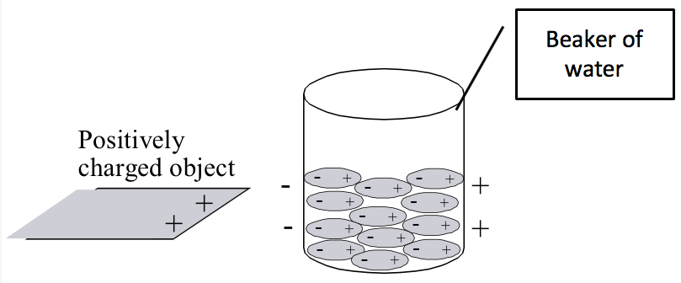

Figure 7 Polarisation of a polar substance e.g. water

#### Activity 6: Simulation activity on charge polarisation

Purpose

In this activity you will use an internet simulation to observe what happens to charges during polarisation.

Suggested time**:** [15 minutes]

What you will do:

* Go to the following web address: <https://phet.colorado.edu/sims/html/balloons-and-static-electricity/latest/balloons-and-static-electricity_en.html>
* Look at the number of positive and negative charges on the balloon and on the jersey. How would you describe the charge on these objects?
* Click on the picture of the balloon, and while holding your mouse button down, rub the balloon against the picture of the jersey that you see on the screen. What do you see happening to the charges?
* If you move the balloon a little distance away from the jersey and let it go, what do you observe? Try to explain your observations using the knowledge that you have gained so far about the forces between charges.
* Now move the balloon to the right of the screen, to the picture of a wall with charges on it. What do you see happening to the charges on the wall?
* Try to explain your observations using what you learnt in Activity 5.

#### Guided reflection

In this simulation you should observe the following:

* At first the charges on the balloon and the jersey are balanced. In other words, there is an equal number of positive and negative charges on each object. You describe the objects as *neutral*.
* As you rub the balloon against the jersey, you will observe that the negative charges move from the jersey to the balloon. This leaves the jersey with an overall positive charge, and the balloon has an overall negative charge.

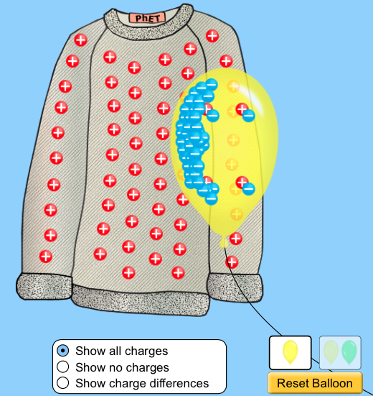

Figure 8 Jersey is rubbed by a balloon, which causes the balloon to be negatively charged

(Source: phet.colorado.edu)

* If you release the balloon it is attracted to the jersey, since unlike charges attract each other.
* When you bring the balloon near to the neutrally charged wall, the negatively charged balloon repels the negative charges in the wall, leaving the part of the wall that is nearer the balloon with a positive charge. The charge in the wall has been **polarised** by the balloon.

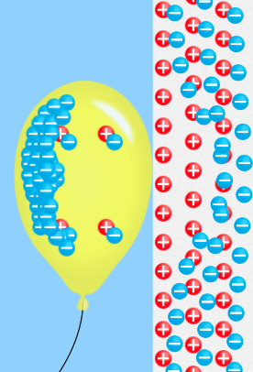

Figure 9 The charge in the wall is polarised as the negatively charged balloon is brought near

(Source: phet.colorado.edu)

* As you move the balloon away again the charges in the wall return to their neutral positions.



Figure 10 The charges in the wall return to their neutral positions

(Source: phet.colorado.edu)

#### Activity 7: Test your knowledge of forces between charged and neutral objects

Purpose:

In this activity, you will test your knowledge of forces between charged and neutral objects.

Suggested time: [15 minutes]

What you will do:

Answer the following questions:

1. A neutral object experiences a force of attraction to a *positively* charged object.
   1. Explain what happens to the charges in the neutral object when the positively charged object is brought close to it.
   2. What is the name of this process?
2. A ruler is negatively charged by rubbing it.
   1. Describe what you will observe if you bring this ruler close to a continual stream of water.
   2. Explain your observations by describing what has happened to the water molecules as the ruler is brought close to them.

#### Solutions or Exemplar answers

* 1. A negatively charged object attracts the positive charges in a neutral object, causing the part of the neutral object that is nearby to be positively charged, and the part that is further away to be negatively charged. This results in a force of attraction between the negatively charged object and the positively charge side of the object.
  2. The name of this process is polarisation
  3. The stream of water is bent towards the charged ruler.
  4. This is because water is a polarsubstance. When a negatively charged ruler is brought near to a polar substance, it causes the particles to turn around so that their positive end is nearer to the charged object, and their negative end is further away. This results in a force of attraction between the negatively charged object and the positive ends of the particles in the polar substance.

[Wordbox: MAIN IDEA:

* A charged object attracts an uncharged object because of *polarisation*.
* In this process, a positively charged object attracts the negative charges in a neutral object, causing the part of the neutral object that is nearby to be negatively charged, and the part that is further away to be positively charged. ]

#### Coulomb’s Law for calculating the force between charges

You can calculate the magnitude of the force between charged objects using *Coulomb’s law.* This law states:

*“The magnitude of the force of interaction between two point charges is directly proportional to the product of the magnitudes of charges and inversely proportional to the square of the distances between them.”*

You can write this using a mathematical equation: $F=k$ $\frac{Q_{1}Q_{2}}{r^{2}}$

where F is the magnitude of the force between the charges, measured in newtons (N)

k is a proportionality constant, k = 9,0×10 9 N.m2/C2

Q1 and Q2 are the magnitudes of the two point charges, measured in coulombs (C)

r is the distance between the charges, measured in meters (m)

Notes on this equation:

* When you use this equation you do not include the + or – signs of the charges. You use this equation to calculate the size (magnitude) of the force.
* The direction of the force can be worked out from the attraction or repulsion of the + and – signs of the charges.

The following example demonstrates how to solve a problem using Coulomb’s Law.

**Example**: *(Try to solve this problem on your own or with a fellow student while covering the solution, and then check your work using the solution below).*

Study the arrangement of charges in the diagram and answer the questions that follow.



Figure 11 Two charges Q1 and Q2 are placed a distance of 3 cm from each other

1. What is the magnitude and direction of the force on charge Q1?
2. What is the magnitude and direction of the force on charge Q2?
3. Draw a free body diagram for each charge, showing the force on that charge.

Remember that when you convert from cm to m you divide by 100, which is the same as multiplying by 10-2

**Solution:**

Given: Q1 = 2,0 C

You can use the notation F21 to describe the force that charge 2 exerts on charge 1.

Q2 = -1,5C

r = 3 cm = 3 × 10-2 m

Calculation:

1. Magnitude of the force F21 on charge Q1 due to charge Q2 is:

Substitute just the magnitudes of the charges into the equation. You can find the direction of the force after you have found the magnitude.

= 3 × 1013 N

To find the direction: the charges have opposite signs, so this is a force of attraction.

Therefore, the force on charge Q1 is F21 = 3 × 1013 N to the right

1. The force on charge Q2 is equal and opposite to the force on charge Q1 (from Newton’s 3rd law). Therefore force on charge Q2 is:

F12 = 3 × 1013 N to the left





Figure 12 Free body diagram for charge Q1



Figure 13 Free body diagram for charge Q2

[Wordbox: **MAIN IDEA:**

The magnitude of the force F between point charges Q1 and Q2 that are a distance r apart can be found using Coulomb’s Law, which you can write mathematically as:

$F=k$ $\frac{Q_{1}Q_{2}}{r^{2}}$ where k = 9,0×109 N.m2/C2. ]

#### Activity 8: Apply your knowledge of Coulomb’s Law

Purpose:

In this activity, you will apply your knowledge of Coulomb’s law to solve problems related to the forces between charged objects.

Suggested time: [30 minutes]

What you will do:

Answer the following questions. You will need to use a calculator:

1. Study the arrangement of charges in the diagram and answer the questions that follow.



Figure 14 Two charges Q1 and Q2 are placed a distance of 0,3 mm from each other

* 1. Find the magnitude and the direction of the force on charge Q1.
  2. Draw a free body diagram showing the force acting on charge Q1.  (Recall from the Mechanics section on Newton’s Laws how to draw a free body diagram)
  3. Find the magnitude and the direction of the force on charge Q2.
  4. Draw a free body diagram showing the force acting on charge Q2.

1. The magnitude of the force between two unknown charges is 8 N. The distance between the charges is then halved. What is the new force between these charges? Explain your answer.
2. A 1,6 µC charge experiences a force of 7200 N to the right when it is placed 2 mm to the left of an unknown charge Q. What is the charge on Q?

Remember to always write down the information that you are given when solving a problem

#### Solutions

1. Given: Q1 = 2×10-5 C

Q2 = -6×10-5 C

Remember that when you convert from mm to m you divide by 1000, which is the same as multiplying by 10-3

r = 0,3 mm

= 0,3 × 10-3 m

= 3 × 10-4 m

* 1. You first calculate the magnitude of the force on charge Q1 as a result of charge Q2 using the Coulomb’s law equation:

Be careful to substitute the numbers into the equation correctly

$$F_{21}=k\frac{Q_{1}Q_{2}}{r^{2}}$$

$=9 × {10}^{9} Nm^{2}C^{-2} × \frac{2×{10}^{-5}C × 6×{10}^{-5}C }{{(3×{10}^{-4}m)}^{2}}$

Don’t forget to square this, I.e. (r)2

To find the direction: the charges have opposite signs, so this is a force of attraction.

Therefore F21 = 1,2 × 108 N downward

Force is a vector, so it must have a magnitude and a direction





Figure 15 Free body diagram of the force acting on charge Q1

* 1. The magnitude of the force on charge Q2 as a result of charge Q1 is *equal* to the magnitude of the force on charge Q1 as a result of charge Q2 (from Newton’s third law). ∴ the magnitude of F12 = 1,2 × 108 N

Since the charges have opposite signs, this is a force of attraction.

Therefore F12 = 1,2 × 108 N upward





Figure 16 Free body diagram of the force acting on charge Q2

1. From Coulomb’s law, the magnitude of the force between two charges is inversely proportional to the square of the distance between the charges. You write this mathematically as: $F∝ \frac{1}{r^{2}}$

If the distance between the charges is halved, this means that the new force (F2)

is related to the old force F in this way:

$$F_{2} = \frac{1}{{\left(\frac{1}{2}\right)}^{2}} F = \frac{1}{\frac{1}{4}}F = 4F$$

So the new force will be greater than the previous force F by a factor of 4.

Therefore the magnitude of the force will be $F_{2}=8N × 4=32 N$

Remember that µ means micro (10-6)

So 1 µC = 1× 10-6 C

1. Given: Q1 = 1,6 µC

= 1,6× 10-6 C

F21 = 7200 N

r = 2 mm

= 2 × 10-3 m

Calculation:

To find the magnitude of charge Q2 you can rewrite Coulomb’s law with Q2 as the subject of the formula:

To make Q2 the subject of Coulomb’s equation you want to get Q2 on its own on the right hand side of:

So you divide both sides by kQ1 and multiply by *r2*:

*=* = Q2which gives you

$$\frac{F r^{2}}{k Q_{1}}= Q_{2}$$

$Q_{2}= \frac{F r^{2}}{k Q_{1}}$

= $\frac{7200 × (2×{10}^{-3})}{9×{10}^{9} × 1,6×{10}^{-6}}$

= $2×{10}^{-6}$ C

= 2 µC

To find the sign on charge Q2: If charge Q1 experiences a force to the *right* when it is placed to the left of the unknown charge, then this is a force if attraction.

So the unknown charge must be negative.

∴ Q2 = -2 µC

### Unit 2: The electric field

#### Learning Outcomes

By the end of the unit, you should be able to:

* describe an electric field as a region in which an electric charge experiences a force;
* draw the electric field of an isolated point charge and recall that the direction of the field lines gives the direction of the force acting on a positive test charge;
* draw the electric field pattern between two isolated point charges
* define the magnitude of the electric field at a point as the force per unit charge, *E = F/q ;*
* calculate the electric field at a point due to a number of point charges in 1-dimension, using the equation E = $\frac{kQ}{r^{2}}$.

#### Introduction

In Unit 1 you learnt about the forces between charged objects. Reflect on the following questions, either on your own or with a fellow student:

* What do you observe when two pieces of tape that have the same kind of charge are brought close to one another?
* What do you observe when two pieces of tape that have opposite kinds of charge are brought close to one another?
* Do the objects have to touch one another before they experience the force?

What you should notice from your activities in Unit 1 is that charged objects can exert forces of attraction or repulsion on one another without needing to touch each other. This is because any charged object creates an electric field in the space around it, and any other object that moves into this space experiences the effects of this electric field.

The electric field is described as a region in which an electric charge experiences a force. In this unit you will learn how to draw the electric field using electric field lines, and how to find the magnitude and direction of the electric field.

#### Electric field lines

When a charge experiences a force, this is because there is an electric field at the position where that charge is placed. The electric field is a vector, and so it has a direction. The direction of the electric field is the same as the direction of the force that a positive test charge “q” experiences when it is placed in the electric field. (A *test charge* is a charge with a magnitude so small that placing it at a point does not affect the field around the point.)

Force

q

Electric field

**+**

Figure 17 The direction of the electric field is the same as the direction of the force that a positive test charge experiences

You use electric field lines to show the direction of the field. The arrow on the end of an electric field line shows you the direction of the field. The more closely spaced the electric field lines are, the stronger the electric field is at that point.

#### The electric field strength

The strength of the field is the amount of force that a +1 C charge would experience. In other words, you can calculate the magnitude of the electric field (E) by dividing the magnitude of the force (F) experienced by some test charge by the value of its charge (q).

Mathematically you write this as: E = $\frac{F}{q}$

where E is the magnitude of the electric field strength, measured in units of N/C

F is the magnitude of the force on the test charge, measured in newtons (N)

q is the charge on the test charge, measured in coulombs (C)

If the test charge has a negative charge on it, the direction of the force is opposite to the direction of the electric field at that point, as the diagram below shows.

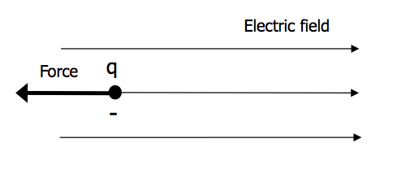

Figure 18 The direction of the electric field is opposite to the direction of the force that a negative test charge experiences

#### Activity 1: Determine the electric field using a test charge

Purpose:

In this activity you will learn how to use a test charge to determine the direction and strength of an electric field.

Suggested time: [20 minutes]

What you need:

* Some paper and pencils
* Scissors

What you will do:

Copy a diagram like the one you see below onto a piece of paper, and cut it out. This represents a *positive test charge*. You will use this test charge to answer the questions about the boxes below.



Figure 19 Positive test charge

Box 1

* Place your test charge into the box shown below.

Figure 20 Box 1

* When your test charge is placed in this box, you are told the following information:
  + the direction of the *force* on the test charge is to the *right*
  + the magnitude of the force on the charge is 4 N and the size of the charge is 2 C
* Use this information and the equation for the electric field strength to work out the magnitude and direction of the electric field in the box. Place arrows on the lines in the box to show the direction of the field.

Box 2

* Place your test charge into the box shown below.

Figure 21 Box 2

* When your test charge is placed in this box, you are told the following information:
  + the direction of the *force* on the test charge is *down*
  + the magnitude of the force on the charge is 0,06 N and the size of the charge is 3 µC
* Use this information and the equation for the electric field strength to work out the magnitude and direction of the electric field in the box. Place arrows on the lines in the box to show the direction of the field.

Box 3

* Place your test charge into the box shown below.

Figure 22 Box 3

* When your test charge is placed in this box, you are told the following information:
  + the arrows show the direction of the *electric field* in the box
  + the magnitude of the electric field in the box is 3 N.C-1
  + the magnitude of the force on the charge is 1,5 × 10-4 N
* Use this information to work out the amount of charge on the test charge, and the direction of the force on the test charge.
* If you place a *negative* test charge in this same box, what is the direction of the force on this charge?

#### Guided reflection

Box 1

* When your test charge is placed in the box, you are told that the direction of the force on the test charge is to the right (as the diagram shows). Therefore, since the direction of the electric field is the same as the direction of the force on a positive test charge, this means that the direction of the electric field inside the box is to the right. This is shown with the arrows on the electric field lines in the box.



force

Figure 23 Box 1 with the force and electric field for a positive test charge

* To work out the magnitude of the electric field inside the box:

Given: F = 4 N and q = 2 C

Calculation:

E = $\frac{F}{q}$

Remember that units of N.C-1 mean the same as N/C, which you read as “newtons per coulomb”

=

= 2 N.C-1

The electric field inside Box 1 is therefore 2 N.C-1 to the right.

Box 2

* When your test charge is placed in the box, you are told that the direction of the force on the test charge is down (as the diagram shows). Therefore, since the direction of the electric field is the same as the direction of the force on a positive test charge, this means that the direction of the electric field inside the box is down. This is shown with the arrows on the electric field lines in the box.



force

Figure 24 Box 2 with the force and electric field for a positive test charge

* To work out the magnitude of the electric field inside the box:

Given: F = 0,06 N and q = 3 µC = 3 × 10-6 C

Calculation:

E = $\frac{F}{q}$

Remember that µ means micro (10-6)

So 1 µ C = 1× 10-6 C

=

= 20 000 N.C-1

= 2 × 104 N.C-1

The electric field inside Box 2 is therefore 2 × 104 N.C-1 down.

Box 3

* Place your test charge into the box shown below.



Figure 25 Box 3 with the force and electric field for a positive test charge

* You are told that the direction of the electric field in the box is to the left (as the diagram shows). When your test charge is placed in the box, it will therefore experience a force to the left, since the direction of the electric field is the same as the direction of the force on a positive test charge.

Given: E = 3 N.C-1

F = 1,5 × 10-4 N

Calculation:

You find the amount of charge on the test charge by making q the subject of formula E = $\frac{F}{q}$:

q = $\frac{F}{E}$

To make q the subject of the formula you multiply both sides of the equation by q and divide both sides by E:

So E = $\frac{F}{q}$ becomes $\frac{E×q}{E}$ = $\frac{F×q}{q×E}$

On the left hand side the E at the top cancels with the E at the bottom, and on the right hand side the q at the top cancels with the q at the bottom, leaving you with q =

=

= 5 × 10-5 C

= 0,5 µC

5 × 10-5 C = 0,5 × 10-6 C

and since 10-6 C = 1 µC

you can write this answer as 0,5 µC

So 1 µ C = 1× 10-6 C

* If you place a *negative* test charge in this same box, the direction of the force on this charge is opposite to the direction of the electric field, so the force is to the right.

[Wordbox: MAIN IDEA:

* The magnitude of the *electric field* E on a test charge q that experiences a force F can be calculated using the equation:

E = $\frac{F}{q}$

* The direction of the force on a positive test charge is the same as the direction of the electric field at that point.
* The direction of the force on a negative test charge is opposite to the direction of the electric field at that point. ]

#### Activity 2: Determine the direction of the electric field around a negative charge

Purpose:

In this activity you will apply your knowledge of the force between charges to work the direction of the electric field around a negative charge.

Suggested time: [20 minutes]

What you need:

* Some paper and pencils
* Scissors

What you will do:

1. Copy a diagram like the one you see below into your workbook. The circle in the centre represents a negative charge.

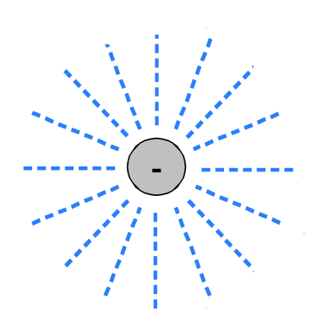

Figure 26 A negative charge that creates an electric field around itself



Figure 27 Positive test charge

* On another piece of paper draw a small circle with a + inside it like the one shown on the right, and cut it out. This represents a *positive test charge*.
* Now place this positive test charge onto your diagram of the negative charge, and position it at the end of one of the dotted lines (an example is shown in the diagram below):

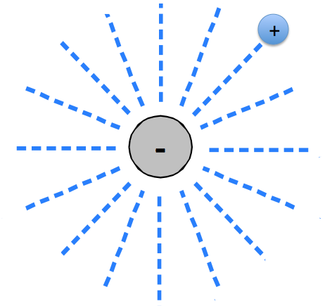

Figure 28 Insert the positive test charge at the end of each of the lines around the negative charge

* Work out the direction of the force on this small positive test charge as a result of its position near the negative charge. Show this direction using an arrow on the dotted line.
* Move your positive test charge to the end of another dotted line, and draw an arrow to show the direction of the force on this positive test charge.
* Keep doing this until you have arrows on all of your dotted lines.
* Remove your positive test charge. What you should have now is a diagram showing the electric field that is formed in the space around a negative charge.

#### Guided reflection

From this activity, you should find that your diagram with the direction of the electric field around a negative charge looks similar to the one below:



Figure 29 Electric field that is created around a negative charge

The electric field points inward *towards* a negative charge. You use electric field lines to show the direction of the field. Where the lines are closer together, it shows that the field is stronger at this point. The lines never overlap each other. On the above diagram you can see that the electric field is stronger closer to the charge, and gets weaker further away from the charge.

You can repeat Activity 1 with a positive charge in the centre of the dotted lines, and moving the positive test charge around to different positions around it (as shown in the diagram below):

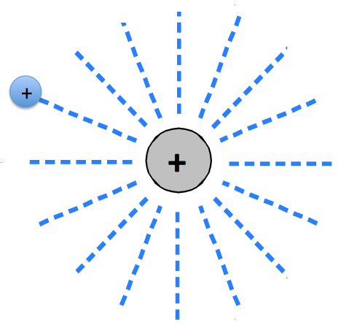

Figure 30 Insert the positive test charge at the end of each of the lines around a positive charge

When you draw in the arrows that show the direction of the force on this positive test charge, you should find that the electric field lines around the positive charge look like the diagram below:



Figure 31 Electric field that is created around a positive charge

This shows you that the electric field points *outward* from a positive charge.

#### Activity 3: Simulation activity to observe the electric field around charges

Purpose

In this activity you will use an internet simulation to observe the electric field around positive and negative charges.

Suggested time: [15 minutes]

What you will do:

* Go to the following web address: <https://phet.colorado.edu/sims/html/charges-and-fields/latest/charges-and-fields_en.html>.
* When the window opens with the simulation, at the bottom of the screen you will see a red positive charge (labelled +1 nC) and a blue negative charge (labelled -1 nC).
* Drag the positive charge into the middle of the screen. (You can do this by clicking on the charge and moving it while keeping your mouse button pressed, then let go of the mouse button when the charge is in the middle of the screen).
* As soon as you have positioned the charge in the middle of the screen you will notice the electric field lines around it. The brightness of the field lines tell you about the strength of the electric field at that point.
  + What direction are the electric field lines pointing in?
  + What do you notice about the colour of the field lines further away from the charge? What does this tell you about the strength of the electric field near the charge compared with further away from the charge?
* What difference do you expect to see if you replace the positive charge with a negative charge?
* Click the “Reset” button on the bottom right of the screen , and now drag the negative charge into the middle of the screen. Are the field lines pointing in the direction that you expect them to?
* Now reset all of the settings and add one positive and one negative charge to the window. Notice the shape of the electric field that forms around these charges.
* Now reset all of the settings and add two positive charges to the window. Notice the shape of the electric field that forms around these charges.
* You can have some fun with adding a number of different charges to the window and see how they interact with each other.

#### Guided reflection for simulation

In this simulation you should observe the following:

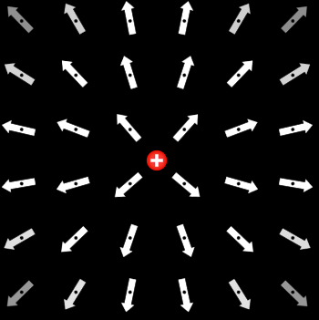

Figure 32 Electric field around a positive charge

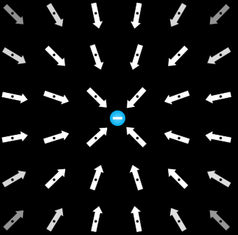

Figure 33 Electric field around a negative charge

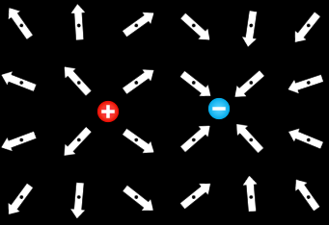

Figure 34 Electric field around a positive and negative charge

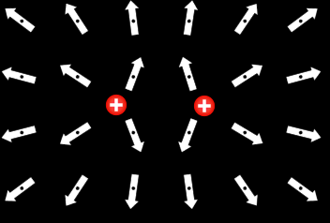

Figure 35 Electric field around two positive charges

This simulation shows that the direction of the electric field points outward from a positive charge, and inward towards a negative charge. When two charges are near to each other, the electric fields combine to form a field pattern which depends on the types of the charges.

#### Calculating the electric field strength around a charge

In Activity 3 you would have noticed that the electric field lines become less bright further away from the charges. This tells you that the electric field is strongest nearer the charge, and becomes weaker the further out you go from the charge.

If you want to find the strength of the electric field at a distance r from a charge Q, you can use the equation: E = $\frac{kQ}{r^{2}}$

where E is the magnitude of the electric field strength, measured in units of N/C

k is a proportionality constant: k = 9,0×10 9 N.m2/C2

Q is the magnitude of the charge that creates the field, measured in coulombs (C)

r is the distance from the charge, measured in meters (m).

In this equation you can see that the electric field is proportional to 1/r2. In other words, the greater the distance away from the charge, the weaker the electric field. This supports your observations of the reduced strength of the electric field further away from the charge in Activity 3.

#### Activity 4: Work through an example problem on the electric field

Purpose:

In this activity you will be guided through an example problem where you calculate the electric field at some distance from a charge.

Suggested time: [15 minutes]

What you will do:

Read the following problem, and then follow the steps that will guide you through the steps for solving the problem.

**Problem**:

What is the electric field at a point that is 3 mm to the right of a charge Q = ‑2 nC?

**Complete the steps in this solution:**

It is always helpful to first draw a diagram of the situation. Draw this in your workbook.

From this diagram write down the given information in the spaces below.

Given: r = 3 mm

= __________ m

Q = -2 nC

= __________ C

Calculation:

Complete the calculation below to find the magnitude of the electric field:

E = $\frac{kQ}{r^{2}}$

=

=

Work out the direction of the electric field using your diagram.

Final answer: The electric field at this point is E = _________ N.C-1 to the ________.

Once you have completed working through the above problem, check your working using the completed solution below.

**Completed solution:**

The diagram of the situation is shown below:



3 mm

Q = -2 nC

From this diagram you can write down the given information.

When you convert from mm to m you divide by 1000, or multiply by 10-3

**Given:** r = 3 mm

= 310-3 m

Q = -2 nC

= -210-9 C

Remember that n means nano (10-9)

So 1 nC = 1× 10-9 C

The electric field strength is calculated as:

E =

=

= 3 106 N.C-1

The electric field direction at this point is left, since the electric field points inwards toward a negative charge.

So the electric field at this point is E = 3106 N.C-1 to the left.

**Reflect on your solution to this problem:**

Reflect on the following questions:

* Were there any steps that you struggled with in solving the problem?
* Which steps were they?
* How can you address these difficulties when you solve problems in future?

If you need further explanation and practice with solving problems like this, you can go to the following web address: <https://www.physicsclassroom.com/class/estatics/Lesson-4/Electric-Field-Intensity>

[Wordbox: MAIN IDEA:

* The magnitude of the electric field E at a distance r from a charge Q that is creating the field can be calculated using the equation:

E = $\frac{kQ}{r^{2}}$

* The direction of the electric field points outward from a positive charge, and inward towards a negative charge.]

#### Activity 5: Test your knowledge of the electric field

Purpose:

In this activity you will test your knowledge of the electric field by solving various problems.

Suggested time: [30 minutes]

What you will do:

Answer the following questions. You will need to use a calculator.

1. A positive test charge q = 2 C experiences a force of 0,8 N downward. What is the electric field at this point?
2. A negative test charge q = -3 µC experiences a force of 90 N to the left. What is the electric field at this point?
3. The electric field at point P is 5 × 104 N.C-1 to the left.
   1. What is the force on a positive test charge q1 = 2 nC that is placed at this point P?
   2. Charge q1 is removed, and an unknown charge q2 is placed in its place at point P. This charge experiences a force of 500 kN to the right. What is the charge on q2?
4. What is the electric field strength and direction at a point that is 3 mm to the left of a charge Q = 1,8 µC?

#### Solutions

1. Given: q = 2 C

F = 0,8 N down

The electric field strength is calculated in this way:

E =

=

= 0,4 N.C-1

The electric field direction is the same as the direction of the force on the positive test charge.

Therefore E = 0,4 N.C-1 downward.

1. Given: q = -3 µC

= -3 × 10-6 C

Remember that µ means micro (10-6)

So 1 µC = 1× 10-6 C

F = 90 N left

Calculation:

The electric field strength is:

E =

=

= 3 × 107 N.C-1

The electric field direction is opposite to the direction of the force on the negative test charge, so E = 3 × 107 N.C-1 to the right.

1. Given: E = 5 × 104 N.C-1 to the left

Remember that n means nano (10-9)

So 1 nC = 1× 10-9 C

q1 = 2 nC

= 210-9 C

Calculation:

* 1. To find the magnitude of the force you write the equation with f as the subject of the formula:

To make F the subject of the formula you multiply both sides of the equation by q:

So E = $\frac{F}{q}$ becomes $E×q$ = $\frac{F×q}{q}$

On the right hand side the q at the top cancels with the q at the bottom, leaving you with $E×q$ = F

F = E.q

= 5 × 104 N.C-1 × 2 × 10-9 C

= 1 × 10-4 N

The direction of the force on a positive test charge is the same as the direction of the electric field.

Therefore F = 1 × 10-4 N to the left

Remember that k means kilo (103)

So 1 kN = 1× 103 N

Therefore 500 kN = 500× 103 N

= 5 × 105 N

* 1. Given**:** F = 500 kN

= 5 × 105 N to the right

Calculation:

Magnitude of the charge is

q2 =

Look at the calculation for Box 3 in Activity 1 to remind yourself how to make q the subject of the formula.

= $\frac{5×{10}^{5} N}{5×{10}^{4} N.C^{-1}}$

= 10 C

Since the force and electric field are in opposite directions, the charge must be negative.

Therefore q2 = -10 C.

1. Diagram: the diagram of the scenario is shown below



Given**:** r = 3 mm

= 3×10-3 m

Q = 1,8 µC

= 1,8×10-6 C

Calculation:

The electric field direction at this point is left (shown in the diagram), since the electric field points outwards from a positive charge.

The electric field strength is:

E =

=

= 1,8 109 N.C-1

So the electric field at this point is E = 1,8×109 N.C-1 to the left.

#### Activity 6: Applications of electrostatics

Purpose:

In this activity you will investigate some of the applications of electrostatics in everyday life.

What you need:

* A computer or cell phone with internet access
* OR a media centre or library

Suggested time: [60 minutes]

What you will do:

1. Choose one of the applications of electrostatics described below:
   * Application 1: Photocopy machines or printers
   * Application 2: Spray gun for painting
   * Application 3: Lightning conductors
   * Application 4: A small chain that hangs down and touches the ground at the back of a big truck
2. Use the internet or media centre to investigate how electrostatics is applied in this case. Use the tips given below.
3. Write a few paragraphs to explain this application of electrostatics, and use diagrams in your explanation.
4. If you are working with a group of other students, you could design a poster to present your investigation to them. Make sure you each choose a different application so that you cover all of them if possible.

#### Tips for internet research:

1. Go to [www.google.com](http://www.google.com) and search for key words such as:
   * Applications of electrostatics
   * Electrostatics and copy machines
   * Electrostatics and spray guns
   * Etc.
2. Always check the information that you read, as there are some websites with incorrect information. It is safest to check that your information is agreed on by *at least 3 websites*.
3. Never just cut and paste information from the internet, but rather try to express it in your own words. This avoids illegal copying (called *plagiarism*), and also helps you to understand the ideas that you are reading and writing about.

#### Guided reflection

The following are brief descriptions of each of the applications. This is the minimum information that you should have found in your investigation, but hopefully you would have found some additional information and created your own diagram to illustrate this.

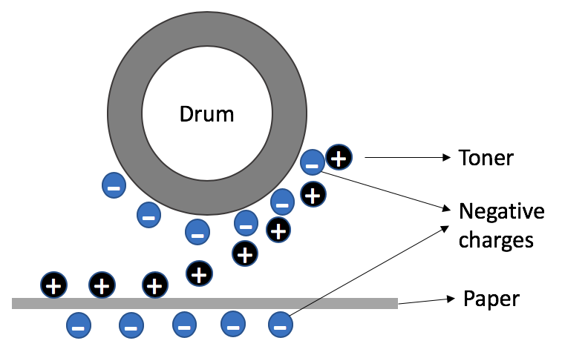Application 1: Photocopy machines or printers

Figure 36 A photocopy machine uses electrostatics in the printing process

Photocopying machines and printers use the principle of electrostatics to make photocopies. Light is reflected off the original page onto a rotating drum. The drum becomes negatively charged in the places where light does **not** shine onto it (in other words, the black parts of the page), and a positively charged black powder, called toner, is attracted to these negatively charged parts of the drum. This is then transferred to the blank paper, which is also negatively charged to help the toner to stick to it. This makes it look similar to the original page.

NOTE: Some web pages might have the charges the opposite way around. This does not matter, the main point is that the drum and the paper must have the same kind of charge so that the toner sticks to the drum, and then sticks to the page.

Application 2: Spray gun for painting

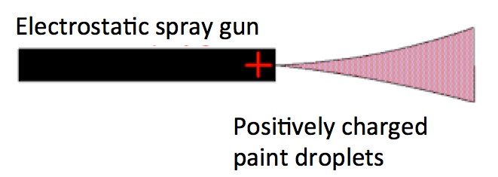Electrostatics is applied in spray painting, where particles of paint are given a positive charge as they leave the spray gun. The object to be painted is earthed so that there is an electric field between the spray gun and the object. The charged paint droplets follow the electric field lines, and are deposited evenly over the object’s surface.

Figure 37 A spray gun uses electrostatics to spread paint evenly on a surface

Figure 38 A lightning conductor applies electrostatics to prevent lightning from striking anything nearby

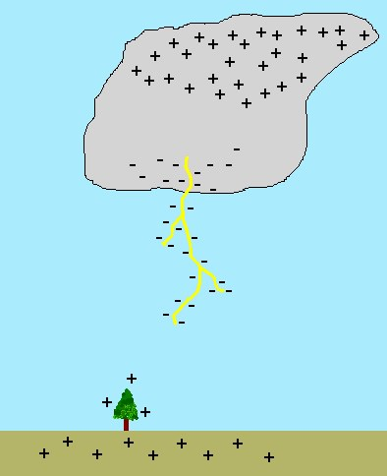

Lightning

conductor

Application 3: Lightning conductors

Lightning takes place when a thunder cloud becomes charged. It is not yet well understood by scientists exactly how the charge builds up. The charges in the clouds create an electric field between the cloud and the ground. A lightning strike occurs when there is a massive release of charge between the cloud and the ground.

Lightning conductors are tall metal poles that are attached to the earth by a conducting wire. This creates a safe path for lightning to pass through.

Application 4: A small chain that hangs down and touches the ground at the back of a big truck

When vehicles drive, the friction between the tyres and the road causes charges to build up on the vehicle. This can be dangerous, especially for petrol tankers, since a spark could jump as a result of this charge, and cause a fire. By hanging a chain from the vehicles, the charge is allowed to drain, or leak, back to the ground.

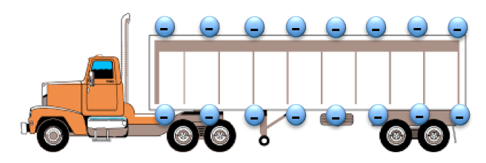

Figure 39 Charges build up on a truck as it drives

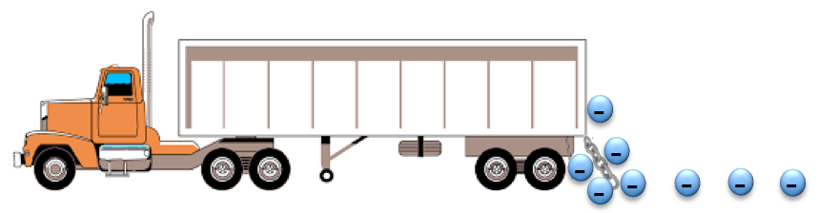

Figure 40 A chain lets charges flow to the ground, leaving the truck neutral

#### More resources to help you:

If you need further explanations about electrostatics you can visit the website: <http://www.physicsclassroom.com/Concept-Builders/Static-Electricity>

For a brief summary of electrostatics visit the website:

<https://www.bbc.com/bitesize/guides/zt7t4j6/revision/2>

The following two pages of this website will give you more information on the dangers and uses of electrostatics:

* <https://www.bbc.com/bitesize/guides/zt7t4j6/revision/3>
* https://www.bbc.com/bitesize/guides/zt7t4j6/revision/4

This website also has a short test that you could take to test your understanding of electrostatics:

* <https://www.bbc.com/bitesize/guides/zt7t4j6/test>

A helpful video teaching on electrostatics can be seen at:

<http://learn.mindset.co.za/resources/physical-sciences/grade-11/electricity-magnetism-electrostatics/learn-xtra-lessons-ncs/electrostatics>

This is a long video, so just watch the section of the video that is relevant to this course, which is from 1.44 to 35.40.

#### Activity 7: Consolidate your learning of electrostatics

Purpose:

In this activity you will consolidate your learning of electrostatics by answering the questions below and then assessing your own understanding using the solutions provided. Give yourself a mark out of the total of 40 marks, which will give you an idea of how well you understand this section of the work.

Suggested time: [60 minutes]

1. A positively charged object is brought close to a negatively charged object. What do you observe? (1)
2. Object A is a negatively charged.
   1. Were electrons added to Object A or removed from Object A when it was charged? (1)
   2. Object B is a charged object that is *repelled* by Object A. What is the charge on Object B? (1)
   3. If Object C is a charged object that is *attracted* to Object A, what is the charge on Object C? (1)
   4. Will Object B and Object C attract each other, or repel each other? (1)
3. Object X has an unknown charge, and is attracted to both a positively charged object and a negatively charged object.
   1. What is the charge on Object X to make this possible? (positive / negative / neutral) (1)
   2. Explain the process that happens in Object X to allow it to experience a force of attraction to the negatively charged object. (3)
   3. What is the name given to this process? (1)
4. The force between two charged objects is F. Which of the following changes will increase the force between the charges to 4F? (Just write YES or NO)
   1. Double the charge on one of the objects. (1)
   2. Increase the charge on one of the objects by a factor of 4. (1)
   3. Double the charge on both of the objects. (1)
   4. Increase the charge on both of the objects by a factor of 4. (1)
   5. Halve the distance between the charges. (1)
   6. Double the distance between the charges. (1)
   7. Reduce the distance between the charges by a factor of 4. (1)
   8. Increase the distance between the charges by a factor of 4. (1)
5. An electric field is formed in the space around a charge Q. The electric field at point P in the diagram is 600 N.C-1 to the left.



Figure 41 An electric field is formed by charge Q

* 1. What is the charge on Q? (4)
  2. If a test charge q = 4nC is placed at point P, what is the magnitude and direction of the force it would experience? (4)

1. Study the arrangement of charges in the diagram and answer the questions that follow.



Figure 42 Two charges Q1 and Q2 are placed a distance of 3 cm from each other

1. Calculate the magnitude and direction of the force that charge Q1 experiences. (4)
2. If charge Q1 is removed, find the magnitude and direction of the electric field at this position. Calculate this in *two different ways*. (7)
3. Describe one of the ways that electrostatics is applied in everyday life. (3)

#### Solutions

1. When a positively charged object is brought close to a negatively charged object you will observe a force of repulsion between them. (1)
   1. Since object A is a negatively charged, this means that electrons were added to it when it was charged (electrons are negatively charged particles). (1)
   2. If object B is *repelled* by Object A, Object B must have the opposite type of charge, so object B has a positive charge. (1)
   3. If Object C is *attracted* to Object A, Object C must have the same kind of charge, so object C has a negative charge. (1)
   4. Object B and Object C will attract each other, since they have unlike charges. (1)
   5. The charge on object X is *neutral*. (1)
   6. A negatively charged object attracts the positive charges in a neutral object, causing the part of the neutral object that is nearby to be positively charged, and the part that is further away to be negatively charged. This results in a force of attraction between the negatively charged object and the positively charge side of the neutral object. (3)
   7. This process is called polarization. (1)
   8. Double the charge on one of the objects. **NO** (F $∝$ q, force is proportional to charge, so this will increase the force to 2F, not 4F) (1)
   9. Increase the charge on one of the objects by a factor of 4. **YES** (F $∝$ q, force is proportional to charge, so this will increase the force to 4F) (1)
   10. Double the charge on both of the objects. **YES** (F $∝$ q, force is proportional to charge, so this will increase the force to 4F) (1)
   11. Increase the charge on both of the objects by a factor of 4. **NO** (F $∝$ q, force is proportional to charge, so this will increase the force to 16F, not 4F) (1)
   12. Halve the distance between the charges. **YES** (F $∝$ $\frac{1}{r^{2}}$, force is inversely proportional to the square of the distance between the charges, so this will increase the force to 4F) (1)
   13. Double the distance between the charges. **NO** (F $∝$ $\frac{1}{r^{2}}$, force is inversely proportional to the square of the distance between the charges, so this will decrease the force to ¼F) (1)
   14. Reduce the distance between the charges by a factor of 4. **NO** (F $∝$ $\frac{1}{r^{2}}$, force is inversely proportional to the square of the distance between the charges, so this will increase the force to 16F) (1)
   15. Increase the distance between the charges by a factor of 4. **NO** (F $∝$ $\frac{1}{r^{2}}$, force is inversely proportional to the square of the distance between the charges, so this will decrease the force to $\frac{1}{16}$ F) (1)
2. Given: r = 0,3 m

E = 600 N.C-1 to the left

* 1. If the electric field direction at point P is left, this means that Q is a **negative** charge, since the electric field points inwards towards a negative charge.

To find the magnitude of charge Q you can rewrite the equation with Q as the subject of the formula:

To make Q the subject of the formula you want to get Q on its own on the right hand side of:

$$E=k\frac{Q}{r^{2}}$$

So you divide both sides by kQ and multiply by r2:

*=* = Qwhich gives you

$$\frac{E r^{2}}{k }= Q$$

$Q= \frac{E r^{2}}{k }$

= $\frac{600N.C^{-1} × {(0,3m)}^{2}}{9×{10}^{9} }$

= $6×{10}^{-9}$ C

= 6 nC

Therefore Q = - 6 nC (4)

* 1. Given: E = 600 N.C-1 to the left

q = 4 nC

To make F the subject of the formula you multiply both sides of the equation by q:

So E = becomes =

On the right hand side the q at the top cancels with the q at the bottom, leaving you with = F

= 4×10-9 C

The magnitude of the force is

F = E.q

= 600 N.C-1 × 4 × 10-9 C

= 2,4 × 10-6 N

The direction of the force on a positive test charge is the same as the direction of the electric field.

Therefore F = 2,4 × 10-6 N to the left (4)

1. Given: Q1 = 6 × 10-5 C

Remember that when you convert from cm to m you divide by 100, which is the same as multiplying by 10-2

Q2 = -1 × 10-5 C

r = 3 cm

= 3 × 10-2 m

1. You can calculate the magnitude of the force on charge Q1 due to charge Q2:

Remember that you don’t need to include the signs of the charges when calculating the magnitude of the force. You use the signs later when you find the direction of the force.

$=9 × {10}^{9} Nm^{2}C^{-2} × \frac{1×{10}^{-5}C × 6×{10}^{-5}C }{{(3×{10}^{-2}m)}^{2}}$

$=1,2 × {10}^{8} N$

To find the direction:

The charges have opposite signs, so this is a force of attraction.

Therefore F21 = 1,2 × 108 N downward (4)

1. Method 1: If you want to find the magnitude of the electric field at the position where charge Q1 is located, you can use charge Q2 in the equation:

E =

=

= 1 108 N.C-1

The direction of the electric field is to the right, since the electric field points inwards towards the negative charge Q2.

Therefore E = 1 × 108 N.C-1 to the right

Method 2: You can treat charge Q1 as the test charge. So the electric field strength at Q1 is:

E = = = 1 × 108 N.C-1

The electric field direction is the same as the direction of the force on the positive test charge Q1, so E = 1 × 108 N.C-1 to the right. (7)

1. Describe any one of these applications, or any others you have investigated: (3)

* **Photocopying machines** and printers use the principle of electrostatics to make photocopies. Light is reflected off the original page onto a rotating drum. The drum becomes negatively charged in the places where light does **not** shine onto it (in other words, the black parts of the page), and a positively charged toner is attracted to these negatively charged parts of the drum. This is then transferred to the blank paper which is also negatively charged. This makes it look similar to the original page. (The signs can be the opposite way around in the explanation.)
* Electrostatics is also applied in **spray painting**, where particles of paint are given a positive charge as they leave the spray gun. The object to be painted is earthed so that there is an electric field between the spray gun and the object. The charged paint droplets follow the electric field lines, and are deposited evenly over the object’s surface.
* Lightning takes place when a thunder cloud becomes charged by the rubbing together of air and water particles moving past each other. This creates an electric field between the cloud and the ground. A lightning strike occurs when there is a massive release of charge between the cloud and the ground. **Lightning conductors** are tall metal poles that are attached to the earth by a conducting wire. This creates a safe path for lightning to pass through.
* A **small chain** hangs down and touches the ground at the back of a big truck. When vehicles drive, the friction between the tyres and the road causes charges to build up on the vehicle. This can be dangerous, especially for petrol tankers, since a spark could jump as a result of this charge, and cause a fire. By hanging a chain from the vehicles, the charge is allowed to drain, or leak, back to the ground.

## Sub-topic 2: Electric Circuits

### Unit 1: Current, resistance and potential difference in electric circuits

#### Learning Outcomes

By the end of the unit, you should be able to:

* state that current (I) is a rate of flow of charge, measured in amperes;
* apply the equation I = Q/ $∆$ t ;
* explain conventional current;
* define electromotive force (*emf*) as the work done in moving a unit charge around a complete circuit, measured in volts;
* define the potential difference (V) across an element in a circuit as the work done to move a unit charge through the element, measured in volts;
* draw diagrams to show how to connect an ammeter to measure current through a circuit element, and a voltmeter to measure voltage across a circuit element;
* define resistance;
* apply the formulae for the equivalent resistance of a number of resistors in series and in parallel;
* state that the current is constant through each element in a series circuit;
* state that the total potential difference is equal to the sum of the potential differences across the individual elements in a series circuit;
* calculate the equivalent resistance of resistors connected in series: Rs = R1 + R2 + … ;
* state that the potential difference is constant across circuit elements that are connected in parallel;
* state that the current from the source is the sum of the currents in the separate branches of a parallel circuit;
* calculate the equivalent resistance of resistors connected in parallel: 1/Rp  = 1/R1 + 1/R2 + … ;
* state that the potential difference across the separate branches of a parallel circuit is the same and apply the principle to new situations or to solve related problems;
* state Ohm’s Law in words and mathematically: R = V/I ;
* solve problems for circuits involving resistors connected in series and parallel.

#### Introduction

Reflect on the following questions, either on your own or with a fellow student:

* What do you understand about the term “electricity”?
* When you turn on a light switch, what do you think causes the light bulb to glow?

In the previous unit you learnt about the forces between positive and negative charges (electrostatics). In this unit you will learn what happens when these charges move around a circuit, creating an electric current.

#### Activity 1: Investigate what is needed for charges to move in a circuit

Purpose

In this activity you will investigate what is needed for charges to move in an electric circuit.

What you need:

* 1 battery (a 1.5V torch battery is best)
* 1 torch bulb
* 1 electric lead (any piece of wire which has both ends not covered in plastic)

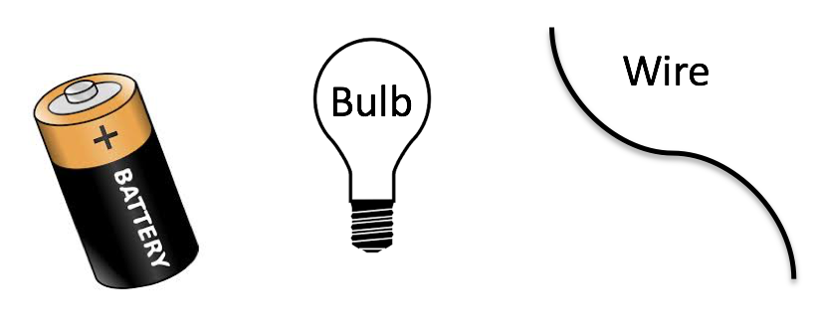

Figure 43 Equipment needed: a battery, a torch bulb and a wire

Suggested time**:** [20 minutes]

What you will do:

1. Using your torch battery, bulb and leads, try to find all of the ways in which these can be arranged so that your bulb lights up. Hint: there are 4 possible ways.
2. Explain what is needed for a light bulb to glow in a circuit.
3. Assume that the charges that move around your circuit are positive charges. Using this information, trace the path of the charges from one end of the battery through the circuit to the other end of the battery. (The positive side of the battery is the part with the smaller tip: you should see a + sign, and the negative side is the flat end where you will see the – sign.)
4. What do you think is causing the light bulb to glow? Write down your ideas, or discuss your ideas with a fellow student.

#### Guided reflection

If you look carefully at your light bulb you will see a thin wire inside of it. This is called a *filament*. When charges move through this filament they cause friction, and as a result the filament glows. A glowing lightbulb is therefore evidence that charges are moving in a circuit.

In this activity you would have found that your light bulb glows when the circuit elements are connected in a closed loop. In other words, for charge to move there should be no gaps in the circuit. This is called a *closed circuit*. You also need an electrical energy source, which is the battery. *Resistors* are the parts of a circuit that use the electrical energy for some purpose, for example to provide heat (heater), light (bulb) or sound (bell). The light bulb in your circuit is a resistor. The diagrams below show the four possible ways of connecting your circuit that would have caused your light bulb to glow.



Figure 44 The four ways of connecting a circuit with a bulb, battery and wire that causes a light bulb to glow

#### Alternative Simulation Activity

If you do not have the equipment to do the electricity experiments in this unit, but have internet access, you can construct all of the electrical circuits using a Circuit Construction Kit. Go to the website: <https://phet.colorado.edu/sims/html/circuit-construction-kit-dc/latest/circuit-construction-kit-dc_en.html>

You will see a page that looks like this:

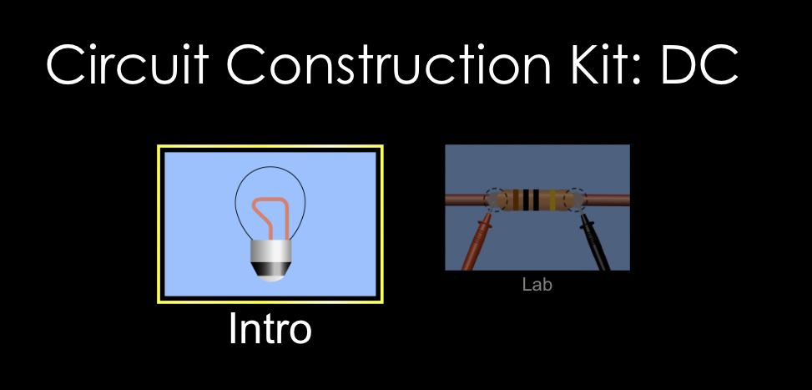

Figure 45 Front page of circuit construction kit

(Source: phet.colorado.edu)

Click on the Intro window, and you will see the following page:

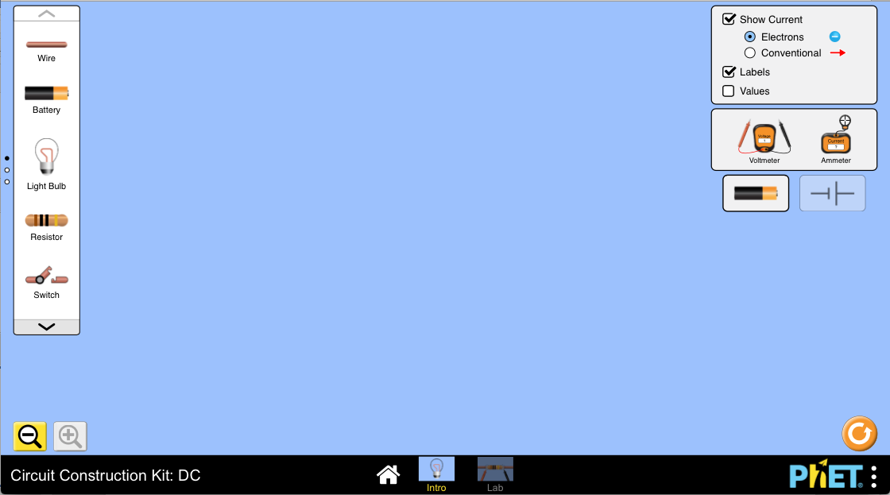

Figure 46 Construction window of circuit construction kit

On this page you can construct an electrical circuit by dragging different circuit elements into the middle of the page and connecting them together, as the diagram below shows.

First, make sure you click the button at the top right and side of the screen that says “Conventional” so that the direction of the current flows from the positive side of the battery to the negative side.

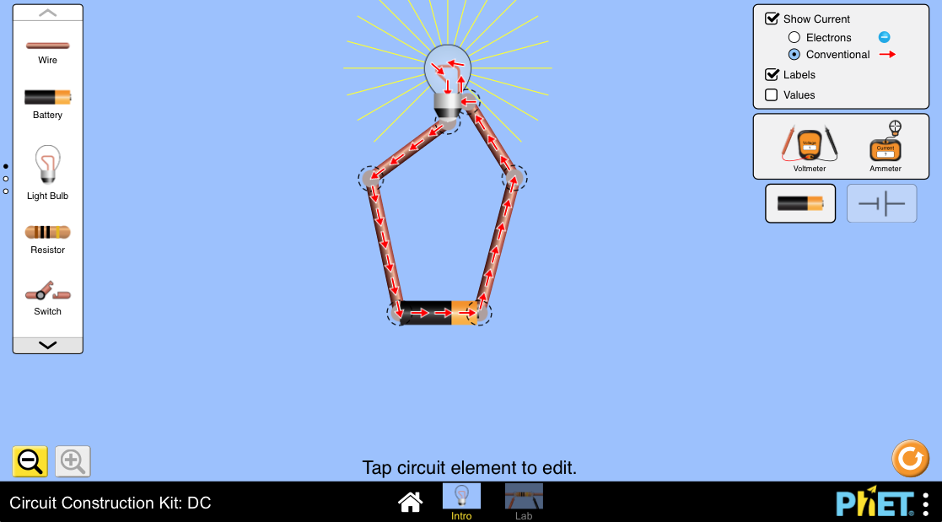

Figure 47 Construction of a simple electrical circuit with battery, wire and bulb

Connections are shown with a dotted circle:



Figure 48 Connection symbol

When you need to change something in your circuit, you can break a connection by clicking on that connection, and then clicking on the image of scissors. This is shown in the diagram below.

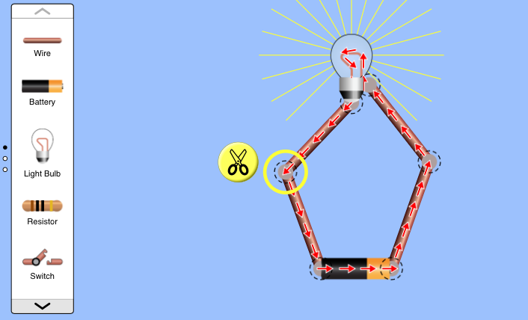

Figure 49 Click on a connection, and then click on the image of scissors to break the connection

#### Current

When charges move from one atom to another in an electrical circuit, this forms a flow of charges around the circuit, which is called an electrical *current*. The word “current” describes how fast the charges move in a circuit. In other words, you can define current as the rate of the flow of charges, which is denoted by the symbol “I”, and is measured in Amperes (A). You can express this in an equation:

I = $\frac{Q}{∆t}$

where I is the current, measured in amperes (A),

Q is the amount of charge, measured in coulombs (C), and

$∆t$ is the time interval, measured in seconds (s).

From this equation you can see that 1 A = 1 C/s. In other words, the current tells you how many coulombs of charge are passing a point in the circuit in one second. The value of the current affects the physical effect that this current has in a circuit. For example, the greater the current that flows through a light bulb, the brighter the bulb will be.

The examples below shows how to solve problems using this euqation for current.

**Example 1**:

16 C of charge passes a point in a circuit in the time of 4 seconds. What is the value of the current that passes this point in the circuit?

**Solution:**

Given: Q = 16 C;

$∆t$ = 4 s

Calculation:

To calculate the current you use the equation:

I = $\frac{Q}{∆t}$

= $\frac{16 C}{4 s}$

= 4 A

**Example 2**:

A current of 2 A flows through a resistor. How much charge flows through this resistor in 30 seconds?

Solution:

To make Q the subject of the formula you multiply both sides of the equation by $∆$ t, and I = $\frac{Q}{∆t}$ becomes $I×∆$ t = Q

Given: I = 2 A;

$∆t$ = 30 s

Calculation:

From the equation I = $\frac{Q}{∆t}$ you can solve for Q by changing the subject of the formula:

Q = I $×$ $∆t$

UNITS: Since 1A = 1C/s, when you multiply the units you get: A $×$ s = C/s $×$ s = C

= 2 A $×$ 30 s

= 60 C

The *convention* (rule) that has been chosen by scientists is that current flows from the positive terminal of the battery to the negative terminal. The term “conventional current” is sometimes used to describe this direction for the current flow.

#### Circuit Diagrams

When you draw diagrams of electrical circuits, you do not show the physical shapes or connections of the circuit elements. Rather, you use symbols to show the circuit elements, and lines to show the electrical connections. This way of representing an electrical circuit is called a *circuit diagram*. From a circuit diagram, you cannot tell how close together the circuit elements are. This is because circuit diagrams do not show the physical layout of the circuit. They show you the electrical connections.

The symbol for a battery, a resistor, a switch and a light bulb are shown in the diagrams below.

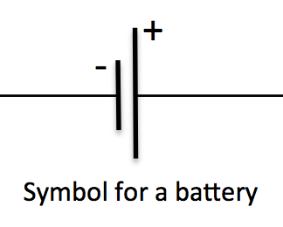

Figure 50 Symbol for a battery

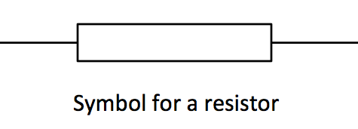

Figure 51 Symbol for a resistor

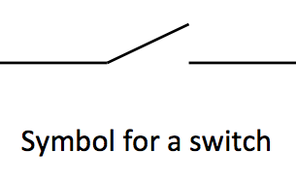

Figure 52 Symbol for a switch

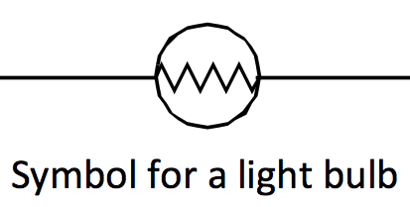

Figure 53 Symbol for a light bulb

The circuit diagram below represents an open circuit with a battery, a resistor and a switch.

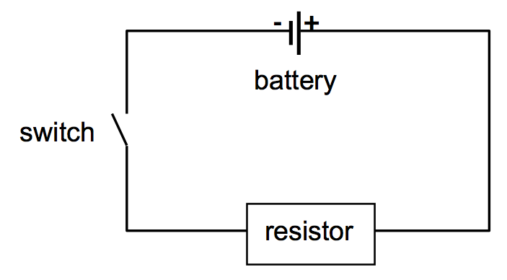

Figure 54 Open circuit with a battery, a resistor and a switch

The circuit diagram below shows a closed circuit, which is formed when the switch is closed, allowing the current to flow. When circuit elements are connected together in a single loop this is called a *series circuit*.

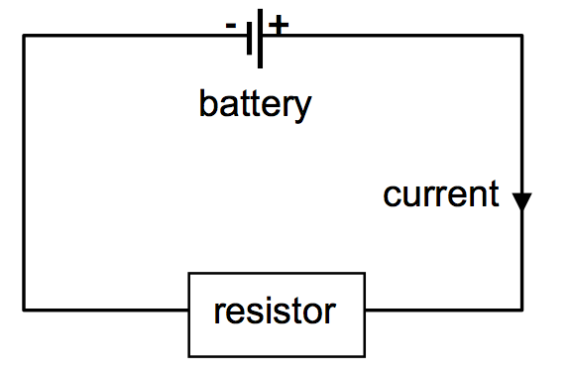

Figure 55 Closed circuit with a battery, a resistor and a switch connected in series

#### Activity 2: Test your understanding of current

Purpose

In this activity you will test what you have understood about electrical current so far.

Suggested time**:** [20 minutes]

What you will do:

Answer the following questions:

1. Draw a *circuit diagram* for a circuit containing a battery, a switch, a resistor and a light bulb connected in series.
2. Explain in your own words what the term *current* means.
3. Carefully work through the examples shown below, and then try to answer the next two exercises yourself:
4. 6 C of charge passes a point in a circuit in the time of 3 seconds. What is the value of the current at this point in the circuit?
5. A current of 0,2 A flows through a bulb. How much charge flows through this bulb in 5 minutes?
6. In Circuit A half a coulomb of charge passes through a bulb in each second. In a Circuit B 10 C of charge passes through a bulb in half a minute. In which circuit will the bulb will be brightest, Circuit A or Circuit B?

#### Solutions or Exemplar answers

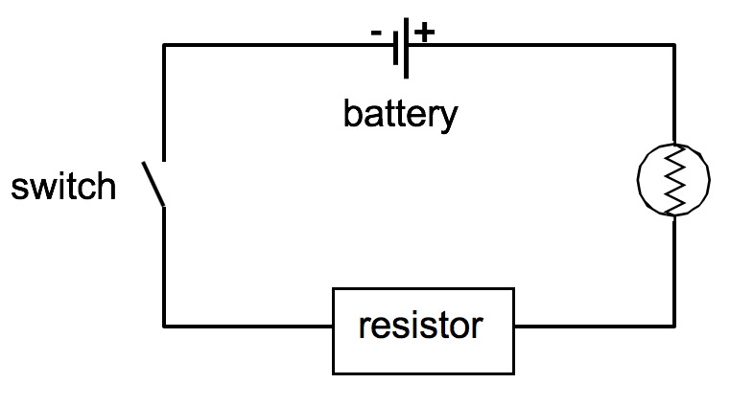

Figure 56 Circuit diagram for a circuit containing a battery, a switch, a resistor and a light bulb connected in series

1. Current is the rate of the flow of charges, or a measure of how quickly charges flow in a circuit.
2. (This just involved you working through the examples provided)
3. Given: Q = 6 C;

$∆t$ = 3 s

Calculation:

I = $\frac{Q}{∆t}$

= $\frac{6 C}{3 s}$

= 2 A

Remember that to convert from minutes to seconds you multiply by the number of seconds in each minute (60 s/min)

1. Given: I = 0,2 A;

$∆t$ = 5 min $×$ 60 s/min = 300 s

Calculation:

From the equation I = $\frac{Q}{∆t}$ you can solve for Q:

Look at Example 2 above to recall how to change the subject of the formula to solve for Q

Q = I $×$ $∆t$

= 0,2 A $×$ 300 s

= 60 C

1. **Circuit A:** Given: Q = 0,5 C

$∆t$ = 1 s

Calculation:

I = $\frac{Q}{∆t}$

= $\frac{0,5 C}{1 s}$

= 0,5 A

**Circuit B:** Given: Q = 10 C

$∆t$ = 0,5 min $×$ 60 s/min = 30 s

Calculation:

I = $\frac{Q}{∆t}$

= $\frac{10 C}{30 s}$

= 0,33 A

Therefore the bulb in Circuit A will be the brightest, since it has the greatest current.

[Wordbox: MAIN IDEAS:

* Current flows from the positive terminal of the battery to the negative terminal
* For current to flow you need a *closed**circuit* with a power supply (battery)
* When circuit elements are connected together in a single loop this is called a *series circuit*. ]

#### Measuring current

When you want to measure the amount of current that is flowing in a circuit, you use an instrument called an *ammeter*. The ammeter measures the current that flows through it, so you connect the ammeter in *series* with a circuit element.

Ammeter

**+**

**-**

**+**

**-**

In an actual circuit, the positive (red) terminal of the ammeter must always be connected to the positive terminal of the battery, and the negative (black) terminal of the ammeter must be connected to the negative terminal of the battery.

#### Figure 57 Potential difference

#### Activity 3: Measure current in a 1-bulb circuit

Purpose

In this activity you will use an ammeter to measure the current in a simple 1-bulb circuit.

What you need:

* 1 battery
* 1 torch bulb
* An ammeter
* Electric leads



Suggested time**:** [15 minutes]

What you will do:

1. Create a circuit where the cell is connected in a loop with a light bulb, as shown on the right.

Figure 58 Measure the current at position 1 and 2

1. Connect your ammeter into the position marked 1 in this circuit. Write down the current reading. (NOTE: If the ammeter has more than one scale, always connect to the largest scale first so that the ammeter will not be damaged by having to measure values that are too large).
2. Connect your ammeter into the position marked 2 in this circuit. How does this current reading compare to the one at position 1?
3. Write a summary of your findings from this experiment.

#### Alternative Simulation Activity

Remember that you can construct all of the electrical circuits in this unit using a Circuit Construction Kit by going to the website: <https://phet.colorado.edu/sims/html/circuit-construction-kit-dc/latest/circuit-construction-kit-dc_en.html> and clicking on the Intro window.

In the Circuit Construction Kit you can include an ammeter in your circuit, as the picture below shows:

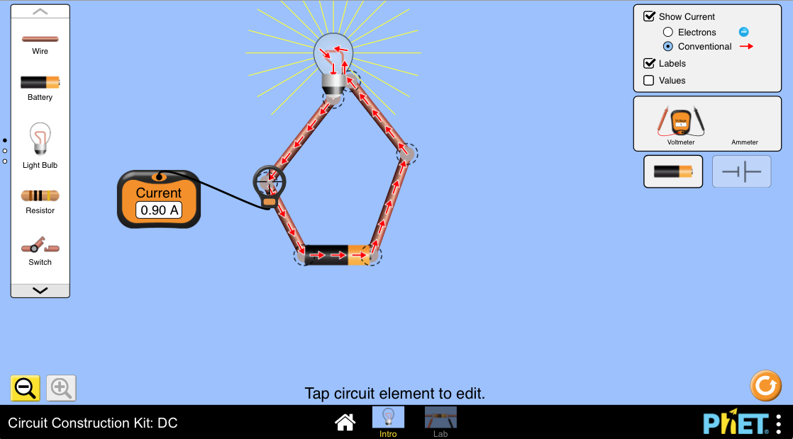

Figure 59 An ammeter can be used to measure current in the Circuit Construction Kit

(The ammeter can be found on the right hand side of the window, and you can just drag it to where you want to measure the current. You drag the  to the exact position).

#### Guided reflection

In this activity you should find that the current is *the same* at Points 1 and 2 in the circuit.

This might seem strange to some of you, as you might think that the current is used up at the first bulb, so that there is less current flowing at point 2 in the circuit. But remember that current is defined as the rate of the flow of charges around the circuit, and so it is NOT used up by a bulb. The current flows from the cell, into the bulb, then back to the cell. No current is lost, or used up, in the process. Nice discussion of the misconception.

[Wordbox: MAIN IDEAS:

* You use an *ammeter* to measure electrical current.
* The ammeter must be connected in *series* in the circuit.
* Thecurrent is the *same* at all points in a *series circuit*. ]

#### Potential difference

In a circuit the battery is the source of the electrical energy. There is no flow of charges without a battery, since it gives a push which sends the charges around the wires in the circuit. This push of the charges is called the *electrical potential difference*. Electrical potential difference is measured in units of *volts* (V).

The definition of potential difference across a circuit element is the work done to move a unit charge through the element.

In a circuit, the *battery* creates an *increase* in the potential difference, and the *resistors* cause a *decrease* in the potential difference. In other words, the resistors use up all of the potential difference created by the battery. The potential difference that is measured across the battery in a circuit is called the *emf* of the battery.

[Wordbox: MAIN IDEAS:

* The *electrical potential difference* across a circuit element is the work done to move a unit charge through the element.
* Electrical potential difference is measured in *volts* (V).
* The potential difference across the battery is called the *emf*. ]

#### Measuring potential difference

When you measure the potential difference you use an instrument called a *voltmeter*. The voltmeter measures the potential difference across its terminals, so you connect the voltmeter in *parallel* to the circuit element. In the diagram below the voltmeter is connected in parallel to the battery, meaning that one lead is connected to one side of the battery, and the other lead to the second side of the battery while the battery is connected in the circuit. This connection is shown in the diagram below.

Voltmeter

**+**

**-**

**+**

**-**

Figure 60 A voltmeter is connected in parallel to measure potential difference across a circuit element

In the actual electrical circuit, the positive (red) terminal of the voltmeter must be connected to the positive terminal of the battery, and the negative (black) terminal of the voltmeter to the negative terminal of the battery.

#### Activity 4: Measure potential difference

Purpose

In this activity you will use a voltmeter to measure the potential difference in a simple 1-bulb circuit.

What you need:

* 1 battery
* 1 torch bulb
* 1 voltmeter
* Electric leads

Suggested time**:** [15 minutes]

What you will do:

Figure 61 A series circuit with a cell, a battery and a switch

1. Create a circuit where the cell is connected in series with a switch and a torch bulb, as shown in the circuit diagram.
2. Connect your voltmeter to measure the *emf*, which is the potential difference across the cell. Record the voltage reading when you have closed the switch in your circuit.
3. Connect your voltmeter to measure the potential difference across the bulb when the switch is closed. Write down the voltage reading.
4. How does the potential difference across the resistor compare with the *emf* measured across the battery?
5. Connect your voltmeter to measure the potential difference across the switch when it is closed. Can you explain this reading?

#### Alternative Simulation Activity

Remember that you can construct all of the electrical circuits in this unit using a Circuit Construction Kit by going to the website: <https://phet.colorado.edu/sims/html/circuit-construction-kit-dc/latest/circuit-construction-kit-dc_en.html> and clicking on the Intro window.

In the Circuit Construction Kit you can include a voltmeter and a switch in your circuit, as the picture below shows:

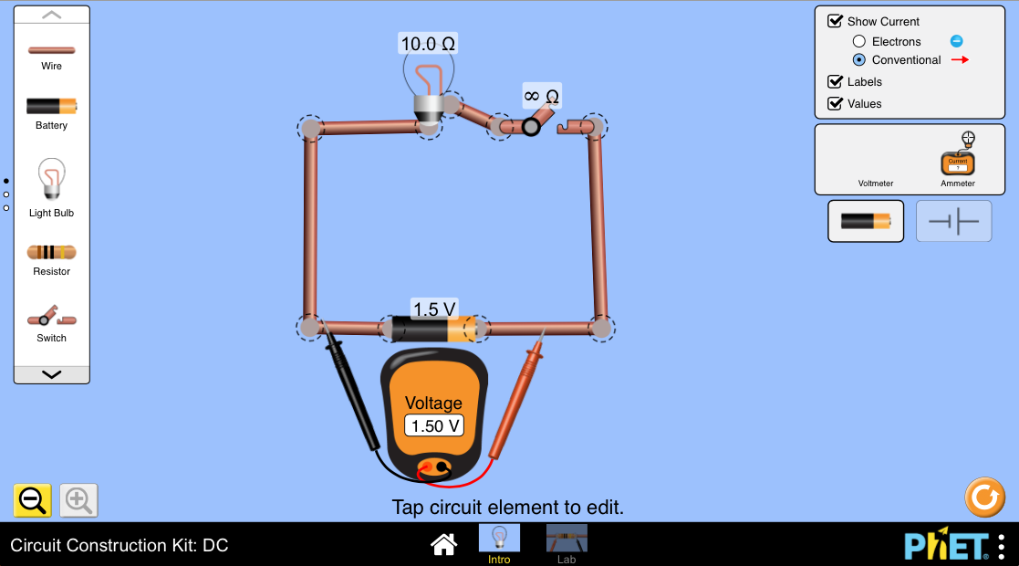

Figure 62 Circuit with a voltmeter connected in parallel to the battery in the Circuit Builder Kit

NOTE:

* From here on you might find it helpful to click the option for “Values” on the top right hand side of the screen.
* To change the value of the potential difference for your battery, click on the battery and you will see a slider at the bottom that you can adjust. Change this to 1.50 V to show the voltage for a typical one-battery circuit.

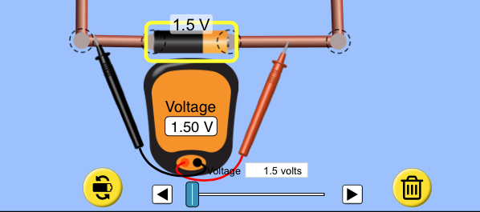

Figure 63 Click the “Values” button to see the voltage, current and resistance values in the circuit.

* If you use the simulation, do the steps numbered 1 to 5 from Activity 4.

#### Guided reflection

In this activity you should find that the potential difference across a single battery is about 1,5 V. If you measured this with the switch closed, you would have found that it is similar to the potential difference across the light bulb.

You also should find that the potential difference across the switch is 0 V (while the switch is closed). This is because the switch is not a resistor, so it does not use up any of the electrical energy. It therefore does not cause a drop in the potential difference.

[Wordbox: MAIN IDEAS:

* The *electrical potential difference* across a circuit element is the work done to move a unit charge through the element.
* Electrical potential difference is measured in *volts* (V).
* The potential difference across the battery is called the *emf*.
* You use a *voltmeter* to measure electrical potential difference.
* The voltmeter must be connected in *parallel* to the circuit element. ]

Figure 64 Resistors make it harder for current to flow

(Source: Background image is from <https://www.dse.nl/~boncoeur/ohms_law/ohms_law_formula.jpg>)

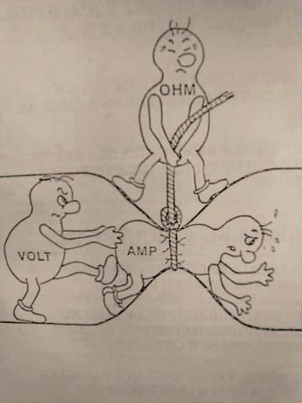

Resistor

Push from the battery

Current is blocked

#### Resistance

A resistor makes it more difficult for charges to pass through it than through ordinary conductors. Resistors oppose, or resist, the path of the current. The greater the value of its resistance, the more a resistor will resist the flow of current in the circuit. Resistance is measured in ohms (Ω).

A higher value for the resistance in a circuit causes the current flowing in that circuit to decrease. This is because resistors cause an obstacle to the flow of current in a circuit. Therefore when the resistance increases, the current in the circuit decreases. The picture on the right gives you an idea of how a resistor works in a circuit, by causing a blockage to the flow of current.

[Wordbox: MAIN IDEAS:

* A *resistor* opposes the path of the current.
* *Resistance* is measured in ohms (Ω). ]

#### Ohm’s Law

#### Activity 5: Investigate the relationship between current, voltage and resistance

Purpose

In this activity you will investigate the mathematical relationship between current, voltage and resistance.

What you need:

* 4 batteries and a battery holder,
* 2 resistors, one that has double the resistance of the other
* 1 ammeter and 1 voltmeter
* Some connecting leads
* 1 switch

Suggested time**:** [30 minutes]

What you will do:

1. Design and build a circuit consisting of one battery connected in series with the smaller resistor and a switch.
2. Connect the ammeter and voltmeter in your circuit so that you can measure the current through the resistor, and the voltage across it.
3. Measure the current through the resistor, and the voltage across it, for circuits consisting of two, three and four batteries. (NOTE: only close your circuit for a short time when taking your readings, because the temperature must be kept constant.)
4. Record your measurements in a table like the one below:

|  |  |  |  |  |  |
| --- | --- | --- | --- | --- | --- |
|  |  | **Reading 1** (One battery) | **Reading 2** (Two batteries) | **Reading 3** (Three batteries) | **Reading 4** (Four batteries) |
| Small resistor | Voltage (V) |  |  |  |  |
| Current (A) |  |  |  |  |
| Large resistor | Voltage (V) |  |  |  |  |
| Current (A) |  |  |  |  |

1. Using a piece of graph or squared paper, plot a graph of voltage on the y-axis (vertical) against current on the x-axis (horizontal).
2. What do you notice about the shape of this graph? What does this tell you about the relationship between voltage and current?

If you need help with plotting a graph, and finding the gradient of the best-fit line, remind yourself of how to do this by looking at the graph section of Chapter 1 again.

1. Draw a best-fit line through your points.
2. Calculate the gradient of the best-fit line.
3. Repeat steps 2 to 4 with the larger resistor.
4. On the same set of axes as your previous graph, plot the graph of voltage against current for this larger resistor. Answer the following questions:
   * How do your two graphs compare with one another?
   * Which graph has the higher value for its gradient?
   * What would the graph look like for a resistor that has half the resistance of the smaller resistor?
5. Write a clear and precise summary of your conclusions.

#### Suggestion for alternative equipment

1. If you do not have two resistors with different resistances, you can use different lengths of pencil lead, since pencil lead is made of graphite, which is a resistor. The longer the length of pencil lead, the greater its resistance.
2. As previously, you can construct all of the electrical circuits in this unit using a Circuit Construction Kit by going to the website: <https://phet.colorado.edu/sims/html/circuit-construction-kit-dc/latest/circuit-construction-kit-dc_en.html> and clicking on the Intro window.
3. If you do not have any of the equipment to do this experiment yourself, or access to the internet, you have provided some possible values for you to work with. These are shown in the table below. Use these values to try to complete all of the steps from point 5 above onwards.

|  |  |  |  |  |  |
| --- | --- | --- | --- | --- | --- |
|  |  | **Reading 1** (One battery) | **Reading 2** (Two batteries) | **Reading 3** (Three batteries) | **Reading 4** (Four batteries) |
| Small resistor | Voltage (V) | 0,9 V | 1,4 V | 2,6 V | 3,2 V |
| Current (A) | 1,2 A | 2,5 A | 4,1 A | 5,8 A |
| Large resistor | Voltage (V) | 1,5 V | 2,5 V | 4,5 V | 5,9 V |
| Current (A) | 1,3 A | 2,6 A | 4,5 A | 5,7 A |

#### Guided reflection

From this activity, you would have observed that, as the voltage in the circuit is increased (by adding cells to the circuit), the current also increases. If you only closed your switch for a short time when taking your readings, the temperature would have remained constant, and so your graph should have been a straight line. An example graph using the data shown in the above table is shown below:

Figure 65 Graph of voltage vs current for Activity 5

This straight line graph tells you that, at constant temperature, the *current is directly proportional to the voltage*. You can summarize this relationship in the following mathematical way: V α I.

This relationship between voltage and current is called *Ohm’s Law*, which states that the current through a resistor is directly proportional to the voltage across the resistor at constant temperature.

The gradient of your graph for the smaller resistance should have been lower than the gradient for the higher resistance. So the gradient of the graph of voltage against current tells you about the value of the resistance. The greater the resistance, the higher the value that you find for the gradient.

When you calculate the gradient of this graph, you are dividing the voltage by the current, and this tells you about the resistance.

You can express Ohm’s Law using a mathematical equation as: $R=$ $\frac{V}{I}$

where R is the resistance of a resistor, measured in ohms (Ω)

V is the voltage (potential difference) across the resistor, measured in volts (V)

I is the current through the resistor, measured in amperes (A)

From this equation you can see that 1 ohm is equal to one volt per ampere. You can write this mathematically as 1 Ω = 1 V/A.

#### Resistors in series

#### Activity 7: Investigate resistors in series

Purpose

In a circuit that has two or more resistors that are connected in series (next to each other), the current in the resistors is equal. This is because current in a series circuit only has one path to move through. In this activity you will compare the voltage and current in circuits with different numbers of resistors in series.

What you need:

* 2 batteries
* 3 torch bulbs
* Electric leads
* 2 switches

Suggested time**:** [20 minutes]

What you will do:

1. Connect the two circuits shown in the diagrams below.

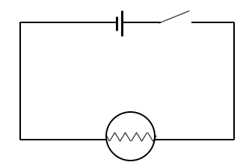

Figure 66 Circuit 1

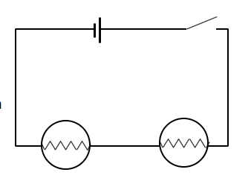

Figure 67 Circuit 2

1. Close the switch in Circuit 1 and observe the brightness of the bulb.
2. Close the switch in Circuit 2 and observe the brightness of the bulbs.
3. Compare the brightness of the bulbs in Circuit 2 with Circuit 1. Discuss the following questions:
   1. What can you conclude about the current in the bulb in Circuit 1 compared to Circuit 2?
   2. What can you conclude about the current through the cell in Circuit 1 compared to Circuit 2?
4. Use your ammeter to measure the current through the cell in Circuit 1 and Circuit 2. Do your current readings agree with the conclusions that you made from your discussions?
5. Use your voltmeter to measure the potential difference across the bulb and the cell in Circuit 1 *with the switch closed*. How do these voltage readings compare?
6. Use your voltmeter to measure the potential difference across the bulbs and the cell in Circuit 2*with the switch closed*. How do these voltage readings compare?
7. What can you conclude about the relationship between the cell terminal potential difference and the potential difference across the resistors in a series circuit?

#### Alternative Simulation Activity

Remember that you can construct all of the electrical circuits in this unit using a Circuit Construction Kit by going to the website: <https://phet.colorado.edu/sims/html/circuit-construction-kit-dc/latest/circuit-construction-kit-dc_en.html> and clicking on the Intro window.

In this simulation (a single bulb with greater battery voltage), you can see the difference in brightness of the light bulbs by looking at the length of the yellow lines around the light bulb. The longer the lines, the greater the brightness of the light bulb. In the diagram below the light bulb on the right has a greater brightness than the one on the left.

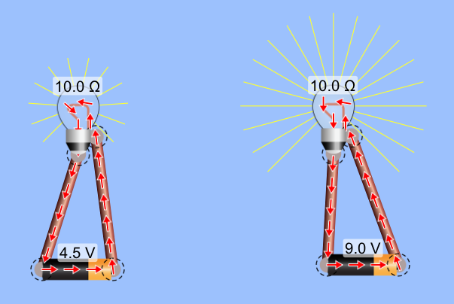

Figure 68 The difference in brightness of the light bulbs is shown by the length of the yellow lines around the light bulb in the Circuit Builder Kit

#### Guided reflection

In this activity you should have noticed the following:

* The brightness of the bulb in Circuit 1 is greater than the brightness of the bulbs in Circuit 2.
* Answers to the discussion questions:
  1. The current in the bulb in Circuit 1 is greater than in Circuit 2, since the bulb is brighter.
  2. The current in the cell in Circuit 1 is greater than in Circuit 2.
* The ammeter reading for the current through the cell in Circuit 1 should be nearly double that in Circuit 2.
* The potential difference across the bulb should be equal to the potential difference across the cell in Circuit 1.
* The potential difference across both of the bulbs together should be equal to the potential difference across the cell in Circuit 2.
* The cell terminal potential difference is equal to the sum of the potential difference readings across the resistors in a series circuit.

These results show you some very important aspects of an electric circuit.

The potential difference across the battery in a circuit is equal to the total potential difference across the resistors in a series circuit. For example, in a series circuit with two resistors, R1 and R2, with potential differences of V1 and V2, the potential difference across the battery can be expressed as:

Vbattery = V1 + V2

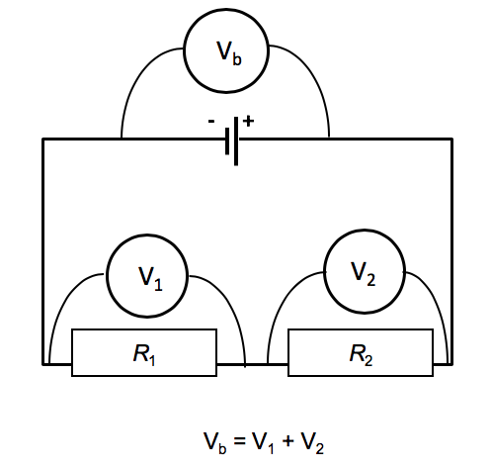

Figure 69 The voltage across the battery is equal to the voltages across all of the series resistors

For any circuit with two or more resistors connected in series, you can write the battery potential difference in a circuit as:

Vbattery = V1 + V2 + …

Resistors that are connected in series are called *potential dividers* because they share the battery’s potential difference. The larger resistance will get the greater share of the potential difference. In other words, the potential difference across a resistor is proportional to the value of its resistance.

The total resistance is equal to the sum of the resistances that are connected in series. For example, in a series circuit with two resistors, R1 and R2, with total resistance can be expressed as: Rs = R1 + R2

For any circuit with two or more resistors connected in series, you can write the total equivalent resistance of resistors in series as:

Rs = R1 + R2 + …

When resistors are connected in series, they together oppose the flow of charge more than when they are on their own. This has the effect of decreasing the current through the circuit. Therefore, the higher the resistance in a circuit, the lower the current. Mathematically you say that the current is inversely proportional to the resistance.

You can prove this mathematically from the equation for Ohm’s Law, which is $R=$ $\frac{V}{I}$. From this equation you can see that

R $∝ \frac{1}{I}$

Mathematically, this tells you that R is inversely proportional to I (current).

[Wordbox: MAIN IDEAS:

* The *current* (I) in series resistors is equal.
* Theterminalpotential difference across the battery in a circuit is always equal to the *sum of the potential difference* across the resistors in a series circuit: *V*battery = *V*1 + *V*2 + ….
* The potential difference across a resistor is *proportional* to its resistance
* The *total equivalent resistance* of series resistors is equal to the sum of the individual resistances: Rs = R1 + R2 + …
* The current in a circuit is *inversely proportional* to the total resistance. ]

The examples below demonstrate how you solve problems using Ohm’s Law.

**Example 1**:

Study the circuit shown in the diagram below and answer the questions that follow.

Figure 70 Circuit diagram for Example 1

*R*1 = 2Ω

*R*2 = 6Ω

1. What is the total resistance in the circuit?
2. What is the potential difference across the 6 Ω resistor?
3. What is the battery voltage?
4. Calculate the current in the 2 Ω resistor.

**Solution:**

1. For series resistors you add together the resistances:

Rs = R1 + R2

= 2 Ω + 6 Ω

= 8 Ω

1. If V1 = 4 V, then since R2 has 3 times the resistance of R1, its voltage must be 3 times V1. Therefore V2 = 3 × 4 V = 12 V.
2. For series resistors you add together the voltages across them:

Vbattery = V1 + V2

= 4 V + 12 V

= 16 V

1. From Ohm’s Law $R=$ $\frac{V}{I}$, you can solve for current you change the subject of the formula:

$I=$ $\frac{V}{R}$

To make I the subject of the formula you multiply both sides of the equation by I and divide both sides by R, so R = $\frac{V}{I}$ becomes = $\frac{R×I}{R}$ = $\frac{V×I}{I×R}$. You can cancel R on the left hand side and I on the right hand side, leaving you with the equation $I=$ $\frac{V}{R}$

$=$ $\frac{4 V}{2 Ω}$

= 2 A.

**Example 2:**

Find the current I2 in Circuit 2 below. (All of the batteries are the same, and ignore internal resistance.)

8 Ω

I2 = ?

2 Ω

I1 = 4 A

Figure 71 Circuit 2

Figure 72 Circuit 1

**Solution**

The current is inversely proportional to the resistance. The resistance in Circuit 2 is 4 times the resistance in Circuit 1, so its current must be a quarter of that in the first circuit.

∴ I2 = ¼ I1 = ¼ × 4 A = 1 A

#### Activity 8: Test your understanding of resistors in series

Purpose

In this activity you will test your understanding of resistors in series by first looking through some worked examples, and then answering questions yourself.

Suggested time**:** [20 minutes]

What you will do:

Test your understanding of the concepts that have been covered about resistors in series by answering the questions below:

1. List the bulbs in the circuits shown in the diagram in order from brightest to dimmest. Explain your reasons for your answer.



Figure 73 Circuits with light bulbs connected in series

R1 = 3Ω

2 A

R2 = 2Ω

R3 = 1Ω

1. The current through the battery in the circuit on the right is 2 A and the potential difference across the 2 Ω resistor is 4 V. (Ignore the effects of the battery’s internal resistance.)
   1. Find the total equivalent resistance in the circuit.
   2. Find the current through resistors R1 and R3.
   3. Find the potential difference across resistors R1 and R3.

Figure 74 Series circuit with three resistors

* 1. Find the terminal potential difference of the battery.

1. Resistor R1 is removed from the circuit so that you now have a closed circuit with just R2 and R3 connected in series with the battery.
   1. Find the total equivalent resistance in the circuit.
   2. Find the current through the battery.
   3. Find the terminal potential difference of the battery.

#### Solutions

1. F > A = B > C = D = E.

Reason: The circuit with bulb F has the lowest resistance, so it will have the greatest current, and therefore the bulb will have the greatest brightness. The circuit with bulbs C, D and E has the greatest resistance, so it will have the lowest current, and therefore the bulb will have the least brightness.



Look back at Example 1 to recall how to make I the subject of the formula

* 1. Rs = R1 + R2 + R3 = 3 Ω + 2 Ω + 1 Ω = 6 Ω
  2. For resistor R2: = 2 A

Therefore IR1 = IR3 = 2 A (since current is the same everywhere in a series circuit).

* 1. The ratio of R1 : R2 is 3:2, therefore the ratio of VR1 : VR2 is also 3:2.

If VR2 = 4 V, this means that VR1 = 6 V (since VR1 : VR2 = 6V:4V = 3:2)

R3 has half the resistance of R2, so its voltage must be half VR2.

Therefore VR3 = ½ × 4 V = 2 V.

* 1. Vtpd = VR1 + V R2 + V R3 = 6 V + 4 V + 2 V = 12 V
  2. Rs = R2 + R3 = 2 Ω + 1 Ω = 3 Ω
  3. The total resistance is half of what it was before resistor R1 was removed, so the current must be double what it was.

Therefore current = 2 × 2 A = 4 A

The terminal potential difference of the battery will not change, so Vtpd = 12 V.

#### Resistors in parallel

We can connect resistors in a circuit in such a way that they branch out from a point in the circuit. This is called a parallel connection. The diagram below illustrates this kind of connection.

R1

R2

Figure 75 Circuit with resistors R1 and R2 connected in parallel

#### Activity 9: Investigate resistors in parallel

Purpose

In this activity you will investigate the effect on the current and resistance in a circuit when two resistors are connected in parallel.

What you need:

* 2 batteries
* 3 torch bulbs
* Electric leads
* 2 switches

Suggested time**:** [20 minutes]

What you will do:

1. Connect the two circuits shown in the diagrams below.

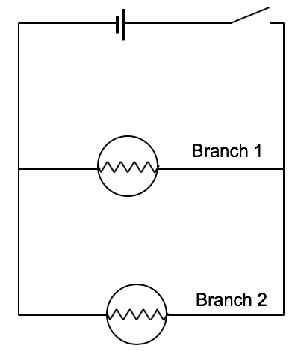

Figure 76 Circuit 1

Figure 77 Circuit 2

1. Close the switch in Circuit 1 and observe the brightness of the bulb.
2. Close the switch in Circuit 2 and observe the brightness of the bulbs.
3. Compare the brightness of the bulbs in Circuit 2 with Circuit 1. Discuss the following questions:
   1. What can you conclude about the current in the bulb in Circuit 1 compared to Circuit 2?
   2. What can you conclude about the current through the cell in Circuit 1 compared to Circuit 2?
4. Use your ammeter to measure the current through the cell in Circuit 1 and Circuit 2. Do your current readings agree with the conclusions that you made from your discussions?
5. Use your ammeter to measure the current in Branch 1 and Branch 2 of Circuit 2. How do these current readings compare with the current through the cell?
6. Use your voltmeter to measure the potential difference across the bulb and the cell in Circuit 1 *with the switch closed*. How do these voltage readings compare?
7. Use your voltmeter to measure the potential difference across the bulbs and the cell in Circuit 2*with the switch closed*. How do these voltage readings compare?
8. What can you conclude about the relationship between the cell terminal potential difference and the potential difference across the resistors in a parallel circuit?

#### Alternative Simulation Activity

Remember that you can construct all of the electrical circuits in this unit using a Circuit Construction Kit by going to the website: <https://phet.colorado.edu/sims/html/circuit-construction-kit-dc/latest/circuit-construction-kit-dc_en.html> and clicking on the Intro window.

#### Guided reflection

1. You should observe that the brightness of the bulb in Circuit 1 is *similar* to the brightness of the bulbs in Circuit 2. (You can ignore small differences in brightness).
2. You should find that the voltage reading across the battery is equal to the voltage reading across bulb 3. This voltage is also equal to the voltage across the combination of Bulbs 1 and 2. This will probably surprise you, as people often think that the branch with a larger resistance will have a larger voltage. The points on either side of the branches are actually the same electrical connection, so the drop in electrical potential between these points is exactly the same.
3. Answers to discussion questions:
   1. The current in the bulb in Circuit 1 is equal to the current in *each* of the bulbs in Circuit 2.
   2. From this you can conclude that the current through the cell in Circuit 1 is *less* than the current through the cell in Circuit 2, since the current from each of the parallel branches will add together through the cell in Circuit 2.
4. Your ammeter readings should show that the current through the cell in Circuit 1 is less than that in Circuit 2.
5. Your ammeter readings should show that the sum of the currents through Branch 1 and Branch 2 of Circuit 2 gives you the total current through the cell.
6. The potential difference across the bulb and the cell in Circuit 1 with the switch closed should be equal, and should be about 1,5 V for a single cell circuit.
7. The potential difference across each of the bulbs in Circuit 2 should be equal to the potential difference across the cell, and each of these readings should be about 1,5 V for a single cell circuit.
8. You can conclude that the cell terminal potential difference is equal to the potential difference across each of the resistors in a parallel circuit if the resistors are connected directly across the cell.

*To summarise*, what this activity shows you is that when two resistors are connected in parallel, their combined equivalent resistance is less than for one of the resistors on its own. This is because the parallel connection opens more pathways for the current to move through, so there is less total resistance to the flow of the current.

**Circuit 2**

**Circuit 1**

Figure 78 Circuit 2 has more paths for the current, so the total resistance is *less* than in Circuit 1.

You can find the equivalent resistance for parallel resistors using the equation:

$$\frac{1}{R_{p}}= \frac{1}{R_{1}}+ \frac{1}{R_{2}}+…$$

where Rp is the total resistance of the parallel resistors, and

R1, R2 etc are the resistances of the parallel resistors.

R1

R2

I3 = I1 + I2

*I*1

*I*2

Vb = VR1 = VR2

I3 = I1 + I2

When **current** enters a parallel branch in a circuit, it is divided. The branch with the lower resistance receives a higher current. For this reason, parallel resistors are called ***current dividers***.

The **potential difference** across parallel branches is **equal**, even if the branches have different resistances. When parallel branches are connected directly across the battery, the potential difference across each branch is equal to the potential difference of the battery.

#### Activity 10: Test your understanding of resistors in parallel

Purpose

In this activity you will test your understanding of resistors in parallel by first looking through some worked examples, and then answering questions yourself.

Suggested time**:** [20 minutes]

What you will do:

Look through the two worked examples below, and then try to solve the following problems yourself to test your understanding of the concepts that have been covered about resistors in series.

**Example 1:**

What is the total resistance in the circuit on the right?

Figure 79 Circuit diagram for Example 1

R1 = 3Ω

R3 = 6Ω

R2 = 6Ω

Solution

Therefore $R_{p}$ = $\frac{6 Ω}{4 }$ = 1,5 Ω.

**Example 2:**

*R*1 = 2Ω

*R*2 = 4Ω

I2

I1

2 A

The battery in the circuit has a potential difference of 8 V. (Ignore the effects of the internal resistance of the battery.)

1. Find the unknown currents I1 and I2
2. Find the potential difference across the 4 Ω and 2 Ω resistors.

**Solution**

1. R1 has half the resistance of R2, so the current divides so that the R1 branch will receive double the current of the R2 branch.

Figure 80 Circuit diagram for Example 2

Therefore I1 = 2 × 2 A = 4 A.

and I2 = I1 + 1 A = 4 A + 2 A = 6 A

1. The potential difference across each of the parallel branches is equal to the potential difference across the battery.

Therefore V6Ω = V3Ω = Vbattery = 8 V.

R1 = 4Ω

R2 = 6Ω

**Now try to solve the following problems on your own.**

* 1. Calculate the total resistance in Circuit 1 on the right.
  2. What is the direction of the current in resistor R1 of Circuit 1?

Figure 81 Circuit 1



Figure 82 Circuit 2

*I*1

R1 = 4Ω

R4 = 8Ω

R2 = 4Ω

R3 = 4Ω

1 A

*I*2

I3

* 1. Calculate the total resistance in Circuit 2 on the right.
  2. Find currents I1 , I2 and I3.
  3. The terminal potential difference of the battery is 8 V. Find the potential difference across resistors R1, R2 and R4.
  4. If the branch with the resistor R4 is removed from the circuit, explain what effect this will have on:
     1. the total resistance in the circuit,
     2. the current through the battery, and
     3. the potential difference across resistor R1.

#### Solutions

Don’t forget that your answer here gives you a value for $\frac{1}{R_{p}}$. To find the total parallel resistance Rp you have to invert this answer (turn it upside down).

$\frac{1}{R_{p}}= \frac{1}{R_{1}}+ \frac{1}{R_{2}}$

$$= \frac{1}{4 Ω}+ \frac{1}{6 Ω}$$

$$= \frac{3}{12 Ω}+ \frac{2}{12 Ω}$$

$$= \frac{5}{12 Ω}$$

Therefore = = 2,4 Ω

* 1. The current is flowing to the *left* in resistor R1. This is because current flows from the positive terminal of the battery (shown with the longer line in the circuit diagram), around the circuit to the negative terminal (shown with the shorter line in the circuit diagram).

R1 = 4Ω

R2 = 6Ω

**Circuit 1**

+

-



You add R2 and R3 together in this equation because they are connected in series in the same branch, so their combined resistance is equal to the sum of R2 + R3.

Therefore = = 2 Ω.

* 1. The branch with R2 and R3 has the same resistance as R4, so this branch will receive the same current as the R4 branch. So I1 = 1 A.

R1 has half the resistance of R4, so the current divides so that the R1 branch will receive double the current of the R4 branch. So I2 = 2 × 1 A = 2 A.

I3 = I1 + I2 + 1 A = 2 A + 1 A + 1 A = 4 A

* 1. VR1 = 8 V since it is connected directly across the battery, so it will have the same voltage as the battery.

VR2 = 4 V since this branch has two 4 Ω resistors that are together connected across the battery, so they share 8 V equally between them.

VR4 = 8 V since it is connected directly across the battery.

* + 1. If one of the parallel branches is removed, then there are fewer pathways for the current, so the total resistance will be increased.
    2. Since the resistance is increased, the current through the battery will decrease because current is inversely proportional to resistance.
    3. The potential difference across resistor R1 will not change, because it is connected directly across the battery, so will receive the full battery terminal potential difference.

[Wordbox: MAIN IDEAS:

* The equivalent resistance of *parallel resistors* is less than for one resistor on its own.
* The *total equivalent resistance* can be calculated using the equation:

$\frac{1}{R_{p}}= \frac{1}{R_{1}}+ \frac{1}{R_{2}}+…$

* *Current is divided* as it enters parallel branches.
* Greater current will go to the branch with lower resistance.
* The *potential difference* for resistors connected in parallel is *equal*.
* When parallel branches are connected directly across the battery, the potential difference across each branch is equal to the terminal potential difference of the battery.

#### More resources to help you:

You might find it useful to watch the following YouTube videos that demonstrate some helpful experiments on series and parallel circuits:

* *Parallel and series circuits*: <https://www.youtube.com/watch?v=tZOoBr4ghrw> (Duration: 5.12) – this video gives a helpful explanation of a closed circuit, and of series and parallel circuits
* *Electric circuits: Series and Parallel*: <https://www.youtube.com/watch?v=XSukRnxGy5c> (Duration: 4.19) – this video gives a helpful explanation of the difference between series and parallel circuits
* *Connecting light bulbs in PARALLEL*: <https://www.youtube.com/watch?v=vIicY0Y491Q> (Duration: 1.24) – this video shows voltage measurements across resistors that are connected in parallel across the battery
* *Series and parallel circuits:* <https://www.youtube.com/watch?v=x2EuYqj_0Uk> (Duration: 8.04) – this is a longer video that explains the difference between series and parallel circuits, and uses the Circuit Construction Kit in the explanations.

Another circuit building kit is available online at <http://www.physicsclassroom.com/Physics-Interactives/Electric-Circuits/Circuit-Builder>.

### Unit 2: Energy transfer in electrical circuits

#### Learning Outcomes

By the end of the unit, you should be able to:

* define power as the rate at which electrical energy is converted in an electric circuit, measured in watts;
* state that electrical power dissipated in a device is equal to the product of the potential difference across the device and current flowing through it: P =I V ;
* apply the concepts of electrical energy and power to solve related problems, in familiar and novel contexts;
* apply knowledge of electrical circuits, energy and power to everyday electrical appliances, for example the torch, kettle etc.

#### Introduction

Think back to the last time you turned on a kettle, a stove or a heater.

* What changes take place as time goes on?
* From what you learnt about current and resistance in the previous unit, what do you think happens as you turn on the switch to enable these changes to happen?

You will recall from the previous unit that when you close a switch, you create a closed circuit which allows charged to move through the circuit. This is called current. When this current passes through a circuit element that has resistance, energy is transferred or used in the electric circuit. This energy is used because the charges have to do work to pass through the resistance. So the energy that is used by a resistor is equal to the word done by the current in that resistor.

The work done in a resistor can be calculated using the equation:

W = VIt

where W is the work done (or energy transferred) in the resistor, measured in joules (J)

V is the voltage across the resistor, measured in volts (V)

I is the current through the resistor, measured in amperes (A)

t is the amount of time for which the current flows, measured in seconds (s).

Below is an example of how to apply this equation in solving problems with electrical energy.

**Example:**

A resistor with a resistance of 5 Ω is connected to a 2 V battery.How much work is done in the light bulb in 2 minutes?

**Solution**:

Remember that to convert from minutes to seconds we multiply by the number of seconds in 1 minute, which is 60 s/min.

Given: R = 5 Ω

V = 2 V

t = 2 min × 60 s/min = 120 s

Calculation: We first find the current using Ohm’s Law:

I = $\frac{V}{R}$

= $\frac{2 V}{5 Ω}$

= 0,4 A

Therefore the work done is:

W = V I t

= 2 V × 0,4 A × 120 s

= 96 J

#### Activity 1: Test your understanding of electrical energy

Purpose

In this activity you will test your understanding of electrical energy by solving various problems.

Suggested time**:** [20 minutes]

What you will do:

Answer the following questions:

The voltage across a lightbulb in a circuit is measured to be 2,5 V, and the current through it is 0,6 A.

1. Calculate the resistance of the lightbulb.
2. If the lightbulb is operated for half an hour, what is the total energy transferred to this lightbulb?

#### Solutions

Given: V = 2,5 V

I = 0,6 A

1. To calculate the resistance of the lightbulb you use Ohm’s law:

$R=$ $\frac{V}{I}$

$=$ $\frac{2,5 V}{0,6 A}$

$=$ 4,17 Ω

1. You first convert the time of half an hour to seconds:

t = ½ h × 60 min/h

= 30 mins × 60 s/min

To convert from hours to seconds you first multiply by the number of minutes in each hour (60 min/h), then you multiply by the number of seconds in each minute (60 s/min)

= 1 800 s

To find the total energy transferred to this

lightbulb you find the work done in 1800 s:

W = V I t

= 2,5 V × 0,6 A × 1 800 s

= 2 700 J

#### Activity 2: Explore work and power

Purpose

In this activity you will explore the relationship between work and power, and you will derive some of the equations used to calculate power.

Suggested time**:** [20 minutes]

What you will do:

Reflect on the following questions:

1. Electrical power is defined as “the rate at which electrical energy is transferred or converted in an electric circuit”. In other words, the power of an electrical appliance is the amountof *work done per unit time*. Using this definition, can you think of a way of calculating power if you are given the amount of work done and the time for which this work is done?
2. If you use the symbol P for electrical power, W for work and t for time, try to write an equation for calculating the power.
3. Power is measured in Watts (W), work is measured in joules (J) and time in seconds (s). Can you work out the relationship between the units of W, J and s?

#### Guided reflection

* Since power is the rate at which work is done, another way of saying this is that power is the work done per unit time, or the work done in one second. You can therefore calculate the power by dividing the work done by the time.
* You can write this using an equation:

$P=$ $\frac{W}{t}$

where P is the power dissipated by the resistor, measured in watts (W)

W is the energy converted in the resistor, measured in joules (J)

t is the amount of time for which the current flows, measured in seconds (s).

* From this equation you can see that 1 watt is equal to 1 joule per second. (1 W = J/s)

Recall that the energy converted by a resistor can be expressed as:

W = VIt

If you substitute this equation into the equation for power, you get:

$P=$ $\frac{W}{t}=$ $\frac{V I t}{t}=$ VI

This gives you another way of calculating the power dissipated in a resistor:

$P=V I$

where P is the power dissipated by the resistor, measured in watts (W)

V is the voltage across the resistor, measured in volts (V)

I is the current flowing through the resistor, measured in amperes (A).

From this equation you can see that 1 W is equivalent to 1 V.A. Recall that current is the rate at which charge flows, so 1 A = 1 C/s. Voltage is the potential energy per unit charge, so 1 V = 1 J/C. If you combine these you again find that 1 W = J/s.

Here is a very helpful video that uses an experiment to explain electrical power:

*Electric Power:* <https://www.youtube.com/watch?v=p8JQTLkV5C8> (Duration: 5.31)

#### Activity 3: Test your understanding of electrical power

Purpose

In this activity you will test your understanding of electrical power by first looking through some worked examples, and then answering questions yourself.

Suggested time**:** [20 minutes]

What you will do:

Look through the worked examples below, and then try to solve the following problems yourself to test your understanding of the concepts that have been covered about resistors in series.

**Example 1:**

A torch bulb is labelled with 4 V and 0,8 A.

1. Calculate the power dissipated by this bulb.
2. If this bulb is connected to a battery for 10 minutes, what is the energy that is transferred to the bulb in this time?

**Solution**:

Given: V = 4 V

I = 0,8 A

t = 10 min × 60 s/min = 600 s

Calculation:

1. Since you are given the voltage and the current, you use the following equation to calculate the power:

P = V I

= 4 V × 0,8 A

= 3,2 W

1. From the equation $P=$ $\frac{W}{t}$ you solve for the energy used (or work done) by making W the subject of the formula:

To make W the subject of the formula you multiply both sides of the equation by t. You can then cancel t on the right hand side and rearrange the equation with W on the left.

W = Pt

= 3,2 W × 600 s

= 1920 J

You can use a second method to calculate the energy:

W = V I t

= 4 V × 0,8 A × 600 s

= 1920 J

**Example 2:**

A 12,1 Ω fan heater is connected to a 220 V power supply.

1. Calculate the power dissipated by this heater.
2. Calculate the current in the heater.
3. 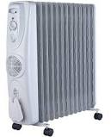An oil heater is advertised as a 2kW heater. Which heater would be cheaper to run, the bar heater or the oil heater?

Figure 83 An oil heater (Source: takealot.com)

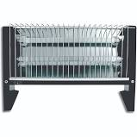

Figure 84 A bar heater (Source: takealot.com)

**Solution**:

Given: R = 12,1 Ω

V = 220 V

Calculation:

1. P = $\frac{V^{2}}{R}$

= $\frac{{(220 V)}^{2}}{12,1 Ω}$

= 4 000 W

1. Since you are given the voltage and the resistance, you can use Ohm’s law to find the current:

I = $\frac{V}{R}$

Since there are 1 000 J in 1 kJ, you can divide the answer in J by 1 000 to give you the answer in kJ.

= $\frac{110 V}{12,1 Ω}$

= 9,09 A

1. The bar heater’s power usage is 4000 W = 4kW. The oil heater’s power usage is only 2 kW, which means that is uses less energy per second than the bar heater. This makes the oil heater cheaper to run.

**Now try to solve the following problem on your own.**

1. The voltage across a lightbulb in a circuit is measured to be 2,5 V, and the current through it is 0,6 A. Calculate the power dissipated by this lightbulb.
2. A 200 W mini-heater is connected across a voltage of 220 V. Find the value of the resistance of the heater.
3. A 1760 W kettle is plugged into a 220 V socket.
   1. Calculate the current drawn by the kettle.
   2. If the kettle is used for an average of 2 hours per day, what is the total energy that is used in 1 week?

#### Solutions

1. Given: V = 2,5 V

I = 0,6 A

Calculation:

P = V . I

= 2,5 V × 0,6 A

= 1,5 W.

1. Given: P = 200 W

To make R the subject of the formula you multiply both sides of the equation by R and divide both sides by P.

V = 220 V

Calculation:

From P = $\frac{V^{2}}{R}$ you can solve for R:

R = $\frac{V^{2}}{P}$

= $\frac{{(220 V)}^{2}}{200 W}$

= 242 Ω

To make I the subject of the formula you divide both sides by V and rearrange the equation so that I is on the left hand side.

1. Given: P = 1760 W

V = 220 V

Calculation:

1. From P = V . I you can solve for I:

I = $\frac{P}{V}$

= $\frac{1 760 W}{220 V}$

= 8 A

1. Given: Total time in one week = 2 hours per day × 7 days

= 14 hours × 60 s/min × 60 min/hr

= 50 400 seconds

W = V . I . t

= 220 V × 8 A × 50 400 s

= 88 704 000 J

= 88 704 kJ

#### Activity 4: Consolidate your learning of electricity

Purpose

In this activity you will consolidate your learning of electricity by answering the questions below and then assessing your own understanding using the solutions provided. Give yourself a mark out of the total of 90 marks, which will give you an idea of how well you understand this section of the work.

Suggested time**:** [90 minutes]

1. Choose the correct word or phrase from the box that matches each of the following descriptions. (10)

**emf resistor current**

**ohm volt electrical potential difference**

**voltmeter ampere power**

**work watt ammeter**

* 1. Instrument that is used to measure potential difference
  2. Instrument that is used to measure current
  3. Unit that is equivalent to C/s
  4. Unit that is equivalent to V/A
  5. Unit that is equivalent to J/s
  6. The across a circuit element is the work done to move a unit charge through the element
  7. Circuit element that opposes the path of the current
  8. The rate of flow of charges in a circuit
  9. The potential difference across the battery in the circuit
  10. The rate at which electrical energy is transferred or converted in an electric circuit

1. A current of 6 mA flows through a resistor. How much charge flows through this resistor in 15 seconds? (3)
2. 2 coulombs of charge passes a point in a circuit in the time of 5 minutes. What is the value of the current at this point in the circuit? (3)
3. Explain the difference between series and parallel resistors. (4)
4. Study the circuit on the right and answer the questions:

R3 = 3Ω

R2 = 6Ω

R1 = 6Ω

* 1. What is the total resistance in the circuit? (2)
  2. What is the potential difference across resistors R1 and R3? (2)

Figure 85 Series circuit with three resistors

* 1. What is the battery voltage? (3)
  2. Calculate the current flowing in the circuit. (3)

Figure 86 Parallel circuit with three resistors

*I*1

R1 = 2Ω

R3 = 2Ω

R2 = 4Ω

2 A

*I*2

*I*3

1. Study the circuit on the right and answer the following questions:
   1. Calculate the total resistance in the circuit. (4)
   2. Find currents I1 , I2 and I3. (6)
   3. Find the potential difference across R2. (2)
   4. What is the battery potential difference? (2)

Another resistor is added in parallel to resistor R3. Explain what effect this will have on:

* 1. the total resistance in the circuit, (2)
  2. the current through the battery, and (2)
  3. the potential difference across resistor R1. (2)



Figure 87 Graph of voltage vs current

1. The diagram shows a graph of voltage across a resistor plotted against current through that resistor. From this graph calculate:
   1. the current from a 2,5V battery (2)
   2. the number of 1,5V batteries that would be needed to give a current of 0,9A (3)
   3. the size of the resistance. (4)

Figure 88 Circuit with series and parallel resistors

R2 = 8 Ω

R4 = 4 Ω

R3 = 8 Ω

R1 = 1 Ω

1. For the circuit shown on the right, calculate:
2. the total resistance (4)
3. the current through R2 (3)
4. the current through R4 (2)
5. the current through R1 (3)
6. the battery potential difference (4)
7. A 9 V battery and a 3 Ω resistor are connected in a closed loop with a switch.
8. Draw a circuit diagram for this circuit. (3)
9. How much energy does the resistor use in 5 minutes? (3)
10. What is the power dissipated in the resistor? (3)
11. If another 3 Ω resistor is connected in *series* with the first, will the total power dissipated in the circuit increase or decrease? Explain your answer. (3)
12. If another 3 Ω resistor is connected in *parallel* (instead of in series) with the first, will the total power dissipated in this circuit increase or decrease, compared with the circuit with just the 3 Ω resistor? Explain your answer. (3)

#### Solutions

1. The correct answers are shown below (10)
2. Instrument that is used to measure potential difference **voltmeter**
3. Instrument that is used to measure current **ammeter**
4. Unit that is equivalent to C/s **ampere**
5. Unit that is equivalent to V/A **ohm**
6. Unit that is equivalent to J/s **watt**
7. The work done to move a unit charge through a circuit element **electrical potential difference**
8. Circuit element that opposes the path of the current **resistor**
9. The rate of flow of charges in a circuit **current**
10. The work done in moving a unit charge around a complete circuit **emf**
11. The rate at which electrical energy is transferred or converted in an electric circuit **power**

Remember that there are 1 000 mA in 1 A, so you divide the number of mA by 1 000 to find the number of A.

1. Given: I = 6 mA = 0,006 A

$∆t$ = 15 s

You make Q the subject of the formula by multiplying both sides of the equation by $∆t$, and then rearranging the equation with Q on the left hand side.

From the equation I = $\frac{Q}{∆t}$ you can solve for Q:

Q = I × $∆t$

= 0,006 A × 15 s

= 0,09 C (3)

1. Given: Q = 2 C

$∆t$ = 5 min $×$ 60 sec/min = 300 s

I = $\frac{Q}{∆t}$

Since there are 1 000 mA in 1 A, you multiply the answer in A by 1 000 to find the answer in mA.

= $\frac{2 C}{300 s}$

= 0,0067 A

= 6,7 mA (3)

1. Series resistors are connected in a single closed loop with the battery. Parallel resistors are connected in separate branches, so that the current splits as it goes to each parallel resistor. (4)
   1. Rs = R1 +R2 + R3

= 6 Ω + 6 Ω + 3 Ω

= 15 Ω (2)

* 1. Since R1 = R2 = 6 Ω , V across R1 = 3V

Since R3 = ½ R2 = 3 Ω , V across R3 = ½ 3V = 1,5 V (2)

* 1. Vbattery = V1 + V2 + V3

= 3 V + 3 V + 1,5 V

= 7,5 V (3)

* 1. I =

=

= 0,5 A (3)

This answer gives a value for $\frac{1}{R_{p}}$. To find the total parallel resistance Rp you have to invert this answer (turn it upside down).

$= \frac{2}{4 Ω}+ \frac{1}{4 Ω}+\frac{2}{4 Ω}$

$= \frac{5}{4 Ω}$

Therefore = = 0,8 Ω. (4)

* 1. The resistance in the parallel branch with current I1 is double the resistance in the branch with the known current of 2A. Since current is inversely proportional to resistance, this means that I1 = ½ 2A = 1 A

The resistance in the parallel branch with current I2 is equal to the resistance in the branch with the known current of 2A. Therefore I2 = 2A

The current I3 is the sum of the other currents where the parallel branches join together, therefore I3 = I1 + I2 + 2A = 2A + 1A + 2A = 5 A (6)

* 1. V2 = I R2

= 1A 4Ω

= 4 V (2)

* 1. The battery potential difference is the same as the potential difference across each of the parallel branches. Therefore Vbattery = 4 V (2)
  2. If another resistor is added in parallel to resistor R3, the total resistance in the circuit will decrease. This is because there is an additional pathway for the current, which reduced the overall resistance in the circuit. (2)
  3. The current through the battery will increase, since current is inversely proportional to the resistance. (2)
  4. The potential difference across resistor R1 will not change, since each of the parallel branches has the same potential difference as the battery, and this does not change. (2)
  5. The current strength from a 2,5V battery is 0,5 A. You read this from the graph as the diagram below shows: (2)

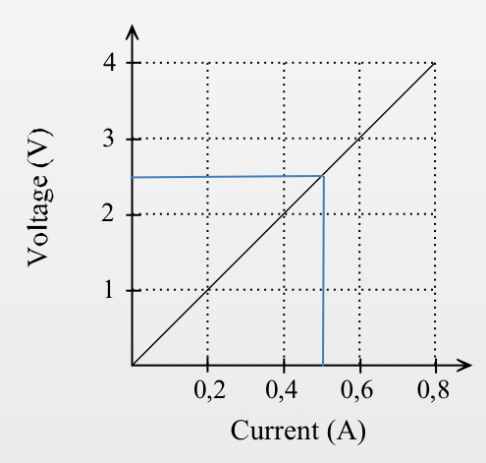

Figure 89 Graph of voltage vs current with 2,5V and 0,5 A current shown on the graph

* 1. On the graph, each 0,1A of current corresponds to a voltage of 0,5 V.

Therefore to give a current of 0,9A you would need a voltage of 4,5 V.

So the number of 1,5V batteries that would be needed

is $\frac{4,5V}{1,5V }$ = 3 batteries. (3)

* 1. The size of the resistance is the gradient of this graph:

R = gradient

= $\frac{∆y}{∆x}$

= $\frac{y_{2}-y_{1} }{x_{2}-x_{1}}$

= $\frac{4 V-1 V }{0,8 A-0,2 A}$

= 5 Ω (4)

1. To find the total resistance, you must first find the equivalent of the parallel resistors:

$$\frac{1}{R_{p}}= \frac{1}{R_{2}}+ \frac{1}{R_{3}}+ \frac{1}{R_{4}}$$

$= \frac{1}{8 Ω}+ \frac{1}{8 Ω}+ \frac{1}{4 Ω}$

$= \frac{4}{8 Ω}$

Therefore $R_{p}$ = $\frac{8 Ω}{4 }$ = 2 Ω. (3)

RT = R1 + RP = 2 Ω + 1Ω = 3 Ω (1) (4)

1. To find the current through R2 you use Ohm’s Law:

Therefore IR2 0,15 A (3)

1. Since R4 has half the resistance of R2, the current through R4 is double the current through R2. Therefore IR4 = 0,3 A (2)
2. The current through R3 = 0,15 A since it has the same resistance as R2. So the current through R1 is the sum of the parallel currents.

Therefore IR1 IR2 + IR3 + IR4 = 0,15 A + 0,15 A + 0,3 A = 0,6 A (3)

1. To find the battery potential difference you use Ohm’s Law:

Vbattery = RT . I = 3 Ω × 0,6 A = 1,8 V (4)

1. The circuit diagram for this circuit is shown below: (3)

Figure 90 Circuit diagram showing current direction

3 Ω

9 V

1. Given: V = 9 V

R = 3 Ω

t = 5 min × 60 s/min = 300 s

I = $\frac{V}{R}$

= $\frac{9V}{3Ω}$

= 3 A

W = VIt

= 9 V $×$ 3 A $×$ 300 s

= 8100 J

= 8,1 kJ (3)

1. P = VI

= 9 V $×$ 3 A

= 18 W (3)

1. If another 3 Ω resistor is connected in series with the first, the total power dissipated in the circuit will *decrease*. This is because the power is proportional to the voltage and the current. The voltage remains constant but the current decreases with an increase in resistance. (3)
2. If another 3 Ω resistor is connected in parallel with the first, the total power dissipated in the circuit will *increase*. This is because the power is proportional to the voltage and the current. The voltage remains constant but the current increases with a decrease in resistance, since parallel resistors have less resistance than a single resistor on its own. (3)

## Sub-topic 3: Magnetism

### Unit 1: Magnetism

#### Learning Outcomes

By the end of the unit, you should be able to:

* describe a permanent magnet as having a North Pole and a South Pole;
* state that like poles repel and unlike poles attract.

#### Introduction

Reflect on the following questions, either on your own or with a fellow student:

* What do you understand by the term “magnet”?
* List at least five ways that you use magnets in your everyday life.

#### Magnets

In your everyday there are some obvious ways in which you use magnets, for example when you stick something on a fridge door using a magnet, or the magnetic tip of a screw driver that allows it to hold nails in place. But there are many ways in which magnets are used that are *not* obvious to you, for example every time you drive in a car or listen to a radio, magnetism is used in some way. It is therefore important to understand magnets and how they interact.

#### Activity 1: Explore magnets

Purpose

In this activity, you will explore how magnets interact with various objects.

What you need:

* A magnet
* Various objects made from different materials

You don’t need to buy a magnet, you can find them in various places around your home, e.g. take an old (broken) pair of headphones apart; check an old handbag to see if it is closed using a magnet; old hard drive in a broken computer, etc.

Suggested time**:** [10 minutes]

What you will do:

1. Find a range of objects made from different materials such as plastic, aluminium, steel, brass, cloth and wood.
2. Bring your magnet close to each object. What do you observe?
3. Make a table like the one below. In the first column, fill in the list of objects that are not attracted to the magnet, and in the right hand column fill in those that are attracted to the magnet.

|  |  |
| --- | --- |
| **Objects that are not attracted to the magnet** | **Objects that are attracted to the magnet** |
|  |  |

1. Do you notice any trends about the objects that are attracted to the magnet?
2. Are all metals able to be attracted by a magnet?

#### Guided reflection

In this activity you should observe the following:

* Some of the metal objects, such as iron nails, metal paper clips etc are attracted to the magnet.
* Not all metals will be attracted to the magnet (e.g. objects made from aluminium).
* Most non-metals will not be attracted to the magnet.

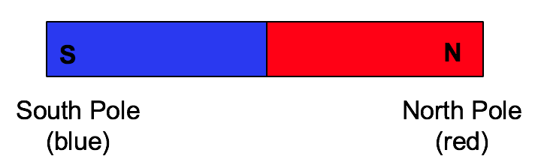 Magnets are objects that are able to attract other magnets, or to attract other objects that are made from magnetic materials. A magnet has a North Pole at one end, and a South Pole at the other end. The North Pole of a bar magnet is usually painted red, and the South Pole is usually painted blue. (Not all magnets are painted with these colours.)

Figure 91 A bar magnet

Figure 92 If a magnet is broken into smaller pieces, each piece will have a North Pole at one end and a South Pole at the other

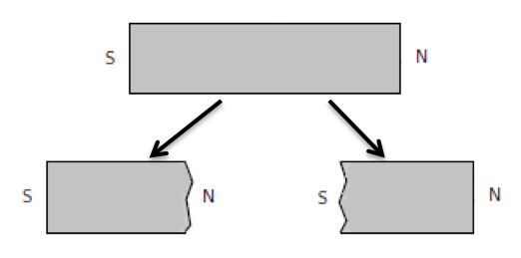It is never possible to have an object that only has a North Pole, or only a South Pole. If a magnet is broken into smaller pieces, each of these small pieces will have a North Pole at one end and a South Pole at the other. Even if you have a round magnet, one side will have the North pole, while the other side with have the South pole.

#### Interactions between magnets

#### Activity 2: Explore the interactions between magnets

Purpose

In this activity, you will explore the interactions between magnets that are close to one another.

What you need:

* 2 bar magnets
* Some string
* A compass

If you haven’t got a compass, you can make one. The following web page explains how to do this: <https://www.wikihow.com/Make-a-Compass>

Suggested time**:** [15 minutes]

What you will do:

1. Hang one of the magnets from a string so that it is free to move around. Make sure that there are no other magnets or ferromagnetic objects nearby.
2. Bring the one end of the other magnet near to one of the ends of the hanging magnet. What do you observe?
3. Turn the magnet that you are holding around, and observe the effect that it has on the hanging magnet.
4. Bring a compass close to the North Pole of the magnet. What do you observe?
5. Now move this compass around to the South Pole of the magnet. What do you observe?
6. What can you infer from your observations?

#### Guided reflection

In this activity you should have noticed that when you bring two *like* poles close to each other, such as two North Poles, they *repel* one another.

Figure 93 Like poles repel one another



If you bring two *unlike* poles close to each other, such as a North Pole and a South Pole, they *attract* one another.

Figure 94 Unlike poles attract one another

When a compass is brought close to a magnet, the compass turns to line up with the magnet. This is because the compass is a small magnet that is free to turn. The North Pole of the compass turns to point towards the South Pole of the magnet.

Figure 95 A compass

#### Activity 3: Test your knowledge of interactions between magnets

Purpose

In this activity, you will test your understanding of what you have learnt so far about interactions between magnets.

Suggested time**:** [20 minutes]

What you will do:

Answer the following questions:

1. Explain what you will observe in each of the following arrangements of magnets:

Figure 96 Arrangement of magnets #1

**N**

**S**

**N**

**S**



Figure 97 Arrangement of magnets #2

**N**

**S**

**S**

**N**

1. You bring one side of a magnet close to a compass and you find that the *South Pole* of the compass is attracted to this side of the magnet.
   1. Is this side of the magnet a north or a South Pole?
   2. If you bring a compass close to the *opposite side* of the magnet, what will you observe?
2. You have a bar magnet like the one shown in the picture below.



Figure 98 A bar magnet

* 1. If you break the magnet in half, and you bring the broken part of the blue half near to the South Pole of another magnet, what will you observe?

**N**

**S**

Figure 99 The broken part of the blue half of a magnet is brought near to the South Pole of another magnet

* 1. If you bring the broken part of the red half near to the South Pole of another magnet, what will you observe?

Figure 100 The broken part of the red half of a magnet is brought near to the South Pole of another magnet

**N**

**S**

#### Solutions

* 1. The magnets will be attracted to each other (since opposite or unlike poles are brought close to each other)
  2. The magnets will be repelled by each other (since like poles are brought close to each other)
  3. This side of the magnet is a North pole, since it attracted the South pole of the compass.
  4. If you bring a compass close to the opposite side of the magnet, you will be bringing it close to a like pole (another South pole), so the compass needle will be repelled and deflected away from the magnet.
  5. The broken part of the blue half will be a North pole, since the other end remains a South pole. If you bring the broken part close to a South pole they will *attract* each other.
  6. The broken part of the red half will be a South pole, so if you bring it close to a South pole they will *repel* each other.

[Wordbox: MAIN IDEAS:

* A magnet has a North Pole at one end, and a South Pole at the other end.
* Unlike poles attract each other, and like poles repel each other.
* A compass is a small magnet that is free to spin around. ]

### Unit 2: The magnetic field

#### Learning Outcomes

By the end of the unit, you should be able to:

* define the magnetic field;
* describe the magnetic field around a bar magnet and a pair of bar magnets placed close together;
* explain how a compass indicates the direction of a magnetic field;
* describe the Earth’s magnetic field.

#### Introduction

In Unit 1 you learnt about the interactions between magnets. Reflect on the following questions, either on your own or with a fellow student:

* Describe the interaction when two magnets are brought close to each other.
* Do the magnets have to touch one another to experience a force?

From your activities in Unit 1 you should have noticed that magnets do not have to be in contact with one another to experience a force of attraction or repulsion. This is because the magnetic force is an example of a *field force*. What this means is that there is a magnetic field in the space around a magnet. Any magnetic material that is brought into this field will experience a force. In this unit you will explore the magnetic field in more detail.

#### The magnetic field around a magnet

In the space around a magnet, there is a magnetic field. This is a region in space where another magnet, or an object made from a magnetic material, will experience a force.

#### Activity 1: Exploring the magnetic field around a magnet

Purpose

In this activity you will explore the shape of the magnetic field around a bar magnet.

What you need:

* 1 bar magnet
* A sheet of clear plastic or an overhead transparency
* Iron filings
* A piece of paper
* A compass

Iron filings are small particles of iron produced by filing a piece or iron. You can make them yourself, or you could go to a car mechanic and ask if they can give you some from car brake drums or if they use a lathe. In some areas, you can even find them in your soil! (See <http://teacherblogspot.com/?p=4024>)

Suggested time**:** [20 minutes]

What you will do:

1. Place the bar magnet in the middle of your piece of paper.
2. Cover the bar magnet with your sheet of clear plastic or transparency.
3. Scatter your iron filings onto the sheet of plastic and lightly tap the plastic until the filings form into a pattern. Observe the shape of the patter that is formed. This tells you the shape of the magnetic field around the magnet.
4. Remove your sheet of plastic and carefully pour your iron filings back into their container.
5. Place the compass near to the magnet.
6. Draw a small arrow on your piece of paper to show the direction of the compass needle.
7. Move your compass to a new position on your piece of paper, and draw in the needle direction.
8. Continue moving your compass to as many positions on the paper as you can, drawing in the needle direction.
9. The arrows that you have drawn are the magnetic field lines which show the direction of the magnetic field around the bar magnet. What conclusions can you draw about this shape?

#### Guided reflection

1. When the iron filings are scattered on the plastic sheet they should form a pattern around the magnet, as the diagram below shows.

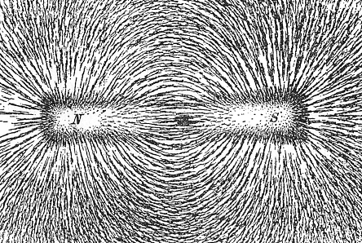

Figure 101 Iron filings show the shape of the magnetic field

(Source: https://upload.wikimedia.org/wikipedia/commons)

1. The picture below shows the direction that the compass needle will point in at different places in the magnetic field.



Figure 102 Magnetic field lines around a bar magnet

1. When using the compass to draw the magnetic field, you should draw in the arrow direction so that the arrow-head points in the same direction as the North pole of the compass needle.
2. You should notice that the magnetic field lines point outward from the North pole, and inward towards the South pole of the bar magnet.

These lines that you have drawn show the shape and direction of a magnetic field that is formed around a bar magnet. You call the lines *magnetic field lines*. These lines don’t cross each other, and are further apart where the field is weaker, and closer to each other where the field is stronger. You never actually see the magnetic field, it is invisible to your eyes, but you use the magnetic field lines to shows where it is in the space around the magnet.

[Wordbox: MAIN IDEAS:

* There is a *magnetic field* around a magnet.
* Any other magnet or magnetic object that is brought into this magnetic field will experience a *magnetic force*.
* The *magnetic field lines* are used to show the magnetic field, and point outward from the North Pole, and inward toward the South Pole. ]

#### Activity 2 – Make your own compass

Purpose

If you do not have a compass, this activity shows you how you can make your own compass.

What you need:

* A pin or needle
* A magnet
* A plastic container
* Some water
* Some cardboard or thin plastic
* Some sellotape or waterproof glue
* Some scissors

Suggested time**:** [20 minutes]

What you will do:

1. Fill your container with some tap water.
2. Using your cardboard or plastic, cut out a small circle that has the same length as your pin.
3. Stick a pin to your circle using your sellotape or glue.
4. Place this on your table top so that the pin is facing upward.
5. Hold your magnet in one hand, and stroke along the length of the pin 30 times. Lift the magnet high above your pin between strokes.
6. Once you have stroked the pin using your magnet, place it in the water, and place your bowl of water far away from any magnets or metals. Observe the direction that the pin points in.
7. When this magnetised pin floats freely in water, it acts as a compass, and will align with the Earth’s magnetic field (which you learnt about in Sub-topic 3).
8. Bring a magnet near to the side of the water container that has your magnetised pin in it, and watch the compass move to align with the magnetic field of the magnet.

Add diagram here

#### The magnetic field around a pair of magnets

#### Activity 3: Exploring the magnetic field around a group of magnets

Purpose

When magnets are brought close to each other, their magnetic fields interact with one another. In this activity you will explore the shape of the magnetic field around a pair of bar magnets.

What you need:

* 2 bar magnets
* A sheet of clear plastic or an overhead transparency
* Iron filings
* 2 pieces of paper
* A compass

Suggested time**:** [20 minutes]

What you will do:

Use your equipment to draw the magnetic field around the following arrangements of the magnets:

* Two magnets with their north poles close to each other
* Two magnets with opposite poles close to each other

#### Guided reflection

In this activity you should find that the magnetic fields around the pairs of magnets have the following shapes:

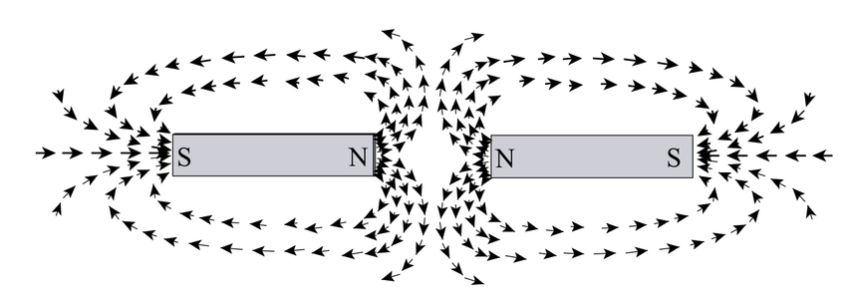

Figure 103 The magnetic field around two magnets with their north poles close to each other

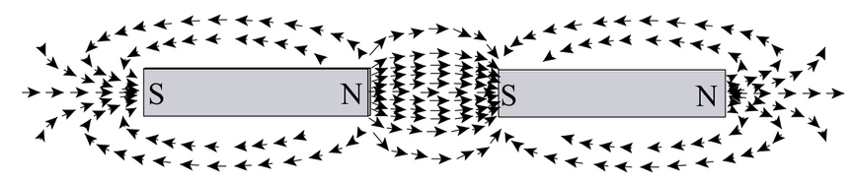

Figure 104 The magnetic field around two magnets with opposite poles close to each other

When magnetic fields add together like this you call it a *superposition* of the fields.

#### The Earth’s magnetic field

There is a large magnetic field around the Earth. This is why compasses help us to find our direction if we are lost.

The North Pole of a compass points to the Earth’s magnetic North Pole, and so the earth’s magnetic North Pole is actually a South Pole, as the diagram shows.

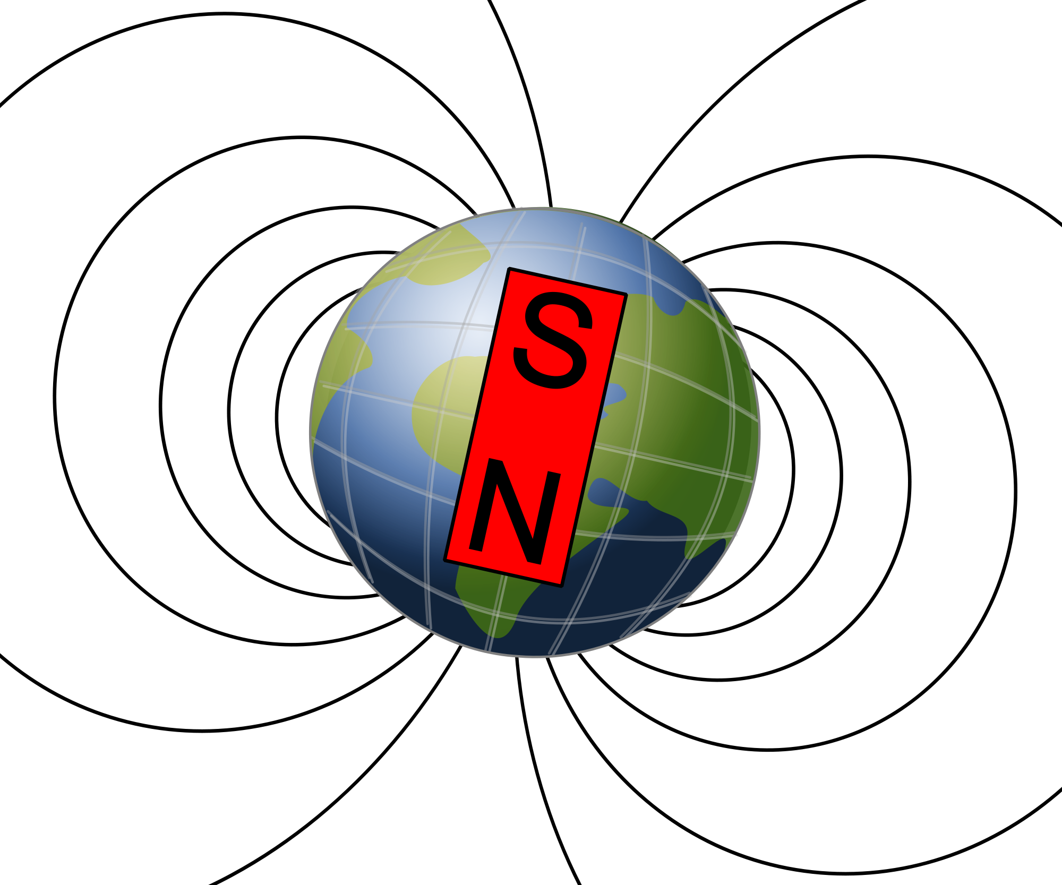

Figure 105 The Earth's magnetic field

[Wordbox: MAIN IDEA:

* The *Earth* has a *magnetic field* surrounding it, which can be observed using a compass.]

#### More resources to help you:

If you need further explanations about magnetism you can see a teaching video at the website: <http://learn.mindset.co.za/resources/physical-sciences/grade-10/electrostatics/learn-xtra-lessons-caps/magnetism-electrostatics> (This video also covers electrostatics concepts, and is more than an hour long. The relevant part for magnetism is from 1.22 to 26.10)

You can watch a helpful YouTube video that demonstrates the magnetic field: *Teacher Workshop: Make a Magnetic Field:* <https://www.youtube.com/watch?v=j8XNHlV6Qxg> (Duration: 1.57)

#### Activity 4: Consolidate your learning of magnetism

Purpose

In this activity you will consolidate your learning of magnetism by answering the questions below and then assessing your own understanding using the solutions provided. Give yourself a mark out of the total of 20 marks, which will give you an idea of how well you understand this section of the work.

Suggested time**:** [30 minutes]

1. Give one word for each of the following: (3)
   1. An object that attracts magnetic materials.
   2. An instrument consisting of a small, rotating magnet that shows the direction of a magnetic field.
   3. The area around a magnet where a magnetic force would be experienced by another magnet or an object made of ferromagnetic material.
2. Describe what you would observe if you brought the South Pole of a bar magnet close to the following:
   1. The North Pole of another magnet (2)
   2. The South Pole of another magnet (2)
   3. An object made from a magnetic material (2)
   4. A piece of aluminium (2)
3. Side X of a bar magnet is brought close to the North Pole of another magnet, and you observe a force of attraction between them.

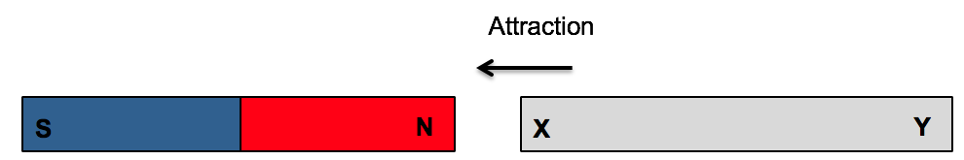

Figure 106 Interaction between magnets

1. Is side Y of the bar magnet a North or a South Pole? (1)
2. What will you observe if you bring side X of the bar magnet close to the South Pole of the other magnet? (2)
3. Draw the magnetic field lines around the arrangement of bar magnets shown in the diagram below. (3)



Figure 107 Two magnets with South Poles near each other

1. Draw a circle to represent the Earth, and draw the magnetic field lines around the Earth. Show the directions of the magnetic field lines on your diagram. (3)

#### Solutions

1. The correct words are shown below: (3)
   1. An object that attracts magnetic materials: **a magnet**
   2. An instrument consisting of a small, rotating magnet that shows the direction of a magnetic field: **a compass**
   3. The area around a magnet where a magnetic force would be experienced by another magnet or an object made of ferromagnetic material: **a magnetic field**
   4. You would observe attraction, since these are unlike poles. (2)
   5. You would observe repulsion, since these are like poles. (2)
   6. You would observe attraction, since a magnet attracts objects made from magnetic material (2)
   7. You would not observe any force, since aluminium is a non-magnetic metal. (2)
2. If side X is attracted to the North pole, this means side X is a South pole. So side Y must be a North pole. (1)
3. If you bring side X of the bar magnet close to the South Pole of the other magnet, you will observe repulsion, since these are both South poles. (2)
4. (3)



Figure 108 The magnetic field around two magnets with their South Poles close to each other

1. Your diagram should look similar to the one below: (3)

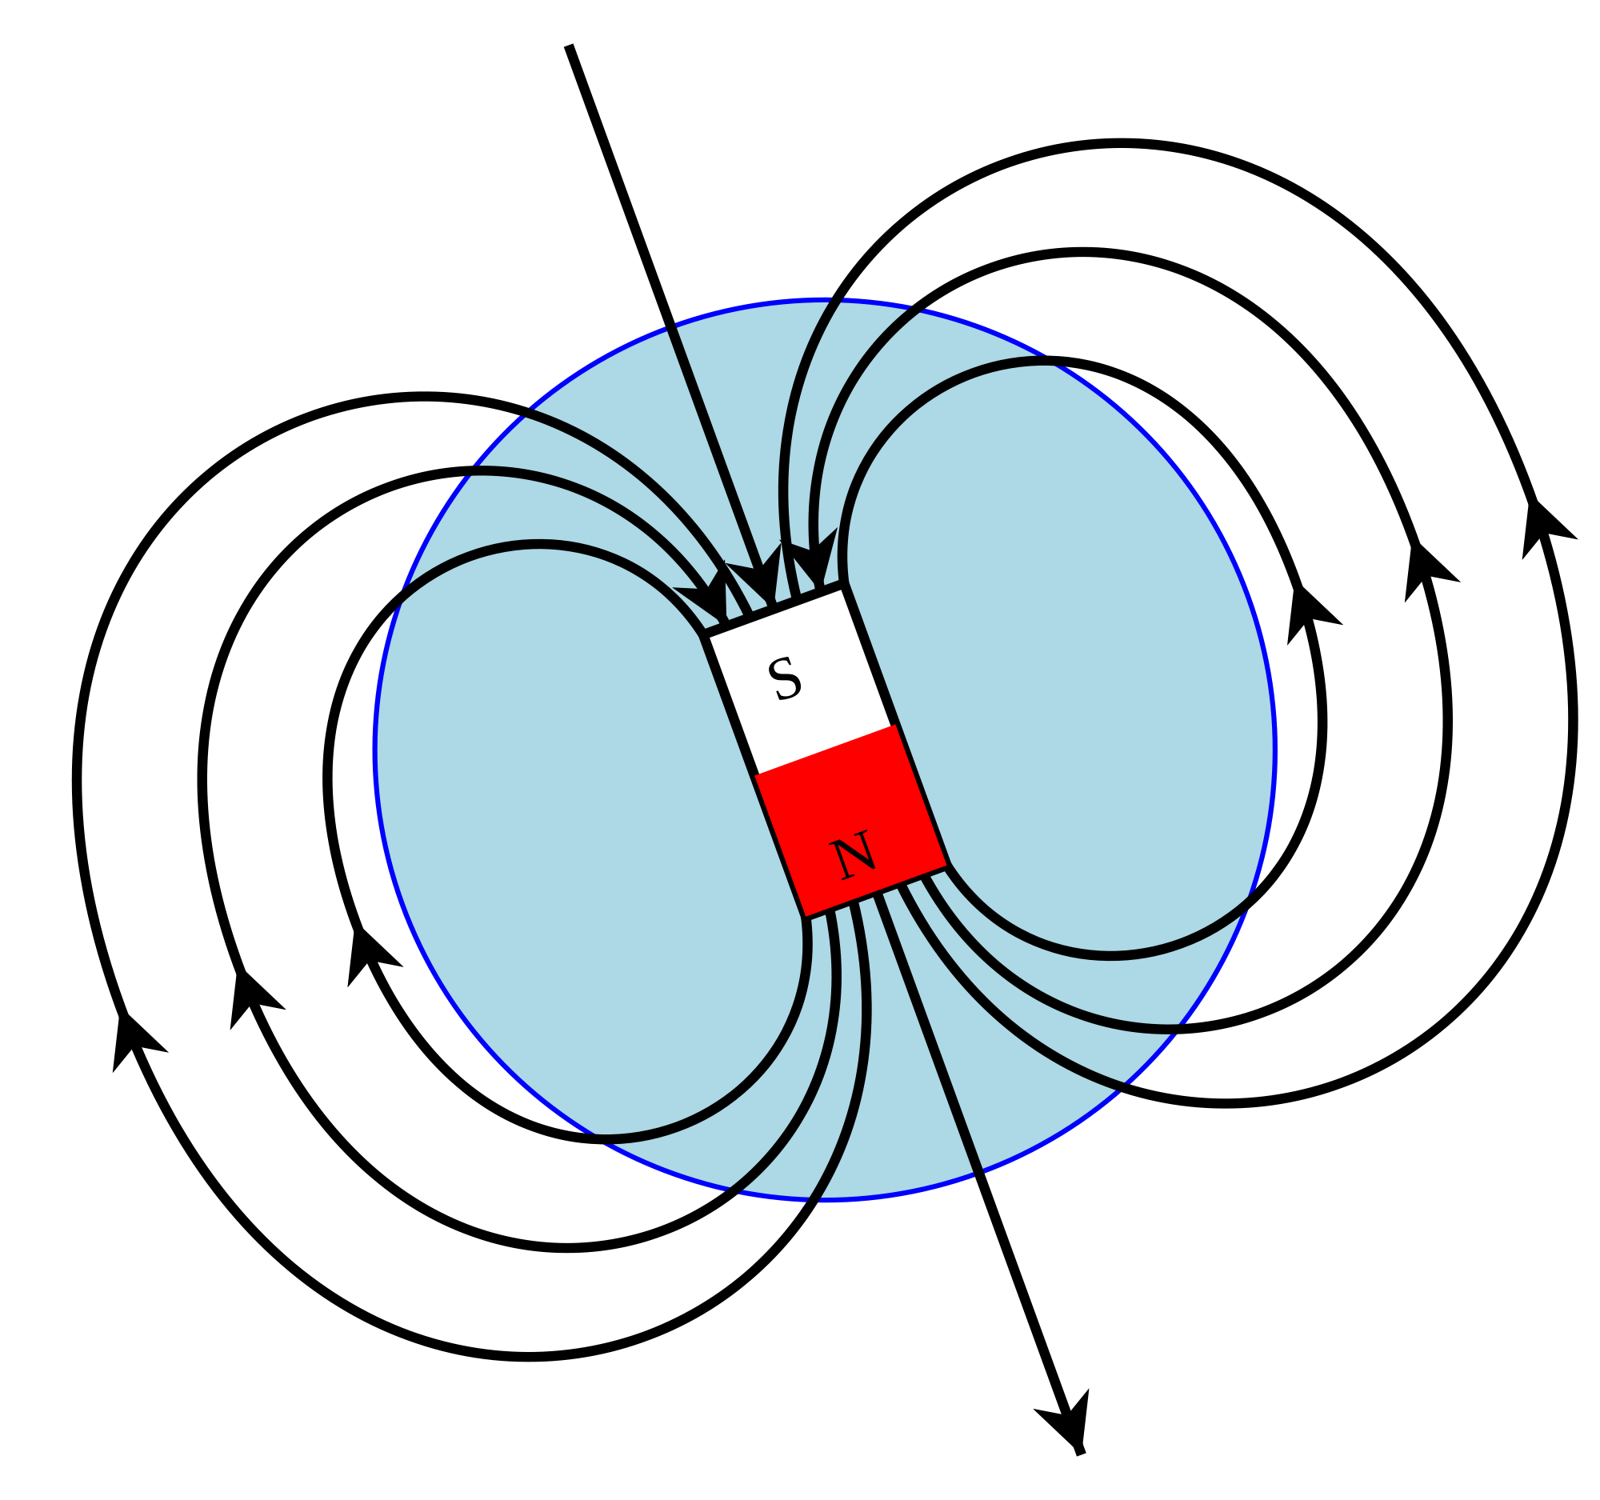

Figure 109 Diagram of the Earth’s magnetic field lines

## Sub-topic 4: Electromagnetism

### Unit 1: The magnetic effect of a current

#### Learning Outcomes

By the end of the unit, you should be able to:

* draw the direction of the magnetic field near a current-carrying wire and a current-carrying loop;
* state the effect on the magnetic field of changing the magnitude and / or direction of the current;
* explain how an electromagnet works.

#### Introduction

Up to this point you have learnt about electricity and magnetism as separate concepts. In this unit you will learn about the relationship between them. This relationship is called electromagnetism. Before you explore this concept, you need to recall some of the concepts from previous units:

* Describe in your own words what an electric current is.
* Describe in your own words what a magnetic field is.

You should recall that an electric current is the movement of charges through a conducting wire. The higher the value of the current, the higher the rate of movement of the charges the wire. You should also recall that a magnetic field is formed around a magnet, and when an object made of a magnetic material is brought into this space it will experience a force. You use magnetic field lines to show what the magnetic field looks like.

In the activities that follow you will be investigating the relationship between electric current and the magnetic field, and you will see electromagnetism in action and learn why it is important for everyday life.

#### The magnetic field near a current-carrying wire

#### Activity 1: Investigating the magnetic field around a current carrying conductor

Purpose

In this activity, you will investigate the magnetic field near a wire that has a current flowing through it.

What you need:

* 2 torch cells (1,5V each)
* 1 electric lead (about 30cm in length)
* A compass (you can make your own, as explained in Sub-topic 3)

Suggested time**:** [20 minutes]

What you will do:

1. Lay your compass on a table, facing upwards. Wait until the needle settles – if it is not close to another object made of magnetic material it should be pointing North.
2. Lay the middle of your electric lead above the compass needle, so that it lines up with the needle.
3. Connect one end of the wire to one end of the battery. *Very briefly* connect the other end to the other terminal of the battery. What do you observe on your compass? (*NOTE*: only connect the leads to the battery for a *few seconds*, as you will drain the battery if you leave it connected for too long!)
4. What do you observe about the needle as you disconnect the leads from the battery?

You can see YouTube videos with similar experiments to the one in this Activity:

* *Magnetic field of a current:* <https://www.youtube.com/watch?v=3KkOqVEa1oI> (Duration: 1.31)
* *Magnetic field of a wire:* <https://www.youtube.com/watch?v=nfSJ62mzKyY> (Duration: 7.33) – this video also has an explanation that you might find helpful.

#### Guided reflection

In this activity you should observe the following:

* When there is no current flowing in the wire, the compass needle remains still.
* As soon as there is a current flowing in the wire, the compass needle is deflected (turns).
* When you disconnect the battery or remove the wire, the compass needle returns to its original position.

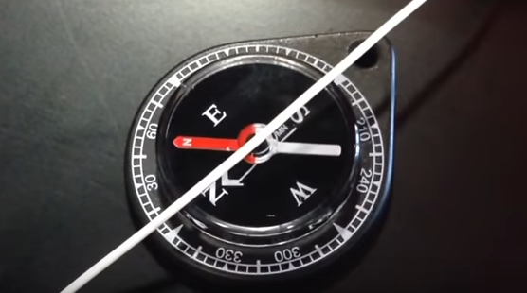 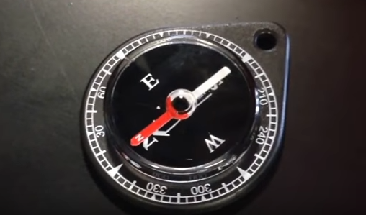

Figure 110 The compass needle is deflected when current flows in the wire, and returns to its original position when the wire is removed (Source: screenshot from YouTube video <https://www.youtube.com/watch?v=48EVEXpVqUE>)

What this shows you is that there is a magnetic field that is formed when a current flows through a wire. You can see this from the movement of the compass as the circuit is connected.

The relationship between electricity and magnetism is *circular*. Any wire or conductor that has a current flowing through it has a magnetic field that circles it. The greater the value of the current in the wire, the stronger the magnetic field that will be produced around the wire. This relationship is shown in the diagram below:

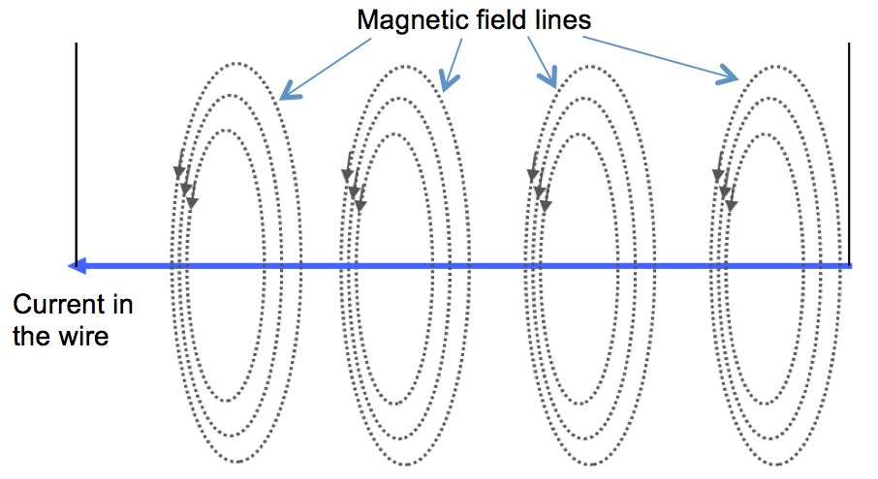

Figure 111 A circular magnetic field is formed around a current

A simple rule to help one to work out the direction of the magnetic field that is induced by the current is called the *Right Hand Rule*. Curl the fingers of your right hand around, and point your thumb out straight. With your thumb pointing in the direction of the current flow, your curled fingers will be pointing in the direction of the magnetic field.

Figure 112 Use the *Right Hand Rule* to work out the direction of the magnetic field



You can show the direction of the magnetic field coming out of the page using a dot .

A cross can be used to show that the direction of the magnetic field is into the page. These symbols are used because, if you picture an arrow coming out of the page, you would see its sharp tip, which looks like a dot. If the arrow is going into the page, you would see the back of the arrow, which looks like a cross.

You can use these symbols show the direction of the magnetic field around a current-carrying conductor. This is shown in the diagram below.

Figure 113 Magnetic field around a current represented using symbols

#### Activity 2: Test your understanding of the magnetic field around a current-carrying wire

Purpose

In this activity, you will assess your understanding of the magnetic field that is formed near a wire that has a current flowing through it.

Suggested time**:** [20 minutes]

What you will do:

Answer the following questions.

1. Use the Right Hand Rule to draw the direction of the magnetic field around the wires shown below, where the current direction is shown by the arrows. (You can use curved arrows to show the direction of the magnetic field, or you can use dots and crosses).

Figure 114 Wire with current flowing in the downward direction

Figure 115 Wire with current flowing to the right

1. You can also use dots to show that the direction of the current is flowing out of the page, or crosses to show that current is flowing into the page. Draw the direction of the magnetic field around the current represented by the dot and the cross shown below:





Figure 116 Draw magnetic field lines around a current that is flowing into the page

Figure 117 Draw magnetic field lines around a current that is flowing out of the page

#### Solutions or Exemplar answers

Remember to use your right hand to find these directions: if your thumb is pointing in the direction of the current, then the curl of your other fingers shows you the direction of the magnetic field.



1. a.

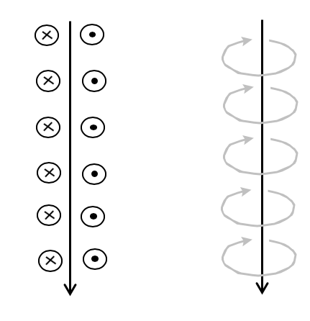

Figure 118 Magnetic field lines around downward current

b.

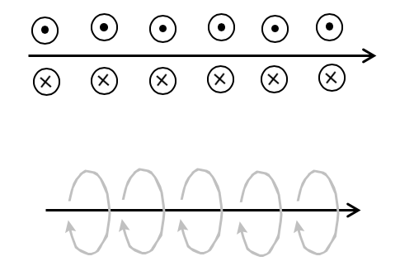

Figure 119 Magnetic field lines around current that flows to the right

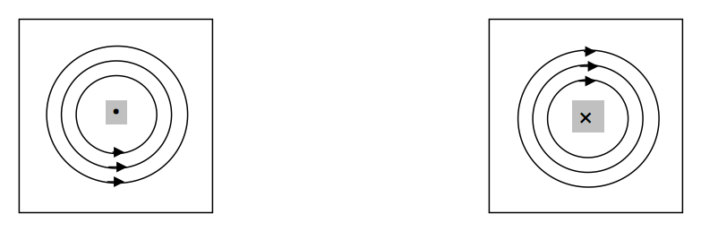

Here your thumb of your right hand should be pointing out of the page (up), so the curl of your other fingers shows that the magnetic field direction is anti-clockwise.

Figure 120 Magnetic field lines around a current that is flowing out of the page



Here your thumb of your right hand should be pointing into the page (down), so the curl of your other fingers shows that the magnetic field direction is clockwise.

Figure 121 Magnetic field lines around a current that is flowing into the page

[Wordbox: MAIN IDEA:

* When a current flows in a conducting wire, it creates a *circular magnetic field* around the wire.
* The direction of the magnetic field lines can be found using the *Right Hand Rule*. ]

#### The magnetic field near looped wires

If you take a current-carrying wire and make a single loop with it, you can work out the pattern of the magnetic field near the wire. The magnetic field around the loop is shown on the left using curved arrows, and in the diagram on the right using dots where the magnetic field is pointing out of the page, and crosses where it is pointing into the page.

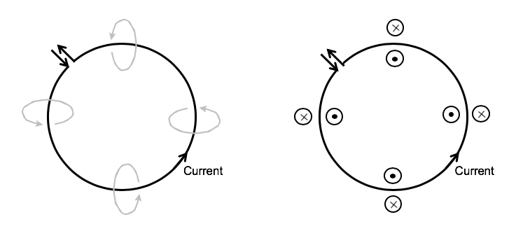

Figure 122 Magnetic field lines around a current in a looped wire

From this diagram you can see that the magnetic field at the center of the loop points outward from the page, and on the outside of the loop it points into the page. Again you can use the *Right Hand Rule* to work this out. If you curl your fingers in the direction of the current in a current-carrying loop, your thumb will point in the direction of the magnetic field at the center of the loop.

If you have a number of current-carrying loops, all wound in the same direction, they form a **solenoid**. {add description here}

The magnetic fields from the loops in a solenoid have the same direction, so they add together through superposition to create a stronger magnetic field. The diagram below shows what a magnetic field associated with a solenoid looks like.



Figure 123 The magnetic field of a solenoid

#### Activity 3: Test your understanding of the magnetic field near looped wires

Purpose

In this activity, you will assess your understanding of the magnetic field that is formed near a wire that has a current flowing through it.

Suggested time**:** [20 minutes]

What you will do:

Answer the following questions.

Current

1. The diagram on the right shows the direction of the current in a single looped wire.
   1. What is the direction of the magnetic field at the center of the loop?
   2. What can you do to change the direction of the magnetic field so that it has the opposite direction?

Figure 124 Current flowing through a looped wire in a clockwise direction

1. The diagram below shows the direction of the magnetic field around a current-carrying looped conductor. Draw in the direction of the current in the loop.

Figure 125 The magnetic field around a current-carrying looped wire

#### Solutions

Current

* 1. The direction of the magnetic field at the centre of the loop is *into the page*, since the current is flowing in a clockwise direction. If you position your right hand so that your fingers curl in the direction of the current in this wire, you will find that your thumb is pointing downward, into the page.

Figure 126 Current flowing in a clockwise direction

* 1. To change the direction of the magnetic field, you need to change the direction of the current to be anti-clockwise.

1. The direction of the current in the loop is shown in the diagram below.

Here the dots inside the wire show that the magnetic field is pointing out of the page on the inside of the loop, so you will position your right hand so that your thumb is pointing upward (out of the page). Then your fingers will curl in the direction of the current in the wire, which is anti-clockwise (as the diagram shows).

Figure 127 The magnetic field around a current-carrying looped wire that is caused by a current flowing in the anti-clockwise direction

[Wordbox: MAIN IDEA:

* You can use the *Right Hand Rule* to work out the direction of the magnetic field created by a current-carrying loop.
* A number of current-carrying loops, all wound in the same direction, form a coil that is called a *solenoid***.** ]

#### Activity 4: Build an electromagnet

Purpose

In this activity, you will apply the principal of electromagnetism to build your own electromagnet.

What you need:

* A 9V battery, or 4 torch batteries (1,5V each), taped together to create one large 9V battery
* About 1.5m to 2m of plastic-coated wire
* A large nail
* Some metal paper clips or pins
* A compass (you can make your own, as explained in Sub-topic 3)

Suggested time**:** [20 minutes]

What you will do:

1. Wind the wire around the nail, and connect one of the bare ends of the wire to a terminal of the battery. Do not connect the other end of the wire to the battery yet.
2. Bring the tip of the nail near to the pins or paper clips. Close your circuit so that there is current flowing through the wire. What do you observe?
3. Disconnect the circuit by removing one of the ends of the wire from the battery. What do you observe?
4. Design an experiment in which you use your compass to test which end of your electromagnet is north.
5. Draw a diagram of your electromagnet, showing the direction of the current in the wire. Draw in the magnetic field lines.

You can observe the direction of the magnetic field using the internet simulator by going to the address: <https://phet.colorado.edu/en/simulation/legacy/magnets-and-electromagnets> . When the simulation is running, click on the tab at the top of the window labelled “Electromagnet”.

You can move the compass around to see the direction of the magnetic field around the electromagnet.

*IMPORTANT NOTE*: In this simulation the movement of charges shows the direction in which electrons would move, i.e. negative charges. Keep in mind that conventional current, which is the direction that you have been using for current, is opposite to the direction of electron movement.

#### Guided reflection

In this activity, you should have observed the following:

* When you close the circuit so that current flows through the coil of wire, you observe that the nail is able to attract paperclips or pins.
* This tells you that the nail becomes magnetised when there is an electric current flowing through the coil of wire. This is called an *electromagnet*, since you are creating a magnet using electricity.
* As soon as the current is stopped, the nail no longer attracts the paper clips.
* Using your compass or the internet simulation, you would have been able to observe the direction of the magnetic field. The direction of the magnetic field in the electromagnet is shown in the diagram below (from the simulation).
* If you curl the fingers of your right hand in the direction of the conventional current (from the positive terminal of the battery to the negative), then your thumb will point in the direction of the North pole of the magnetic field (which is to the right in this diagram).

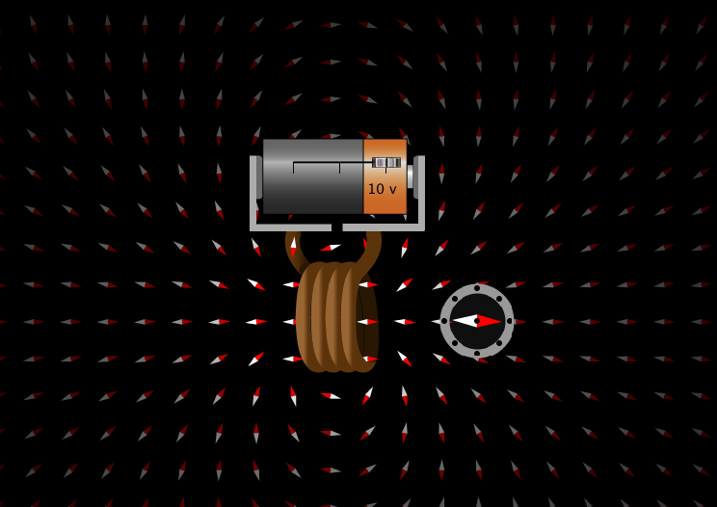

Figure 128 The direction of the magnetic field in an electromagnet

[Wordbox: MAIN IDEA:

* An *electromagnet* can be made by winding a conducting wire around a magnetic material. When a current flows in the wire, a magnetic field is created in the magnetic material. ]

### Unit 2: Force on a current-carrying conductor

#### Learning Outcomes

By the end of the unit, you should be able to:

* determine the direction of the force on a current-carrying conductor in a magnetic field.

#### Introduction

In Unit 1 you learnt about the relationship between the current that flows in a conducting wire and the magnetic field that is created in the process. Refresh your memory of these by reflecting on the following questions:

* If a current flows to the left in a conducting wire, describe the magnetic field that is created.
* Describe how you could construct an electromagnet using simple equipment.

If you are unsure of the answers to these questions, refresh your memory by looking back in the last unit. Remember that the relationship between an electric current and the magnetic field that is created around it is circular.

In this unit you will extend this knowledge by looking at what happens if a current flows through a magnetic field that already exists.

#### Charged particles moving through a magnetic field

#### Activity 1: Investigate the force on charged particles moving through a magnetic field

Purpose

In this activity you will investigate the question of what would happen if a current flows through a magnetic field that already exists. You will first look at three possibilities for a single positive charge in a magnetic field, and then reflect on these by answering a question.

Suggested time**:** [15 minutes]

What you will do:

Think carefully about the three scenarios described below. Note that in the diagrams, the symbol B is used to label the magnetic field lines. The velocity of the charge is shown with the symbol *v*.

Possibility 1:



Figure 129 A positive charge q is not moving in a magnetic field

Result: Scientists have found that there is *no force* on this charge

Possibility 2:

Figure 130 A positive charge q moves parallel to the direction of a magnetic field (either in the same direction, or in the opposite direction to the magnetic field lines)



Result: Scientists have found that there is *no force* on this charge

Possibility 3:



Figure 131 A positive charge q moves at right angles to the direction of a magnetic field

Result: Scientists have found that there is an*upward force* on this charge.

**Reflection question:**

After looking at the three possibilities described above, try to answer the following questions:

* Can you describe the conditions that are needed for a charge to experience a force when it is moving in the presence of a magnetic field?
* How does the direction of this force compare to the direction of the magnetic field?
* How does the direction of the force compare to the direction of the movement of the charge?

#### Guided reflection

What you should notice from these scenarios described above is that if a charge moves at right angles to a magnetic field, it will experience a force. The direction of this force is at right angles to *both* the magnetic field (B) and the direction of movement of the charge (v).

Since an electric current is a continuous movement of charges, you can apply this same principle to a current. You can therefore say that if a current is flowing at *right angles to a magnetic field*, then there will be a *force* on that current which will be perpendicular to both the current direction, and the magnetic field direction.



Figure 132 The Left Hand Rule

To determine the direction of the force, you can use your *left hand* to help you. With the index finger of your hand pointing in the direction of the magnetic field (**B**), and your middle finger pointing in the direction of the velocity of the charge (or in the direction of the current **I**), your thumb will be pointing in the direction of the force (**F**). (This is called the *Left Hand Rule*, or the *FBI* rule).

#### Activity 2: Test your understanding of the force on a charge moving through a magnetic field

Purpose

In this activity, you will assess your understanding of the force on a charge that is moving through a magnetic field.

Suggested time**:** [15 minutes]

What you will do:

Answer the following questions.

1. What is the direction of the force on the positive charge shown in the diagram on the right?
2. What do you think the direction of the force would be on a *negative* charge moving in this same direction?

Figure 133 A positive charge q moves at right angles to a magnetic field

#### Solutions or Exemplar answers

1. The force on the positive charge shown in the diagram is *down*. You work this out from the Left Hand Rule, where you move your hand so that the index finger points to the left, in the direction of the magnetic field, and the middle finger points out of the page, in the direction of the movement of the charge. Then the force on the charge is shown by the thumb, which is pointing downward.

Figure 134 Direction of the force acting on the charge q can be found using the *Left Hand Rule*



F

1. The force on a *negative* charge moving in this same direction would be the opposite direction, so it would be *up*.

[Wordbox: MAIN IDEA:

* When a charge moves at right angles to a magnetic field, it will experience a *force*.
* The direction of this force can be found using the *Left Hand Rule* (or the *FBI* rule). ]

#### More resources to help you:

If you need further explanations about electromagnetism, the following website has a very helpful explanation with diagrams: https://www.sciencebuddies.org/science-fair-projects/references/electricity-magnetism-electromagnetism-tutorial#electromagnetism

The following YouTube video explains magnetism (from 0.00 to 3.47), and then goes on to explain electromagnetism (from 3.47 to 6.22): *Magnetism and Electromagnetism Tutorial*:

<https://youtu.be/V-Gus-qIT74> (Duration: 6.22)

*Note* that in this video, at around the 2.30 mark, the white end of the compass needle points towards the south pole of the magnet. This is because the compass was accidentally re-polarized before the video was made. Normally, the RED end of a compass needle should point towards the south pole of a magnet.

You can watch a YouTube video where electromagnetism is applied in a fun way to build a simple magnetic train: *World’s Simplest Electric Train*: <https://youtu.be/J9b0J29OzAU> (Duration: 1.47)

An explanation for how this works can be seen at the website: <https://skullsinthestars.com/2014/12/12/the-mystery-of-the-magnetic-train/>

#### Activity 3: Consolidate your learning of electromagnetism

Purpose

In this activity you will consolidate your learning of electromagnetism by answering the questions below and then assessing your own understanding using the solutions provided. Give yourself a mark out of the total of 30 marks, which will give you an idea of how well you understand this section of the work.

Suggested time**:** [40 minutes]

1. Describe how you could test for the presence of a magnetic field near a current-carrying conductor. (3)
2. The diagram below shows the direction of the current in a coil of conducting wire. What is the direction of the magnetic field at points A, B and C? (3)

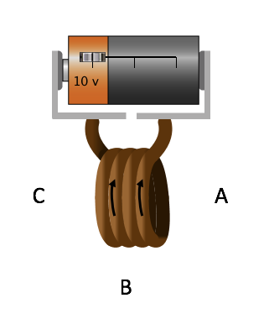

Figure 135 The direction of the current in a coil of conducting wire

1. An electromagnet is made by winding a length of current-carrying wire around a nail. The magnetic north is at the sharp tip of the nail. Draw a diagram of this set-up, showing how the wire should be connected to a torch cell to create a magnetic field in this direction. (3)



Figure 136 The direction of the field lines of a circular magnetic field

1. The diagram shows the direction of the field lines of a circular magnetic field.
   1. What direction of current would create this magnetic field? (1)
   2. How could the direction of the magnetic field lines be reversed? (1)
   3. If a positive charge moves to the left at point P, what is the direction of the force on it? (2)
   4. If a positive charge moves to the right at point Q, what is the force on it? (2)
   5. If a compass is placed at point Q, what would happen to its needle? (1)
   6. If the current is suddenly switched off, what would happen to the compass needle? (2)
2. In which of the following will a force of magnetic attraction be observed? Explain your answer in each case.
   1. A magnet is brought close to a paper clip that is made from iron. (3)
   2. An iron rod is brought close to an iron paper clip. (3)
   3. Some wire that is attached to a battery is wound around an iron rod, and the rod is brought close to an iron paper clip. (3)
   4. Some wire that is attached to a battery is wound around an aluminium rod, and the rod is brought close to an iron paper clip. (3)

#### Solutions

1. You could test for the presence of a magnetic field using a compass. When a current is flowing in the wire, the compass needle will point in the direction of the magnetic field. You could also use pins or paper clips made from iron or some other magnetic metal. When a current is flowing in the wire, the paper clips will be attracted by the wire. (3)
2. You can work this out using your right hand – curl your fingers in the direction of the current in the wire, and then your thumb will point in the direction of the magnetic field (left). Therefore:

At point A: direction of magnetic field is **left**  (1)

At point B: direction of magnetic field is **right** (1)

At point C: direction of magnetic field is **left** (1)

1. Your drawing should look similar to the diagram shown below: (3)

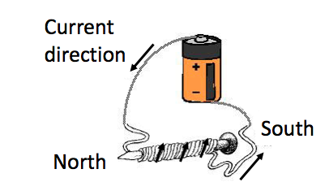

Figure 137 Drawing of an electromagnet

1. Current direction would be into the page. (1)
2. By reversing the current direction (I.e. out of the page). (1)
3. Force direction is into the page (you use the left-hand rule) (2)
4. No force, since it is moving parallel to the magnetic field. (2)
5. The compass needle would point to the left (in the direction of the magnetic field). (1)
6. It would point in the direction of the Earth’s magnetic North. (2)
   1. There WILL be a force of magnetic attraction, since the paper clip is a magnetic material, and will be attracted to the magnet. (3)
   2. There will NOT be a force of magnetic attraction, since none of the objects are magnetised. (3)
   3. There WILL be a force of magnetic attraction, since the iron rod will become an electromagnet when a current flows through the wire. (3)
   4. There WILL NOT be a force of magnetic attraction, since aluminium is non-magnetic, so it will not form an electromagnet. (3)