Topic: The nature of science

Overview

Write a heading: ‘The nature of science’ in your workbook.

Reflect on the following questions, either on your own or with a fellow student.

Write your answer to each question into your workbook.

Leave about 8 lines between each answer so you can come back later and add to your answers as you learn more in this Unit.

* Do you think scienceis important?
* Why… or why not?
* What’s the point of learning science?
* Will you use it again after your exams?

We all believe that if we are going to spend time learning something, then it should *benefit* us in some very real way. Before we can make a judgement and say whether learning about science will benefit us or not, we need to find out a little more about *what science really is and what it means to ‘do science’*.

Some people may think ‘science’ is the knowledge contained in textbooks and scientists are very clever, older people who work in white coats in laboratories! But these ideas are not true.

Science is more than just a body of knowledge found in science textbooks; it is a way of *asking and answering questions* about the **natural world** [the non-living physical things and the living things in the world].

Science tries to detect *patterns* and find *explanations* for things we observe in the natural world.

We use science in many ways in our everyday lives.

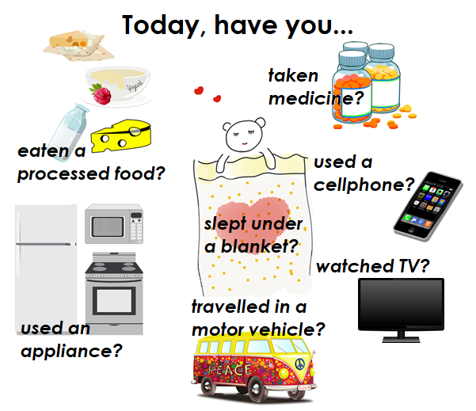

**Figure 1: Have you used science today?** [insert NOS AWB Figure 1]

Source: adapted from :

<https://pixabay.com/en/iphone-cellphone-smartphone-mobile-37856/>

<https://pixabay.com/en/lcd-monitor-screen-flat-display-2059995/>

<https://pixabay.com/en/appliances-refrigerator-microwave-993782/>

<https://pixabay.com/en/medicine-pills-bottles-medical-296966/>

<https://pixabay.com/en/volkswagen-car-bus-mobile-home-158463/>

<https://pixabay.com/en/teddy-bear-sleeping-love-bear-1968202/>

<https://pixabay.com/en/dairy-food-group-health-living-eat-1489124/>

All the products in the diagram are based on science. We accept them as part of modern life.

* Science has helped humans to live longer, healthier lives by producing medication.
* Modern transport allows us to move around the country and the world easily.
* Electricity provides us with heat to cook food, lights to see at night, and power for a TV set and to charge our cell phones.
* Technology has given us processed foods and materials that make our lives more comfortable and healthier.

Science is our best hope to find solutions to global problems such as how to produce enough food for the growing human population, how best to prevent and treat diseases such as malaria and HIV/ AIDS, and how to protect the natural environment.

*Studying science may start you on a journey to contribute to the future!*

The approach to Natural Sciences that will be taken in this course:

Natural Sciences in the NASCA consists of an overarching study of the Nature of Science (which you are working through right now), followed by three disciplines: Physics, Biology and Chemistry. You will learn more about these disciplines later in Unit 1.3.

We recommend that you begin this course by studying the Nature of Science. You should then study Physics, Biology and Chemistry each week so that you do not neglect any of the disciplines.

Ready to explore science further and come to grips with how science works?

Let’s get on with it then!

Topic: The nature of science

Sub-topic 1: What is Natural Science?

This section gets you thinking about what science really is and the different kinds of science you will be doing in this course.

[START TEXT BOX]

You have been reading about two similar sounding terms: ‘*nature* of science’ and ‘*natural* science’.

When we talk about the ‘nature of science’, we are not talking about wildlife or the environment! We mean *what science is and how we do science*.

When we talk about ‘natural science’ we mean the components or disciplines in science: Physics, Biology and Chemistry.

[END TEXT BOX]

Unit 1: The nature of science and scientific knowledge

Unit 1 learning outcomes

By the end of this unit, you should be able to:

1. Describe the nature of science as a comprehensive and reliable way of understanding patterns observed in the natural world.
2. Demonstrate understanding that although much scientific knowledge is long-lasting, it is subject to modification as new information becomes available.
3. Describe the broad scientific disciplines, such as Physics, Chemistry, Biology, Geology, and Environmental Science.

Unit 1.1: What is science?

Begin this Unit by starting off with Activity 1.1. Write a heading, ‘Activity 1.1’ in your workbook and follow the instructions in the Activity.

Activity 1.1: What do you understand by ‘science’?

Suggested time:

15 minutes

Aim:

This short activity poses some questions for you to consider. You will come back to these questions a little later in this topic to see if your understanding of what science is has changed in any way.

What you will do:

Record your responses in your workbook. Remember to include the number and title of this activity, so that you can return to it later and know what your writing was about.

1. Read the following statements. Do you agree or disagree with each statement?

Record your answers in your workbook.

Statement 1:

*Science is a collection of facts that scientists have proven to be true over the years*.

Statement 2:

*Science is what scientists do in order to develop a whole lot of knowledge*.

Statement 3:

*‘Doing science’ involves doing experiments and investigations in order to discover things about our world and ourselves.*

Statement 4:

*The processes of science produce ideas, information, concepts, rules and theories which help us to explain the world in which we live.*

Statement 5:

*Science is always the same. It never changes*.

Statement 6:

*Science can only be done by specially trained and highly educated scientists in a laboratory*.

2. Select words from the list below that you think relate to science and scientific knowledge.

experiment; facts; laboratory; beautiful, apparatus; evidence; religion; observation; belief; investigate; opinion; theory; reasoning; mathematics; unchanging; reliable; faith.

3. Now write a sentence or two in your workbook, describing what *you* think science is.

Discussion of the activity

As you work your way through the rest of this section of work, you may find that you need to add to or refine the definition of science that you have written down at the end of the Activity. That is good. That is actually how scientific ideas develop – by refining and modifying what you originally thought after investigation and careful thinking. Science is *not* a fixed body of knowledge. Science is *tentative*. It changes as we come to new understanding and discover new things.

Exemplar answer

1. At this time, there are no model answers for this part of the activity. You will return to these ideas later.

2. Words that relate to science are: experiment; facts; laboratory; apparatus; evidence; observation; investigate; theory; reasoning; mathematics; reliable. In Unit 2.3, you will look at why we don’t recognise the other terms as part of science.

3. You will come back to this definition and modify or change your ideas if necessary.

Now watch these very simple videos that introduce you to the nature of science:

*The Nature of Science*: <https://www.youtube.com/watch?v=fpeLuU6hxkA> (Duration: 2.25)

and

*The Nature of Science:* <https://www.youtube.com/watch?v=ui8X_TTFIzI> (Duration: 3.02)

After watching the simple videos, try this website: <https://evolution.berkeley.edu/evolibrary/>article/nature_01 (Seven pages from ‘What is science?’ to ‘Science exists in a cultural context’)

You will find seven (short!) pages of ideas that explain what science is in a simple and straightforward way.

Once you have watched the videos and read these pages, go back to Activity 1.1 and revise anything you need to change, based on what you now know.

Now do this quick assessment to see how your ideas about what science is are forming.

Quick progress check

1. Yes or no: Science deals with the way we understand the natural world.
2. Yes or no: Science starts with us asking questions.
3. Yes or no: Science requires us to make observations using all our senses. We may also need to use different technological tools to help us make these observations, such as microscopes, telescopes, machines that analyse the elements present in a gas sample etc.
4. Yes or no: Without any evidence, we cannot make definite scientific claims.
5. Yes or no: Science does not deal with subjects that relate to beliefs and imaginary creatures.
6. Yes or no: Scientific claims are made after testing ideas by doing investigations.
7. Yes or no: A scientist’s claims gain more weight after other scientists have tested the claims and can come to the same conclusions.
8. Yes or no: Science is as much a process as it is a body of knowledge.
9. Yes or no: Science may change with new information.

Discussion of the progress check

Make sure you go back to Activity 1.1 in your workbook and edit your answers!

The answer to each of the questions in the Progress check is Yes!

Now make your way through these notes. Keep focussed on the idea that you are in the process of working out for yourself ‘What is science?’ Keep refining your ideas from Activity 1.1.

* Is science the stuff you find in science *textbooks*?
* Is science something you can *do*?
* Is science always *factual*?
* Is science *more* than this?

Science is not just books of facts. Science is a way of asking and answering questions about the natural world. Scientists look for patterns in the natural world. They investigate the natural world by careful observation and experiments. They try to explain what they are observing. They study similar work of other scientists. Eventually, if most of the evidence agrees, they develop a theory that explains a whole lot of related observations.

[START TEXT BOX]

*For example, Robert Hooke discovered the first cells in 1663. He cut thin slices of cork and examined them with his simple microscope. He saw that cork consisted of little boxes that he called ‘cells’. Over the next two hundred years, microscopes improved and scientists studied thin slices of many different plants and animals. Eventually, in 1883, a pattern emerged that led to a Law:*

All living things are made up of cells.

*No living thing has yet been found that is not made up of cells. The theory has proved to be reliable and consistent.*

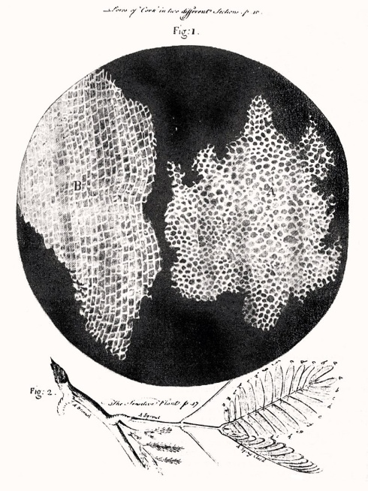

**Figure 2: Robert Hooke’s cork cells** [insert NOS AWB Figure 2]

(Source: <https://en.wikipedia.org/wiki/Robert_Hooke#/media/File:RobertHookeMicrographia1665.jpg>)

[END TEXT BOX]

This short video introduces you to Hooke and his first view of cells:

*How Robert Hooke discovered the cell:*  <https://www.youtube.com/watch?v=2gtrkxtsQ2k> (Duration: 2.34)

This video shows how Hooke’s investigations were only part of the many investigations that led to the cell theory:

*The wacky history of cell theory:* <https://www.youtube.com/watch?v=4OpBylwH9DU> (Duration: 6.11)

[START TEXT BOX]

*What’s the main idea?*

Science is more than a large body of knowledge. Science is a systematic process or way of investigating the natural world and arriving at explanations.

[END TEXT BOX]

Unit 1.2: Scientific knowledge grows and changes

Perhaps you thought that science consists of a lot of facts that you have to memorise! It is true that science has many facts, but all of them began with observations about the natural world. Facts are established knowledge. The knowledge began with observation and experimenting, leading to reliable facts. Some facts have remained true for centuries. Other facts change as new knowledge is discovered. (Go back to the previous Progress check in Unit 1.1 and read again question 9: Science may change with new information.)

For example, in Unit 1.1, you learnt about Robert Hooke’s discovery of cells. The first cells that Robert Hooke discovered were dead cork cells. They had no cell contents. Later, methods of staining samples of tissue were discovered, and microscopes improved. Scientists noticed that there were objects inside cells. One object was present in all cells, and was called the nucleus. New knowledge had been discovered.

For humans today, the world is a place of amazing discoveries. Earth (and beyond!) is our laboratory and our imagination knows few boundaries. We have discovered an incredible amount about our planet, the life forms on earth, the solar system, and the universe as a whole. Science is the way we find out this information, as well as the knowledge that we have.

Did you know that people have not always felt this way? For much of human history, people thought of Earth as a fearful place, a place ruled by an assortment of gods, giants and demons. Storms, volcanoes, earthquakes, eclipses and even the sun were not considered features of this planet to investigate and understand. They were considered to be warnings and threats and punishments to be feared. Human and animal sacrifices were used as a form of communication and peace making between humans and their gods.

Activity 1.2: Scientific knowledge changes over time

Suggested time:

20 minutes

Aim:

You are going to explore how the scientific knowledge we have today has evolved out of supernatural beliefs.

What you will do:

You will need your workbook and pen.

Read the following carefully:

*In Mexico, the ancient Aztecs offered human sacrifices to the sun in order to ensure good crops. In western Africa, a group of people believed that the jungle was the hair of a giant. Earthquakes happened when the giant shook his head. In ancient Iceland, the people believed earthquakes resulted from quarrels among the gods. They believed that their most active volcano, Hekla, was Hell’s Gate and that the lava that shot out of its crater contained the souls of the damned. Ancient Polynesian islanders believed that the goddess Pele and her sister Namakaokahai battled across the Pacific Ocean and that a scar of each battle created each of the Hawaiian islands.*

*The beliefs of these ancient people seem strange to us today. This is because we live in a time in which* scientific explanation has replaced fear-based explanation*. Today, scientific knowledge is based on logic, observation and experimentation. However, it is important to realise that our scientific explanations sometimes change as new information has become available to humans. While explanations may have changed over time, one thing has not changed: people have always tried to explain in the most meaningful way they can, those things that they observe and those things that are important to them.*

Answer the questions in your workbook, under the heading Activity 1.2.

1. In the passage you just read, a number of beliefs explaining natural phenomena were described.

Do you know of any other such beliefs which were held by ancient people, maybe even your ancestors? Write a few sentences describing this belief.

Then, in a new paragraph, write a few sentences describing the scientific explanation for that phenomenon.

1. *“Maggots (the larval stage of flies) form from the rotting remains of meat.”*

This was a belief that was held in the sixteenth century. We know today, it was a false belief, even though the people believed it to be true in the sixteenth century.

Why may people have drawn this conclusion?

What do we know today?

3. Say whether each of the following statements is true or false. If false, say why the statement is false.

1. Scientific knowledge was established 200 years ago and has not changed since then.
2. Science is a process or way of asking and answering questions about the natural world.
3. Scientists produce knowledge that is always true.
4. Scientists try to explain their observations and experimental results.
5. Science can answer every question we may ask.

Discussion of the activity

By now you should be realising that science is *not* a fixed body of knowledge. Science is *tentative*. It changes as we come to new understanding and discover new things.

Exemplar answer

1. There is no model answer for this question. Your answers will vary depending on your circumstances.
2. They saw maggots emerge from the rotting meat and presumed that the meat gave rise to the maggots. However, we know today that certain flies lay their eggs on fresh meat. The eggs are very small and are not always visible to the naked eye. As the bacteria begin to rot the meat, they produce heat. The heat helps the fly eggs to hatch. The maggots hatch out of the eggs and crawl through the meat tissue, eating and growing.
3. a. False. Scientific knowledge began thousands of years ago and has changed significantly over time.

b. True.

c. False. Scientific knowledge changes as new evidence is discovered.

d. True.

e. False. Science can only investigate questions that are testable.

[START TEXT BOX]

*What’s the main idea?*

Scientific ideas are subject to change. We say that science is *tentative* [open to examination, may change if new facts emerge].

[END TEXT BOX]

Unit 1.3: Science is organised into scientific disciplines

Science is a collection of different fields of study, which are called *disciplines*.

[START TEXT BOX]

*What do we mean by ‘discipline’?*

You are probably most familiar with the meaning of ‘discipline’ relating to how your behaviour is controlled! When you obey certain codes or rules of behaviour, you are called a *disciplined* person. Maybe you have self-discipline, or maybe you have been trained in such a way that you have discipline and follow rules and ways of behaving appropriately.

But there is another meaning of the word ‘discipline’. In academic studies, a particular branch or field of knowledge is called a ‘discipline’.

[END TEXT BOX]

All the scientific disciplines have the same purpose and *philosophy* [way of thinking about something]: to develop the natural laws that describe how the universe works through careful observation, measurement and experiments.

Here are some examples of scientific disciplines:

* *Physics* is the study of the physical properties of matter and energy, and the interactions and relationships between these. Physics tries to develop mathematical models to explain physical events.
* *Chemistry* is the study of the properties of matter and materials. It includes the ways in which matter changes from one form to another, and how forms of matter react with one another.
* *Biology* is the study of life and living organisms. It investigates living things from the level of molecules and cells to the ways in which whole organisms interact with each other and their physical environment.
* *Geology* is the study of solid Earth, its rocks, and the processes by which they change.
* *Environmental science*is the study of the physical, chemical and biological conditions of the environment and their effect on living organisms. It is an *interdisciplinary science* because it draws on Physics, Chemistry, Biology and Geology.

These are just five of the scientific disciplines. Each is subdivided into many sub-disciplines. For example, Biology has about 600 sub-disciplines, for example *Botany* is the study of plants, *Genetics* is the study of inheritance, and *Mycology* is the study of fungi.

Why do you need to know about scientific disciplines?

Your Natural Science course includes the following disciplines:

* this Nature of Science component, in which you investigate the characteristics of science and how scientific knowledge is built
* a physics component
* a biology component, and
* a chemistry component.

Activity 1.3: Understanding different scientific disciplines

Suggested time:

20 minutes

Aim:

You are going to demonstrate that you understand the relationships between the different scientific disciplines.

What you will do:

You will need your workbook and pen, pencil and a compass or something to help you draw large circles (maybe a saucer or side plate).

Do you remember what a Venn diagram is, from when you studied maths in primary school?

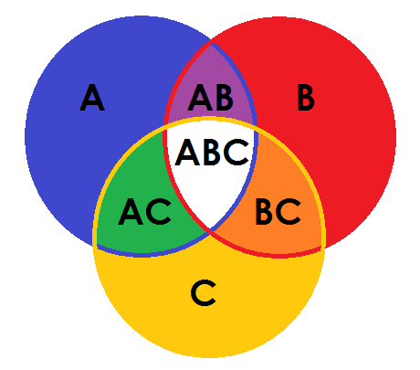

**Figure 3: Example of a Venn diagram** [insert NOS AWB Figure 3]

[START TEXT BOX]

*What’s a Venn diagram?*

Let’s say there are three things: A, B and C. In the Venn diagram in Figure 3, the blue circle represents the characteristics that only A possesses, the red circle represents the characteristics that only B has and the yellow circle represents the characteristics that only C has. In the purple intersection between A and B, we would see characteristics that A and B share, but C does not. Likewise in the green intersection between A and C, we would see characteristics that A and C share, but B does not. The orange intersection represents the characteristics that B and C share, but not A. Finally, in the white centre of the diagram, we see the characteristics that A, B and C all share or have in common.

[END TEXT BOX]

You are going to draw a large Venn diagram, like the one in Figure 3. Don’t worry about colours! (It might be a good idea to use a double sheet of paper for your Venn diagram.)

Create three large intersecting circles, similar to the circles in Figure 3, and label each one as follows: Physics, Biology, and Chemistry.

Now read the following statements and decide where each of the disciplines will be inserted in your Venn diagram, based on the characteristics referred to in the statements. Write the numbers of the relevant statements into your Venn diagram.

Statements:

1. The study of animals.
2. Determining the melting point of elements at different pressures.
3. Calculating the time it takes light to travel to Earth from a particular star.
4. Determining which fertilisers work best for which crop plants.
5. Investigating the frequencies at which dolphins make sounds.
6. Finding various ways to combat climate change on a global scale.
7. The study of chemical reactions.
8. Describing the life cycle of a particular plant species.
9. Creating mechanical membrane systems.
10. Understanding electric circuits in your house.
11. Working out the chemical composition of snake venom.
12. Developing ways to clean up an ecosystem which has been affected by nuclear waste from a nuclear power station.
13. Studying the relationship between matter and energy in atoms.
14. Explaining the change in compounds during chemical reactions.

Discussion of the activity

Some of the statements are rather straightforward and easy to place in your Venn diagram. Other statements are a little more challenging! If you are not certain what some of the words mean in the statements, google them, or look them up in a dictionary.

Exemplar answer

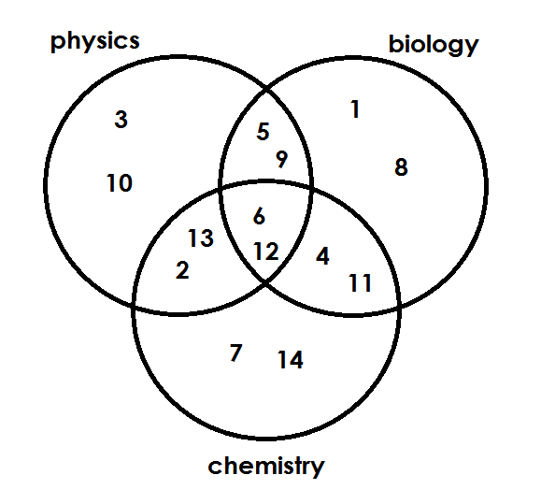

**Figure 4: Answer to Activity 1.3** [insert NOS AWB Figure 4]

These four short videos will help you understand a little more about the three disciplines of science that you will be studying in the Natural Sciences:

*What is science?* <https://www.youtube.com/watch?v=hDQ8ggroeE4&t=14s> (Duration: 2.01)

*What is physics? – Inspiration*: <https://www.youtube.com/watch?v=HuZZpJJF71U> (Duration: 2.19)

*What is biology?* <https://www.youtube.com/watch?v=oFtVDLFXKLA> (Duration: 2.10)

*What is chemistry?* <https://www.youtube.com/watch?v=j7d6RETP6PQ> (Duration: 1.59)

[START TEXT BOX]

*What’s the main idea?*

Science is a collection of disciplines. Physics and Chemistry try to discover the natural laws that describe how the non-living world works. Biology studies the living world, which is much more variable than the non-living world. There are many areas of scientific investigation that overlap between these three disciplines.

[END TEXT BOX]

Moving on

Before you move on to the next unit, go back to your answers in Activity 1.1. Do you have a better understanding of what science is and what it isn’t?

In the next unit, you will explore the role that science plays in society.

Topic: The nature of science

Sub-topic 1: What is Natural Science?

Unit 2: Science in society

Unit 2 learning outcomes

By the end of this unit, you should be able to:

1. Explain the value of science for human society.
2. Identify the limitations of science in its inability to investigate phenomena that cannot be proved or disproved, such as beliefs, the purpose of life, issues of good and evil.

Unit 2.1: Science has value for human society

Go back to Unit 1 and look again at Figure 1.

In your workbook, under a heading ‘Science has value for human society’, answer the question: ‘Have you used science today?’ by making a bulleted list of all the areas in which science has been of value to in the past 24 hours.

Now read these notes:

Science gives us a powerful way of *understanding things* that happen in our natural world. The laws of nature (laws of physics, biology and chemistry) explain how the world behaves.

We are naturally curious about our world. Science provides a way of *learning more* and investigating new questions that we ask, because science is a process as well as the body of knowledge we generally call ‘science’. By understanding the world, we can predict future events, such as floods, flu epidemics, and eclipses of the Sun.

Science is a *way of thinking* about the world. It uses reasoning, and evaluates statements in terms of how they are supported by evidence. People who master scientific ways of thinking can solve problems and think critically.

Science is our best *hope* for curing diseases such as HIV and AIDS, discovering new materials that do not pollute the earth, and developing new technological products such as machines that can diagnose [analyse the cause of] illnesses and smartphones.

Science also enables us to marvel at the order in the natural world.

There are two different kinds of research that scientists can do:

1. *Basic research* tries to find out more about the universe because it is interesting. Scientists who conduct basic research are curious about the universe. Their findings may be useful to humans in the future, but that is not the primary goal of their research. They are trying to advance scientific knowledge about the universe.
2. *Applied research* is done with specific goals in mind. Applied researchers want to use science to create machines or processes that make money and/or benefit humans. Their research may result in a new process, a new machine, or a new treatment for a disease.

Applied research is closely linked to *technology*. Technology applies the results of science for commercial or industrial goals. Engineers and technicians convert the findings of applied research into factories and industries.

Some people may think that applied science is ‘useful’ while basic science is ‘useless’. However, if you look at the history of science, you would see that basic knowledge has resulted in many significant applications of great value. Some scientists think that a basic understanding of science is necessary before an application is developed; therefore, applied science relies on the results made possible through basic science. Other scientists think that it is time to move on from basic science and rather find solutions to actual problems. Both approaches are legitimate and valid. It is true that there are problems that demand immediate attention; however, few solutions would be found without the help of the knowledge generated through basic science.

Very importantly, science teaches ordinary people to think critically! In our everyday lives, we have to make decisions about our health and our diet, for example. We have to be able to predict the consequences if we allow rubbish to collect in our neighbourhood. At a national level, we have to contribute to decision-making about the sources of our energy supply, and the importance of providing clean water to all communities.

Science provides us with the reasons why we need to live a healthy lifestyle, keep the local environment clean, and use renewable energy like solar and wind energy to generate electricity. Science informs us about bacteria in dirty water, and how it causes cholera and diarrhoea. Science helps us understand why it is important to vaccinate our babies. Science enables us to understand that dwarfism is caused by genes, not by evil spirits.

Activity 2.1: Understanding how science has value for society

Suggested time:

15 minutes

Aim:

Analysing whether you understand the value of science in society.

What you will do:

You will need your workbook, pen, pencil and ruler.

Answer carefully in your workbook under the heading Activity 2.1.

Copy the following table into your workbook:

|  |  |  |
| --- | --- | --- |
| Statement | Basic or Applied research | Value to humans |
| An astronomer discovers a new galaxy. |  |  |
| A materials scientist finds a new way to make rubber tyres. |  |  |
| An animal breeder breeds a new variety of chickens that are resistant to disease. |  |  |
| A biologist studies the diet of crowned eagles in South Africa. |  |  |
| A chemist discovers a new element. |  |  |
| A zoologist draws up a list of all the spider species in a nature reserve. |  |  |
| A botanist discovers a new plant in a rainforest. |  |  |
| A chemist discovers the structure of the way atoms are organised in a crystal of a compound. |  |  |
| A physicist uses the crystalline structure of a compound to make super fast conductors in a computer. |  |  |

Decide whether each of the statements listed in the table is basic research or applied research by indicating ‘basic’ or ‘applied’ in the middle column.

In the right hand column, decide how this aspect of science could be of value to human society.

Discussion of the activity

Determining whether a product of scientific research has value and what that value may be, is a *subjective* [personal, may be biased] decision in many cases. Remember to add weight to your decision by providing good reasoning or justifying your decision with evidence.

Exemplar answer

|  |  |  |
| --- | --- | --- |
| Statement | Basic or Applied research | Value to humans |
| An astronomer discovers a new galaxy. | basic | Whilst it may seem at first that there is little real value to human society in discovering a new galaxy millions of light years away, studying that galaxy could help us understand how galaxies, even our own, formed. We could have more definite knowledge about our origins. And don’t forget the ‘marvel’ aspect of such a discovery…what if life exists in that galaxy? |
| A materials scientist finds a new way to make rubber tyres. | applied | The new process could make vehicles safer, the rubber may be recycled thus reducing pollution. |
| An animal breeder breeds a new variety of chickens that are resistant to disease. | applied | This could have a direct impact on food security and make foods safer for human consumption. |
| A biologist studies the diet of crowned eagles in South Africa. | basic | Understanding the diet of the eagle may help us to put in place better conservation efforts to prevent the extinction of the species; we could understand more about the impact humans have on the ecosystem in which the eagle lives. |
| A chemist discovers a new element. | basic | The element may prove to be a solution to countless technological problems: think of how discovery of the element radium in 1898 has led to technological advancements such as the treatment of certain kinds of cancer. |
| A zoologist draws up a list of all the spider species in a nature reserve. | basic | This information could provide insight into the ‘health’ of the rainforest and how humans are impacting this vital ecosystem. |
| A botanist discovers a new plant in a rainforest. | basic | The plant, as in the case of many plants, could contain a chemical that could be used in medicines. |
| A chemist discovers the structure of the way atoms are organised in a crystal of a compound. | basic | A different scientist could use the crystalline structure of the compound to make super fast conductors in a computer. |

[START TEXT BOX]

*What’s the main idea?*

Science adds value to our lives in helping us to understand the natural world, and to think logically. Science benefits humans in providing improved health, new materials such as plastics, and new technologies such as mobile phones. It enables us to marvel at the order in the natural world.

[END TEXT BOX]

Unit 2.2: Science provides opportunities for employment

If you are very interested in science, you could become a professional scientist. Professional scientists are employed in universities and research institutes. They have to spend many years studying science in order to eventually work as a professional scientist. Only a few people are employed as professional scientists.

Many more people become technicians who apply science and technology in their work. Farmers, computer technicians and medical technologists are examples of jobs that are based on science. There are many job opportunities for people who understand science.

This is a small list of careers in science:

* astronomer
* biomedical engineer
* climate change analyst
* clinical psychologist
* clothing technologist
* colour technologist
* food science technician
* forensic scientist
* pharmacist
* meteorologist
* microbiologist
* nuclear power plant technician
* geneticist
* product development scientist
* science teacher
* science writer
* soil scientist
* sound engineering technician
* toxicologist
* water quality scientist

Quick progress check

Choose five of the careers on the list that interest you. It could be that you have never heard of them before and the name of the career sounds interesting!

Write the name of the career into your workbook.

Google the name of the career and learn a little more about what the career involves doing.

Decide into which scientific discipline the career falls. Remember that many careers will be interdisciplinary.

Also decide if the career is one that will involve doing basic research, or applied research.

Think of the value of that career to human society.

Discussion of the progress check

You may discover something you have never considered doing as a career!

At the very least, you will see that most of the careers on the list involve interdisciplinary studies and most of the careers are also in the applied sciences. Without many of these scientists, our society would not function the way it does now.

[START TEXT BOX]

Scientists tell us that in the near future, there will be careers in science that do not exist right now!

Keeping this thought in mind, consider the threat of climate change, global warming and rising levels. Maybe in the near future there will be a career known as a ‘drowned city expert’. What would such a career involve, do you think?

[END TEXT BOX]

Activity 2.2: Reflection on the value of science in society

Suggested time:

30 minutes

Aim:

You will link the knowledge you obtained in Unit 2.1 to the concept of careers in science to further reflect on the value of science in society.

What you will do:

You will need your workbook and pen

You will watch three videos and then answer the question that follows carefully in your workbook under the heading Activity 2.2.

This TEDTalk suggests that the value of science is linked to technology and jobs:

*Scientific literacy is necessary:* <https://www.youtube.com/watch?v=b-EsmVbIjLU> (Duration: 9.31)

This video suggests that the value of science lies in ideas:

*The value of science is ideas:* https://www.youtube.com/watch?v=_gryAXIbDtg (Duration: 2.12)

This video suggests that science is not just something that happens in science class! It is something that we do, and should do, everyday.

*Hey Bill Nye, What’s Science Good for Outside of School?* <https://www.youtube.com/watch?v=YoS9Dli-IaM> (Duration: 3.25)

So what is the value of science in society?

After viewing the videos, do you think science should be valued for its ideas alone, or for what it contributes to technology and society by way of jobs? Should we maybe value science for the everyday things we do using science?

Write a critical mini-essay in which you discuss these three viewpoints, and come to a conclusion.

Discussion of the activity

You can consult the Student Handbook for information and skills on writing a critical essay. However, for this essay, you will need to:

* pose the problem in an introduction
* write a paragraph outlining each of the three viewpoints suggested (i.e. three paragraphs)
* come to a conclusion that may well reflect your personal opinion too.

Exemplar answer

There is no one model answer for this essay. You have been exposed to three different points of view, and you will formulate your own view, based on what you have learnt, as well as your personal experience.

Read over the essay carefully, to ensure that has no spelling or grammar errors. Give the essay to someone else to read (it could be another student or someone that you know who has a career in science) and ask them for their honest critical opinion of your essay. Listen to what they have to say, and re-evaluate some of your ideas if you feel that they have raised some important issues.

As with any essay that requires critical thinking, you will be assessed on your ability to lay out the argument and then present evidence, before coming to a reasonable conclusion based on that evidence.

[START TEXT BOX]

*What’s the main idea?*

Science is a gateway subject to many jobs. Science helps us make informed decisions at home, in our communities and as a nation.

[END TEXT BOX]

Unit 2.3: Science and the arts and belief systems

You have spent a great deal of time learning about what science *is*. What about considering *what science is not*?

Science is different from the arts because it starts with observation. For example, a scientist can study a piece of pottery and identify the type of clay that was used, how the pottery was fired to make it hard, and even how old the piece of pottery is. But a scientist cannot say whether it is beautiful or not, or what it meant to the person who made it.

Scientific statements describe *reality*, not how humans perceive [observe, notice, understand] that reality. Appreciation of art, music and physical beauty lie outside the boundaries of science.

Likewise, beliefs in supernatural powers such as a god or gods, or ancestral spirits, cannot be proved or disproved, and are therefore outside the boundaries of science. Scientists cannot give answers to questions such as

* What is the purpose of life?
* What is “good” and what is “evil”?
* What is beautiful or enjoyable in music, art or literature?
* What morals should I apply to my life?
* Is there a god or supernatural forces such as ancestral spirits that control my life?
* Do miracles happen?

Activity 2.3: Some of the limitations of science

Suggested time:

20 minutes

Aim:

By analysing an artwork, you will demonstrate that you understand some of the limitations of science.

What you will do:

You will need your workbook and pen.

Study the artwork in Figure 5 and then answer the questions that follow.

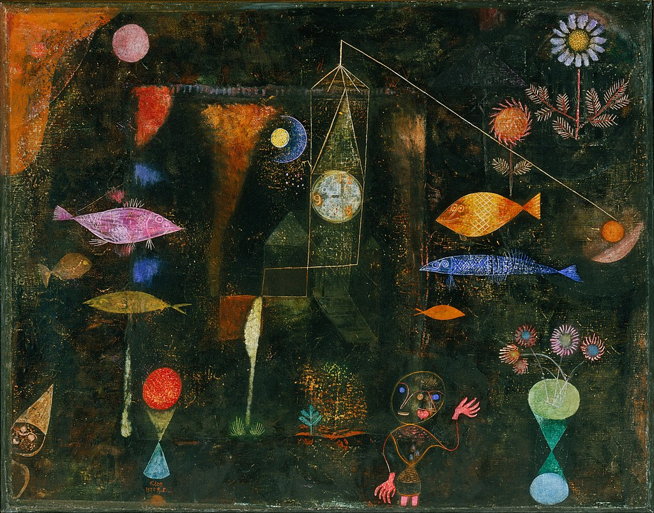

**Figure 5: *Fish Magic* by Paul Klee** [insert NOS AWB Figure 5]

Source: <https://commons.wikimedia.org/wiki/File:Paul_Klee,_Swiss_-_Fish_Magic_-_Google_Art_Project.jpg>

Paul Klee was a Swiss artist who lived from 1879 to 1940. He painted *Fish Magic,* a very large oil and water colour painting in 1925. In the middle of the painting is a sheet of muslin [a thin, delicate fabric], that has been stuck onto the canvas and painted over. Klee scraped and sanded the black paint to reveal mysterious specks and passages of glowing colour underneath, a sophisticated version of the art children produce using wax crayons and black paint.

1. What images from the natural world as depicted [shown] in the painting?
2. Are the images you identified in (1) realistically portrayed in the painting?
3. There are a number of fish in the painting. List three scientific facts you know about fish.
4. Although you may know scientific facts about fish (or plants, moons, planets, time, i.e. other elements from the natural world that appear in the painting), does the painting add to your scientific body of knowledge of fish (or plants, moons, planets, time etc.)? Explain your answer.
5. If you look carefully at the clock, four numbers are highlighted in yellow/orange paint. Can you give a scientific or factual reason for these numbers being highlighted?
6. What does the painting mean to you? What is the meaning of the muslin square in the middle of the painting? Will it mean the same to all other people?
7. Do you find the painting beautiful? Will all other people rate its beauty (or lack thereof) in the same way?
8. What do your answers to all these questions reveal about art, meaning and aesthetics [how beautiful something is], and science?

Discussion of the activity

In this activity, you will use critical thinking to answer some questions, and finally come to a conclusion about what science is and what it isn’t.

Exemplar answer

1. The painting depicts elements from the sea and the earth (fish, flowers) as well as elements from space such as moons and planets. These are considered parts of the natural world. There is a clock in the painting, representing the element of time, a dimension in the natural world.
2. No, these images are depicted in an expressionist or surreal manner.
3. Fish live in aquatic [watery] environments; fish do not have lungs but rather obtain oxygen from the water by means of gills; fish are generally streamlined to assist their locomotion [method of movement] in water; fish use fins to swim through the water; the skin of fish is covered with scales, etc.
4. No. In fact the representation of fish in the painting seems to contradict scientific knowledge of fish. The fish are depicted in an unrealistic manner in the painting. For example, the fish do not seem to be living in an aquatic environment; they are in the same environment as the plants. Some of the fish do not appear to have fins or gills or scales.
5. The highlighted numbers are 1, 2, 5 and 9. If you reorder these numbers, you get 1925, the year in which Klee painted this artwork. But why did he do this? Was he attaching some significance to the year 1925? Is it simply a coincidence that these numbers are highlighted and that in fact the artist did not do this intentionally to bring your attention to 1925? Without being able to ask the artist, we will not know for a fact why these numbers in particular are highlighted on the clock.
6. There is no way to establish a universal meaning of this artwork, without asking the artist, who is now dead, and who never interpreted his art publically while he was alive. Maybe the square of muslin is meant to represent a curtain, and maybe the artist was suggesting that if you pull back the curtain, the natural world will reveal more ‘magic’ and wonderful things! But we don’t know for sure.
7. In the same way, the artwork may appear beautiful to you, or it may appear messy and ugly! But someone else will love it. (It hangs in the Philadelphia Museum of Art and is valued at over $6 000 000!)
8. There is no way of scientifically determining the meaning of an artwork, or deriving scientific knowledge from the artwork. We also cannot make scientific claims as to whether the artwork is beautiful. These things lie outside the realms of science.

[START TEXT BOX]

*What’s the main idea?*

Science only addresses questions that can be proved or disproved. Other questions fall outside the boundaries of science.

[END TEXT BOX]

Moving on

This Sub-topic has presented a comprehensive exploration of what science is (and what it isn’t) and the role science plays in society. In the next Sub-topic, you will focus more closely on how science is done as you look at the process of scientific inquiry.

Topic: The nature of science

Sub-topic 2: Scientific inquiry

Unit 1: The process of scientific inquiry

Unit 1 learning outcomes

By the end of this unit, you should be able to:

1. Explain that scientific knowledge is based on systematically-collected (rigorous) evidence, with no fixed sequence of steps followed by every scientist.
2. Describe observation as the essence of science.
3. Distinguish among the terms *theory*, *hypothesis* and *prediction* as used in science.
4. Describe the use of controlled experiments as one way of collecting rigorous evidence in science, specifically experiment and control, dependent, independent and controlled variables, accurate data recording, replication of experiments.
5. Explain the importance of recording accurate data in the form of measurements, verbal descriptions, photographs or diagrams.
6. Explain how analysis of data enables inferences to be made.
7. Explain the importance of avoiding bias by striving for objectivity in collecting and interpreting data, for example, by having many different investigators or groups of investigators working on a problem.

Unit 1.1: Scientific inquiry

In the previous Sub-topic, you were presented with a comprehensive exploration of what science is (and what it isn’t) and the role science plays in society. In this Sub-topic, you will focus more closely on how science is done as you look at the process of scientific inquiry.

You have learnt that science is based on observation and experimentation. Science and scientists use many different kinds of investigations when they investigate the universe. There is no fixed series of steps that all scientists must follow. However, there are only a few basic steps that can be called the *scientific method**of inquiry*, which generally apply to the natural sciences.

[START TEXT BOX]

*What’s the difference between ‘enquiry’ and ‘inquiry’?*

Both words refer to the act of ‘finding out’.

‘Enquiry’ is most often used in a general sense, such as when you want to ask someone something and so, you make an enquiry. For example: “I want to make an enquiry about how to open a savings account at your bank” or “Please enquire about your aunt’s health – how is she doing after her operation?”.

‘Inquiry’ is most often reserved for making a formal investigation. For example: “There was an inquiry into why the aeroplane crashed into the mountain” or “I am conducting an inquiry into how electromagnets work”.

In this course, we use the form ‘scientific inquiry’ to refer to formal scientific investigations.

[END TEXT BOX]

Figure 6 is a flow chart that shows the basic steps in the general scientific method of inquiry.

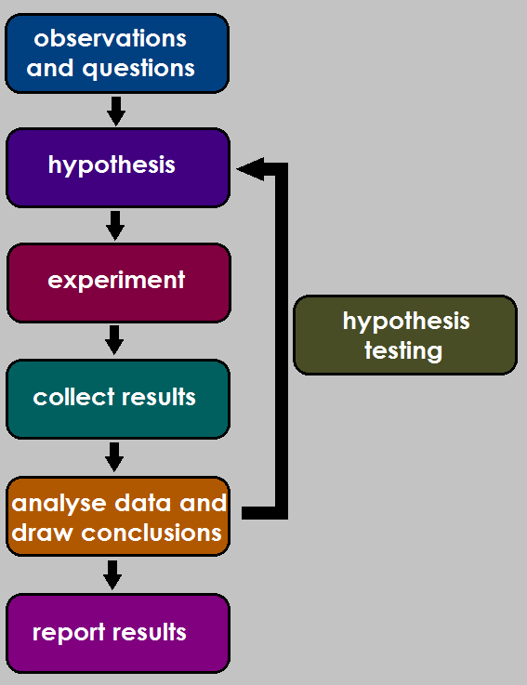

**Figure 6: The scientific method of inquiry** [insert NOS AWB Figure 6]

You will refer to this Figure throughout this Unit and in Unit 2 as well.

This video provides an example for how the scientific method might work in a particular context:

*The scientific method:* <https://www.youtube.com/watch?v=N6IAzlugWw0> (Duration: 11.48)

Watch the video and relate the steps provided in the video to Figure 6. You can plot the example given in the video against the steps given in Figure 6 in your workbook.

This website: Science Buddies: <https://www.sciencebuddies.org/science-fair-projects/science-fair>

provides excellent guidance on the scientific method.

[START TEXT BOX]

*What’s the main idea?*

Scientific inquiry is based on observation and experimentation and although the investigation may take a number of different forms, it most usually involves some basic steps called the scientific method.

[END TEXT BOX]

Unit 1.2: Observation

Science generally begins with an observation which triggers the asking of some kind of question.

Observation is gathering information about nature as it exists. We talk about observing “with a scientific eye”. That means noticing every detail, using all our senses, and often using instruments that enhance [improve or boost] our senses. Some details about nature come from sources that human senses cannot detect. Instruments are necessary in order for humans to make observations about these sources.

For example:

* Microscopes allow us to see objects that are too small for the eye to see.
* Telescopes enable us to see objects that are very far away.
* Very sensitive listening equipment allows us to hear sounds that are too high for the human ear to hear, such as the squeaks of bats.
* A gas chromatograph can be used to detect trace [very small amounts] chemicals in the atmosphere.
* Humans cannot detect magnetic fields, but birds use the earth’s magnetic field when they migrate. Humans use instruments called magnetometers to detect and measure magnetic fields.
* Humans do not have a sense that can detect electrical fields, but some fish use electrical fields to detect their prey. We use instruments such as galvanometers, ammeters and voltmeters to measure electrical fields and currents.

Once something has been observed in nature, the next step in the scientific method is to question what has been observed. For example:

* What does it look like inside a cell?
* Why do stars appear to twinkle [sparkle with a flickering light]?
* How do bats not fly into walls at night?
* What chemicals are present in the atmosphere around a fertiliser factory?
* What is controlling the migration of birds?
* Why does the electricity in my house trip when I have too many plugs on?

Further observation and investigation will be undertaken, often using instrumentation.

[START TEXT BOX]

*What’s the main idea?*

Observing natural events ‘with a scientific eye’ lies at the heart of how the scientific method both begins and proceeds. Often instruments can help human observe things they are unable to observe naturally.

[END TEXT BOX]

Unit 1.3: Hypotheses, theories, predictions and laws

Refer back to Figure 6. Once a scientist has made beginning observations, and asked a question to investigate, the next step is to suggest an answer to that question. This is called ‘stating a hypothesis’. The hypothesis is a testable statement. The investigation or experiment that follows, will test the hypothesis.

Write the heading of this sub-unit in your workbook.

Before you properly begin this section, test what you understand now about the words in the title of this sub-unit. Because this is a discovery task, try your best, but don’t be too worried if you are very unsure. You will come back to this after some more work.

Here are some terms: *fact, hypothesis, theory, prediction, law, opinion*

Here are some definitions. You must match one of the given terms to each definition. Write your answers into your workbook, numbering carefully. Leave a few lines between each answer so you can come back later and revise your answers if necessary.

Definition 1: A personal belief that is often based on a person’s own value system, for example “The study of dinosaurs is a waste of money”.

Definition 2: A statement, based on evidence and observation, that scientists and others agree on, for example “Water can move against gravity up narrow tubes in a process called capillary action”.

Definition 3: The act of making an educated guess as to the outcome of a situation based on previously found information, for example “Based on the changes in temperature and atmospheric pressure, it will snow tomorrow”.

Definition 4: A reasonable explanation of an observation, that can be tested, for example “Eating chocolate causes pimples”.

Definition 5: An overarching statement that describes how something in the natural world works, for example “Planets orbit the sun on elliptical paths”.

Definition 6: A series of statements about the world that are testable, supported by evidence and can be used to make explanations and predictions, for example “Continents are land masses that have moved in the past and continue to move today.”

Now read the following information:

After a scientist has observed a natural event, and perhaps read up on the event to see what other scientists say, she develops a *hypothesis*. A hypothesis is an educated guess that explains a set of observations. Very importantly, the hypothesis statement must be testable. A hypothesis may be very simple, for example:

*Every time you kick a ball into the air, it comes back to the ground.*

*You could state a hypothesis as simply as “A ball kicked into the air always falls”.*

[START TEXT BOX]

*What is a hypothesis?*

A hypothesis is a statement that answers a question or explains a set of observations and is testable; plural = hypotheses.

[END TEXT BOX]

A *theory* is a statement about the world that is supported by evidence from many different sources. Theories apply to many more events than a single hypothesis.

A boy kicking a football may decide to experiment with all kinds of different objects to see if they all fall back to the Earth if you kick them. He gets his friends to join him in his investigations. He contacts people living in other countries to repeat his investigation and he combines all the data. After observing and measuring the rate of falling in thousands of experiments, he could come up with a theory that states:

*“All objects fall a distance proportional to the square of the time of the fall”.*

This theory can be tested by anyone else. It might need to be refined.

For example, some people may have found that wind affects the results. The theory needs to be re-stated:

“Without wind, all objects fall a distance proportional to the square of the time of the fall”.

Some theories are based on observations, rather than experiments. Theories based on events that happened a long time ago cannot be tested by experiments. However, in these cases, evidence is overwhelming and no evidence exists to contradict it.

*The theory that continents have moved across the Earth’s surface explains evidence from the shape of continents, the same fossils found on different continents, and the contours of the ocean floor.*

A theory such as the movement of the continents may not be easy to test experimentally. It is the best explanation considering all the evidence we have.

[START TEXT BOX]

*What is a theory?*

A theory is a statement about the world that is supported by evidence from many different sources; it can be used to predict and explain things.

[END TEXT BOX]

Scientists test each hypothesis and theory. They make *predictions* about what will happen in a particular system if the theory is correct. They then observe nature or conduct experiments to see if the system supports the theory.

*Suppose we hypothesise that all objects fall when dropped. We predict that if we drop a feather, a stone, a sheet of paper, and a cup of tea, they will all fall to the earth. Each object we drop is a test of our prediction. If all the objects fall to the earth, our predictions were correct and our hypothesis is supported.*

Tests do not necessarily prove or disprove a hypothesis or theory. They often say something about the range of situations under which the theory is valid.

*If we tested whether all objects fall when dropped in space, the objects would float away. They would not drop. If we filled a balloon with helium gas, it would float upwards. The theory that all objects fall when dropped is true on earth, and for all types of matter except certain gases.*

[START TEXT BOX]

*What is a prediction?*

A prediction is a guess or speculation about how a particular system will behave if a theory or hypothesis is correct.

[END TEXT BOX]

*law*: an overarching statement that describes how the universe works

When a theory has been tested many times, and the evidence seems to always agree, the theory may be raised to the level of a *law*. A law is an overarching statement that describes how the natural world works.

*In the earlier example about Robert Hooke’s discovery of cells, 200 years passed before a law was stated. The law stated that all living things are made of cells.*

Although science tries to describe the natural world in terms of laws, the laws may change if further evidence is discovered.

Opinions and beliefs do not have a place in science! Unless there is evidence for something, it does not fall into the category of science.

[START TEXT BOX]

*What is a law?*

A law is an overarching statement that describes how the universe works.

[END TEXT BOX]

So what then is an opinion?

An opinion is *not* science! It is a personal belief. It is a view or judgement formed about something that is not necessarily based on facts or knowledge.

Some opinions can be very damaging to science, because they may be expressed as fact or scientific knowledge.

For example:

* “Global warming is a lot of rubbish…look how cold this winter has been.”
* “Evolution is just a theory, I don’t believe in it.”
* “Vaccines cause autism; I will not be vaccinating my child.”

The above are all opinions that have no place in science! In fact, science has shown us just how incorrect these opinions are.

This is a great video to help you understand the difference between facts, hypotheses, theories and laws and how they all work together to make science!

*Fact vs. Theory vs. Hypothesis vs. Law… EXPLAINED!* <https://www.youtube.com/watch?v=lqk3TKuGNBA> (Duration: 7.11)

[START TEXT BOX]

*What’s the main idea?*

Science works through statements that have increasing levels of certainty: *hypothesis, theory*, and *law*. Hypotheses and theories generate *predictions* that can be *tested* to see if the hypothesis or theory is supported.

[END TEXT BOX]

Activity 1.1: Distinguishing amongst facts, hypotheses, theories, predictions and laws

Suggested time:

20 minutes

Aim:

You are going to test what you have learnt about the different kinds of scientific statements.

What you will do:

You will need your workbook and pen.

Answer each question carefully in your workbook under the heading Activity 1.1.

1. Go back to the short activity you did at the start of Unit 1.3. Do you wish to revise any of your decisions? Modify your answers now.
2. Now read each statement given below. Decide which kind of statement it is (fact, hypothesis, prediction, theory, law or opinion).
3. Rock music is the best kind of music to listen to.
4. Moonlight is light from the sun that reflects off the moon’s surface.
5. The valleys on Mars are most likely a result of erosion by ancient rivers on the Martian surface.
6. My aunt firmly maintains that regardless of medical research, vitamins produced in a laboratory can’t be as good for you as vitamins found naturally in food.
7. Diamond is harder than steel.
8. The earth was created in a miraculous event about 4000 years ago.
9. The earth formed over 4 billion years ago.
10. The Drakensberg mountains are the most beautiful mountains in the world.
11. The body of knowledge that describes how planets revolve around the sun is called a heliocentric model.
12. The changing weather patterns we are seeing at the beginning of the 21st century are a consequence of global warming. This is known as climate change.
13. Scientists have warned that global summer temperatures are set to increase next year.
14. E = mc2

Discussion of the activity

It is always difficult to learn new terminology associated with new ideas. As you work through the rest of this Sub-topic, you will find that these terms are used again and again. It helps to use the terminology as much as possible. And of course, when you move into the different Natural Science disciplines, you will find many opportunities to apply these ideas in context. That is where you will really find yourself using the terminology and learning it will be far easier!

Exemplar answer

1. Don’t get worried if you got some of these wrong first time around. Hopefully you have now learnt something important and can modify your original ideas.

Definition 1: opinion

Definition 2: fact

Definition 3: prediction

Definition 4: hypothesis

Definition 5: law

Definition 6: theory

2.

1. not scientific – this is an opinion
2. fact
3. hypothesis
4. not scientific – this is an opinion
5. fact
6. not scientific – opinion/belief
7. fact
8. not scientific - opinion
9. theory
10. theory
11. prediction
12. law

Unit 1.4: Carrying out experiments

Refer back to Figure 6. Once a scientist has made beginning observations, and asked a question to investigate, the next step is to suggest an answer to that question. This is called ‘stating a hypothesis’. The hypothesis is a testable statement. The investigation or experiment that follows, will test the hypothesis.

In this sub-unit, you will consider all the important aspects of experimentation.

In an experiment, the scientist changes some aspect of the natural world and observes the effects of the change.

For example, a chemist might mix two substances, such as vinegar and bicarbonate of soda, and observe what happens.

**Experiment and control**

Experiments must be carefully designed so that the effect the scientist observes is the result of the change he has made and nothing else. Some experiments are designed around an experiment and a control.

* The experiment is set up to test the effect of the change he is making.
* The control is set up to make sure that only the change he has made causes the effect.

For example, a scientist wants to test whether bean seeds need light to germinate.

He plants 10 bean seeds in one tray of soil, and 10 bean seeds in a second tray of soil. He waters each tray with exactly 100 ml of water every second day. He puts one tray inside a closed cardboard box. This is the *experiment*. The change he has made is to remove all light. He puts the second tray next to a window. This is the *control*. The control receives light.

By setting up an experiment and a control, the scientist can be sure that the results are due to the presence or absence of light, and not any other factor.

[START TEXT BOX]

*What’s the difference between an experiment and a control?*

Experiment: the setup that tests the effect of a change in the environment.

Control: the setup that makes sure that the results are due only to the change in the environment.

[END TEXT BOX]

**Dependent, independent and controlled variables, and fair tests**

Setting up experiments and controls are one way of ensuring that an investigation is a *fair test*.

What is a fair test?

Imagine that your friend challenges you to a race. You agree, thinking the race will be sometime in the future. However, he has his tracksuit and running shoes on and says that you will race him right now. You are in jeans and you are wearing a jacket and smart shoes. You’ve also just eaten a rather large lunch. As you start to take your jacket off, he starts running!

Is this a fair race?

Of course not! To be fair, you should both be dressed in similar running clothes. If you had known that the race was to be that day and at that time, and you wouldn’t have had a big lunch! And you certainly should start the race at the same time! There are too many factors that are not controlled for this race to be fair. The only thing you should be measuring is the speed at which you both can run. Not wearing running shoes, having eaten a big lunch, starting the race late…these are all factors that will affect your running speed.

What do you need to do to keep a test *fair*? First, you need to understand some concepts related to fair testing:

*Variables* are factors that cause or influence the outcome of an experiment. (In the example of the race just described, your clothing, the contents of your stomach and the starting time of the race are all variables.)

* The *independent variable* is the variable that the scientist controls. He decides the values of this variable. (In the example of the race, you and your friend are the independent variables.)
* The *dependent variable* changes as a result of the scientist changing the independent variable. It is the effect of the independent variable on the event. It is the variable that the scientist will measure. (In the example of the race, how fast you can run is the dependent variable. The scientist will measure this by determining which person gets to the finishing line first.)
* *Controlled variables* are variables that could influence the outcome of an experiment. The scientist tries to make sure that these variables are kept under control. They must not affect his measurement of the effect of the independent variable on the dependent variable. (In the example of the race, clothing, how much was eaten before the race and simultaneous starting time are the controlled variables.)

Here is another example. Bicarbonate of soda fizzes when you mix it with vinegar. You can try this at home.

Get five identical jugs or large glasses. Make sure they are clean and perfectly dry inside.

Put about quarter of a teaspoon of bicarb into one container. Add 50 ml of vinegar. Measure how high the fizzy mixture rises in the container.

Now test the effect of increasing the quantity of bicarb on the reaction. Try half a teaspoon, one teaspoon and two teaspoons. Always add 50 ml vinegar each time.

* The *independent variable* is the amount of bicarb you use.
* The *dependent variable* is how high the fizzy mixture rises.
* The *controlled variables* are the amount and type of vinegar you add, the type of container (glass, metal, or china), and the temperature at which you do the experiment.

When a scientist designs an experiment, it is essential that the experiment is a fair test. All the variables must be identified and carefully controlled. Only one variable at a time must be changed in order to determine its effect. A control should be set up where possible.

This website gives you more information about fair tests:

*Fair tests: A do-it-yourself guide*: <http://nsdl.oercommons.org/courses/understanding-science-fair-tests-a-do-it-yourself-guide/view>

Controlling the variables in an investigation ensures that your test is fair, and *valid*. *Validity* is an important concept in scientific inquiry. Simply put, validity is the degree to which your investigation measured what it set out to measure. You can see that if you did not control your variables, there will be no way of knowing which variable brought about the observed effect.

For example:

Sandra wanted to find out if her biscuits would taste better with more sugar. So she added ½ cup extra sugar, some more chocolate chips and some pecan nuts to the biscuit dough. Her three friends liked the new biscuits much better. “I was right!” Sandra said. “More sugar does make biscuits taste better.” Does this test have validity? How could you increase the validity?

This test lacks validity. Sandra has no way of knowing if the sugar alone made the biscuits better. It was just as likely that the addition of chocolate chips and nuts made the biscuits better! She could have increased the validity of the investigation by baking a batch of biscuits that *only* had the increased sugar, *not* the added chocolate chips and nuts. In this way, her test would have been measuring what she set out to measure: does increasing the amount of sugar make a tastier biscuit?

But how does Sandra know that it was just a coincidence that that particular batch of biscuits turned out tastier? How does she know if other friends will also agree with the three friends she used in this first test? Sandra has to make her test more *reliable*.

*Reliability* is another important scientific inquiry concept. Reliability refers to the degree to which the investigation produces *consistent* or regular, dependable outcomes or results. How could Sandra make her investigation more reliable?

Sandra needs to *repeat* the identical recipe mixture a number of times, with a *larger sample* of tasters. She needs to show that her conclusions that adding more sugar improves the recipe are reliable because she has produced the biscuits according to that changed recipe 20 times, and has asked 50 people to taste test the biscuits.

[START TEXT BOX]

*What’s the main idea?*

Experiments involve changing some aspect of a natural event and observing the effects of the change. The experiment must be carefully designed to test only one variable at a time, while controlling other variables, in order to ensure a fair test. Investigations must be valid and reliable to be considered fair tests.

[END TEXT BOX]

Activity 1.2: Understanding experimental design

Suggested time:

30 minutes

Aim:

This activity tests if you have understood what you have read about.

What you will do:

You will need your workbook and pen.

Answer each question carefully in your workbook under the heading Activity 1.2.

1. Match the correct definition with each term listed below.

|  |  |
| --- | --- |
| **Term** | **Definition** |
| 1. Dependent variable | A. The degree to which the investigation measured what it set out to measure. |
| 2. Experiment | B. The variable that the scientist controls. |
| 3. Controlled variable | C. The degree to which the investigation produces consistent or regular, dependable outcomes or results. |
| 4. Control | D. The setup that tests the effect of the change a scientist is making. |
| 5. Independent variable | E. A setup that ensures that only the change the scientist has made is responsible for the effect. |
| 6. Validity | F. The variable that changes as a result of changes in the independent variable. |
| 7. Reliability | G. A variable that must be kept exactly the same for the experimental setup and the control setup. |

1. Phindile kept a plant on the kitchen counter. She accidentally spilled a small amount of washing powder in the soil. She soon noticed that the plant seemed to grow bigger and healthier. She wondered whether it had anything to do with the washing powder. To find out, she decided to grow some old bean seeds she found in her cupboard in a few old seed envelops. She used a small pot of soil from her garden and a slightly larger old pot of soil she had from a previous pot plant that had died. She planted 3 bean seeds in each of two pots. She put them both on the windowsill and watered them both everyday. In the one pot, she sprinkled a small amount of washing powder. In three weeks, the plants in the pot with the washing powder averaged 12 cm tall. The plants in the pot without the washing powder were an average of 8 cm tall. Phindile concluded that the washing powder had made the plants healthier and bigger.
   1. Which is the experiment and which is the control?
   2. Is this a fair test? Why or why not? If it isn’t fair, what could be changed to make it fair?
   3. Is this test reliable? Why? If it isn’t, how could you make it more reliable?
   4. Is this test valid? Why? If it isn’t, how could you increase the validity?

Discussion of the activity

When you engage with the Physics, Biology and Chemistry components of your Natural Science course, you will become more familiar with experimental design in these contexts.

Exemplar answer

|  |  |
| --- | --- |
| **Term** | **Definition** |
| 1. Dependent variable | F. The variable that changes as a result of changes in the independent variable. |
| 2. Experiment | D. The setup that tests the effect of the change a scientist is making. |
| 3. Controlled variable | G. A variable that must be kept exactly the same for the experimental setup and the control setup. |
| 4. Control | E. A setup that ensures that only the change the scientist has made is responsible for the effect. |
| 5. Independent variable | B. The variable that the scientist controls. |
| 6. Validity | A. The degree to which the investigation measured what it set out to measure. |
| 7. Reliability | C. The degree to which the investigation produces consistent or regular, dependable outcomes or results. |

1. The pot with the washing powder is the experiment. The pot without the washing powder is the control.
2. It is not a completely fair test in that Phindile has not controlled all her variables. Firstly, the bean seeds are not from the same batch/seed envelop, so they could be different kinds of beans. Also, the bean seeds are old. This may affect their ability to germinate. She needs to have used fresh bean seeds from one batch/seed envelop. She has also used two different sized pots and two different sources of soil. The pots and the soil need to be identical. The fact that she planted three bean seeds in each pot, kept them in the same place and watered them identically is good – this is controlling variables well. The only difference between the pots of seeds should have been the addition of washing powder to one of the pots. For the test to be fair, *all* the other variables should have been kept the same.
3. The test is not completely reliable. Phindile only used three bean seeds in each pot. She needed to have many more samples to make the test reliable.
4. The test lacks validity, because the variables are not well controlled. The difference in observed growth between the two pots of plants could be due to the soil, the size of the pot or the kind of bean seeds. These variables need to have been controlled so that the only difference between the experiment and the control was the presence/absence of washing powder.

Unit 1.5: Recording data

Refer back to Figure 6. Once a scientist has designed and performed the investigation, results must be collected. The results form the *data.*

*Data* means the observations and measurements a scientist makes. Data must be accurately recorded. *Accurately* means data must be exactly what the scientist observes. The scientist cannot make changes to the results. This would make the investigation lack reliability.

Here are some ways that scientists record data:

* Drawings or photographs
* Measurements
* Descriptions.

Here is an example of how data about an animal, a cheetah, may be recorded:

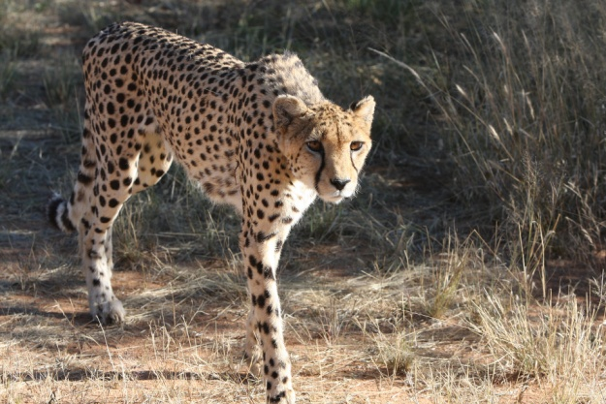

**Figure 7: Cheetah** [insert NOS AWB Figure 7]

(Source: https://pixabay.com/en/cheetah-namibia-wild-nature-2042448/)

|  |  |  |
| --- | --- | --- |
| **Measurements of a cheetah (average for 7 male and 7 female cheetah)** | | |
| **Body part measured** | **Males** | **Females** |
| Nose to tip of tail | 2,06 m | 1,9 m |
| Ear | 75 mm | 75 mm |
| Shoulder height | 881 mm | 847 mm |
| Mass | 48,4 kg | 35,8 kg |

**Form of the cheetah:**

Cheetahs are tall and slender, with long, thin legs. They have spotted coats. The background is slightly brownish, and is covered with many oval or round black spots. They have a black stripe from the corner of each eye to the corner of the mouth.

Any observation or experiment must be able to be repeated by another scientist. This is called *replicability*. We say a scientist *replicates* another experiment. Replicability is lionked to making an investigation more reliable.

For example:

I tried the experiment with vinegar and bicarbonate of soda, and got the following results:

|  |  |  |  |  |
| --- | --- | --- | --- | --- |
| Volume of fizzing when different amounts of bicarb are mixed with 50 ml vinegar. | | | | |
| Amount of bicarb | ¼ teaspoon | ½ teaspoon | 1 teaspoon | 2 teaspoons |
| Amount of fizzing | 110 ml | 120 ml | 135 ml | 135 ml |

My friend repeated the experiment, and she got the following results:

|  |  |  |  |  |
| --- | --- | --- | --- | --- |
| Volume of fizzing when different amounts of bicarb are mixed with 50 ml vinegar. | | | | |
| Amount of bicarb | ¼ teaspoon | ½ teaspoon | 1 teaspoon | 2 teaspoons |
| Amount of fizzing | 100 ml | 115 ml | 130 ml | 135 ml |

Her measurements were not exactly the same as mine, but the same *trend* [pattern of results] was visible: the more bicarb you mix with the vinegar, the more fizzing took place, up to about 1 teaspoon.

Refer to the Student Handbook for more guidance on other ways of recording data: tables and graphs in particular.

[START TEXT BOX]

*What’s the main idea?*

Scientists must record data as accurately as possible. Observations and experiments must be replicable.

[END TEXT BOX]

Quick progress check

Read the data given for the cheetah and answer the questions in your workbook:

1. Name the part/s of the data that shows measurements.
2. Name the part/s of the data that is a description.
3. What type of data is shown in Figure 7?
4. The figures shown in the table are the averages for seven adult male and seven adult female cheetahs. What trend or pattern can you see in the data?
5. “I used a kitchen measuring jug to measure the fizzing of vinegar and bicarb. It has markings in 25 ml units. My friend and I estimated (guessed) the height of the fizzing if it was between the 25 ml markers.” Write a sentence about the *accuracy* of data collection in this experiment.

Discussion of the progress check

1. The table titled “Measurements of a cheetah” shows measurements.
2. The part with the heading “Form” is a description. The photograph also shows what the cheetah looks like and is therefore a description too.
3. The figure records data visually by means of a drawing.
4. The ear size is the same in males and females. In all other measurements, males are larger than females.
5. The data is not very accurate, because the measuring instrument (a kitchen measuring jug) did not have enough markings. The researchers had to estimate measurements.

Unit 1.6: Identifying patterns

Refer back to Figure 6. Once a scientist has collected the data, the data/results must be analysed and interpreted so that conclusions can be drawn.

In sub-unit 1.5, you have already begun to interpret results when you start identifying trends or patterns in the data.

When a scientist has collected similar data many times over, she may start to recognise a pattern. The patterns may begin to appear in tables and graphs. Then she can make a general statement about her observations. The general statement is called an *inference*. An inference is a conclusion based on evidence and reasoning.

For example:

After measuring 50 male and female cheetahs, researchers have found that, apart from the ear size, the average measurements for females are smaller than those of males. They can make an *inference*: Female cheetahs are smaller and lighter than males.

In Physics and Chemistry, an inference can be written in words or in the form of a mathematical equation.

For example:

A scientist drops a soccer ball from a tall building. He measures how far the ball has fallen after 1 second, 2 seconds, 3 seconds, 4 seconds and 5 seconds. He finds that the ball that falls for 2 seconds falls four times further than the ball that falls for 1 second. The ball that falls for 3 seconds falls nine times further than the ball that falls for 1 second. After many tests, the scientist makes a general inference, which can be stated in three different ways:

* In words: The distance travelled is proportional to the square of the time of travel
* In equation form: distance = constant x (time)2
* In symbols: *d = k x t2*

The scientist can then engage in hypothesis testing (see Figure 6). If the conclusion supports the hypothesis then the hypothesis has been confirmed. If the conclusion does not support the hypothesis, then the hypothesis has been overturned.

[START TEXT BOX]

*What’s the main idea?*

If data collected from many experiments and observations agrees, a scientist draw a general conclusion called an inference. If the conclusion supports the hypothesis then the hypothesis has been confirmed. If the conclusion does not support the hypothesis, then the hypothesis has been overturned.

[END TEXT BOX]

Quick progress check

If you complete a scientific investigation and you discover that your conclusions do not support your original hypothesis, is this bad? Have you still ‘done science’?

Discussion of the progress check

Overturning (or refuting) a hypothesis is not a ‘bad’ thing in science. You have simply shown what is *not* the case, rather than what you suggested previously *is* the case! Provided your investigation was valid and reliable, you have most definitely still ‘done science’.

Unit 1.7: Avoiding bias

Scientists’ observations should not be influenced by what they *expect to happen*. Their interpretations of their results must also be *impartial* [neutral, objective]. We say their observations and interpretations must be *unbiased*.

If several researchers investigate an event, the chances of collecting unbiased data increase. The researchers may work separately or as a group. They must discuss their results and agree on the interpretation of results. Their conclusions are then unbiased.

You should be able to recognise that an unbiased investigation will lead to the investigation being more reliable.

[START TEXT BOX]

*What’s the main idea?*

Scientists try to be as unbiased as possible in their investigations and interpretation of their findings.

[END TEXT BOX]

Moving on

You have explored the different steps in the scientific method. If you refer back to Figure 6, you will see that one aspect is missing: reporting results. This will be covered in the next unit.

Topic: The nature of science

Sub-topic 2: Scientific inquiry

Unit 2: Presenting scientific reports

Unit 2 learning outcomes

By the end of this unit, you should be able to:

1. Identify the structure and style of a scientific report.
2. Identify the ethical norms of science, such as accurate recordkeeping, openness, replication, critical review of each other’s work, honesty in reporting results, avoiding unnecessary pain and suffering, taking care of animals in captivity, and obtaining informed consent from human participants in research.

Unit 2.1: Scientific reports

Refer again to Figure 6. In Unit 1, you reviewed the scientific method of inquiry, with the exception of how to report results. In this Unit, you will learn how to compile a scientific report that communicates to other scientists, and to society, what you have done.

A *scientific report* is the way a scientist reports her investigation and findings.

A scientific report describes exactly:

* why an investigation was done
* how it was done
* and what the findings were.

The report must enable other scientists to repeat the study to test whether their findings agree with the first investigation. Eventually, if enough scientists achieve similar findings, a general principle or theory can be stated.

There are many different types of scientific reports. One that is commonly used reports on an investigation. It has four main sections:

*Introduction*: Here the author states what problem was investigated, and what other scientists have found out about similar problems. The author states why it was important to investigate the problem. The author will also state their hypothesis in this section.

*Methods*: The author describes the methods in detail. This is important for other scientists to replicate the investigation. The full experimental design, as well as how the design was implemented or put into practice, must be described.

*Results*: The author presents the results in the form of measurements, descriptions, diagrams and/or photographs. Measurements are often presented in the form of tables and graphs.

*Discussion*: The author interprets the results. She shows how the results answer the problem she stated in the introduction. She also shows how her findings relate to the findings of other scientists.

Activity 2.1: Writing a scientific report

Suggested time:

30 minutes

Aim:

This is a scientific report on a student’s replication of Galileo’s experiment with rolling balls. You will read through the report and answer the questions that follow, demonstrating your understanding of the report.

What you will do:

You will need your workbook and pen.

Answer each question carefully in your workbook under the heading Activity 2.1.

*Investigation into the relationship between distance travelled and time as a ball rolls down a slope.*

*Introduction:*As an object falls from a height to the earth, its speed seems to increase. This investigation tried to find out whether there is a relationship between time and distance covered as an object falls. We predict that distance covered increases with the time over which an object falls.

*Method:* A straight, steep section of road, a soccer ball, a tape measure and a stopwatch were used for the experiment. The researcher released the ball at the top of the slope. After two seconds, a helper stopped the ball. The researcher measured the distance the ball had rolled. He started the ball at the top of the slope again, and let it roll for four seconds. The helper stopped the ball, and the researcher measured the distance the ball had travelled. The researcher repeated this method for 6, 8, 10 and 12 seconds.

The researcher repeated the whole experiment 10 times, and calculated the average distance that the ball travelled in each 2-second interval that it rolled.

*Results:* Table 1 shows the average distance travelled by the ball after it was released. Figure 1 shows the same information in the form of a graph. It is clear that as time increases, the ball travels greater distances.

|  |  |  |  |  |  |  |  |
| --- | --- | --- | --- | --- | --- | --- | --- |
| **Table 1: Average distance versus time of a falling ball** | | | | | | | |
| Time (s) | 0 | 2 | 4 | 6 | 8 | 10 | 12 |
| Distance (m) | 0 | 1.6 | 3.8 | 7.9 | 14.5 | 18.8 | 29 |



**Figure 1: Average distance versus time of a falling ball**

*Discussion:* If speed = distance ÷ time, this investigation shows that speed increases from 0,8 m/s in the first two seconds to 2,4 m/s between the 10th and 12th seconds. The prediction is correct. A ball travels a greater distance the longer the time that it falls.

Answer the questions that follow.

1. What is the title of the scientific report?

2. Which section of the report:

a) Presents the findings of the study.

b) Describes how the investigation was conducted.

c) Draws a conclusion based on the evidence.

d) Describes why the investigation was carried out.

3. How did the researcher make sure the data was accurate?

Discussion of the activity

In this activity, you analyse an existing scientific report to demonstrate your understanding of the structure of the report..

Exemplar answer

1. Investigation into the relationship between distance travelled and time as a ball rolls down a slope.

2. a) Results.

b) Methods.

c) Discussion.

d) Introduction

3. The researcher repeated the investigation 10 times and calculated averages.

You may be concerned that you are not a scientist and you are unable to ‘do science’ and present a scientific report. Watch this video that shows the outstanding results of a 16 year old girl in South Africa, who entered the Google Science Fair, and won it!

*Kiara Nirghin – GSF 2016 Global Finalist:* <https://www.youtube.com/watch?v=rIIgLIm4lQ0> (Duration: 2.06)

As you watch the video, in your workbook, identify the steps in the scientific method that Kiara followed, in particular:

* What problem did she identify?
* What was her solution to the problem?
* What were her methods?
* How did Kiara communicate her findings?

This video clarifies how to write a scientific report. Add any new information that you learn form this video to your notes:

*How to write a scientific report*: <https://www.youtube.com/watch?v=Yqioa8Njhhk> (Duration: 6.15)

This website gives clear but detailed instructions on how to write a scientific report:

*Scientific reports:* <https://writingcenter.unc.edu/tips-and-tools/scientific-reports/>

This is a useful summary guide to completing scientific research and writing a report:

*Investigation prompt sheet*

*Introduction and Research question*: After observing something that causes you to ask a question or highlight a problem you wish to solve, you should do some reading on the problem/question. See what other scientists say about the problem, or if they have posed a solution to your question. It does not matter if someone has answered your question; your original research can answer the question from a different perspective. This question can also be thought of and phrased as the *aim* of the investigation. It will set out the problem you intend to solve. Someone reading this will know immediately what the investigation is about.

*Hypothesis*: This is a testable guess. It is a sensible possible answer to your question or solution to your problem. It is important that the guess can be tested. The hypothesis should be phrased as a statement. The statement of the hypothesis is included in the introduction of your final report.

*Method*: When you plan the investigation, this section is writing in the future tense: what you intend to do to test the hypothesis. When you have done the investigation, in your report, you write this section in the past tense, indicating what you did.

1. List all the variables that can affect your investigation.
2. Decide which variable you will change in order to carry out your test.
3. Work out how you will control the other variables in order to keep the test a fair test.
4. Write down a list of the apparatus or equipment you will need in order to perform your test.
5. Write down the steps of the investigation, in point form and in the correct logical order.
6. You can include labelled diagrams to show how you set up apparatus or performed the investigation, if appropriate.
7. Show how you will make the measurements/observations and collect the data in order to record your results.
8. Show how you will ensure your investigation is valid and reliable.

*Results*: Record and interpret your results.

1. Make accurate observations and measurements.
2. Choose a suitable way to record your results, for example, table, list, graph, paragraph.

*Discussion*: Explain your results in a clear and straightforward way. Discuss any unexpected results and try to account for them (i.e. give reasons why these happened). Describe any trends or patterns in the data. Finally, write your *conclusions*:

*Conclusions*: Write down the conclusions that you can draw from the results you obtained. Do the results agree with your original hypothesis? Do the results answer your question as you predicted? You need to state whether your hypothesis was upheld or overthrown.

(Does it really matter if your hypothesis was wrong? No! It is equally valid to say what is not, as to say what is! You have still done science!)

*Evaluate*: It is often very useful after an investigation, to evaluate your efforts. Ask questions such as: Was it a fair test? Could there be another interpretation of my results? How accurate were my results? How can I improve on this plan? And very importantly – now that I have shown this – what can I ask further? How can I continue this investigation?

[START TEXT BOX]

*What’s the main idea?*

A scientific report makes a scientists’ investigations available to the scientific community and to society. It enables other scientists to replicate the study.

[END TEXT BOX]

Unit 2.2: Ethics in research

Growth of scientific knowledge depends on *honesty* in the scientific profession. Scientists are expected to keep accurate records. Anyone can check the records. Another scientist should be able to replicate the experiment and get similar results. Before a scientific paper is published, it is *reviewed* by other scientists.

These are all safeguards that make sure scientists are honest in their claims. Occasionally, a scientist is caught out for making up data, or holding back information. A dishonest scientist can lose their job, and lose the funding for their research. They may be barred from the scientific profession.

*Ethics* are moral principles that govern a person's behaviour or the way we conduct an activity. Scientists have moral principles. They make sure that experiments do not harm the environment, including all living organisms and humans. Living organisms that are used in experiments are properly cared for. If research involves humans, they must be fully informed about the purpose of the research. They must agree to participate, and allowed to withdraw if they wish to.

Scientists should not conduct research that could endanger the lives of others or the environment without their consent. This kind of research is not ethical.

This video explores ethics in scientific research: *"Hey Bill Nye, How Are Ethics and Morals Related to Science?"* <https://www.youtube.com/watch?v=cNbAk7FVb5M> (Duration: 3.52)

One very important area of ethics in research relates to *plagiarism*. Plagiarism is academic theft. It is when you pass off ideas and written/art work as your own without referencing the author.

By all means refer to the work of someone else, but do not copy their work. Use your own words to describe their ideas and then reference them in your reports. If you use their words, put these words into quotation marks. Quotes should not occupy more than 5% of a piece of your work.

At most academic institutions, if you are found guilty of plagiarism, you will receive no marks for that piece of work, and you stand the risk of being banned from the institution.

Please consult your Student Handbook to learn more about plagiarism and referencing the work of other people.

Activity 2.2: Writing your own scientific report and considering ethics

Suggested time:

30 minutes

Aim:

To determine if you able to write a scientific report and analyse the ethics associated with the investigation.

What you will do:

You will need your workbook and pen.

Read the following information and then answer each question carefully in your workbook under the heading Activity 2.2.

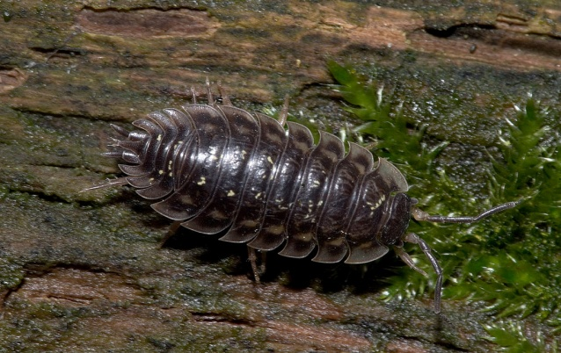

**Figure 8: Woodlouse** [Insert NOS AWB: Figure 8]

(Source: https://en.wikipedia.org/wiki/Oniscus_asellus#/media/File:Oniscus_asellus_Furlbachtal01.jpg)

*Thandi was playing in the garden. She found some bricks that had been left piled up against the shady side of the house. She turned over the bricks and discovered some crawling segmented organisms. She wondered what they were all doing under the bricks. When she turned over some bricks that were in the sunshine, she noticed there were no organisms under these bricks. Maybe, Thandi thought, these animals like the cool and damp place under the bricks in the shade. When Thandi was next online, she searched for images of organisms similar to the ones she had seen in her garden. She discovered that the organisms were called woodlice and that they were crustaceans. Thandi was very interested and decided to test her idea. She found a cardboard box and put a layer of dry garden soil into the box. She made sure the soil was the same depth across the box and that any bits of compost (which she thought the woodlice ate) were evenly distributed across the box. She then sprinkled quite a bit of water onto the soil at the one end of the box. She then went out and collected 20 woodlice. She put them in the middle of the box. She waited to see what happened. In the beginning, the woodlice scurried about in all directions. However, over the course of one hour, Thandi noticed that the woodlice began to stay in the wetter part of the box. Once all the woodlice had collected in the damp end of the box and stayed there for an hour, she gently collected them and again placed them into the middle of the box. Thandi noticed the same thing happening again. She repeated her experiment twice more. Each time the woodlice scurried about before finally all moving to the damp side of the box. Thandi concluded that the woodlice prefer cooler damp environments. After she returned the woodlice to the same spot in the garden where she found them, and watched them move to damp places and then burrow under rocks, bricks and plants, she wondered if sunlight was also something that affected woodlice behaviour. . .*

1. Write Thandi’s scientific report.
2. Comment on Thandi’s research ethics as you can infer them from the information provided.

Exemplar answer

Although there will be variation in the final version of your research report, the basics should be the same!

1. Introduction: Here you will have identified the question and problem that Thandi identified. You should have included a research question (*Do these animals prefer the cool and damp place under the bricks in the shade?)* as well as research into the subject (*She discovered that the organisms were called woodlice and that they were crustaceans.*) The hypothesis would also have been stated here: Woodlice prefer cool damp environments.

Method: In this section, you would have described what Thandi used, as well as what she did as she carried out her investigation. Also mention how the investigation was made a fair test, valid and reliable.

Results: Here you should indicate what Thandi discovered. You can present her results in a paragraph, as there were no measurements made, only observations.

Discussion: Here you should include Thandi’s conclusions: that woodlice do prefer the cool, damp environment to a dry, warm environment. You should also include Thandi’s reflection for further research: that she wondered whether sunlight affects the behaviour of woodlice.

1. Because Thandi was working with living organisms, she has a responsibility, as a researcher, not to harm the organisms. The information indicates that Thandi *returned the woodlice to the same spot in the garden where she found them*. This indicates that she did not harm the woodlice and replaced them in the environment. She also did not subject them to long periods of harsh testing in dry environments. She also ensured they had compost in the experimental box, which she believed was their food source. It appears then, that Thandi behaved ethically, as a researcher.

[START TEXT BOX]

*What’s the main idea?*

For scientists to trust each other and for society to trust science, there needs to be honesty and transparency. Scientists must ensure that their research does not harm other humans, living organisms or the environment.

[END TEXT BOX]

Key learning points

The Topic Nature of Science focussed on the following key points:

* Science is more than a large body of knowledge. Science is a systematic process or way of investigating the natural world and arriving at explanations.
* Scientific ideas are subject to change. We say that science is tentative and open to examination; it may change if new facts emerge.
* Science is a collection of disciplines. Physics and Chemistry try to discover the natural laws that describe how the non-living world works. Biology studies the living world, which is much more variable than the non-living world. There are many areas of scientific investigation that overlap between these three disciplines.
* Science adds value to our lives in helping us to understand the natural world, and to think logically. Science benefits humans in providing improved health, new materials such as plastics, and new technologies such as mobile phones. It enables us to marvel at the order in the natural world.
* Science is a gateway subject to many jobs. Science helps us make informed decisions at home, in our communities and as a nation.
* Science only addresses questions that can be proved or disproved. Other questions fall outside the boundaries of science.
* Scientific inquiry is based on observation and experimentation and although the investigation may take a number of different forms, it most usually involves some basic steps called the scientific method.
* Observing natural events ‘with a scientific eye’ lies at the heart of how the scientific method both begins and proceeds. Often instruments can help human observe things they are unable to observe naturally.
* Science works through statements that have increasing levels of certainty: hypothesis, theory, and law. Hypotheses and theories generate predictions that can be *tested* to see if the hypothesis or theory is supported.
* Experiments involve changing some aspect of a natural event and observing the effects of the change. The experiment must be carefully designed to test only one variable at a time, while controlling other variables, in order to ensure a fair test. Investigations must be valid and reliable to be considered fair tests.
* Scientists must record data as accurately as possible. Observations and experiments must be replicable.
* If data collected from many experiments and observations agrees, a scientist draw a general conclusion called an inference. If the conclusion supports the hypothesis then the hypothesis has been confirmed. If the conclusion does not support the hypothesis, then the hypothesis has been overturned.
* Scientists try to be as unbiased as possible in their investigations and interpretation of their findings.
* A scientific report makes a scientists’ investigations available to the scientific community and to society. It enables other scientists to replicate the study.
* For scientists to trust each other and for society to trust science, there needs to be honesty and transparency. Scientists must ensure that their research does not harm other humans, living organisms or the environment.

Moving on

You have now completed a very brief look at the Nature of Science. You will now move onto the three components that make up your Natural Sciences course: Physics, Biology and Chemistry.